**Sample Test for GoogleMapsUpdate API**

Google Maps Put Place API (PUT):

This API Will update existing place in Server with new values

Complete URL : http://rahulshettyacademy.com/maps/api/place/get/json?place_id=xxxx&key=qaclick123

Base URL :  [https://rahulshettyacademy.com](https://rahulshettyacademy.com/)

Resource: /maps/api/place/update/json

Query Parameters: key

Http Method: PUT

Note: Key value is hardcoded and it is always qaclick123

Sample Request:

{

"place_id":"8d2573bdf6ceec0e474c5f388fa917fb",

"address":"70 winter walk, USA",

"key":"qaclick123"

}

Sample Response for the Provided Place_Id

{

"location":{

"lat" : -38.383494,

"lng" : 33.427362

},

"accuracy":50,

"name":"Frontline house",

"phone_number":"(+91) 983 893 3937",

"address" : "29, side layout, cohen 09",

"types": ["shoe park","shop"],

"website" : "http://google.com",

"language" : "French-IN"

}

1. For Updating, we use PUT

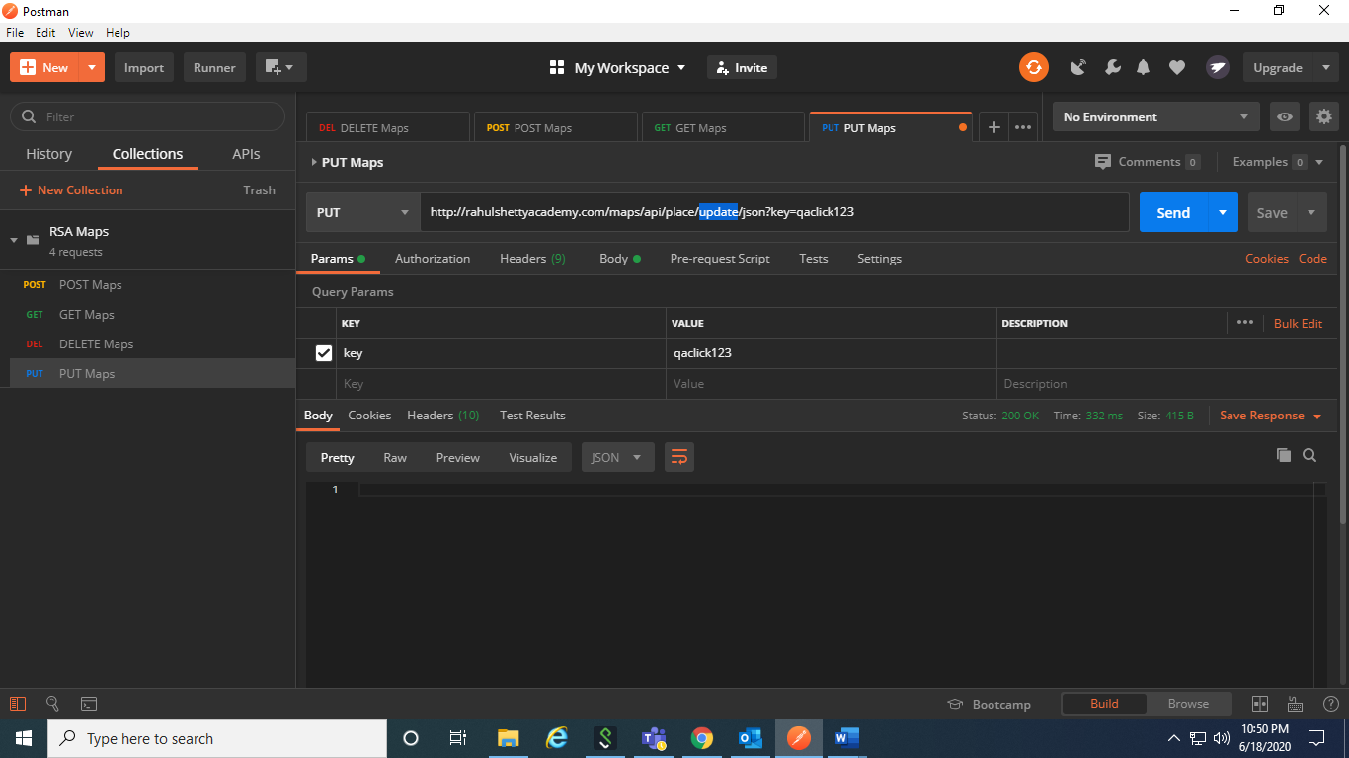

1. Except GET, everything will have a body. Since we have deleted the place id, post maps again and copy placeid from it.

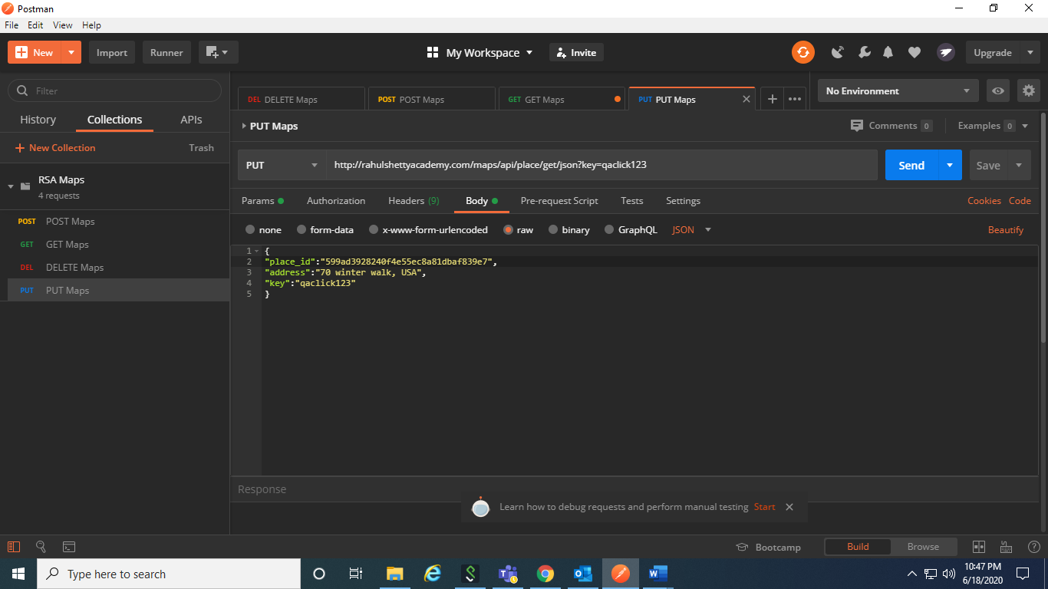

1. After the address is updated, check whether the address is updated from GET.