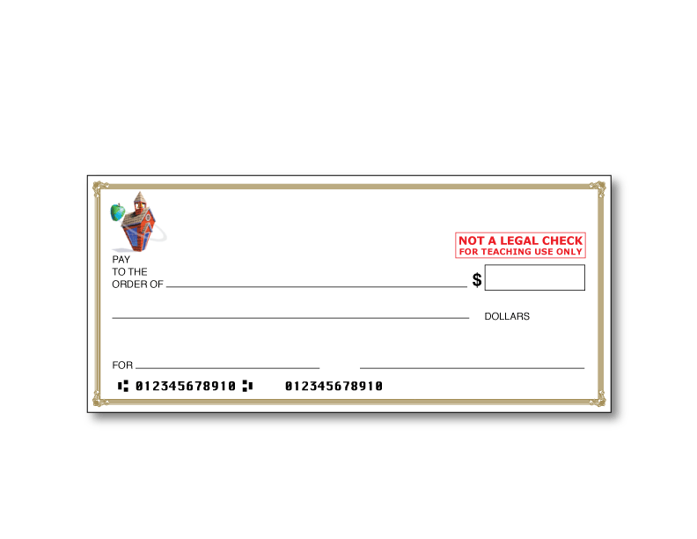
INSERT NAME
ADDRESS
CITY, STATE, ZIP CODE
0001
0001
INSERT Bank Name (example: Bank of 5th Grade)

