DATA WAREHOUSE ASSIGNMENT-1

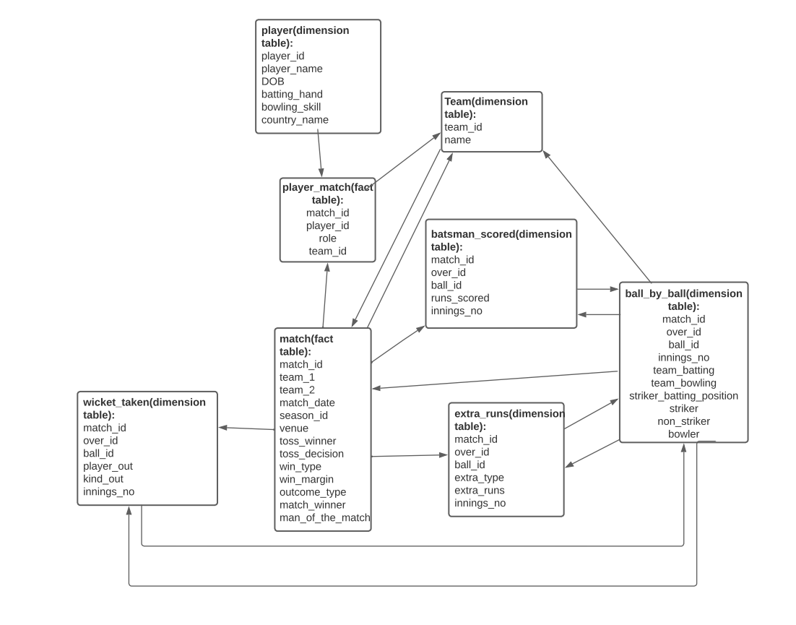

1.IPL Cricket Tournament start schema Design

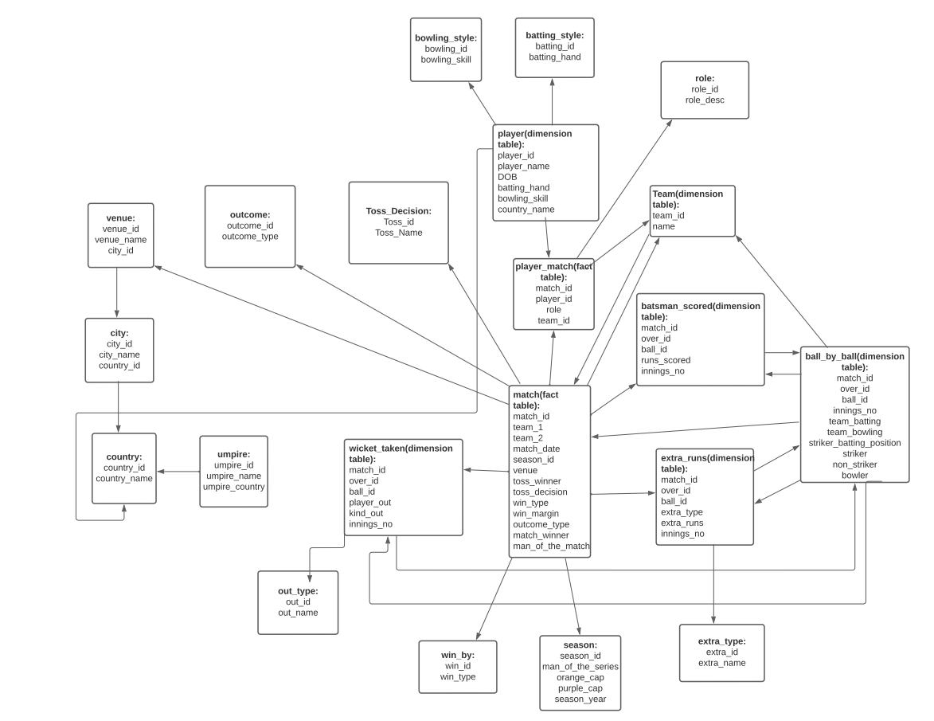

1.IPL Cricket Tournament Snowflake Schema

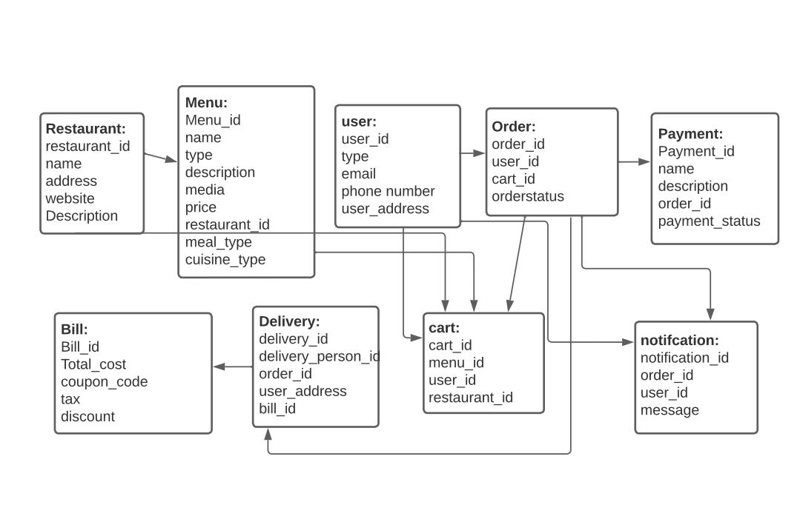2. Food Delivery Apps like Swiggy, Zomato Star Schema Design

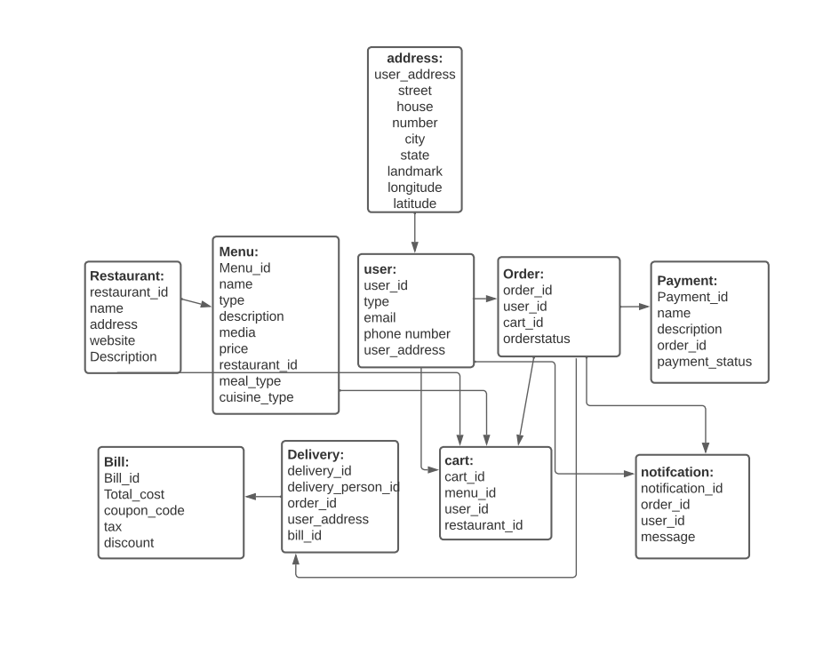2. Food Delivery Apps like Swiggy, Zomato Snowflake Schema Design

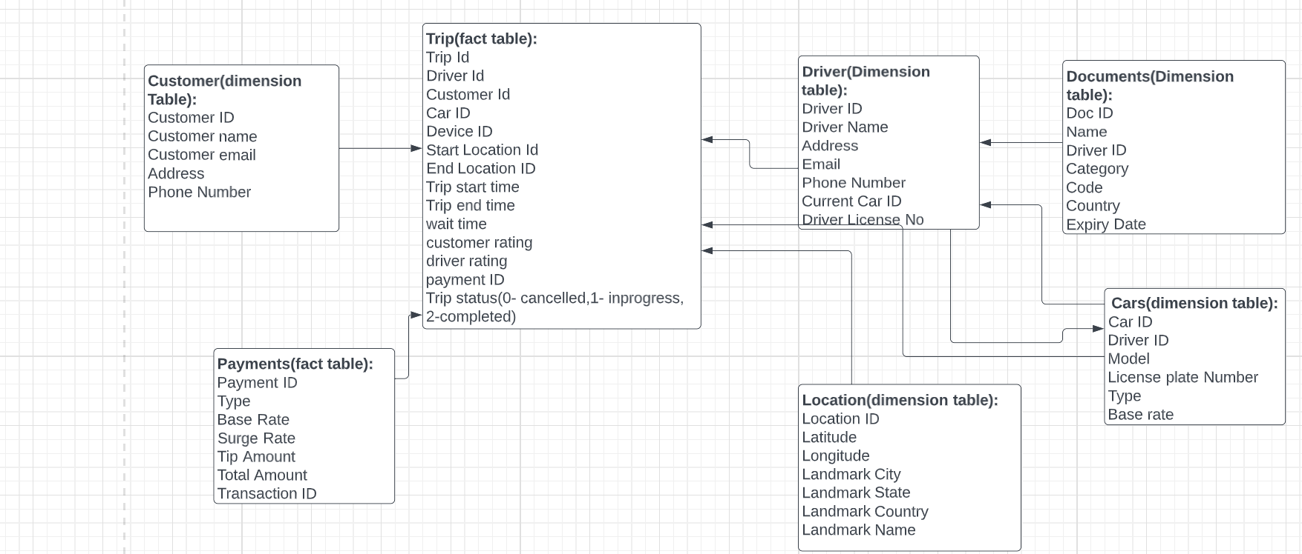

3. Cab ride services like uber star schema design

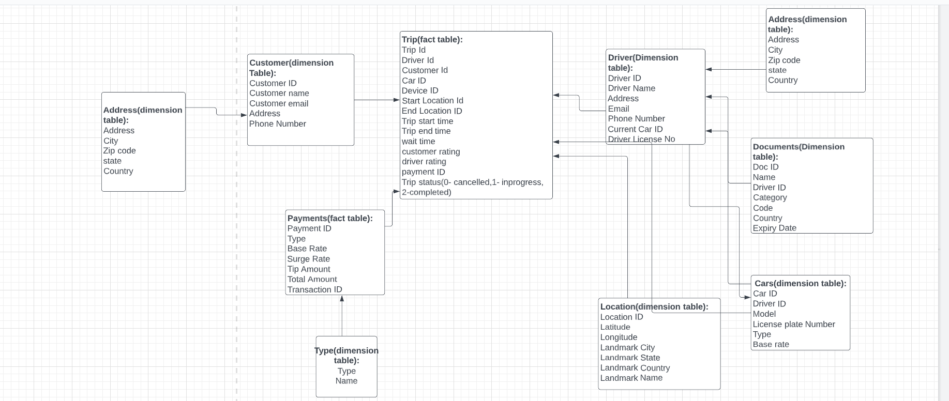

3. Cab ride services like uber snowflake schema design

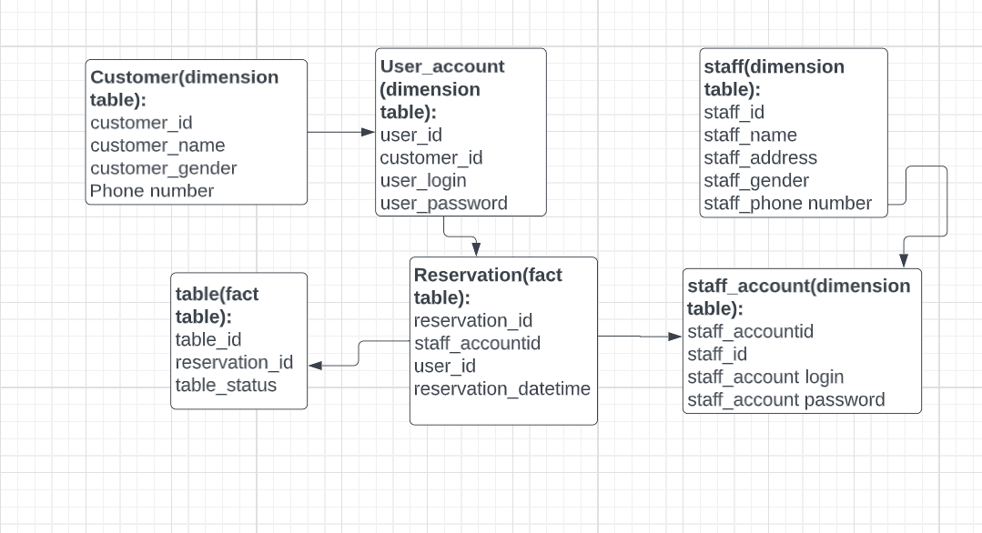

4. Restaurant table booking app like Dineout star Schema

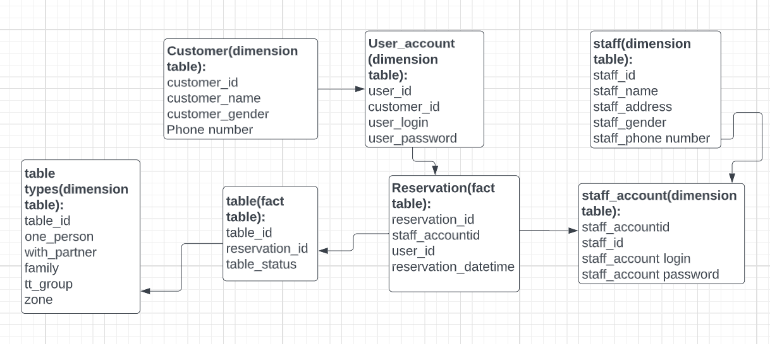

4. Restaurant table booking app like Dineout Snowflake Schema

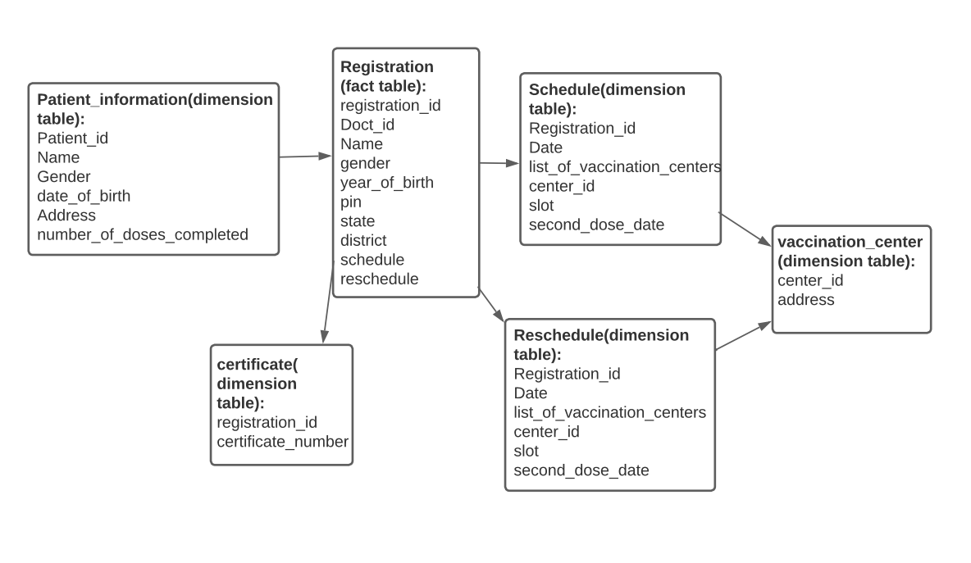

5.Covid Vaccination Application start schema

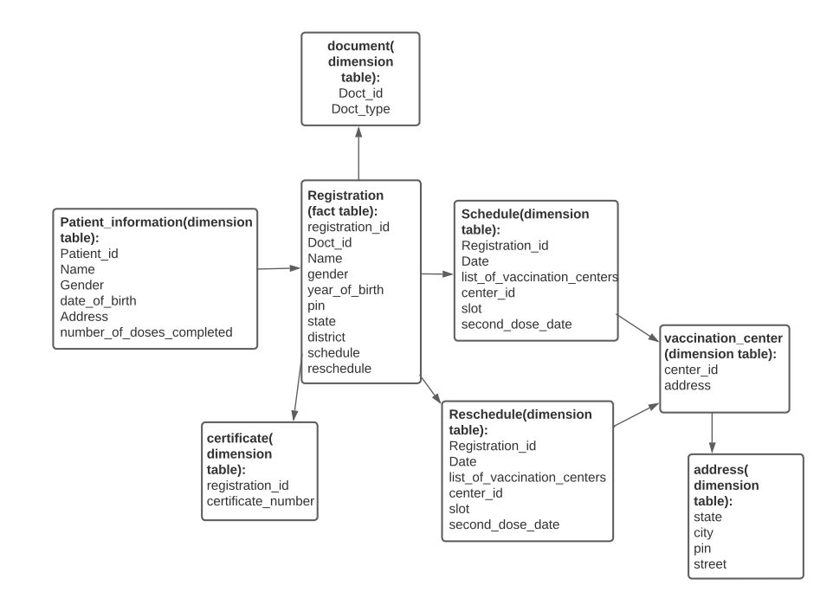

5.Covid Vaccination Application snowflake schema