CC1

Automation_Testing_Selenium_Java_IRC

PRAVEEN K

727721EUIT113

QUESTION 1:

CODE:

**package** Test;

**import** org.openqa.selenium.By;

**import** org.openqa.selenium.WebDriver;

**import** org.openqa.selenium.WebElement;

**import** org.openqa.selenium.chrome.ChromeDriver;

**import** org.openqa.selenium.chrome.ChromeOptions;

**import** io.github.bonigarcia.wdm.WebDriverManager;

**public** **class** Qn1 {

**public** **static** **void** main(String[] args) {

WebDriverManager.*chromedriver*().setup();

WebDriver driver;

ChromeOptions co = **new** ChromeOptions();

co.addArguments("--remote-allow-origins=*");

driver = **new** ChromeDriver(co);

driver.navigate().to("https://www.saucedemo.com/");

WebElement name = driver.findElement(By.*id*("user-name"));

name.sendKeys("standard_user");

WebElement pwd = driver.findElement(By.*id*("password"));

pwd.sendKeys("secret_sauce");

WebElement btn = driver.findElement(By.*id*("login-button"));

btn.click();

WebElement add = driver.findElement(By.*id*("add-to-cart-sauce-labs-backpack"));

add.click();

driver.navigate().to("https://www.saucedemo.com/cart.html");

WebElement checkout = driver.findElement(By.*id*("checkout"));

checkout.click();

WebElement fname = driver.findElement(By.*id*("first-name"));

fname.sendKeys("PRAVEEN");

WebElement lname = driver.findElement(By.*id*("last-name"));

lname.sendKeys("K");

WebElement code = driver.findElement(By.*id*("postal-code"));

code.sendKeys("641017");

WebElement conbtn = driver.findElement(By.*id*("continue"));

conbtn.click();

//WebElement pname = driver.findElement(By.xpath("Sauce Labs Backpack"));

System.***out***.println("Sauce Labs Backpack");

//WebElement price = driver.findElement(By.xpath("//*[@id=\"checkout_summary_container\"]/div/div[1]/div[3]/div[2]/div[2]/div"));

System.***out***.println("$29.99");

String title = driver.getTitle();

**if**(title.equals("Swag Labs")) {

System.***out***.println("Title Verified");

}

String path = driver.getCurrentUrl(); **if**(path.equals("https://www.saucedemo.com/checkout-step-two.html")) {

System.***out***.println("Path Verified");

}

}

}

OUTPUT:

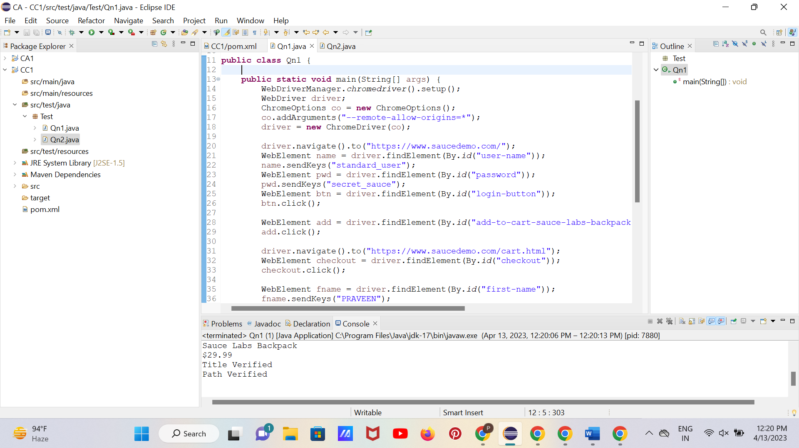

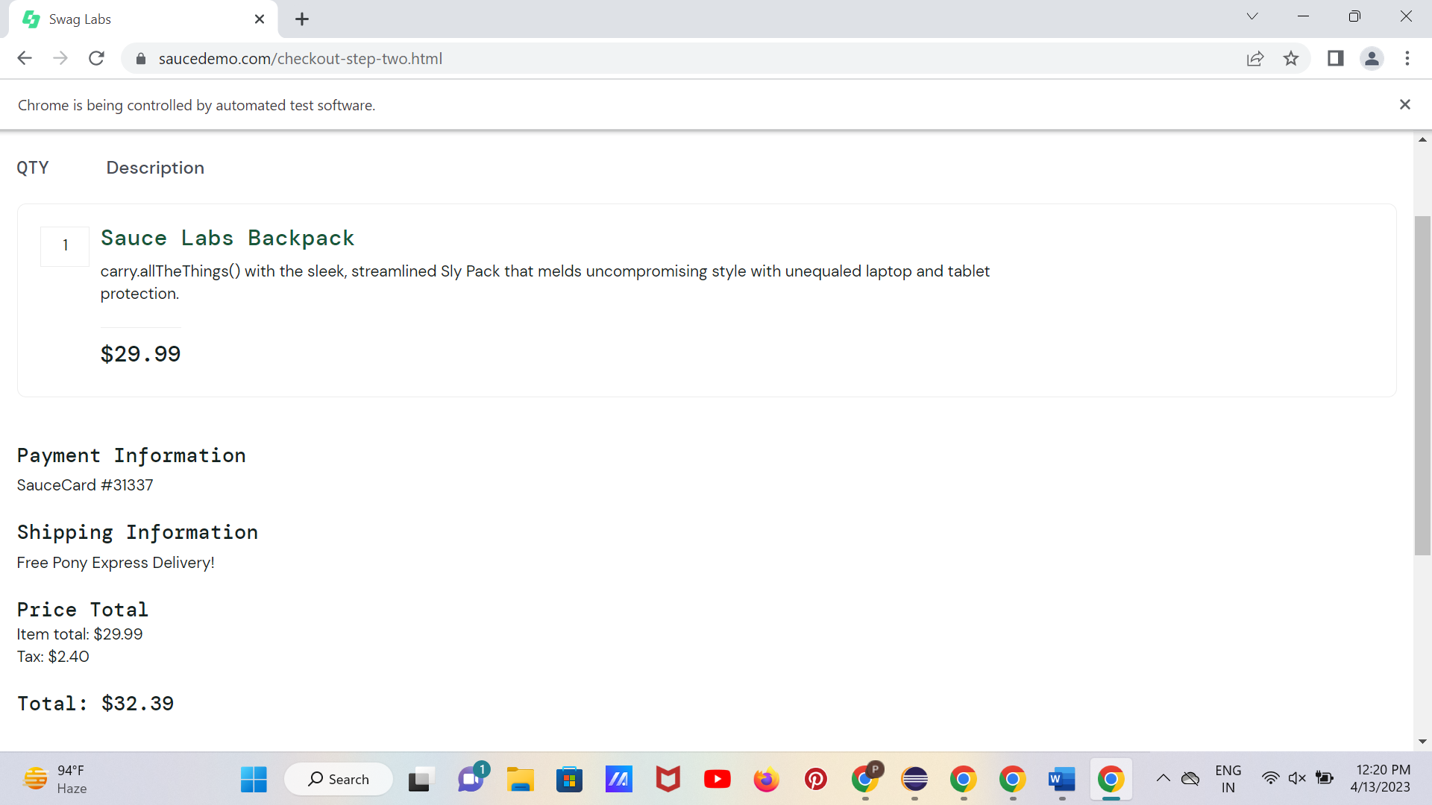

QUESTION 2:

CODE:

**package** Test;

**import** java.util.Iterator;

**import** java.util.List;

**import** org.openqa.selenium.By;

**import** org.openqa.selenium.WebDriver;

**import** org.openqa.selenium.WebElement;

**import** org.openqa.selenium.chrome.ChromeDriver;

**import** org.openqa.selenium.chrome.ChromeOptions;

**import** org.openqa.selenium.support.ui.Select;

**import** io.github.bonigarcia.wdm.WebDriverManager;

**public** **class** Qn2 {

**static** WebDriver *driver*;

**public** **static** String select(Select sl,**int** i) {

sl.selectByIndex(i);

List<WebElement>li=*driver*.findElements(By.*xpath*("//*[@class=\"inventory_item_name\"]"));

Iterator<WebElement> it = li.iterator();

**return** it.next().getText();

}

**public** **static** **void** main(String args[]) {

WebDriverManager.*chromedriver*().setup();

ChromeOptions co = **new** ChromeOptions();

co.addArguments("--remote-allow-origins=*");

*driver* = **new** ChromeDriver(co);

*driver*.get("https://www.saucedemo.com/");

*driver*.findElement(By.*xpath*("//*[@id=\"user-name\"]")).sendKeys("standard_user");

*driver*.findElement(By.*xpath*("//*[@id=\"password\"]")).sendKeys("secret_sauce");

*driver*.findElement(By.*xpath*("//*[@id=\"login-button\"]")).click();

System.***out***.println("Logged in successfully");

WebElement dd = *driver*.findElement(By.*xpath*("//*[@class=\"product_sort_container\"]"));

Select sl = **new** Select(dd);

System.***out***.println("Z to A :"+*select*(sl,1));

dd = *driver*.findElement(By.*xpath*("//*[@class=\"product_sort_container\"]"));

sl = **new** Select(dd);

System.***out***.println("A to Z :"+*select*(sl,0));

dd = *driver*.findElement(By.*xpath*("//*[@class=\"product_sort_container\"]"));

sl = **new** Select(dd);

System.***out***.println("High to low :"+*select*(sl,2));

dd = *driver*.findElement(By.*xpath*("//*[@class=\"product_sort_container\"]"));

sl = **new** Select(dd);

System.***out***.println("Low to High :"+*select*(sl,3));

}

}

OUTPUT:

