1. What is Inheritance in Java?

Ans: The technique of creating a new class by using an existing class functionality is called inheritance in Java. In other words, inheritance is a process where a child class acquires all the properties and behaviours of the parent class.

2. What is superclass and subclass??

Ans: A class from where a subclass inherits features is called superclass. It is also called base class or parent class.

A class that inherits all the members (fields, method, and nested classes) from another class is called a subclass. It is also called a derived class, child class, or extended class.

3. How is Inheritance implemented/achieved in Java?

Ans: Inheritance can be implemented or achieved by using two keywords “extends” extends is a keyword that is used for developing the inheritance between two classes and two interfaces.

Implements: implements keyword is used for developing the inheritance between a class and interface.

4. What is polymorphism?

Ans: Polymorphism in OOP is the ability of an entity to take several forms. In other words, it refers to the ability of an object (or a reference to an object) to take different forms of objects. It allows a common data-gathering message to be sent to each class. Polymorphism encourages what is called ‘extendibility’ which means an object or a class can have its uses extended.

5. Differentiate between method overloading and method overriding.

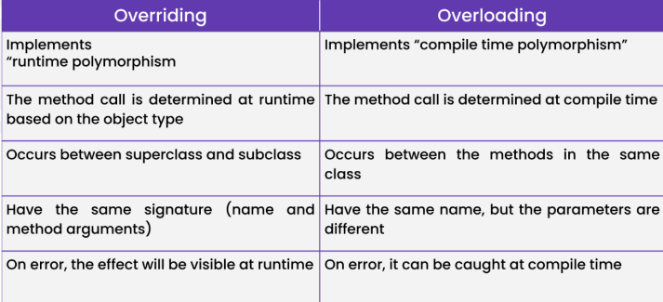

6. What is an abstraction explained with an Example?

Ans: Abstraction is nothing but the quality of dealing with ideas rather than events. It basically deals with hiding the internal details and showing the essential things to the user.

Abstract class Sports { // abstract class sports

Abstract void jump(); // abstract method

}

7. What is the difference between an abstract method and final method in Java?Explain with an example

Ans: The abstract method is incomplete while the final method is regarded as complete. The only way to use an abstract method is by overriding it, but you cannot override a final method in Java.

8. What is the final class in Java?

Ans: A class declared with the final keyword is known as the final class. A final class can’t be inherited bysubclasses. By using the final class, we can restrict the inheritance of the class. We can create a class as a final class only if it is complete in nature, which means it must not be an abstract class. In java, all the wrapper classes are final classes like String, Integer, etc.If we try to inherit a final class, then the compiler throws an error at compilation time. We can’t create a class as immutable without the final class.

final class ParentClass{

void showData(){

System.out.println("This is a method of final Parent class");

}

}

//It will throw compilation error

class ChildClass extends ParentClass{

void showData(){

System.out.println("This is a method of Child class");

}

}

class MainClass{

public static void main(String arg[])

{

ParentClass obj = new ChildClass();

obj.showData();

}

}

9. Differentiate between abstraction and encapsulation.

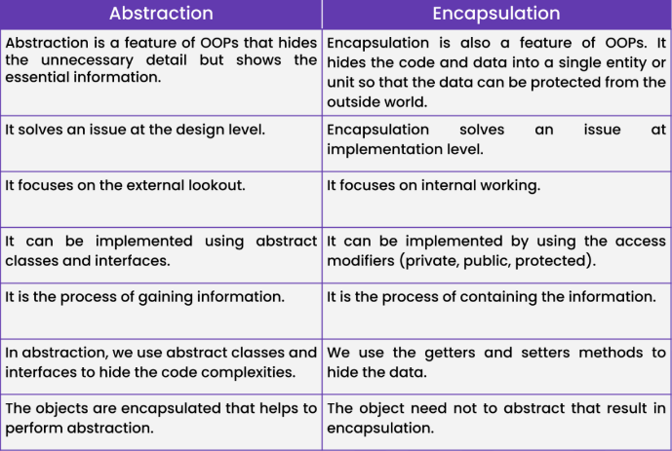

10. Difference between Runtime and compile time polymorphism explain with an example

