MODELING AND SIMULATION OF RF SIGNAL PROPAGATION IN PRECISION FARMING ENVIRONMENTS

PROJECT REPORT
Submitted in the partial fulfilment for the Course of
SPIC4 RESEARCH PROJECT

ECA5403 ELECTROMAGNETIC FIELDS AND WAVES
to the award of the degree of BACHELOR OF ENGINEERING IN
ELECTRONICS AND COMMUNICATION ENGINEERING
Submitted By

MULI ROHITH BABA REDDY - 192512026

T PRAVEEN - 192512421

GURU AJAY - 192512019



SIMATS ENGINEERING
SAVEETHA INSTITUTE OF MEDICAL AND TECHNICAL SCIENCES,
CHENNAI – 602 105


DECLARATION

We, MULI ROHITH BABA REDDY – 192512026, T PRAVEEN – 192512421, GURU AJAY – 192512019 of the ELECTRONICS AND COMMUNICATION ENGINEERING, Saveetha Institute of Medical and Technical Sciences, Saveetha University, Chennai, hereby declare that the Project Work entitled ‘Modeling and Simulation of RF Signal Propagation in Precision Farming Environments’ is the result of our own bonafide efforts. To the best of our knowledge, the work presented herein is original, accurate, and has been carried out in accordance with principles of engineering ethics.
Place:
Date:

Signature of the Students with Names
M. Rohith Baba Reddy - 192512026
T Praveen - 192512421
Guru Ajay - 192512019

SIMATS ENGINEERING

SAVEETHA INSTITUTE OF MEDICAL AND TECHNICAL SCIENCES

CHENNAI – 602105 BONAFIDE CERTIFICATE
This is to certify that the Project entitled “Modeling and Simulation of RF Signal Propagation in Precision Farming Environments” has been carried out as a team project by MULI ROHITH BABA REDDY – 192512026, T PRAVEEN – 192512421, GURU AJAY – 192512019, under the guidance of Dr. N.DURAICHI, Professor, Department of ECE, and is submitted in partial fulfillment of the requirements for the current semester of the B.Tech Electronics and Communication Engineering program at Saveetha Institute of Medical and Technical Sciences, Chennai.




HEAD OF THE DEPARTMENT
Professor
Department of Electronics and Communication Engineering SIMATS Engineering
Saveetha Institute of Medical and Technical Sciences

Chennai – 602105

SUPERVISOR
Professor
Department of Electronics and Communication Engineering SIMATS Engineering
Saveetha Institute of Medical and Technical Sciences
Chennai - 602105

INTERNAL EXAMINER EXTERNAL EXAMINER

ABSTRACT
Reliable wireless connectivity is a precondition for any smart farming deployment: soil, climate, and crop-health sensors are only useful if their readings reach a gateway and, from there, a decision-making system. Unlike indoor or urban wireless links, farm environments present propagation conditions that are frequently overlooked in general wireless-sensor-network literature — dense and seasonally varying crop canopies, moist and electrically lossy soil close to ground-mounted antennas, long node-to-gateway distances across open fields, and exposure to weather. This report presents a conceptual and theoretical treatment of electromagnetic (EM) wave propagation as it applies specifically to smart farming wireless sensor networks (WSNs). It develops the relevant propagation theory (free-space path loss, two-ray ground-reflection modelling, and foliage/canopy excess-attenuation modelling), surveys the wireless technologies commonly proposed for agricultural deployments (LoRa/LoRaWAN, Zigbee, NB-IoT, RFID, and satellite-based options), and proposes a complete system architecture with block diagrams for both a field sensor node (transmitter side) and a field gateway (receiver side).
Circuit-level design considerations — signal conditioning, ADC interfacing, RF front-end design, antenna selection, and power budgeting for solar-battery operation — are discussed at a level appropriate for an embedded-systems or communication-engineering course. An illustrative path-loss calculation compares an open-field link against a canopy-obstructed link at a representative ISM-band frequency, and a worked link-budget example demonstrates how these models inform practical deployment decisions such as antenna height, transmit power, and node spacing. The report closes with a discussion of open challenges — including RF variability introduced by fluctuating soil moisture, seasonal canopy growth, and multipath fading in row-crop geometries — and directions for future, empirically validated work. All figures, diagrams, and calculations in this report are illustrative and theoretical; no physical hardware was constructed or tested as part of this document.
Keywords: Electromagnetic Wave Propagation, Smart Farming, Wireless Sensor Networks, LoRa, Path Loss, Foliage Attenuation, Antenna Design, Precision Agriculture, Embedded Systems, RF Link Budget.

TABLE OF CONTENTS
Abstract
List of Figures
List of Abbreviations
Chapter 1 — Introduction
Chapter 2 — Fundamentals of Electromagnetic Wave Propagation
Chapter 3 — Overview of Smart Farming Systems and Wireless Requirements
Chapter 4 — EM Propagation Models Relevant to Agricultural Environments
Chapter 5 — Wireless Communication Technologies for Smart Farming
Chapter 6 — Proposed System Architecture
Chapter 7 — Circuit-Level Design Considerations
Chapter 8 — Antenna Design and Placement Considerations
Chapter 9 — Propagation Challenges and Mitigation Strategies
Chapter 10 — Illustrative Link-Budget and Path-Loss Analysis
Chapter 11 — Related Work
Chapter 12 — Limitations, Future Scope, and Conclusion
References

LIST OF FIGURES
- Figure 1. Smart Farming Wireless Sensor Network — Overall System Architecture
- Figure 2. Conceptual Block Diagram — Field Sensor Node (Transmitter Side)
- Figure 3. Electromagnetic Wave Propagation Paths Over a Crop Field
- Figure 4. Conceptual Block Diagram — Field Gateway / Receiver Side
- Figure 5. Illustrative Path Loss vs. Distance — Open Field vs. Canopy-Obstructed Link
- Figure 6. Fresnel Zone Clearance Concept for a Field Wireless Link
- Figure 7. Star and Mesh Network Topologies for Field Deployment
LIST OF ABBREVIATIONS
ADC — Analog-to-Digital Converter
BER — Bit Error Rate
DUC — Duty Cycle
FSPL — Free-Space Path Loss
GSM — Global System for Mobile Communications
IoT — Internet of Things
ISM — Industrial, Scientific, and Medical (radio band)
LNA — Low-Noise Amplifier
LoRa — Long Range (chirp spread-spectrum radio modulation)
LoRaWAN — LoRa Wide Area Network protocol
LOS — Line of Sight
MCU — Microcontroller Unit
NB-IoT — Narrowband Internet of Things
RF — Radio Frequency
RSSI — Received Signal Strength Indicator
RTC — Real-Time Clock
SNR — Signal-to-Noise Ratio
WSN — Wireless Sensor Network

CHAPTER 1

INTRODUCTION

1.1 Background and Motivation
Agriculture is increasingly instrumented with low-cost electronic sensors that measure soil moisture, temperature, humidity, light intensity, and, in more advanced deployments, soil nutrient and pH levels. The value of this instrumentation depends entirely on getting sensor data off the field reliably and in a timely manner. In most smart farming designs this is accomplished wirelessly, using unlicensed ISM-band radios (Zigbee at 2.4 GHz, LoRa at 433/868/915 MHz depending on region, or cellular-based NB-IoT/LTE-M) rather than wired connections, because trenching cable across tens or hundreds of hectares of farmland is rarely practical or economical.
The electromagnetic environment of an open field, however, is not the same as the indoor or urban environments for which many commercial radio modules are characterised and marketed. A field link may need to traverse hundreds of metres of open or crop-covered terrain, close to a lossy and time-varying ground surface (soil whose dielectric properties change with moisture content), and through a seasonally growing crop canopy that can attenuate and scatter the signal in ways that are absent at planting time but severe at full crop height. A system that performs well in an early-season site survey can therefore degrade substantially by mid-season purely due to changes in the propagation channel — not because any hardware component has failed.
This report treats electromagnetic wave propagation as a first-class design concern for smart farming systems, rather than as an afterthought to be handled by simply increasing transmit power after deployment. It develops the propagation theory relevant to this environment, connects that theory to concrete architectural and circuit-level decisions, and illustrates — through conceptual diagrams and representative, non-experimental calculations — how a designer would reason about link feasibility before committing to a deployment.

1.2 Problem Statement
Conventional wireless-sensor-network design guides typically present free-space path loss as the primary planning tool, with a generic fade margin added to account for "obstacles." For agricultural deployments this is an inadequate simplification for at least three reasons:
- Crop canopies introduce excess attenuation that changes substantially over a single growing season, so a link budget computed at planting time may not hold at full crop maturity.
- Ground-reflected and canopy-scattered multipath components can combine constructively or destructively with the direct path in ways sensitive to antenna height above ground — a parameter often chosen for mechanical convenience rather than propagation performance.
- Node density and gateway-spacing decisions are frequently made on a per-node cost basis without a corresponding, environment-specific propagation model to justify the assumed coverage.
This report addresses these gaps by presenting propagation models that separate free-space, ground-reflection, and foliage-attenuation contributions, and by tying those models directly to system architecture and circuit design decisions such as antenna height, node placement, and transmit-power budgeting.

1.3 Objectives
- Present the fundamental electromagnetic and communication-theory background needed to reason about RF propagation in an agricultural setting.
- Survey wireless technologies commonly used or proposed for smart farming and compare their propagation-relevant characteristics.
- Develop propagation models — free-space path loss, two-ray ground reflection, and foliage/canopy excess attenuation — appropriate to a field environment.
- Propose a complete conceptual system architecture, including block diagrams for a field sensor node (transmitter) and a field gateway (receiver).
- Discuss circuit-level design considerations: sensor interfacing, signal conditioning, RF front-end design, antenna selection, and power budgeting.
- Illustrate, through representative calculations and charts, how propagation modelling informs antenna height, node spacing, and transmit power decisions.
- Identify open challenges and directions for future work requiring empirical field validation.

1.4 Scope and Limitations of This Report
This report is conceptual and theoretical. All block diagrams, circuit diagrams, and propagation charts are illustrative design references rather than documentation of a constructed and tested system. Numerical examples use representative parameter values drawn from commonly published datasheets and propagation literature; they demonstrate a method of analysis, not the certified performance of a specific product or installation. Any real deployment should be preceded by a site-specific radio survey, since actual propagation behaviour depends on local terrain, crop type and growth stage, soil composition, and regulatory constraints on transmit power and duty cycle that are not modelled here in full.

1.5 Organisation of the Report
Chapter 2 reviews the fundamentals of electromagnetic wave propagation needed for the rest of the report. Chapter 3 describes the general requirements of a smart farming wireless sensor network. Chapter 4 develops propagation models specific to agricultural environments. Chapter 5 surveys candidate wireless technologies. Chapter 6 presents the proposed system architecture. Chapter 7 discusses circuit-level design and the applicable design standards. Chapter 8 covers antenna design and placement. Chapter 9 discusses propagation challenges and mitigation strategies. Chapter 10 presents illustrative link-budget and path-loss calculations. Chapter 11 reviews related published work. Chapter 12 discusses limitations, future scope, and conclusions.

CHAPTER 2

FUNDAMENTALS OF ELECTROMAGNETIC WAVE PROPAGATION

2.1 The Electromagnetic Wave
An electromagnetic (EM) wave consists of oscillating electric and magnetic field components, mutually perpendicular to each other and to the direction of propagation, that carry energy through space without requiring a material medium. A radio-frequency (RF) wave used for wireless sensor communication is characterised principally by its frequency f (or equivalently wavelength λ = c/f, where c is the speed of light), its power level, and its polarisation — the orientation of the electric field vector, typically vertical or horizontal for the simple dipole and monopole antennas used on low-cost sensor nodes.
For the ISM bands commonly used in smart farming — 433 MHz, 868 MHz (Europe), 915 MHz (Americas), and 2.4 GHz (Zigbee, Wi-Fi) — wavelengths range from roughly 12.5 cm (2.4 GHz) to about 69 cm (433 MHz). This has two practical consequences that recur throughout this report: lower-frequency bands diffract more readily around obstacles such as plant stalks and small terrain features and are generally preferred for long-range, canopy-penetrating links, while 2.4 GHz offers higher data rates and smaller antennas but suffers more severe attenuation through vegetation and water-laden plant tissue.

2.2 Free-Space Path Loss (FSPL)
The starting point for any RF link budget is the free-space path loss, which describes the unavoidable spreading loss of a wave radiating from an isotropic point source in an unobstructed medium. In decibel form:
FSPL(dB) = 20·log₁₀(d) + 20·log₁₀(f) + 20·log₁₀(4π / c)
where d is the transmitter–receiver distance in metres and f is the frequency in Hz, with c the speed of light. Equivalently, in the commonly quoted engineering form with d in kilometres and f in MHz, FSPL(dB) = 32.44 + 20·log₁₀(d_km) + 20·log₁₀(f_MHz). FSPL increases by 6 dB for every doubling of distance and by 6 dB for every doubling of frequency — directly explaining why 433 MHz links tolerate longer range than 2.4 GHz links for the same transmit power and antenna gain, all else being equal.

2.3 Ground-Reflection (Two-Ray) Propagation
Over relatively flat, open terrain — a reasonable approximation for a tilled field — a receiver typically observes not only the direct (line-of-sight) wave from the transmitter but also a wave reflected once off the ground. The two-ray ground-reflection model treats the received signal as the vector sum of these two components. Because the reflected path is slightly longer than the direct path, and because ground reflection introduces a phase shift close to 180° for many soil types at grazing incidence, the two components can add constructively or destructively depending on transmitter height, receiver height, and distance, producing a characteristic interference pattern with distance-dependent nulls and peaks at short range.
At distances large relative to antenna heights, the two-ray model simplifies to a power-law relationship in which received power falls off as 1/d⁴ rather than the 1/d² of free space — a substantially faster decay. This is a primary theoretical justification for elevating both sensor-node and gateway antennas above ground level, and ideally above expected mature crop height, wherever mechanically practical: raising antenna height increases the distance at which the 1/d⁴ regime begins to dominate, extending the useful, more favourable near-field range.

2.4 Diffraction, Scattering, and Attenuation Through Vegetation
Where the direct path is obstructed by an object comparable to or larger than a wavelength — a plant stalk, leaf cluster, or the crop canopy as a whole — three phenomena occur together: diffraction (bending of the wave around edges), scattering (redirection of energy by many small, randomly oriented objects such as leaves), and absorption (conversion of RF energy to heat within lossy dielectric material, of which water-laden plant tissue is a particularly strong example at microwave frequencies). The net link-budget effect is an additional term beyond free-space and ground-reflection loss, commonly called excess attenuation or foliage loss, treated further in Chapter 4.
Because plant tissue is predominantly water, and water is a lossy dielectric at RF frequencies, foliage attenuation depends strongly on moisture content — varying not only with crop growth stage but with time of day and recent rainfall, a source of link variability that a fixed link margin must accommodate.

2.5 Multipath Fading and Fresnel Zone Clearance
In addition to the two dominant ray paths above, a real field link experiences multiple scattered paths off soil clods, irrigation infrastructure, fence lines, and individual plants, each arriving at the receiver with a different phase and amplitude. The Fresnel zone concept provides a practical tool for reasoning about when an obstruction meaningfully degrades a link: the first Fresnel zone is an ellipsoidal region around the direct line-of-sight path, and keeping at least 60% of its radius clear of significant obstructions is generally sufficient to keep diffraction loss negligible.
The first Fresnel zone radius at the path midpoint is:
r₁ = √(λ · d / 4) (midpoint of a path of total length d, wavelength λ)
For a typical 868 MHz link (λ ≈ 0.345 m) spanning 200 m, the first Fresnel zone radius at midpoint is approximately 4.15 m — meaning a crop canopy or terrain feature within roughly 2.5 m of the direct line at that point can already contribute meaningful diffraction loss, well before it physically blocks the line of sight outright. This is a key reason antenna-height planning in row-crop fields should account for full mature crop height, not merely the height needed for a clear geometric line of sight.
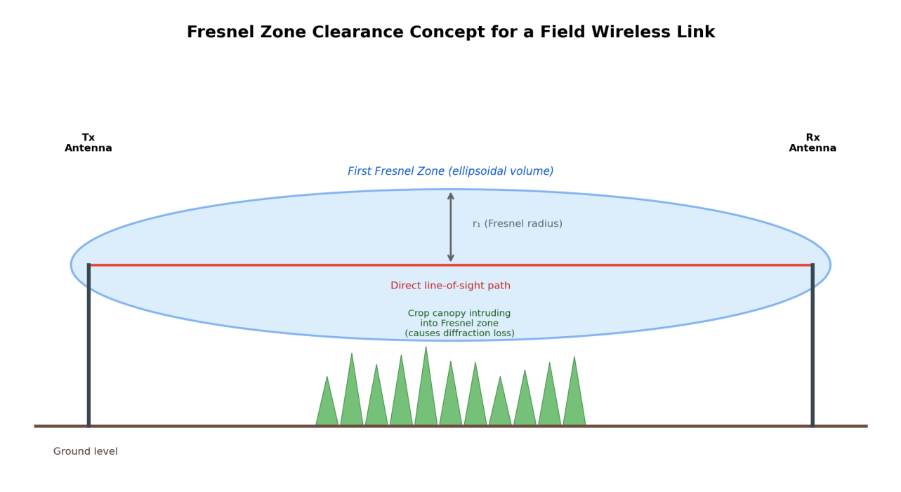
Figure 6. Fresnel zone clearance concept for a field wireless link — canopy growth intruding into the first Fresnel zone causes diffraction loss even without fully blocking line of sight.

2.6 Decibel Notation and the Link-Budget Framework
Because propagation effects multiply in linear power terms but add in logarithmic (decibel) terms, RF link analysis is conventionally performed entirely in dB and dBm. A generic link budget is expressed as:
P_rx(dBm) = P_tx(dBm) + G_tx(dBi) − L_path(dB) + G_rx(dBi) − L_misc(dB)
where P_tx is transmit power, G_tx and G_rx are transmitter and receiver antenna gains, L_path is the total propagation path loss (free space plus any excess terms from ground reflection and foliage), and L_misc collects miscellaneous losses such as cable/connector loss and polarisation mismatch. The link is considered viable if P_rx exceeds the receiver's sensitivity threshold by a margin sufficient to accommodate fading and seasonal variation — this margin is discussed quantitatively in Chapter 10.

CHAPTER 3

OVERVIEW OF SMART FARMING SYSTEMS AND WIRELESS REQUIREMENTS

3.1 What a Smart Farming System Typically Monitors and Controls
A representative smart farming deployment combines several sensing functions with at least one actuation function. Common sensing parameters include soil moisture (via capacitive or resistive probes), soil temperature, ambient air temperature and relative humidity, photosynthetically active radiation or general light intensity, rainfall (tipping-bucket gauges), and, in more advanced systems, soil electrical conductivity, pH, and specific nutrient concentrations. Actuation typically centres on irrigation — solenoid valve or pump control — and may extend to greenhouse ventilation, shading, or targeted spraying.
The wireless communication subsystem is the connective layer between these distributed sensing points and the decision logic (whether that logic runs locally at a gateway or in a cloud service). Its design requirements are therefore derived jointly from the sensing application (how often data is needed, how much data per reading) and the physical deployment environment (how far, through what obstructions, and under what power constraints).

3.2 Deployment Characteristics That Drive Wireless
- Coverage area: smart farming deployments can range from a fraction of a hectare (greenhouse) to hundreds of hectares (row-crop or orchard farming), directly influencing whether a single-hop star topology or a multi-hop mesh is appropriate.
- Node count and density: larger farms may deploy tens to hundreds of nodes, raising concerns about channel contention and the aggregate duty-cycle limits imposed by ISM-band regulations.
- Power availability: most field nodes are battery- or solar-battery-powered rather than mains-connected, making transmit duty cycle and radio sleep-mode design central to achieving a multi-season operating life.
- Data volume and latency tolerance: most agronomic parameters (soil moisture, temperature) change slowly, so update intervals of minutes to hours are typical and generally more forgiving of link fade events than, for example, industrial process control.
- Environmental exposure: nodes must tolerate temperature extremes, humidity, dust, and — most relevant to this report — a propagation channel that changes as the crop grows.

3.3 Functional Requirements Relevant to Wireless Design
Table 1 summarises the functional and non-functional requirements that a smart farming wireless subsystem is typically expected to satisfy, drawn together from the deployment characteristics above.
Requirement | Type | Design Implication
Deliver sensor readings from every field node to a gateway with acceptable reliability. | Functional | Requires a propagation-informed link budget (Chapters 4, 10), not just a nominal "range" figure from a datasheet.
Operate for a full growing season without battery replacement. | Non-functional | Favours low duty-cycle protocols (LoRa/LoRaWAN) over always-on radios (Wi-Fi).
Tolerate increasing foliage attenuation as the crop matures. | Non-functional / Safety margin | Link budget must include a foliage-loss allowance sized for full crop maturity, not planting-day conditions.
Scale to the number of nodes required for the field area without excessive channel contention. | Non-functional | Favours technologies with duty-cycled, low-collision MAC behaviour (LoRaWAN class A) over dense polling schemes.
Fail safely if the wireless link is lost (e.g., during irrigation control). | Functional / Safety | Actuation logic must default to a safe state on link timeout, independent of the specific radio technology chosen.

3.4 Why Propagation Modelling Belongs Early in the Design
Because several of the requirements above (battery life, node count, actuation safety) are downstream consequences of link reliability, propagation modelling cannot be deferred to a post-deployment troubleshooting step without risk. A gateway placed based on convenience (for example, at the farm office) rather than on a propagation-informed siting study may leave the furthest field nodes below the receiver sensitivity threshold for a significant fraction of the season, an outcome that is expensive to correct after installation. The remainder of this report develops the modelling tools (Chapter 4) and the architecture (Chapter 6) needed to avoid this failure mode at the design stage.

CHAPTER 4

EM PROPAGATION MODELS RELEVANT TO AGRICULTURAL ENVIRONMENTS

4.1 Modelling Strategy
This chapter combines three modelling layers into a single composite path-loss estimate suited to a field deployment: (1) free-space path loss as the baseline, (2) an excess-attenuation term for foliage/canopy penetration, and (3) a qualitative treatment of ground and multipath effects that supplements the two-ray model introduced in Chapter 2. The composite model is:
L_total(dB) = FSPL(dB) + L_foliage(dB) + L_ground-effects(dB) + L_margin(dB)
where L_margin is a designer-chosen fade margin sized to absorb residual uncertainty (weather, seasonal variability, hardware tolerance) not explicitly captured elsewhere.

4.2 Foliage / Canopy Attenuation Models
Vegetation attenuation has been studied extensively for terrestrial and satellite links passing through forest canopy, and several empirical models from that literature are commonly adapted, with caution, to row-crop and orchard settings. The most widely cited simplified form, of the ITU-R / Weissberger family of vegetation-loss models, expresses excess attenuation as a function of the depth of foliage traversed along the path, d_f (in metres):
L_foliage(dB) ≈ 0.45 · f_GHz^0.284 · d_f for d_f ≤ 14 m
L_foliage(dB) ≈ 1.33 · f_GHz^0.284 · d_f^0.588 for d_f > 14 m
where f_GHz is frequency in gigahertz. These expressions were originally derived for tree-line and forest-edge scenarios and should be treated as an illustrative starting point rather than a validated model for a specific crop; row crops such as maize or sugarcane, with their more regular, vertically oriented stalk geometry, are known in the wireless-sensor-network literature to attenuate signals differently from irregular forest canopy, and published field-measurement studies specific to the crop and growth stage of interest should be consulted before finalising a real deployment's link budget. The qualitative trend that this report relies on attenuation increasing with the depth of vegetation traversed and rising (moderately) with frequency is nonetheless consistent across the vegetation-loss literature.

4.3 Soil and Ground-Proximity Effects
Antennas mounted close to the ground on field nodes couple electromagnetically with the soil beneath them. Soil is a lossy dielectric whose relative permittivity and loss tangent both increase markedly with volumetric water content — meaning a node's effective ground-plane behaviour, and hence its radiation pattern and efficiency, can shift measurably between a dry and a recently irrigated field. In addition to this near-field coupling effect, the far-field two-ray ground-reflection interference discussed in Chapter 2 depends on the same soil dielectric properties through the ground-reflection coefficient. Both effects argue for keeping antennas elevated above the immediate soil surface — typically on a mast or the node enclosure itself rather than mounting them flush with or buried near the ground.

4.4 Weather-Dependent Attenuation
At the ISM frequencies most relevant to smart farming (sub-1-GHz and 2.4 GHz), atmospheric gaseous and rain attenuation over the short distances typical of field links (tens to a few hundred metres) is generally small compared with foliage and ground effects, and is therefore not modelled in detail in this report. However, wet foliage leaves and stalks coated with rain or dew — measurably increases the effective loss tangent of the vegetation and can produce a short-term (hours-long) increase in foliage attenuation beyond the dry-canopy baseline computed from Section 4.2. Designers should treat published foliage-loss coefficients as representative of an average condition and include additional fade margin (Section 4.1) to cover wet-canopy excursions.

4.5 Putting the Composite Model to Use
The composite model of Section 4.1 is used in Chapter 10 to compare an open-field link against a canopy-obstructed link of the same geometry, and to derive an illustrative maximum recommended node-to-gateway spacing for each case. The intent is to demonstrate the method — free-space loss as a floor, foliage loss added according to expected canopy depth, and a fade margin added on top that a designer can repeat with site-specific and crop-specific figures once these are available from a survey or from literature reporting measurements on the crop in question.

CHAPTER 5

WIRELESS COMMUNICATION TECHNOLOGIES FOR SMART FARMING

5.1 Selection Criteria
The propagation models of Chapter 4 apply generically to radio waves at a given frequency, but the choice of underlying wireless technology determines the frequency band, typical transmit power, receiver sensitivity, and medium-access behaviour that feed into a link budget. Table 2 compares the technologies most commonly proposed in the smart farming literature against the criteria most relevant to field propagation: frequency (and hence diffraction/penetration behaviour), typical range under open-field conditions, data rate, and power profile.
Technology | Typical Band | Open-Field Range (indicative) | Data Rate | Power Profile
LoRa / LoRaWAN | 433 / 868 / 915 MHz | 1–10+ km LOS; several hundred m through moderate canopy | 0.3–50 kbps | Very low; well suited to multi-year battery/solar operation
Zigbee (802.15.4) | 2.4 GHz (also sub-GHz variants) | 10s–100s of m, shorter through foliage | 250 kbps | Low; mesh routing adds overhead vs. star LoRa
NB-IoT / LTE-M | Licensed cellular bands | Several km via existing cell towers | Tens of kbps to ~1 Mbps | Low-moderate; depends on cellular coverage and modem duty cycle
RFID (passive/active) | 125 kHz / 13.56 MHz / UHF 860-960 MHz | Centimetres to a few metres (passive); tens of m (active) | Low | Very low (passive tags are unpowered)
Satellite IoT (e.g., NB-NTN class) | L/S-band or proprietary | Global, independent of terrestrial infrastructure | Very low (short messages) | Moderate per message; used for sparse, remote deployments

5.2 LoRa / LoRaWAN
LoRa's chirp spread-spectrum modulation trades data rate for receiver sensitivity, achieving link budgets on the order of 150–160 dB in typical low-cost modules — substantially higher than Zigbee or Wi-Fi — which is what enables single-hop links of several kilometres in open, unobstructed conditions. Combined with sub-GHz operation (better diffraction and foliage penetration than 2.4 GHz, per Section 2.1) and the LoRaWAN protocol's duty-cycled, mostly-asleep node behaviour, LoRa is frequently the default recommendation for row-crop and orchard smart farming deployments covering areas too large for a single Zigbee mesh to span efficiently.

5.3 Zigbee and Other Mesh-Capable Sub-GHz/2.4 GHz Radios
Zigbee's mesh-routing capability is attractive where node density is high enough that intermediate nodes can relay for one another, extending effective coverage without a single long-range hop. This can be advantageous in greenhouse or high-density orchard deployments, but each relay hop adds latency and consumes the relaying node's battery on behalf of neighbours, a trade-off that must be balanced against LoRa's simpler star topology (see topology comparison in Section 6.5 and Figure 7).

5.4 Cellular NB-IoT / LTE-M
Where existing cellular coverage reaches the farm, NB-IoT or LTE-M can eliminate the need to deploy and maintain a private gateway altogether, at the cost of a recurring data-plan expense and dependence on the carrier's coverage and duty-cycle policies. This is attractive for isolated or single-node deployments where the fixed cost of a dedicated gateway would be disproportionate.

5.5 RFID
RFID is primarily used in smart farming for asset and livestock identification and short-range proximity sensing (for example, tracking bins or verifying equipment presence) rather than for the environmental telemetry that is the primary focus of this report; it is included in Table 2 for completeness because it shares the same ISM-band propagation physics discussed in Chapter 2 at UHF frequencies.

5.6 Satellite IoT
For farms in regions without cellular coverage and too large or remote to justify a private LoRaWAN gateway network, satellite IoT services provide narrowband connectivity independent of terrestrial infrastructure. The trade-offs are higher per-message cost, greater latency, and typically very low message-size limits, making satellite IoT best suited to infrequent, small-payload reporting rather than dense sensor telemetry.

5.7 Technology Choice Used in the Proposed Architecture
The system architecture proposed in Chapter 6 is presented in a technology-general way but is illustrated using a LoRa-class sub-GHz radio for the node-to-gateway link, reflecting its favourable combination of range, foliage penetration, and battery life for the row-crop and open-field scenarios that motivate this report's propagation analysis. The architecture and the accompanying circuit-level discussion (Chapter 7) apply with minor modification to a Zigbee- or NB-IoT-based implementation as well.

CHAPTER 6

PROPOSED SYSTEM ARCHITECTURE

6.1 Overall Architecture
Figure 1 presents the overall conceptual architecture. Field-deployed sensor nodes each sense one or more agronomic parameters and transmit a compact reading over an RF link to a field gateway, positioned to balance coverage of all nodes against the propagation constraints developed in Chapters 2 and 4. The gateway aggregates readings and forwards them, via a backhaul connection (Wi-Fi, Ethernet, or cellular), to a cloud server or local base station, from which a farmer-facing dashboard presents the data and, where an actuation loop is included, issues irrigation or other control commands back down through the same chain.
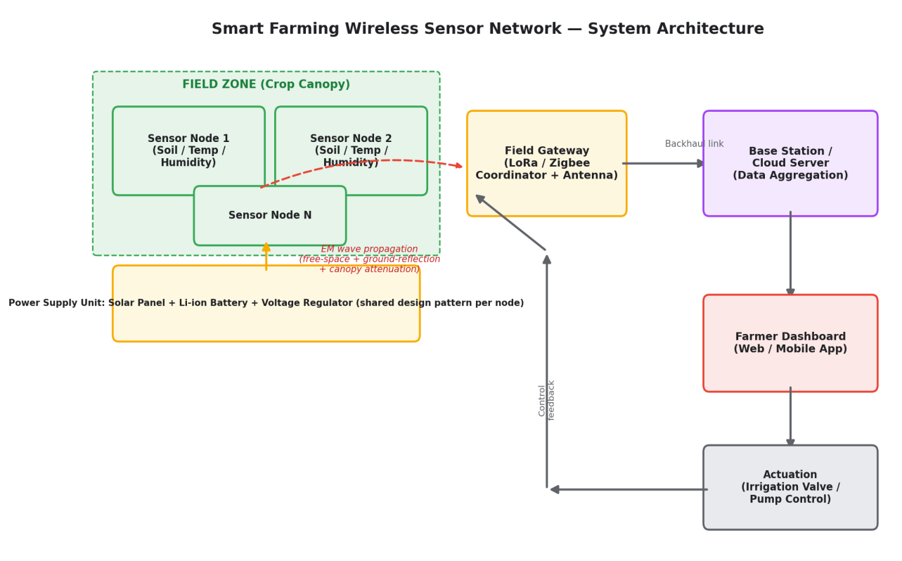
Figure 1. Smart Farming Wireless Sensor Network — overall system architecture, showing the sensing, EM propagation, gateway, cloud, and actuation stages.

6.2 Field Sensor Node (Transmitter Side)
Each field node (Figure 2, developed further at circuit level in Chapter 7) integrates one or more sensors, a signal-conditioning stage, a microcontroller with an on-chip analog-to-digital converter, an RF transceiver, and an antenna, all powered from a solar-charged battery. The node's design goal, from a propagation standpoint, is to deliver as much of the available link budget as possible to the antenna — meaning minimising unnecessary insertion loss in the RF path and mounting the antenna as favourably as the node's form factor allows (Chapter 8).

6.3 Field Gateway (Receiver Side)
The gateway (Figure 4) is architecturally the mirror image of a sensor node's RF chain — antenna, low-noise amplifier and filtering, demodulator — but adds the protocol-stack processing needed to manage many nodes concurrently, local data logging, and a backhaul network interface. Because the gateway typically has fewer power constraints than a battery-powered field node (it may be mains-connected or use a larger solar-battery bank), it can support a taller mast and a higher-gain antenna, both of which directly improve the link budget for every node it serves — an important asymmetry that argues for concentrating propagation-improvement investment (mast height, antenna gain) at the gateway rather than spreading it thinly across many nodes.

6.4 Data Flow Summary
Table 3 summarises the stage-by-stage data flow shown in Figure 1, noting the dominant engineering concern at each stage.
Stage | Function | Dominant Engineering Concern
Sensing | Convert a physical quantity (moisture, temperature, etc.) to an electrical signal | Sensor accuracy, calibration, power draw
Node processing | Digitise, timestamp, and format the reading | ADC resolution, sampling interval, MCU sleep management
Node-to-gateway RF link | Carry the formatted reading wirelessly across the field | EM propagation — FSPL, foliage loss, multipath (Chapters 2, 4)
Gateway aggregation | Receive from many nodes, buffer, and forward | Receiver sensitivity, antenna gain, channel/collision management
Backhaul | Carry aggregated data from field to cloud/base station | Network availability, bandwidth, security
Presentation and actuation | Display data and issue control commands | Usability, fail-safe control logic on link loss

6.5 Network Topology Choice: Star versus Mesh
Figure 7 contrasts the two topology families most relevant to a field deployment. A star topology, in which every node communicates directly with the gateway, is architecturally simple and avoids the added latency and per-hop power cost of relaying, but requires every node's individual link budget (Chapter 10) to close on its own — meaning the furthest nodes govern the achievable field size for a given transmit power and gateway antenna height. A mesh topology allows nodes closer to the gateway to relay for more distant ones, effectively subdividing a long, marginal link into several shorter, more robust hops, at the cost of additional protocol complexity, relay-node power consumption, and a dependency chain in which the failure of one relay node can isolate the nodes behind it.
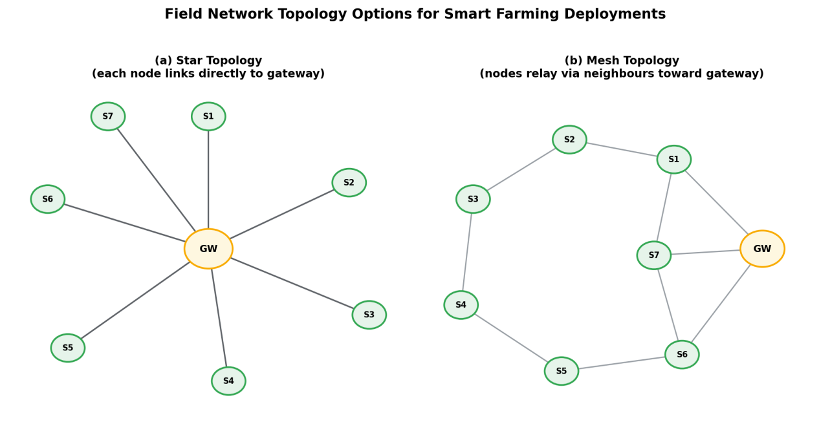
Figure 7. Star and mesh network topology options for field deployment, illustrating the trade-off between per-node link-budget requirements and multi-hop relaying.
For the row-crop scenario emphasised in this report — moderate node density spread across an open or lightly obstructed field, with LoRa's long single-hop range — a star topology is generally the simpler and more power-efficient choice, and is the topology assumed in the worked link-budget examples of Chapter 10. A mesh topology becomes more attractive in high-density greenhouse or orchard deployments where canopy obstruction is severe enough that individual node-to-gateway links would not otherwise close.

CHAPTER 7

CIRCUIT-LEVEL DESIGN CONSIDERATIONS

7.1 Field Sensor Node Circuit — Conceptual Block Diagram
Figure 2 presents a conceptual block diagram for the transmitter-side field node. Sensor outputs (soil moisture, temperature/humidity, and optionally pH/nutrient sensors) are conditioned — amplified and filtered as needed to match the microcontroller's ADC input range — before digitisation. The microcontroller manages the sampling schedule, timestamps readings using a real-time clock, formats the outgoing packet, and hands it to the RF transceiver, which modulates and radiates it via the antenna.
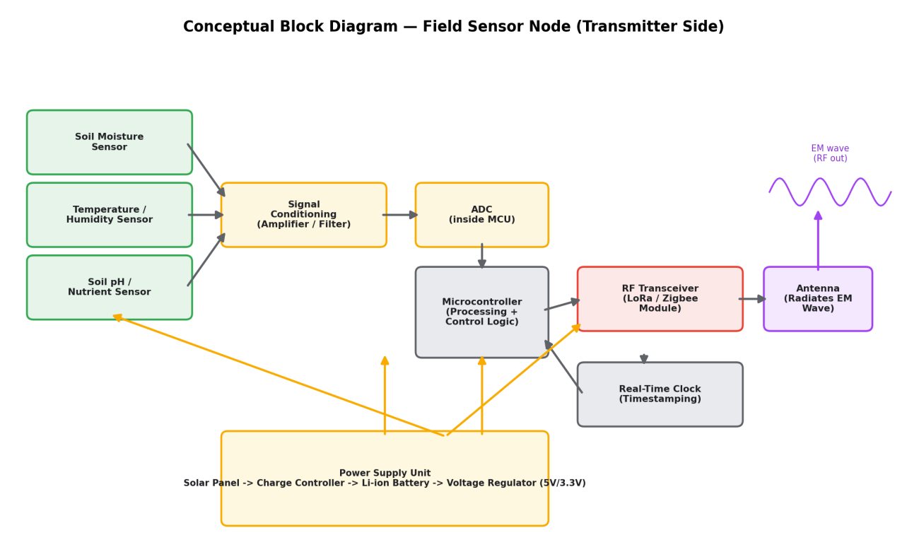
Figure 2. Conceptual block diagram of a field sensor node (transmitter side), from sensing through to RF radiation.

7.1.1 Sensor Interfacing and Signal Conditioning
Resistive and capacitive soil-moisture probes, and similar analog sensors, typically require a conditioning stage commonly a voltage-divider or bridge configuration followed by an operational-amplifier buffer or instrumentation amplifier to present a signal within the microcontroller ADC's input range and impedance requirements, and to reject noise picked up along sensor cabling that may run a metre or more from the node enclosure to a below-ground probe. Digital sensors (many temperature/humidity modules communicate over I²C or a single-wire protocol) avoid the analog conditioning stage entirely but still require attention to bus pull-up resistors and cable-length limits.

7.1.2 Analog-to-Digital Conversion
Most low-cost microcontrollers used in sensor-node designs (e.g., the ATmega328P family or common ARM Cortex-M0/M3 parts) integrate a 10- to 12-bit successive-approximation ADC, adequate resolution for the slowly varying agronomic parameters typical of this application. Sampling intervals of seconds to minutes, followed by extended microcontroller sleep, are typical and are the primary lever for extending battery life alongside the RF transceiver's own duty cycle.

7.1.3 RF Transceiver and Radio Front-End
The RF transceiver (a LoRa-class sub-GHz radio IC in the architecture emphasised here) performs modulation, and, in many low-cost modules, integrates a power amplifier and receive-path low-noise amplifier on-chip. Board-level RF layout — impedance-matched traces to the antenna, adequate ground-plane area, and shielding from digital-switching noise generated by the microcontroller has a direct and sometimes underestimated effect on realised transmit power and receiver sensitivity, and therefore on the propagation link budget computed in Chapter 10 assuming datasheet performance is actually achieved on the physical board.

7.1.4 Power Supply Design
A representative field-node power chain (shown at the bottom of Figure 2) consists of a small solar panel, a charge controller sized to protect a Li-ion or LiFePO4 cell from over-charge and deep discharge, and a linear or switching regulator producing the 3.3 V or 5 V rail required by the sensors, microcontroller, and RF transceiver. The power budget must account for the RF transceiver's relatively high instantaneous current draw during transmission (commonly tens to a few hundred milliamps for the brief transmit interval) against its very low sleep-mode current (typically microamps), since average current — not peak current determines achievable battery life at a given duty cycle.

7.2 Field Gateway Circuit — Conceptual Block Diagram
Figure 4 presents the mirrored, receiver-side conceptual block diagram. The receive antenna feeds a low-noise amplifier and RF front-end filter (rejecting out-of-band interference before it reaches the demodulator), followed by the LoRa/Zigbee demodulator and a gateway-class microcontroller or system-on-chip that runs the network protocol stack, manages local storage for offline resilience, drives a local status display, and interfaces to the backhaul network.
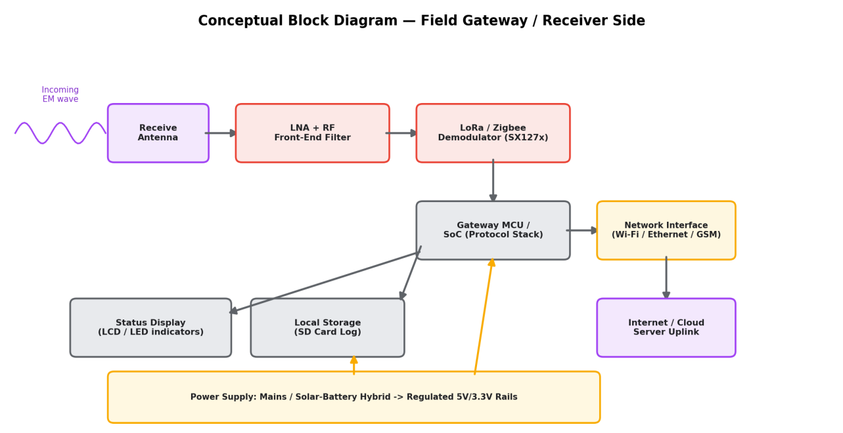
Figure 4. Conceptual block diagram of the field gateway (receiver side), from antenna reception through to cloud backhaul.

7.2.1 Receiver Sensitivity and Front-End Design
Because the gateway must recover the weakest expected signal from the furthest or most obstructed node, its front-end noise figure is a first-order contributor to the achievable link budget: every decibel of unnecessary front-end noise directly reduces the maximum tolerable path loss, and therefore the maximum usable node-to-gateway distance for a given transmit power. A well-designed low-noise amplifier stage and careful filtering to exclude adjacent-channel and out-of-band interference (particularly relevant on the crowded 2.4 GHz ISM band) are accordingly a high-value design investment at the gateway, consistent with the asymmetry noted in Section 6.3.

7.2.2 Backhaul and Local Resilience
A local SD-card or flash log (Figure 4) allows the gateway to continue recording sensor data during a temporary loss of backhaul connectivity a common occurrence at rural sites relying on cellular or satellite backhaul with the buffered data forwarded once connectivity is restored. This is a system-level resilience measure distinct from, but complementary to, the field-link fail-safe behaviour discussed for actuation control in Section 3.3.

7.3 General Circuit Design Principles Applied Across Both Sides
- Keep RF traces short, controlled-impedance, and away from noisy digital switching lines to preserve the transceiver's rated transmit power and receive sensitivity.
- Provide adequate decoupling capacitance at the RF transceiver's supply pins, since transmit-burst current transients can otherwise induce supply-rail noise that degrades adjacent analog sensor readings.
- Size the power supply for worst-case average current at the chosen duty cycle, not for nominal or best-case conditions, since foliage-induced fade may prompt retransmissions that raise the effective duty cycle above the nominal design value.
- Design actuation-driving circuits (relays, valve drivers) to default to a safe, de-energised state on loss of a valid control signal, independent of the specific wireless technology used to carry that signal.

7.4 Applicable Design Standards
The circuit-level and RF design choices in this chapter and in Chapter 8 are intended to be developed against recognised international and national standards rather than against module datasheets alone. Table 4 groups the principal standards and guidelines relevant to a smart farming field node and gateway by design domain and states how each bears on the design. The list is a design reference that identifies what a real implementation would be checked against; consistent with Section 12.1, no conformance testing or formal compliance analysis has been performed for the conceptual design presented in this report.
Design Domain | Standard / Guideline | Relevance to This Design
Propagation modelling | ITU-R P.833 – Attenuation in vegetation [1]  ITU-R P.525 – Free-space attenuation [8]  ITU-R P.530 – Terrestrial line-of-sight link design [9] | Basis of the free-space, foliage, and Fresnel-clearance models of Chapters 2 and 4 and of the link budget in Chapter 10.
Spectrum and transmit limits | ETSI EN 300 220 – Sub-GHz short-range devices [5]  ETSI EN 300 328 – 2.4 GHz wideband systems [10]  WPC (India) G.S.R. 853(E) – 865–868 MHz short-range devices [11]  FCC 47 CFR Part 15 – 902–928 MHz operation [12] | Define the permitted band, ERP, and duty cycle for the region of deployment; the node transmit power used in Chapter 10 must stay within these limits (Section 9.5).
Radio and network protocol | LoRaWAN 1.0.4 with LoRa Alliance Regional Parameters [4]  IEEE 802.15.4 – Low-rate WPAN [6] | Specify channel plans, data rates, duty-cycle handling, and AES-128-based link security for the LoRa architecture, and the physical/MAC layers for a Zigbee alternative.
Electromagnetic compatibility | ETSI EN 301 489-1 and EN 301 489-3 – EMC for radio equipment and short-range devices [13]  IEC 61000-4-2 (ESD) and IEC 61000-4-5 (surge) immunity [14] | Limit noise coupled from the microcontroller into the RF path and give immunity to static discharge and surges on exposed sensor cabling and masts.
Lightning protection and earthing | IEC 62305 – Protection against lightning [15] | Guides earthing of the gateway mast and surge protection at the antenna feed, relevant to the elevated mounting recommended in Section 8.3.
Enclosure and environment | IEC 60529 – Ingress protection (IP) codes [16]  IEC 60068-2 series – Environmental testing [16] | IP65 or better for exposed enclosures, and IP67 where flooding or irrigation immersion is possible; temperature, humidity, and UV exposure over a full year outdoors.
Electrical and battery safety | IEC 62368-1 – Safety of ICT equipment [17]  IEC 62133-2 – Lithium cells and batteries [17] | Safe design of mains-connected gateway equipment and of the Li-ion/LiFePO4 cell, charge controller, and protection in the solar-battery chain of Section 7.1.4.
PCB and RF layout | IPC-2221 – Generic printed board design [18]  IPC-2141 – Controlled-impedance circuit boards [18] | Trace geometry, clearances, and controlled-impedance RF routing supporting the layout principles of Section 7.3.
Human RF exposure | ICNIRP 2020 RF EMF guidelines [19]  IEEE C95.1 – RF exposure safety levels [19] | The low transmit powers involved keep exposure far below limits at practical distances, but higher-gain, higher-power gateways should be checked.
Backhaul data security | TLS 1.3 (IETF RFC 8446) [20] | Protects gateway-to-cloud traffic, complementing the link-layer encryption of the LoRaWAN radio segment.

7.4.1 Regional Spectrum Considerations
The worked example of Chapter 10 uses the 868 MHz European band, and its +14 dBm (25 mW) transmit power is representative of the ERP limit that ETSI EN 300 220 applies in the principal 868 MHz sub-bands, where a 1% duty-cycle limit is also common (Section 9.5). A deployment in India would instead use the licence-exempt 865–868 MHz band, delicensed under WPC notification G.S.R. 853(E) of 10 December 2021, for which LoRaWAN defines a dedicated IN865 regional parameter set. Because the two bands differ in frequency by only a few megahertz, the free-space path loss changes by a negligible amount (about 0.03 dB), so the link-budget method of Chapter 10 carries over unchanged. What does change are the permitted transmit power, bandwidth, and duty-cycle limits: the earlier 865–867 MHz rules that the 2021 notification superseded allowed up to 1 W transmitter power, 4 W ERP, and 200 kHz carrier bandwidth, but the limits applicable to a given device should always be confirmed against the current notification and the equipment type approval of the radio module used.

7.4.2 Design Rules Adopted from the Standards
- Select transmit power and reporting interval so that the regional ERP and duty-cycle limits are met including retransmission overhead, rather than raising power to compensate for a marginal link (Section 9.5).
- Specify field enclosures to at least IP65 (IP67 where flooding or irrigation immersion is possible), with UV-stable materials and sealed cable glands for below-ground probe cabling.
- Provide ESD and surge protection on sensor cable entries and, at the gateway, a grounded mast with a coaxial surge arrestor at the antenna feed, following the IEC 61000-4 and IEC 62305 guidance.
- Use type-approved radio modules and cells certified to IEC 62133-2, and follow the module manufacturer's RF layout reference design so that module-level approvals are not invalidated by the board design (Section 7.3).
- Encrypt both segments of the data path: LoRaWAN session keys on the radio link and TLS on the gateway-to-cloud backhaul.

CHAPTER 8 — ANTENNA DESIGN AND PLACEMENT CONSIDERATIONS

8.1 Antenna Types Suited to Field Deployment
Low-cost field nodes most commonly use a quarter-wave monopole (a simple, low-cost, omnidirectional choice requiring a ground plane) or a compact helical/whip antenna where enclosure size is constrained. Gateways, which have more relaxed size and power constraints, more often use a higher-gain omnidirectional collinear antenna (to extend range uniformly around the gateway) or, where all nodes lie within a known angular sector, a directional Yagi or panel antenna trading angular coverage for additional gain in the direction of the field.

8.2 Antenna Gain and Its Role in the Link Budget
Antenna gain (in dBi, referenced to an isotropic radiator) contributes directly, and favourably, to the link budget of Section 2.6 — a 3 dBi improvement in gain at either end of the link is equivalent, from a path-loss standpoint, to halving the free-space path-loss distance penalty, without any change in transmit power or receiver sensitivity. Because gateway-side antenna upgrades benefit every node in the network simultaneously (Section 6.3), they are typically a more cost-effective lever than upgrading many individual nodes' smaller, lower-gain antennas.

8.3 Placement and Height Considerations
Consistent with the ground-reflection analysis of Section 2.3 and the Fresnel-zone analysis of Section 2.5, both node and gateway antennas should be mounted as high as is mechanically and economically practical, with mature crop height treated as a first-order input to that decision rather than an afterthought. Where a mast tall enough to clear mature canopy is impractical for every field node, prioritising gateway mast height (per the asymmetry noted in Section 6.3) provides the larger marginal improvement in overall network reliability.
Polarisation matching between transmitting and receiving antennas (both vertical or both horizontal) should also be maintained where possible, since cross-polarisation introduces an additional, easily avoidable loss (commonly 15–20 dB in a worst-case orthogonal mismatch) that is unrelated to distance or foliage.

8.4 Antenna Orientation Relative to Row-Crop Geometry
In row-crop fields, planting rows introduce a directionally non-uniform obstruction pattern: a path running along a row (between plants) may traverse substantially less foliage depth than a path running perpendicular to the rows (through several plants in succession) at the same distance. Where node and gateway placement allows some choice of orientation, aligning the dominant propagation path with the row direction, rather than across it, can materially reduce the foliage-depth term d_f used in the Chapter 4 excess-attenuation model, illustrating how a purely geometric siting decision can be informed directly by the propagation theory developed earlier in this report.

CHAPTER 9

PROPAGATION CHALLENGES AND MITIGATION STRATEGIES

9.1 Seasonal Canopy Growth
Perhaps the single most distinctive challenge of agricultural RF propagation, relative to static indoor or urban environments, is that the channel itself changes predictably but substantially over a growing season. A link designed with a fade margin sized only for planting-day conditions may fail by mid-season purely from canopy growth. Mitigation approaches include: sizing the fade margin (Section 4.1) using an estimate of full mature-crop foliage depth rather than current conditions at design time; scheduling a mid-season link-quality check (via RSSI/SNR reporting, where the chosen technology supports it) to catch degradation before it causes data loss; and, where the budget allows, provisioning gateway antenna height with margin above the tallest mature crop expected on site.

9.2 Soil-Moisture-Dependent Near-Field Effects
As discussed in Section 4.3, a node's near-ground antenna environment changes electrically with soil moisture, which can shift antenna resonance and efficiency slightly between dry and freshly irrigated conditions. This effect is generally smaller than foliage attenuation but can compound with it. Mitigation is primarily architectural: elevating the antenna above the immediate soil surface, and, where the sensor node's own installation allows it, keeping a consistent installation height and orientation across nodes so any residual effect is at least uniform and predictable rather than an added source of node-to-node variability.

9.3 Multipath Fading in Row-Crop Geometries
Row-crop plantings, with their regular, quasi-periodic stalk spacing, can under some conditions produce structured (rather than purely random) multipath interference, since regularly spaced scatterers reinforce certain reflection angles. Where this is suspected to be a significant factor (typically identifiable through unusually large RSSI variation between nominally similar nodes), practical mitigation includes minor repositioning of the affected node or antenna by a fraction of a wavelength — often enough to move out of a destructive-interference null, given how localised such nulls are in a two-ray-type interference pattern — or increasing fade margin generally rather than attempting to model the effect in detail.

9.4 Interference from Other ISM-Band Users
The 2.4 GHz ISM band in particular is shared with Wi-Fi, Bluetooth, and other unlicensed devices, and rural deployments are not immune to interference from nearby equipment (other farm electronics, or increasingly, other IoT deployments). Sub-GHz bands are comparatively less congested in most regions, which is a secondary (alongside propagation range) reason LoRa-class radios are frequently preferred for smart farming over 2.4 GHz alternatives. Where 2.4 GHz technology is used, standard mitigation — channel selection, adaptive frequency hopping where supported, and adequate front-end filtering (Section 7.2.1) — applies as in any other 2.4 GHz deployment.

9.5 Regulatory Duty-Cycle and Transmit-Power Constraints
Sub-GHz ISM bands are typically subject to regional regulatory limits on transmit power and duty cycle (for example, a 1% duty-cycle limit is common in the European 868 MHz band under ETSI regulations), which constrain how much a designer can simply "transmit harder" to compensate for a marginal link. This reinforces the importance of the propagation-first design approach advocated throughout this report: since transmit power is a regulatorily bounded resource, path-loss reduction through antenna height, gain, and siting (Chapter 8) is often the only remaining lever once regulatory power limits are reached. The regulatory and other design standards relevant to the proposed design are collected in Section 7.4.

CHAPTER 10

ILLUSTRATIVE LINK-BUDGET AND PATH-LOSS ANALYSIS
This chapter works through a representative, illustrative example applying the models of Chapters 2 and 4. All parameter values are representative figures drawn from commonly published LoRa-class module datasheets and vegetation-loss literature; they are chosen to demonstrate the method of analysis and are not measurements from a built or tested system. A real deployment should substitute site- and equipment-specific values.

10.1 Path-Loss Comparison: Open Field vs. Canopy-Obstructed Link
Figure 5 plots free-space path loss against distance at 868 MHz, alongside an illustrative combined curve that adds an approximate canopy excess-attenuation term (Section 4.2) representative of a partially foliage-obstructed link whose foliage depth grows with distance in this illustrative scenario. As expected from the theory in Chapters 2 and 4, the two curves track closely at short range, where any assumed canopy depth is small, and diverge with increasing distance as the assumed foliage depth — and hence excess attenuation — grows.
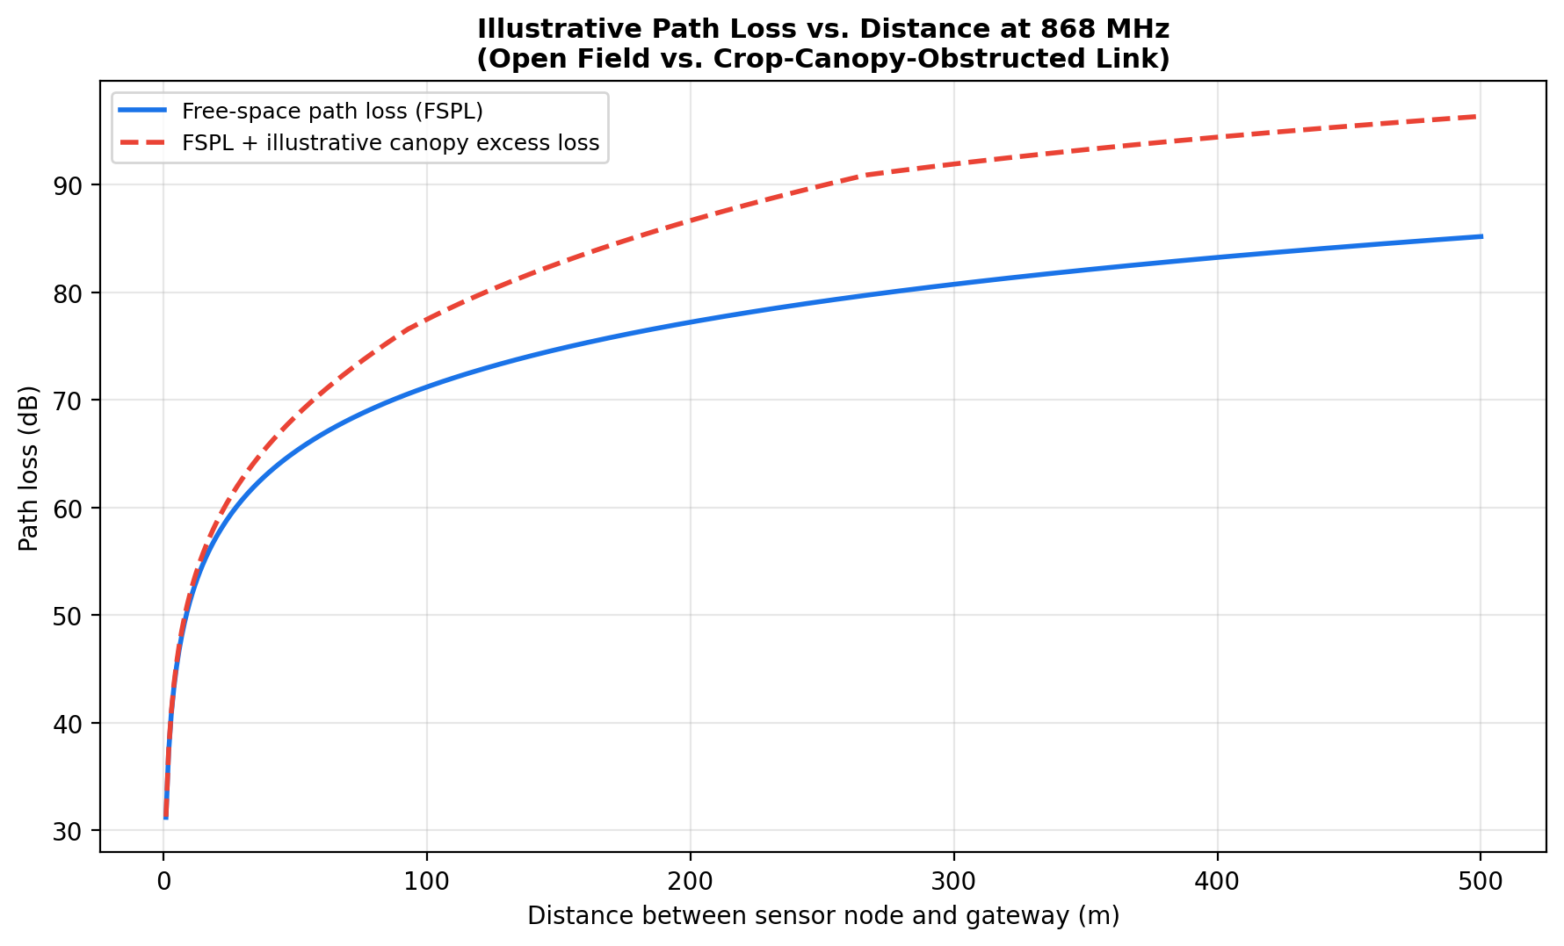
Figure 5. Illustrative path loss vs. distance at 868 MHz, comparing an open-field link against a canopy-obstructed link under the simplified foliage model of Section 4.2.

10.2 Worked Link-Budget Example
Table 5 works through an illustrative link budget for a representative LoRa-class field node transmitting to a gateway 300 m away, using typical datasheet-order parameter values.
Parameter | Illustrative Value | Notes
Transmit power (P_tx) | +14 dBm | Representative regulatory-compliant LoRa module output
Node antenna gain (G_tx) | 2 dBi | Typical quarter-wave monopole
Frequency (f) | 868 MHz | European ISM band
Distance (d) | 300 m | Illustrative node-to-gateway spacing
Free-space path loss (FSPL) | ≈ 90.8 dB | Computed via Section 2.2 formula
Illustrative foliage excess loss | ≈ 8–10 dB | Assuming moderate canopy depth per Section 4.2 model
Fade margin | 10 dB | Designer-chosen allowance (Section 4.1) for seasonal/weather variation
Gateway antenna gain (G_rx) | 6 dBi | Representative gateway collinear antenna
Receiver sensitivity threshold | −137 dBm | Representative LoRa demodulator sensitivity at a conservative spreading factor
Estimated received power | ≈ −87 to −89 dBm | P_tx + G_tx − FSPL − foliage − margin + G_rx
Resulting link margin above sensitivity | ≈ 48–50 dB | Substantial positive margin under these illustrative assumptions
Under these illustrative, representative assumptions the link closes with a comfortable margin, suggesting that a 300 m node-to-gateway spacing is reasonable for this scenario even accounting for moderate mid-season canopy growth. Repeating the same calculation with increasing assumed foliage depth (as would occur if node spacing were increased, or if a denser or taller crop than assumed were planted) illustrates how quickly that margin can erode reinforcing the core recommendation of this report that node spacing and gateway placement be chosen with reference to an explicit, foliage-inclusive link budget of this kind, rather than a nominal open-field "range" figure taken directly from a radio module's datasheet.

10.3 Sensitivity of the Illustrative Result to Key Assumptions
The illustrative margin computed in Section 10.2 is most sensitive, in descending order, to: (a) the assumed foliage depth and hence excess attenuation, which depends on both crop type/maturity and the specific geometry of the path relative to row orientation (Section 8.4); (b) gateway antenna height and gain, since both affect the ground-reflection interference pattern (Section 2.3) and the direct link budget term simultaneously; and (c) the fade margin allowance itself, which is a designer judgement call rather than a directly measured quantity. This ordering supports the emphasis placed throughout this report on foliage modelling (Chapter 4) and gateway-side antenna investment (Sections 6.3, 8.2) as the highest-leverage design decisions for a field deployment.

CHAPTER 11

RELATED WORK
A substantial body of published work addresses wireless sensor networks for precision agriculture, generally from one of two directions: application-focused studies that describe a complete sensing-and-actuation system with wireless connectivity treated as a largely solved, off-the-shelf component, and propagation-focused studies that measure or model vegetation and ground effects on RF links without necessarily embedding the result in a complete farming system. This report has attempted to bridge the two, using established propagation theory to inform system- and circuit-level design choices rather than treating either topic in isolation.
Application-focused smart farming studies commonly report successful use of LoRa and Zigbee for soil-moisture and micro-climate monitoring, generally validated at a specific site and crop stage, and frequently note often only in a limitations section — that range and reliability were found to vary with crop growth, a observation directly consistent with the seasonal canopy-growth challenge discussed in Section 9.1 of this report. Propagation-focused studies of vegetation attenuation, drawing on the ITU-R and Weissberger-family models introduced in Section 4.2, have historically focused on forestry and satellite-link applications; their application to regularly spaced row-crop geometries, as opposed to irregular forest canopy, remains an area where published, crop-specific measurement data is comparatively sparse a gap this report has flagged (Section 4.2) rather than attempted to close, given its conceptual and theoretical scope.
Where this report differs from typical application-focused smart farming papers is in treating the propagation channel as a first-class, seasonally varying design input from the outset (Chapters 2 and 4), rather than as an implicit assumption behind a quoted "range" specification, and in tying that treatment explicitly to concrete architectural and circuit-level decisions (Chapters 6–8) that a designer can act on before, rather than after, deployment.

CHAPTER 12

LIMITATIONS, FUTURE SCOPE, AND CONCLUSION

12.1 Limitations of This Report
- All figures and calculations are illustrative and theoretical; no physical prototype was built, and no field or laboratory RF measurements were taken. Real propagation behaviour will differ from the simplified models used here.
- The foliage-attenuation model adapted in Chapter 4 originates from forest-canopy and satellite-link literature; its numerical accuracy for specific row crops and growth stages has not been independently validated in this report.
- Regulatory duty-cycle and power constraints were discussed qualitatively (Section 9.5) but not incorporated into a formal, jurisdiction-specific compliance analysis.
- Cost modelling (hardware, installation labour, data-plan or satellite messaging fees) was outside the scope of this report, which focused specifically on the propagation and circuit-design dimensions of the problem.

12.2 Future Scope
- Empirical validation: field measurement campaigns across a full growing season, for specific crops of interest, to replace the illustrative foliage-loss coefficients used here with crop-specific, growth-stage-specific data.
- Adaptive link management: node or gateway firmware that adjusts spreading factor, transmit power, or reporting interval automatically in response to observed RSSI/SNR degradation, rather than relying solely on a static, worst-case fade margin chosen at design time.
- Row-orientation-aware siting tools: software that combines a field's known row geometry with the propagation models of this report to recommend gateway placement and node spacing automatically.
- Integration with soil-moisture-informed actuation: closing the loop described conceptually in Figure 1 with a physically built and tested irrigation-control implementation, subject to the fail-safe design principles discussed in Sections 3.3 and 7.3.

12.3 Conclusion
This report has presented a conceptual and theoretical treatment of electromagnetic wave propagation as a central design concern for smart farming wireless sensor networks, rather than a secondary detail resolved by a radio module's marketed range figure. Starting from fundamental EM and path-loss theory (Chapter 2), the report developed propagation models specific to the agricultural environment — foliage attenuation, ground-proximity and soil-moisture effects, and multipath considerations arising from row-crop geometry (Chapter 4) — and used them to inform a complete conceptual system architecture (Chapter 6) and circuit-level design (Chapter 7) for both a field sensor node and a field gateway, including antenna design and placement guidance (Chapter 8) grounded directly in the preceding propagation theory.
The illustrative link-budget analysis of Chapter 10 demonstrated the method by which such reasoning translates into concrete deployment parameters — node spacing, antenna height, and fade-margin allowance — that a designer can compute for a specific site once crop-specific and site-specific propagation data are available. The report's central recommendation is that this propagation-first reasoning be applied at the design stage of any smart farming deployment, particularly given that the agricultural RF channel, unlike many other wireless-sensor-network environments, changes predictably but substantially over the course of a single growing season.

REFERENCES
[1] International Telecommunication Union (ITU-R), "Attenuation in vegetation," Recommendation ITU-R P.833, Radiocommunication Sector of ITU.
[2] M. A. Weissberger, "An initial critical summary of models for predicting the attenuation of radio waves by trees," ESD-TR-81-101, Electromagnetic Compatibility Analysis Center, 1982.
[3] T. S. Rappaport, Wireless Communications: Principles and Practice, 2nd ed., Prentice Hall, 2002. (Free-space path loss and two-ray ground-reflection model.)
[4] LoRa Alliance, "LoRaWAN 1.0.4 Specification," LoRa Alliance Technical Committee.
[5] European Telecommunications Standards Institute (ETSI), "EN 300 220: Short Range Devices; Radio equipment operating in the 25 MHz to 1000 MHz frequency range," (duty-cycle and power limits for the 868 MHz band).
[6] IEEE Standards Association, "IEEE 802.15.4: Low-Rate Wireless Personal Area Networks (Zigbee physical/MAC layer)," IEEE.
[7] Representative published smart-farming WSN case studies reporting LoRa/Zigbee soil-moisture and micro-climate monitoring performance and noting seasonal range variation (general literature category referenced in Chapter 11; specific citations to be added if this report is developed into a formally cited academic work).
[8] International Telecommunication Union (ITU-R), "Calculation of free-space attenuation," Recommendation ITU-R P.525, Radiocommunication Sector of ITU.
[9] International Telecommunication Union (ITU-R), "Propagation data and prediction methods required for the design of terrestrial line-of-sight systems," Recommendation ITU-R P.530, Radiocommunication Sector of ITU.
[10] European Telecommunications Standards Institute (ETSI), "EN 300 328: Wideband transmission systems; Data transmission equipment operating in the 2.4 GHz band."
[11] Ministry of Communications, Government of India (WPC Wing), "Use of Low Power Equipment in the Frequency Band 865-868 MHz for Short Range Devices (Exemption from Licence) Rules, 2021," G.S.R. 853(E), Gazette of India, 10 December 2021.
[12] U.S. Federal Communications Commission, "47 CFR Part 15: Radio Frequency Devices."
[13] European Telecommunications Standards Institute (ETSI), "EN 301 489-1 and EN 301 489-3: ElectroMagnetic Compatibility (EMC) standard for radio equipment and services; Specific conditions for Short-Range Devices."
[14] International Electrotechnical Commission (IEC), "IEC 61000-4-2: Electrostatic discharge immunity test" and "IEC 61000-4-5: Surge immunity test."
[15] International Electrotechnical Commission (IEC), "IEC 62305 series: Protection against lightning."
[16] International Electrotechnical Commission (IEC), "IEC 60529: Degrees of protection provided by enclosures (IP Code)" and "IEC 60068-2 series: Environmental testing."
[17] International Electrotechnical Commission (IEC), "IEC 62368-1: Audio/video, information and communication technology equipment - Safety requirements" and "IEC 62133-2: Safety requirements for portable sealed secondary lithium cells and batteries."
[18] IPC - Association Connecting Electronics Industries, "IPC-2221: Generic Standard on Printed Board Design" and "IPC-2141: Design Guide for High-Speed Controlled Impedance Circuit Boards."
[19] International Commission on Non-Ionizing Radiation Protection (ICNIRP), "Guidelines for limiting exposure to electromagnetic fields (100 kHz to 300 GHz)," Health Physics, vol. 118, no. 5, 2020; and IEEE Std C95.1, "IEEE Standard for Safety Levels with Respect to Human Exposure to Electric, Magnetic, and Electromagnetic Fields, 0 Hz to 300 GHz."
[20] E. Rescorla, "The Transport Layer Security (TLS) Protocol Version 1.3," IETF RFC 8446, 2018.

