Cloud Computing Tutorials – 2
Demonstration of PaaS Application : Creating a Trailblazar app on
Salesforce Trailhead

Observation:

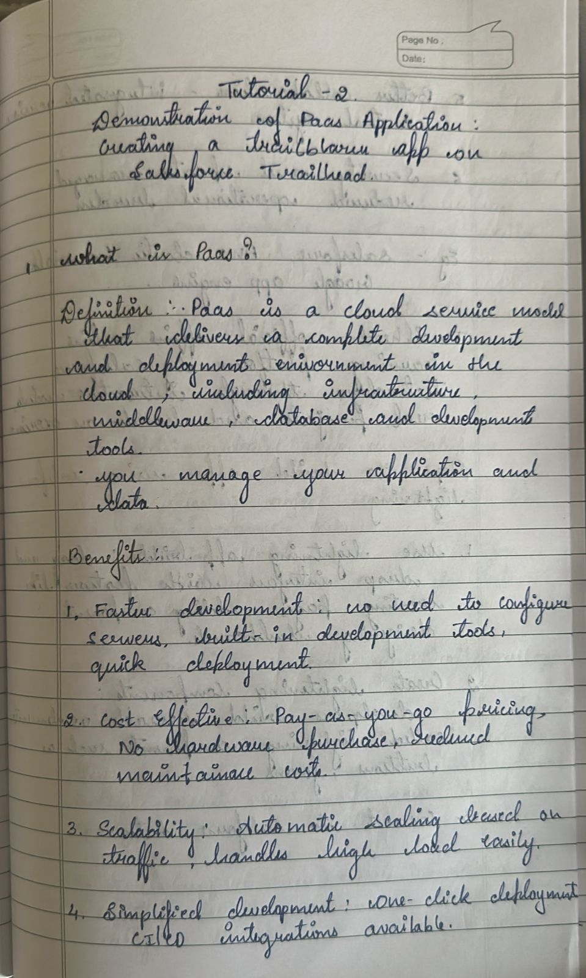

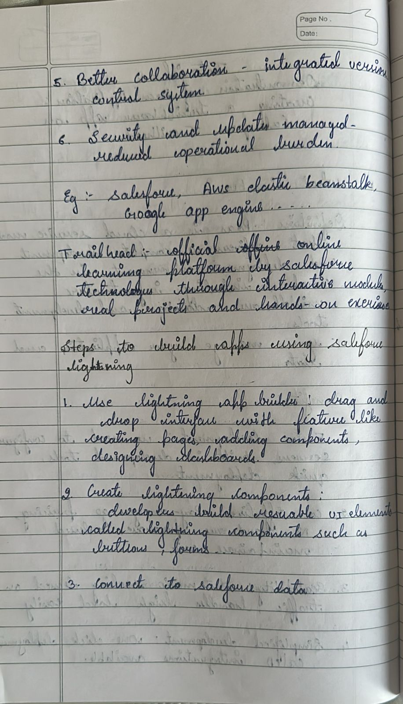

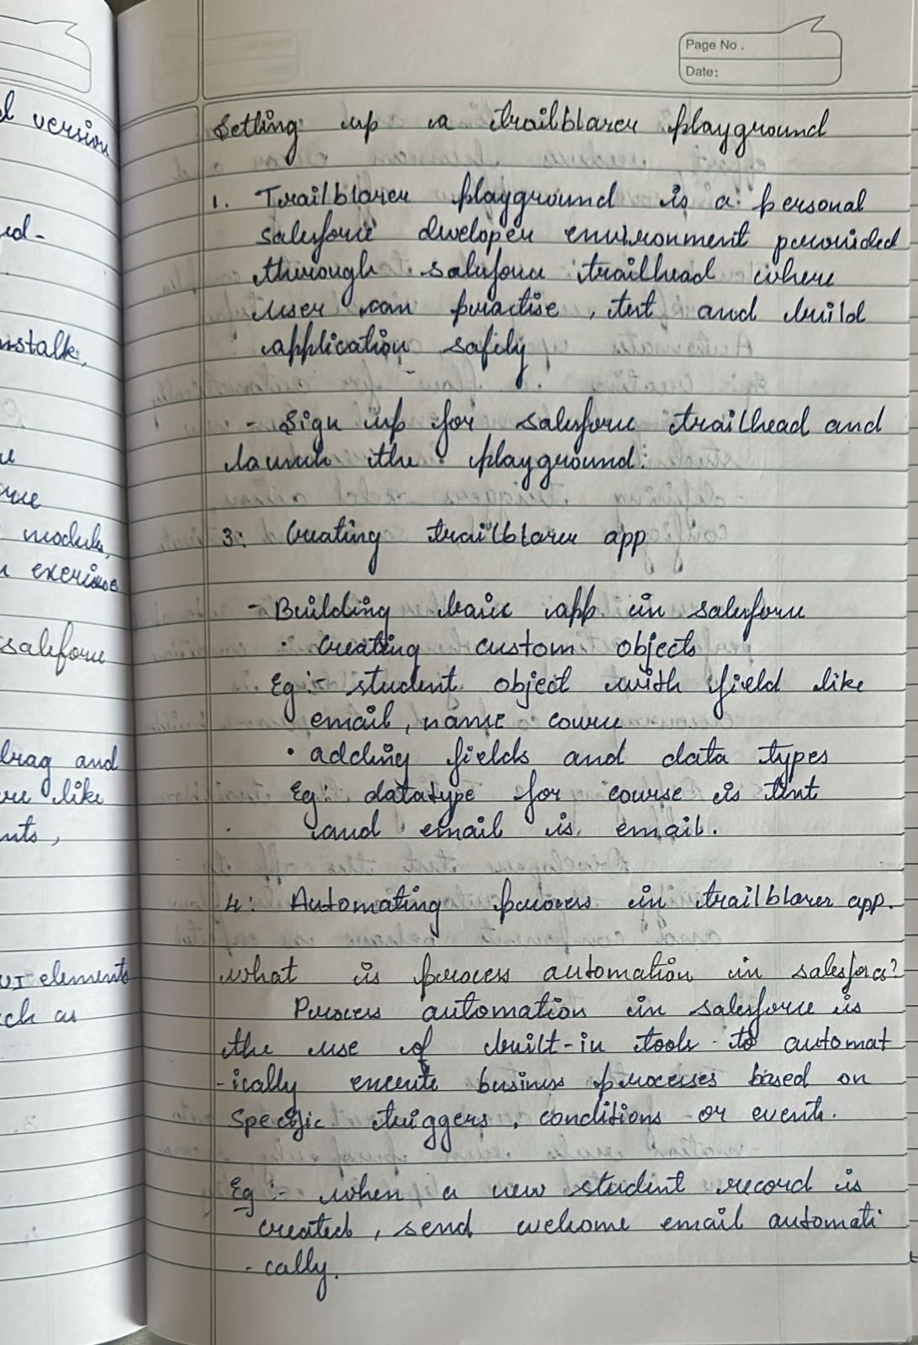

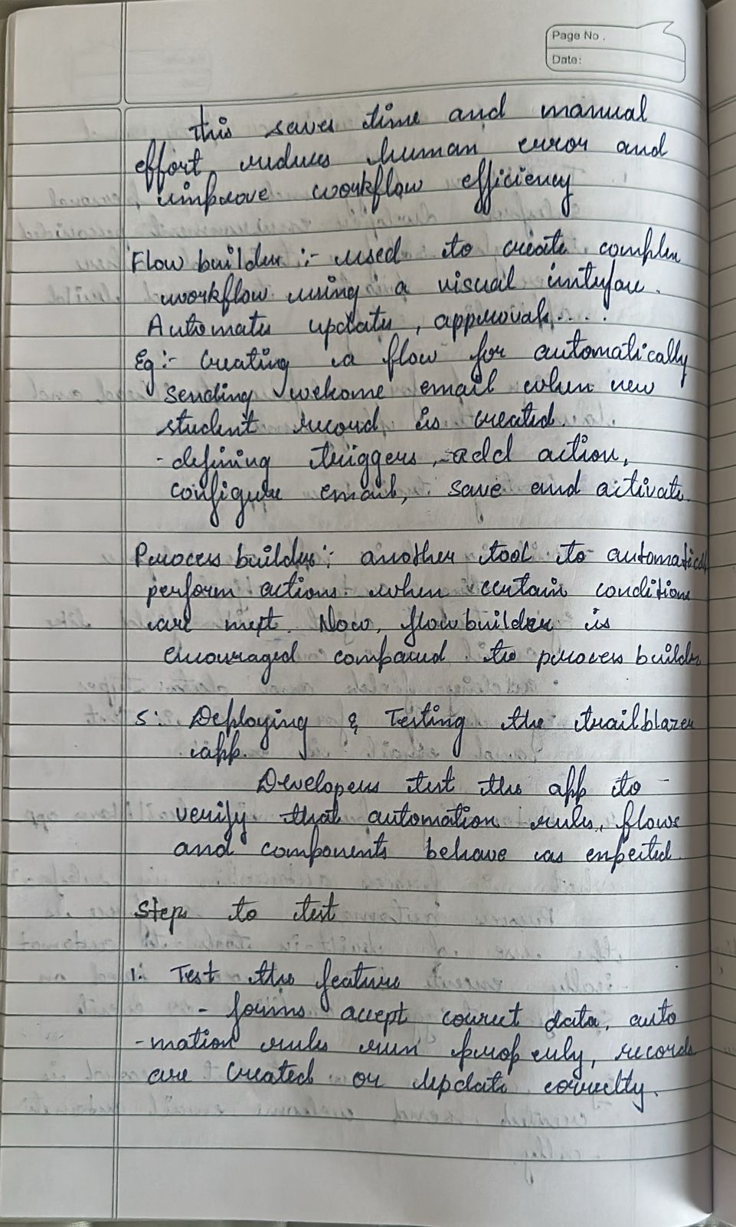
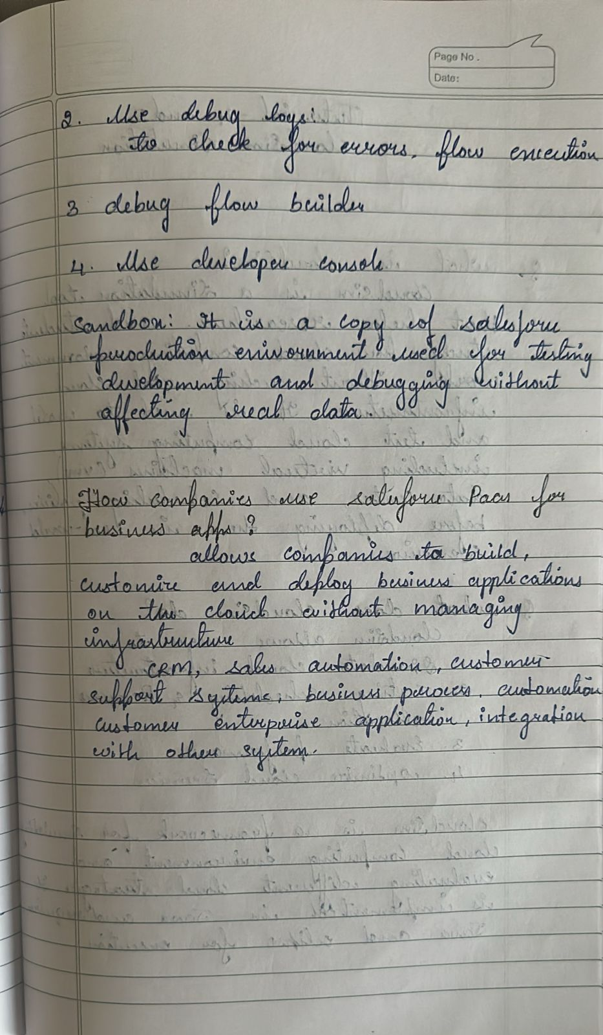
Salesforce Trailhead Demonstration:

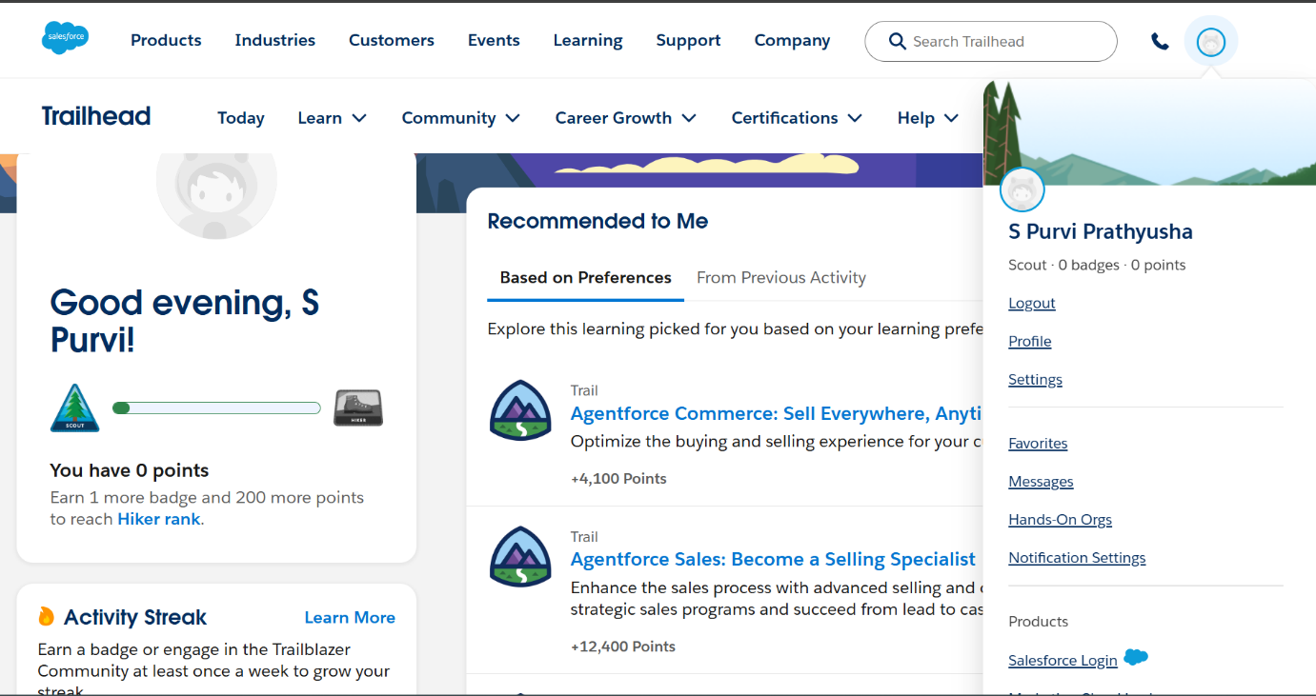
Fig 1.1: Salesforce Trailhead homepage

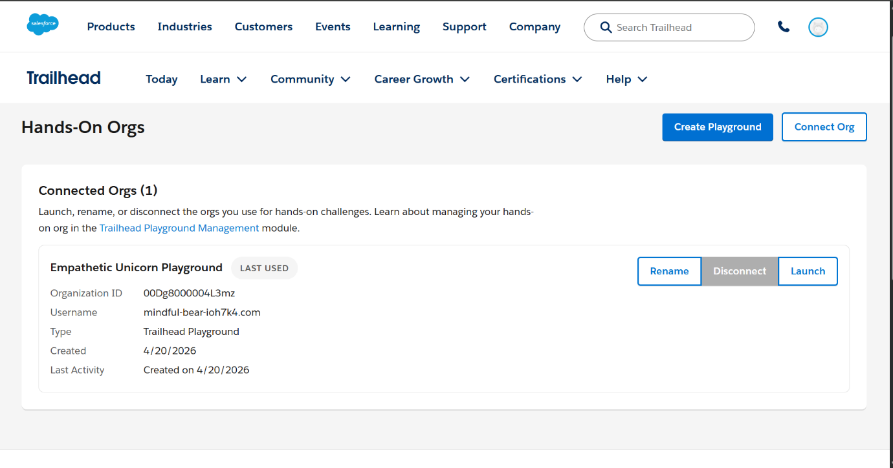
Fig 1.2 :Playground creation

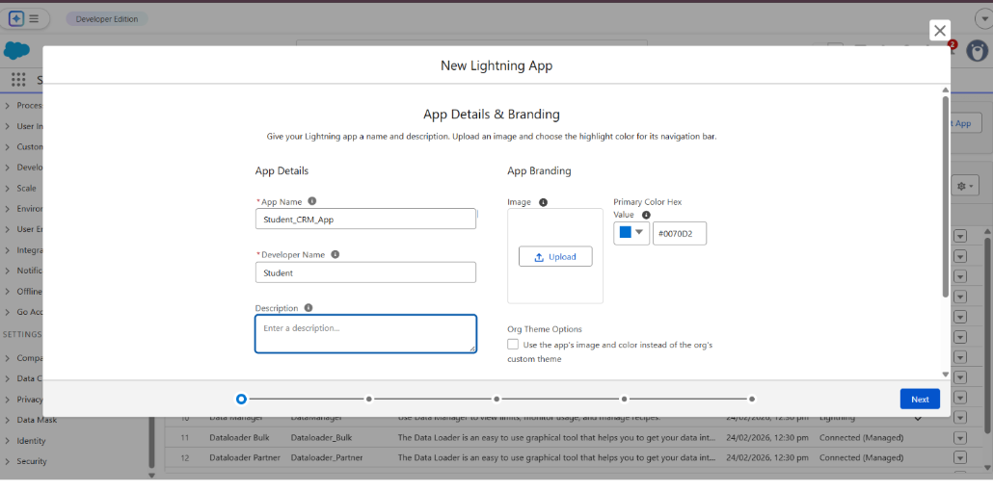
Fig 1.3 : New Lightening app Creation

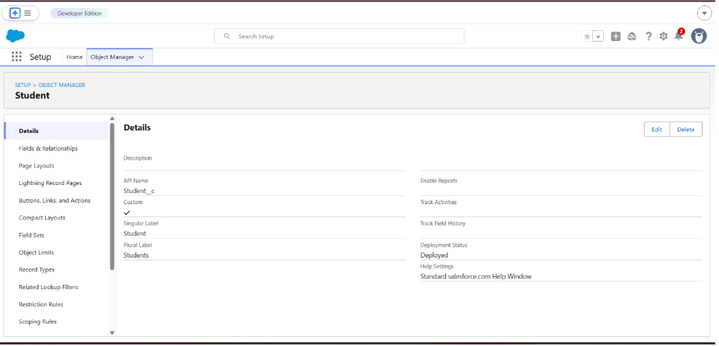
Fig 1.4: Adding a custom object -Student object creation

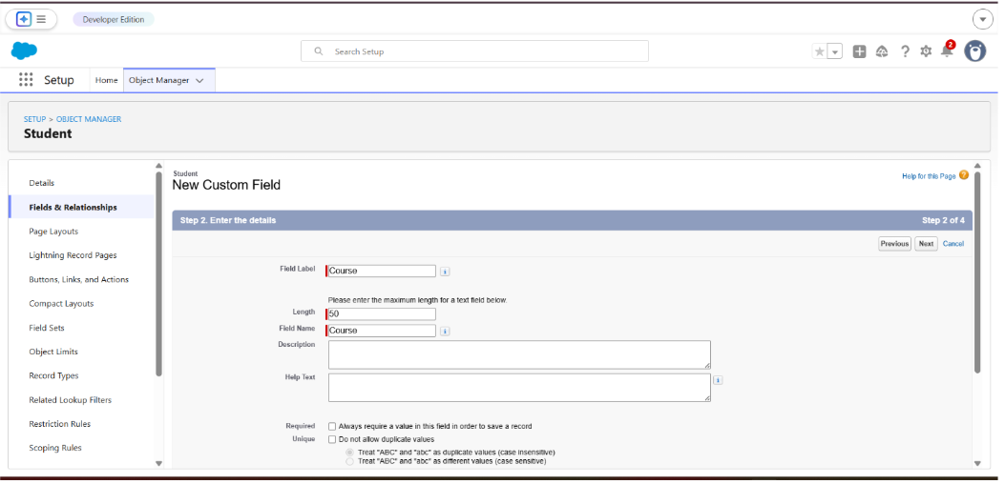
Fig 1.5: Adding a custom field

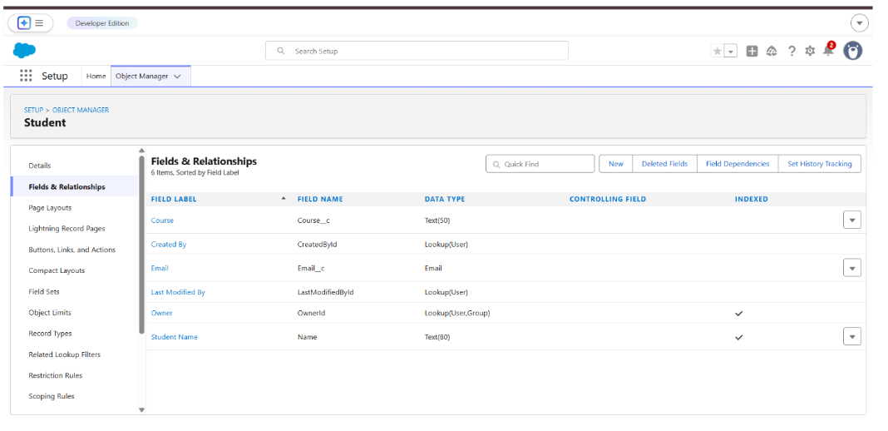
Fig 1.6 : All fields and relationships

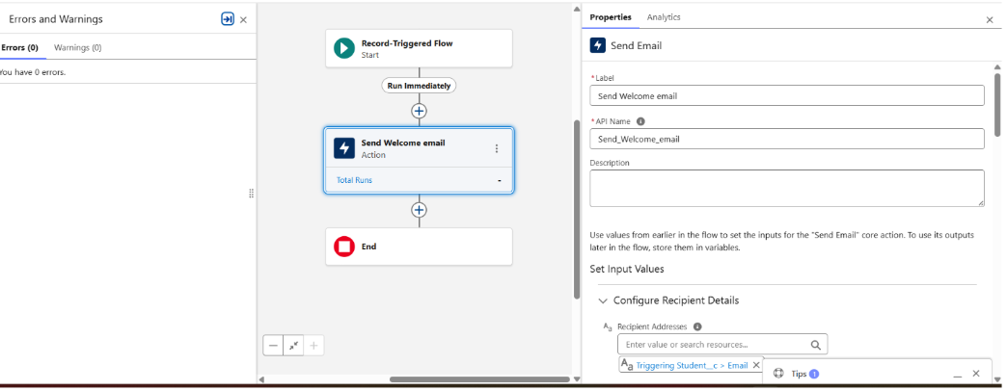
Fig 1.7 : Builder flow creation -setting up automation rules

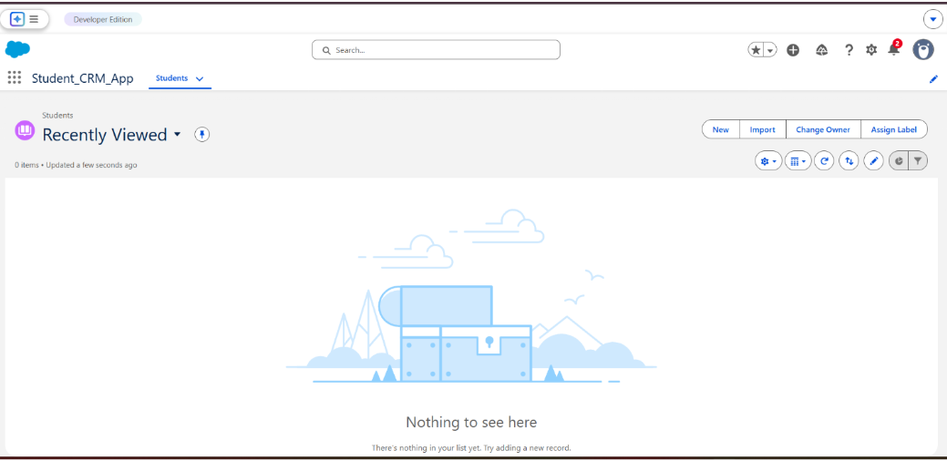
Fig 1.8: Newly created Student_CRM_App

