High-Level Design Document
Maya — Outbound Voice AI Collections Agent for Kapture Finance
Prepared for: Kapture CX — AI Delivery Intern Assignment
Author: Kayala Mohan Simhachala Praveen | Date: August 2026

Document Purpose
This document is the engineer-ready design for “Maya,” an outbound voice agent that calls customers about overdue loan EMIs on behalf of Kapture Finance. It specifies the system architecture, conversation state machine, tool contracts, compliance rules, edge-case handling, and observability plan used to build the Vapi implementation described in the accompanying README.
Scenario used throughout: Customer Rahul Sharma, Personal Loan Account ACC-88392, ₹8,499 overdue, 12 days past due (DPD).

1. Architecture & Pipeline
Maya runs on Vapi.ai, which orchestrates four managed services per conversational turn: speech-to-text, the reasoning LLM, tool/function execution against our own webhook server, and text-to-speech. No component maintains its own long-term state beyond the call — all durable data (verification status, PTP records, disposition) is written out through tool calls to our backend, which is the system of record.
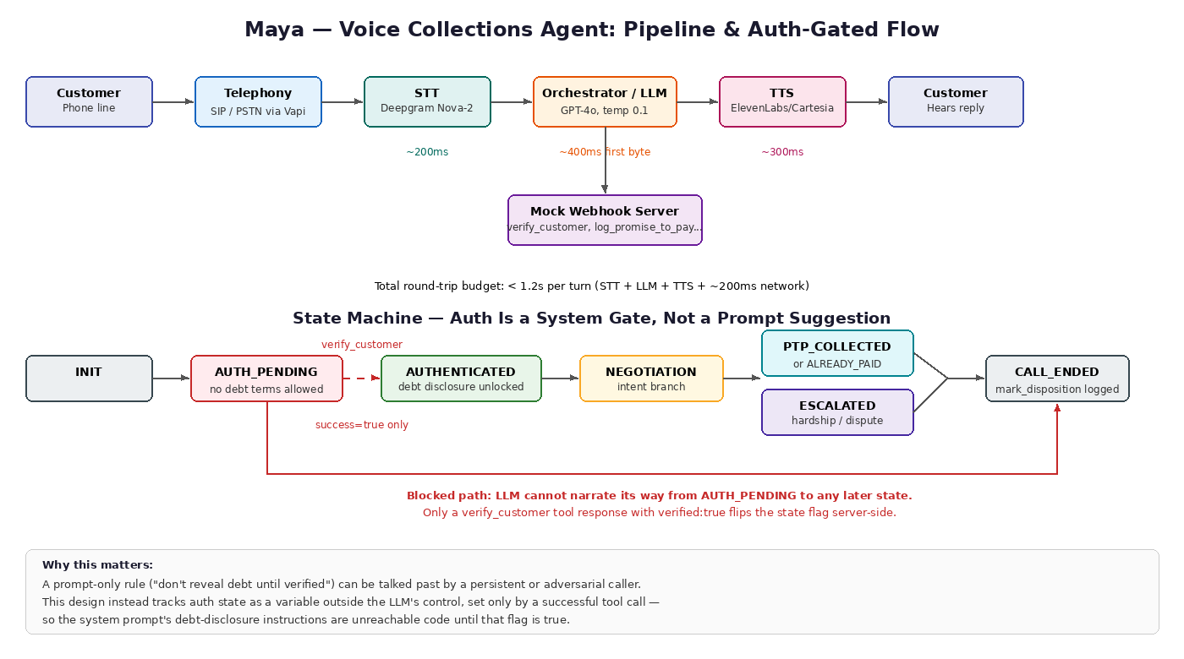
Figure 1: End-to-end pipeline with per-hop latency budget, and the state machine's hard auth gate (Section 2).

1.1 Latency Budget
Target end-to-end round-trip per conversational turn: under 1.2 seconds, so the call feels responsive rather than robotic.
Hop | Component | Budget | Notes
1 | Speech-to-Text | ~200 ms | Deepgram Nova-2, streaming/partial transcripts to start LLM early
2 | LLM first byte | ~400 ms | GPT-4o via Vapi; temperature 0.1 to keep compliance language consistent
3 | Tool call round-trip | ~150–300 ms | Only on turns that invoke verify_customer, log_promise_to_pay, etc.; mocked endpoints return near-instantly
4 | Text-to-Speech | ~300 ms | ElevenLabs/Cartesia streaming synthesis, starts on first sentence
5 | Network overhead | ~200 ms | SIP/PSTN + WebRTC hop, telephony carrier variance
 | Total | < 1.2 s | Measured customer-perceived silence between their utterance ending and Maya's reply starting
If a turn requires a tool call (e.g., verification), the LLM is prompted to emit a short filler acknowledgment (“One moment while I check that”) synthesized immediately, so perceived latency stays low even when the tool round-trip pushes total turn time over budget.

2. Conversation State Machine
States: INIT → AUTH_PENDING → AUTHENTICATED → NEGOTIATION → {PTP_COLLECTED | ESCALATED} → CALL_ENDED.
Core design rule: authentication is state-enforced, not prompt-discretionary.
The system prompt instructs the LLM not to disclose debt terms before verification, but instructions alone are a soft control — a persistent caller can potentially argue, roleplay, or socially engineer the model into skipping ahead. To make this a hard control, the mock server tracks a boolean auth flag per call session, and the LLM's tool-calling contract requires verify_customer to return verified: true before any downstream tool (log_promise_to_pay, send_payment_link) is accepted. If a downstream tool is invoked without a prior successful verification in that session, the server rejects the call and returns an error, and the system prompt instructs Maya to treat that as a hard stop and re-attempt verification. This turns the auth gate from a request the model can ignore into a precondition the backend enforces.
State | Entry Condition | What's Allowed | Exit Condition
INIT | Call connects | Greeting only; confirm speaking with target customer | Customer confirms or denies identity
AUTH_PENDING | Customer confirmed as target | Ask for last-4 PAN or birth year. No debt/loan/EMI/amount language permitted | verify_customer tool called
AUTHENTICATED | verify_customer returns verified:true | Disclose amount, overdue days, purpose | Customer states an intent
NEGOTIATION | Intent expressed | Branch: PTP / Already Paid / Hardship / Dispute / DNC | Branch tool call completes (log_promise_to_pay / mark_disposition / escalate_to_agent)
PTP_COLLECTED | log_promise_to_pay succeeds | Send payment link, confirm details | send_payment_link completes or fails gracefully
ESCALATED | escalate_to_agent called | Set expectations for human follow-up | Call wrap-up
CALL_ENDED | mark_disposition called | Closing line only | Call terminates

3. Intents & Entities

3.1 Intents
- Confirm_Identity — confirms or denies being the target customer
- Promise_To_Pay — commits to a payment date and/or amount
- Already_Paid — claims the debt is already settled
- Hardship_Claim — indicates inability to pay in full
- Dispute_Debt — disputes the amount or its validity
- Request_DNC — asks to stop being called
- Wrong_Person — caller is not the target and the target is unavailable

3.2 Entities
Entity | Type | Format | Extracted During
Verification_Code | String | 4 digits (PAN) or 4-digit year | AUTH_PENDING
PTP_Date | Date | ISO-8601 (YYYY-MM-DD) | NEGOTIATION → Promise_To_Pay
PTP_Amount | Number | INR, no currency symbol in payload | NEGOTIATION → Promise_To_Pay
Hardship_Reason | String | Free text, logged verbatim to notes | NEGOTIATION → Hardship_Claim

4. Tools / API Specifications
All tools are exposed to Vapi as OpenAI-style function schemas and resolved by a single webhook endpoint on our mock server. Full JSON schemas are in tool_definitions.json (submitted alongside this document); summarized contracts below.
Tool | Inputs | Output | Gate
verify_customer | account_id, verification_code | verified: bool, message | Must succeed before any other tool is accepted in this session
log_promise_to_pay | account_id, ptp_date, amount | success: bool, ptp_id | Requires prior verified session
send_payment_link | account_id, channel (SMS/WhatsApp/BOTH) | success: bool, message | Requires prior verified session
escalate_to_agent | account_id, reason | success: bool, ticket_id | Requires prior verified session, except reason=WRONG_PERSON path
mark_disposition | account_id, status (enum), notes | success: bool, timestamp | Always callable — every call must end with one
Disposition status enum: PTP_AGREED, ALREADY_PAID, DISPUTED, HARDSHIP_ESCALATED, WRONG_PERSON, DO_NOT_CALL, NO_RESPONSE.

5. Auth & Data Safety Protocols
- Zero debt disclosure before verification: the words “overdue,” “loan,” “EMI,” amount figures, and “Kapture Finance debt” are prohibited in Maya's output until verify_customer returns verified:true for that session.
- Third-party protection: if the person who answers denies being the target customer, Maya asks only when the target will be available — never confirms that a debt exists, never asks the third party to relay a balance.
- PII masking in logs: customer names are stored masked in application logs (e.g., “Rahul S****”); verification codes are never logged in plaintext, only a boolean match result.
- Session-scoped auth: the verified flag is tied to the specific call session ID and does not persist or transfer across calls.
- Least-privilege tool access: downstream tools reject requests without a verified session, independent of what the LLM “believes” happened.

6. Compliance & Guardrails

6.1 Fair Collections Norms
- Calling window enforced at the dialer/scheduling level: 08:00–19:00 local time only.
- No threats, no harassment, no repeated pressure tactics — tone is fixed as calm, firm, supportive per the system prompt.
- Do-Not-Call requests are honored immediately and logged via mark_disposition(status: DO_NOT_CALL); no further outbound attempts to that account without manual review.

6.2 Hallucination Prevention
- Maya cannot offer waivers, discounts, or settlements greater than 10% without escalating to a human agent — this cap is stated explicitly in the system prompt and is a candidate for future server-side enforcement (see Section 10).
- Maya cannot invent account details, payment history, or policy terms not present in the account context provided at call start.
- Any question outside the collections scope (legal advice, unrelated account changes) is deflected to human escalation rather than answered.

7. Edge Cases Matrix
Scenario | Trigger | Maya's Response
Abusive caller | Hostile/abusive language detected | One calm warning that the call may end if it continues; on repeat, soft hangup + mark_disposition
Silence / voicemail | No speech input | Up to 2 re-prompts, then hangup with NO_RESPONSE disposition
Mid-call language switch | Customer switches English ↔ Hindi | Maya mirrors the switch and continues in that language without losing state or extracted entities
Wrong number | Confirmed not the target, target unreachable | mark_disposition(WRONG_PERSON), polite close, no debt ever mentioned
Already paid | Customer claims prior payment | Capture reference/date, mark_disposition(ALREADY_PAID), explain 24–48h processing window
Dispute | Customer disputes amount/validity | No debate — escalate_to_agent(reason: DISPUTE), warm handoff framing
Do-not-call | Explicit opt-out request | Immediate compliance, mark_disposition(DO_NOT_CALL), end call

8. Escalation & Disposition
Every call, regardless of outcome, ends in exactly one of two ways: a resolved disposition Maya logs herself, or a handoff to a human agent for cases that need judgment Maya isn't authorized to exercise.

8.1 When Maya Escalates to a Human
Trigger | Tool Called | Why it's not left to Maya
Financial hardship claim | escalate_to_agent(reason: HARDSHIP_REQUEST) | Any settlement or extension beyond the 10% waiver cap requires judgment/authorization Maya doesn't have
Dispute of the debt or amount | escalate_to_agent(reason: DISPUTE) | Verifying a disputed claim requires access to account history a mock/voice agent shouldn't adjudicate

8.2 When Maya Logs a Disposition Herself (No Escalation)
For every other outcome, Maya calls mark_disposition directly — this is the one tool that must always be callable, even for calls that never reach AUTHENTICATED (see Section 5), because a call's outcome must be recorded regardless of how it ended.
Outcome | Disposition Status | Verification required first?
Customer commits to pay | PTP_AGREED | Yes
Customer claims prior payment | ALREADY_PAID | Yes
Wrong number / target unavailable | WRONG_PERSON | No
Customer opts out | DO_NOT_CALL | No — honored immediately regardless of call state
No input / voicemail / failed verification | NO_RESPONSE | No
This split is enforced at the server level, not just described in the prompt: escalate_to_agent, log_promise_to_pay, and send_payment_link all require a verified session; mark_disposition does not, since it must remain callable however the call actually ended.

9. Observability Metrics
Metric | Definition | Why It Matters
Containment Rate | % of calls resolved without human escalation | Core efficiency measure — the business case for the bot
PTP Rate | % of calls ending in a valid logged promise-to-pay | Primary collections effectiveness metric
First Call Resolution (FCR) | % of calls ending in any valid, actionable disposition (not NO_RESPONSE) | Signals whether the flow is actually reaching a conclusion
Avg. Turn Latency | Mean STT+LLM+TTS+network round-trip per turn | Tracks against the <1.2s budget; regressions here hurt call quality directly
Auth Success Rate | % of AUTH_PENDING sessions reaching AUTHENTICATED | Distinguishes genuine failed verification from customers hanging up early
Drop Rate | % of calls ending before CALL_ENDED with a logged disposition | Flags flow dead-ends or bugs, not just uninterested customers

10. Assumptions & Future Enhancements
- Assumption: account context (name, account ID, overdue amount, DPD) is pre-loaded per call rather than looked up live — a get_account_details tool would replace this in production.
- Assumption: verification uses last-4 PAN or birth year only, matching the reference scenario; production would likely add a second factor.
- Limitation: verification is knowledge-based (matching a code), not identity-based — anyone who knows the target customer's PAN digits or birth year (e.g. a family member) would pass verification, even if they are not the account holder. This is a common trade-off in phone-based verification generally, but a production version would want a stronger second factor, such as a one-time code sent to the customer's registered number, to close this gap.
- Limitation: the 10% waiver cap is currently enforced only in the system prompt, not server-side. Live adversarial testing (asking Maya to accept a ~65% discount under pushy framing) showed GPT-4o correctly refused and escalated instead — but nothing in the mock server itself would reject a below-cap amount if the model ever failed to follow this instruction, unlike the auth gate, which is enforced independently of the model's behavior. Future: move this and other numeric guardrails into server-side validation in log_promise_to_pay, so an out-of-policy offer is rejected by the backend regardless of what the LLM decides.
- Future: persist full conversation transcripts (redacted) for QA sampling and containment-rate analysis over time.

