PYTHON ACTIVITY-BASED LEARNING
10 Selected Case Studies
Complete Report with Flowchart Diagrams, Pseudocode, Python Programs and Sample Outputs

Name: Nallajeru Praveen kumar
Roll Number: 26001406
Branch/Section: CSD-1
Subject: Python Programming

Note: Ten problems have been selected from the supplied Python Activity-Based Learning case-study list. Sample inputs and outputs are illustrative. The flowchart is presented in diagram form for each problem.

Selected Case Studies
- 1. Employee Payroll and Deduction Analysis (Original case-study number: 4)
- 2. Retail Billing with Multiple Discount Rules (Original case-study number: 7)
- 3. Examination Result and Grace-Mark Validation (Original case-study number: 11)
- 4. ATM Transaction Sequence Simulation (Original case-study number: 13)
- 5. Smart Parking Fee Management (Original case-study number: 15)
- 6. Fuel Consumption and Route Comparison (Original case-study number: 18)
- 7. Password Policy Validation Engine (Original case-study number: 29)
- 8. Student Feedback Sentiment Scoring (Original case-study number: 34)
- 9. Student Marks Matrix Analysis (Original case-study number: 42)
- 10. Food Waste Monitoring System (Original case-study number: 53)
Shape key for flowcharts: Oval = Start/Stop; Parallelogram = Input; Rectangle = Processing/Output; Diamond = Decision.

Case Study 1: Employee Payroll and Deduction Analysis
Selected from original case-study number 4.

1. Problem Statement
Develop a Python program to calculate an employee's gross salary from basic pay, allowances, overtime and incentives. Apply deductions and display a formatted salary statement.

2. Objectives
- Calculate total allowances and gross salary.
- Calculate deductions and net salary.
- Display a clear salary statement.

3. Assumptions
- All amounts are entered in Indian rupees.
- HRA is 20% and DA is 10% of basic pay.
- Overtime and incentives are entered as amounts.
- Provident fund deduction is 12% of basic pay and other deduction is entered by the user.

4. Algorithm (Diagram / Flowchart)
The following diagram shows the main steps of the algorithm.
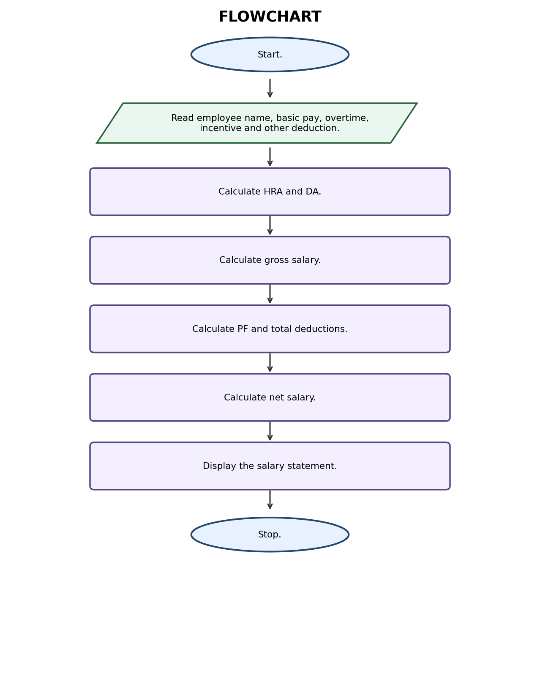
Algorithm steps:
- Start.
- Read employee name, basic pay, overtime, incentive and other deduction.
- Calculate HRA and DA.
- Calculate gross salary.
- Calculate PF and total deductions.
- Calculate net salary.
- Display the salary statement.
- Stop.

5. Pseudocode
BEGIN
INPUT name, basic, overtime, incentive, other_deduction
hra = basic * 0.20
da = basic * 0.10
gross = basic + hra + da + overtime + incentive
pf = basic * 0.12
deductions = pf + other_deduction
net = gross - deductions
DISPLAY salary statement
END

Python Source Code
- 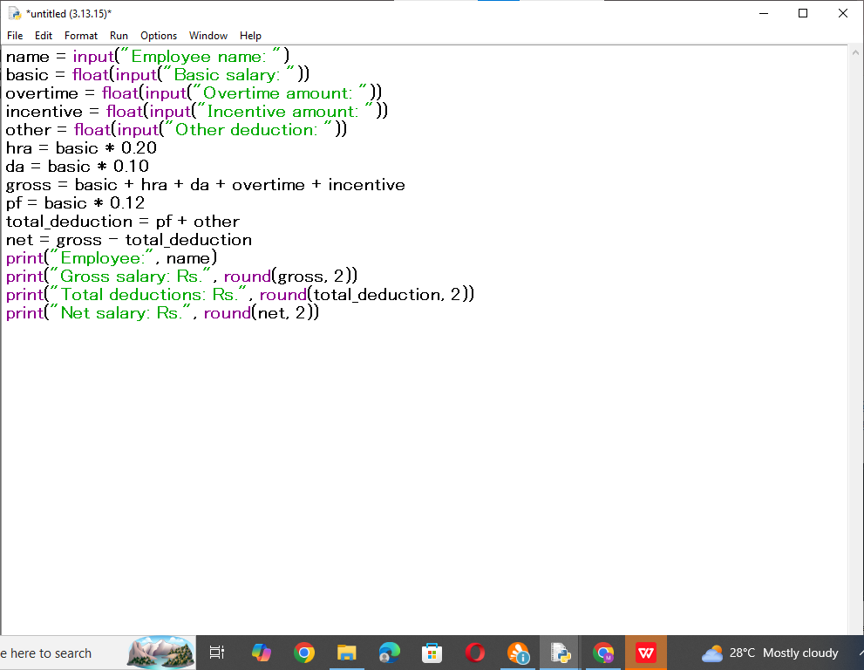

7. Test Cases
Input / Test | Expected result
Ravi; basic=20000, overtime=1000, incentive=500, other=300 | Gross=Rs. 26500.00; deductions=Rs. 2700.00; net=Rs. 23800.00

8. Sample Output Screenshot
Illustrative terminal-style output for the sample test:
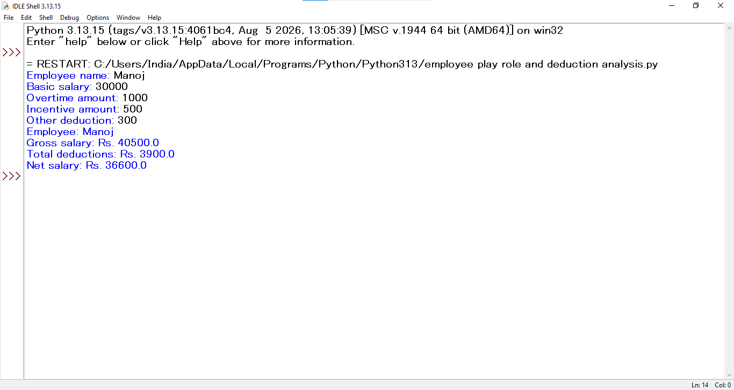

9. Conclusion
The program calculates gross salary, deductions and net salary using basic arithmetic operations and displays an employee salary statement.

Case Study 2: Retail Billing with Multiple Discount Rules
Selected from original case-study number 7.

1. Problem Statement
Create a retail billing program that accepts product prices and quantities, calculates the subtotal, applies a discount when the bill reaches a given threshold, adds tax and prints the final invoice.

2. Objectives
- Calculate item-wise and total cost.
- Apply a threshold-based discount.
- Calculate tax and final amount.

3. Assumptions
- The program accepts three products.
- A 10% discount is applied when subtotal is Rs. 5,000 or more.
- GST is calculated at 5% after discount.
- All prices and quantities are positive.

4. Algorithm (Diagram / Flowchart)
The following diagram shows the main steps of the algorithm.
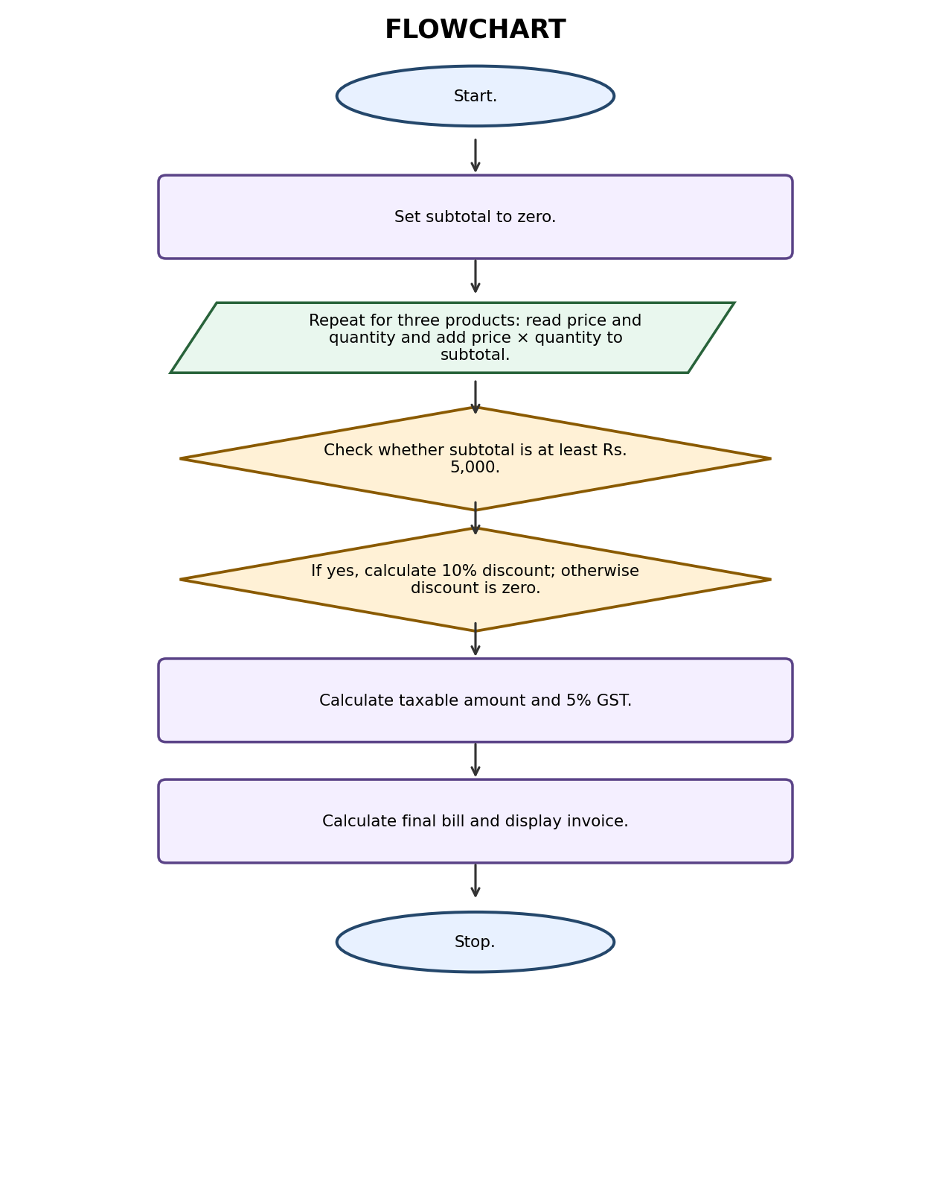
Algorithm steps:
- Start.
- Set subtotal to zero.
- Repeat for three products: read price and quantity and add price × quantity to subtotal.
- Check whether subtotal is at least Rs. 5,000.
- If yes, calculate 10% discount; otherwise discount is zero.
- Calculate taxable amount and 5% GST.
- Calculate final bill and display invoice.
- Stop.

5. Pseudocode
BEGIN
subtotal = 0
REPEAT 3 TIMES
INPUT price, quantity
subtotal = subtotal + price * quantity
END REPEAT
IF subtotal >= 5000 THEN
discount = subtotal * 0.10
ELSE
discount = 0
END IF
taxable = subtotal - discount
tax = taxable * 0.05
total = taxable + tax
DISPLAY subtotal, discount, tax, total
END

Python Source Code
- 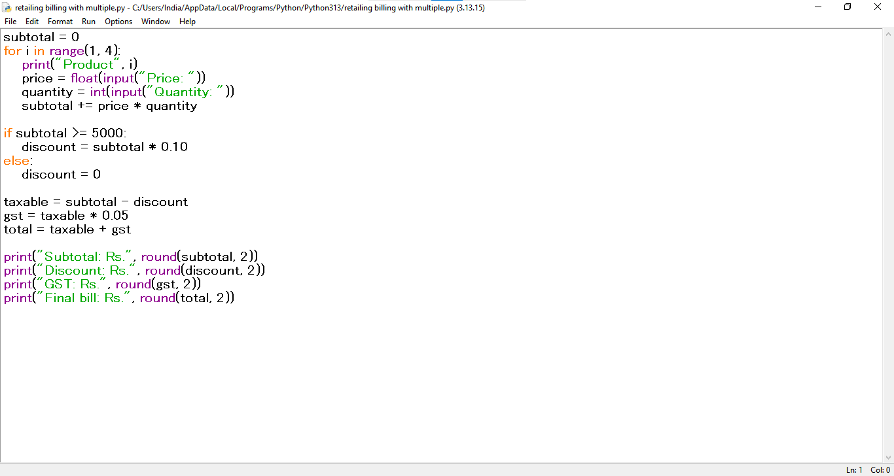

7. Test Cases
Input / Test | Expected result
Prices/quantities: 2000×1, 1500×1, 2000×1 | Subtotal=5500; discount=550; GST=247.50; final=5197.50

8. Sample Output Screenshot
Illustrative terminal-style output for the sample test:
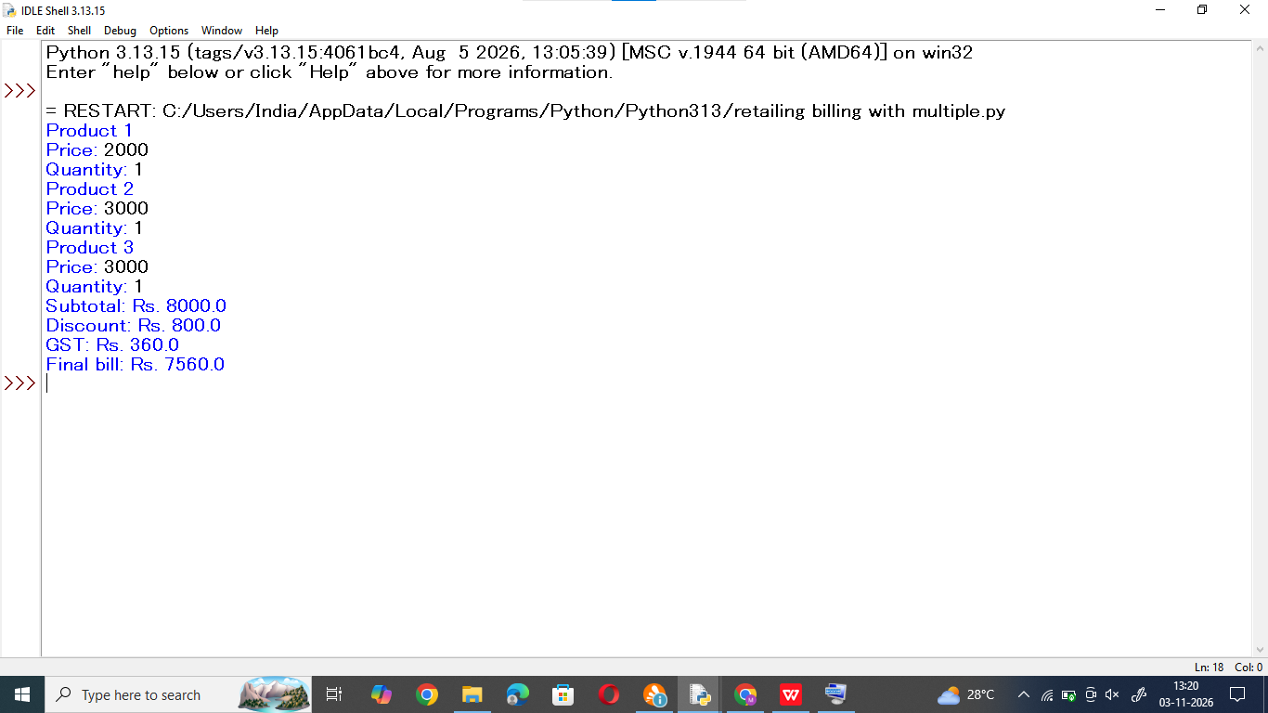

9. Conclusion
The program uses a loop, conditional statement and arithmetic operators to calculate a retail bill with discount and GST.

Case Study 3: Examination Result and Grace-Mark Validation
Selected from original case-study number 11.

1. Problem Statement
Write a program to process marks in multiple subjects, apply a limited grace-mark rule and display the final result without allowing marks to exceed the maximum.

2. Objectives
- Accept marks in subjects.
- Apply a grace mark only when the student is within the permitted range.
- Display subject results and overall result.

3. Assumptions
- There are three subjects, each out of 100.
- Pass mark is 40 in each subject.
- A student short by at most 5 marks in exactly one subject receives the required grace marks.
- Final marks cannot exceed 100.

4. Algorithm (Diagram / Flowchart)
The following diagram shows the main steps of the algorithm.
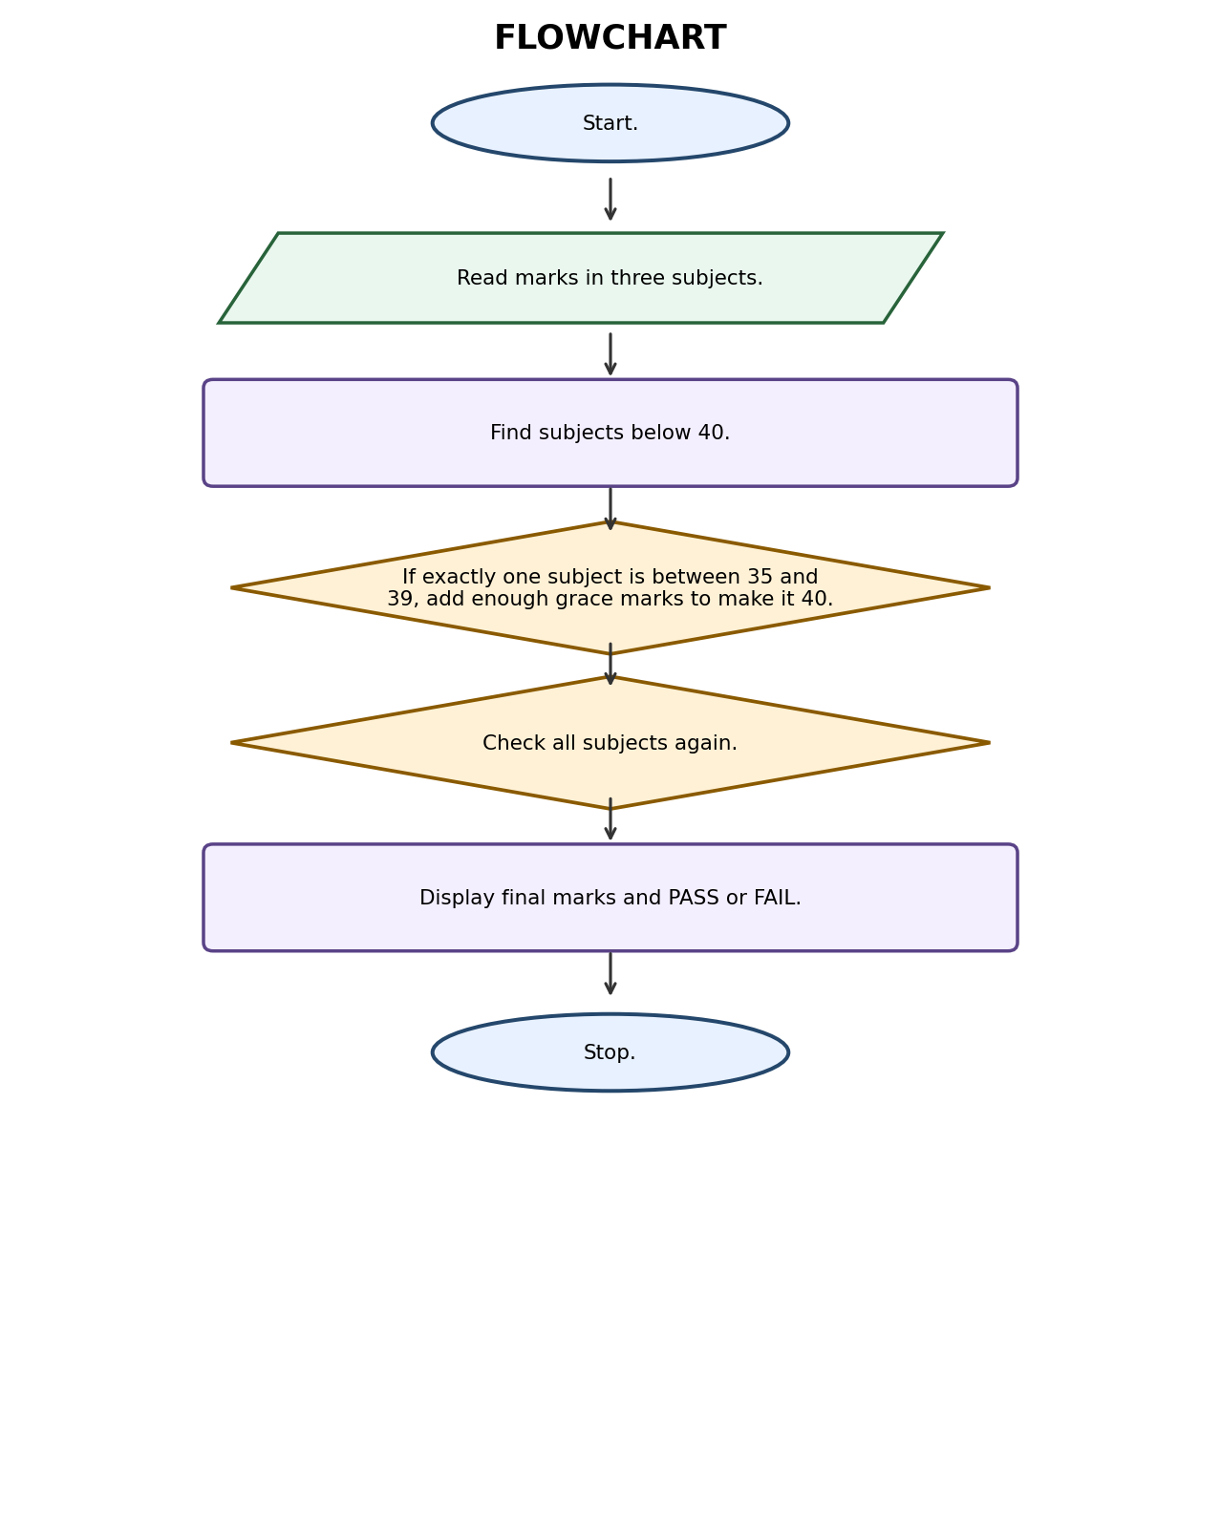
Algorithm steps:
- Start.
- Read marks in three subjects.
- Find subjects below 40.
- If exactly one subject is between 35 and 39, add enough grace marks to make it 40.
- Check all subjects again.
- Display final marks and PASS or FAIL.
- Stop.

5. Pseudocode
BEGIN
INPUT marks for 3 subjects
failed = subjects with marks < 40
IF number of failed subjects = 1 AND failed mark >= 35 THEN
add grace marks to make it 40
END IF
IF every mark >= 40 THEN
result = PASS
ELSE
result = FAIL
END IF
DISPLAY marks and result
END

Python Source Code
- 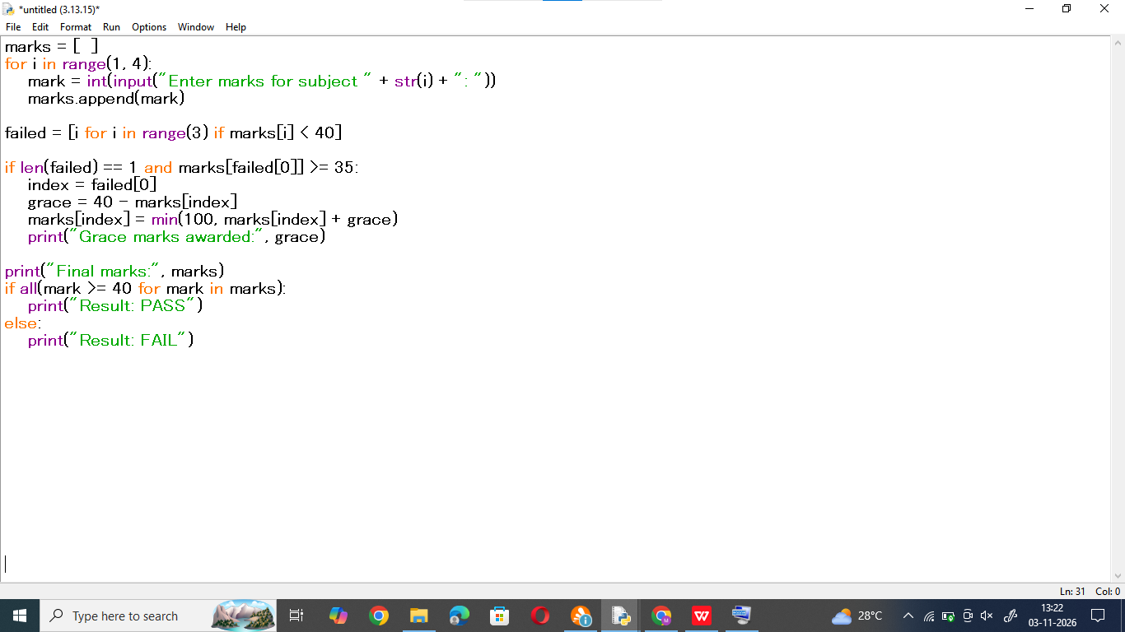

7. Test Cases
Input / Test | Expected result
Marks: 45, 38, 67 | Grace=2; final marks=[45, 40, 67]; PASS
Marks: 32, 38, 67 | Two failed subjects; FAIL

8. Sample Output Screenshot
Illustrative terminal-style output for the sample test:
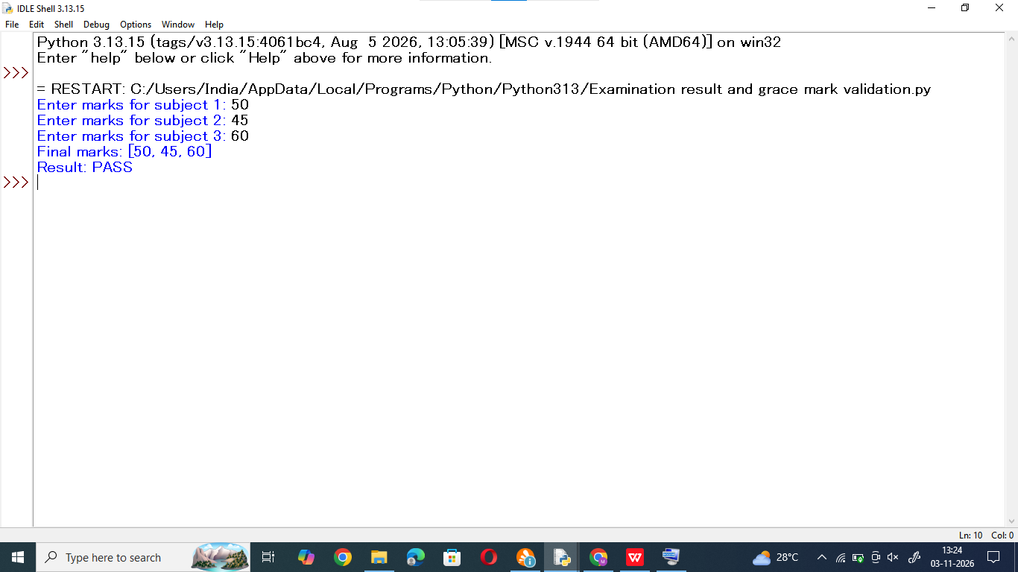

9. Conclusion
The program uses lists and conditional statements to apply a simple grace-mark policy and decide the examination result.

Case Study 4: ATM Transaction Sequence Simulation
Selected from original case-study number 13.

1. Problem Statement
Develop a simple ATM simulation that processes deposits and withdrawals, maintains the account balance, rejects invalid withdrawals and displays the final balance.

2. Objectives
- Perform deposit and withdrawal operations.
- Prevent withdrawals greater than the available balance.
- Show the final account balance.

3. Assumptions
- Opening balance is Rs. 5,000.
- The user enters D for deposit or W for withdrawal.
- Each withdrawal is limited to Rs. 10,000 and cannot exceed the balance.
- Enter X to finish transactions.

4. Algorithm (Diagram / Flowchart)
The following diagram shows the main steps of the algorithm.
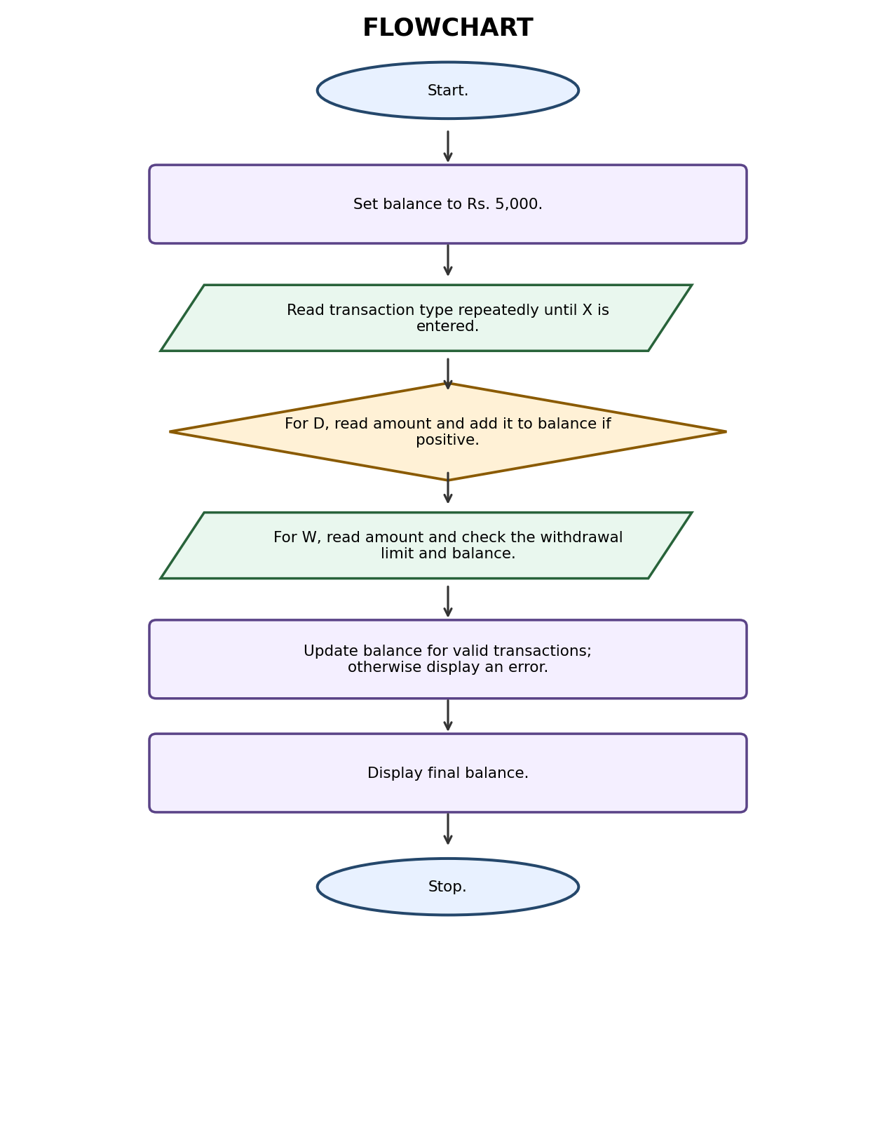
Algorithm steps:
- Start.
- Set balance to Rs. 5,000.
- Read transaction type repeatedly until X is entered.
- For D, read amount and add it to balance if positive.
- For W, read amount and check the withdrawal limit and balance.
- Update balance for valid transactions; otherwise display an error.
- Display final balance.
- Stop.

5. Pseudocode
BEGIN
balance = 5000
INPUT transaction_type
WHILE transaction_type != X
IF type = D THEN
INPUT amount
IF amount > 0: balance = balance + amount
ELSE IF type = W THEN
INPUT amount
IF amount > 0 AND amount <= 10000 AND amount <= balance
balance = balance - amount
ELSE DISPLAY invalid transaction
END IF
INPUT next transaction_type
END WHILE
DISPLAY balance
END

Python Source Code
- 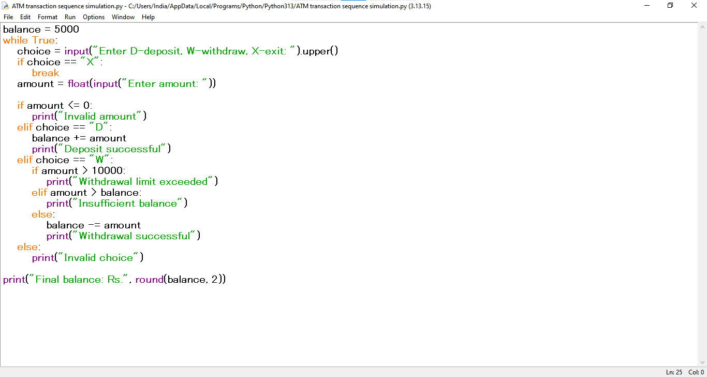

7. Test Cases
Input / Test | Expected result
Deposit 2000; withdraw 1500; exit | Final balance=Rs. 5500.00
Withdraw 7000 from opening balance | Insufficient balance; balance remains Rs. 5000

8. Sample Output Screenshot
Illustrative terminal-style output for the sample test:
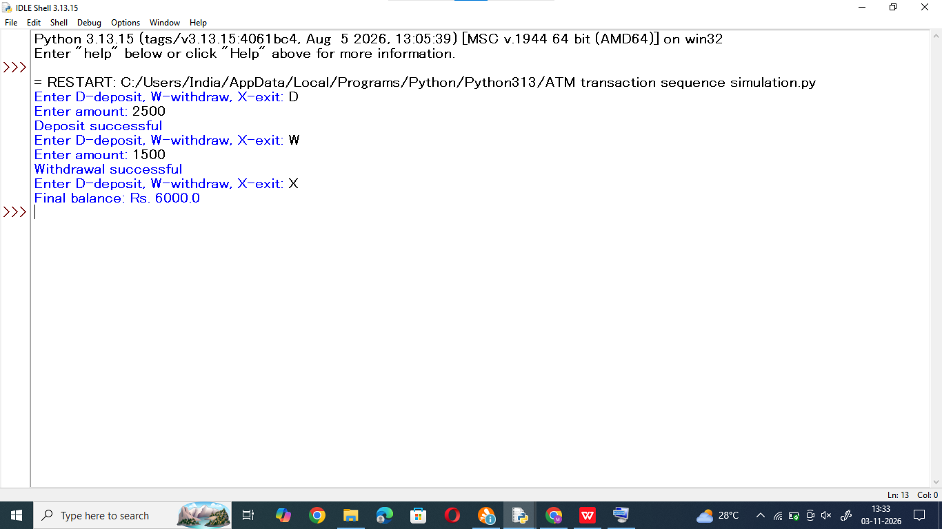

9. Conclusion
The ATM simulation demonstrates loops, selection statements and balance updates while checking transaction limits.

Case Study 5: Smart Parking Fee Management
Selected from original case-study number 15.

1. Problem Statement
Create a parking fee calculator that reads the number of hours a vehicle is parked and calculates the parking charge based on a simple hourly rate.

2. Objectives
- Accept parking duration and vehicle category.
- Calculate parking charges.
- Apply a maximum daily charge.

3. Assumptions
- Car parking costs Rs. 30 per hour.
- Bike parking costs Rs. 15 per hour.
- Any part of an hour is charged as a full hour.
- Maximum charge is Rs. 200 for a car and Rs. 100 for a bike per day.

4. Algorithm (Diagram / Flowchart)
The following diagram shows the main steps of the algorithm.
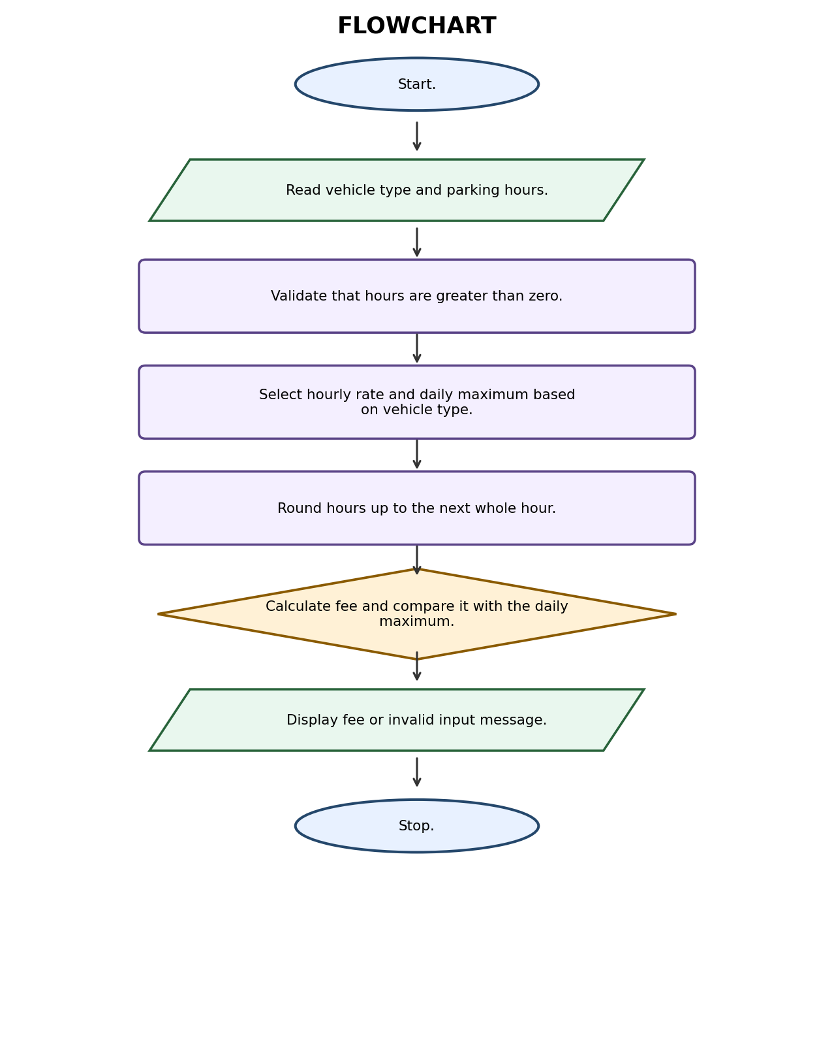
Algorithm steps:
- Start.
- Read vehicle type and parking hours.
- Validate that hours are greater than zero.
- Select hourly rate and daily maximum based on vehicle type.
- Round hours up to the next whole hour.
- Calculate fee and compare it with the daily maximum.
- Display fee or invalid input message.
- Stop.

5. Pseudocode
BEGIN
INPUT vehicle_type, hours
IF hours <= 0 THEN DISPLAY invalid input
ELSE
IF vehicle_type = CAR: rate=30, limit=200
ELSE IF vehicle_type = BIKE: rate=15, limit=100
ELSE DISPLAY invalid vehicle
charged_hours = ceiling(hours)
fee = charged_hours * rate
IF fee > limit: fee = limit
DISPLAY fee
END IF
END

6. Python Source Code

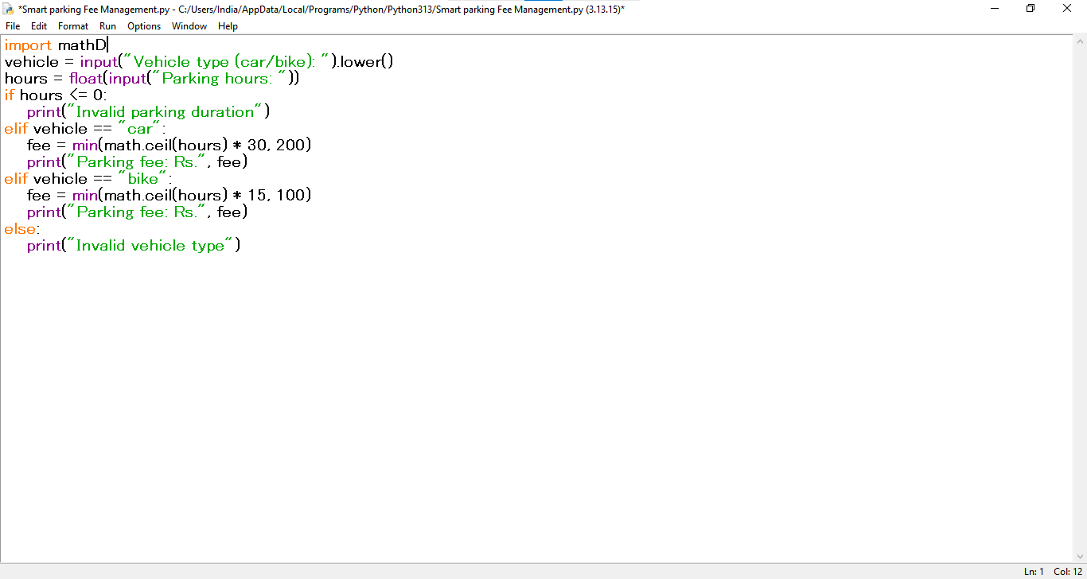7. Test Cases
Input / Test | Expected result
car, 3.5 hours | 4 charged hours × Rs.30 = Rs.120
bike, 9 hours | Rs.100 (daily maximum)

8. Sample Output Screenshot
Illustrative terminal-style output for the sample test:
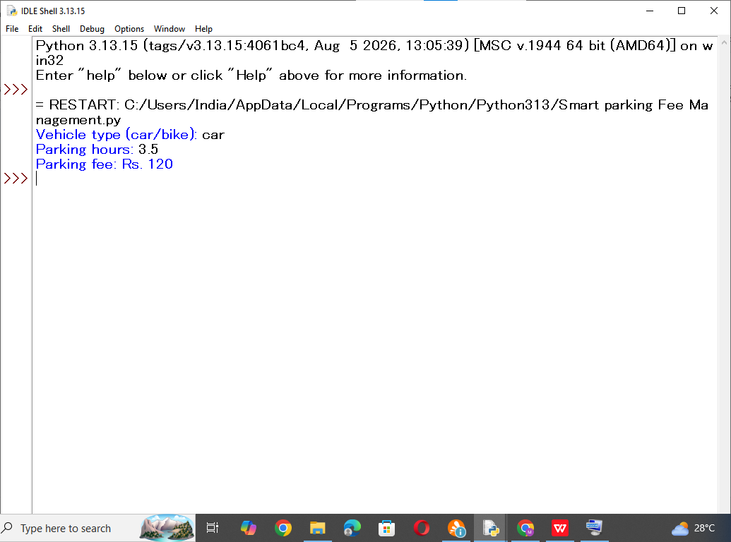

9. Conclusion
The program calculates parking fees using conditions, mathematical rounding and a maximum daily charge.

Case Study 6: Fuel Consumption and Route Comparison
Selected from original case-study number 18.

1. Problem Statement
Write a program to compare the fuel cost of different vehicles for a journey using distance, mileage and fuel price, and identify the lowest-cost vehicle.

2. Objectives
- Calculate fuel required for each vehicle.
- Calculate journey cost.
- Identify the vehicle with the lowest fuel cost.

3. Assumptions
- The same journey distance and fuel price apply to all vehicles.
- Mileage is entered in kilometres per litre.
- Fuel cost is distance divided by mileage multiplied by fuel price.
- At least one vehicle is entered.

4. Algorithm (Diagram / Flowchart)
The following diagram shows the main steps of the algorithm.
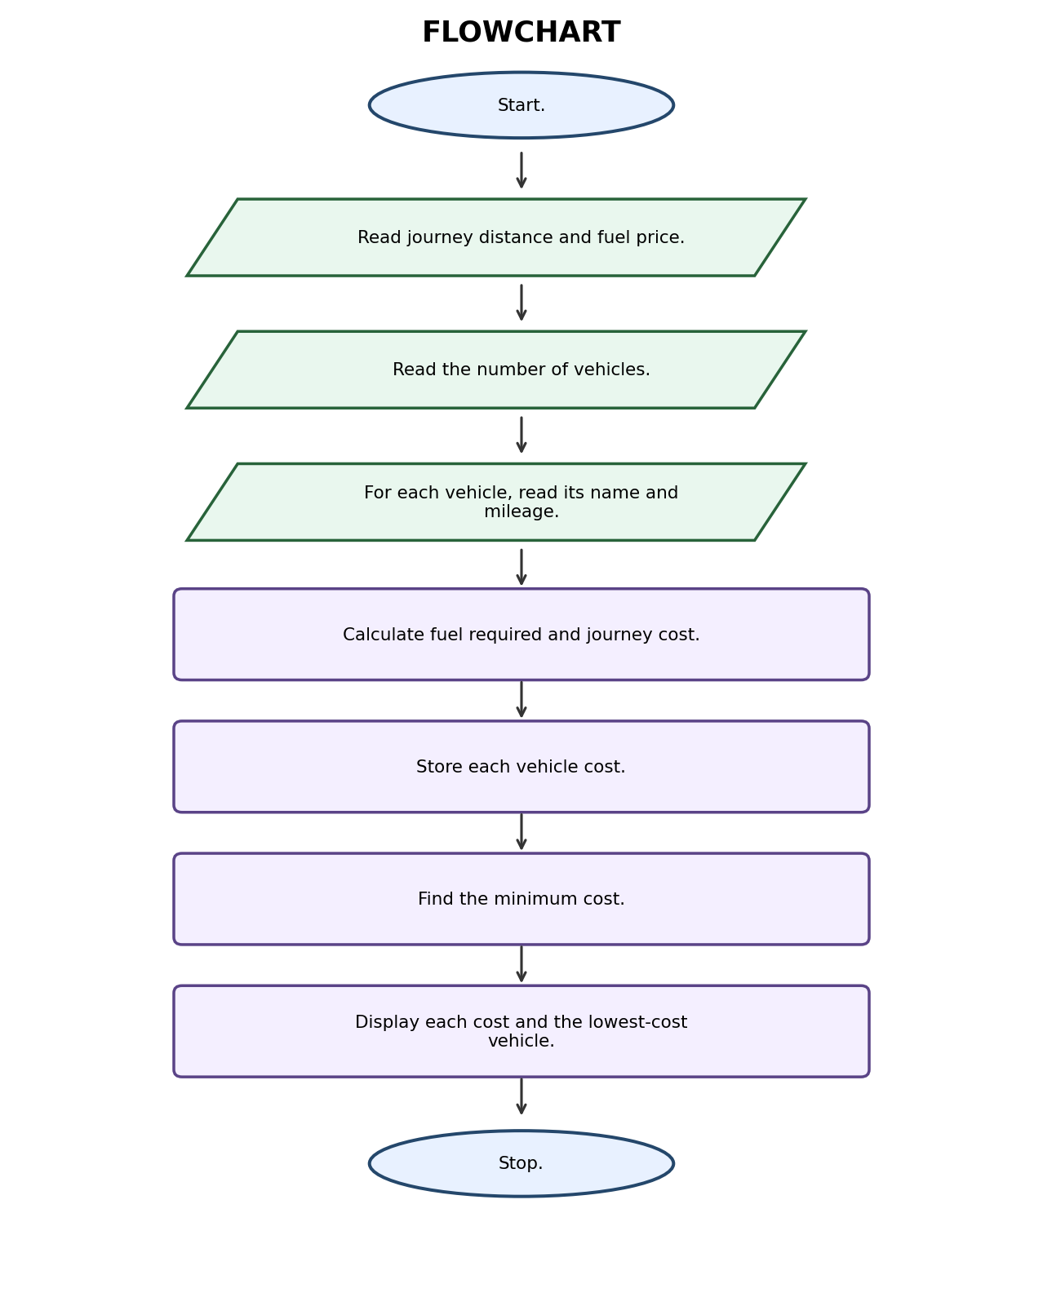
Algorithm steps:
- Start.
- Read journey distance and fuel price.
- Read the number of vehicles.
- For each vehicle, read its name and mileage.
- Calculate fuel required and journey cost.
- Store each vehicle cost.
- Find the minimum cost.
- Display each cost and the lowest-cost vehicle.
- Stop.

5. Pseudocode
BEGIN
INPUT distance, fuel_price, number_of_vehicles
FOR each vehicle
INPUT name, mileage
fuel = distance / mileage
cost = fuel * fuel_price
STORE name and cost
END FOR
best = vehicle with minimum cost
DISPLAY all costs and best vehicle
END

Python Source Code
- 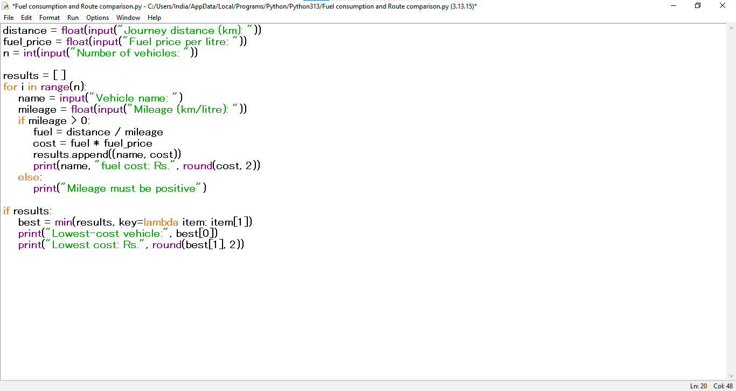

7. Test Cases
Input / Test | Expected result
Distance=300 km, fuel=Rs.100, car mileage=15, bike mileage=30 | Car cost=Rs.2000; bike cost=Rs.1000; bike is lowest cost

8. Sample Output Screenshot
Illustrative terminal-style output for the sample test:
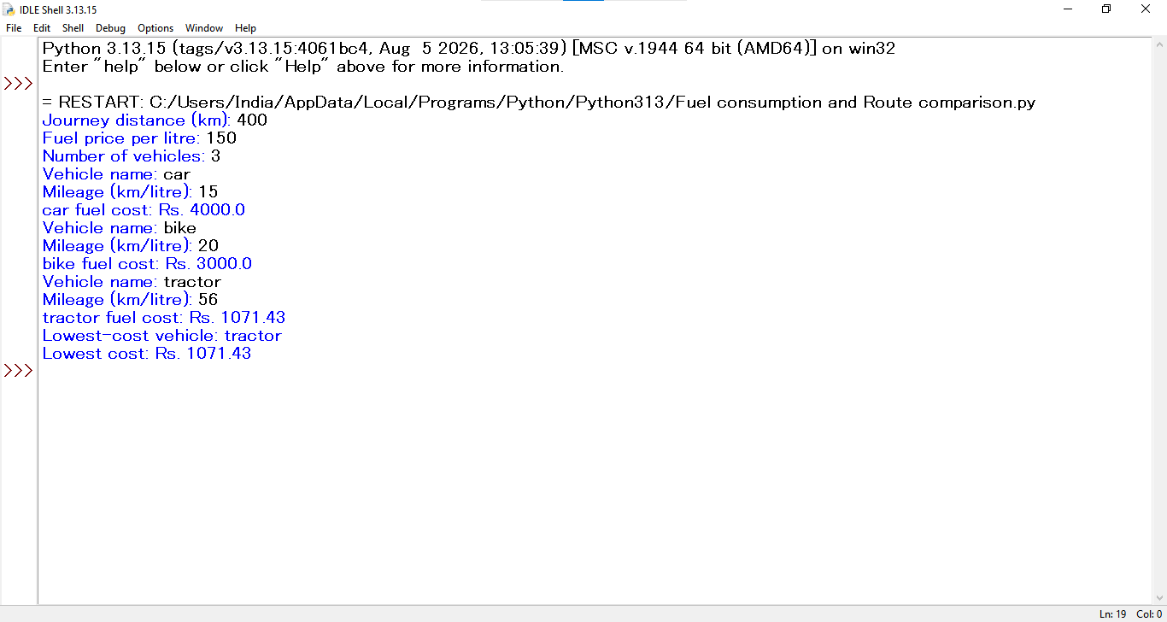

9. Conclusion
The program uses loops, tuples and the minimum function to compare vehicle fuel costs and select the economical option.

Case Study 7: Password Policy Validation Engine
Selected from original case-study number 29.

1. Problem Statement
Develop a Python program to check whether a password follows basic security rules such as minimum length, uppercase letter, lowercase letter, digit and special character.

2. Objectives
- Check the length of a password.
- Check required character types.
- Display whether the password is valid and list missing rules.

3. Assumptions
- A valid password must contain at least 8 characters.
- It must contain one uppercase letter, one lowercase letter, one digit and one special character.
- Whitespace is not accepted as a special character.

4. Algorithm (Diagram / Flowchart)
The following diagram shows the main steps of the algorithm.
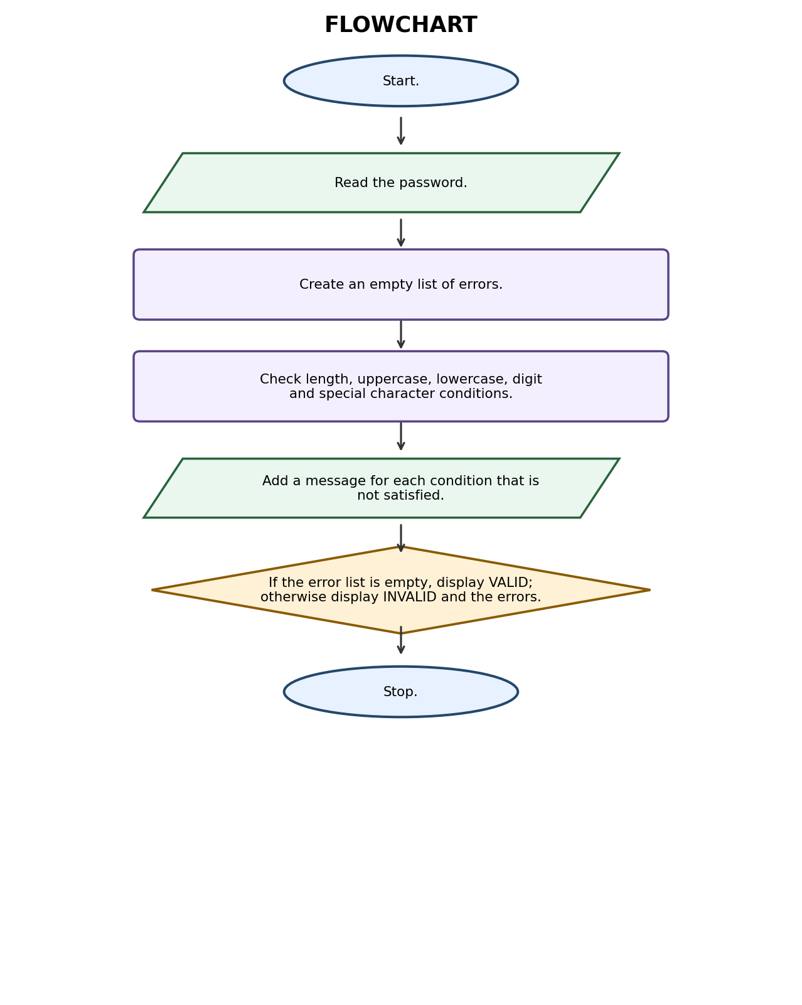
Algorithm steps:
- Start.
- Read the password.
- Create an empty list of errors.
- Check length, uppercase, lowercase, digit and special character conditions.
- Add a message for each condition that is not satisfied.
- If the error list is empty, display VALID; otherwise display INVALID and the errors.
- Stop.

5. Pseudocode
BEGIN
INPUT password
errors = empty list
IF length < 8: add length error
IF no uppercase: add uppercase error
IF no lowercase: add lowercase error
IF no digit: add digit error
IF no special character: add special-character error
IF errors is empty: DISPLAY VALID
ELSE DISPLAY INVALID and errors
END

Python Source Code
- 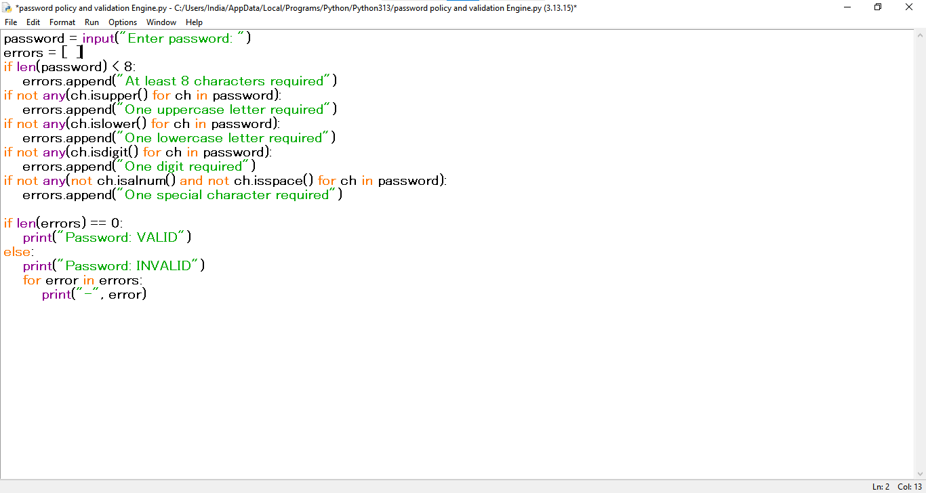

7. Test Cases
Input / Test | Expected result
Abc@1234 | VALID
hello123 | INVALID: uppercase and special character required

8. Sample Output Screenshot
Illustrative terminal-style output for the sample test:
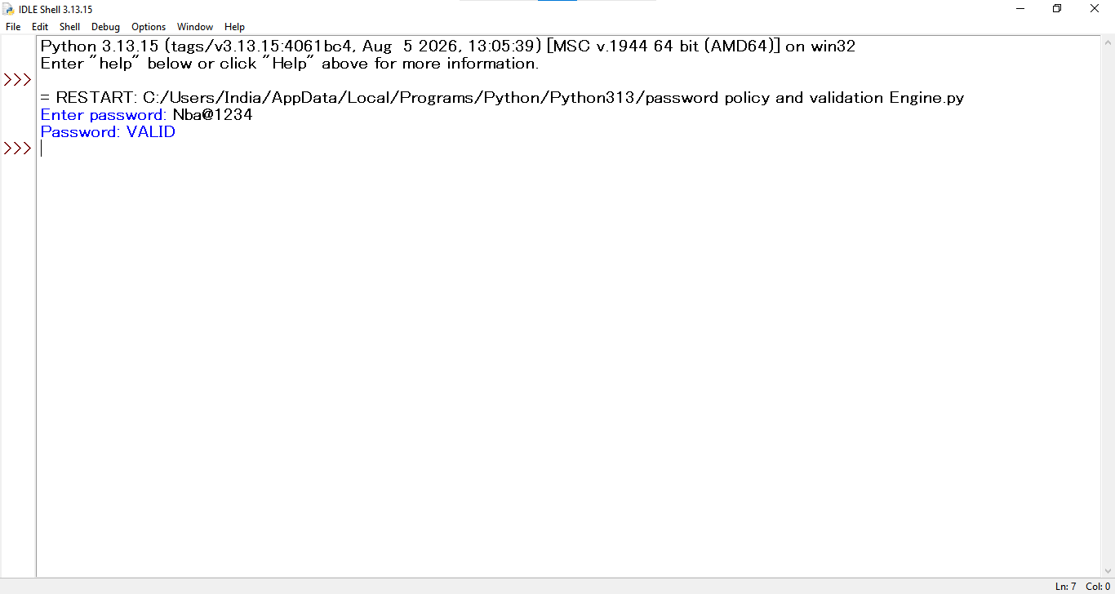

9. Conclusion
The program uses string methods, loops and conditional statements to validate a password against a set of rules.

Case Study 8: Student Feedback Sentiment Scoring
Selected from original case-study number 34.

1. Problem Statement
Create a program that analyses student feedback sentences using positive and negative keywords, calculates a score and classifies the feedback.

2. Objectives
- Read feedback text.
- Count positive and negative keywords.
- Calculate a sentiment score and classify feedback.

3. Assumptions
- The positive words are good, excellent, helpful and interesting.
- The negative words are bad, poor, difficult and boring.
- Each matching word adds one positive or negative point.
- A score above zero is Positive, below zero is Negative, and zero is Neutral.

4. Algorithm (Diagram / Flowchart)
The following diagram shows the main steps of the algorithm.
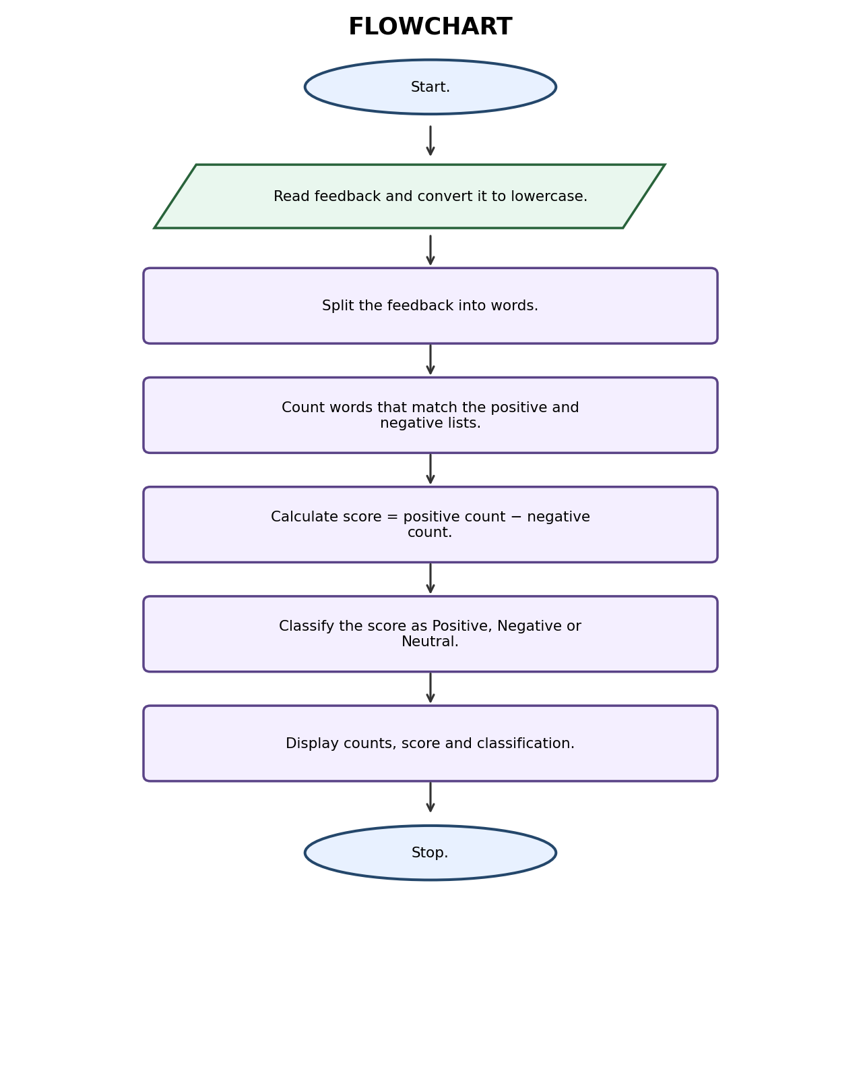
Algorithm steps:
- Start.
- Read feedback and convert it to lowercase.
- Split the feedback into words.
- Count words that match the positive and negative lists.
- Calculate score = positive count − negative count.
- Classify the score as Positive, Negative or Neutral.
- Display counts, score and classification.
- Stop.

5. Pseudocode
BEGIN
INPUT feedback
words = lowercase feedback split into words
positive_words = [good, excellent, helpful, interesting]
negative_words = [bad, poor, difficult, boring]
positive_count = number of matching positive words
negative_count = number of matching negative words
score = positive_count - negative_count
IF score > 0: sentiment = Positive
ELSE IF score < 0: sentiment = Negative
ELSE: sentiment = Neutral
DISPLAY counts, score, sentiment
END
- Python Source Code
- 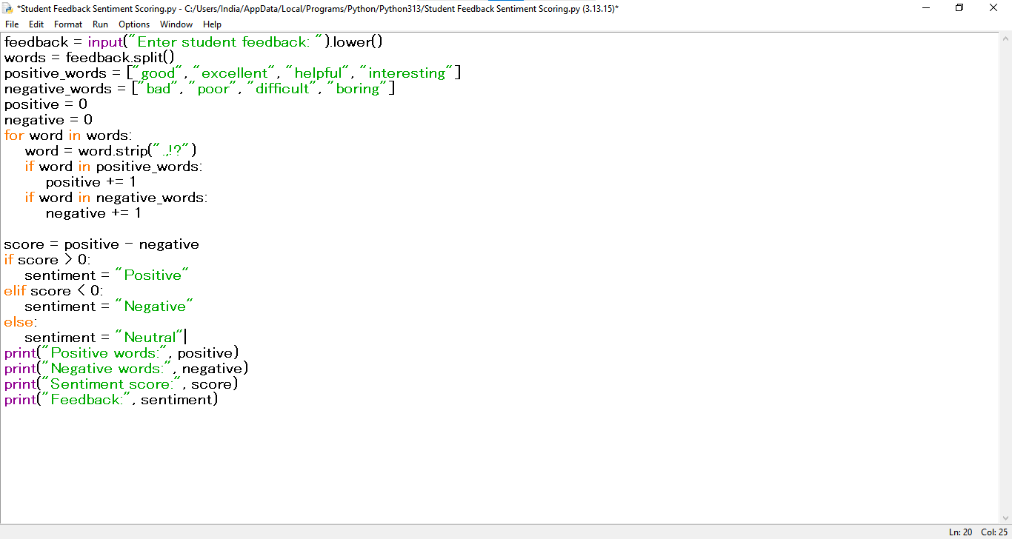

7. Test Cases
Input / Test | Expected result
The class is good and helpful | Positive=2; negative=0; score=2; Positive
The topic is difficult and boring | Positive=0; negative=2; score=-2; Negative

8. Sample Output Screenshot
Illustrative terminal-style output for the sample test:
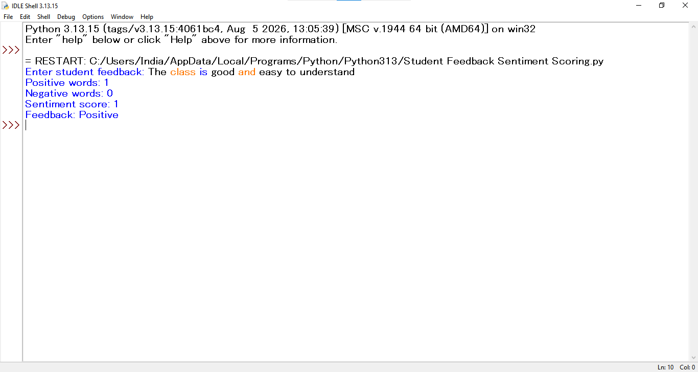

9. Conclusion
The program performs simple keyword-based sentiment analysis using strings, lists, loops and if-elif-else statements.

Case Study 9: Student Marks Matrix Analysis
Selected from original case-study number 42.

1. Problem Statement
Write a program to analyse marks stored in a nested list. Calculate each student's total and average, calculate subject averages and identify the highest total.

2. Objectives
- Store marks in a nested list.
- Calculate student-wise totals and averages.
- Calculate subject-wise averages and identify the top student.

3. Assumptions
- Three students and three subjects are used in the sample.
- Every mark is out of 100.
- Each row represents one student and each column represents one subject.
- The subjects are Maths, Physics and Programming.

4. Algorithm (Diagram / Flowchart)
The following diagram shows the main steps of the algorithm.
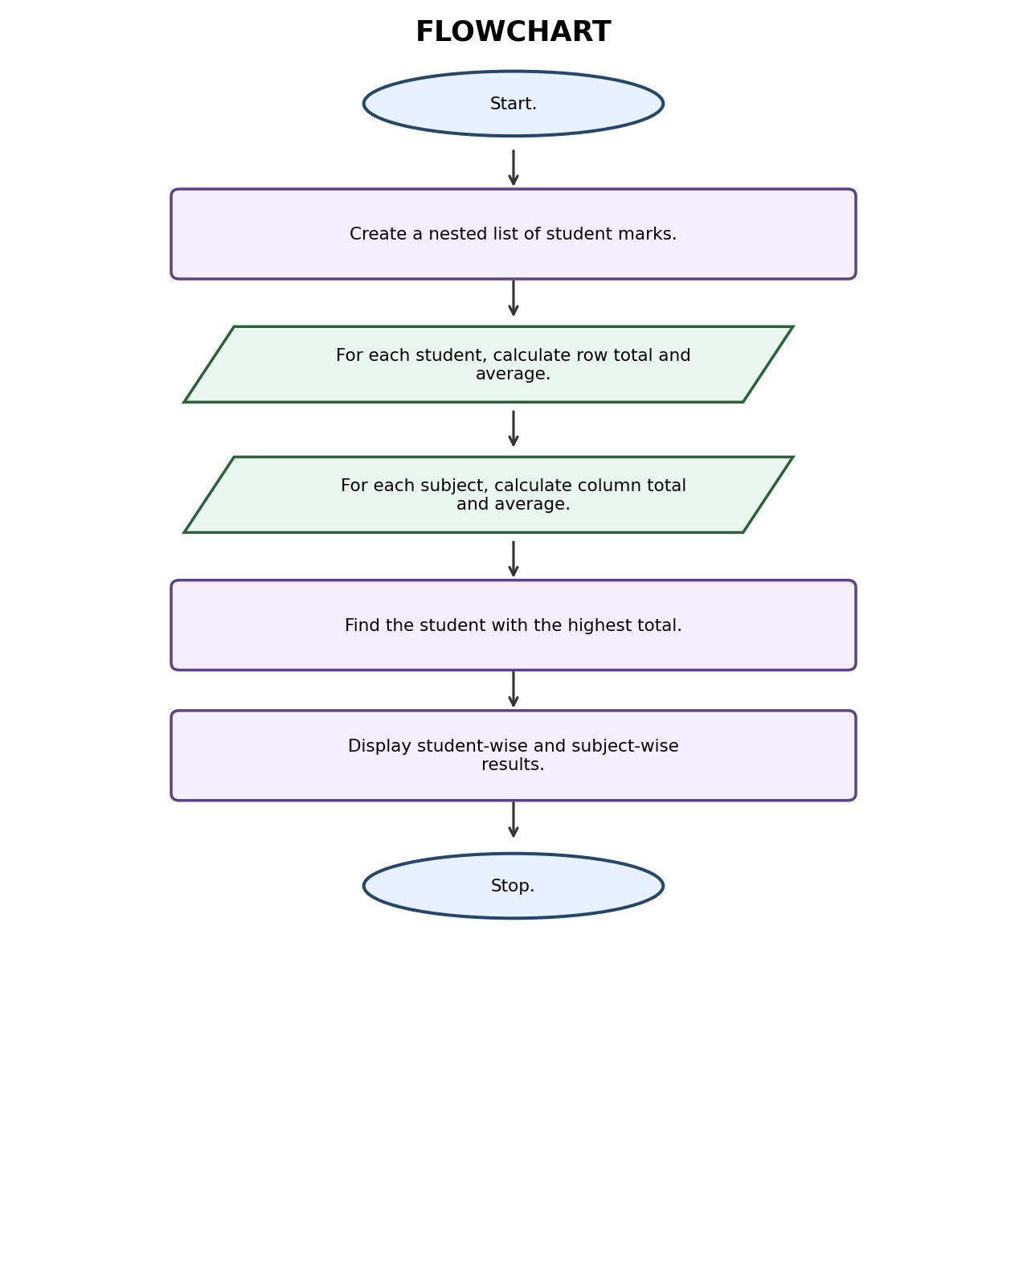
Algorithm steps:
- Start.
- Create a nested list of student marks.
- For each student, calculate row total and average.
- For each subject, calculate column total and average.
- Find the student with the highest total.
- Display student-wise and subject-wise results.
- Stop.

5. Pseudocode
BEGIN
marks = nested list of student marks
FOR each student row
total = sum(row)
average = total / number of subjects
DISPLAY total and average
END FOR
FOR each subject column
subject_total = sum of that column
subject_average = subject_total / number of students
DISPLAY subject_average
END FOR
top_index = index of maximum row total
DISPLAY top student
END

Python Source Code
- 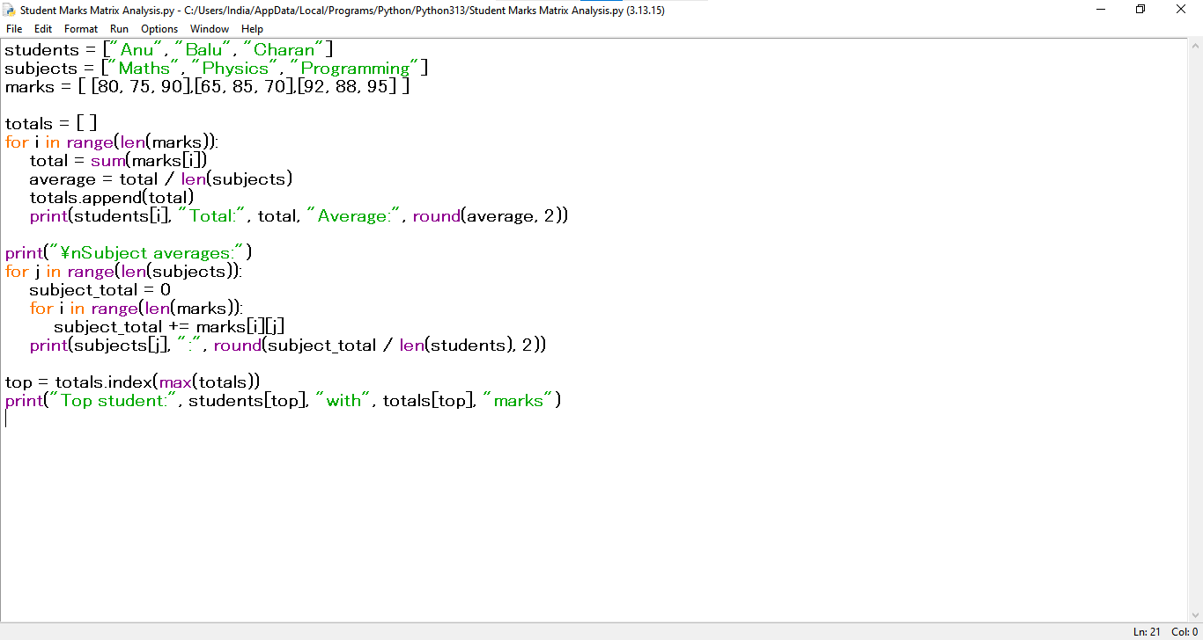

7. Test Cases
Input / Test | Expected result
Rows: [80,75,90], [65,85,70], [92,88,95] | Totals=245,220,275; top student=Charan; subject averages=79.00,82.67,85.00

8. Sample Output Screenshot
Illustrative terminal-style output for the sample test:
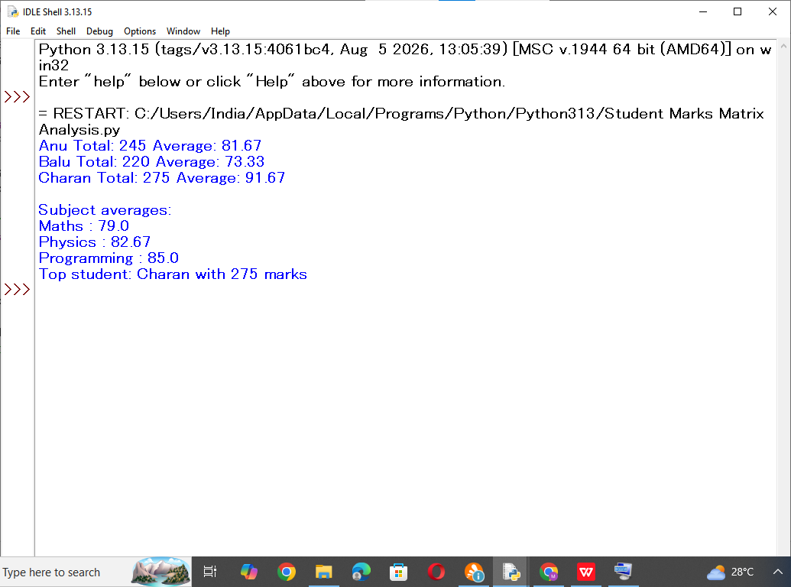

9. Conclusion
The program demonstrates nested lists and nested loops to calculate row-wise and column-wise statistics.

Case Study 10: Food Waste Monitoring System
Selected from original case-study number 53.

1. Problem Statement
Develop a program to compare the number of meals prepared, served and left over across several days. Calculate wastage percentage and identify days exceeding the allowed limit.

2. Objectives
- Record meals prepared and served.
- Calculate leftover meals and wastage percentage.
- Identify days with high food wastage.

3. Assumptions
- The sample monitors three days.
- Meals prepared must be greater than zero.
- Wastage percentage = leftover meals ÷ prepared meals × 100.
- A day is flagged when wastage is greater than 10%.

4. Algorithm (Diagram / Flowchart)
The following diagram shows the main steps of the algorithm.
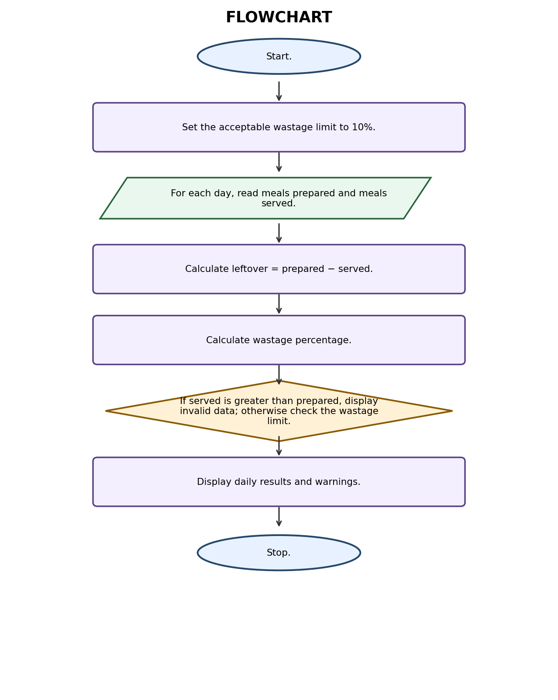
Algorithm steps:
- Start.
- Set the acceptable wastage limit to 10%.
- For each day, read meals prepared and meals served.
- Calculate leftover = prepared − served.
- Calculate wastage percentage.
- If served is greater than prepared, display invalid data; otherwise check the wastage limit.
- Display daily results and warnings.
- Stop.

5. Pseudocode
BEGIN
limit = 10
FOR each day
INPUT prepared, served
IF prepared <= 0 OR served < 0 OR served > prepared
DISPLAY invalid data
ELSE
leftover = prepared - served
wastage = leftover / prepared * 100
DISPLAY leftover and wastage
IF wastage > limit: DISPLAY high wastage warning
END IF
END FOR
END

6. Python Source Code

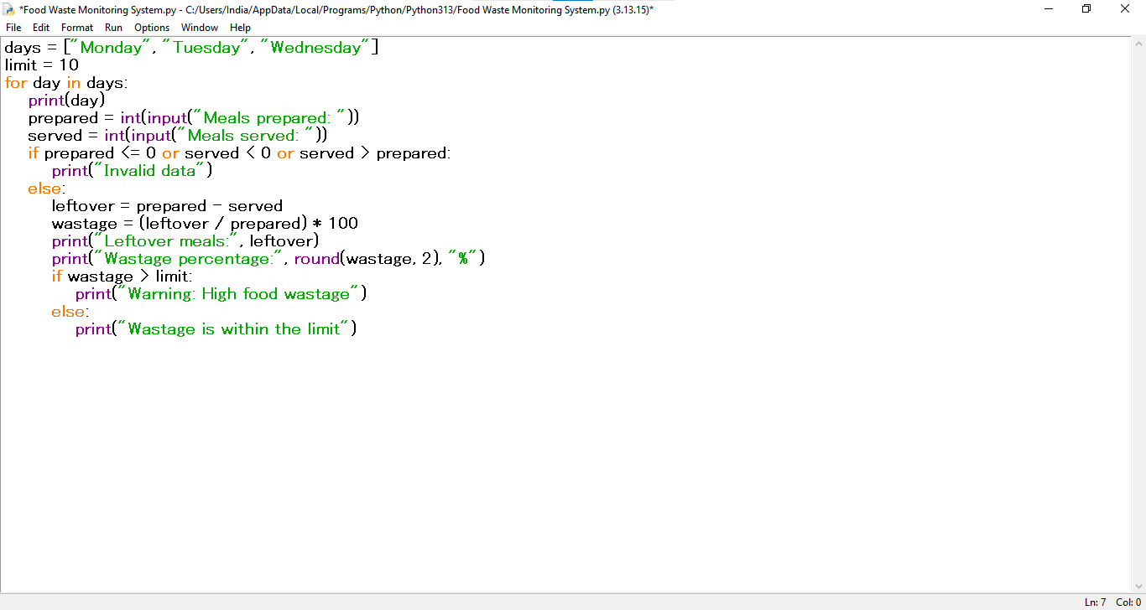7. Test Cases
Input / Test | Expected result
Prepared=100, served=85 | Leftover=15; wastage=15%; high wastage warning
Prepared=100, served=95 | Leftover=5; wastage=5%; within limit

8. Sample Output Screenshot
Illustrative terminal-style output for the sample test:
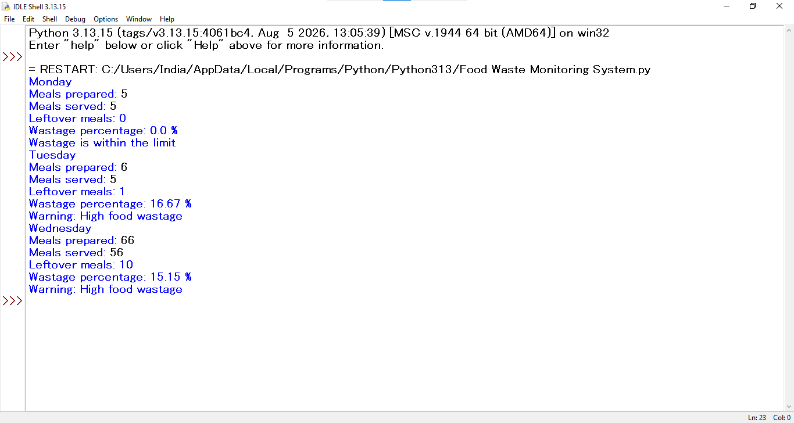

9. Conclusion
The program calculates food wastage percentages and identifies days that exceed the allowed limit using arithmetic and conditional statements.

