LAB NO 10
Obscuring Sensitive regions in video frames

Aim
To obscure sensitive regions in video frames using blurring techniques with OpenCV in Google Colab.

Requirements
- Google account
- Internet connection
- Input video file (samples_data_vtest.mp4)
- OpenCV library

Procedure
Step 1: Open Google Colab
- Go to: https://colab.research.google.com
- Click New Notebook

Step 2: Install Required Library
!pip install opencv-python-headless

Step 3: Upload Video
from google.colab import files
files.upload()
- Select video from your system

Step 4: Import Libraries
import cv2
from google.colab import files

Step 5: Video Processing Code
video_path = "samples_data_vtest.mp4"
output_path = "output.mp4"

cap = cv2.VideoCapture(video_path)

width = int(cap.get(3))
height = int(cap.get(4))

fps = cap.get(cv2.CAP_PROP_FPS)
if fps == 0:
fps = 20

out = cv2.VideoWriter(output_path, cv2.VideoWriter_fourcc(*'mp4v'), fps, (width, height))

while True:
ret, frame = cap.read()
if not ret:
break

# Blur sensitive region (center area)
h, w, _ = frame.shape
x, y = w//3, h//3

frame[y:y+200, x:x+300] = cv2.GaussianBlur(frame[y:y+200, x:x+300], (51,51), 0)

out.write(frame)

cap.release()
out.release()

print("Processing Completed")

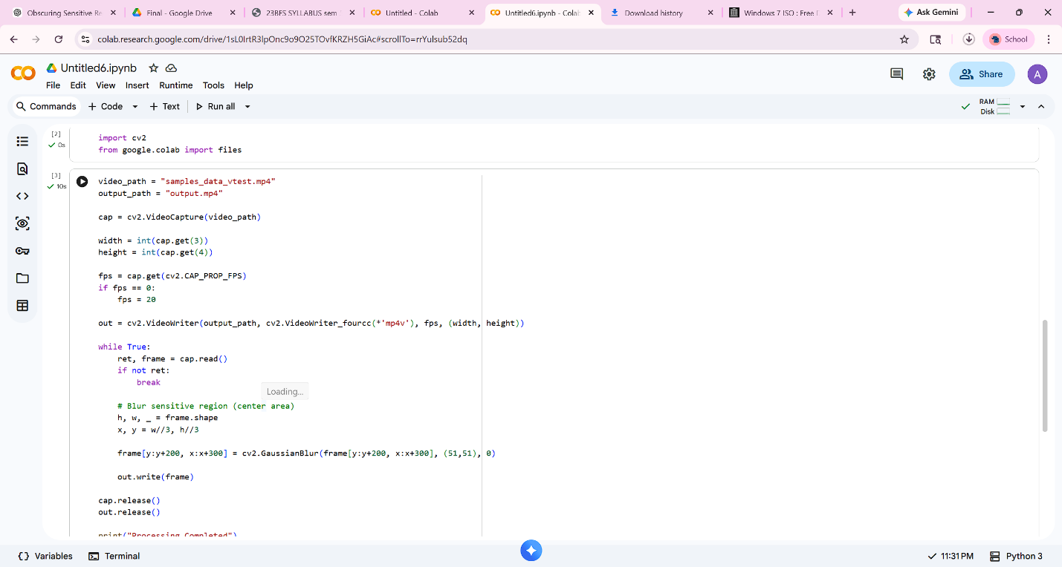
Step 6: Download Output
files.download("output.mp4")
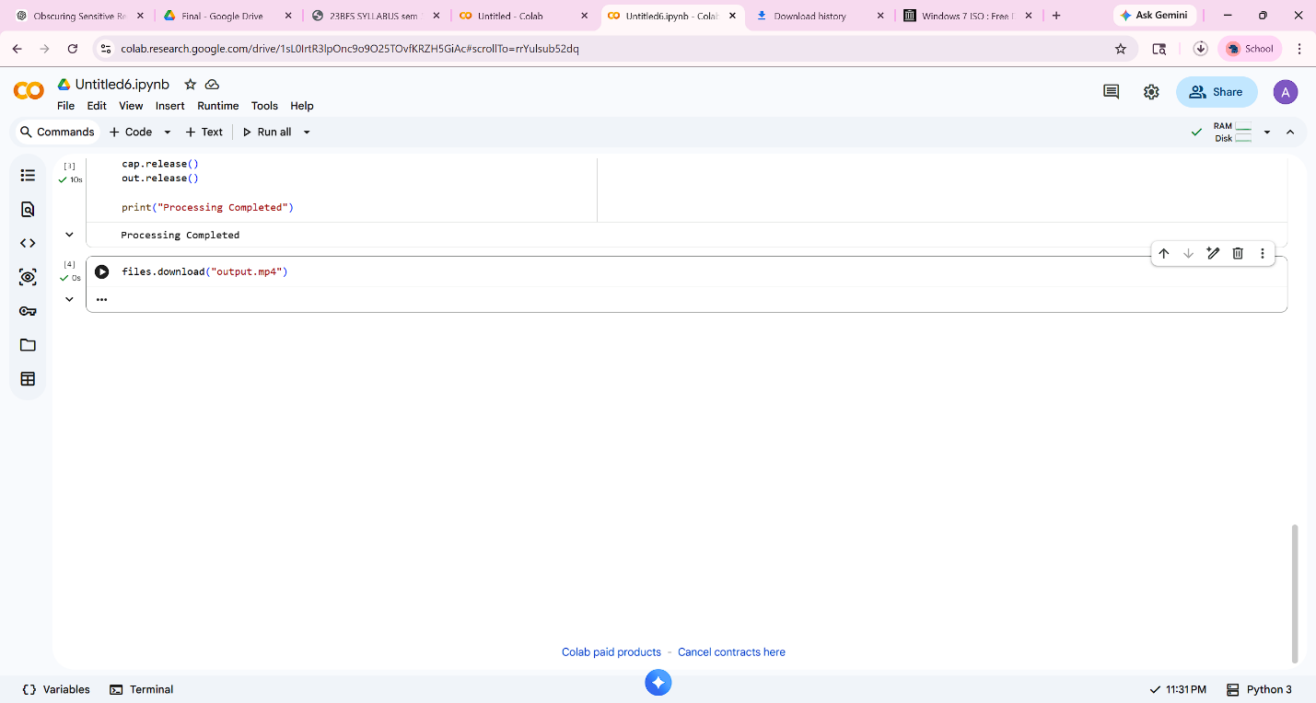

Output
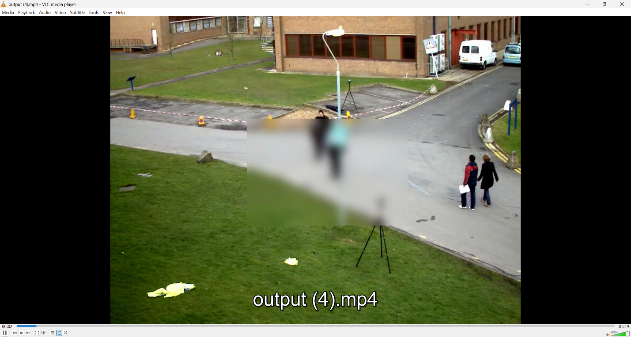
- Processed video (output.mp4)
- A blurred rectangular region visible in the center of each frame

Result
Sensitive regions in the video frames were successfully obscured using region-based Gaussian blurring technique.

Conclusion
The experiment successfully demonstrated how sensitive regions in video frames can be obscured using OpenCV in a free cloud environment.

