**VGG-NETWORK BASED DEEP CONVOLUTED FACIAL RECOGNITION**

Shruti Bhargava Choubey1, K. Praveen kumar2, K. Vinay kumar3, MD. Abu Sufian4

1Associate professor, ECE department, Sreenidhi institute of Science and Technology, Yamnampet, Medchal

2B.tech 4th year, ECE department, Sreenidhi institute of Science and Technology, Yamnampet, Medchal

3B.tech 4th year, ECE department, Sreenidhi institute of Science and Technology, Yamnampet, Medchal

4B.tech 4th year, ECE department, Sreenidhi institute of Science and Technology, Yamnampet, Medchal

**ABSTRACT:**

Recently Convolution neural network of Deep Learning provided promising results in the development of facial recognition. However, there are no certain techniques which prove its greater ability to perform these tasks. The question about How to create a good architecture still remains as unanswered. The studies only depict us the results they are producing but no the process going on backend. In this paper we designed a model in which the tasks are easily replicated any number of times. Convolution neural networks work better for facial recognition system. We call it as CNN-FRS. Generally, there are methods which train the model by using private database but here we are using a public database LFW (labeled faces in the wild) contradictory to it. We propose 3 CNN architectures which are trained using these LFW, these are compared against each other and evaluates the effect of each architecture.

**Keywords:** Convolution neural networks, LFW, backend, Facial recognition;

1. **INTRODUCTION:**

Due to increase in usage of biometrics for several applications human face recognition has become a challenging task to the computer vision as the pose, illumination and other factors vary from inbuilt data.

In recent years deep learning became the most useful technique to obtain this method as it takes raw data and convolve them into multiple levels which are used in detecting high-level or low-level data representation from labeled or unlabeled data for determining and distinguishing their underlying patterns. Optimizing these millions of parameters by deep learning require millions of training samples and usage of high computational hardware such as Graphical Processing unit (GPU).

Transfer learning can be obtained in two different approaches. The first approach is fine tuning the pre trained data set with a new set using back propagation. This method is best for large datasets since fine-tuning with fewer samples may lead to over fitting. In second approach, the learned weights are directly extracted to classify features.

In this paper, the higher layer portion of the learned weights is pre-trained over a larger dataset for facial recognition. They are extracted using two deep convolutional neural networks of FGG face and Lightened CNN. We selected the above two methods as they proved to be most successful in facial recognition.

1. **LITERATURE SURVEY:**

The article named “Robust Realtime Object Detection” is very most every now and again refered to article in a progression of article’s by “Viola” which makes face discovery genuinely useful. We can find out around a few face discovery techniques and calculation’s from the above distribution. The article named “Fast revolution in-variant multisee face identification” dependend’s on the genuine adaboost just because genuine adaboost applied to question recognition, and proposed an increasingly develop and functionalamultiface location ,home structured referenced on a course structure upgrades likewise have great outcomes.

More than 3 paper’s have examined about a face location and the face tracking issues. As indicated by the exploration bring about these papers, we can make constant face identification frameworks. The important feature is to detect size and the position of face in the video or image but in regard to tracking it is important to determine the similarity between the faces in the casing.

1. **PROPOSED TECHNOLOGY**

The main theme of this paper is face recognition using deep Learning. In this we are using Convolutional Neural Networks this is one of the most popular deep learning architecture. People are showing more interest in Deep learning because of its effectiveness and popularity. In this first there will be an input image with which we are working. We will perform a series of convolution then followed by Pooling.

**FLOW CHART:**

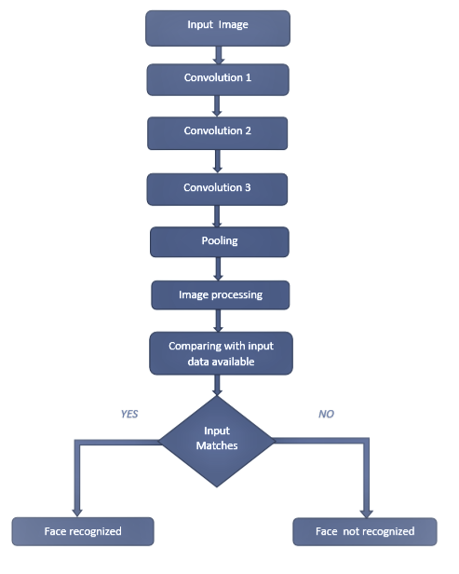

**CONVOLUTION:**

The main block of CNN is convolutional layer; convolution in mathematical terms is merging the two information sets, and where as coming to our case convolution will be applied on the input with the help of the convolution filter to produce a feature map. One of the important point is that wee will perform the multiple convolutions by using different types of filters which results in different feature maps. Let us assume that we have a image of size 32*32*32 and the filter of size 5*5*3 if we carefully observe the depth of the filter and the image matches. Now the convolution can be performed by sliding the filter on the input image . We have to use different filters for different convolutions which results in different feature maps

**POOLING:**

The second step we perform here is pooling this is done to reduce the dimensions. Pooling layer will down sample each feature map and it reduces the height and the width keeping the depth same. There are different types of pooling out of which we have selected the max pooling. In this it will select the maximum value from each feature map and so the size of the image is reduced.

In the next step face extraction is done and next the image is processed and next the input image is compared with the datasets.

So with the help of deep learning that is by performing series of convolution and pooling we can recognize the face.

**ALGORITHMS USED:**

We are defining two approaches in this paper the first one is the Convolution neural network and the second is based on two models

**VGG-FACE NETWORK:**

This network contains sixteen CNN layers and 3 fully connected layers and five max pooling layers. This takes the input image and utilizes regularization in the fully connected networks. We have evaluated this method based on the LFW datafile and we have achieved an accuracy of 97.66%

**LIGHTENED CNN**:

Mostly CNN is used for the facial recognition techniques. Here we introduce the maxout concept from fully connected layer to convolution layer ,this leads to a new function named “Max Feature Map”(MFM). If we compare this with ReLU MFM can catch competitive information and compact representation simultaneously. We have evaluated this method based on the LFW datafile and we have achieved an accuracy of 96.23% .

**Comparison table**

|  |  |  |
| --- | --- | --- |
| **Parameters** | **Existing System** | **Proposed System** |
| Accuracy | 93.16 | 94.02 |
| No. of Layers | 12 | 16 |
| Recognition time | Takes more time | Takes less time |

1. **CONCLUSION AND FUTURE SCOPE:**

We proposed to assemble a superior, adaptable, nimble, and ease facial recognition framework. We differentiated the proposed approach into a few smaller sub-ventures. In the first place, we considered the neural system and convolutional neural system. In the way of obtaining a profound learning method, we used the Siamese system which will prepare the neural networks accordingly. At that point we look at and analyze the accessible open-source informational collection, we picked the ORL dataset and prepared the model using GPU. This model will take a human picture and convert it to a vector. Similarly many vectors are created and these are contrasted with one another to find they both are of the same person.

During the manufacturing of neural system model, there are numerous constraints which are tuned to obtain a model suitable for execution. We can further tune this for better accuracy.

Moreover, for a prepared base model, we can re-train it utilizing a particular dataset. There is another approach to expand the framework operation by catching the individual faces which can go up to 3000 individuals. Which helps in better utilisation. We can use and retrain this component in the framework.

1. **REFERENCES**

[1]  Y. Bengio, J. Louradour, R. Collobert, and J. Weston.Curriculum learning. In Proc. of ICML, New York, NY, USA, 2009. 2

[2] D.Chen, X.Cao, L.Wang, F.Wen, and J. Sun. Bayesian face revisited: A joint formulation. In Proc. ECCV, 2012. 2

[3]  D. Chen, S. Ren, Y. Wei, X. Cao, and J. Sun. Joint cascade face detection and alignment. In Proc. ECCV, 2014. 7

[4]  J. Dean, G. Corrado, R. Monga, K.Chen, M.Devin, M.Mao, M.Ranzato, A.Senior,P.Tuck-er, K.Yang, Q.V.Le, and A.Y.Ng. Large scale distributed deep networks.In P.Bartlett, F.Pereira, C.Burges,L.Bottou, and K. Weinberger, editors, NIPS, pages 1232–1240. 2012. 10

[5] J. Duchi,E.Hazan,andY.Singer. Adaptive

subgradient methods for online learning and stochastic optimization. J. Mach. Learn. Res., 12:2121–2159, July 2011. 4

[6]  I. J. Goodfellow,D.Warde farley, M. Mirza, A. Courville, and Y. Bengio. Maxout netwo-rks. In In ICML, 2013. 4

[7]  G.B.Huang, M.Ramesh, T.Berg, and E. Learned Miller. Labeled faces in the wild: A database for studying face recognition in unconstrained environ-ments. Technical Report 0749,University of Massachusetts, Amherst, October 2007. 5

[8] Y. LeCun, B.Boser, J. S. Denker, D. Henderson, R. E.Howard, W. Hubbard, and L. D. Jackel. Backpropagation applied to handwritten zip code recognition. Neural Computation,

1(4):541–551, Dec. 1989. 2, 4