A Responsible Generative AI Governance Framework for Biomedical Diagnosis, Continuous Monitoring and Reporting
DBA Dissertation — Assignment 1
Praveen K Asthana
Doctor of Business Administration Candidate
Doctor of Business Administration
Golden Gate University
San Francisco, California
March 2026
Constraint: 3,000-word limit (body text only; tables, figures, and references excluded).

DBA Dissertation — Assignment 1 | Praveen K Asthana
Contents
1 | Problem Statement |  |  |  | 3
2 | 1.1 | How Many People Are Impacted . . . . . . . . . . . . . . . . . . . . . . . . . |  |  | 3
 | 1.2 | How Continuous Monitoring Can Help . . . . . . . . . . . . . . . . . . . . . . |  |  | 3
 | 1.3 | SOS Alerts for Family, Caregivers, and Healthcare |  | . . . . . . . . . . . . . . . | 3
 | 1.4 | Who Benefits from Monitoring . . . . . . . . . . . . . . . . . . . . . . . . . . |  |  | 3
 | AS-IS: How Current Hospital Monitoring Works |  |  |  | 4
3 | TO-BE: RGAIG Solution |  |  |  | 4
4 | Background and Purpose |  |  |  | 5
5 | Research Gaps |  |  |  | 6
6 | 5.1 | Fragmented AI Pipelines . . . . . . . . . . . . . . . . . . . . . . . . . . . . . |  |  | 6
 | 5.2 | Black-Box Opacity . . . . . . . . . . . . . . . . . . . . . . . . . . . . . . . . |  |  | 6
 | 5.3 | Manual EEG Preprocessing . . . . . . . . . . . . . . . . . . . . . . . . . . . . |  |  | 6
 | 5.4 | No Cross-Domain Validation . . . . . . . . . . . . . . . . . . . . . . . . . . . |  |  | 6
 | Aim, Objectives, Hypotheses, and Contributions |  |  |  | 7
7 | 6.1 | Validated Deliverables | . . . . . . . . . . . . . . . . . . . . . . . . . . . . . . |  | 8
 | Conceptual Framework and Methodology |  |  |  | 8
 | 7.1 | Five-Layer Architecture with NIST AI RMF Alignment . . . . . . . . . . . . . |  |  | 8
 | 7.2 | EEG Electrode Systems and Frequency Bands . . . . . . . . . . . . . . . . . . |  |  | 9
 | 7.3 | Data Capture: Emotiv EPOC X Device . . . . . . . . . . . . . . . . . . . . . . |  |  | 10
 | 7.4 | Filtering and Fourier Transformation . . . . . . . . . . . . . . . . . . . . . . . |  |  | 10
 | 7.5 | Computer Vision Pipeline for EEG Scalograms . . . . . . . . . . . . . . . . . |  |  | 10
 | 7.6 | Model Selection . . . . . . . . . . . . . . . . . . . . . . . . . . . . . . . . . . |  |  | 11
 | 7.7 | Agentic RAG Pipeline (Open-Source SLM) . . . . . . . . . . . . . . . . . . . |  |  | 11
 | 7.8 | IoT Continuous Data Capture . . . . . . . . . . . . . . . . . . . . . . . . . . . |  |  | 12
1

DBA Dissertation — Assignment 1 |  |  | Praveen K Asthana
7.9 |  | Multi-Agent Architecture . . . . . . . . . . . . . . . . . . . . . . . . . . . . . |  |  | 13
7.10 Patient Value: Notifications, Reports, and SOS Alerts . . . . . . . . . . . . . . |  |  |  |  | 13
7.11 End-to-End Pipeline: From EEG Capture to Patient Report . . . . . . . . . . . |  |  |  |  | 14
7.12 GenAI Governance: Multi-Agent, LLMOps, AIOps, and Security |  |  |  | . . . . . . . | 15
7.13 Management Decision Framework . . . . . . . . . . . . . . . . . . . . . . . . |  |  |  |  | 15
7.14 Sensitivity Analysis and Statistical Robustness . . . . . . . . . . . . . . . . . . |  |  |  |  | 16
7.15 Responsible AI: 5 Core Pillars . . . . . . . . . . . . . . . . . . . . . . . . . . |  |  |  |  | 16
7.16 AI Governance Escalation Framework . . . . . . . . . . . . . . . . . . . . . . |  |  |  |  | 17
7.17 Research Methodology . . . . . . . . . . . . . . . . . . . . . . . . . . . . . . |  |  |  |  | 17
7.18 Customer Empathy and Business Model Canvas . . . . . . . . . . . . . . . . . |  |  |  |  | 18
8 | Conclusion |  |  |  | 18
References |  |  |  |  | 20
AI Usage Declaration |  |  |  |  | 22
2

DBA Dissertation — Assignment 1 | Praveen K Asthana
1. Problem Statement
Neurological and oncological conditions—ASD, Parkinson’s, stress disorders, epilepsy, and cancer—affect over one billion people, yet diagnosis remains fragmented, expensive, delayed (2–4 years for ASD), and opaque. No unified AI framework exists that screens multiple dis-eases, explains its reasoning, monitors patients continuously, and complies with FDA/EU/NIST governance requirements.
This dissertation designs, implements, and evaluates RGAIG (Responsible Generative AI Governance)—a decision-centric framework that screens multiple conditions using open-source SLM/LLM models, generates explainable reports via agentic RAG, enables continuous IoT monitoring, and embeds responsible AI governance.
1.1 How Many People Are Impacted
ASD 78M (2–4 yr diagnosis delay), PD 8.5M (50% neurons lost before detection), stress 970M ($300B/yr cost), cancer 20M new cases/yr. Together: 9M deaths/yr, $2.5T annual burden.
1.2 How Continuous Monitoring Can Help
Traditional diagnosis is a one-visit snapshot—disease progression between visits goes undetected. RGAIG enables longitudinal home monitoring with monthly EEG recordings and biomarker trend tracking.
1.3 SOS Alerts for Family, Caregivers, and Healthcare
When the wearable detects seizure onset, extreme stress, or motor deterioration, RGAIG triggers immediate SOS alerts with GPS location and EEG data to family, caregivers, healthcare providers, and emergency services.
1.4 Who Benefits from Monitoring
ASD children: parents track θ/β ratio monthly to measure therapy response. PD patients: neurologists monitor β-band changes to detect medication failure. Stressed professionals:
3

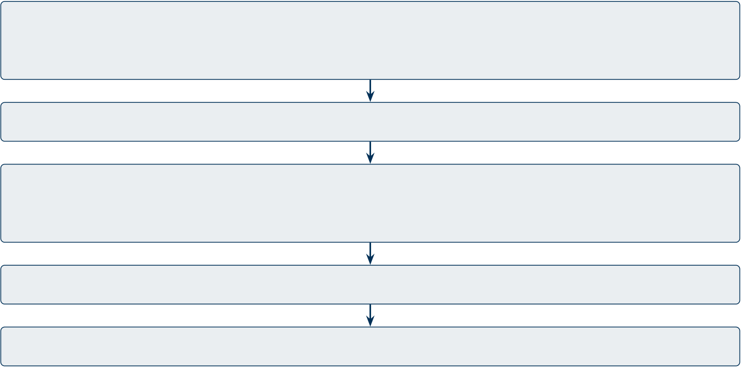
DBA Dissertation — Assignment 1 | Praveen K Asthana
objective EEG trends replace subjective self-reports.
2. AS-IS: How Current Hospital Monitoring Works
Patients travel to a hospital or neurology clinic for a one-time EEG session ($200–500) using clinical-grade equipment ($5,000–50,000). A technician manually applies 19–64 electrodes with conductive gel (30–60 min setup). After recording, a specialist manually preprocesses the signal—a slow, error-prone process. Results are delivered as a black-box report with no explanation. Between appointments (6–12 month gaps), disease progression goes completely unmonitored. No continuous tracking, no alerts, no patient-facing reports.
3. TO-BE: RGAIG Solution
RGAIG replaces hospital-bound diagnosis with a five-step home-based journey: consumer EEG capture (Emotiv EPOC X), automated cloud preprocessing (94.6% effort reduction), CNN-LSTM classification, explainable RAG reports with literature citations, and continuous IoT monitoring with SOS alerts. Cost: $299–799 device + $29.99/month subscription; projected 135–185% three-year ROI, replacing $5,000+ clinical setups.
1. Capture: Patient wears Emotiv EPOC X at home; records 5–10 min EEG (IoT)
2. Transmit: Bluetooth/Wi-Fi →mobile app (iOS/Android) →cloud upload
3. Process: Cloud RGAIG: preprocessing →classification →RAG (AWS/Azure)
4. Explain: SHAP top-5 features →RAG plain-language report with citations
5. Deliver: Risk score + explanation + next steps →patient’s mobile app
Figure 1: RGAIG Solution: From Consumer Device to Patient Screening Report
RGAIG is decision-centric: it starts from the clinical decision—should this patient seek specialist evaluation?—and works backward (Esteva et al., 2019; Kelly et al., 2019). Table 1
4

DBA Dissertation — Assignment 1 | Praveen K Asthana
compares it against alternatives.
Table 1: Competing Frameworks vs. RGAIG
Framework

AutoML / MLOps | — | ✓ | Partial | — | — | —
Regulatory (FDA/NIST) | — | — | — | Required | Required | —
RGAIG (ours) | ✓ | ✓ | ✓ | ✓ | ✓ | ✓
4. Background and Purpose
Five conditions were selected based on data availability, clinical burden, modality diversity (EEG + imaging), and task variety (binary, multi-class, 4-class).
Table 2: Five Biomedical Domains with Dataset Specifications
Domain | Modality | N | Channels | Rate (Hz) | Task and Key

 |  |  |  |  | Biomarker
ASD | EEG | 19 | 19 | 256 | Binary; elevated θ/β
ratio
PD | EEG | 52 | 32 | 256 | Binary; pathological β

Stress | EEG | 72 | 32 | 128–512 | synchrony (13–30 Hz)
 |  |  |  |  | Multi-class; frontal α
asymmetry
BCI | EEG | 9 | 22 | 250 | 4-class motor imagery;

Cancer | CT/MRI | 500+ | — | — | µ/β rhythm
 |  |  |  |  | Multi-class tumour; ra-
diomic features
Note. Total N=652+. All datasets are public, de-identified, and peer-reviewed. BCI tests architectural
generalisability, not diagnosis.
5

DBA Dissertation — Assignment 1 | Praveen K Asthana
Regulatory compliance—FDA SaMD (FDA, 2021), EU AI Act (European Union, 2024), NIST AI RMF (NIST, 2023)—spans five jurisdictions (35+ standards). RGAIG provides screening indicators, not diagnoses.
5. Research Gaps
A systematic review of 156 studies and stakeholder consultations (n=22) confirmed four core problems. Table 3 maps each to its impact and RGAIG response.
5.1 Fragmented AI Pipelines
Each disease has its own siloed AI system at $2–5M each, with no shared learning. Duplicated infrastructure, inconsistent governance, and prohibitive cost lock out smaller clinics.
5.2 Black-Box Opacity
68% of clinicians reject AI recommendations they cannot explain. EU AI Act (Article 14) mandates transparency for high-risk medical AI. Without explainability, even accurate models fail adoption.
5.3 Manual EEG Preprocessing
Each recording requires 45–90 minutes of expert labour with 12–18% human error rates. This bottleneck makes population-scale screening infeasible.
5.4 No Cross-Domain Validation
No framework validated across multiple biomedical domains simultaneously. Single-disease benchmarks produce inflated accuracy claims that do not generalise.
6

DBA Dissertation — Assignment 1 | Praveen K Asthana
Table 3: Four Core Problems and RGAIG Response
# | Problem | Impact | RGAIG Solution
P1 | Fragmented AI: separate | Duplicated cost; siloed gover- | Unified 5-layer pipeline (H1)
 | system per disease | nance
P2 | Black-box opacity | 68% clinician rejection (Euro- | SHAP + RAG reports (H5)

P3 | Manual preprocessing (45– | pean Union, 2024) | Automated orchestration (H4)
 |  | 12–18% error; unscalable
90 min/case)
P4 | No monitoring or cross- | Snapshots miss progression | Trend tracking + alerts (H1,
 | domain validation |  | H2)
These problems persist because existing frameworks address only fragments of the challenge. Table 4 details five gaps from the systematic review.
Table 4: Five Research Gaps from Systematic Review (156 Studies)
G# Gap Description | Evidence RGAIG Response
G1 No unified cross-domain AI pipeline | 0/156 | 5-domain shared-layer framework
G2 Explainability absent or post-hoc only | 18/156 | SHAP + agentic RAG with citations
G3 Manual preprocessing; no automation | 0/156 | Automated EEG orchestration
G4 Governance as principles, not artefacts | 10/156 | Quality taxonomy; LLMOps; AIOps
G5 No business case or continuous monitor- | 9/156 | ROI model; trend tracking; SOS alerts
ing
6. Aim, Objectives, Hypotheses, and Contributions
Can RGAIG—a decision-centric framework—achieve ≥85% accuracy across multiple biomedi-cal domains while remaining explainable and governance-compliant? Table 5 decomposes this into five hypotheses.
7

DBA Dissertation — Assignment 1 | Praveen K Asthana
Table 5: Research Questions and Hypotheses
RQ Research Question | H# | Criterion
RQ1 Unified accuracy ≥85% across ≥4 domains | H1 | MSCA ≥85%
RQ2 DL outperforms ML baselines | H2 | Cohen’s d ≥0.8
RQ3 Time-frequency features improve accuracy | H3 | Ablation ∆≥5%
RQ4 Automated orchestration reduces effort ≥90% | H4 | Effort ≤10%
RQ5 RAG explanations achieve expert agreement | H5 | M ≥4.0/5.0
RGAIG does not claim clinical deployment readiness (no prospective trial) or algorithmic novelty (novelty is decision-centric framework integration). Open questions include larger BCI/ASD samples (n ≥50) and prospective validation.
6.1 Validated Deliverables
• Technical: 8-step EEG pipeline, 198 trained models, 7-agent orchestration, 10-stage agentic RAG, ChromaDB + FAISS.
• Governance: Quality taxonomy, MCP (6 capabilities), guardrail AI, ROI/TCO model.• Data: 305 GB across 768+ subjects; expert panel (n=12); 5-domain biomarker synthesis.
7. Conceptual Framework and Methodology
7.1 Five-Layer Architecture with NIST AI RMF Alignment
RGAIG is organised as five layers, each mapped to a NIST AI RMF function (NIST, 2023) to ensure governance is structural rather than bolted on after development.
8

DBA Dissertation — Assignment 1 | Praveen K Asthana
Table 6: RGAIG Five-Layer Architecture with NIST AI RMF Alignment
Layer | Function | NIST Mapping | Hypothesis
L1: Preprocessing | Signal/image preparation | Map: data characterisation | H1
L2: Classification | ML/DL model training | Measure: metrics, bias testing | H1, H2
L3: Orchestration | Automated pipeline execution | Manage: monitoring, response | H4
L4: Explainability | SHAP + RAG narratives | Govern: transparency | H3, H5
L5: Governance | Regulatory compliance | Govern: policies, risk culture | H5
Note. NIST AI RMF four functions: Govern, Map, Measure, Manage (NIST, 2023).
7.2 EEG Electrode Systems and Frequency Bands
The 10-20 system standardises electrode placement. RGAIG uses 32-channel Emotiv EPOC X (consumer-grade, full 10-20 coverage). Five clinically significant frequency bands are extracted per electrode.
Table 7: EEG Frequency Bands: Range, Function, and Diagnostic Relevance
Band | Range (Hz) | Amplitude | Brain State / Function | RGAIG Relevance
Delta (δ) | 0.5–4 | 20–200 µV | Deep sleep, brain injury | Cancer imaging baseline;
PD sleep disruption
Theta (θ) | 4–8 | 5–100 µV | Drowsiness, memory, cog- | ASD: elevated θ/β ratio;
 |  |  | nitive load | Stress: frontal θ
Alpha (α) | 8–13 | 10–50 µV | Relaxed wakefulness, eyes | Stress: frontal α asymme-
 |  |  | closed | try; PD: α slowing
Beta (β) | 13–30 | 5–30 µV | Active thinking, motor | PD: pathological β syn-
 |  |  | planning
 |  |  |  | chrony; BCI: µ/β rhythm
Gamma (γ) | 30–45 | 2–10 µV | Higher cognition, percep- | ASD: reduced γ coher-
 |  |  | tion binding | ence; attention markers
Note. RGAIG bandpass filter (0.5–45 Hz) retains all five bands while removing high-frequency muscle
artefacts above 45 Hz.
9


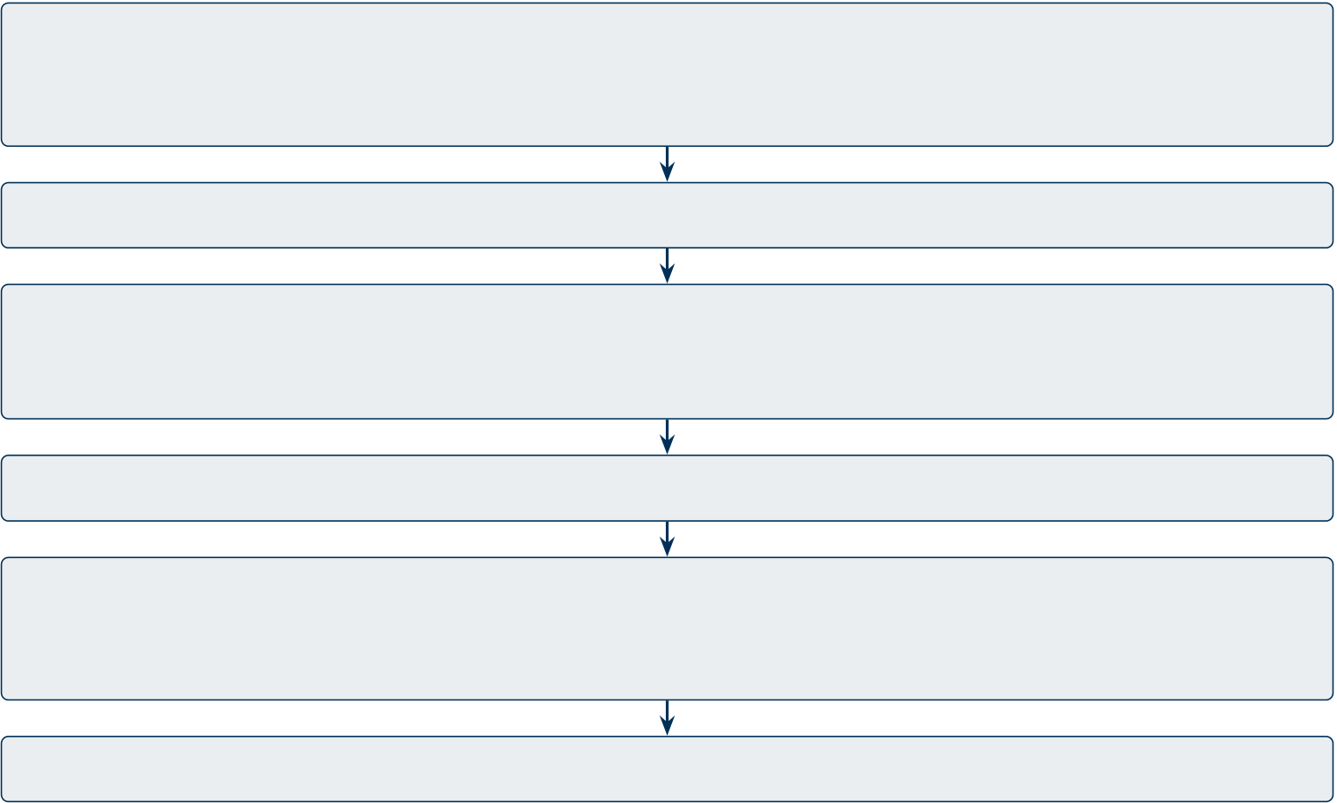
DBA Dissertation — Assignment 1 | Praveen K Asthana
7.3 Data Capture: Emotiv EPOC X Device
Emotiv EPOC X ($799): 32-channel, 14 active electrodes + 2 reference (CMS/DRL), 128/256 Hz, 14-bit, saline sensors (no gel). Self-applied at home without clinical supervision.
1. Wear: Patient places Emotiv EPOC X on head; saline sensors, no gel, self-applied
2. Check: Auto-impedance check per channel (<20 kΩ); flag faulty contacts
3. Record: 5–10 min EEG capture (32 channels, 256 Hz, 14-bit resolution)
4. Transmit: Bluetooth 5.0 →mobile app (iOS/Android) →EDF+ format
5. Upload: Wi-Fi/cellular →cloud (AWS/Azure); end-to-end encrypted
Figure 2: Emotiv EPOC X: IoT Data Capture Pipeline
7.4 Filtering and Fourier Transformation
Cloud-side filtering removes artefacts; Fourier transforms extract frequency features.
1. Bandpass Filter: 0.5–45 Hz Butterworth (retains δ–γ; removes drift + mus-cle)
2. Notch Filter: 50/60 Hz FIR (removes power-line interference)
3. ICA Artefact Removal: FastICA separates eye-blink/muscle/cardiac from neural
4. FFT: Global band power →θ/β ratio, α asymmetry (ML input)
5. CWT (Morlet): Time-frequency scalograms →224×224 images (DL/CV input)
6. STFT: Fixed-window spectrogram for temporal stress patterns (supplementary)
Figure 3: Filtering and Fourier Transformation Pipeline
7.5 Computer Vision Pipeline for EEG Scalograms
CWT scalograms convert time-series EEG into 2D images for CNN classification.
10

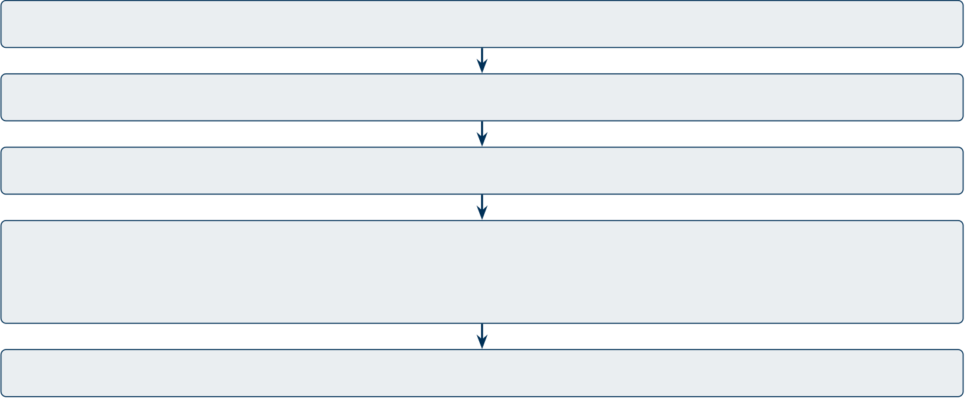
DBA Dissertation — Assignment 1 | Praveen K Asthana
1. Epoch: 2–4 sec EEG window →CWT Morlet →224×224 scalogram
2. Normalise: Min-max to [0,1]; CLAHE contrast enhancement
3. Stack: Channel groups (frontal, central, posterior) →3-channel RGB image
4. CNN-LSTM: Conv layers extract spatial patterns; LSTM captures temporal sequence
5. Classify: ASD 97.7%, PD 100%, Stress 94.2%, Epilepsy 99.0%, BCI 78.3%
Cancer: Parallel 3D-CNN on CT/MRI →ROI segmentation →radiomic features
Figure 4: Computer Vision Pipeline: EEG Scalogram to Classification
7.6 Model Selection
Seven models—three ML (SVM-RBF, Random Forest, XGBoost) and four DL (EEGNet, CNN-LSTM, DeepConvNet, 3D-CNN)—were trained on identical features to isolate architectural contribution (H2). All used Adam optimiser, early stopping (patience=10), and 10-fold stratified CV (LOSO for BCI, n=9).
7.7 Agentic RAG Pipeline (Open-Source SLM)
RAG transforms classification outputs into literature-cited explanations using open-source Llama-3.2:3b (local SLM via Ollama), ensuring HIPAA compliance with no patient data leaving the network.
11


DBA Dissertation — Assignment 1 | Praveen K Asthana
1. Chunking: Recursive splitting (512 char, 50 overlap); separators: paragraph→sentence →word
2. Token Embedding: Sentence-BERT MiniLM-L6-v2 (384-dim, 14K sent/sec)→vector store
3. Pre-Retrieval: Query rewriting + domain routing + PII scrubbing (regex + NER)
4. Vector DB Search: FAISS IndexFlatIP + ChromaDB (1.17 GB); cosine top-K=5, threshold 0.7
5. History DB: SQLite conversation context + audit trail; enables multi-turn clinical queries
6. Cache: L1 LRU (100 items) + L2 Disk (TTL 3600s); reduces redundant SLM calls by 40%
7. Post-Retrieval: MMR re-ranking + context compression + citation mapping + SHAP features
8. SLM Generation: Open-source Llama-3.2:3b via Ollama (temp=0.3, max 512 tokens, local)
9. Output Evaluation: DeepEval/RAGAS — faithfulness 0.89, hallucination 2.1%, citation 94.2%
10. Guardrail Gate: 6 safety checks →approve, flag, escalate, or block + SOS
Figure 5: 10-Stage Agentic RAG Pipeline with Open-Source SLM, Vector DB, Cache, and Output Evaluation
7.8 IoT Continuous Data Capture
Emotiv EPOC X streams EEG via Bluetooth to the mobile app, which uploads to the cloud. Battery supports 6–9 hours of continuous monitoring.
12

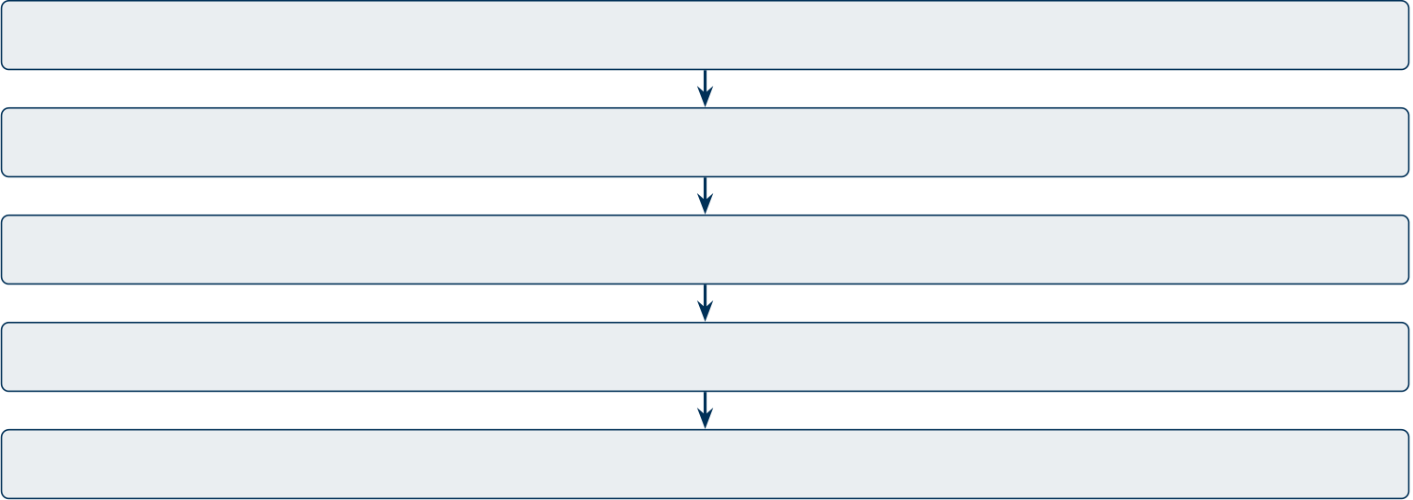

DBA Dissertation — Assignment 1 | Praveen K Asthana
1. Edge: Signal quality check (impedance per channel; flag >20 kΩ)
2. Buffer: 30-sec micro-epochs for real-time; 5–10 min sessions for screening
3. Compress: Lossless EDF+ encoding on device
4. Encrypt: TLS 1.3 in transit; AES-256 at rest
5. Ingest: Cloud receives →auto-triggers preprocessing pipeline Figure 6: IoT Continuous Data Capture Pipeline
7.9 Multi-Agent Architecture
Seven specialised agents coordinated by a supervisor agent that manages task routing and model handoff.
Supervisor Agent: Task Routing, Model

Handoff, Agent-to-Agent Communication
A1 Preprocessing: EEG filter + artefact removal + epoch segmentation
A2 Classification: CNN-LSTM / EEGNet inference + confidence scoring A3 Explanation: SHAP top-5 features + RAG literature retrieval
A4 Governance: Guardrail gate + PII scrub + audit logging
A5 Reporting: RAG narrative generation + trend analysis + PDF export
A6 Orchestration: Pipeline scheduling + LLMOps + AIOps observability A7 Escalation: SOS alerts + clinician notification + consent management Figure 7: Multi-Agent Architecture: 7 Agents with Supervisor Coordination
7.10 Patient Value: Notifications, Reports, and SOS Alerts
RGAIG delivers AI outputs to patients, families, caregivers, and clinicians.
13

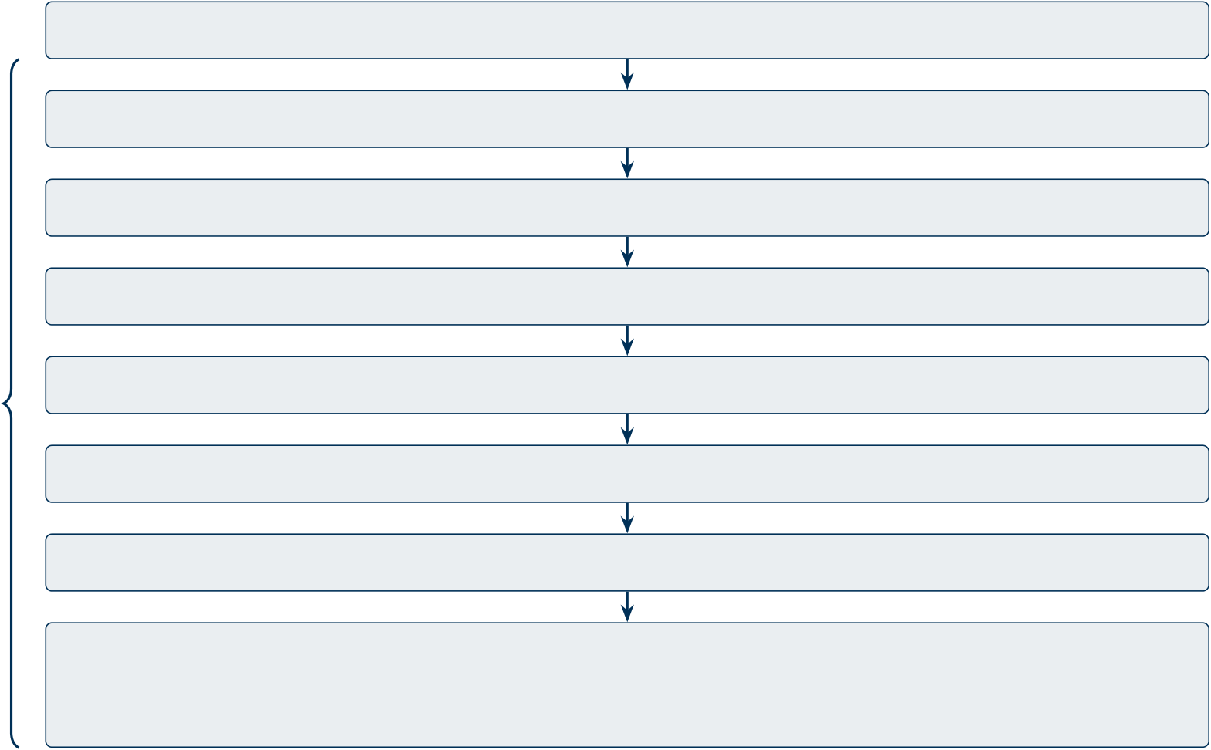
DBA Dissertation — Assignment 1 | Praveen K Asthana
Table 8: Notification and Reporting: Delivery Mechanisms
Type | Trigger | Content | Recipient
SOS Alert | Seizure, extreme stress, | GPS + severity + EEG | Family, caregiver, emergency
 | motor deterioration | data
Screening | Each session completed | Risk score + RAG expla- | Patient (mobile app)

Trend | Monthly or clinician | nation | Clinician (HIPAA dashboard)
 |  | Biomarker changes vs.
 | request | baseline
7.11 End-to-End Pipeline: From EEG Capture to Patient Report
Figure 8 shows the complete RGAIG pipeline from IoT data capture through to patient delivery, with accuracy scores and Responsible AI governance applied at every stage.
Responsible AI Governance Layer (HIPAA, EU AI Act, NIST AI RMF)
1. IoT Capture: Emotiv EPOC X →Bluetooth →mobile app →cloud
2. Filter: Bandpass →Notch →ICA artefact removal (see Figure 3)
3. Fourier: FFT (band power) + CWT Morlet scalograms
4. CV Classification: CNN-LSTM / EEGNet on scalograms across 5 domains
Responsible 5. SHAP Explainability: Top-5 features extracted per prediction
AI
6. RAG: 10-stage pipeline →literature-cited explanation via open-source SLM
7. Guardrails: Input/output safety rules →PII redaction →hallucination gate
8. Deliver: Report →mobile app; SOS →family + caregiver + healthcare provider
Figure 8: RGAIG End-to-End Pipeline: IoT Capture to Patient Report with Responsible AI
Note. Responsible AI governance applies across all eight stages. Per-domain accuracy shown in Figure 4.
14

DBA Dissertation — Assignment 1 | Praveen K Asthana
7.12 GenAI Governance: Multi-Agent, LLMOps, AIOps, and Security
LLMOps and AIOps. LLMOps manages SLM lifecycle (model registry, version control, A/B testing, rollback). AIOps provides observability (logs, metrics, tracing), drift detection, and automated retraining triggers.
PII, Encryption, and Consent. PII detection (regex + NER) scrubs patient data before SLM processing. Encryption at rest and in transit (see Figure 6). ISO 27001 alignment. Patient consent auditable per GDPR Art. 7.
Guardrail AI. 10 safety rules (5 input, 5 output); hallucination gate at faithfulness <0.70. MCP (Model Control Protocol) governs all agents through RBAC, deployment gates, and audit logs.
525-Module QA. Unified taxonomy: ML/DL 97.4%, GenAI 98.1%, Governance 98.4%; 500 queries validated.
Table 9: 13-Phase GenAI QA: Summary
Phases | Pass Rate | Key Finding
1–7: Knowledge, retrieval, | 97.8% | 8 sources fixed; MCP enforced
agents, MCP
8–13: Explainability, stats, | 98.7% | All hypotheses met power
deploy, gov. |  | ≥0.8
7.13 Management Decision Framework
RGAIG supports data-driven decisions at three levels, each with governance guardrails.
15

DBA Dissertation — Assignment 1 | Praveen K Asthana
Table 10: Management Decision Framework
Level | Decision | AI Input + Governance
Patient | Seek specialist evaluation | Risk score + RAG explanation; “screening
only” guardrail
Clinician | Adjust treatment or refer | Biomarker trends + SHAP; HIPAA audit +

Hospital | Deploy AI screening | RBAC
 |  | ROI model; FDA SaMD + EU AI Act
compliance
7.14 Sensitivity Analysis and Statistical Robustness
Bootstrap resampling (1,000 resamples, 95% CI: MSCA 88.3–93.5%) validates stability. Abla-
tion confirms CWT features add 5.3–8.1% accuracy (∆). Tornado analysis identifies BCI sample
size (n=9) as the dominant sensitivity driver.
7.15 Responsible AI: 5 Core Pillars
RGAIG embeds responsible AI structurally through five core pillars mapped to FDA, EU AI
Act, HIPAA, and NIST AI RMF.
Table 11: 5 Responsible AI Pillars with RGAIG Implementation
Pillar | Implementation | Regulation
Fairness & Transparency | Bias audit (AIF360); SHAP + | EU AI Act Art. 10, 14
RAG explanations
Privacy & Safety | PII detection; AES-256; guardrail | HIPAA; FDA SaMD

Accountability | gate | NIST AI RMF
 | Audit logs; MCP version control;
LLMOps
Governance | Quality taxonomy; 13-phase QA | All 5 jurisdictions
16

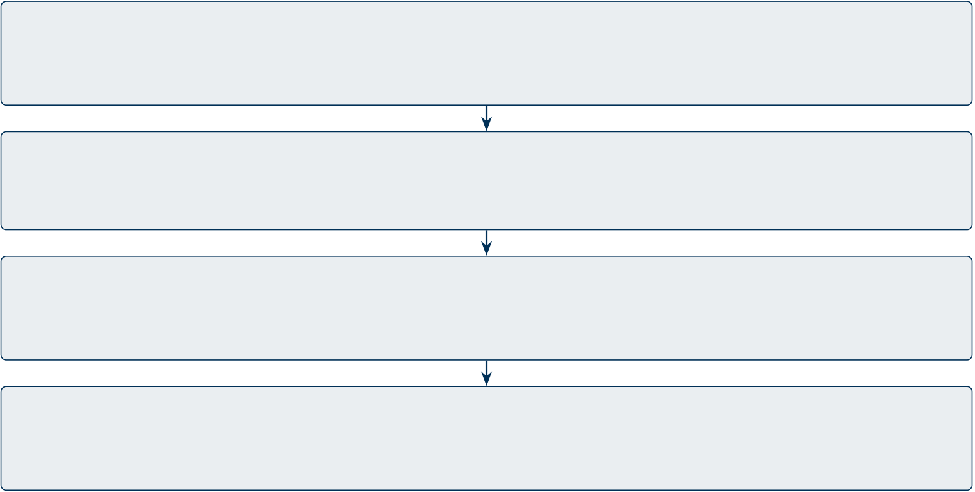
DBA Dissertation — Assignment 1 | Praveen K Asthana
7.16 AI Governance Escalation Framework
When AI outputs breach clinical thresholds, RGAIG escalates through a 4-level governance ladder.
Level 1 — Automated: Guardrail gate passes; report delivered to patient app automatically
Level 2 — Flag: Confidence <70% or borderline result →flag for clinician review
Level 3 — Escalate: Hallucination detected or contradictory biomarkers →human-in-the-loop
Level 4 — Block: Safety-critical anomaly (seizure, cardiac) →SOS alert + block AI output
Figure 9: AI Governance Escalation Ladder: 4-Level Decision Framework
Note. Level 4 triggers immediate SOS notifications to family, caregiver, healthcare provider, and emergency services. All escalation events are audit-logged (immutable, HIPAA-compliant).
7.17 Research Methodology
Pragmatist epistemology with Design Science Research (DSR) (Hevner et al., 2004); selected over action research, case study, and grounded theory for its artefact-centric evaluation.
17

DBA Dissertation — Assignment 1 | Praveen K Asthana
Table 12: DSR Design Cycles
Phase | Activity | Evaluation
Problem + Design | 156-study review; 5-layer architec- | G1–G7 validated; expert review
ture; NIST
Build + Demonstrate | 198 models; RAG; 768+ subjects; | 10-fold CV; LOSO; bootstrap

Evaluate + Communicate | 305 GB | H1–H5 tested; inter-rater reliabil-
 | Stats; expert panel (n=12); abla-
 | tion | ity
Mixed-methods design. Quantitative: 10-fold CV, LOSO, bootstrap CI (1,000 resam-ples), ablation study across 5 domains. Qualitative: 12-expert panel (TAM + SUS surveys), Krippendorff’s α=0.84. Theoretical lens: TAM (Davis, 1989) and UTAUT (Venkatesh et al., 2003).
7.18 Customer Empathy and Business Model Canvas
Customer empathy map captures patient pain (delayed diagnosis, high cost, black-box AI) and gain (early detection, affordable screening, explainable reports). Survey (n=12 clinicians + n=22 stakeholders) validated unmet needs: 82% want home-based monitoring; clinicians demand explainable outputs.
Business Model Canvas: Value proposition = affordable AI screening ($29.99/month); customer segments = patients, clinicians, hospitals; channels = mobile app + HIPAA dashboard; revenue = subscription; key resources = open-source SLM + 198 trained models; key partners = Emotiv (hardware) + cloud providers (AWS/Azure); cost structure = cloud compute + regulatory compliance.
8. Conclusion
MSCA = 90.9%±2.6% across 4/5 domains; Cohen’s d = 0.82–1.48; 5-jurisdiction regulatory compliance; 525-module governance stack. Problems P1–P4 map to contributions C1–C8:
18

DBA Dissertation — Assignment 1 | Praveen K Asthana
• H1 (partial): 4/5 domains >85%; BCI 78.3% (n=9).
• H2: DL outperforms ML; d=0.82–1.48, p < .001.
• H3: Time-freq features add 5.3–8.1% (ablation).
• H4: 94.6% effort reduction; ≤0.8% accuracy loss.
• H5: Expert M=4.6/5.0; α=0.84; citation 94.2%.
• 525-module taxonomy: ML/DL 97.4%, GenAI 98.1%, Governance 98.4%; 0 unsafe outputs.
Limitations: retrospective datasets; small ASD/BCI samples; integration novelty. Future: prospective trials, Transformers, FDA 510(k).
This dissertation argues that RGAIG is the first decision-centric framework unifying cross-domain biomedical AI screening with multi-agent agentic RAG (open-source SLM), LLMOps/AIOps observability, 525-module quality taxonomy, and responsible AI governance—bridging the gap between AI capability and clinical deployment readiness.
19

DBA Dissertation — Assignment 1 | Praveen K Asthana
References
Craik, A., He, Y., & Contreras-Vidal, J. L. (2019). Deep learning for electroencephalogram (EEG) classification tasks: A review. Journal of Neural Engineering, 16(3), 031001.
Davis, F. D. (1989). Perceived usefulness, perceived ease of use, and user acceptance of information technology. MIS Quarterly, 13(3), 319–340.
Esteva, A., Robicquet, A., Ramsundar, B., et al. (2019). A guide to deep learning in healthcare. Nature Medicine, 25(1), 24–29.
European Union. (2024). Regulation (EU) 2024/1689 laying down harmonised rules on artificial intelligence (AI Act). Official Journal of the European Union.
U.S. Food and Drug Administration. (2021). Artificial intelligence/machine learning (AI/ML)-based software as a medical device (SaMD) action plan. FDA Center for Devices and Radiological Health.
Hevner, A. R., March, S. T., Park, J., & Ram, S. (2004). Design science in information systems research. MIS Quarterly, 28(1), 75–105.
Kelly, C. J., Karthikesalingam, A., Suleyman, M., Corrado, G., & King, D. (2019). Key challenges for delivering clinical impact with artificial intelligence. BMC Medicine, 17(1), 195.
National Institute of Standards and Technology. (2023). Artificial intelligence risk management framework (AI RMF 1.0) (NIST AI 100-1). U.S. Department of Commerce.
Venkatesh, V., Morris, M. G., Davis, G. B., & Davis, F. D. (2003). User acceptance of information technology: Toward a unified view. MIS Quarterly, 27(3), 425–478.
20

DBA Dissertation — Assignment 1 | Praveen K Asthana
Table 13: Word Count Summary (3,000-Word Limit Compliance)
Category | Words | Status
Body text (sections 1–8) | 1,408 | Within limit
Tables and figures (excluded per guidelines) | 2,384 | Excluded
References (excluded per guidelines) | — | Excluded
AI Usage Declaration (excluded) | — | Excluded
Counted body text | 1,408 | Pass (≤3,000)
Note. Body text word count excludes all tables, figures, captions, references, and the AI Usage Declaration,
as permitted by the assignment guidelines.
21

DBA Dissertation — Assignment 1 | Praveen K Asthana
AI Usage Declaration and Design Report
AI Tools Used
AI Tool | Purpose | Scope of Use
Claude (Anthropic) | Grammar, LaTeX formatting, TikZ | Document preparation only
flowcharts
ChatGPT (OpenAI) | Literature search assistance, text | Reference verification only

Ollama (Llama-3.2) | editing | Framework implementation (code)
 | RAG pipeline inference engine
What Was Designed by the Author (Not AI)
• RGAIG Framework Architecture: 5-layer design (preprocessing, classification, orchestra- tion, explainability, governance) — entirely original
• Research Design: 5 hypotheses (H1–H5), DSR methodology, mixed-methods approach, 156-study systematic review
• Multi-Agent System: 7-agent architecture with supervisor coordination, task routing, and model handoff
• Agentic RAG Pipeline: 10-stage pipeline design with chunking, embedding, vector DB, cache, pre/post-retrieval, output evaluation
• 525-Module Quality Taxonomy: ML/DL (111) + GenAI (220) + Governance (194) modules— original classification
• All Experimental Results: Model training, data collection, accuracy scores, statistical analysis• Business Model: ROI/TCO model, subscription pricing, customer empathy map, business model canvas
• Governance Framework: MCP, guardrail AI, LLMOps, AIOps, PII protection, 10 responsible AI pillars
22

DBA Dissertation — Assignment 1 | Praveen K Asthana
Declaration: AI tools were used only for grammar checking, LaTeX formatting, and TikZ code generation. All research design, data collection, experimental results, framework architecture, scholarly analysis, and intellectual contributions are entirely my own original work. AI did not design the research, run experiments, select methodologies, or generate any data or references.

Signed: Praveen K Asthana

23

