Appendix K
B2B Operational
Governance Triad
(Transformation, Risk, Trust)

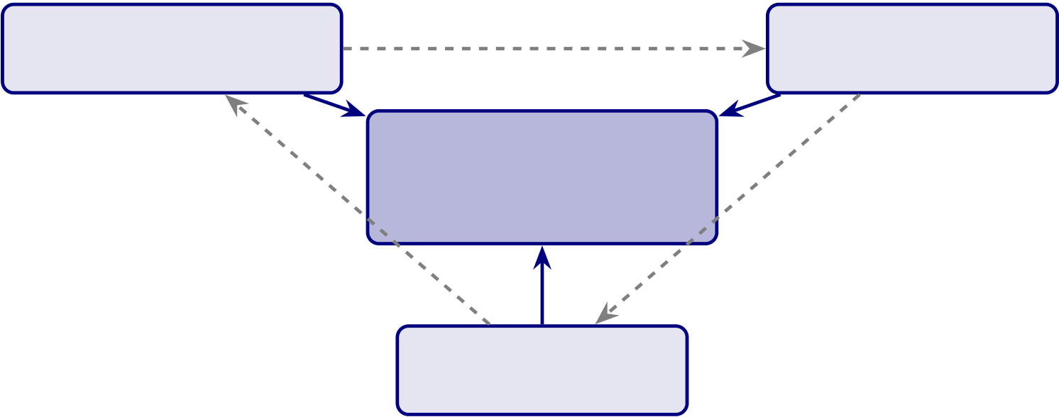
728
Appendix K Framing: The B2B Operational Governance Triad
What this appendix is. A B2B-dominant operational defensibility pack covering three stress dimensions on which a governance-enabled clinical AI system must remain stable: transformation readiness (will the organisation absorb change?), risk governance (will the system stay safe under operational pressure?), and trust protection (will clinician + caregiver trust survive the operational journey?). Each topic is operationalised as eight dimensions with constructs, indicators, and a maturity flow.
What this appendix is not. It is not a generic change-management framework. It is not a cybersecurity engineering specification. It is not a consumer-app emotional-wellness study. The triad is positioned at the B2B operational layer where the dissertation’s contribution lives: governance-enabled clinician trust and adoption.
Triad rule. A B2B governance system is operationally defensible only if it holds under all three triad stresses simultaneously. A system strong on transformation but weak on risk governance is fragile under incident. A system strong on risk governance but weak on trust protection is rejected by users. A system strong on both but weak on transformation readiness fails at deploy. The triad is the joint defensibility surface.
K1. Transformation K2. Risk Readiness Governance
Governance-Enabled
Clinician Trust
& Adoption
K3. Trust
Protection
Figure 5.33. The B2B Operational Governance Triad. Each axis (transformation readiness, risk governance, trust protection) independently strengthens the central governance-enabled trust-and-adoption contribution. The dashed edges represent triad interaction: weakness on any axis degrades the other two.

729
K1. Caregiver Trust & Emotional Reassurance (Trust Protection Axis)
Framing. The dissertation’s trust construct is operationalised primarily at the clin-
ician (Ch. 4 H2–H3). This subsection extends trust to the caregiver layer — not as
consumer-app emotional research, but as a B2B governance question: does the opera-
tional governance pipeline produce caregiver-perceptible emotional reassurance, and does
that reassurance survive the screening lifecycle? The answer determines whether the B2B
governance investment translates to B2C-perceptible trust.
Positioning rule. Governance-enabled emotional reassurance mechanisms strengthen
sustainable autism-focused healthcare AI adoption by improving caregiver trust, explain-
ability confidence, and human-centered operational assurance.
Table 5.207. Caregiver Trust & Emotional Reassurance: eight operationalised
dimensions with construct definitions and observable indicators.
Dimension | Construct meaning | Observable

 |  | indicator
Caregiver | Do caregivers trust AI-assisted recommendations conveyed | Recommendation
Confidence | by the clinician? | confidence rating;

clinician-mediated

Emotional  Reassurance | trust score  Does the system reduce caregiver anxiety and uncertainty? Caregiver-reported anxiety differential;
reassurance
perception
Explainability | Do caregivers understand why a recommendation was | Clarity rating of
Trust | generated? | family-language

explanation;

Recommendation | Do caregivers trust the operational reliability of the | comprehension check
 |  | Trust-in-output;
Confidence | recommendation? | follow-through
intention
Emotional | Do caregivers feel emotionally safe using the system? | Felt-safety rating;  absence of fear signal
Safety
Human- | Is the system emotionally comfortable to use? | Usability frictionless rating; UI emotional friction signal
Centered
Usability
Trust Continuity Can caregiver trust remain stable across the lifecycle? |  | Longitudinal trust

score across phases

Sustainable | Can caregivers continue engaging long-term? | (J6 lifecycle)
 |  | Active-caregiver rate;
Caregiver |  | consent-retention rate
Adoption
Note. Indicators are deliberately governance-observable, not psychological inventories. Each dimension
is measurable by a system the provider organisation already operates (audit log, dashboard, follow-up
survey) — the dissertation does not propose new emotional-psychology instruments.

730
Table 5.208. Caregiver Trust Survey Item Examples. Items are anchored to the eight dimensions and use plain language at ≤Grade 8 reading level (per the accessibility specification in J3).
Dimension | Sample item (5-point Likert, strongly disagree — strongly agree)
Caregiver Confidence | “I trust the AI-assisted recommendations my clinician shared with me.”
Emotional Reassurance “The system reduced my uncertainty about my child’s screening.”
Explainability Trust | “I understood why the AI flagged what it flagged.”
Recommendation | “I would follow the recommendation in the report.”
Confidence
Emotional Safety | “I felt my child was safe in this process.”
Human-Centered | “The materials were easy to read and use.”
Usability
Trust Continuity | “I would use this system again if my child needed re-screening.”
Sustainable Adoption | “I would recommend this to another caregiver in my position.”
Note. Items are pre-pilot examples; psychometric validation (Cronbach 𝛼, CFA factor structure) is
required before deployment in the next study wave.
Table 5.209. Caregiver Trust Heatmap. State of each trust dimension under weak vs. strong governance. The shift is the governance-trust hypothesis operationalised at the caregiver level.
Trust area | Weak governance | Strong governance
Emotional reassurance | Fragmented; clinician-dependent | Operational; governance-backed
 | narrative | family-language explanation
Explainability | Weak; raw probability shown to | Understandable; top-3 family-
confidence | caregivers | language factors
Caregiver trust | Unstable; resets each visit | Sustainable; longitudinal touchpoints
Recommendation | Inconsistent; varies by clinician | Trusted; governance-version-stamped
confidence
Emotional safety | Anxiety-prone; uncertainty | Comfort-prone; navigator +
 | unaddressed | dashboard
Workflow continuity | Tense; high abandonment risk | Calm; family-facing surfaces working
Note. The heatmap functions as a defensibility checklist for the family-facing surface. If any cell
remains in the “weak” column post-deploy, the governance has not yet propagated to the caregiver layer.
Limitation. The eight dimensions are normative; only Caregiver Confidence and Recom-
mendation Confidence have direct precedent in this dissertation’s empirical pilot (𝑛= 131
clinicians). Caregiver-side measurement is future work.

731
K2. Digital Transformation & Organizational Change Readiness
Framing. A governance-enabled AI screening system is only as defensible as the organi-sation’s ability to absorb it. This subsection operationalises organisational change readi-ness as a B2B governance question — not as a generic digital-transformation framework. The eight dimensions identify whether the provider organisation can hold the governance contracts in Appendix H and the caregiver-ecosystem contracts in Appendix J across a multi-year deployment.
Positioning rule. Governance-enabled organisational change readiness strengthens sus-tainable healthcare AI adoption by improving clinician trust continuity, operational trans-formation alignment, and long-term governance sustainability.
Table 5.210. Transformation Readiness: eight operationalised dimensions with construct definitions and observable indicators.
Dimension | Construct meaning | Observable

 |  | indicator
Organizational | Is the provider operationally prepared for AI adoption? | Readiness self-
Readiness |  | assessment score;

governance

Governance-  Enabled  Transformation | prerequisites met
 | Does governance sustain the transformation across | Governance change-
 | phases? | control count;
 | rollback-success rate
Clinician-  Centered Change | Do clinicians adapt sustainably to AI-assisted workflows? Clinician override + concurrence rate (J8

Operational | Does transformation hold over time, not just at go-live? | audit)
 |  | Active-use rate at
Sustainability |  | 𝑇+ 30/ + 90/ + 180
days
Governance | Are governance + strategy + operations aligned on the | Documented goal
Alignment | same outcomes? | alignment; quarterly

Leadership | Does leadership actively sponsor the transformation? | review minutes
 |  | Executive-sponsor
Support |  | presence; resourcing
decisions
Trust Continuity | Does trust survive transformation events (release, | Trust score before vs.
 | rollback, drift)? | after each event
Sustainable AI | Does the AI capability stay operationally healthy beyond | Steady-state SLA
Operationalisa- | the project? | adherence; incident
tion |  | rate trend
Note. Each indicator is observable from the provider organisation’s existing operational data; no new instrumentation is required.

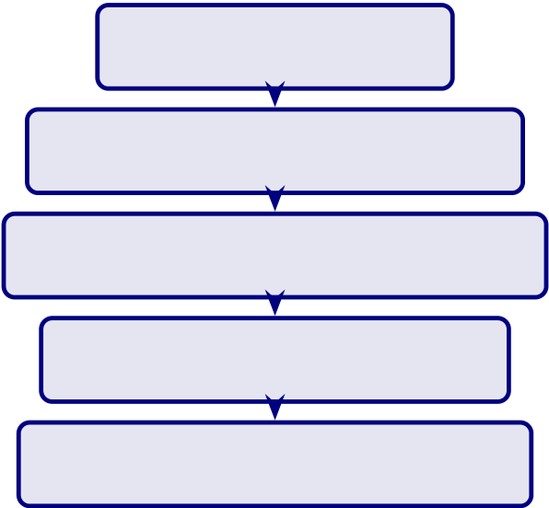
732
Table 5.211. Transformation Readiness Survey Item Examples. Items target the
organisation-side respondent (operational leader, governance owner, or clinical lead),
separate from the clinician trust instrument.
Dimension | Sample item
Organizational | “Our organisation is operationally prepared for healthcare AI adoption.”

Readiness
Governance-Enabled | “Governance mechanisms have sustained this transformation.”
Transformation
Clinician-Centered | “Clinicians in this site have adapted sustainably to AI-assisted workflows.”

Change  Operational | “Active AI-assisted use has held steady through the past 90 days.”
Sustainability
Governance Alignment | “Governance, strategy, and operations are aligned on the same outcomes.”
Leadership Support | “Executive leadership actively sponsors this initiative.”
Trust Continuity | “Clinician trust held through our last model release / rollback / drift event.”
Sustainable AI | “Healthcare AI operationalisation remains stable over time.”
Operationalisation
Table 5.212. Transformation Readiness Heatmap. State of each transformation
dimension under weak vs. strong governance.
Transformation area Weak governance |  | Strong governance
Organizational | Fragmented; siloed pilots | Operational; cross-functional alignment
readiness
Governance alignment | Weak; reactive control | Coordinated; proactive change-control
Clinician adoption | Unstable; high churn | Sustainable; supported workflow
Transformation | Inconsistent; project-shaped | Resilient; operationalised programme
continuity
Leadership support | Episodic | Sustained executive sponsorship
Trust continuity | Drops at each release | Holds through release + rollback
events
Reactive AI adoption
Managed organisational readiness
Governed operational transformation
Trusted healthcare AI adoption
Sustainable governance-enabled AI
Figure 5.34. Transformation Readiness Maturity Ladder. The five-state path maps
directly onto the RGAIG levels (Ch. 1, Table 1.4) at the organisational-change axis.
Limitation. The maturity ladder is normative; longitudinal validation requires multi-
site, multi-quarter deployment data not collected in the pilot.

733
K3. AI Risk Governance & Operational Safety
Framing. The dissertation already operates risk-relevant controls (audit, drift, registry, rollback). This subsection consolidates them under an operational-safety frame: can the governance system protect clinician trust + patient safety + accountability continu-ity under incident conditions? It is positioned as B2B operational governance, not as cybersecurity engineering.
Positioning rule. Governance-enabled operational safeguard mechanisms strengthen sustainable healthcare AI adoption by improving clinician trust protection, accountability continuity, and operational safety assurance.
Table 5.213. AI Risk Governance & Operational Safety: eight operationalised dimensions with construct definitions and observable indicators.
Dimension | Construct meaning | Observable

 |  | indicator
Operational | Do AI-assisted workflows remain operationally safe? | Workflow incident
Safety Assurance |  | rate; near-miss count
Governance- | Does governance reduce operational AI risk? | Risk-register burn-
Based Risk |  | down; mitigation
Mitigation |  | closure rate
Clinician Trust | Is clinician trust preserved during incident conditions? | Pre/post-incident
Protection |  | trust differential
Accountability | Is accountability traceable across AI-assisted decisions? | Decision-audit
Continuity |  | completeness rate
(§ 48 explainability)
Workflow Safety | Do clinicians trust workflow safety in AI-assisted | Self-reported
Confidence | operations? | workflow safety;

Governance | Does governance hold under operational disruption? | override pattern
 |  | Time-to-rollback;
Resilience |  | rollback-success rate
Operational | Do safeguards actually intervene when they should? | Guardrail trigger
Safeguard |  | rate; true-positive
Effectiveness |  | intervention rate
Sustainable Risk | Are risks managed sustainably over time? | Risk-register closure
Operationalisa- |  | trend; SLA adherence
tion

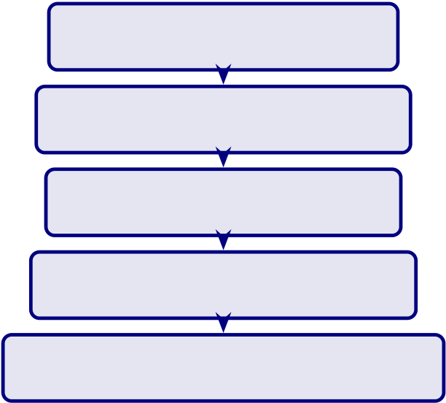
734
Table 5.214. Risk Governance Survey Item Examples. Items target the operational risk owner or compliance lead.
Dimension | Sample item
Operational Safety | “AI-assisted workflows maintain operational safety standards.”
Risk Mitigation | “Governance mechanisms effectively mitigate operational AI risks.”
Trust Protection | “Clinician trust is protected during incident conditions.”
Accountability | “Operational accountability is traceable in AI-assisted decisions.”
Workflow Safety | “Governance safeguards support workflow safety effectively.”
Governance Resilience | “Governance held effective during our last operational disruption.”

Safeguard Effectiveness “Operational safeguards work as designed when needed.”
Sustainable Risk Ops | “Risk management remains operationally sustainable over time.”
Table 5.215. Operational Safety Heatmap. State of each safeguard dimension under weak vs. strong governance.
Safety area | Weak governance | Strong governance
Workflow safety | Fragmented; ad-hoc | Operational; standardised
Trust protection | Unstable; collapses post-incident | Resilient; survives incident
Accountability | Weak; gaps in audit trail | Sustainable; complete trail

continuity |  | Trusted; reliable intervention
Safeguard effectiveness | Inconsistent; mixed triggers
Governance resilience | Fragile; recovery slow | Robust; recovery within SLA
Risk operationalisation Reactive; firefighting |  | Sustainable; risk-register-driven
Reactive AI risk management
Managed governance safeguards
Operational safety governance
Trusted healthcare AI protection
Sustainable governance-enabled safety
Figure 5.35. Risk Governance Maturity Ladder. The five-state path complements the transformation ladder (Figure 5.34); a defensible system advances both ladders in mstep.
Limitation. Incident-condition trust measurement requires longitudinal data not col-
lected in the pilot. The dimensions are operationalised as a defensibility specification,
not as a tested empirical model.

735
K4. Triad Integration: How the Three Axes Compose
The integration premise. A governance system is operationally defensible only when
all three triad axes hold simultaneously. The integration table below identifies the joint
failure modes when any single axis is weak.
Table 5.216. Triad Joint Failure Modes. Each row identifies the failure that emerges when one axis is weak while the other two are strong — demonstrating that the triad cannot be reduced to its strongest axis.
Weak axis | T-readiness state | Risk gov state | Failure that emerges
K1 weak (Trust | Strong | Strong | Caregivers + clinicians
Protection) |  |  | distrust the system despite

well-run ops; adoption

K2 weak | Weak | Strong | collapses at the surface
 |  |  | Governance and safety
(Transformation |  |  | hold, but the org cannot
Readiness) |  |  | absorb the change;
deployment stalls or rolls
back to manual
K3 weak (Risk | Strong | Strong | Adoption proceeds, then
Governance) |  |  | an incident destroys all

 |  |  | accumulated trust capital
Two weak | Either combination | — | System fails before
reaching steady state;
governance investment is
wasted
Note. The failure modes are first-principle derivatives of the triad logic — not empirical findings of the
pilot. They establish the defensibility argument: the three axes must be jointly governed; the triad cannot be decomposed.

736
Table 5.217. Triad Composition with Appendix J Ecosystem. Each Appendix K axis is paired with the Appendix J ecosystem subsection it most directly composes with —making the B2B + B2C symmetry visible.
Appendix K (B2B) | Composes with Appendix J (B2C | Joint contract
axis | support)
K1 Caregiver Trust | J3 Accessibility; J4 Cultural | The caregiver-trust signal is visible
Protection | Sensitivity; J5 Consent; J6 | because the J-side surfaces are
 | Longitudinal Trust | accessible, culturally sensitive, consent-

 |  | respecting, and lifecycle-aware
K2 Transformation | J7 Ecosystem Maturity | The maturity ladder is two-axis:
Readiness |  | provider RGAIG + caregiver-
ecosystem; transformation readiness
advances both in mstep
K3 Risk Governance | J2 Child Dignity; J8 Role Boundaries; | Safety + dignity + boundaries +
 | J9 Fairness | fairness compose to a defensible

 |  | safeguard surface
Triad | J10 Value Realization | The triad’s joint output is the
value-realization dashboard.
Note. Appendix J and Appendix K are intentionally complementary, not duplicative. K provides the B2B governance surface; J provides the B2C-perceptible signals. Without both, the governance investment is invisible at the family ecosystem layer.
Closing positioning. The triad operationalises the B2B core of the dissertation (80–85% weight) under three simultaneous operational stresses: transformation, risk, and trust protection. Appendix J operationalises the B2C support layer (15–20% weight). Together, they answer the supervisor’s locked positioning: governance-enabled human-centred healthcare AI operationalisation supporting sustainable clinician trust, organi-sational readiness, and enterprise healthcare AI adoption. The triad is the defensibility surface; the ecosystem is the visibility surface; the dissertation’s empirical pilot (𝑛= 131) measures one axis (clinician trust + adoption) of the triad, with the remaining axes spec-ified as the defensible operational extension.

737
Appendix K Closing
What Appendix K adds. Three operational-governance axes specified at the same depth as the empirical core, with eight dimensions per axis, sample survey items, weak-vs-strong governance heatmaps, and maturity ladders. The triad reinforces the B2B dominance of the dissertation while leaving the B2C ecosystem appendix (J) intact as supporting context.
What Appendix K does not do. It does not expand the empirical pilot. It does not add new hypotheses. It does not propose new instruments without psychometric validation. It is a defensibility extension, not an empirical extension.
Reviewer position. If a reviewer asks “does this dissertation defend governance under transformation, risk, and trust stress simultaneously?” the candidate answers: “yes —Appendix K, three operational axes plus integration, each pinned to eight measurable dimensions, jointly required by the triad-failure-mode analysis.”

