Software Requirements Specification (SRS)

Project: Railway Reservation System
Version: 1.0
Authors: Team 2 (Praveen - PES2UG24CS373, Praveen Balaji P - PES2UG24CS374,
Prithvi S Paraddi - PES2UG24CS375, Priyaan G - PES2UG24CS376)
Date: 03-09-2026
Status:

Revision history
Version | Date | Author | Change summary | Approval
1.0 | 03-09-2026 | Team 2 | Initial SRS draft for Railway Ticket Reservation System

Approvals
Role | Name | Signature / Email | Date

Table of Contents
1. Introduction
2. Overall description
3. External interface requirements
4. System features (detailed)
5. Non-functional requirements (detailed)
6. Quality attributes & Acceptance tests
7. System models and diagrams
8. Requirements Traceability Matrix (RTM)

Introduction

1.1 Purpose

This document is a Software Requirements Specification (SRS) for a Railway Reservation System (RRS). It defines functional and non-functional requirements, interfaces, verification criteria, and system architectural models intended for instructors, students, and evaluators to use as a formal engineering reference.

1.2 Scope
Covers passenger interactions at booking consoles and client terminals, train schedule and route inquiry, multi-class berth inventory tracking (1A, 2A, 3A, Sleeper, Chair Car), automated reservation with 10-digit PNR issuance, waitlist (RAC/WL) FIFO queue processing, ticket cancellation with dynamic slab refund deductions, operational counter management by clerks, and administrative master train catalog configuration. Excludes physical rail interlocking systems, signaling hardware, and third-party payment gateway banking internals beyond standard APIs.

1.3 Audience
Developers, QA Engineers, System Integrators, Station Booking Clerks, System Administrators, Course Instructors, and Assessment Evaluators.

1.4 Definitions
List of acronyms:
RRS: Railway Reservation System, PNR: Passenger Name Record, CNF: Confirmed Berth, RAC: Reservation Against Cancellation, WL: Waiting List, FIFO: First-In, First-Out queue scheduling, CLI/TUI: Command-Line Interface / Text User Interface, RBAC: Role-Based Access Control, ACID: Atomicity, Consistency, Isolation, Durability, SHA-256: Secure Hash Algorithm 256-bit

Overall description

2.1 Product perspective
The Railway Reservation System is a modular, high-performance console and networked reservation platform developed in C/C++. It serves as a central transaction engine handling concurrent multi-terminal booking requests. It integrates local binary/relational transactional persistence, thread-safe memory management, role-based user authentication, and deterministic state transitions across passenger booking lifecycles.

2.2 Major product functions
- Authenticate users across Passenger, Clerk, and Administrator roles with masked credentials.
- Train route and schedule inquiry by source, destination station codes, and journey dates.
- Real-time berth inventory checking across coach classes (1A, 2A, 3A, SL, CC) and quotas.
- Multi-passenger reservation with age-based fare concession calculation and automated berth allocation.
- Generation and tracking of unique 10-digit Passenger Name Records (PNRs).
- Ticket cancellation processing with slab-based penalty calculation and ledger refund processing.
- Automated FIFO queue promotion cascading RAC passengers to CNF and WL passengers to RAC upon cancellation.
- Administrative master management for onboarding new train routes, configuring coach compositions, and modifying fare-distance tariffs.
- Final passenger reservation charting and daily station revenue accounting.

2.3 User roles and characteristics
- Passenger: General public user; expects quick schedule searches, clear berth availability, transparent fare calculation, and prompt PNR status updates.
- Booking Clerk/Counter Operator: Station counter personnel; requires high-throughput data entry, bulk booking shortcuts, immediate ticket printing, and daily cash reconciliation.
- Railway Administrator: System supervisor; requires elevated access to maintain train timetables, adjust quota boundaries, inspect audit trails, and manage system backups.

2.4 Operating environment
- POSIX-compliant UNIX/Linux or Windows console environment.
- C/C++ runtime (GCC / G++ 9.0+).
- Terminal supporting ANSI escape codes and non-canonical password masking.
- Non-volatile disk storage for structured binary records or SQLite transactional store.

2.5 Constraints
- Memory safety: zero buffer overflows, memory leaks, or dangling pointers in C/C++ string and struct handling.
- Concurrency: thread-safe mutual exclusion (mutexes / file record locking) preventing race conditions and double-allocated berths during concurrent transactions.
- Transaction atomicity: ACID compliance ensuring power loss or process kill does not corrupt booking records.
- Standard compliance: reliance on portable standard libraries with decoupled business logic.

External interface requirements

3.1 User interfaces
Primary UI: Interactive ANSI-colored Command-Line Interface (CLI) / Text User Interface (TUI) with clear hierarchical menus. Accessibility: masked password inputs (*), high-contrast formatting, and explicit input validation error messages.

3.2 Hardware interfaces
- Standard keyboard input with stream buffer flushing.
- Monitor/terminal display (standard 80x24 and 120-column formatted grids).
- Local hard drive/SSD for persistent binary record storage.
- Optional receipt/ticket printer interface generating 40-column passenger receipts.

3.3 Software interfaces
- C/C++ Standard Runtime Library (<cstdio>, <iostream>, <vector>, <cstring>).
- POSIX thread subsystem (pthread / <mutex>) for multi-terminal thread safety.
- Binary file serialization subsystem managing fixed-size structs for records.
- Cryptographic hashing module executing salted SHA-256 digests.

3.4 Communications
- POSIX TCP/IP Sockets for client-server multi-counter communications.
- Binary packet or structured JSON over TCP with retry/backoff mechanisms.

System features
Each requirement below includes acceptance criteria and a reference test case. IDs follow RRS-F-###.

4.1 Authentication & User Management
Req ID | Requirement (shall...) | Type | Priority | Source/ Stakeholder | Acceptance criteria / Test case ref | Comments / Dependencies
RRS-F-001 | Authenticate users using unique usernames and SHA-256 hashed passwords across Passenger, Clerk, and Admin roles. | Functional | High | Security / All Users | AC-RRS-F-001: Correct credentials grant role-specific menu access. Test: TC-Auth-01 | Requires Crypto Module
RRS-F-002 | Mask password entry and lock accounts after 3 consecutive failed login attempts. | Functional | High | Security / PCI-DSS | AC-RRS-F-002: Characters echoed as '*' or suppressed; account locked. Test: TC-Auth-02 | Terminal I/O
RRS-F-003 | Register new passengers capturing unique User ID, Name, Contact, Age, and Gender. | Functional | High | Passenger | AC-RRS-F-003: Passenger profile persisted in user master. Test: TC-Auth-03 | User Data Store

4.2 Train Schedule & Route Inquiries
Req ID | Requirement (shall...) | Type | Priority | Source/ Stakeholder | Acceptance criteria / Test case ref | Comments / Dependencies
RRS-F-004 | Search for active trains by Source Station, Destination Station, and Date of Journey. | Functional | High | Passenger / Clerk | AC-RRS-F-004: Returns all matching train routes. Test: TC-Inq-01 | Train Catalog
RRS-F-005 | Display intermediate halt stations, timetables, and cumulative route distances. | Functional | Medium | Passenger | AC-RRS-F-005: Formatted timetable rendered. Test: TC-Inq-02 | Train Catalog
RRS-F-006 | Check real-time seat availability across all travel classes (1A, 2A, 3A, SL, CC) and quotas. | Functional | High | Passenger / Clerk | AC-RRS-F-006: Returns exact available count or WL/RAC status. Test: TC-Inq-03 | Inventory Engine

4.3 Ticket Reservation & PNR Generation
Req ID | Requirement (shall...) | Type | Priority | Source/ Stakeholder | Acceptance criteria / Test case ref | Comments / Dependencies
RRS-F-007 | Support multi-passenger reservations (up to 6 passengers) capturing Name, Age, Gender, and Berth Preference. | Functional | High | Passenger / Clerk | AC-RRS-F-007: Validates fields and count boundaries (1-6). Test: TC-Book-01 | Inventory Engine
RRS-F-008 | Calculate ticket fare dynamically based on base tariff, distance, class multiplier, and age concessions. | Functional | High | Finance / Passenger | AC-RRS-F-008: Senior citizen receives 40% concession. Test: TC-Book-02 | Tariff Matrix
RRS-F-009 | Allocate seats according to availability hierarchy: Confirmed (CNF) -> RAC -> Waiting List (WL). | Functional | High | Operations | AC-RRS-F-009: Transitions from CNF to RAC to WL automatically. Test: TC-Book-03 | Inventory Engine
RRS-F-010 | Assign specific coach and berth numbers, honoring preferences when possible. | Functional | High | Passenger | AC-RRS-F-010: Assigns berths based on inventory rules. Test: TC-Book-04 | Berth Allocator
RRS-F-011 | Generate a globally unique 10-digit numeric Passenger Name Record (PNR). | Functional | High | System Core | AC-RRS-F-011: PNR generated using timestamp-counter hash. Test: TC-Book-05 | PNR Generator
RRS-F-012 | Commit booking transactions atomically using file locks to prevent double-booking. | Functional | High | Integrity / Ops | AC-RRS-F-012: Prevents race conditions during simultaneous bookings. Test: TC-Book-06 | Mutex / File Lock
RRS-F-013 | Generate electronic ticket receipts showing PNR, Train, Berths, Total Fare, and Timestamp. | Functional | Medium | Passenger / Clerk | AC-RRS-F-013: Summary exported as text ticket file. Test: TC-Book-07 | Reporting Module

4.4 Ticket Cancellation & Refund Processing
Req ID | Requirement (shall...) | Type | Priority | Source/ Stakeholder | Acceptance criteria / Test case ref | Comments / Dependencies
RRS-F-014 | Allow cancellation of individual or all passengers on an existing ticket using PNR. | Functional | High | Passenger / Clerk | AC-RRS-F-014: Status updated in persistent store. Test: TC-Canc-01 | Booking Store
RRS-F-015 | Compute cancellation deduction charges based on time window prior to train departure. | Functional | High | Finance / Rules | AC-RRS-F-015: Deductions adhere to 48hr, 25%, and 50% rules. Test: TC-Canc-02 | Tariff Matrix
RRS-F-016 | Automatically cascade seat promotions: RAC to CNF, and WL to RAC upon cancellation. | Functional | High | Operations | AC-RRS-F-016: Strict FIFO queue promotion executed atomically. Test: TC-Canc-03 | Queue Cascade Engine

4.5 Administrative Master & Charting
Req ID | Requirement (shall...) | Type | Priority | Source/ Stakeholder | Acceptance criteria / Test case ref | Comments / Dependencies
RRS-F-017 | Allow Administrators to add, update, and deactivate train routes and schedules. | Functional | High | Railway Admin | AC-RRS-F-017: Updates persist across restarts. Test: TC-Adm-01 | Train Master File
RRS-F-018 | Configure coach compositions, class quotas, and maximum waitlist caps per train. | Functional | High | Railway Admin | AC-RRS-F-018: Quota modified without corrupting bookings. Test: TC-Adm-02 | Quota Config
RRS-F-019 | Update the distance-tariff matrix and dynamic pricing surge multipliers. | Functional | Medium | Railway Admin | AC-RRS-F-019: Future bookings use updated tariffs. Test: TC-Adm-03 | Tariff Matrix
RRS-F-020 | Generate a final Passenger Reservation Chart (Manifest) 4 hours prior to departure. | Functional | High | Station Master | AC-RRS-F-020: Outputs manifest and locks cancellations. Test: TC-Chart-01 | Reporting Engine
RRS-F-021 | Export daily station accounting reports summarizing revenue. | Functional | Medium | Accounts / Clerk | AC-RRS-F-021: Generates report matching audit log. Test: TC-Rep-01 | Ledger Module

5. Non-functional requirements
Req ID | Requirement (shall...) | Category | Priority | Acceptance criteria / Measurement
RRS-NF-001 | Train search and availability queries shall return results in <= 150 ms. | Performance | High | 95th percentile latency <= 150 ms under load. Test: TC-Perf-01
RRS-NF-002 | Booking transactions shall complete in <= 500 ms. | Latency | High | Average transaction time <= 500 ms with disk sync. Test: TC-Perf-02
RRS-NF-003 | Achieve 99.95% transaction durability and crash resiliency. | Reliability | High | Zero corrupted records upon SIGKILL simulation. Test: TC-Rel-01
RRS-NF-004 | Support at least 50 concurrent booking clerk sessions. | Concurrency | High | Zero double-allocated berths in stress tests. Test: TC-Conc-01
RRS-NF-005 | Adhere to ISO C++17 standards, compiling with zero warnings. | Portability | Medium | Clean pass under -Wall -Wextra -Wpedantic. Test: TC-Port-01
RRS-NF-006 | Clerk shall be able to complete an end-to-end booking in under 45 seconds. | Usability | Medium | Workflow completion time <= 45 seconds. Test: TC-UX-01

5.1 Security

5.1.1 Security Objectives
1. Confidentiality: Protect passenger credentials and personal contact information.
2. Data Integrity: Guarantee ticket and inventory records cannot be modified outside transactional routines.
3. Authenticity & Non-Repudiation: Enforce strict RBAC and maintain a tamper-evident audit log.
4. System Availability: Safeguard against buffer overflows and resource deadlock.

5.1.2 Security Requirements
Req ID | Requirement (shall...) | Type | Priority | Acceptance criteria / Test case ref
RRS-SR-001 | Store passwords as salted SHA-256 cryptographic digests. | Security | High | Plaintext never stored or logged. Test: TC-Sec-01
RRS-SR-002 | Enforce Role-Based Access Control (RBAC). | Security | High | Unauthorized attempts return 'Access Denied'. Test: TC-Sec-02
RRS-SR-003 | Enforce strict boundary checking on all string and numeric inputs. | Security | High | Prohibit 'gets' and unsafe 'strcpy'. Test: TC-Sec-03
RRS-SR-004 | Maintain an append-only, tamper-evident transaction audit log. | Security | High | Rolling SHA-256 block checksums used. Test: TC-Sec-04
RRS-SR-005 | Encode a 32-bit CRC verification checksum within each PNR. | Security | High | Detect and reject forged ticket lookups. Test: TC-Sec-05

6. Quality attributes & Acceptance tests
- Exit criteria for acceptance: All 21 high-priority functional requirements implemented and verified, zero memory leaks reported under Valgrind, zero race conditions in concurrent stress testing, all 6 NFRs and 5 Security Requirements passed, and RTM confirms full test coverage.
- Acceptance test suites: Authentication & RBAC Suite, Train Search & Inquiry Suite, Booking & PNR Lifecycle Suite, Cancellation & Cascade Suite, Admin Master Suite, Security & Sanitization Suite, Performance & Concurrency Stress Suite.

7. System models and diagrams

7.1 UML Use-Case Diagrams

Diagram 1: Passenger Ticket Booking & Cancellation Lifecycle

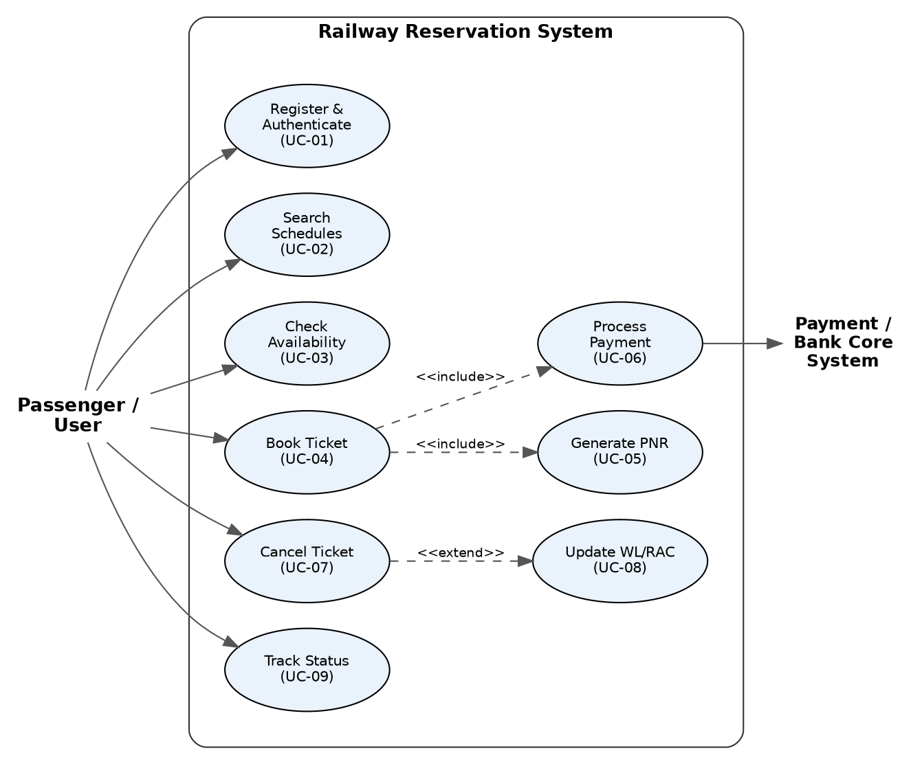
Actors: Passenger / User, Payment / Bank Core System. Booking (UC-04) includes Generate PNR (UC-05) and Process Payment (UC-06), which associates with the external Payment/Bank Core actor. Cancel Ticket (UC-07) extends to Update WL/RAC (UC-08) to trigger the FIFO promotion cascade.

Diagram 2: Railway Operations, Counter Clerk & Administration
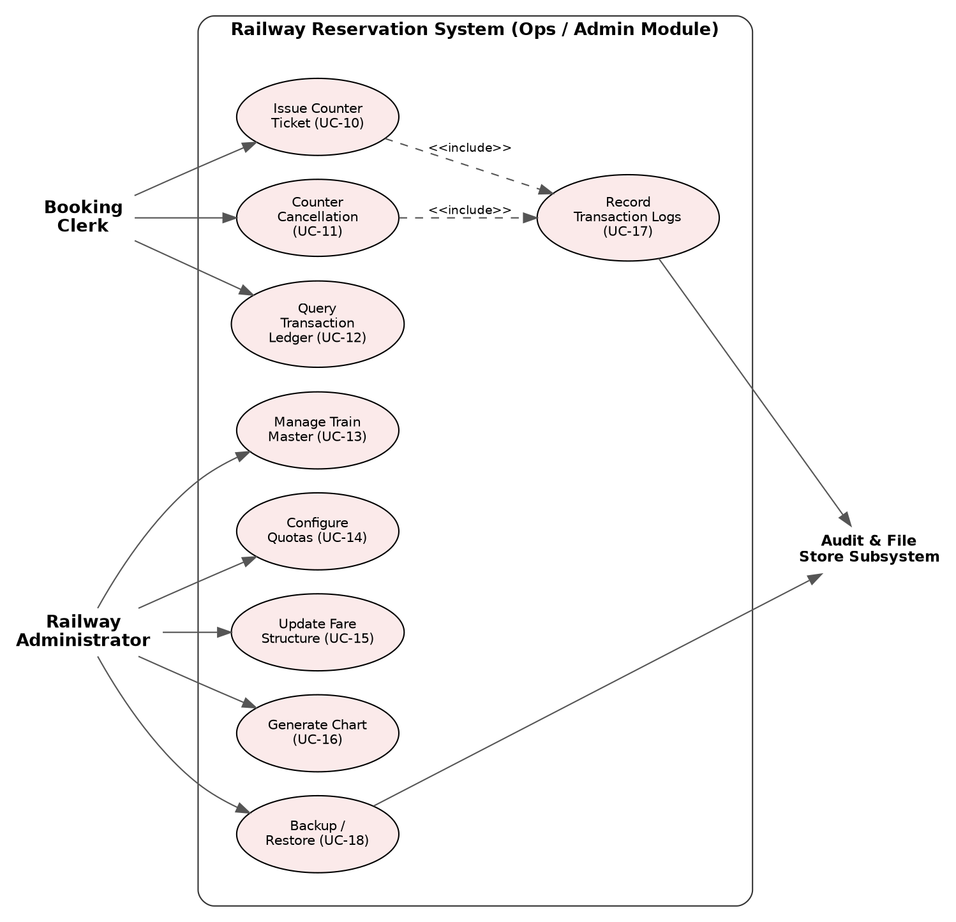
Actors: Booking Clerk, Railway Administrator, Audit & File Store Subsystem. Issue Counter Ticket (UC-10) and Counter Cancellation (UC-11) both include Record Transaction Logs (UC-17), which writes to the Audit & File Store Subsystem, as does Backup/Restore (UC-18).

8. Requirements Traceability Matrix (RTM)
Status uses N = Not yet tested, P = In progress, A = Accepted/passed.
As this SRS precedes implementation, all items are marked N.
Req ID | Requirement (short) | Section ref | Module | Test case(s) | Status (N/P/A) | Comments
RRS-F-001 | User Authentication | 4.1 | AuthModule | TC-Auth-01 | N
RRS-F-002 | Password Masking | 4.1 | TerminalUI | TC-Auth-02 | N
RRS-F-003 | Passenger Registration | 4.1 | UserStore | TC-Auth-03 | N
RRS-F-004 | Train Schedule Search | 4.2 | CatalogModule | TC-Inq-01 | N
RRS-F-005 | Intermediate Timetable | 4.2 | CatalogModule | TC-Inq-02 | N
RRS-F-006 | Real-Time Availability | 4.2 | InventoryEngine | TC-Inq-03 | N
RRS-F-007 | Multi-Passenger Form | 4.3 | BookingEngine | TC-Book-01 | N
RRS-F-008 | Dynamic Tariff | 4.3 | TariffModule | TC-Book-02 | N
RRS-F-009 | Seat Hierarchy | 4.3 | InventoryEngine | TC-Book-03 | N
RRS-F-010 | Berth Allocation | 4.3 | BerthAllocator | TC-Book-04 | N
RRS-F-011 | 10-Digit PNR | 4.3 | PNRGenerator | TC-Book-05 | N
RRS-F-012 | Atomic Transaction | 4.3 | TransactionStore | TC-Book-06 | N
RRS-F-013 | E-Ticket Receipt | 4.3 | ReportingModule | TC-Book-07 | N
RRS-F-014 | Cancellation | 4.4 | BookingEngine | TC-Canc-01 | N
RRS-F-015 | Refund Slabs | 4.4 | TariffModule | TC-Canc-02 | N
RRS-F-016 | Queue Cascade | 4.4 | CascadeEngine | TC-Canc-03 | N
RRS-F-017 | Train Route Onboarding | 4.5 | CatalogModule | TC-Adm-01 | N
RRS-F-018 | Quota Configuration | 4.5 | InventoryEngine | TC-Adm-02 | N
RRS-F-019 | Pricing Updates | 4.5 | TariffModule | TC-Adm-03 | N
RRS-F-020 | Manifest Charting | 4.5 | ReportingModule | TC-Chart-01 | N
RRS-F-021 | Accounting Ledger | 4.5 | LedgerModule | TC-Rep-01 | N
RRS-NF-001 | Search Latency | 5 | CatalogModule | TC-Perf-01 | N
RRS-NF-002 | Booking Latency | 5 | BookingEngine | TC-Perf-02 | N
RRS-NF-003 | Crash Durability | 5 | FileStore | TC-Rel-01 | N
RRS-NF-004 | Concurrency Safety | 5 | TransactionStore | TC-Conc-01 | N
RRS-NF-005 | Clean Compile | 5 | CoreEngine | TC-Port-01 | N
RRS-NF-006 | Clerk Booking Time | 5 | TerminalUI | TC-UX-01 | N
RRS-SR-001 | Salted SHA-256 | 5.1 | CryptoModule | TC-Sec-01 | N
RRS-SR-002 | RBAC | 5.1 | SecurityManager | TC-Sec-02 | N
RRS-SR-003 | Buffer Protections | 5.1 | InputSanitizer | TC-Sec-03 | N
RRS-SR-004 | Audit Log | 5.1 | AuditLogger | TC-Sec-04 | N
RRS-SR-005 | PNR Checksum | 5.1 | PNRGenerator | TC-Sec-05 | N

