ZEDPATH
Team Kestrel · IntelliCon '26 Buildathon
ZP-DOC-01
Vision and Scope
Business requirements, product vision, scope boundaries and business context
Version | 0.9
Status | In review
Date | 5 October 2026
Classification | Public
Document owner | B.M.P Banneka, Product Owner
© 2026 Team Kestrel. Published under the classification shown above.
Uncontrolled when printed or exported. The controlled version is the Markdown source in the repository: docs/01-vision-and-scope/ZP-DOC-01_Vision-and-Scope.md

Document control
Document information
Document ID | ZP-DOC-01
Title | Vision and Scope
Version | 0.9
Status | In review
Classification | Public
Document owner | B.M.P Banneka, Product Owner
Author | Team Kestrel (drafted with Claude, AI coding partner)
Conforms to | Vision and scope document template (K. Wiegers and J. Beatty, Software Requirements, 3rd ed.); ZP-DOC-00
Source file | docs/01-vision-and-scope/ZP-DOC-01_Vision-and-Scope.md
Repository | https://github.com/PraveenBanneka/zedpath

Revision history
Version | Date | Author | Description of change
0.9 | 5 Oct 2026 | Team Kestrel | First issue, derived from the Gate 1 Problem and Proof deck; submitted for approval

Review and approval
This document takes effect when the approver signs below. Until then its status is as shown on the cover.
Role | Name | Signature | Date
Reviewer | Claude (AI coding partner), consistency and traceability review
Approver | B.M.P Banneka, Product Owner

Contents
1 Introduction 5
1.1 Purpose 5
1.2 Scope 5
1.3 Intended audience 5
1.4 Relationship to other documents 5
2 Business requirements 6
2.1 Background 6
2.2 Business opportunity 6
2.3 Business objectives 6
2.4 Market size 7
2.5 Success metrics 7
2.6 Vision statement 7
2.7 Business risks 7
2.8 Assumptions and dependencies 8
3 Scope and limitations 9
3.1 Major features 9
3.2 Scope of initial and subsequent releases 9
3.3 Limitations and exclusions 10
4 Business context 11
4.1 Stakeholder profiles 11
4.2 Project priorities 11
4.3 Deployment considerations 11
Appendix A: Glossary 12
Appendix B: References 13

List of figures
Figure 1: ZedPath system context (C4 model, level 1) 10

List of tables
Table 1: Position of this document in the ZedPath document set 5
Table 2: Business objectives and how each is measured 6
Table 3: Market sizing from the Gate 1 deck 7
Table 4: Business risks, their likelihood and impact, and mitigations 7
Table 5: Assumptions (AS) and dependencies (DE) 8
Table 6: Major features 9
Table 7: Release scope by feature (story counts and points from ZP-DOC-02) 9
Table 8: Stakeholders, their interests and constraints 11
Table 9: Project priorities (constraint = fixed; driver = key success goal; degree of freedom = may be adjusted) 11
Table 10: Terms and abbreviations used in this document 12
Table 11: Sources referred to in this document 13

1 Introduction

1.1 Purpose
This document states why ZedPath is being built, what it will and will not do, and how its success will be judged. It is the parent of every other ZedPath document: user stories (ZP-DOC-02) refine its features, and the requirements specification (ZP-DOC-03) makes them precise.

1.2 Scope
It covers the business requirements, the product vision, the scope of the first two releases, and the business context (stakeholders, priorities, risks and deployment constraints). Technical design is out of scope.

1.3 Intended audience
The product owner, buildathon judges and mentors, and anyone deciding whether ZedPath is worth building.

1.4 Relationship to other documents
Table 1: Position of this document in the ZedPath document set
Document | Relationship
Gate 1 Problem and Proof deck | Source. Evidence, market sizing and the three-week plan come from it
ZP-DOC-02 User Stories | Child. Each feature FE-n below is refined into the stories of epic EPn
ZP-DOC-03 Software Requirements Specification | Child. Business objectives become measurable quality requirements
ZP-DOC-06 Software Architecture | Child. The deployment constraints below bind the architecture

2 Business requirements

2.1 Background
Every year about 275,000 students sit the G.C.E. Advanced Level (A/L) examination in Sri Lanka. In 2025, 281,810 sat the examination, 176,527 qualified for university admission, and there were 42,937 state-university places for the 2025/26 intake [1][2].
Within a few weeks of results, each student must decide. Students aiming for a state university must choose and rank up to 125 course preferences under rules published in a handbook of more than 200 pages that changes every year, inside a three-week application window. Because places are limited, most also need a backup: a private or non-state degree, study abroad, a government job examination announced in the Gazette, a vocational course, or sitting the examination again. Each path has its own rules, calendar and website.
Gate 1 research (six interviews, E1 to E6, and a hands-on test of four existing tools, T1) found one pattern: students decide mostly on hearsay from tuition teachers, seniors and social-media groups. A badly ordered preference list, an ineligible choice, a missed deadline or a path never heard of can cost a year. The National Education Commission reached the same conclusion: most students and parents are unaware of alternative education and career options [3].

2.2 Business opportunity
No existing tool combines the student's own results, every path they can reach and dated deadlines in one place. The tools tested (findmydegree.lk, Unicompass, induwara.lk, ThuSh LK) compare a Z-score with cut-offs, but none checks subject and grade rules, preference order or deadlines, and none covers routes outside the University Grants Commission (UGC) [4].
Two developments make a better tool feasible now:
- AI that reads documents. Language models can turn a 200-page handbook and weekly Gazette PDFs into structured, page-cited rules, which previously needed manual re-coding every year.
- A free global edge platform. Cloudflare's free plan provides hosting, database, storage, scheduled jobs, queues and AI inference at zero cost, close to users in Sri Lanka.

2.3 Business objectives
Table 2: Business objectives and how each is measured
ID | Objective | Measure and target
BO-1 | Reach students in the first admission cycle | 10,000 students use ZedPath in year one (serviceable obtainable market)
BO-2 | Make every fact checkable | 100% of displayed cut-offs, rules, dates and fees link to an official source
BO-3 | Let a student plan alone | A first-time user goes from entering results to a checked preference list in under 10 minutes without help
BO-4 | Prevent costly mistakes | Every ordering mistake defined in ZP-DOC-03 is detected in test, with no false "safe" claims
BO-5 | Show every path | All seven route groups (state, private, diploma, professional, vocational, job exam, abroad) are covered for every A/L stream
BO-6 | Operate at zero cost | Year-one hosting and inference stay within the Cloudflare free plan and free AI tiers

2.4 Market size
Table 3: Market sizing from the Gate 1 deck
Measure | Estimate | Basis
Total addressable market | about 275,000 students a year | All A/L candidates face an after-results choice (269,613 sat in 2023; 281,810 in 2025) [1]
Serviceable available market | about 105,000 | Students who qualify (176,527 in 2025) × about 60% who use the internet [5]
Serviceable obtainable market (year one) | about 10,000 | Tuition teachers, A/L Facebook groups, Telegram channels and word of mouth; to be validated

2.5 Success metrics
- Adoption: unique students per admission cycle (target BO-1); returning visits after results day.
- Task success: share of usability-test participants who complete a checked preference list unaided (BO-3).
- Trust: reported mistakes per 1,000 facts, and median time to fix a reported mistake.
- Accuracy: share of AI-extracted rules on which the extractor and the independent checker agree; share approved without change by the curator.
- Cost: daily usage as a percentage of each free-plan limit (BO-6).

2.6 Vision statement
For Sri Lankan students between A/L results and their next step, who must choose among a state university, private degrees, job examinations and other routes within weeks and mostly on hearsay, ZedPath is a free, mobile-first guide that shows every path their own results can reach, with dated deadlines and answers that cite the official source, in Sinhala, Tamil and English. Unlike cut-off lookup sites and social-media groups, ZedPath checks subject and grade rules, preference order and deadlines, covers routes outside the UGC, and never states a fact without its source.

2.7 Business risks
Table 4: Business risks, their likelihood and impact, and mitigations
ID | Risk | Likelihood | Impact | Mitigation
RK-01 | A wrong rule or cut-off leads a student to a costly decision | Medium | High | Every fact sourced and dated; two-model check; human review of uncertain facts; one-tap mistake reports; wording never promises admission
RK-02 | Official sources change format or are published late | High | Medium | Source registry with fingerprints; extraction re-run per edition; dates shown as estimated until confirmed
RK-03 | Traffic spike on results day exhausts free-plan limits | Medium | High | Static front end served free; API responses cached; per-client rate limits; budget in ZP-DOC-06
RK-04 | AI answers are wrong or poorly translated in Sinhala or Tamil | Medium | High | Answers grounded only in stored sources; refuse when unsupported; native-speaker review of interface text
RK-05 | ZedPath is mistaken for an official UGC service | Low | Medium | Clear independence notice on every page; no UGC branding
RK-06 | A single developer cannot finish R1 by 11 October 2026 | Medium | High | Walking skeleton first; MoSCoW release plan; AI-assisted development; R2 holds deferrable stories
RK-07 | Personal data of students (many are minors) is exposed | Low | High | No account to explore; profile kept on the device; photos deleted after reading; opt-in only

2.8 Assumptions and dependencies
Table 5: Assumptions (AS) and dependencies (DE)
ID | Statement
AS-1 | The UGC continues to publish its admission handbook and cut-off tables as public documents each year
AS-2 | Government Gazette issues remain publicly available online each week
AS-3 | Target students have a smartphone with a modern browser and some mobile data
AS-4 | Cloudflare free-plan limits remain as verified on 5 October 2026 (recorded in ZP-DOC-06)
DE-1 | The UGC handbook and cut-off table for the 2025/26 intake (received 5 October 2026)
DE-2 | Cut-off tables for at least three earlier intakes, needed for Safe/Likely/Reach bands (US-203)
DE-3 | A free tier of the Google Gemini API, accessed through Cloudflare AI Gateway (to be verified in ZP-DOC-06)

3 Scope and limitations

3.1 Major features
Each feature corresponds to one epic in ZP-DOC-02.
Table 6: Major features
ID | Feature | Epic
FE-1 | Enter results once (typed, estimated or read from a photo), in three languages | EP1
FE-2 | Eligible state-university courses with Safe/Likely/Reach bands, reasons for hidden courses, and sourced course pages | EP2
FE-3 | Preference-list builder that detects ordering mistakes and copies uni-codes | EP3
FE-4 | Journey with confirmed and estimated deadlines, aptitude tests and reminders | EP4
FE-5 | Every other route matched to the student's results, with Gazette job-exam alerts | EP5
FE-6 | Ask: cited answers in Sinhala, Tamil and English that refuse to guess | EP6
FE-7 | Family share card, verified seniors, groups and a teacher view | EP7
FE-8 | After selection: registration, Mahapola, gap-year plan, documents | EP8
FE-9 | Data and trust: source registry, AI extraction with two-model check, review queue, mistake reports | EP9

3.2 Scope of initial and subsequent releases
Table 7: Release scope by feature (story counts and points from ZP-DOC-02)
Feature | Release R1, Gate 3 (11 October 2026) | Release R2, after the buildathon
FE-1 | All 5 stories | None
FE-2 | 7 stories: eligibility, bands, course page, filters, dream course, compare | Cost of living
FE-3 | All 4 stories | None
FE-4 | Journey, confirmed and estimated dates, aptitude tests, reminders | Special intake, custom steps
FE-5 | Route matcher, route details, Gazette alerts, retry | Recognition check, loan scheme, scholarships
FE-6 | Ask in three languages, citations, no predictions | Actions under answers
FE-7 | Family share card | Seniors, groups, teacher view
FE-8 | None | All 4 stories
FE-9 | All 7 stories | None
Total | 35 stories, 122 points | 15 stories, 54 points

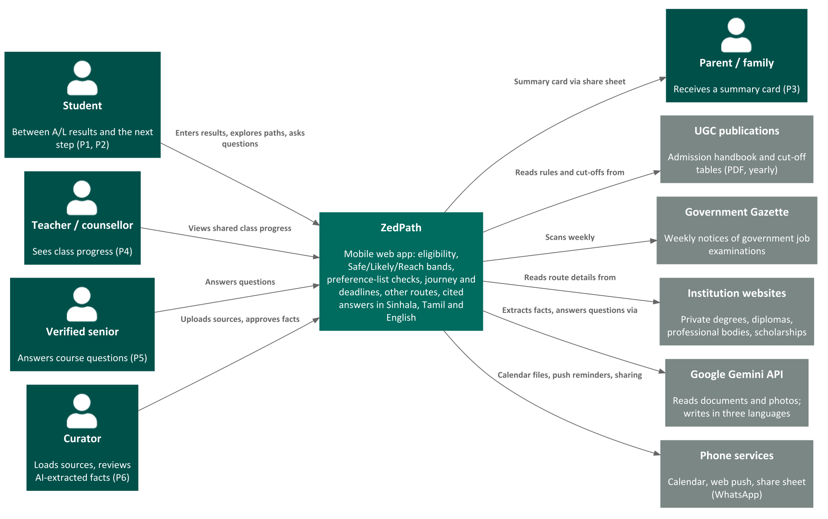
Figure 1: ZedPath system context (C4 model, level 1)

3.3 Limitations and exclusions
ZedPath will not:
- submit applications or any data to the UGC or to any institution; it prepares the student to do so;
- predict future cut-offs or promise admission;
- accept payment for placement or ranking from any institution;
- send SMS, WhatsApp or email messages (not free on the chosen platform); reminders use calendar files and web push;
- require an account to explore, or store a student's results on the server without consent;
- keep results photos after they are read;
- cover postgraduate study or routes that do not start from A/L results;
- be a native mobile app in R1; it is a mobile web app that can be added to the home screen.

4 Business context

4.1 Stakeholder profiles
Table 8: Stakeholders, their interests and constraints
Stakeholder | Main value to them | Attitude and interests | Constraints
Students (P1, P2) | Every reachable path, no costly mistakes | Anxious, time-pressed; trust peers more than institutions | Mobile data cost; language; low-end phones
Parents (P3) | A clear summary in their language | Want certainty about cost and recognition | Limited English; not app users
Teachers and counsellors (P4) | See who needs help before deadlines | Supportive; overloaded | No time for manual tracking
Verified seniors (P5) | A safe place to help juniors | Willing if protected from abuse | Must prove enrolment
Curator / product owner (P6) | Accurate data with little effort | Accountable for every published fact | One person in year one
UGC and Department of Examinations | Students who apply correctly | Publishers of the data, not partners | ZedPath must not appear official
Buildathon judges and mentors | Evidence of a real problem and a working, well-engineered solution | Assess Gates 1 to 3 | Gate 3 due 11 October 2026

4.2 Project priorities
Table 9: Project priorities (constraint = fixed; driver = key success goal; degree of freedom = may be adjusted)
Dimension | Role | Explanation
Schedule | Constraint | Gate 3 submission is due on 11 October 2026
Cost | Constraint | Zero cash budget: Cloudflare free plan and free AI tiers only
Staff | Constraint | One developer (the product owner) with Claude as AI coding partner
Quality | Driver | Accuracy and sourcing of every fact matter more than feature count
Features | Degree of freedom | Could and Should stories move between R1 and R2 to protect quality and schedule

4.3 Deployment considerations
- ZedPath is a mobile web application delivered from Cloudflare's global network, so it needs no installation and loads quickly on Sri Lankan mobile networks.
- It must run entirely within the Cloudflare free plan; ZP-DOC-06 records the verified limits and the usage budget for each service.
- Interface text must render correctly in Sinhala and Tamil scripts on common Android phones.
- Official source documents are stored privately by ZedPath and cited, not redistributed.

Appendix A: Glossary
Table 10: Terms and abbreviations used in this document
Term | Meaning
A/L | G.C.E. Advanced Level examination
C4 model | A set of architecture diagrams at four levels; level 1, System Context, shows the system and its surroundings
Gazette | The Government Gazette of Sri Lanka, which announces government job examinations
SAM, SOM, TAM | Serviceable available market, serviceable obtainable market, total addressable market
UGC | University Grants Commission of Sri Lanka
Z-score | A standardised score combining a student's three A/L subject results; used for university selection

Appendix B: References
Table 11: Sources referred to in this document
Ref | Source
[1] | Department of Examinations, Sri Lanka, G.C.E. (A/L) Performance of Candidates, 2023 and 2025
[2] | University Grants Commission, University Admission 2025/2026
[3] | National Education Commission, Study on Career Guidance in General Education in Sri Lanka, Research Series No. 08, 2014
[4] | Team Kestrel, Gate 1 Problem and Proof, IntelliCon '26 Buildathon, September 2026 (tool test of 27 September 2026)
[5] | DataReportal, Digital 2026: Sri Lanka
[6] | K. Wiegers and J. Beatty, Software Requirements, 3rd edition, Microsoft Press, 2013
[7] | G. Moore, Crossing the Chasm, HarperBusiness (vision statement template)

