ZEDPATH
Team Kestrel · IntelliCon '26 Buildathon
ZP-DOC-06
Software Architecture
Context, containers, components, runtime flows, security, free-plan budget and architecture decisions
Version | 0.9
Status | In review
Date | 15 October 2026
Classification | Public
Document owner | B.M.P Banneka, Product Owner
© 2026 Team Kestrel. Published under the classification shown above.
Uncontrolled when printed or exported. The controlled version is the Markdown source in the repository: docs/06-architecture/ZP-DOC-06_Architecture.md

Document control
Document information
Document ID | ZP-DOC-06
Title | Software Architecture
Version | 0.9
Status | In review
Classification | Public
Document owner | B.M.P Banneka, Product Owner
Author | Team Kestrel (drafted with Claude, AI coding partner)
Conforms to | C4 model (levels 1 to 3) for structure; UML 2.5.1 sequence diagrams for behaviour; Architecture Decision Records (Nygard format); ZP-DOC-00
Source file | docs/06-architecture/ZP-DOC-06_Architecture.md
Repository | https://github.com/PraveenBanneka/zedpath

Revision history
Version | Date | Author | Description of change
0.9 | 11 Oct 2026 | Team Kestrel | First issue: architecture as deployed, verified against wrangler.jsonc, worker/, src/, shared/ and migrations 0001 to 0010; six ADRs; free-plan budget; submitted for approval
0.9 | 15 Oct 2026 | Team Kestrel | Revised in review for CR-007 to CR-010: demo route `POST /api/auth/demo` and migration 0011; university-facts and aptitude read models on the course page; weak-ETag revalidation (D-05); `crossSite()` shared by every write route (D-03); group-socket kick path on log out, log out everywhere, recovery and leaving; research block list by page fingerprint; the hardening of security audit run-1 (account write budget, IPv6 /64 network limits, whole-service Ask cap, feedback cap and retention, demo cap, report weighting, post-attempt and socket limits, normalised contact filter, rooms an account opened purged on deletion via migration 0012, owner-tagged local data); security controls and the summary of audit run-1; ADR-07 and ADR-08; ADR-02 updated; risks R-08 to R-10; verified against the code at commit f704d0b

Review and approval
This document takes effect when the approver signs below. Until then its status is as shown on the cover.
Role | Name | Signature | Date
Reviewer | Claude (AI coding partner), consistency and traceability review
Approver | B.M.P Banneka, Product Owner

Contents
1 Introduction 5
1.1 Purpose 5
1.2 Scope 5
1.3 Intended audience 5
1.4 Relationship to other documents 5
2 Architectural drivers 6
2.1 Constraints 6
2.2 Quality attributes 6
3 System context 8
4 Container and deployment view 9
5 Component view 11
5.1 Worker modules 11
5.2 Client screens 12
5.3 Shared rule engine 12
5.4 Offline data pipeline 12
6 Key runtime flows 13
6.1 Results to bands 13
6.2 Ask with citations 13
6.3 Joining a group, rules accepted once 14
6.4 Journey step window (409) 14
6.5 Try the demo (CR-007) 14
6.6 Ending a session closes open chats (CR-010) 14
6.7 Course page: university facts and aptitude test (CR-008, CR-009) 15
7 Security 16
8 Free-plan budget 18
9 Architecture decision records 19
10 Deployment and rollback 22
11 Risks 23
Appendix A: Traceability: requirements to architecture 24
Appendix B: Glossary 25
Appendix C: References 26

List of figures
Figure 1: C4 container view of ZedPath as deployed 9
Figure 2: Ask ZedPath: retrieval, engine facts and generation with model fallback 13

List of tables
Table 1: Position of this document in the ZedPath document set 5
Table 2: Binding constraints (from ZP-DOC-03) 6
Table 3: Non-functional requirements that shape the architecture 6
Table 4: External systems and what crosses each boundary 8
Table 5: Containers and bindings (from wrangler.jsonc) 9
Table 6: Worker components (worker/) 11
Table 7: Security controls 16
Table 8: Daily budget on the Cloudflare free plan (limits verified 5 October 2026) 18
Table 9: ADR-01 Vite + React SPA on static assets with a Hono API, instead of Next.js SSR 19
Table 10: ADR-02 Read model compiled into the Worker for rules, cut-offs, routes and Journey dates 19
Table 11: ADR-03 Durable Objects for group chat 19
Table 12: ADR-04 Password key derived on the device 19
Table 13: ADR-05 Expand-then-contract database migrations 20
Table 14: ADR-06 Preset avatars generated at build time 20
Table 15: ADR-07 Demo as a private throwaway account, marked by an attribute of ACCOUNT 20
Table 16: ADR-08 Blocked research pages stored as fingerprints, not addresses 20
Table 17: Release runbook 22
Table 18: Architectural risks 23
Table 19: Requirements traced to architectural elements 24
Table 20: Terms used in this document 25
Table 21: Sources referred to in this document 26

1 Introduction

1.1 Purpose
This document describes how ZedPath is built and deployed: the parts of the system, how they talk to each other, why each major choice was made, and how the system stays inside the Cloudflare free plan. It is written from the code as deployed, not from intentions; where something is designed but not yet running, it says so.

1.2 Scope
The whole of Releases R1 and R2: the web application (also installable as a progressive web app and wrapped by the Android app), the single Cloudflare Worker that serves it and its API, the data and AI services that Worker binds to, the offline data pipeline that compiles the read model, and the release and safety tooling around deployment.

1.3 Intended audience
Developers, reviewers and buildathon judges assessing how the system works and whether it is sound.

1.4 Relationship to other documents
Table 1: Position of this document in the ZedPath document set
Document | Relationship
ZP-DOC-01 Vision and Scope | Grandparent. Business objectives BO-1 and BO-6 (free to run, at scale) shape the platform choice
ZP-DOC-02 User Stories | Grandparent. Stories US-101 to US-204 define the walking skeleton built first
ZP-DOC-03 SRS | Parent. Constraints CON-1 to CON-5 and the non-functional requirements NFR-001 to NFR-080 are the architectural drivers
ZP-DOC-04 Use Case Model | Parent. Use-case flows become the runtime flows of Section 6
ZP-DOC-05 Data Design | Sibling. Owns the D1 schema; this document decides how the read and write paths use it
ZP-DOC-07 UI/UX, ZP-DOC-08 Test Plan | Children. Screens built on the components here; tests that prove the NFRs

2 Architectural drivers

2.1 Constraints
Table 2: Binding constraints (from ZP-DOC-03)
ID | Constraint | Architectural consequence
CON-1 | Cloudflare free plan only | 10 ms CPU per request, 100,000 Worker requests a day, Workers AI 10,000 neurons a day; static assets free and unlimited. Every choice below is checked against these
CON-2 | TypeScript everywhere | One language across client, Worker, shared rule engine and tooling; types in shared/ are imported by both sides
CON-3 | Material Design 3 | React components styled to MD3 tokens; no heavy UI framework (keeps NFR-006)
CON-4 | No email, SMS or WhatsApp | Reminders are local notifications on the device (PWA and Android); account recovery uses a recovery code, not email
CON-5 | Official documents cited, not redistributed | The read model holds extracted facts with source and page; Ask returns citations, not files

2.2 Quality attributes
Table 3: Non-functional requirements that shape the architecture
NFR | Requirement (summary) | How the architecture meets it
NFR-003, NFR-005 | API under 500 ms; under 10 ms CPU per request | Eligibility and bands computed from a read model compiled into the Worker (no database round trip); D1 only for account data (ADR-01, ADR-02)
NFR-007 | Revalidate instead of re-download | One ETag per build of the read models; If-None-Match compared after stripping the weak prefix W/ that compression adds, so 304 is answered (test-campaign finding D-05)
NFR-010, NFR-011 | 10,000 students per cycle; quotas below 70% on a typical day | Free-plan budget, Section 8
NFR-012 | Page navigation uses no Worker requests | Static assets with run_worker_first limited to /api/*; SPA fallback for every other path
NFR-006, NFR-063 | Small first download; runs in any browser, installable | Vite + React SPA, code split; service worker public/sw.js caches the shell
NFR-033 | Secrets never in source | Wrangler secrets (GEMINI_API_KEY, PEPPER); .dev.vars locally, gitignored; pre-push leak scan
NFR-034, NFR-037 | Ask and sign-in limits | Workers Rate Limiting bindings plus a daily allowance in D1 keyed by salted hashes
NFR-035, NFR-038 | Validation and rules enforced on the server | Every write re-checked in the Worker; bound parameters only; 4xx with a field name on rejection
NFR-036 | Password never leaves the device | PBKDF2-SHA256, 600,000 iterations, on the phone; server stores SHA-256 of the derived key (ADR-04)
NFR-039 | Moderation fails closed | GroupRoom calls llama-guard before posting; unreadable verdict means not posted
NFR-040 | Core browsing works without AI | AI is reached only by /api/ask and group posting; results, courses, list and Journey never call it
NFR-043 | Idle group connection stays open | WebSocket hibernation with a ping/pong auto-response that does not wake the room (ADR-03)
NFR-054 | No data links a page blocked during research | Blocked pages kept as SHA-256 fingerprints in tools/research/blocked-pages.ts; data test DAT-054 scans every URL in data/ and the compiled rulebook (ADR-08)
NFR-076 | Cross-site, "null" and malformed Origins refused with 403 | One function, crossSite() in worker/account.ts, used by the account, Journey and group middleware and by both Ask routes; a URL that cannot be parsed counts as cross-site
NFR-077 | No chat outlives its session or membership | kickFromRooms() asks each affected GroupRoom to close the sockets opened under the session or by the member (Section 6.6)
NFR-081, NFR-082 | Per-account and per-network limits | accountBudget middleware (100 writes a minute per account, on the IP_LIMITER binding with an account key) on /me, /me/*, groups and blocks; ipBucket() keys IPv6 clients by their /64 network
NFR-083 | Developer tools unreachable from outside | Ask /dev/* answers only on localhost with DEV_TOOLS=1 and refuses a cross-site call even there
NFR-050, NFR-051 | Every fact cited; exact cut-offs | Read model carries source and page per fact; Z-scores stored as integers in ten-thousandths
NFR-060, NFR-062 | Rules as tested pure functions; new year without code changes | Rule engine in shared/ (pure, unit tested); the yearly read model is regenerated by tools/

3 System context
ZedPath has one human actor in production, the student (with a senior variant who joins groups by invitation). It depends on three external systems: Cloudflare (hosting, data, AI), Google AI Studio (Gemini models, reached only through Cloudflare AI Gateway) and GitHub (public source repository). The University Grants Commission (UGC) is a source of data, not a runtime dependency: its handbook and cut-off tables are processed offline into the read model.
Table 4: External systems and what crosses each boundary
External system | Direction | What crosses | Protection
Student's browser or Android app | In | HTTPS requests, WebSocket for group chat | Rate limits, session cookie, server-side validation
Google AI Studio (Gemini) | Out | Question, retrieved passages, engine facts (no name, contact or account id) | Through AI Gateway; key held as a Worker secret; payload logging off
GitHub | Out (developer only) | Source code | Pre-push leak scan of every new commit
UGC publications | Offline input | Handbook and cut-off PDFs | Processed on the developer laptop; facts verified by two extraction methods (NFR-052)

4 Container and deployment view
All server-side code is one Cloudflare Worker named zedpath. It serves the built single-page application as static assets and runs a Hono API only for paths under /api/. Everything else it needs is a binding declared in wrangler.jsonc.
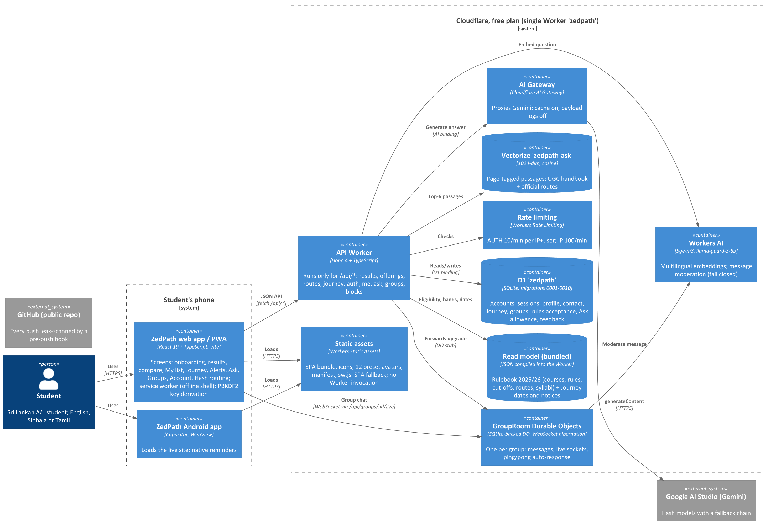
Figure 1: C4 container view of ZedPath as deployed
Table 5: Containers and bindings (from wrangler.jsonc)
Container | Technology | Binding | Role
Web app / PWA | React 19, TypeScript, Vite; hash routing; service worker | (static assets) | All screens; keeps the preference list and compare on the device; derives the password key
Android app | Capacitor WebView | (loads the live site) | Same app in its own window; native reminders
Static assets | Workers Static Assets | assets (SPA fallback, run_worker_first: /api/*) | Serves the bundle, icons, 12 preset avatars, manifest, sw.js; free and unlimited
API | Hono 4 on Workers | main: worker/index.ts | JSON API; mounts account, Journey, Ask and group routes
Read model | JSON compiled into the Worker | (bundled) | worker/generated/rulebook-2025-2026.json and journey-2025-2026.json: courses, rules, five years of cut-offs, routes, syllabi, Journey dates and notices. Added 15 October 2026: worker/generated/statistics-2024.json (university facts, CR-008) and data/aptitude/aptitude-2025-2026.json (aptitude notices, CR-009)
Database | Cloudflare D1 (SQLite) | DB | Accounts (including demo accounts, CR-007), sessions, profile, contact, Journey, groups, rules acceptance, Ask allowance, answer feedback (migrations 0001 to 0012; 0012 adds group_room_seen, the rooms an account opened)
Group rooms | Durable Objects, SQLite storage | GROUP_ROOM (class GroupRoom) | One object per group: messages and live WebSockets, with hibernation
Embeddings and moderation | Workers AI | AI | @cf/baai/bge-m3 (multilingual, 1024 dimensions); @cf/meta/llama-guard-3-8b for messages
Retrieval index | Vectorize zedpath-ask | ASK_INDEX | Page-tagged passages from the UGC handbook and official routes; cosine
Model gateway | AI Gateway | via AI.gateway() | Proxies Gemini; cache on; payload logs off
Rate limiting | Workers Rate Limiting | AUTH_LIMITER, IP_LIMITER | 10 a minute per IP and username; 100 a minute per IP

Scheduled jobs. ZP-DOC-03 provides for a weekly Cron job to check the Gazette and official notices. In this release no Cron trigger is configured: Journey dates and notices are compiled into the read model by tools/journey and shipped with each deploy (ADR-02). The Cron job is planned (Risk R-05).

5 Component view

5.1 Worker modules
Table 6: Worker components (worker/)
Module | Routes | Responsibility
index.ts | GET /health, /meta, POST /results, GET /offerings/:uniCode, /routes, /journey | Read path: eligibility and Safe/Likely/Reach bands from the bundled read model; the course detail adds the institution's university facts (facts) and, for offerings with a test, the aptitude notice (aptitude); ETag caching keyed to the rulebook, syllabus, Journey and statistics builds, with weak ETags accepted
account.ts | /auth/salt, /auth/signup, /auth/login, /auth/recover, /auth/demo, /auth/logout(-all), GET/PUT/DELETE /me, /me/contact, /me/avatar | Accounts and sessions; the /me/* session middleware; crossSite() and the sameOrigin middleware; accountBudget and ipBucket() (CR-010); the demo account with its cap of 500 and bounded clean-up (CR-007, CR-010); kickFromRooms(), which closes group sockets when a session or membership ends (CR-010); full account deletion including every group room the account is in or ever opened (group_room_seen, CR-010)
my-journey.ts | /me/journey, /me/journey/courses/:uni, /notices/:route, /notices/:route/applied, /steps/:stepId | The student's Journey on the account; step and notice windows enforced (409)
ask.ts | POST /ask, /ask/feedback; localhost-only /dev/* | Retrieval, engine facts, Gemini generation with fallback, reply guard, daily allowance per device and network plus a whole-service cap of 3,000 questions a day; feedback capped at 2,000 a day and kept one year; both routes, and the developer tools, refuse cross-site requests through crossSite()
groups.ts | /groups, /groups/join, /groups/:id, /leave, /live, /members, /report, /blocks | Membership and rules acceptance in D1; forwards the WebSocket upgrade to the room with the session hash and a read-only flag for demo accounts; refuses group creation and reports by demo accounts; counts toward hiding only reports from accounts at least a day old and not demo; records each room opened in group_room_seen; rate-limits /live per account
group-room.ts | (Durable Object) | Message storage, moderation, broadcast, hibernation, ping/pong; refuses posts on read-only sockets; counts post attempts before moderation (20 per 10 minutes); keeps at most three sockets per account; refuses contact details by looksLikeContact() in shared/groups.ts, which also checks a normalised copy; /kick closes the sockets of one session or of one account
rulebook.ts, syllabi.ts | (internal) | Load and index the read model; syllabus data and the blocked-hosts list

5.2 Client screens
The client (src/) is a Vite + React 19 SPA with hash routing, so every navigation stays on the static asset and never calls the Worker (NFR-012). Screens in src/screens/: Onboarding (results entry), Compare, MyList, Journey, Alerts, Ask, Groups, Syllabus and Account. src/i18n/ holds English, Sinhala and Tamil strings (NFR-023). src/pwa.ts registers the service worker; src/notify.ts schedules local reminders.

5.3 Shared rule engine
shared/ is imported by both the client and the Worker, so a rule exists exactly once. It holds the eligibility rules (rules.ts), banding to BR-030 to BR-036 (banding.ts, integer Z-scores), preference-list checks (list.ts), Journey windows (journey.ts), the key-derivation constants (kdf.ts, account.ts), group rules (groups.ts) and the API types (api.ts). Each has unit tests beside it (NFR-060, NFR-061). Added 15 October 2026: the sample student used by both demo paths (demo-data.ts, CR-007) and the types of the university facts (statistics.ts, CR-008).

5.4 Offline data pipeline
tools/ compiles verified data into the read model before a build (ADR-02). Added 15 October 2026: tools/statistics/build-statistics.ts compiles the double-checked extracts of the UGC report Sri Lanka University Statistics 2024 (data/ugc/statistics-2024/*.json, Chapters 2, 3, 4 and 7) into worker/generated/statistics-2024.json: 96 facts for 20 institutions, keyed by institution letter, each with its table, PDF page and link, and the report's caveats as flags. The aptitude notices (data/aptitude/aptitude-2025-2026.json: 13 official notices covering 22 Uni-Codes, and 2 Uni-Codes whose joint practical test is held at other universities) are imported by the Worker as they are. tools/research/check-url.ts tells a research agent whether a URL is on a blocked host or a blocked page before it is fetched (ADR-08).

6 Key runtime flows

6.1 Results to bands
- The student enters stream, subjects, grades, district and Z-score in Onboarding.
- The client posts the profile to POST /api/results.
- The Worker validates it (parseProfile), then for every offering in the bundled rulebook runs the eligibility rules and the banding function. No D1 read is involved, so the request stays well under 10 ms CPU.
- The response lists each offering with its band, years used, latest cut-off and trend, plus hidden offerings with the quoted reason and handbook page (NFR-050).

6.2 Ask with citations
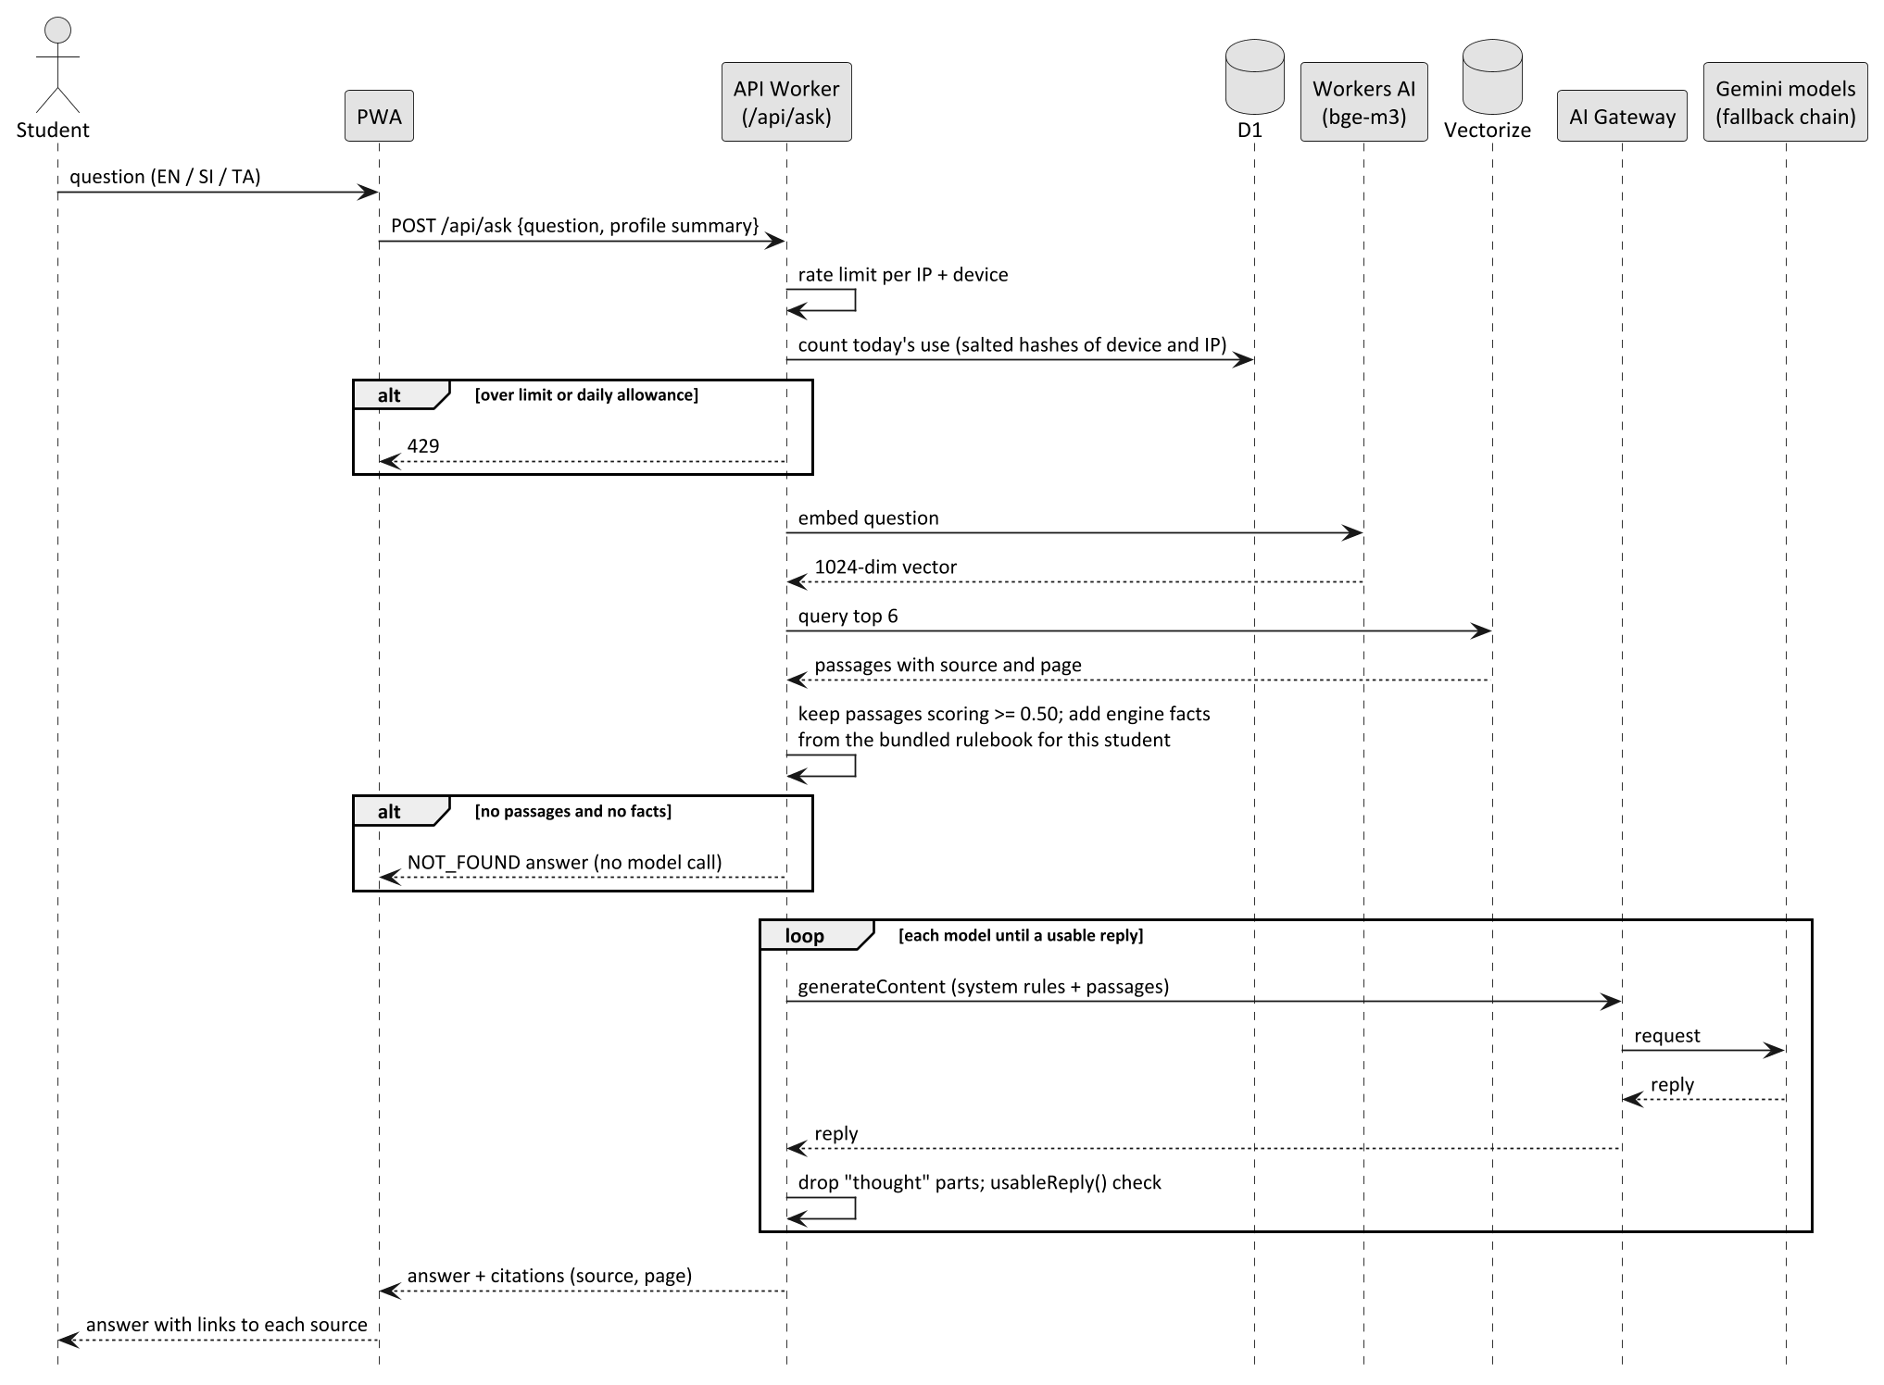
Figure 2: Ask ZedPath: retrieval, engine facts and generation with model fallback
Two guards matter. Passages below a similarity of 0.50 (calibrated on Sinhala and Tamil questions) are dropped, and when nothing relevant remains the Worker answers "not found" without calling a model. Each model reply passes usableReply(), which rejects a reply that talks about its own instructions; the next model in the chain (gemini-flash-latest, gemini-2.5-flash, gemini-flash-lite-latest, gemini-2.5-flash-lite) is then asked. A model that is missing, busy or out of quota (404, 429, 5xx) also falls through to the next.

6.3 Joining a group, rules accepted once
- The client posts POST /api/groups/join with the group kind and, the first time, acceptRules set to the current rules version.
- The Worker refuses (400) unless the rules are accepted in this request or were accepted before (group_rules_acceptance, one row per account and version).
- A batch group requires results saved to the account (403 otherwise).
- Group creation, rules acceptance and membership are written in one D1 batch with INSERT OR IGNORE, so a repeat join is harmless.
- GET /api/groups/:id/live checks membership, then forwards the WebSocket upgrade to the group's GroupRoom, with the username added by the Worker (the client cannot claim another name).

6.4 Journey step window (409)
A Journey step can be ticked done only once its official window has opened. The client greys the tick out, but the rule is enforced in PUT /api/me/journey/steps/:stepId: the Worker computes stepWindow() from the bundled Journey dates and Sri Lanka's date, and returns 409 "This step has not opened yet" if it is closed. I applied on a notice follows the same rule (409 before the notice opens; 404 if not followed). The same shared function drives the client, so the two cannot disagree (NFR-038).

6.5 Try the demo (CR-007)
- The Welcome screen posts POST /api/auth/demo (no body). The request passes sameOrigin and the log-in rate limits.
- The Worker deletes every account whose demo_expires_at has passed; the foreign keys cascade to every row under it. The partial index idx_account_demo_expires serves this without scanning real accounts (ZP-DOC-05, migration 0011).
- In one D1 batch it creates the account with demo_expires_at 24 hours ahead, a password_login row with a random username (demo_ and eight hexadecimal digits) and a random, unusable verifier, a session, and the sample student's contact, profile, achievements and interests from shared/demo-data.ts, normalised by the same functions as a sign-up.
- It sets the session cookie for 24 hours and answers 201 with the account, flagged demo: true.
- In groups, isDemo() lets the account join only groups that already exist (403 otherwise) and refuses reports (403); /live forwards the upgrade with a read-only flag, and the room refuses every post on that socket.

6.6 Ending a session closes open chats (CR-010)
- POST /api/auth/logout deletes the session row, then calls kickFromRooms() with the account and the session's token hash; log out everywhere and recovery call it with the account only; leaving a group calls it for that group only.
- kickFromRooms() lists the account's groups and posts /kick to each GroupRoom (all calls in parallel, failures ignored).
- Each room closes the sockets of that account, only those opened under that session when a session is given, with close code 1008. The Worker had added the session hash to each socket's attachment when it forwarded the upgrade.
- A room that cannot be reached closes the socket at its next message, because the membership and session checks no longer pass.
- Account deletion goes further: before the cascade, the Worker reads every group the account is in or ever opened (group_member united with group_room_seen, at most 45 rooms per request, the free-plan subrequest limit) and asks each room to purge the account's messages and close its sockets (ZP-DOC-05, migration 0012).
- On the phone, stored results, list and Journey are tagged with the owner's username; a different student logging in clears them first, and a failed log-out is reported instead of being shown as success.

6.7 Course page: university facts and aptitude test (CR-008, CR-009)
GET /api/offerings/:uniCode adds two blocks from the read model, without any D1 read: facts, the institution's facts from the statistics file (matched by the last letter of the Uni-Code), and aptitude, the official notice for an offering with a test. aptitudeFor() marks the notice past when the later of its closing date and test date is before today's Sri Lanka date; for the two Uni-Codes whose joint practical test is held elsewhere it returns the notices of the universities that hold it. The ETag includes the statistics retrieval date, so a data change reaches phones at once.

7 Security
Table 7: Security controls
Area | Control
Passwords | PBKDF2-SHA256, 600,000 iterations, run on the device; only the derived key is sent; the server stores its SHA-256 with a per-user salt derived from a server-side pepper (NFR-036, ADR-04)
Sessions | Random token in a cookie: HttpOnly, Secure, SameSite=Lax, path /api; only the token's hash is stored; log out everywhere deletes all sessions
Abuse | Rate limiting on sign-up, log-in and Ask; daily Ask allowance keyed by salted, day-scoped hashes (no raw IP stored)
Server-side enforcement | Validation, membership, rules acceptance, Journey windows, moderation: all in the Worker or Durable Object; the UI only mirrors them
Privacy | Contact details in their own table, never shown to others; groups show username and preset avatar only; account deletion removes every row and the member's room data (NFR-070, NFR-071, NFR-075)
Secrets | GEMINI_API_KEY and PEPPER as Wrangler secrets; .dev.vars locally, gitignored
Repository | Public repo; .githooks/pre-push runs a leak scan of every new commit (API keys, private keys, env files, forbidden account identifiers)
Deployment | A PreToolUse guard hook blocks deploys, secrets, remote migrations and resource changes unless the Worker config pins the project's own Cloudflare account and the product owner's message starts with GO
External content | Research reads only official domains; page text is data, never instructions; a blocked-hosts list is kept in the code. Added 15 October 2026: single pages can be blocked without blocking their host; they are kept only as SHA-256 fingerprints of the normalised address (tools/research/blocked-pages.ts), checked before fetching (tools/research/check-url.ts) and kept out of all data by test DAT-054 (ADR-08)
Cross-site requests | Added 15 October 2026 (D-03): crossSite() refuses every data-changing request whose Origin is another site, "null" or malformed, with 403 and no write; it is shared by the account, Journey, group and Ask routes
Demo accounts | Added 15 October 2026 (CR-007): private copy per visitor; no usable password; 24-hour expiry with clean-up on the next tap; read-only in groups, enforced by the Worker and the room; the app ships no demo password and clearing the phone clears demo mode (audit run-1, leads 1 and 5)
Open chats | Added 15 October 2026 (audit run-1, lead 2): group sockets close when the session ends (that device on log out; every device on log out everywhere and recovery) or the member leaves
Links | Added 15 October 2026 (audit run-1, lead 15): a #/ask/<question> link only fills the question box; nothing is sent until the student taps send
Leak scanner | Hardened 14 October 2026: reads files with --no-textconv (a PDF text converter had crashed the scan on tag pushes) and, for a new branch or tag, scans only the commits the remote lacks; the planted-token self-check still blocks

| Abuse limits | Added 15 October 2026 (audit run-1, leads 8, 10 to 14): 100 writes a minute per account; IPv6 limited per /64; Ask capped at 3,000 questions a day for the whole service; answer feedback capped at 2,000 a day and kept one year; at most 500 live demo accounts, clean-up 50 per tap; 20 post attempts per 10 minutes counted before moderation; three sockets per account per room; /live rate-limited | | Group safety | Added 15 October 2026 (leads 4 and 16; test-campaign D-04): reports from accounts under a day old or demo accounts do not count toward hiding; the contact filter also checks a normalised copy (0094, separators, full-width and spelled-out digits, "[at]" emails, chat-invite links); email length is checked before the pattern | | Deletion and shared phones | Added 15 October 2026 (leads 3, 6, 7): deletion purges every room the account ever opened (group_room_seen); local data tagged with its owner and cleared for the next student; failed log-out reported |
Security audit run-1 (15 October 2026). The Cloudflare security-audit skill was run against the repository with 37 agents; the report is kept outside the public repository. It produced 0 confirmed findings (no sandbox was available to prove exploitation), 17 leads that need validation, and 1 rejected lead. Every lead except lead 9 was addressed on 15 October 2026, each with a test (ZP-DOC-08). Lead 9 (the log-in limit is keyed per username) is deliberately not tightened per network, because a school laboratory shares one address; a human check (Turnstile) is planned. The method, the tests and the status of each lead are reported in ZP-DOC-08.

8 Free-plan budget
Table 8: Daily budget on the Cloudflare free plan (limits verified 5 October 2026)
Resource | Free limit | Use per student session (estimate) | Typical day (1,000 sessions) | Results day (5,000 sessions)
Worker requests | 100,000 a day | about 8 API calls (pages are static and free) | 8,000 (8%) | 40,000 (40%)
Worker CPU | 10 ms a request | read path about 1 to 3 ms; PBKDF2 runs on the phone, not here | within limit | within limit
Static assets | unlimited | all page loads | free | free
D1 | 5 million rows read, 100,000 rows written a day | about 20 read, 5 written | well under 10% | under 25%
Workers AI | 10,000 neurons a day | bge-m3 embedding per question; llama-guard per group message | low; Ask capped at 30 a device a day | watch item (Risk R-02)
Durable Objects | free with SQLite storage | hibernating rooms cost nothing while idle | low | low
D1 writes per demo tap (CR-007) | within the 100,000 rows a day above | about a dozen rows (account, sign-in, session, contact, profile, subjects, achievements, interests), and the deletion of expired demo accounts | rate-limited like log-in | watch item (Risk R-08)
Vectorize | free tier | one query per question | low | low

The figures are planning estimates; ZP-DOC-08 defines the measurement that checks NFR-011.

9 Architecture decision records
Table 9: ADR-01 Vite + React SPA on static assets with a Hono API, instead of Next.js SSR
Field | Record
Status | Accepted, approved by the product owner on 5 October 2026
Context | The deck proposed Next.js. Server rendering on Workers runs on every page view and risks exceeding the free plan's 10 ms CPU (Error 1102) and its request quota
Decision | Build a static SPA served as Workers Static Assets, plus a small Hono API in the same Worker that runs only for /api/*
Consequences | Page views are free and fast; one deployable unit. No server rendering, so the first screen relies on a small bundle (NFR-006)

Table 10: ADR-02 Read model compiled into the Worker for rules, cut-offs, routes and Journey dates
Field | Record
Status | Accepted
Context | Banding every offering for a student would need many D1 reads per request; the data changes once a year (dates a few times)
Decision | tools/ compile verified data into JSON bundled with the Worker; D1 holds only per-student data. ETags keyed to the build let clients revalidate cheaply
Consequences | Read path needs no database and fits the CPU limit. A data change needs a deploy; the D1 system-of-record schema (ZP-DOC-05) remains the design for later live curation
Update (15 October 2026) | The same decision now covers the university facts (statistics-2024.json, CR-008) and the aptitude notices (aptitude-2025-2026.json, CR-009): published reference data that students only read. The ETag includes their build dates

Table 11: ADR-03 Durable Objects for group chat
Field | Record
Status | Accepted
Context | Live group chat needs one ordered place per group and long-lived connections, on the free plan
Decision | One SQLite-backed GroupRoom Durable Object per group, using the WebSocket hibernation API and a ping/pong auto-response so keep-alives never wake the room. Posts are processed one at a time and moderated by llama-guard, failing closed
Consequences | Idle rooms cost nothing; ordering is natural. Membership stays in D1 and is checked by the Worker before the upgrade is forwarded

Table 12: ADR-04 Password key derived on the device
Field | Record
Status | Accepted
Context | A strong password hash (PBKDF2 at 600,000 iterations) would exceed 10 ms CPU on the Worker
Decision | The phone derives the key with PBKDF2-SHA256 using a salt from /auth/salt; the server hashes the received key once with SHA-256
Consequences | The password never leaves the device and the Worker stays within its CPU limit. Older phones take about a second to sign in

Table 13: ADR-05 Expand-then-contract database migrations
Field | Record
Status | Accepted
Context | Remote migrations run before the deploy that needs them, so old and new Worker versions briefly share one schema
Decision | A migration only adds; removal happens in a later migration once no deployed version reads the old shape. Example: 0010 moved rules acceptance to group_rules_acceptance but keeps group_member.rules_version
Consequences | No downtime and a safe rollback to the previous version; a withdrawn column lingers until a contract step

Table 14: ADR-06 Preset avatars generated at build time
Field | Record
Status | Accepted
Context | Students need a picture in groups, but uploaded photos would carry privacy and moderation risk (NFR-071)
Decision | tools/avatars/make-avatars.ts generates 12 SVG avatars into public/avatars/; the account stores only a choice. No outside image service is called
Consequences | No uploads, no third-party calls, served free as static assets. Update (14 October 2026): the 12 avatars were redrawn as plain silhouettes in 12 colours (own artwork, no licence or credit); the codes a01 to a12 are unchanged, so saved choices keep working

Table 15: ADR-07 Demo as a private throwaway account, marked by an attribute of ACCOUNT
Field | Record
Status | Accepted, product owner's decision of 15 October 2026 (CR-007)
Context | Judges and students should see the app working without signing up. A shared demo account with a published password let every visitor see and change what the others did, and the password became public (security audit run-1, leads 1 and 5)
Decision | Each tap on Try the demo creates a private account holding the sample student, with no usable password. "Demo until T" is stored as account.demo_expires_at (NULL for real accounts) with a partial index; expired demo accounts are deleted on a later tap, because the free plan has no scheduled job (Section 4). Demo accounts are read-only in groups
Consequences | Visitors never see each other's data; every row a demo creates is removed by the existing cascades, with no second deletion path. Expired demos linger until the next tap. Each tap costs about a dozen D1 writes, limited by the log-in rate limits

Table 16: ADR-08 Blocked research pages stored as fingerprints, not addresses
Field | Record
Status | Accepted, product owner's decision of 15 October 2026 ("block that page only")
Context | During aptitude-test research one page on a university site carried hidden third-party spam links. The project's research rules say the address of an unsafe page is never published, yet the public repository must still block it, and the rest of that university's site was safe and in use
Decision | Block single pages by the SHA-256 fingerprint of the normalised address (host and path, lower case, without scheme, query, fragment or trailing slash) in tools/research/blocked-pages.ts; keep whole-host blocks in BLOCKED_HOSTS. Agents check a URL with tools/research/check-url.ts before fetching; data test DAT-054 fails if any URL in the data matches
Consequences | The address never appears in the repository, and the rest of the host stays usable. A fingerprint cannot be read back, so the specifics are kept privately by the product owner

10 Deployment and rollback
Table 17: Release runbook
Step | Action
1 | npm run build (TypeScript build and Vite bundle) is green and npm test passes
2 | The bundle is checked locally with wrangler dev, key flow clicked through
3 | wrangler whoami confirms the ZedPath Cloudflare account (the pinned account in wrangler.jsonc), shown to the product owner
4 | Remote D1 migrations, if any, are applied first (expand-only, ADR-05)
5 | The product owner replies with a message starting GO; the guard hook blocks the deploy otherwise
6 | Deploy; record the version id Wrangler prints
7 | Verify on the live URL through a channel that can see it
8 | Log version, URL and change in WORKLOG.md; commit and push (leak-scanned)

Rollback. The previous version id is written down before deploying. wrangler rollback <previous-version-id> restores it (also GO-gated). Because migrations only expand, the earlier version still works on the newer schema.

11 Risks
Table 18: Architectural risks
ID | Risk | Mitigation
R-01 | Results-day spike exhausts the 100,000 daily requests | Pages are static; ETag revalidation; IP rate limit; budget monitored in Cloudflare observability
R-02 | Workers AI neuron quota exhausted by Ask and moderation | Per-device and per-IP daily allowance; "not found" answers skip the model; core browsing does not depend on AI (NFR-040)
R-03 | Gemini model retired or rate limited | Four-model fallback chain through AI Gateway; clear 503 message
R-04 | Model returns reasoning instead of an answer | usableReply() guard and thought-part filtering, with tests
R-05 | Gazette and notice changes missed between deploys | Planned weekly Cron job; until then notices are curated and redeployed; each shows its retrieval date
R-06 | Deploy to a wrong Cloudflare account | Account pinned in config; guard hook checks the pin and requires GO
R-07 | Secret leaked to the public repo | Pre-push leak scan of all new commits; rotate first if a hit ever reaches a commit
R-08 | Demo taps used to flood D1 or the groups | Log-in rate limits on /auth/demo; 24-hour expiry with clean-up on each tap; demo accounts cannot create groups, post or report
R-09 | Password guessing spread across many usernames from one network (audit run-1, lead 9, accepted) | Network-wide limit of 100 a minute; Turnstile human check planned; the other 16 leads fixed with tests, to be re-validated on a separate staging environment once it exists (ZP-DOC-08)
R-10 | University facts or aptitude dates age between editions | Each fact shows its report, table and page; aptitude dates of a past intake are labelled as past and the next intake's are never estimated (BR-064)

Appendix A: Traceability: requirements to architecture
Table 19: Requirements traced to architectural elements
Requirement | Element | Section
CON-1, NFR-005, NFR-010, NFR-011 | ADR-01, ADR-02, free-plan budget | 2, 8, 9
NFR-012, NFR-063 | Static assets, SPA fallback, service worker | 4, 5.2
NFR-033, NFR-036, NFR-037 | Security controls, ADR-04 | 7, 9
NFR-007 | Weak-ETag revalidation | 5.1
NFR-054, NFR-080 | Research block list, leak scanner, ADR-08 | 5.4, 7, 9
NFR-076 to NFR-079, NFR-081 to NFR-083 | crossSite(), socket kick path, demo controls, links, abuse limits | 5.1, 6.5, 6.6, 7
FE-1 Try the demo (CR-007) | /auth/demo, ADR-07 | 5.1, 6.5, 9
FE-2 University facts and aptitude tests (CR-008, CR-009) | Read model, tools/statistics/, course detail | 4, 5.4, 6.7
NFR-035, NFR-038 | Worker enforcement, Journey 409, group join | 6.3, 6.4
NFR-039, NFR-043, NFR-071 | GroupRoom, ADR-03, ADR-06 | 4, 9
NFR-040, NFR-050 | Ask flow, read model with citations | 6.2, ADR-02
NFR-060, NFR-061, NFR-062 | Shared rule engine, tools/ pipeline | 5.3, ADR-02
FE-6 Ask | ask.ts, Vectorize, AI Gateway | 5.1, 6.2
FE-7 People around the student | groups.ts, group-room.ts | 5.1, 6.3
FE-4 Journey and deadlines | my-journey.ts, shared/journey.ts | 5.1, 6.4

Appendix B: Glossary
Table 20: Terms used in this document
Term | Meaning
ADR | Architecture Decision Record: a short record of one decision, its context and consequences
AI Gateway | Cloudflare service that proxies calls to AI providers, with caching and analytics
C4 model | A way of drawing software at four levels: context, containers, components, code
D1 | Cloudflare's serverless SQL database, built on SQLite
Demo account | A private, throwaway account holding the sample student, created by POST /api/auth/demo and deleted after 24 hours (CR-007)
Durable Object | A Cloudflare object with a single location and its own storage, used here for one chat room per group
ETag | A response header naming the version of a response; a weak ETag (prefix W/) is what a browser sends back after compression
Fingerprint | A SHA-256 hash of a normalised web address, used to block a page without publishing its address
Hibernation | Durable Object WebSocket mode in which an idle object is evicted while its connections stay open
Hono | A small web framework for Workers
Origin | A request header naming the website a request came from
PBKDF2 | Password-Based Key Derivation Function 2: a deliberately slow, salted hash
PWA | Progressive web app: a website that can be installed and work offline
Read model | A query-optimised copy of data derived from the system of record
SPA | Single-page application
Vectorize | Cloudflare's vector database, used to find passages similar to a question

Appendix C: References
Table 21: Sources referred to in this document
Ref | Source
[1] | S. Brown, The C4 model for visualising software architecture, c4model.com
[2] | M. Nygard, Documenting Architecture Decisions, 2011
[3] | Cloudflare, Workers limits, Static Assets, D1 limits, Durable Objects: WebSocket hibernation, Workers AI pricing, developers.cloudflare.com, retrieved 5 October 2026
[4] | ZP-DOC-03 Software Requirements Specification; ZP-DOC-05 Data Design
[5] | wrangler.jsonc, worker/, shared/, src/, migrations/, tools/ and data/ in the ZedPath repository
[6] | ZP-DOC-08 Test Plan and Test Summary Report (test-campaign findings; security audit run-1)
[7] | University Grants Commission, Sri Lanka University Statistics 2024, Chapters 2, 3, 4 and 7

