INTELLICON '26 BUILDATHON · GATE 3 FINAL SUBMISSION
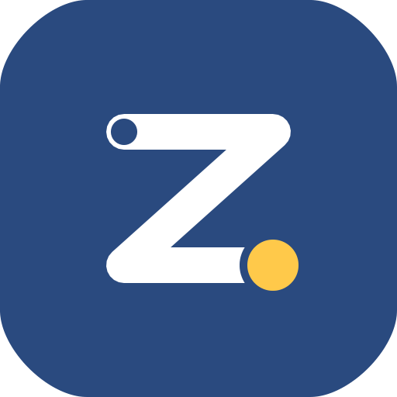
ZedPath
Business Case
One place for every path after A/L results.
Enter results once, see every path you can reach, and never miss a deadline,
with a source for every number.

TEAM | Team Kestrel
PREPARED BY | B.M.P Banneka
EVENT | IntelliCon '26 Buildathon
SUBMISSION | Gate 3 final submission
DATE | 11 October 2026
Each year about 275,000 Sri Lankan students get their A/L results [1] and have a few weeks to choose their future, using rules spread across a 200-page handbook, the weekly Gazette and dozens of websites. ZedPath is built and live: it checks each student's real options against official data, and every number it shows links to its source. Every figure in this document is cited in the References at the end.

Executive summary
ZedPath gives a Sri Lankan student one place to go from A/L results to a plan: enter results once, see every path they can reach, and never miss a deadline.
- Problem. 281,810 students sat the 2025 A/L and 176,527 qualified for university [1], competing for 42,937 state places [2]. About three in four qualified students will not get a state place, so most must also weigh other paths (private degrees, job exams, vocational courses, study abroad, etc.) within weeks, mostly on hearsay.
- Solution. A free, trilingual web and Android app. It rates every state course Safe, Likely or Reach from five years of district cut-offs and lists the other paths. It checks the student's preference order and tracks deadlines with reminders. Ask ZedPath, its AI assistant, answers in Sinhala, Tamil or English only from the official sources it retrieves, and every answer shows the page it came from so the student can check it.
- Market. About 275,000 students a year face this choice [1]. About 106,000 of them are qualified and online (176,527 qualified × about 60% internet use [5]). We target 10,000 in year one through teachers, A/L groups and seniors (Section 3 shows how each number is reached).
- Business model. The core is free for every student. Income comes from several small streams: an optional ZedPath Plus (LKR 490 a season), verified profiles for private institutes (never paid ranking), CSR grants from banks and mobile operators, and, from year two, opt-in aggregated reports.
- Cost. ZedPath runs today on Cloudflare's free plan. At 10,000 students, year one costs about LKR 98,100 (about USD 330) including AI answers, about LKR 10 per student [8][10].

1. The problem
After A/L results, a student has a few weeks to choose between many paths, and the rules for each sit in a different place.
In 2025, 281,810 students sat the A/L and 176,527 qualified for university [1], and the state system offered 42,937 places [2]. So about 133,600 qualified students, roughly three in four, will not get a state place and must find another path. Those aiming for a state university must pick and rank up to 125 courses within a three-week window, under rules in a 200+ page UGC handbook that changes every year [2].
The other paths run on their own calendars:
Path | Where the rules live | When it moves
State university | UGC handbook, yearly cut-offs, UGC notices | Fixed 3-week window, then later rounds of about one week
Private or non-state degree | Each institute's own website and fairs | Each institute sets its own intake, fees and entry rules
Gazetted job exam (e.g. Customs) | Weekly Government Gazette | A notice can appear any week
Vocational course | Separate institutes and notices | Rolling intakes
Study abroad | Scholarship and university sites | Varies by country
Others (professional bodies, diplomas, etc.) | Each body's own website | Own intakes and dates
With no single source, students decide from tuition teachers, seniors and Facebook groups. The cost of a wrong move is high:
- A badly ordered list. Selection follows the order of preference, so a Safe course listed first blocks the courses the student wanted more.
- An ineligible choice. Some courses need a specific subject grade or an aptitude test that the student never checked.
- A missed date. Missing the application window loses a year; missing a later round loses the place.
- An unknown path. A job exam or scholarship the student never heard of.
The National Education Commission found most students and parents unaware of alternative education and career options [3], and school guidance "more substantial on paper than in reality", especially in rural areas.

Evidence from students
Six conversations with people at many points on the path showed one pattern: nobody knew where to look.
We spoke to a current A/L student, two private-university undergraduates, a student on an alternate path, a foreign-scholarship holder and a state-university undergraduate (E1 to E6), between 23 and 29 September 2026. All six conversations are recorded [4].
What we heard | People | In their words
Didn't know the other paths, or found them by luck | 4 of 6 | "Basically it's luck." (E5, on a foreign scholarship)
Couldn't follow the application or the handbook | 3 of 6 | "No one can really read the campus book. I got my info from YouTube." (E2)
No single source; relied on parents, friends and YouTube | 3 of 6 | "I had no proper way to find out, like about the Gazette." (E3)
One gap changed their path | 2 of 6 | "I missed one course… life altering situation." (E4)
Wanted to know what a degree actually teaches | 2 of 6 | "If you could show the curriculum, that would be good." (E6)
Two requests shaped the product directly. E5 asked us to "show all the options he can take after the Z-score is released, and the steps". E6 warned that student groups must "first check that the seniors and admins are legit", so ZedPath verifies every senior before they can post.
We also tested three existing cut-off tools hands-on with one real profile (Physical Science, Kurunegala, Z 1.4821). All compared the Z-score with cut-offs. None checked subject grades, the preference order or deadlines. For example, Computer Science at Ruhuna needs a C in Combined Maths or Physics, yet each tool listed it as eligible without asking for grades.

2. Proposed solution: ZedPath
ZedPath turns the handbook, the cut-off tables and the Gazette into checks a student can run on their own results in under a minute.
Feature | What the student gets | Problem it removes
Enter results once | Stream, district, Z-score and subject grades, entered one time and reused everywhere | Re-checking the same facts on every site
Every path | All 255 state course codes (Uni-Codes) rated Safe, Likely or Reach from five years of district cut-offs [2][6], beside private degrees, job exams, vocational courses, study abroad, etc. | Not knowing the other paths
Course pages | Entry rules checked against the student's own grades, aptitude-test flags, the cut-off history and the official syllabus | Ineligible choices; "what does this degree teach?"
My list | The UGC preference list (up to 125 courses), with warnings when the order blocks a course the student wants more | A badly ordered list
Compare | Up to three courses side by side: chance, length, first-year subjects, extra steps | Choosing between degrees blind
Ask ZedPath | Questions answered in Sinhala, Tamil or English from the UGC handbook and official pages, each answer citing its page and linking to the official source to check; off-topic questions refused | Hearsay and unreadable handbooks
Gazette alerts | Every weekly Gazette read; a new job exam the student qualifies for becomes an alert with its closing date | Missing job exams
Journey and reminders | Every step from results to registration, marked confirmed or estimated, with reminders as phone notifications | Missed windows and later rounds
Course groups | A group per target course, verified seniors marked with a badge, report and block on every message | Unverified Facebook advice
Three languages | The whole interface in Sinhala, Tamil and English, reviewed by native speakers | English-only tools
Account | Required at the start: full name, email, Sri Lankan mobile and date of birth, with recorded consent; password hashed on the phone, delete everything in one tap | Losing a plan when the phone changes
ZedPath runs in any phone browser, installs like an app, and ships as a native Android app with its own notifications.
Trust rules ZedPath keeps. Every number links to its official source. ZedPath never says "you will get in"; it rates chances and shows the cut-off behind each rating. There is no paid placement: no institute can pay for a higher position. Every detail stored is listed at sign-up with its purpose and needs the student's consent, and a student can delete everything at any time.

3. Target audience
About 275,000 students face this choice every year, and a new cohort arrives with every set of results, so the market renews itself.
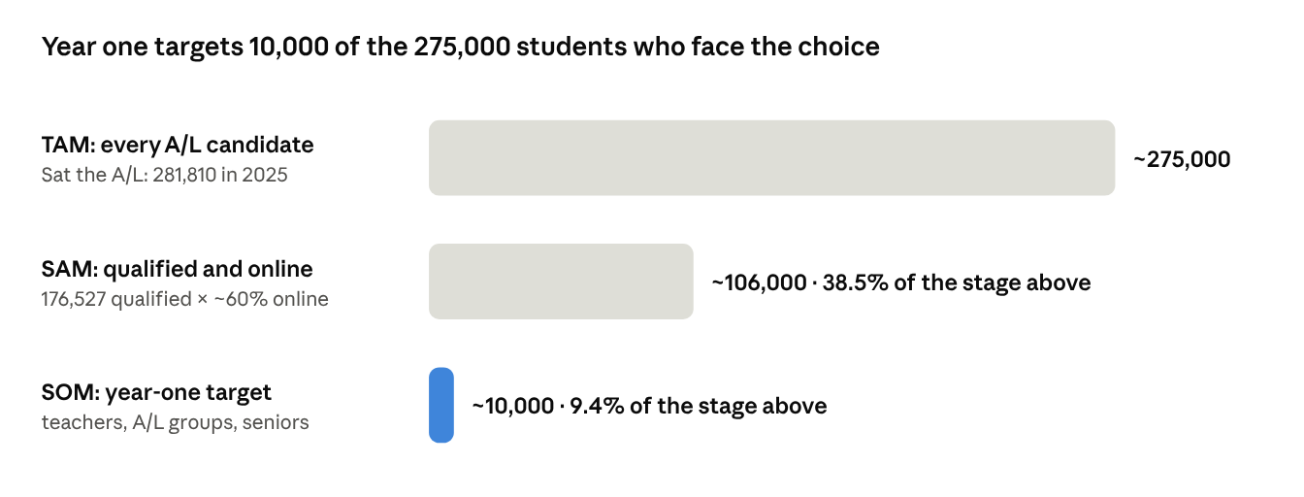
Department of Examinations, A/L results 2023 and 2025 · DataReportal, Digital 2026: Sri Lanka · year-one target is our estimate
The user is a student between A/L results and their next step, on a phone, often first in their family to apply. Parents, tuition teachers and school guidance teachers are not users we sell to, but they are how students find ZedPath.
How we reached each number.
Number | How we got it | Source
About 275,000 a year | Average of A/L candidates in 2023 (269,613) and 2025 (281,810) | [1]
176,527 qualified | Candidates eligible for university admission, 2025 | [1]
42,937 state places | 42,037 places across the 255 Uni-Codes plus 900 additional Arts places, 2025/26; ZedPath's own extraction of the handbook adds up to the same total | [2]
About 106,000 reachable | 176,527 qualified × about 60% internet use | [1], [5]
10,000 in year one | Sum of the channel estimates below; our assumptions, to be tested in the first cycle | Team estimate

Year-one channel | Basis (our estimate) | Students
A/L Facebook groups | 5 groups × ~20,000 members × 5% | 5,000
Tuition teachers | 20 teachers × ~150 students | 3,000
A/L Telegram channels | 2 channels × ~65,000 subscribers × 1% | 1,300
Seniors and friends sharing | Word of mouth | 700
Total |  | 10,000

4. Value proposition
For students: every path they can reach, checked against their own results, with the source behind every number, free. For institutes and sponsors: a neutral, trusted place to reach students at the moment they decide, with no paid ranking.

Against the alternatives
Students already patch the answer together from eight sources; none combines their own results, every reachable path and dated deadlines.
Alternative | Why students use it | Where it breaks
Seniors and relatives | Trusted and free | Advice from one year and one course
WhatsApp and Facebook groups | Fast answers from peers | Unverified and often contradictory
Tuition-class seminars | A teacher they trust | One list for the whole class, no personal check
UGC handbook and website | The official source | 200+ pages, no personal answer, no other routes
Cut-off tools (findmydegree.lk, Unicompass, induwara.lk) | Quick cut-off lookup | No grade, order or deadline checks (our hands-on test)
ThuSh LK (site, Telegram, YouTube) | Degree details, comparisons, cut-off trends | A reference guide: doesn't read your results, check your order or track Gazette exams
Gazette and department notices | Official source for job exams | Hard to find, no alerts, easy to miss
Institute counsellors and fairs | Cover private degrees | Each promotes its own programmes
ZedPath's edge is the combination, and four things no tested tool does:
- Checks the student, not just the cut-off. Subject-grade rules and aptitude tests are applied before a course is called reachable.
- Checks the order. The preference list is tested against how selection actually works.
- Covers paths outside the UGC. Private degrees, job exams, vocational courses, study abroad and more sit beside state courses.
- Tracks time. Deadlines, later rounds and new Gazette exams become dated reminders.
The defensible part is the data pipeline: the yearly handbook, five years of cut-offs and the weekly Gazette are turned into tested rules, each tied to its source page. A competitor would have to rebuild that pipeline and keep it current every year.

5. Implementation

How it is built
ZedPath is built and running on a serverless stack that costs almost nothing when idle and scales on results day without anyone touching it.
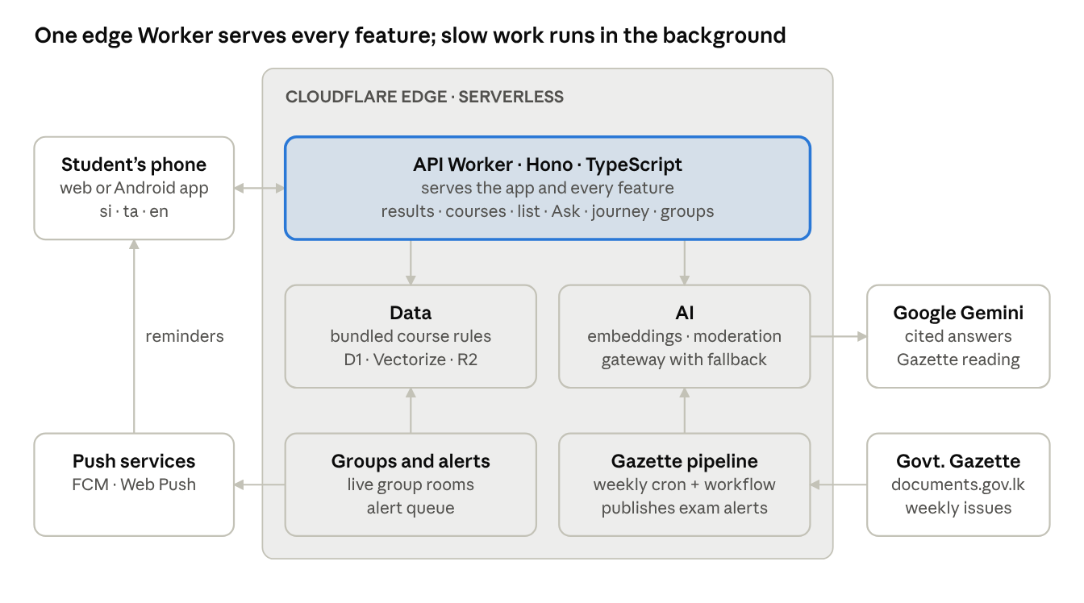
ZedPath architecture · simplified
- One codebase, TypeScript throughout. A React web app and a Hono API run in one Cloudflare Worker at the edge, close to students in Sri Lanka. The Android app is a native shell around the same app, so every web update reaches it without a new install.
- Fast on mobile data. The course rules and five years of cut-offs are compiled into the app's server bundle, so checking a student's results needs no database reads.
- Official sources only. The UGC handbook 2025/26, UGC cut-off tables 2021/22 to 2025/26, official route pages, university curriculum pages and the Government Gazette. Every fact shown links to its source.
- Rules built to be checked. Two independent extraction methods and two AI models must agree before a rule is published, and automated tests run against hand-verified cases before every release.
- AI that cites. Ask ZedPath searches multilingual embeddings of the official pages, answers through an AI gateway with a model fallback chain, and keeps only answers that cite a retrieved page.

Go-to-market and roadmap
We reach students where they already decide (tuition classes, A/L groups and seniors) and time every push to the admission calendar.
- Teachers first. A tuition teacher who shares ZedPath with a class reaches about 150 students at once, and teachers gain a tool that checks each student individually.
- Results day is the launch. Interest peaks when results are released; ZedPath must already hold the new handbook rules by then.
- Reminders bring students back. Saved lists, deadline alerts and Gazette exam alerts give a reason to return through the four-month season.
- Seniors spread it. Verified seniors in course groups are both a feature and a channel: each one is a trusted voice inside the next cohort.
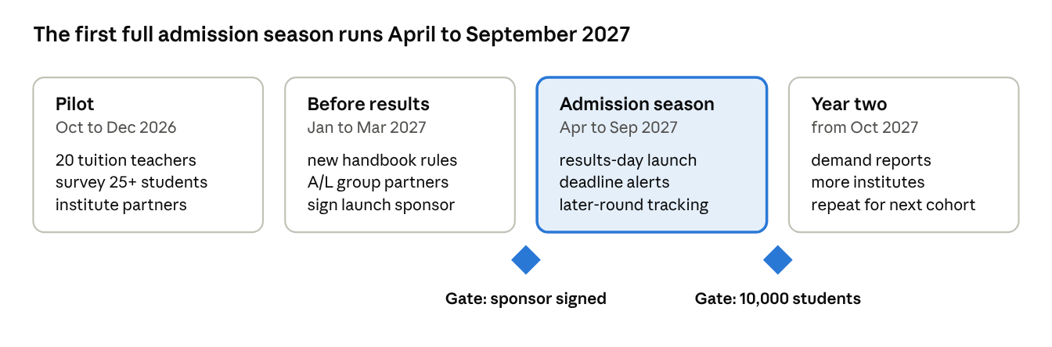
Roadmap to the 2027 admission cycle · phases and gates
Each cycle repeats with a new cohort, so the work of year one (rules pipeline, partners, channels) is reused every year.

Business model and costs
ZedPath is funded from several small income streams, so no single partner decides its future. The core stays free for every student, and no stream can buy a higher place in a student's results.
Income stream | What the payer gets | Price | Year-one estimate (LKR)
ZedPath Plus (optional, for students) | More Ask ZedPath questions a day, a printable application pack (ordered list, checklist, deadlines) and SMS or WhatsApp reminders. Results, every path, chances, Alerts, Journey and Groups stay free | LKR 490 per admission season | 98,000 (2% of 10,000 students)
Private and non-state institutes | A verified profile: intake dates, fees and entry rules kept current in ZedPath's neutral format | LKR 25,000 per institute per year | 50,000 (2 institutes)
CSR and grants (banks, mobile operators, education funds) | Named support for one admission cycle, shown on the About screen, never beside results or answers | One grant | 100,000 (1 grant)
Demand reports for universities and policy makers (from year two) | Aggregated, opt-in reports; never individual data, small groups suppressed | LKR 50,000 per report | 0 in year one
Year-one costs are small, because the app runs on serverless infrastructure and volunteers cover the language review. Figures use about LKR 300 per USD.
Cost | Year one (LKR)
Cloudflare Workers paid plan, USD 5 a month [8] (ZedPath runs on the free plan today) | 18,000
Usage above the plan's included amounts at 10,000 students: requests stay inside the 10 million a month included; search and group moderation add about USD 10 in the season [8] | 3,000
AI answers: about 100,000 questions on Gemini 2.5 Flash, about 3,000 input and 250 output tokens each (USD 0.30 and 2.50 per million tokens) [10] | 46,000
Domain name (about USD 12 a year) | 3,600
Google Play developer account, one time (USD 25) | 7,500
Native-speaker review of the Sinhala and Tamil interface | 0 (volunteers)
Data checker for the four-month admission season (student stipend, LKR 5,000 a month) | 20,000
Total | 98,100
That is about LKR 10 per student a year, of which AI answers are about LKR 4.60. ZedPath covers its costs without any grant: Plus at 2% and two institute profiles bring LKR 148,000. Even with no institute at all, Plus at 2% almost covers year one (LKR 98,000 against 98,100), and one CSR grant funds the next cycle's growth.

Risks and mitigations
The biggest risk is a wrong rule shown with confidence; every safeguard below exists to stop that.
Risk | Effect | Mitigation
A rule or cut-off is extracted wrongly | A student drops a course they could have got | Two independent extraction methods must agree; every rule is tested against hand-checked cases and links to its source page
The AI answers beyond its sources | Confident hearsay, the thing ZedPath replaces | Answers only from retrieved official pages; uncited claims are removed; off-topic questions are refused
Official formats change (handbook layout, Gazette site) | The yearly update or weekly reading breaks | Each run checks its output against the last; a failed check holds the update and alerts us instead of publishing
Students read "Likely" as a promise | False confidence, then disappointment | Never "you will get in"; the cut-off and year behind each rating are always shown
Unverified or harmful posts in groups | Misinformation, harassment | Seniors verified before posting; automatic moderation; report and block on every message
Personal data exposure | Loss of trust | Only four contact fields, each with a stated purpose and recorded consent (Personal Data Protection Act No. 9 of 2022 [9]); contact details kept apart from results; passwords hashed on the phone; one-tap delete; rate limits on sign-in
Revenue pressure to rank paying institutes | Breaks the core promise | No paid placement is a written rule; paying partners get profiles and reports, never position
Usage spikes on results day | Slow or failed pages when it matters most | Serverless edge hosting scales automatically; course data is bundled with the app, so a results check needs no database reads

References
- Department of Examinations, Sri Lanka, G.C.E. (A/L) Examination: Performance of Candidates, 2023 and 2025 (candidates sat: 269,613 in 2023, 281,810 in 2025; 176,527 eligible for university admission in 2025).
- University Grants Commission, Admission to Undergraduate Courses of the Universities in Sri Lanka, Academic Year 2025/2026 (student handbook): proposed intake per Uni-Code, entry rules, up to 125 preferences. ugc.ac.lk
- National Education Commission, Study on Career Guidance in General Education in Sri Lanka, Research Series No. 08, 2014.
- Team Kestrel, Gate 1: Problem and Proof, IntelliCon '26 Buildathon: six recorded interviews (E1 to E6, 23 to 29 September 2026) and a hands-on test of three cut-off tools (27 September 2026).
- DataReportal, Digital 2026: Sri Lanka (share of the population using the internet, about 60%).
- University Grants Commission, Minimum Z-scores for selection to courses of study, by district, academic years 2021/22 to 2025/26.
- Government of Sri Lanka, Gazette of the Democratic Socialist Republic of Sri Lanka, Part I Section (IIA), issues of 28 August, 11 September and 18 September 2026 (examination and intake notices shown in ZedPath Alerts).
- Cloudflare, Workers pricing and Workers AI pricing, developers.cloudflare.com, checked 11 October 2026 (Workers paid plan: USD 5 a month with 10 million requests included; Vectorize: 50 million queried dimensions a month included, then USD 0.01 per million; Workers AI: 10,000 neurons a day free, then USD 0.011 per 1,000).
- Parliament of Sri Lanka, Personal Data Protection Act, No. 9 of 2022.
- Google, Gemini API pricing (Gemini 2.5 Flash: USD 0.30 per million input tokens, USD 2.50 per million output tokens), ai.google.dev, checked 11 October 2026.

