ZEDPATH
Team Kestrel · IntelliCon '26 Buildathon
ZP-DOC-05
Data Design
Conceptual EER model, relational mapping, normalisation and the Cloudflare D1 physical schema
Version | 0.9
Status | In review
Date | 5 October 2026
Classification | Public
Document owner | B.M.P Banneka, Product Owner
© 2026 Team Kestrel. Published under the classification shown above.
Uncontrolled when printed or exported. The controlled version is the Markdown source in the repository: docs/05-data-design/ZP-DOC-05_Data-Design.md

Document control
Document information
Document ID | ZP-DOC-05
Title | Data Design
Version | 0.9
Status | In review
Classification | Public
Document owner | B.M.P Banneka, Product Owner
Author | Team Kestrel (drafted with Claude, AI coding partner)
Conforms to | Enhanced ER model and mapping algorithm (Elmasri and Navathe, 7th ed.); relational normalisation to BCNF/4NF; ZP-DOC-00
Source file | docs/05-data-design/ZP-DOC-05_Data-Design.md
Repository | https://github.com/PraveenBanneka/zedpath

Revision history
Version | Date | Author | Description of change
0.9 | 5 Oct 2026 | Team Kestrel | First issue: four EER diagrams, rule grammar, mapping, normalisation, D1 schema validated against the real UGC 2025/26 and 2024/25 data; submitted for approval

Review and approval
This document takes effect when the approver signs below. Until then its status is as shown on the cover.
Role | Name | Signature | Date
Reviewer | Claude (AI coding partner), consistency and traceability review
Approver | B.M.P Banneka, Product Owner

Contents
1 Introduction 5
1.1 Purpose 5
1.2 Scope 5
1.3 Intended audience 5
1.4 Relationship to other documents 5
1.5 Notation 5
2 Conceptual model (EER) 6
2.1 Offerings and cut-offs 6
2.2 Subjects and requirement rules 7
2.3 Provenance and trust 8
2.4 Journey and other routes 9
2.5 Entity catalogue 10
3 Rule grammar 11
4 Mapping the EER model to relations 12
5 Normalisation 15
5.1 From the source form to 1NF 15
5.2 Functional and multi-valued dependencies 15
5.3 2NF, 3NF and BCNF 15
5.4 Deliberate departures 16
6 Physical design for Cloudflare D1 17
6.1 Conventions 17
6.2 Indexes 17
6.3 Capacity against the free plan 17
7 Validation against real data 18
Appendix A: Traceability: requirements to tables 19
Appendix B: Physical schema (migration 0001) 20
Appendix C: Glossary 26
Appendix D: References 27

List of figures
Figure 1: EER model of institutions, courses, offerings, intake years, selection groups and cut-offs 7
Figure 2: EER model of streams, subjects and the recursive requirement-rule tree 8
Figure 3: EER model of cited facts, sources, revisions, AI extraction, review and mistake reports 9
Figure 4: EER model of deadlines, push reminders and the specialisation of other routes 9
Figure 5: Logical schema, admission data (generated from the migration file) 13
Figure 6: Logical schema, trust, routes and journey data (generated from the migration file) 14

List of tables
Table 1: Position of this document in the ZedPath document set 5
Table 2: Entities, their type, identifier and the requirements that justify them 10
Table 3: Rule node kinds and their meaning 11
Table 4: EER-to-relational mapping steps applied 12
Table 5: Dependencies identified in R1 15
Table 6: Controlled denormalisations and why they are safe 16
Table 7: Secondary indexes and the query each serves 17
Table 8: Data volume per intake year and free-plan headroom 17
Table 9: Schema validation results (5 October 2026) 18
Table 10: Requirements and the tables that realise them 19
Table 11: Terms used in this document 26
Table 12: Sources referred to in this document 27

1 Introduction

1.1 Purpose
This document designs ZedPath's data in three steps, as a database engineer would: a conceptual model in Enhanced Entity-Relationship (EER) notation, its logical relational schema derived with the standard mapping algorithm and normalised, and the physical schema for Cloudflare D1. The physical schema is the real migration file the application uses, and it has been proved by loading the real UGC data into it.

1.2 Scope
All data held on the server for Releases R1 and R2. The student's own profile and preference list are not stored on the server (NFR-030); they live on the student's device and are outside this model.

1.3 Intended audience
Developers, reviewers and anyone assessing the data design.

1.4 Relationship to other documents
Table 1: Position of this document in the ZedPath document set
Document | Relationship
ZP-DOC-03 SRS | Parent. Business rules BR-001 to BR-043 and data-quality requirements NFR-050 to NFR-052 become entities and constraints
ZP-DOC-04 Use Case Model | Parent. Nouns in the use cases name the entities
ZP-DOC-06 Software Architecture | Child. Decides how the read path uses this schema within free-plan limits
migrations/0001_initial_schema.sql | Implementation. Appendix A reproduces it verbatim

1.5 Notation
Conceptual diagrams use Chen notation as extended by Elmasri and Navathe: rectangles are entities; double rectangles are weak entities; diamonds are relationships; double diamonds are identifying relationships; ovals are attributes, with keys underlined, double ovals for multi-valued and dashed ovals for derived attributes; bold lines show total participation; a circle marked d or o shows a disjoint or overlapping specialisation, and a circle marked U a union category. Partial keys of weak entities are named in the entity catalogue. Logical diagrams use crow's-foot (Information Engineering) notation.

2 Conceptual model (EER)

2.1 Offerings and cut-offs
The admission domain has a feature that a simple design misses: a course of study (for example, Management) is offered at several institutions; each pair is an offering with its own Uni-Code; an offering exists anew in each intake year with its own intake and requirements; and a few offerings split their seats into selection groups by stream or category, each with its own cut-offs. Loading the real 2025/26 cut-off table confirmed this: its 260 columns correspond to 255 Uni-Codes, because five Uni-Codes are split.
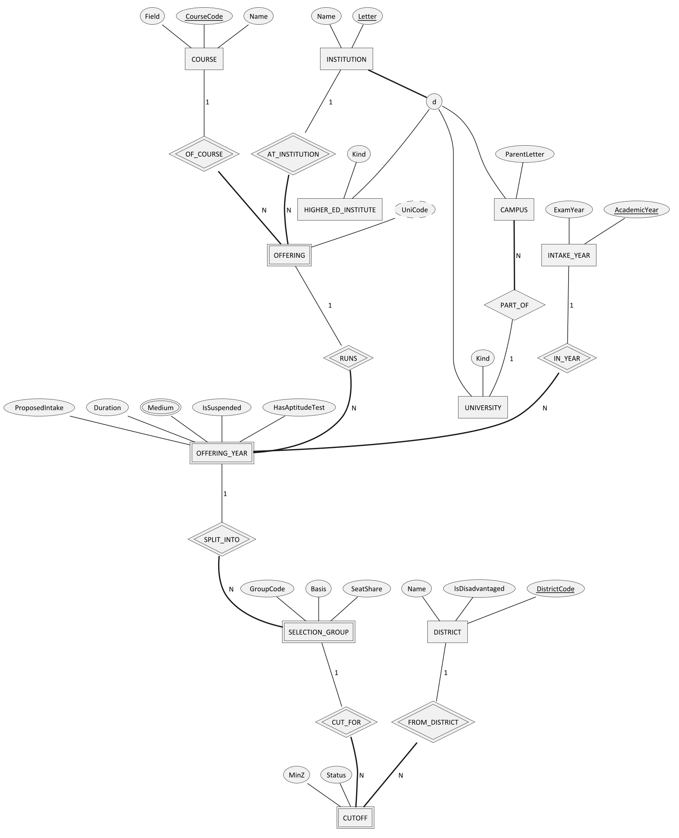
Figure 1: EER model of institutions, courses, offerings, intake years, selection groups and cut-offs

2.2 Subjects and requirement rules
Entry requirements follow twenty different patterns (BR-020). Instead of twenty columns or free text, every requirement is a tree of rule nodes (recursive relationship CHILD_OF) whose leaves test subjects. One structure serves state-university selection groups and other routes alike.
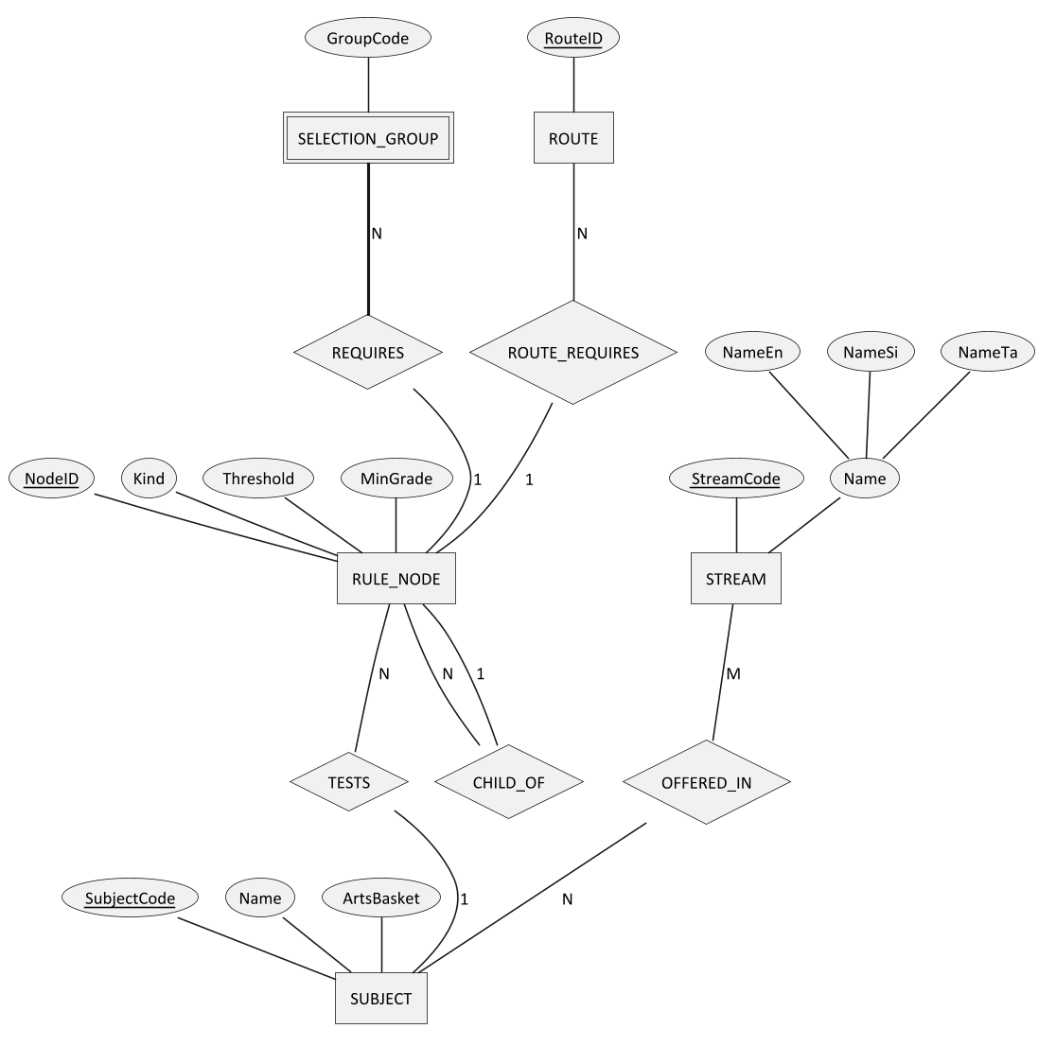
Figure 2: EER model of streams, subjects and the recursive requirement-rule tree

2.3 Provenance and trust
Every published fact must cite its source (BO-2). Cut-offs, offering details, rules, deadlines and routes are different entity types, yet each needs citations, revisions and mistake reports. The model makes them members of one union category, CITED_FACT, so these trust features are designed once.
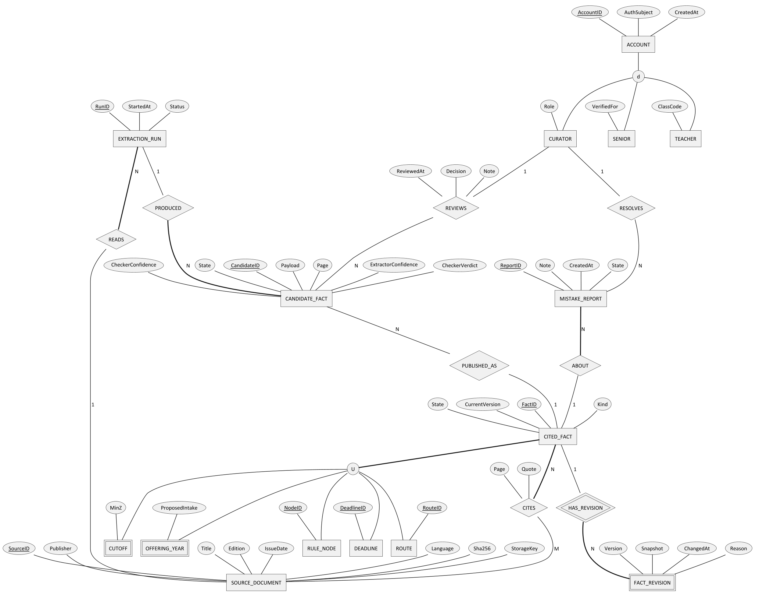
Figure 3: EER model of cited facts, sources, revisions, AI extraction, review and mistake reports

2.4 Journey and other routes
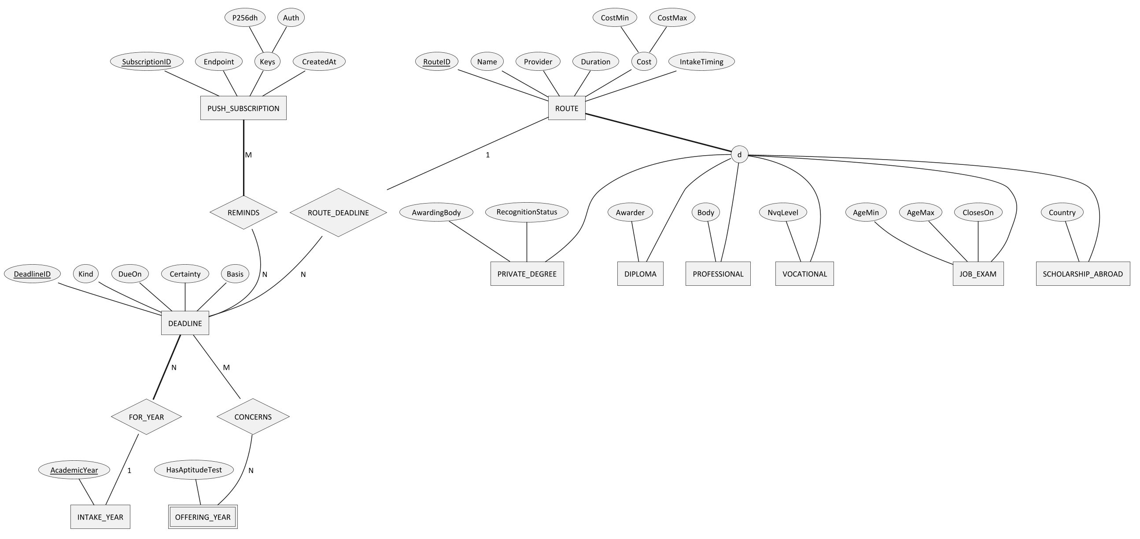
Figure 4: EER model of deadlines, push reminders and the specialisation of other routes

2.5 Entity catalogue
Table 2: Entities, their type, identifier and the requirements that justify them
Entity | Type | Identifier | Justified by
STREAM, SUBJECT | Strong | StreamCode; SubjectCode | BR-010 to BR-012
DISTRICT | Strong | DistrictCode | BR-006, BR-007
INSTITUTION | Strong, superclass of UNIVERSITY, CAMPUS, HIGHER_ED_INSTITUTE (disjoint, total) | Letter | BR-015
COURSE | Strong | CourseCode (3 digits) | BR-015
OFFERING | Weak, owners COURSE and INSTITUTION | (CourseCode, Letter); UniCode derived | BR-015
INTAKE_YEAR | Strong | AcademicYear | BR-028
OFFERING_YEAR | Weak, owners OFFERING and INTAKE_YEAR | (UniCode, AcademicYear) | BR-013, BR-014, BR-025, BR-026
SELECTION_GROUP | Weak, owner OFFERING_YEAR | partial key GroupCode | Discovered in the 2025/26 cut-off table
CUTOFF | Weak, owners SELECTION_GROUP and DISTRICT | (group, District) | BR-028, BR-029
RULE_NODE | Strong, recursive | NodeID | BR-020 to BR-022
CITED_FACT | Union category of CUTOFF, OFFERING_YEAR, RULE_NODE, DEADLINE, ROUTE | FactID (surrogate) | BO-2, FR-209, FR-911
SOURCE_DOCUMENT | Strong | SourceID; Sha256 unique | FR-901, FR-902
FACT_REVISION | Weak, owner CITED_FACT | partial key Version | FR-911
EXTRACTION_RUN, CANDIDATE_FACT | Strong | RunID; CandidateID | FR-903 to FR-907
ACCOUNT | Strong, superclass of CURATOR, SENIOR, TEACHER (disjoint, partial) | AccountID | NFR-032, FR-704, FR-706
MISTAKE_REPORT | Strong | ReportID | FR-910
DEADLINE | Strong | DeadlineID | FR-401 to FR-403
ROUTE | Strong, superclass of six route groups (disjoint, total) | RouteID | FR-501 to FR-507
PUSH_SUBSCRIPTION | Strong | SubscriptionID | FR-405, FR-406

3 Rule grammar
A requirement is stored as a tree of rule_node rows. Evaluation assigns each of the student's three A/L subjects to at most one leaf, which captures the handbook's meaning of phrases such as "and the third subject from".
Table 3: Rule node kinds and their meaning
Kind | Meaning | Example (handbook pattern)
ALL | Every child is satisfied, by distinct subjects | Fixed trio (pattern 1)
ANY | At least one child is satisfied | "Combined Mathematics or Physics"
AT_LEAST n | At least n children are satisfied, by distinct subjects | "two other subjects from the list" (pattern 7)
SUBJECT s ≥ g | Leaf: the student has subject s at grade g or better, and it is not used elsewhere | "a 'C' grade in Chemistry"
ANY_SUBJECTS n ≥ g | n further subjects of any kind, not used elsewhere | "any other two subjects" (pattern 8)
GRADE_COUNT n ≥ g | A check on subjects already used: at least n of the listed subjects reach grade g | Medicine: two 'C' grades (pattern 2)
STREAM_IS x | Leaf: the student's stream is x | "any three subjects in the Commerce Stream" (pattern 13)
PREDICATE name | A named check implemented in code | ARTS_BASKETS: the Arts basket rules (pattern 17)
OL_SUBJECT s ≥ g | Leaf in the O/L tree: the O/L subject s at grade g or better | "a Credit Pass in English" (pattern 18)

Example: Medicine (Uni-Code 001A) is ALL( SUBJECT Biology ≥ S, SUBJECT Chemistry ≥ S, SUBJECT Physics ≥ S, GRADE_COUNT 2 ≥ C of {Biology, Chemistry, Physics} ). Category splits with separate seats (pattern 14) are modelled as separate selection groups, each with its own rule tree.

4 Mapping the EER model to relations
The relational schema was derived with the standard nine-step algorithm.
Table 4: EER-to-relational mapping steps applied
Step | Construct | Applied to | Result
1 | Strong entities | STREAM, SUBJECT, DISTRICT, COURSE, INTAKE_YEAR, RULE_NODE, SOURCE_DOCUMENT, EXTRACTION_RUN, CANDIDATE_FACT, MISTAKE_REPORT, DEADLINE, PUSH_SUBSCRIPTION, ACCOUNT, ROUTE | One table each, primary key from the key attribute
2 | Weak entities | OFFERING; OFFERING_YEAR; SELECTION_GROUP; CUTOFF; FACT_REVISION | Owners' keys become part of the primary key: offering(course_code, institution_letter), cutoff(group_id, district_code), fact_revision(fact_id, version). OFFERING_YEAR and SELECTION_GROUP also get surrogate keys to keep later foreign keys short
3 | 1:1 relationships | CANDIDATE_FACT PUBLISHED_AS CITED_FACT | Foreign key published_fact_id
4 | 1:N relationships | PART_OF, CHILD_OF, TESTS, REQUIRES, READS, PRODUCED, ABOUT, RESOLVES, REVIEWS, FOR_YEAR | Foreign key on the N side; REVIEWS' attributes (decision, note, time) move into candidate_fact
5 | M:N relationships | OFFERED_IN, CITES, CONCERNS, REMINDS | Relationship tables stream_subject, citation (with page and quote), deadline_offering_year, push_subscription_deadline
6 | Multi-valued attributes | Medium of OFFERING_YEAR | Table offering_year_medium
7 | N-ary relationships | None | Not needed
8 | Specialisation | INSTITUTION; ACCOUNT | Option 8C, one table with a discriminator (kind, role): subclasses have almost no own attributes
8 | Specialisation | ROUTE | Option 8A: superclass table plus route_private_degree and route_job_exam for subclasses with several constrained attributes; single-attribute subclasses keep the attribute on route with a guard constraint
9 | Union category | CITED_FACT | Surrogate key fact_id in table fact; every member table carries a unique foreign key to it

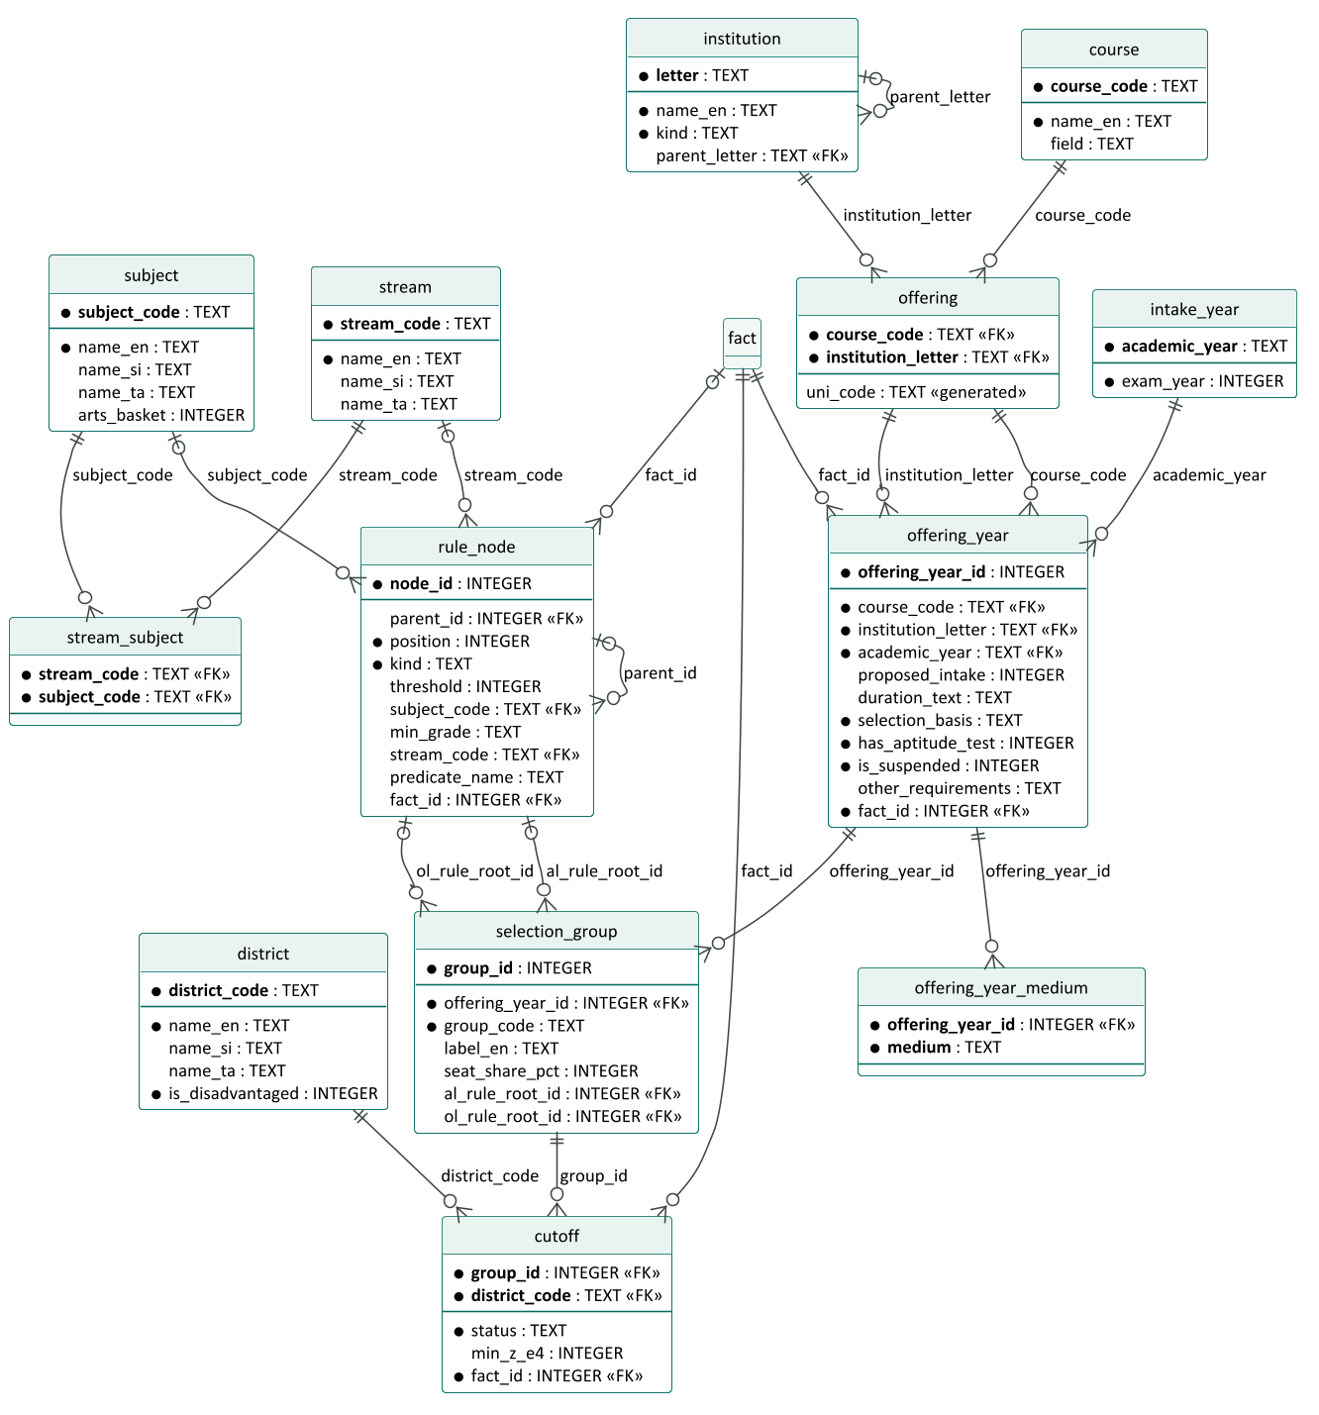
Figure 5: Logical schema, admission data (generated from the migration file)
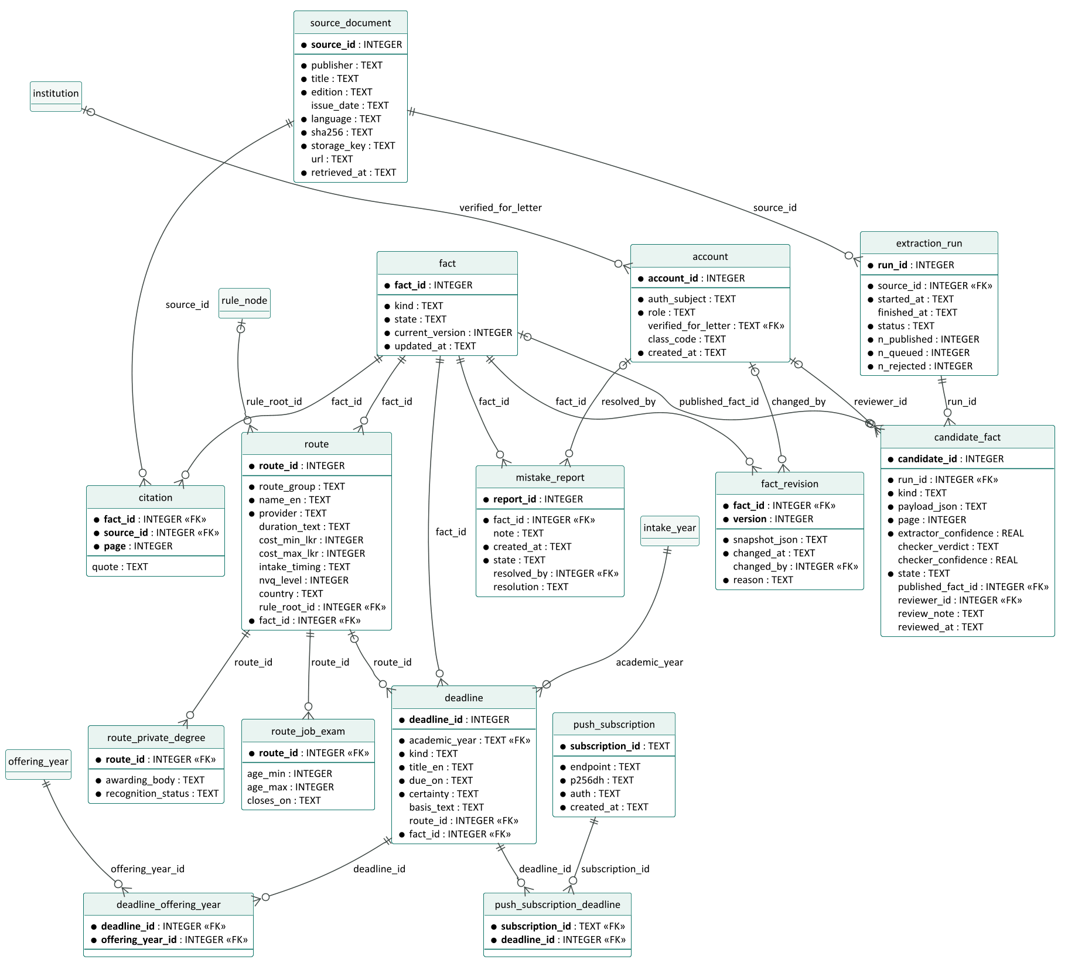
Figure 6: Logical schema, trust, routes and journey data (generated from the migration file)

5 Normalisation

5.1 From the source form to 1NF
The UGC cut-off table, as printed, is a single wide relation: one row per district and one column per offering, with each column header packing several facts into one string, for example "MANAGEMENT STUDIES (TV) - A [Commerce Stream] (University of Vavuniya)", plus markers * (merit only) and # (aptitude test). It violates first normal form twice: a repeating group (260 offering columns) and non-atomic values (the header). Unpivoting gives one row per (offering column, district), and splitting the header gives atomic attributes:
R1 ( UniCode, CourseCode, CourseName, Letter, InstitutionName, Year, GroupCode, District, IsDisadvantaged, MinZ, Status, ProposedIntake, SelectionBasis, HasAptitudeTest, Medium )

5.2 Functional and multi-valued dependencies
Table 5: Dependencies identified in R1
# | Dependency | Source of the rule
FD1 | UniCode → CourseCode, Letter (and the reverse: CourseCode, Letter → UniCode) | BR-015
FD2 | CourseCode → CourseName | Handbook course list
FD3 | Letter → InstitutionName | Handbook Uni-Code list
FD4 | District → IsDisadvantaged | BR-007
FD5 | UniCode, Year → ProposedIntake, SelectionBasis, HasAptitudeTest | Handbook, per intake
FD6 | UniCode, Year, GroupCode, District → MinZ, Status | Cut-off table
MVD1 | UniCode, Year ↠ Medium | Medium is independent of every other attribute

The candidate key of R1 is (UniCode, Year, GroupCode, District, Medium).

5.3 2NF, 3NF and BCNF
- 2NF removes attributes that depend on part of the key: FD5's attributes move to OFFERING_YEAR(UniCode, Year, ...); FD4's to DISTRICT; FD1 to OFFERING. CUTOFF keeps only MinZ and Status, which need the whole key.
- 3NF removes transitive dependencies: UniCode → CourseCode → CourseName puts CourseName in COURSE; UniCode → Letter → InstitutionName puts the name in INSTITUTION.
- BCNF: in every resulting relation, every determinant is a candidate key. The only relation with two candidate keys, OFFERING, has (CourseCode, Letter) and the derived UniCode, both keys, so it is in BCNF.
- 4NF: MVD1 is non-trivial, so Medium moves to its own relation, offering_year_medium.
The same analysis applied to the provenance data separates citation (fact, source, page) from fact, because a fact may cite several pages and a page supports many facts.

5.4 Deliberate departures
Table 6: Controlled denormalisations and why they are safe
Departure | Reason | How consistency is kept
uni_code stored alongside its parts in offering | Lookup by the code students know | Generated column, computed by the database; cannot disagree
Surrogate keys on offering_year and selection_group | Short foreign keys in the 13,000-row cutoff table | Natural keys kept as UNIQUE constraints
Read model for the student path (ZP-DOC-06) | D1 free plan allows 5 million row reads a day; a district's full eligibility view reads about 3,000 rows, which would cap ZedPath near 1,600 students a day | Built from D1 by a single job after each data change, versioned, and never edited directly

6 Physical design for Cloudflare D1

6.1 Conventions
- STRICT tables: every value must match its declared type.
- Exact Z-scores: stored as integers in ten-thousandths (min_z_e4; 1.4821 is stored as 14821), so comparisons are exact (NFR-051). The valid range −4.0000 to +4.0000 is a CHECK constraint (BR-005).
- Enumerations (streams, statuses, kinds, grades) are CHECK constraints, so invalid states cannot be stored.
- Cross-column rules are CHECK constraints: a CAMPUS must have a parent university; a VALUE cut-off must have a number and an NQC cut-off must not; an auto-published candidate must have two-model agreement at 0.90 or more (FR-905); an estimated deadline must state its basis (FR-402).
- Foreign keys are enforced by D1 by default (equivalent to PRAGMA foreign_keys = ON).
- Personal data: the only student-linked table is push_subscription, holding a browser push endpoint and keys that the student opted in to share (NFR-030); no names, contact details or results.

6.2 Indexes
Table 7: Secondary indexes and the query each serves
Index | Serves
idx_offering_uni_code (unique) | Look up an offering by Uni-Code
idx_cutoff_district | All cut-offs for one district: the core of eligibility and banding
idx_offering_year_year | All offerings of an intake year
idx_rule_node_parent | Loading rule trees in order
idx_deadline_year_due | Journey timeline by date
idx_citation_source | All facts citing a source (re-extraction, audits)
idx_candidate_queue (partial, QUEUED only) | Curator review queue
idx_report_open (partial, OPEN only) | Open mistake reports

6.3 Capacity against the free plan
Table 8: Data volume per intake year and free-plan headroom
Measure | Value | Free-plan limit
Cut-off rows per intake year | about 6,500 | —
Database size with two intake years loaded | 2.3 MB | 500 MB per database
Projected size with five years and all routes | under 10 MB | 500 MB per database
Rows read to rebuild the read model once | about 15,000 | 5 million per day
Rows written to load one intake year | about 13,500 (with facts and citations) | 100,000 per day

7 Validation against real data
The design was tested by loading the official data, not sample data. tools/seed/validate-schema.ts applies the migration to an in-memory SQLite database (the engine D1 is built on), loads the UGC 2025/26 data and the 2024/25 cut-offs printed in the handbook, runs integrity checks, and then attempts 24 deliberately invalid inserts.
Table 9: Schema validation results (5 October 2026)
Check | Result | Expected
Uni-Codes loaded | 255 | 255
Course codes / institutions | 121 / 20 | 121 / 20
2025/26 proposed intake across Uni-Codes (plus 900 Arts additional intake = 42,937) | 42,037 | 42,037
2025/26 cut-off columns matched exactly to a Uni-Code | 260 | 260
2025/26 cut-off cells loaded / of which NQC | 6,500 / 1,026 | 6,500 / 1,026
Uni-Codes split into more than one selection group | 5 | 5
Uni-Codes without cut-offs | 0 | 0
Merit-only offerings with differing district values | 0 | 0
2024/25 cut-off cells loaded | 6,425 | —
Facts without a citation | 0 | 0
Foreign-key violations | 0 | 0
Invalid inserts rejected by constraints | 24 of 24 | 24 of 24

Matching the cut-off table to Uni-Codes surfaced spelling differences between the two UGC documents ("BIO.SC" and "BIOLOGICAL SC.", "AGRI BUSINESS" and "AGRIBUSINESS", "BIO RESOURCES" and "BIORESOURCES") and one misprinted university name. The loader normalises these explicitly; no column is matched by guesswork.

Appendix A: Traceability: requirements to tables
Table 10: Requirements and the tables that realise them
Requirement | Tables
BR-005, NFR-051 (exact Z-scores) | cutoff.min_z_e4 with range CHECK
BR-006, BR-007 (districts) | district
BR-010 to BR-012 (streams, subjects) | stream, subject, stream_subject
BR-013, BR-014 (quotas, merit-only) | offering_year.selection_basis
BR-015 (Uni-Codes) | course, institution, offering
BR-020 to BR-024 (requirements) | rule_node, selection_group.al_rule_root_id, ol_rule_root_id, offering_year.other_requirements
BR-025, BR-026 (aptitude, suspended) | offering_year.has_aptitude_test, is_suspended
BR-028, BR-029 (cut-offs, NQC) | selection_group, cutoff
FR-209, BO-2, NFR-050 (every fact sourced) | fact, citation, source_document
FR-401 to FR-406 (journey, reminders) | deadline, deadline_offering_year, push_subscription, push_subscription_deadline
FR-501 to FR-507 (other routes) | route, route_private_degree, route_job_exam
FR-901 to FR-911 (data and trust) | source_document, extraction_run, candidate_fact, fact_revision, mistake_report, account

Appendix B: Physical schema (migration 0001)
Reproduced verbatim from migrations/0001_initial_schema.sql.
-- ZedPath D1 schema, migration 0001.
-- Designed in ZP-DOC-05 Data Design (conceptual EER -> relational mapping -> normalisation to BCNF/4NF).
-- Conventions: STRICT tables; snake_case; exact Z-scores as INTEGER ten-thousandths (z_e4 = Z x 10000,
-- e.g. 1.4821 -> 14821) so comparisons are exact (NFR-051); timestamps as ISO 8601 UTC text;
-- every published fact has a row in `fact` and at least one `citation` (BO-2, NFR-050).
-- D1 enforces foreign keys by default (equivalent to PRAGMA foreign_keys = ON).

-- ---------------------------------------------------------------- provenance (needed first: other tables reference fact)

CREATE TABLE fact (
fact_id INTEGER PRIMARY KEY,
kind TEXT NOT NULL CHECK (kind IN ('CUTOFF','OFFERING_YEAR','RULE','DEADLINE','ROUTE')),
state TEXT NOT NULL DEFAULT 'PUBLISHED' CHECK (state IN ('PUBLISHED','WITHDRAWN')),
current_version INTEGER NOT NULL DEFAULT 1 CHECK (current_version >= 1),
updated_at TEXT NOT NULL CHECK (updated_at GLOB '[0-9][0-9][0-9][0-9]-[0-9][0-9]-[0-9][0-9]T*Z')
) STRICT;

CREATE TABLE source_document (
source_id INTEGER PRIMARY KEY,
publisher TEXT NOT NULL,
title TEXT NOT NULL,
edition TEXT NOT NULL, -- e.g. 'Academic year 2025/2026'
issue_date TEXT CHECK (issue_date IS NULL OR issue_date GLOB '[0-9][0-9][0-9][0-9]-[0-9][0-9]-[0-9][0-9]'),
language TEXT NOT NULL CHECK (language IN ('EN','SI','TA')),
sha256 TEXT NOT NULL UNIQUE CHECK (length(sha256) = 64 AND sha256 NOT GLOB '*[^0-9a-f]*'),
storage_key TEXT NOT NULL UNIQUE, -- R2 object key; the file itself is never redistributed
url TEXT,
retrieved_at TEXT NOT NULL
) STRICT;

CREATE TABLE citation (
fact_id INTEGER NOT NULL REFERENCES fact(fact_id) ON DELETE CASCADE,
source_id INTEGER NOT NULL REFERENCES source_document(source_id),
page INTEGER NOT NULL CHECK (page >= 1), -- printed page number in the source
quote TEXT, -- short verbatim quote, where useful
PRIMARY KEY (fact_id, source_id, page)
) STRICT;
CREATE INDEX idx_citation_source ON citation(source_id);

CREATE TABLE account (
account_id INTEGER PRIMARY KEY,
auth_subject TEXT NOT NULL UNIQUE, -- identity-provider subject; no passwords stored
role TEXT NOT NULL CHECK (role IN ('CURATOR','SENIOR','TEACHER')),
verified_for_letter TEXT REFERENCES institution(letter),
class_code TEXT UNIQUE,
created_at TEXT NOT NULL,
CHECK ((role = 'SENIOR') = (verified_for_letter IS NOT NULL)),
CHECK ((role = 'TEACHER') = (class_code IS NOT NULL))
) STRICT;

CREATE TABLE fact_revision (
fact_id INTEGER NOT NULL REFERENCES fact(fact_id) ON DELETE CASCADE,
version INTEGER NOT NULL CHECK (version >= 1),
snapshot_json TEXT NOT NULL CHECK (json_valid(snapshot_json)),
changed_at TEXT NOT NULL,
changed_by INTEGER REFERENCES account(account_id),
reason TEXT NOT NULL,
PRIMARY KEY (fact_id, version)
) STRICT;

-- ---------------------------------------------------------------- reference data

CREATE TABLE stream (
stream_code TEXT PRIMARY KEY CHECK (stream_code IN ('ARTS','COMMERCE','BIO','PHYS','ET','BST')),
name_en TEXT NOT NULL,
name_si TEXT,
name_ta TEXT
) STRICT;

CREATE TABLE subject (
subject_code TEXT PRIMARY KEY CHECK (length(subject_code) BETWEEN 2 AND 12 AND subject_code NOT GLOB '*[^A-Z0-9_]*'),
name_en TEXT NOT NULL UNIQUE,
name_si TEXT,
name_ta TEXT,
arts_basket INTEGER CHECK (arts_basket IS NULL OR arts_basket BETWEEN 1 AND 4)
) STRICT;

CREATE TABLE stream_subject (
stream_code TEXT NOT NULL REFERENCES stream(stream_code),
subject_code TEXT NOT NULL REFERENCES subject(subject_code),
PRIMARY KEY (stream_code, subject_code)
) STRICT, WITHOUT ROWID;

CREATE TABLE district (
district_code TEXT PRIMARY KEY CHECK (length(district_code) = 3 AND district_code NOT GLOB '*[^A-Z]*'),
name_en TEXT NOT NULL UNIQUE,
name_si TEXT,
name_ta TEXT,
is_disadvantaged INTEGER NOT NULL CHECK (is_disadvantaged IN (0,1)) -- BR-007
) STRICT;

-- Specialisation UNIVERSITY / CAMPUS / HIGHER_ED_INSTITUTE mapped to one table with a discriminator
-- (Elmasri and Navathe option 8C): the subclasses have almost no own attributes.
CREATE TABLE institution (
letter TEXT PRIMARY KEY CHECK (length(letter) = 1 AND letter GLOB '[A-Z]'),
name_en TEXT NOT NULL UNIQUE,
kind TEXT NOT NULL CHECK (kind IN ('UNIVERSITY','CAMPUS','HEI')),
parent_letter TEXT REFERENCES institution(letter),
CHECK ((kind = 'CAMPUS') = (parent_letter IS NOT NULL))
) STRICT;

CREATE TABLE course (
course_code TEXT PRIMARY KEY CHECK (course_code GLOB '[0-9][0-9][0-9]'),
name_en TEXT NOT NULL,
field TEXT
) STRICT;

-- Weak entity OFFERING, identified by COURSE and INSTITUTION; the Uni-Code is derived (BR-015).
CREATE TABLE offering (
course_code TEXT NOT NULL REFERENCES course(course_code),
institution_letter TEXT NOT NULL REFERENCES institution(letter),
uni_code TEXT GENERATED ALWAYS AS (course_code || institution_letter) STORED,
PRIMARY KEY (course_code, institution_letter)
) STRICT;
CREATE UNIQUE INDEX idx_offering_uni_code ON offering(uni_code);

CREATE TABLE intake_year (
academic_year TEXT PRIMARY KEY CHECK (academic_year GLOB '[0-9][0-9][0-9][0-9]/[0-9][0-9][0-9][0-9]'),
exam_year INTEGER NOT NULL,
CHECK (exam_year = CAST(substr(academic_year, 1, 4) AS INTEGER)),
CHECK (CAST(substr(academic_year, 6, 4) AS INTEGER) = exam_year + 1)
) STRICT;

-- ---------------------------------------------------------------- requirement rules (recursive rule tree)
-- Kinds: ALL / ANY (boolean), AT_LEAST n of the children, SUBJECT (leaf: subject at min_grade),
-- ANY_SUBJECTS n (n further subjects of any kind), GRADE_COUNT (at least n of the child subjects at min_grade,
-- a check on subjects already used), STREAM_IS (leaf), PREDICATE (named check implemented in code, e.g. ARTS_BASKETS),
-- OL_SUBJECT (leaf: G.C.E. O/L subject at min_grade). Semantics in ZP-DOC-05 Section "Rule grammar".
CREATE TABLE rule_node (
node_id INTEGER PRIMARY KEY,
parent_id INTEGER REFERENCES rule_node(node_id) ON DELETE CASCADE,
position INTEGER NOT NULL DEFAULT 0 CHECK (position >= 0),
kind TEXT NOT NULL CHECK (kind IN ('ALL','ANY','AT_LEAST','SUBJECT','ANY_SUBJECTS','GRADE_COUNT',
'STREAM_IS','PREDICATE','OL_SUBJECT')),
threshold INTEGER CHECK (threshold IS NULL OR threshold BETWEEN 1 AND 3),
subject_code TEXT REFERENCES subject(subject_code),
min_grade TEXT CHECK (min_grade IS NULL OR min_grade IN ('A','B','C','S')),
stream_code TEXT REFERENCES stream(stream_code),
predicate_name TEXT CHECK (predicate_name IS NULL OR predicate_name IN ('ARTS_BASKETS')),
fact_id INTEGER UNIQUE REFERENCES fact(fact_id), -- set on root nodes only: the rule is the cited fact
CHECK (kind NOT IN ('SUBJECT','OL_SUBJECT') OR (subject_code IS NOT NULL AND min_grade IS NOT NULL)),
CHECK (kind NOT IN ('AT_LEAST','ANY_SUBJECTS','GRADE_COUNT') OR threshold IS NOT NULL),
CHECK (kind <> 'GRADE_COUNT' OR min_grade IS NOT NULL),
CHECK (kind <> 'ANY_SUBJECTS' OR min_grade IS NOT NULL),
CHECK ((kind = 'STREAM_IS') = (stream_code IS NOT NULL)),
CHECK ((kind = 'PREDICATE') = (predicate_name IS NOT NULL)),
CHECK (subject_code IS NULL OR kind IN ('SUBJECT','OL_SUBJECT')),
CHECK (fact_id IS NULL OR parent_id IS NULL)
) STRICT;
CREATE INDEX idx_rule_node_parent ON rule_node(parent_id, position);

-- ---------------------------------------------------------------- offerings per year, selection groups, cut-offs

CREATE TABLE offering_year (
offering_year_id INTEGER PRIMARY KEY,
course_code TEXT NOT NULL,
institution_letter TEXT NOT NULL,
academic_year TEXT NOT NULL REFERENCES intake_year(academic_year),
proposed_intake INTEGER CHECK (proposed_intake IS NULL OR proposed_intake >= 0),
duration_text TEXT,
selection_basis TEXT NOT NULL CHECK (selection_basis IN ('QUOTA','MERIT_ONLY')), -- BR-013, BR-014
has_aptitude_test INTEGER NOT NULL CHECK (has_aptitude_test IN (0,1)), -- BR-025
is_suspended INTEGER NOT NULL DEFAULT 0 CHECK (is_suspended IN (0,1)), -- BR-026
other_requirements TEXT, -- BR-023 (not evaluated)
fact_id INTEGER NOT NULL UNIQUE REFERENCES fact(fact_id),
FOREIGN KEY (course_code, institution_letter) REFERENCES offering(course_code, institution_letter),
UNIQUE (course_code, institution_letter, academic_year)
) STRICT;
CREATE INDEX idx_offering_year_year ON offering_year(academic_year);

-- Multi-valued attribute Medium (4NF: independent of every other offering-year attribute).
CREATE TABLE offering_year_medium (
offering_year_id INTEGER NOT NULL REFERENCES offering_year(offering_year_id) ON DELETE CASCADE,
medium TEXT NOT NULL CHECK (medium IN ('SI','TA','EN')),
PRIMARY KEY (offering_year_id, medium)
) STRICT, WITHOUT ROWID;

-- Weak entity SELECTION_GROUP: most offerings have one group 'ALL'; a few split their seats by stream or category
-- (e.g. Food Business Management: Biological/Physical Science vs Commerce), each with its own rule and cut-offs.
CREATE TABLE selection_group (
group_id INTEGER PRIMARY KEY,
offering_year_id INTEGER NOT NULL REFERENCES offering_year(offering_year_id) ON DELETE CASCADE,
group_code TEXT NOT NULL DEFAULT 'ALL' CHECK (length(group_code) BETWEEN 1 AND 16),
label_en TEXT,
seat_share_pct INTEGER CHECK (seat_share_pct IS NULL OR seat_share_pct BETWEEN 1 AND 100),
al_rule_root_id INTEGER REFERENCES rule_node(node_id),
ol_rule_root_id INTEGER REFERENCES rule_node(node_id),
UNIQUE (offering_year_id, group_code)
) STRICT;

-- Weak entity CUTOFF, identified by SELECTION_GROUP and DISTRICT (BR-028, BR-029).
CREATE TABLE cutoff (
group_id INTEGER NOT NULL REFERENCES selection_group(group_id) ON DELETE CASCADE,
district_code TEXT NOT NULL REFERENCES district(district_code),
status TEXT NOT NULL CHECK (status IN ('VALUE','NQC')),
min_z_e4 INTEGER CHECK (min_z_e4 IS NULL OR min_z_e4 BETWEEN -40000 AND 40000),
fact_id INTEGER NOT NULL UNIQUE REFERENCES fact(fact_id),
CHECK ((status = 'VALUE') = (min_z_e4 IS NOT NULL)),
PRIMARY KEY (group_id, district_code)
) STRICT;
CREATE INDEX idx_cutoff_district ON cutoff(district_code, group_id);

-- ---------------------------------------------------------------- other routes (specialisation ROUTE)
-- Superclass table + subclass tables for the subclasses with their own constrained attributes
-- (option 8A); single-attribute subclasses keep that attribute on the superclass with a guard CHECK.

CREATE TABLE route (
route_id INTEGER PRIMARY KEY,
route_group TEXT NOT NULL CHECK (route_group IN ('PRIVATE_DEGREE','DIPLOMA','PROFESSIONAL','VOCATIONAL',
'JOB_EXAM','SCHOLARSHIP_ABROAD')),
name_en TEXT NOT NULL,
provider TEXT NOT NULL,
duration_text TEXT,
cost_min_lkr INTEGER CHECK (cost_min_lkr IS NULL OR cost_min_lkr >= 0),
cost_max_lkr INTEGER CHECK (cost_max_lkr IS NULL OR cost_max_lkr >= 0),
intake_timing TEXT,
nvq_level INTEGER CHECK (nvq_level IS NULL OR (route_group = 'VOCATIONAL' AND nvq_level BETWEEN 1 AND 7)),
country TEXT CHECK (country IS NULL OR route_group = 'SCHOLARSHIP_ABROAD'),
rule_root_id INTEGER REFERENCES rule_node(node_id),
fact_id INTEGER NOT NULL UNIQUE REFERENCES fact(fact_id),
CHECK (cost_min_lkr IS NULL OR cost_max_lkr IS NULL OR cost_min_lkr <= cost_max_lkr)
) STRICT;

CREATE TABLE route_private_degree (
route_id INTEGER PRIMARY KEY REFERENCES route(route_id) ON DELETE CASCADE,
awarding_body TEXT NOT NULL,
recognition_status TEXT NOT NULL CHECK (recognition_status IN ('LISTED','NOT_LISTED','UNKNOWN'))
) STRICT;

CREATE TABLE route_job_exam (
route_id INTEGER PRIMARY KEY REFERENCES route(route_id) ON DELETE CASCADE,
age_min INTEGER CHECK (age_min IS NULL OR age_min BETWEEN 14 AND 60),
age_max INTEGER CHECK (age_max IS NULL OR age_max BETWEEN 14 AND 60),
closes_on TEXT CHECK (closes_on IS NULL OR closes_on GLOB '[0-9][0-9][0-9][0-9]-[0-9][0-9]-[0-9][0-9]'),
CHECK (age_min IS NULL OR age_max IS NULL OR age_min <= age_max)
) STRICT;

-- ---------------------------------------------------------------- journey: deadlines and reminders

CREATE TABLE deadline (
deadline_id INTEGER PRIMARY KEY,
academic_year TEXT NOT NULL REFERENCES intake_year(academic_year),
kind TEXT NOT NULL CHECK (kind IN ('UGC_APPLICATION_OPEN','UGC_APPLICATION_CLOSE','PREFERENCE_CHANGE_CLOSE',
'APTITUDE_APPLICATION','APTITUDE_TEST','CUTOFF_RELEASE','APPEAL_CLOSE',
'REGISTRATION_CLOSE','ROUTE_INTAKE','JOB_EXAM_CLOSE','OTHER')),
title_en TEXT NOT NULL,
due_on TEXT NOT NULL CHECK (due_on GLOB '[0-9][0-9][0-9][0-9]-[0-9][0-9]-[0-9][0-9]'),
certainty TEXT NOT NULL CHECK (certainty IN ('CONFIRMED','ESTIMATED')), -- BR / FR-402
basis_text TEXT,
route_id INTEGER REFERENCES route(route_id),
fact_id INTEGER NOT NULL UNIQUE REFERENCES fact(fact_id),
CHECK (certainty = 'CONFIRMED' OR basis_text IS NOT NULL)
) STRICT;
CREATE INDEX idx_deadline_year_due ON deadline(academic_year, due_on);

CREATE TABLE deadline_offering_year (
deadline_id INTEGER NOT NULL REFERENCES deadline(deadline_id) ON DELETE CASCADE,
offering_year_id INTEGER NOT NULL REFERENCES offering_year(offering_year_id) ON DELETE CASCADE,
PRIMARY KEY (deadline_id, offering_year_id)
) STRICT, WITHOUT ROWID;

-- Only data a student explicitly opted in to (NFR-030): a push endpoint, never a name or contact detail.
CREATE TABLE push_subscription (
subscription_id TEXT PRIMARY KEY CHECK (length(subscription_id) = 32),
endpoint TEXT NOT NULL UNIQUE CHECK (endpoint GLOB 'https://*'),
p256dh TEXT NOT NULL,
auth TEXT NOT NULL,
created_at TEXT NOT NULL
) STRICT;

CREATE TABLE push_subscription_deadline (
subscription_id TEXT NOT NULL REFERENCES push_subscription(subscription_id) ON DELETE CASCADE,
deadline_id INTEGER NOT NULL REFERENCES deadline(deadline_id) ON DELETE CASCADE,
PRIMARY KEY (subscription_id, deadline_id)
) STRICT, WITHOUT ROWID;

-- ---------------------------------------------------------------- extraction, review and reports

CREATE TABLE extraction_run (
run_id INTEGER PRIMARY KEY,
source_id INTEGER NOT NULL REFERENCES source_document(source_id),
started_at TEXT NOT NULL,
finished_at TEXT,
status TEXT NOT NULL CHECK (status IN ('RUNNING','SUCCEEDED','FAILED','PAUSED')),
n_published INTEGER NOT NULL DEFAULT 0 CHECK (n_published >= 0),
n_queued INTEGER NOT NULL DEFAULT 0 CHECK (n_queued >= 0),
n_rejected INTEGER NOT NULL DEFAULT 0 CHECK (n_rejected >= 0),
CHECK ((status = 'RUNNING') = (finished_at IS NULL))
) STRICT;

-- REVIEWS (1:N, with attributes) is mapped into candidate_fact with the foreign-key approach (mapping step 4).
CREATE TABLE candidate_fact (
candidate_id INTEGER PRIMARY KEY,
run_id INTEGER NOT NULL REFERENCES extraction_run(run_id) ON DELETE CASCADE,
kind TEXT NOT NULL CHECK (kind IN ('CUTOFF','OFFERING_YEAR','RULE','DEADLINE','ROUTE')),
payload_json TEXT NOT NULL CHECK (json_valid(payload_json)),
page INTEGER NOT NULL CHECK (page >= 1),
extractor_confidence REAL NOT NULL CHECK (extractor_confidence BETWEEN 0 AND 1),
checker_verdict TEXT CHECK (checker_verdict IS NULL OR checker_verdict IN ('AGREE','DISAGREE')),
checker_confidence REAL CHECK (checker_confidence IS NULL OR checker_confidence BETWEEN 0 AND 1),
state TEXT NOT NULL CHECK (state IN ('AUTO_PUBLISHED','QUEUED','APPROVED','CORRECTED','REJECTED')),
published_fact_id INTEGER REFERENCES fact(fact_id),
reviewer_id INTEGER REFERENCES account(account_id),
review_note TEXT,
reviewed_at TEXT,
CHECK ((state IN ('AUTO_PUBLISHED','APPROVED','CORRECTED')) = (published_fact_id IS NOT NULL)),
CHECK ((state IN ('APPROVED','CORRECTED','REJECTED')) = (reviewer_id IS NOT NULL AND reviewed_at IS NOT NULL)),
CHECK (state <> 'AUTO_PUBLISHED' OR (checker_verdict = 'AGREE' AND extractor_confidence >= 0.90
AND checker_confidence >= 0.90)) -- FR-905
) STRICT;
CREATE INDEX idx_candidate_queue ON candidate_fact(state) WHERE state = 'QUEUED';

CREATE TABLE mistake_report (
report_id INTEGER PRIMARY KEY,
fact_id INTEGER NOT NULL REFERENCES fact(fact_id),
note TEXT CHECK (note IS NULL OR length(note) <= 1000),
created_at TEXT NOT NULL,
state TEXT NOT NULL DEFAULT 'OPEN' CHECK (state IN ('OPEN','FIXED','CLOSED')),
resolved_by INTEGER REFERENCES account(account_id),
resolution TEXT,
CHECK ((state = 'OPEN') = (resolved_by IS NULL))
) STRICT;
CREATE INDEX idx_report_open ON mistake_report(state) WHERE state = 'OPEN';

Appendix C: Glossary
Table 11: Terms used in this document
Term | Meaning
BCNF | Boyce-Codd normal form: every determinant is a candidate key
Category (union type) | An EER subclass of the union of several superclasses
D1 | Cloudflare's serverless SQL database, built on SQLite
Identifying relationship | The relationship that links a weak entity to the owner that identifies it
MVD | Multi-valued dependency, the basis of fourth normal form (4NF)
Read model | A query-optimised copy of data derived from the system of record
STRICT table | An SQLite table that rejects values of the wrong type
Weak entity | An entity that cannot be identified by its own attributes alone

Appendix D: References
Table 12: Sources referred to in this document
Ref | Source
[1] | R. Elmasri and S. Navathe, Fundamentals of Database Systems, 7th edition, Pearson, 2016 (chapters 3, 4, 9, 14, 15)
[2] | Cloudflare, D1: Define foreign keys and SQL statements, developers.cloudflare.com, retrieved 5 October 2026
[3] | Cloudflare, D1 limits and pricing, developers.cloudflare.com, retrieved 5 October 2026
[4] | SQLite, STRICT Tables and Generated Columns, sqlite.org
[5] | UGC handbook and cut-off table 2025/26 (see data/ugc/PROVENANCE.md)
[6] | ZP-DOC-03 Software Requirements Specification

