ZEDPATH
Team Kestrel · IntelliCon '26 Buildathon
ZP-DOC-00
Documentation Standard
Rules for identifying, writing, styling, reviewing and controlling ZedPath engineering documents
Version | 0.9
Status | In review
Date | 5 October 2026
Classification | Public
Document owner | B.M.P Banneka, Product Owner
© 2026 Team Kestrel. Published under the classification shown above.
Uncontrolled when printed or exported. The controlled version is the Markdown source in the repository: docs/00-documentation-standard/ZP-DOC-00_Documentation-Standard.md

Document control
Document information
Document ID | ZP-DOC-00
Title | Documentation Standard
Version | 0.9
Status | In review
Classification | Public
Document owner | B.M.P Banneka, Product Owner
Author | Team Kestrel (drafted with Claude, AI coding partner)
Conforms to | ISO/IEC/IEEE 15289:2019 (content of life-cycle information items)
Source file | docs/00-documentation-standard/ZP-DOC-00_Documentation-Standard.md
Repository | https://github.com/PraveenBanneka/zedpath

Revision history
Version | Date | Author | Description of change
0.9 | 5 Oct 2026 | Team Kestrel | First issue, submitted for approval

Review and approval
This document takes effect when the approver signs below. Until then its status is as shown on the cover.
Role | Name | Signature | Date
Reviewer | Claude (AI coding partner), consistency review
Approver | B.M.P Banneka, Product Owner

Contents
1 Introduction 5
1.1 Purpose 5
1.2 Scope 5
1.3 Intended audience 5
1.4 Conformance 5
2 The document set 6
2.1 Document register 6
2.2 Folder and file layout 7
3 Identification 9
3.1 Document identifiers 9
3.2 Item identifiers 9
4 Versioning and status 10
4.1 Version numbers 10
4.2 Status lifecycle 10
5 Review and approval 11
5.1 Roles 11
5.2 Approval procedure 11
6 Change control 12
7 Mandatory structure 13
7.1 Front matter 13
7.2 Generated front pages 13
7.3 Mandatory sections 13
8 Writing rules 14
8.1 Requirement language 14
8.2 Style rules 14
8.3 Privacy in documents 14
9 Visual identity 15
9.1 Page and typography 15
9.2 Header and footer 15
9.3 Section numbering 15
10 Diagram standards 16
11 Traceability 17
12 Tooling and publication 18
Appendix A: Glossary 19
Appendix B: References 20

List of figures
Figure 1: Dependencies between ZedPath documents 7
Figure 2: Document status lifecycle 10
Figure 3: Traceability chain across the document set 17

List of tables
Table 1: ZedPath document register 6
Table 2: Identifier schemes for items inside documents 9
Table 3: Document statuses and their meaning 10
Table 4: Documentation roles 11
Table 5: Keywords that express obligation 14
Table 6: Page and typography specification 15
Table 7: Diagram notations by purpose 16
Table 8: Terms and abbreviations used in this standard 19
Table 9: Standards and sources referred to in this standard 20

1 Introduction

1.1 Purpose
This standard defines how every ZedPath engineering document is identified, structured, written, styled, reviewed, approved and changed. Following one standard makes the document set consistent, lets any reader find the same information in the same place, and lets every requirement be traced from the evidence that justified it to the test that proves it.

1.2 Scope
This standard applies to every document in the docs/ folder of the ZedPath repository (ZP-DOC-00 to ZP-DOC-08 and any later additions). It does not apply to source-code comments, commit messages or the repository README, which follow the conventions in the project CLAUDE.md.

1.3 Intended audience
Authors and reviewers of ZedPath documents, and anyone assessing the quality of the engineering process (for example, buildathon judges).

1.4 Conformance
A document conforms to this standard when it meets every rule written with shall. Rules written with should are recommended practice; a document may depart from them when the reason is recorded in its revision history.

2 The document set

2.1 Document register
The ZedPath document set follows the classic engineering order: each document refines the one before it. A document shall not be approved before the documents it depends on are at least In review.
Table 1: ZedPath document register
ID | Title | Governing standard or model | Answers the question
ZP-DOC-00 | Documentation Standard | ISO/IEC/IEEE 15289:2019 | How do we write and control documents?
ZP-DOC-01 | Vision and Scope | Wiegers and Beatty vision and scope template | Why are we building this, and what is in and out?
ZP-DOC-02 | User Stories | Cohn user stories, INVEST, MoSCoW | Who needs what, and how do we know it is done?
ZP-DOC-03 | Software Requirements Specification | ISO/IEC/IEEE 29148:2018 | What exactly shall the system do, and how well?
ZP-DOC-04 | Use Case Model | UML 2.5.1; Cockburn fully dressed use cases | How do actors achieve their goals, step by step?
ZP-DOC-05 | Data Design | Enhanced ER (Elmasri and Navathe); relational normalisation | What data exists, how is it related and stored?
ZP-DOC-06 | Software Architecture | ISO/IEC/IEEE 42010:2022; C4 model; arc42; ADRs | How is the system structured and deployed, and why?
ZP-DOC-07 | UI/UX Specification | Material Design 3; WCAG 2.2 AA | What does the user see and how do they move through it?
ZP-DOC-08 | Test Plan | ISO/IEC/IEEE 29119-3:2021 | How do we prove the system meets its requirements?

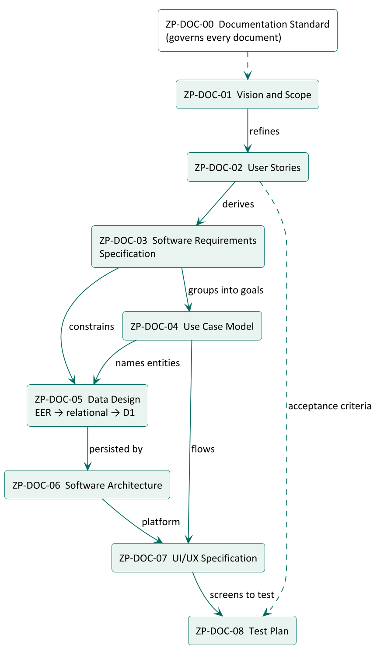
Figure 1: Dependencies between ZedPath documents

2.2 Folder and file layout
- Each document shall live in its own folder docs/NN-kebab-title/, where NN is its two-digit number.
- The source file shall be named ZP-DOC-NN_Title-In-Words.md.
- Generated files shall sit beside the source with the same base name: .docx and .pdf.
- Diagram sources shall live in diagrams/ inside the document folder, as .puml files, with the rendered .png beside them.

3 Identification

3.1 Document identifiers
Every document has a permanent identifier ZP-DOC-NN. Identifiers are never reused, even if a document is withdrawn.

3.2 Item identifiers
Items inside documents carry identifiers so they can be referenced and traced. Identifiers shall be unique across the document set and shall never be renumbered or reused after approval; a deleted item keeps its number and is marked Deleted.
Table 2: Identifier schemes for items inside documents
Item | Pattern | Example | Defined in
Evidence source | En, Tn | E4, T1 | ZP-DOC-02
Persona | Pn | P1 | ZP-DOC-02
Epic | EPn | EP3 | ZP-DOC-02
User story | US-enn (epic digit + number) | US-302 | ZP-DOC-02
Acceptance criterion | AC-enn.k | AC-302.2 | ZP-DOC-02
Business objective | BO-n | BO-1 | ZP-DOC-01
Feature | FE-n | FE-4 | ZP-DOC-01
Business rule | BR-nnn | BR-012 | ZP-DOC-03
Functional requirement | FR-nnn | FR-045 | ZP-DOC-03
Non-functional requirement | NFR-nnn | NFR-007 | ZP-DOC-03
Use case | UC-nn | UC-03 | ZP-DOC-04
Entity or table | singular noun in PascalCase (conceptual); snake_case (physical) | Offering; offering | ZP-DOC-05
Architecture decision | ADR-nnn | ADR-001 | ZP-DOC-06
Risk | RK-nn | RK-04 | ZP-DOC-01
Test case | TC-nnn | TC-118 | ZP-DOC-08

4 Versioning and status

4.1 Version numbers
- 0.1 to 0.8: working drafts.
- 0.9: complete draft submitted for review.
- 1.0: first approved version.
- 1.x: approved revisions that do not change scope (corrections, clarifications, added detail).
- 2.0, 3.0...: approved revisions that change scope or invalidate earlier commitments.

4.2 Status lifecycle
Every document shall show one of these statuses on its cover, in its header and in its document control page.
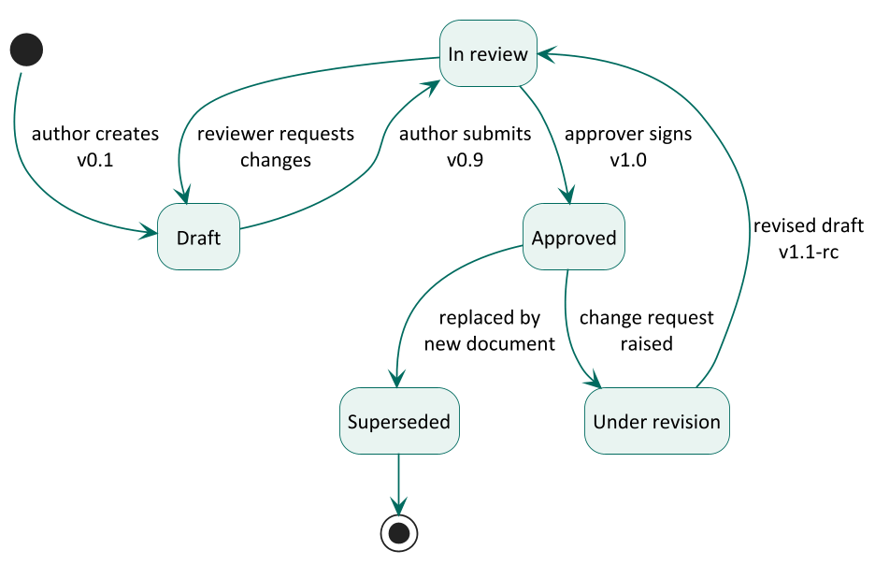
Figure 2: Document status lifecycle
Table 3: Document statuses and their meaning
Status | Meaning | Who changes it
Draft | Being written; content may change without notice | Author
In review | Complete; awaiting review comments and approval | Author submits
Approved | Signed off by the approver; the baseline for later work | Approver
Under revision | An approved document is being changed; the last approved version stays in force | Author
Superseded | Replaced by another document named in its revision history | Approver

5 Review and approval

5.1 Roles
Table 4: Documentation roles
Role | Responsibility | Held by
Document owner | Accountable for the content being correct and current | B.M.P Banneka, Product Owner
Author | Writes and revises the document | Team Kestrel (drafted with Claude)
Reviewer | Checks consistency, completeness and traceability | Claude (AI coding partner) and the owner
Approver | Accepts the document as the baseline | B.M.P Banneka, Product Owner

5.2 Approval procedure
- The author sets the version to 0.9 and the status to In review, and commits.
- Reviewers record findings; the author resolves each one and adds a revision-history row.
- The approver signs the approval table (name and date), sets version 1.0 and status Approved.
- The approval commit is tagged ZP-DOC-NN-v1.0 and noted in WORKLOG.md.
AI-generated content shall be reviewed by the product owner before approval. An AI reviewer may check consistency and traceability, but cannot approve.

6 Change control
- The Markdown source is the controlled version. Generated .docx and .pdf files shall not be edited by hand; they are rebuilt with node docs/_build/build.ts.
- Every new version shall add a revision-history row stating what changed and why.
- A change to an approved item shall be checked against everything that traces from it (see the traceability rules below), and those documents updated in the same commit or flagged in WORKLOG.md.
- Every change is committed to the public repository; Git history is the audit trail.

7 Mandatory structure

7.1 Front matter
Every source file shall begin with a front-matter block containing: id, title, subtitle, version, date, status, classification, owner, author, approver, standard (the governing standard), at least one revision line, and optionally reviewer lines.

7.2 Generated front pages
The build tool generates, in this order: the cover page; the document control page (document information, revision history, review and approval table); the contents; the list of figures and list of tables when the document has any.

7.3 Mandatory sections
Every document shall contain:
- Introduction, with at least Purpose, Scope and Intended audience. Documents that sit in the chain shall also state their relationship to other documents.
- Body sections required by the governing standard named in the register.
- Appendix: Glossary of terms and abbreviations used.
- Appendix: References to every external source cited.

8 Writing rules

8.1 Requirement language
Table 5: Keywords that express obligation
Keyword | Meaning
shall | Mandatory; the system or document is non-conforming without it
should | Recommended; departures need a recorded reason
may | Optional
will | A statement of fact or intent, not a requirement

8.2 Style rules
- Write in plain British English, in the active voice, in short sentences.
- One requirement per statement. Each requirement shall be verifiable.
- Avoid unverifiable words: user-friendly, fast, easy, flexible, robust, etc., and so on, as appropriate. Replace them with numbers and units (for example, "within 2 seconds on a 3G profile").
- Write dates in prose as 5 October 2026; in data, tables of values and identifiers, use ISO 8601 2026-10-05.
- Refer to sections in words: "Section 4.2". The section-sign symbol shall not be used.
- Define every abbreviation on first use and in the glossary.
- Sinhala or Tamil terms are written in English with the original in brackets on first use where it helps.
- Quote evidence verbatim and attribute it to its code (for example, E4).
- Do not refer to a table or figure by number in running text; describe it ("the table below"), because numbers are assigned automatically.

8.3 Privacy in documents
Documents are public. They shall not contain personal data. Interviewees are referred to only by codes (E1 to E6). Account identifiers, keys and tokens shall never appear in a document.

9 Visual identity

9.1 Page and typography
Table 6: Page and typography specification
Element | Specification
Page | A4 portrait; margins 2.0 cm (top 2.35 cm, to clear the header); header and footer 1.0 cm from the edge
Body text | Calibri 10.5 pt, line spacing 1.1, colour #1B1F1E
Heading 1 | Calibri 17 pt bold, ZedPath green #006B5F, rule below, starts a new page
Heading 2 | Calibri 13.5 pt bold, #1B1F1E
Heading 3 | Calibri 11.5 pt bold, dark green #00504A
Captions | Calibri 9 pt italic, #55605D, numbered automatically: "Table n:" above tables, "Figure n:" below figures
Code | Consolas 8.5 pt on a light grey panel
Tables | Header row green #006B5F with white bold text, alternate rows tinted #F3F8F6, 0.5 pt grey rules
Call-outs | Tinted panel with a green bar on the left; used for notes and the narrative of user stories

9.2 Header and footer
- Header: "ZedPath | document title" on the left; "document ID · vversion · status" on the right.
- Footer: "Classification: Public" on the left; "Uncontrolled when printed" in the centre; "Page n of N" on the right.
- The cover page carries no header or footer.

9.3 Section numbering
Headings are numbered automatically: 1, 1.1, 1.1.1. Appendices are lettered: Appendix A, A.1. Front pages (document control, contents and lists) are not numbered and do not appear in the contents.

10 Diagram standards
Diagrams are written as code (PlantUML) so they can be reviewed and versioned like text. Each diagram shall use the notation below for its kind, shall have a caption, and shall be readable when printed in greyscale.
Table 7: Diagram notations by purpose
Purpose | Notation | Used in
Story map | Mind map | ZP-DOC-02
System context | C4 model, level 1 (System Context) | ZP-DOC-01, ZP-DOC-06
Use cases | UML 2.5.1 use case diagram | ZP-DOC-04
Behaviour and flows | UML activity and sequence diagrams | ZP-DOC-04, ZP-DOC-06
Life cycles | UML state machine diagram | ZP-DOC-00, ZP-DOC-05
Conceptual data model | Enhanced Entity-Relationship (EER), Chen notation as in Elmasri and Navathe: rectangles for entities, diamonds for relationships, ovals for attributes, underlined keys, double lines for weak entities and total participation, circles for specialisation with d (disjoint) or o (overlapping) | ZP-DOC-05
Logical data model | Relational schema diagram, crow's foot (Information Engineering) notation | ZP-DOC-05
Containers and deployment | C4 level 2 (Container) and UML deployment diagram | ZP-DOC-06
Screen flow | Navigation map | ZP-DOC-07

11 Traceability
Every item shall trace to its parent, so that any requirement can be followed from the evidence that justified it to the test that proves it, and any test back to its reason.
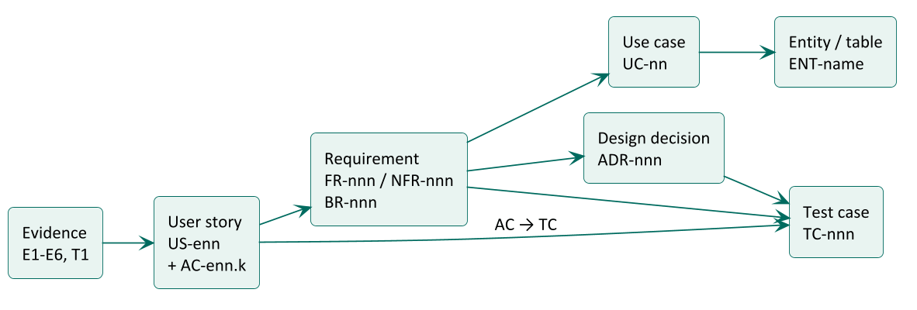
Figure 3: Traceability chain across the document set
- Each document shall contain a traceability table to its parent document.
- ZP-DOC-08 shall contain the full matrix from requirement to test case.
- An item with no parent is either unjustified (remove it) or reveals missing evidence (record it).

12 Tooling and publication
- Sources are Markdown with front matter; diagrams are PlantUML; the build tool (docs/_build/build.ts, TypeScript) produces .docx with docx-js and .pdf through Microsoft Word, which also refreshes the contents, the lists of figures and tables, and page numbers.
- Generated files are committed, so readers without the tools can open every document.
- The repository is public, so every document is classified Public.
- Official third-party documents (for example UGC handbooks and cut-off tables) are cited but shall not be redistributed in the repository.

Appendix A: Glossary
Table 8: Terms and abbreviations used in this standard
Term | Meaning
ADR | Architecture Decision Record: a short record of one significant design decision and its reasons
Baseline | An approved version that later work builds on
C4 model | A model for software architecture diagrams at four levels: context, container, component, code
EER | Enhanced Entity-Relationship model: ER plus specialisation, generalisation and categories
PlantUML | A tool that draws diagrams from text descriptions
Traceability | The ability to follow an item to its origin and to everything derived from it
UML | Unified Modeling Language, maintained by the Object Management Group

Appendix B: References
Table 9: Standards and sources referred to in this standard
Ref | Document
[1] | ISO/IEC/IEEE 15289:2019, Systems and software engineering: Content of life-cycle information items (documentation)
[2] | ISO/IEC/IEEE 29148:2018, Systems and software engineering: Life cycle processes, Requirements engineering
[3] | ISO/IEC/IEEE 42010:2022, Software, systems and enterprise: Architecture description
[4] | ISO/IEC/IEEE 29119-3:2021, Software and systems engineering: Software testing, Part 3: Test documentation
[5] | K. Wiegers and J. Beatty, Software Requirements, 3rd edition, Microsoft Press, 2013 (vision and scope template)
[6] | R. Elmasri and S. Navathe, Fundamentals of Database Systems, 7th edition, Pearson, 2016 (EER notation)
[7] | Object Management Group, Unified Modeling Language, version 2.5.1, 2017
[8] | A. Cockburn, Writing Effective Use Cases, Addison-Wesley, 2001
[9] | S. Brown, The C4 model for visualising software architecture, c4model.com
[10] | M. Nygard, Documenting Architecture Decisions, 2011
[11] | W3C, Web Content Accessibility Guidelines (WCAG) 2.2, 2023
[12] | Google, Material Design 3, m3.material.io

