CONCOURSE PIPELINE CONFIGURATION:

Steps to integrate source code with concourse:
- All the services pom.xml file should have the JaCoCo plugin and git-commit-id plugin in the <build> tag as shown. Also add the <finalName> tag as shown.
<build>
<plugins>
<!-- JaCoCo configuration -->
<plugin>
<groupId>org.jacoco</groupId>
<artifactId>jacoco-maven-plugin</artifactId>
<version>${jacoco.version}</version>
<executions>
<execution>
<id>default-prepare-agent</id>
<goals>
<goal>prepare-agent</goal>
</goals>
</execution>
<execution>
<id>default-report</id>
<phase>prepare-package</phase>
<goals>
<goal>report</goal>
</goals>
</execution>
</executions>
</plugin>
<plugin>
<groupId>pl.project13.maven</groupId>
<artifactId>git-commit-id-plugin</artifactId>
<version>${git-commit-id.version}</version>
<executions>
<execution>
<phase>validate</phase>
<goals>
<goal>revision</goal>
</goals>
</execution>
</executions>
<configuration>
<dotGitDirectory>${project.basedir}/.git</dotGitDirectory>
<generateGitPropertiesFile>false</generateGitPropertiesFile>
</configuration>
</plugin>
</plugins>
<finalName>${project.artifactId}-${project.version}-${git.commit.id.abbrev}</finalName>
</build>

- Sonarscript.sh should be available for all the services in the root directory along with manifest.yml file
- SonarQube server URL should be added to the properties in pom.xml inside <sonar.host.url> tag.
<properties>

<sonar.host.url>http://<<IP>>:9000</sonar.host.url>

</properties>

- If SonarQube server URL or credentials are changed then changes to Sonarscript.sh should be made accordingly.

Concourse Pipeline Template:

- Make changes to the PCF resources’ ‘organization’ and ‘space’ details based on the deployment environment if required. Currently there are 4 environments Dev,QA,Pre-prod and prod. Changes need to be made in all the resources of the respective environments if the resource details change.
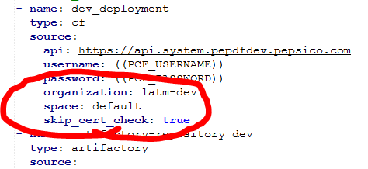

Installation of FLY CLI
- Open concourse server at http://<<IP or HOSTNAME>>:8080/ . Click on the OS that you want to download FLY cli for at the right bottom of concourse homepage as shown.
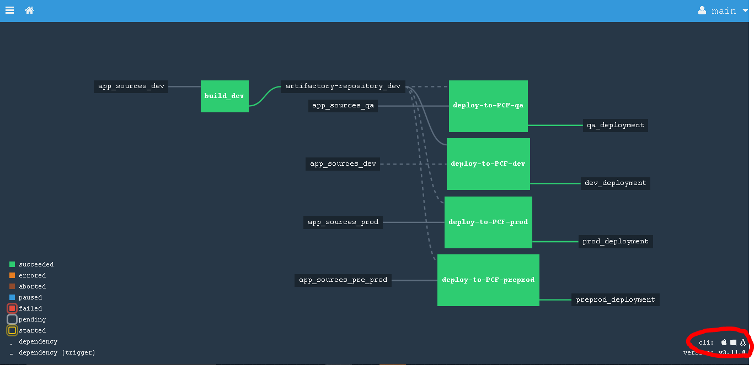
- Open command prompt from the path where your fly.exe is available.

- fly -t myLogin login -c http:// <<IP or HOSTNAME>>:8080/
UserName: ****
Password: ****
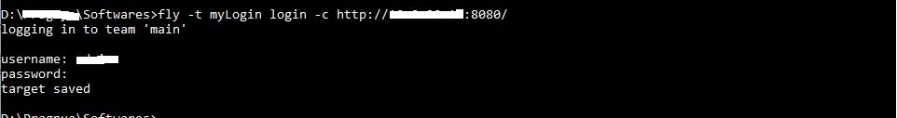

Steps to Create new pipeline

- fly -t myLogin set-pipeline --pipeline pipeline_name –config path_to_pipeline_file/Pipeline_Template.yml -v VSTS_USERNAME=vstsusername -v VSTS_PASSWORD=password -v PCF_USERNAME=pcfusername -v PCF_PASSWORD=password -v REPO_USERNAME=**** -v REPO_PASSWORD=**** -v app_name="projectname" -v VSTS_URL="git_src_url"

Steps to destroy pipeline

- fly -t myLogin destroy-pipeline --pipeline pipeline_name

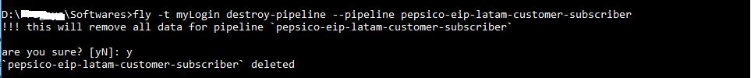

Concourse Steps:
- Open concourse server, login and un-pause the pipeline that you created and the pipeline’s first job will get triggered.
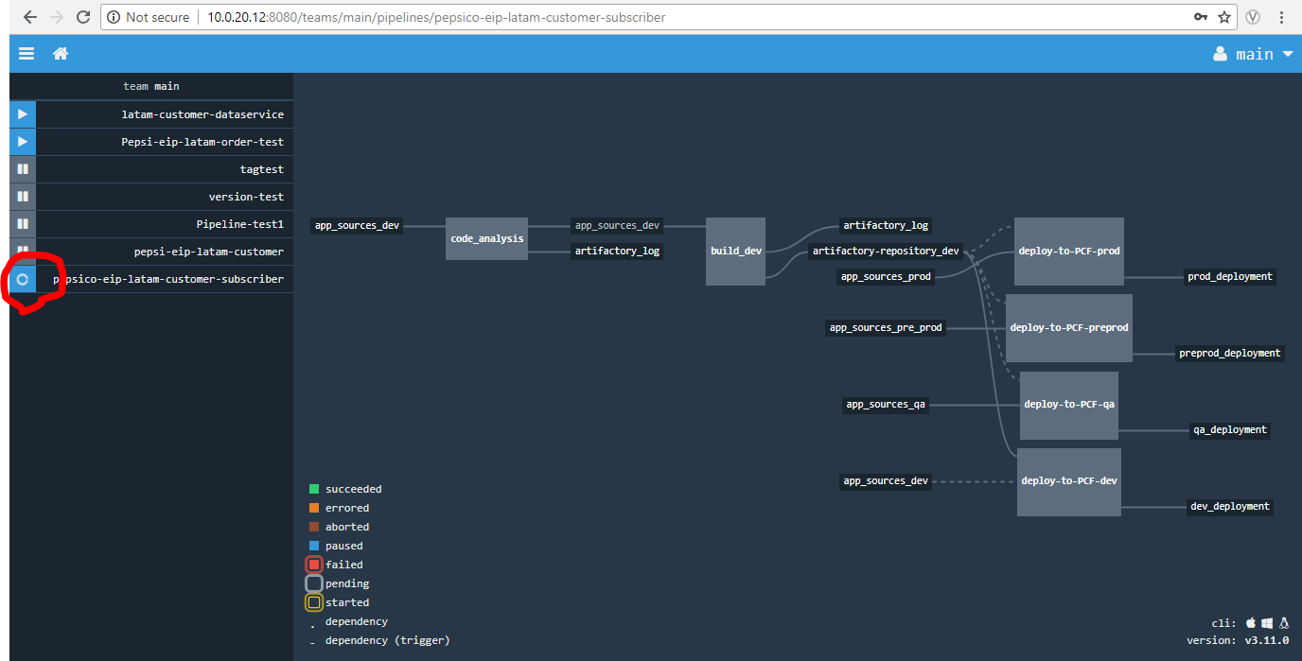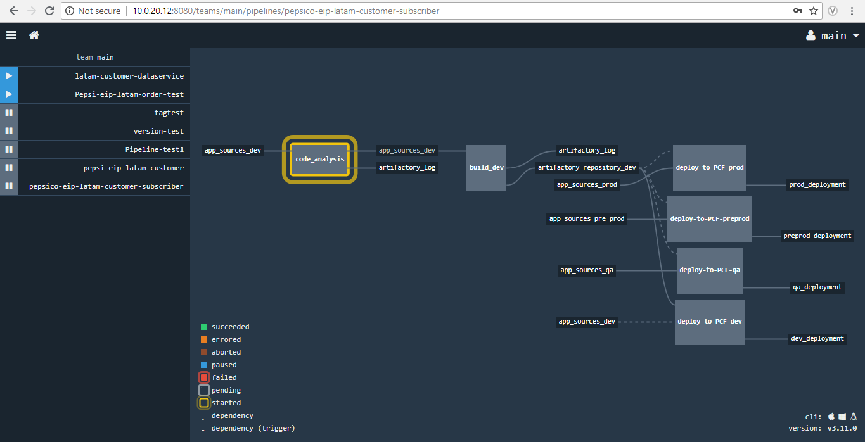
- For manual trigger open the particular job that you want to manually trigger and trigger the build as shown.

