Border Gateway Protocol (BGP) – Detailed Report

1. Introduction
Border Gateway Protocol (BGP) is the core routing protocol that enables communication between different networks on the Internet. It is known as the backbone routing protocol because it controls how data is routed between large networks called Autonomous Systems (AS). The current version in use is BGP-4. It operates over TCP port 179 and functions at the Application Layer (Layer 7) of the OSI model.

2. Autonomous System (AS)
An Autonomous System (AS) is a collection of IP networks and routers managed by a single organization that presents a common routing policy to the Internet. Each AS is identified by a unique Autonomous System Number (ASN). Examples include Internet Service Providers (ISPs), large enterprises, cloud providers, and universities.

3. Purpose and Uses of BGP
BGP is primarily used to exchange routing information between ISPs and large networks. It enables global Internet connectivity, supports traffic engineering, allows policy-based routing decisions, and helps determine the most efficient paths for data transmission across countries and continents.

4. How BGP Works
BGP uses a path-vector routing mechanism. First, two BGP routers establish a TCP connection on port 179, forming a BGP session called peering. They exchange routing information including network prefixes, AS path information, next-hop attributes, and other routing metrics. BGP then selects the best path based on attributes such as shortest AS path, highest local preference, lowest MED, and administrative policies. Once selected, routes are advertised to other BGP peers.

5. Types of BGP
External BGP (eBGP) operates between different Autonomous Systems and is used across the public Internet. Internal BGP (iBGP) operates within the same Autonomous System and distributes routing information internally.

6. Key Features of BGP
BGP supports policy-based routing, loop prevention using AS path verification, incremental route updates, CIDR support, and high scalability for global networks.

7. Famous BGP Attacks and Incidents
BGP has experienced several major incidents due to its trust-based design. In 2008, Pakistan Telecom accidentally hijacked YouTube traffic globally. In 2010, China Telecom briefly redirected significant global traffic. In 2018, Amazon Route 53 traffic was hijacked, affecting cryptocurrency services. Route leaks and prefix hijacking remain common threats.

8. Security Weaknesses
BGP was not originally designed with strong authentication or route validation. It does not automatically verify route ownership, making it vulnerable to hijacking and misconfiguration. Errors can propagate globally within minutes.

9. Security Improvements
Resource Public Key Infrastructure (RPKI) helps validate IP prefix ownership. BGPsec provides cryptographic validation of AS paths, though deployment remains limited. Network operators also use route filtering and monitoring systems to reduce risks.

10. Current Limitations
BGP convergence can be slow during network failures. Configuration is complex and prone to human error. Global routing tables continue to grow, increasing scalability challenges. Security enhancements are not universally deployed.

11. Advantages of BGP
BGP is highly scalable, supports flexible routing policies, enables global Internet connectivity, and provides reliable route exchange over TCP.

12. Conclusion
BGP remains the foundational routing protocol of the Internet. Despite its limitations and security challenges, it continues to enable global communication between Autonomous Systems worldwide. Ongoing security enhancements aim to strengthen its reliability and trustworthiness.

13. BGP Network Topology Diagram
The diagram below illustrates three Autonomous Systems (AS 100, AS 200, and AS 300) connected via BGP peering sessions. Each AS exchanges routing information using TCP port 179. The AS-PATH attribute helps prevent routing loops and determines the best path selection.
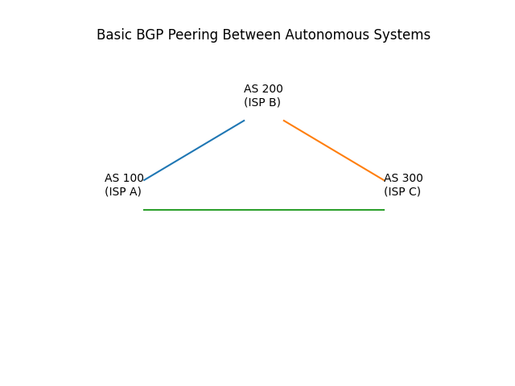

14. Advanced BGP Ecosystem Diagram
This diagram represents a simplified global Internet ecosystem using BGP. Tier-1 ISPs peer with each other (full-mesh). Regional ISPs connect upstream to Tier-1 providers. Enterprise networks and cloud providers advertise their prefixes through regional or Tier-1 ISPs. BGP exchanges route information between all these Autonomous Systems using policy-based routing and AS-PATH selection.
