Domain Name System (DNS)

1. Introduction to DNS
The Domain Name System (DNS) is a hierarchical and distributed naming system that translates human-readable domain names into IP addresses. DNS operates primarily on Port 53 using UDP (default) and TCP (for zone transfers and large responses). It functions at the Application Layer (Layer 7) of the OSI model.

2. DNS Architecture & Components
Major components include:
- DNS Resolver (Recursive Resolver)
- Root Name Servers
- TLD (Top-Level Domain) Servers
- Authoritative Name Servers
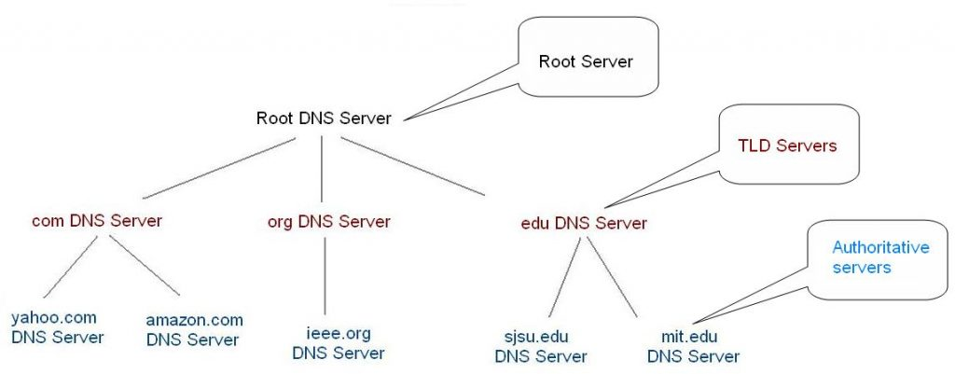

3. How DNS Works
1. Client checks local cache.
2. Query sent to recursive resolver.
3. Resolver contacts Root → TLD → Authoritative server.
4. Authoritative server returns IP address.
5. Resolver sends IP to client and caches result.
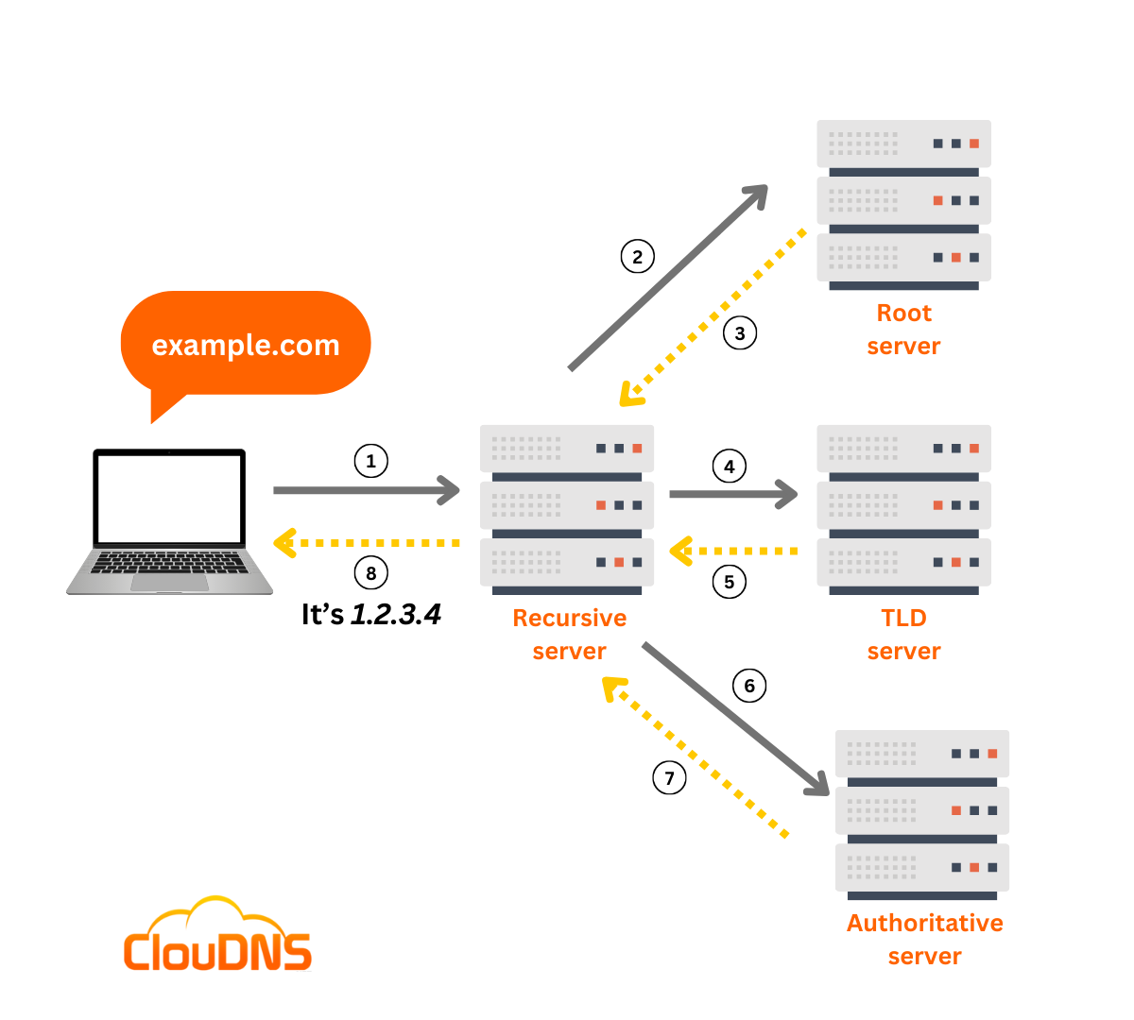

4. DNS Record Types
A – Maps domain to IPv4
AAAA – Maps domain to IPv6
MX – Mail server record
CNAME – Alias record
NS – Name server record
TXT – Text record (SPF, verification)
SOA – Start of Authority

5. DNS Functionality & Uses
- Domain resolution
- Email routing
- Load balancing
- Redundancy & failover
- Reverse lookups
- CDN routing
- Security mechanisms (SPF, DKIM, DMARC)

6. DNS Flaws & Weaknesses
- No built-in authentication
- No encryption (plaintext queries)
- Susceptible to spoofing
- UDP-based (packet forging possible)
- Trust-based architecture

7. Common DNS Attacks
- DNS Spoofing (Cache Poisoning)
- DNS Amplification (DDoS)
- DNS Tunneling
- Domain Hijacking
- NXDOMAIN Flood
- Fast Flux Attack

8. Historical DNS Exploits
- Kaminsky Attack (2008)
- Dyn DNS DDoS Attack (2016)
- DNSChanger Malware (2011)

9. DNS Security Improvements
- DNSSEC (Digital signatures for integrity)
- DNS over HTTPS (DoH)
- DNS over TLS (DoT)
- Response Rate Limiting (RRL)

10. DNS in Cybersecurity
DNS plays a major role in reconnaissance, malware command and control, phishing attacks, botnet infrastructure, and OSINT gathering.

