Simple Mail Transfer Protocol (SMTP)

Abstract
The Simple Mail Transfer Protocol (SMTP) is the foundational protocol used for email transmission across Internet Protocol (IP) networks. Originally standardized in 1982 and later refined in RFC 5321, SMTP operates as a push-based application layer protocol responsible for sending messages between mail clients and mail servers. Despite its simplicity and universal adoption, SMTP was not designed with modern security considerations in mind. This report explores SMTP’s architecture, operational workflow, primary use cases, inherent security flaws, known attack vectors, historical exploitation trends, and modern mitigation mechanisms.

1. Introduction
SMTP is a text-based protocol that facilitates the transmission of electronic mail between systems. It functions at the Application Layer (Layer 7) of the OSI model and is responsible solely for message delivery, not retrieval. Email retrieval is handled by complementary protocols such as POP3 and IMAP.

2. Architecture and Functionality
SMTP architecture consists of several logical components including the Mail User Agent (MUA), Mail Submission Agent (MSA), Mail Transfer Agent (MTA), and Mail Delivery Agent (MDA). The protocol typically operates on port 25 for server-to-server communication and port 587 for client submission.
- Typical SMTP Session Commands:
- HELO / EHLO
- MAIL FROM
- RCPT TO
- DATA
- QUIT
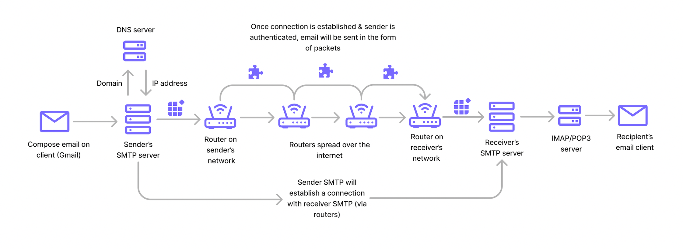

3. Primary Uses of SMTP
• Email transmission between servers
• Transactional notifications (e.g., password resets)
• Marketing and bulk email campaigns
• Automated alert systems in enterprise environments

4. Security Flaws in SMTP Design
SMTP was designed during an era when the Internet was a trusted academic network. Consequently, the protocol lacked built-in encryption, authentication, and integrity verification. Messages were transmitted in plaintext, making them vulnerable to interception and tampering.
- Key weaknesses include:
- Lack of mandatory authentication
- Absence of encryption in original specification
- Susceptibility to header spoofing
- Open relay misconfigurations

5. Common SMTP-Based Attacks
5.1 Email Spoofing – Forging sender addresses to impersonate trusted entities.
5.2 Open Relay Abuse – Exploiting misconfigured mail servers to distribute spam.
5.3 Man-in-the-Middle (MITM) Attacks – Intercepting plaintext traffic.
5.4 Brute Force Attacks – Credential guessing on mail submission ports.
5.5 SMTP Smuggling – Exploiting parsing inconsistencies in mail servers.

6. Historical Exploitation and Abuse
Throughout the late 1990s and early 2000s, SMTP played a central role in the global spam epidemic. Botnets leveraged open relays to distribute unsolicited email at scale. SMTP has also been a primary delivery vector for phishing campaigns and malware distribution.

7. Modern Security Enhancements
To address inherent vulnerabilities, several security mechanisms have been implemented, including:
• STARTTLS for encrypted transmission
• SMTP AUTH for authentication
• SPF (Sender Policy Framework)
• DKIM (DomainKeys Identified Mail)
• DMARC (Domain-based Message Authentication, Reporting & Conformance)

8. Current Limitations
Despite enhancements, SMTP remains dependent on optional encryption policies and correct configuration. Opportunistic TLS does not guarantee end-to-end encryption, and spoofing remains possible when domains lack proper authentication records.

9. Conclusion
SMTP remains a critical component of global Internet infrastructure. While its original design contained significant security shortcomings, layered defensive mechanisms have improved its resilience. Nevertheless, administrators must implement strict authentication, encryption, and monitoring controls to mitigate persistent threats.

