**Counting Duplicate Records**

with cte as (select *,

ROW_NUMBER() over(partition by Record_id order by record_id) as rn

from AmazonSaleReport$

)

select count(*) as Total_Duplicate_Records from cte

where rn >1

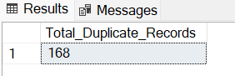

Removing Duplicates

with cte as (select *,

ROW_NUMBER() over(partition by Record_id order by record_id) as rn

from AmazonSaleReport$

)

delete from cte

where rn >1

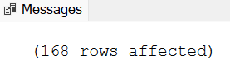

KPIs

1)Total Orders

select count(distinct Order_id) as Total_Orders

from AmazonSaleReport$

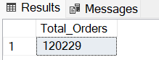

2) Completed orders

select count(distinct Order_id) as Total_Shipments

from AmazonSaleReport$

where Status in ('Shipped','Delivered')

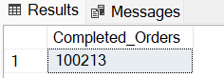

3)Confirmed Revenue (Delivered)

select sum(Amount) as 'Revenue(Rupees)'

from AmazonSaleReport$

where Status = 'Delivered'

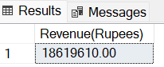

4)Potential Revenue(Delivered + Shipped)

select sum(Amount) as 'Potential_Revenue(Rupees)'

from AmazonSaleReport$

where Status in ('Shipped','Delivered')

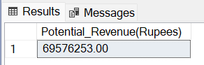

5)Average Order Value

select round(sum(Amount)/count(distinct Order_id),2) as 'AOV(Rupees)'

from AmazonSaleReport$

where Status in ('Shipped','Delivered')

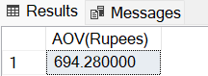

6)Order Status Distribution

select Status, count(distinct Order_id) as Count

from AmazonSaleReport$

group by Status

order by Count desc

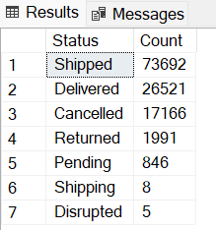

7) Orders by Fulfilment type

select Fulfilled_by, count(distinct Order_id) as Order_Count

from AmazonSaleReport$

group by Fulfilled_by

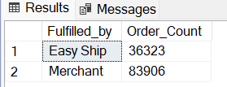

8)Revenue by Product Category

select Category, sum(Amount) as 'Product_Revenue(INR)'

from AmazonSaleReport$

where Status in ('Shipped', 'Delivered')

group by Category

order by 'Product_Revenue(INR)' desc

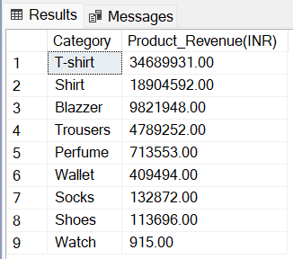

9)Revenue by State(Top 5)

select top 5 Ship_state, sum(Amount) as 'RevenuebyState(INR)'

from AmazonSaleReport$

where Status in ('Shipped', 'Delivered')

group by Ship_state

order by sum(Amount) desc

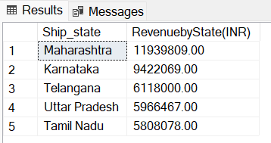

10)Monthly Order Count

select FORMAT(Order_Date,'MM-yyyy') as Month ,

count(distinct Order_id) as No_of_Orders

from AmazonSaleReport$

group by FORMAT(Order_Date,'MM-yyyy')

order by Month

