Brent Crude Oil

Global Stress Scenario Analysis

Model: GJR-GARCH(1,1) + Student-t Innovations

Date: 09 May 2026 | Paths per scenario: 1,000 | Seed: 42

Ten geopolitical and macroeconomic scenarios stress-tested through a calibrated GJR-GARCH volatility model.
Each scenario adjusts calibration window, initial volatility, tail heaviness, leverage, and projection horizon
to reflect the specific risk context of a named global event or structural shift.

Executive Summary
The table below compares all ten scenarios across six key risk metrics. Metrics are derived from Monte Carlo simulation of the fitted GJR-GARCH(1,1) model, pooling daily log-returns across all simulated paths. Daily VaR/ES figures apply to a single trading day; cumulative metrics apply over each scenario's specific projection horizon.
ID | Scenario | Horizon  (days) | Ann. Vol  (%) | Daily  VaR99 (%) | Daily  ES99 (%) | Mean DD  (%) | P95 DD  (%) | Prob  DD>40%
S01 | Baseline | 252 | 39.4 | 6.58 | 9.50 | 27.6 | 52.2 | 14.4 %
S02 | COVID Crash | 63 | 100.0 | 16.96 | 27.78 | 31.7 | 66.4 | 25.7 %
S03 | Russia-Ukraine | 126 | 49.7 | 8.31 | 11.59 | 24.4 | 46.0 | 8.8 %
S04 | OPEC+ Shock | 63 | 58.1 | 9.82 | 14.86 | 20.4 | 44.2 | 6.8 %
S05 | Global Recession | 252 | 44.9 | 7.62 | 12.00 | 32.3 | 58.1 | 26.3 %
S06 | Hormuz Closure | 42 | 79.1 | 12.83 | 16.38 | 25.8 | 48.0 | 11.6 %
S07 | Energy Transition | 504 | 39.9 | 6.65 | 9.10 | 43.5 | 69.7 | 53.7 %
S08 | Dollar Spike | 126 | 56.4 | 9.05 | 12.34 | 29.3 | 48.6 | 13.8 %
S09 | Stagflation | 252 | 51.1 | 8.06 | 14.11 | 31.5 | 59.3 | 24.3 %
S10 | Soft Landing | 252 | 26.4 | 4.26 | 5.82 | 18.6 | 37.7 | 4.2 %

Cross-Scenario Comparison
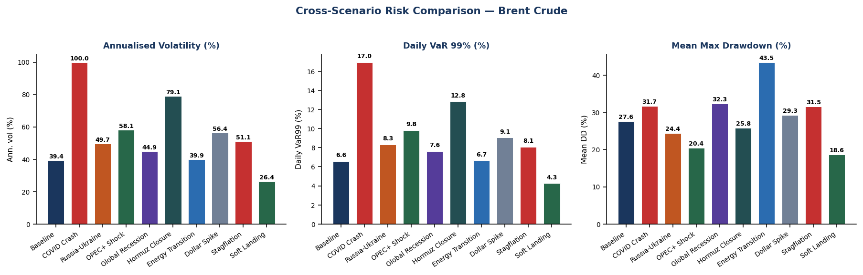

Methodology
Volatility model. GJR-GARCH(1,1) with Student-t innovations is fitted on each scenario's calibration window using maximum likelihood (arch library, Python). The variance equation is σ²ₜ = ω + (α + γ·𝟙_{εₜ₋₁<0})·ε²ₜ₋₁ + β·σ²ₜ₋₁, where γ > 0 captures the leverage effect (negative shocks raise future vol more than positive shocks of equal magnitude). Degrees of freedom ν controls tail heaviness; fitted values for Brent typically fall between 4.5 and 7.
Parameter overrides. Each scenario may modify: (a) calibration window — which historical period drives fitted parameters; (b) initial variance σ²₀ — the starting state of the variance recursion; (c) γ multiplier — amplifies or dampens the leverage effect; (d) ν override — stresses tail heaviness independently of the fit; (e) mean drift shock — adds a constant to μ to impose a directional expectation.
Monte Carlo simulation. Each scenario generates 1,000 independent paths from the (overridden) fitted parameters. Per-path seeding via a master RNG ensures full reproducibility. A 500-step burn-in is used when starting from unconditional variance; burn-in is suppressed when initial_vol is explicitly set.
Risk metrics. Daily VaR/ES are computed from the pooled distribution of all daily returns across all paths. Cumulative metrics (drawdown, total return percentiles) are computed per path and then aggregated. Drawdown is defined as the maximum peak-to-trough decline in the price index over the horizon.

Scenario Detail
Each scenario section shows the economic context, model assumptions, risk metrics, and a fan chart of simulated price paths (start = 100).

S01 | Baseline — Full History (2015–2025)
Geography: Global | Analogy: No specific shock — long-run unconditional distribution
Calibrated on the full ten-year Brent crude history spanning calm periods (2016–2019), the COVID-19 demand collapse (2020), and the Russia-Ukraine supply shock (2022). This is the unconditional benchmark representing 'average' oil market conditions across a full economic cycle and serves as the reference against which all stress scenarios are interpreted. Persistence of 0.978 confirms near-IGARCH behaviour — volatility shocks decay slowly, meaning a bad day echoes for weeks.

Model Assumptions  Calibration window 2015-01-01 – present  Horizon 252 trading days  Starting vol (σ₀) Unconditional  Leverage (γ) 1.0× fitted  Tail heaviness (ν) Fitted  Mean drift shock None  Fitted ν (model) 5.19  Fitted β (persist.) 0.8840 | Risk Metrics  Metric Value  Annualised vol 39.4 %  Daily VaR 95% 3.51 %  Daily VaR 99% 6.58 %  Daily ES 99% 9.50 %  Horizon P1 cum. return -46.0 %  Horizon P10 cum. return -14.6 %  Horizon median return 32.6 %  Mean max drawdown 27.6 %  P95 max drawdown 52.2 %  Prob(drawdown > 20 %) 67.7 %  Prob(drawdown > 40 %) 14.4 %  Prob(total loss > 30 %) 4.9 %

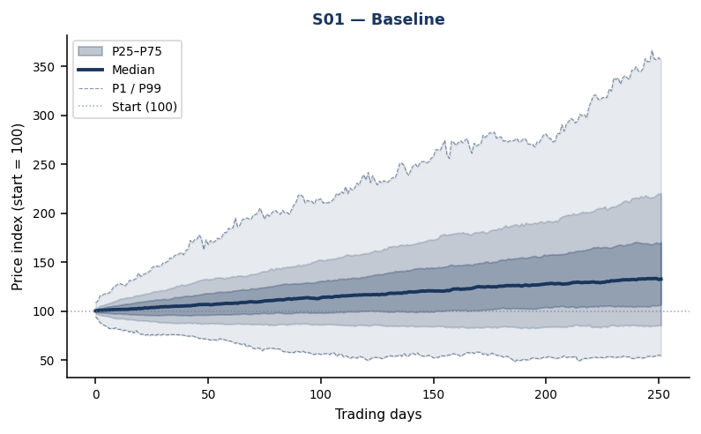

S02 | COVID-19 Demand Collapse (2020)
Geography: Global | Analogy: March–April 2020: Brent lost ~70 %, WTI turned negative
Replicates the pandemic oil price collapse of March–April 2020 when global demand fell ~25 mb/d and Brent dropped from $57 to $18 in six weeks. Model fitted on the 18-month pre/during crash window (Jun 2019 – Dec 2020). Starting volatility of 8 % daily mirrors realised peak conditions during the storage overhang. Structural negative drift of −8 bps/day approximates the demand destruction pace. 3-month horizon captures the acute shock phase before OPEC+ emergency cut took effect.

Model Assumptions  Calibration window 2019-06-01 – 2020-12-31  Horizon 63 trading days  Starting vol (σ₀) 8.0 % / day  Leverage (γ) 1.0× fitted  Tail heaviness (ν) Fitted  Mean drift shock -0.08 % / day  Fitted ν (model) 3.79  Fitted β (persist.) 0.9000 | Risk Metrics  Metric Value  Annualised vol 100.0 %  Daily VaR 95% 8.04 %  Daily VaR 99% 16.96 %  Daily ES 99% 27.78 %  Horizon P1 cum. return -70.9 %  Horizon P10 cum. return -40.6 %  Horizon median return 6.2 %  Mean max drawdown 31.7 %  P95 max drawdown 66.4 %  Prob(drawdown > 20 %) 71.0 %  Prob(drawdown > 40 %) 25.7 %  Prob(total loss > 30 %) 17.1 %

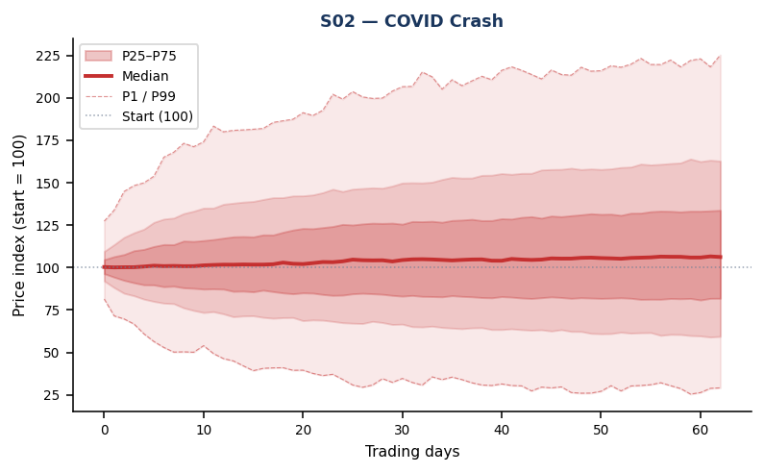

S03 | Russia-Ukraine Supply Shock (2022)
Geography: Europe / FSU | Analogy: Feb 2022: Brent spiked $80 → $130 then reversed sharply
Calibrates on 2021–2023, dominated by Russia's invasion of Ukraine (Feb 2022) which removed ~2.5 mb/d of seaborne Russian crude from Western markets. Brent spiked from $80 to $130 within weeks before reversing as alternative supply from the US, Gulf, and re-routing through Indian/Chinese refiners absorbed the shock. Starting volatility 5 % daily reflects the early-conflict regime. 6-month horizon covers supply displacement and partial re-routing.

Model Assumptions  Calibration window 2021-01-01 – 2023-06-30  Horizon 126 trading days  Starting vol (σ₀) 5.0 % / day  Leverage (γ) 1.0× fitted  Tail heaviness (ν) Fitted  Mean drift shock None  Fitted ν (model) 6.25  Fitted β (persist.) 0.8609 | Risk Metrics  Metric Value  Annualised vol 49.7 %  Daily VaR 95% 4.49 %  Daily VaR 99% 8.31 %  Daily ES 99% 11.59 %  Horizon P1 cum. return -46.3 %  Horizon P10 cum. return -11.8 %  Horizon median return 29.1 %  Mean max drawdown 24.4 %  P95 max drawdown 46.0 %  Prob(drawdown > 20 %) 56.8 %  Prob(drawdown > 40 %) 8.8 %  Prob(total loss > 30 %) 3.2 %

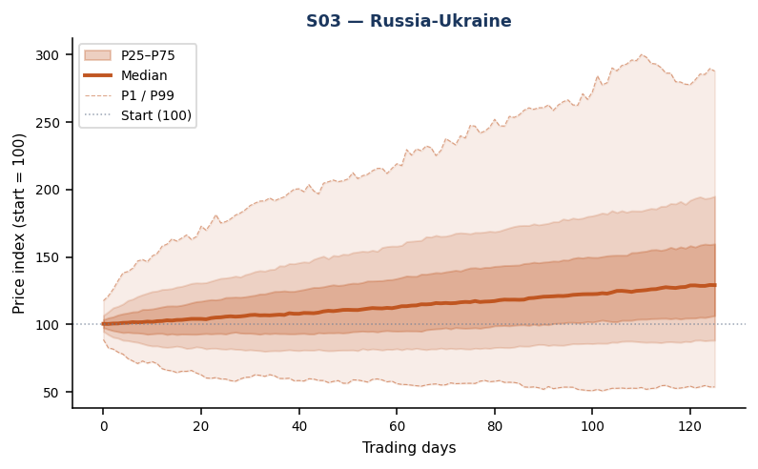

S04 | OPEC+ Surprise Production Cut
Geography: Middle East / OPEC+ | Analogy: Apr 2023 Easter Sunday surprise: 1.16 mb/d cut, no prior signal
Models a repeat of the April 2023 OPEC+ surprise cut announced on a Sunday with no prior market signal, triggering an immediate $5 gap-up open. The leverage parameter (γ) is doubled: in a tight-supply environment bad news amplifies volatility far more than equivalent positive surprises. Starting vol of 3.5 % captures moderate pre-cut stress. A small positive drift (+5 bps/day) reflects the expected upward price reset as the market prices in the new supply floor over a 3-month window.

Model Assumptions  Calibration window 2015-01-01 – present  Horizon 63 trading days  Starting vol (σ₀) 3.5 % / day  Leverage (γ) 2.0× fitted  Tail heaviness (ν) Fitted  Mean drift shock +0.05 % / day  Fitted ν (model) 5.19  Fitted β (persist.) 0.8840 | Risk Metrics  Metric Value  Annualised vol 58.1 %  Daily VaR 95% 5.02 %  Daily VaR 99% 9.82 %  Daily ES 99% 14.86 %  Horizon P1 cum. return -49.6 %  Horizon P10 cum. return -20.2 %  Horizon median return 11.4 %  Mean max drawdown 20.4 %  P95 max drawdown 44.2 %  Prob(drawdown > 20 %) 39.5 %  Prob(drawdown > 40 %) 6.8 %  Prob(total loss > 30 %) 4.5 %

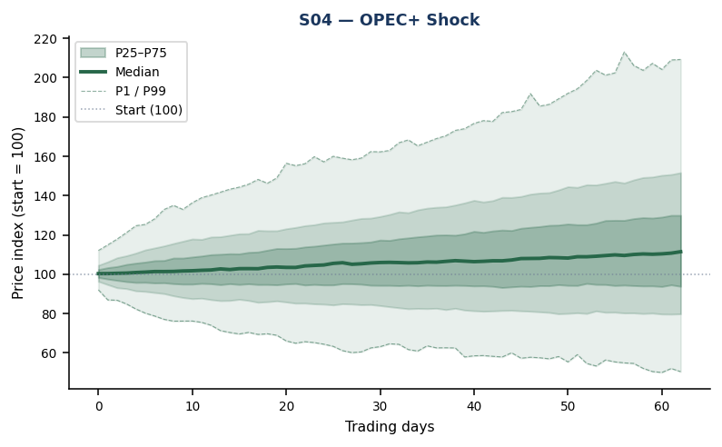

S05 | US / China Recession — Global Demand Destruction
Geography: Global | Analogy: 2008–09 GFC playbook at 2024 leverage levels
A synchronised US-China recession reducing global oil demand by 3–4 mb/d. Calibrated on the full Brent history but with fatter tails (ν = 4.0) to model tail-risk amplification from a systemic credit event. Structural negative drift of −5 bps/day (~−12.5 % annualised) reflects sustained demand weakness over a full year, consistent with GFC dynamics where demand destruction persisted 12–18 months before stabilising. Starting vol of 4 % reflects the early-recession risk-off environment.

Model Assumptions  Calibration window 2015-01-01 – present  Horizon 252 trading days  Starting vol (σ₀) 4.0 % / day  Leverage (γ) 1.0× fitted  Tail heaviness (ν) 4.0  Mean drift shock -0.05 % / day  Fitted ν (model) 5.19  Fitted β (persist.) 0.8840 | Risk Metrics  Metric Value  Annualised vol 44.9 %  Daily VaR 95% 3.73 %  Daily VaR 99% 7.62 %  Daily ES 99% 12.00 %  Horizon P1 cum. return -60.7 %  Horizon P10 cum. return -30.1 %  Horizon median return 14.8 %  Mean max drawdown 32.3 %  P95 max drawdown 58.1 %  Prob(drawdown > 20 %) 79.7 %  Prob(drawdown > 40 %) 26.3 %  Prob(total loss > 30 %) 10.1 %

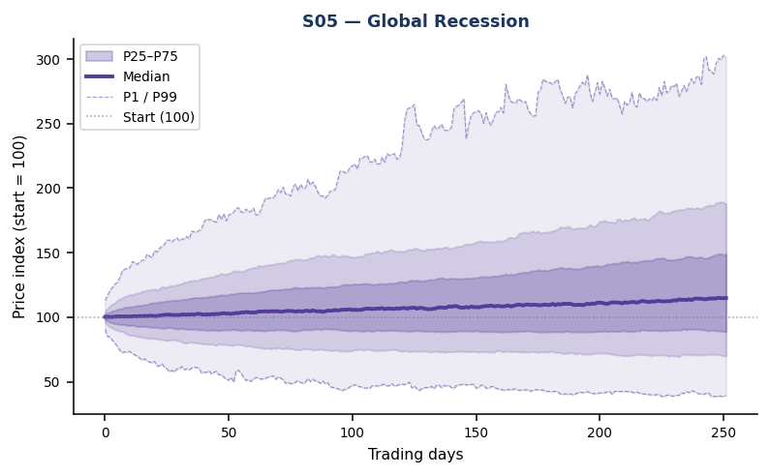

S06 | Strait of Hormuz Disruption
Geography: Middle East / Persian Gulf | Analogy: Threatened / partial closure — ~21 mb/d at risk
Simulates a partial or threatened closure of the Strait of Hormuz through which ~21 mb/d (≈20 % of global seaborne oil) transits. Calibrated on the high-volatility 2022–2023 window. The leverage parameter is scaled 1.5× because downside panic (closure feared) amplifies volatility far more than equivalent upside relief (diplomatic resolution). Initial vol of 6 % captures the acute shock onset. 40-day horizon approximates the window before diplomatic resolution or alternative routing (Cape of Good Hope bypass, strategic reserves release) typically activates.

Model Assumptions  Calibration window 2022-01-01 – 2023-12-31  Horizon 42 trading days  Starting vol (σ₀) 6.0 % / day  Leverage (γ) 1.5× fitted  Tail heaviness (ν) Fitted  Mean drift shock None  Fitted ν (model) 10.10  Fitted β (persist.) 0.9031 | Risk Metrics  Metric Value  Annualised vol 79.1 %  Daily VaR 95% 7.85 %  Daily VaR 99% 12.83 %  Daily ES 99% 16.38 %  Horizon P1 cum. return -50.8 %  Horizon P10 cum. return -29.2 %  Horizon median return 1.7 %  Mean max drawdown 25.8 %  P95 max drawdown 48.0 %  Prob(drawdown > 20 %) 63.3 %  Prob(drawdown > 40 %) 11.6 %  Prob(total loss > 30 %) 9.6 %

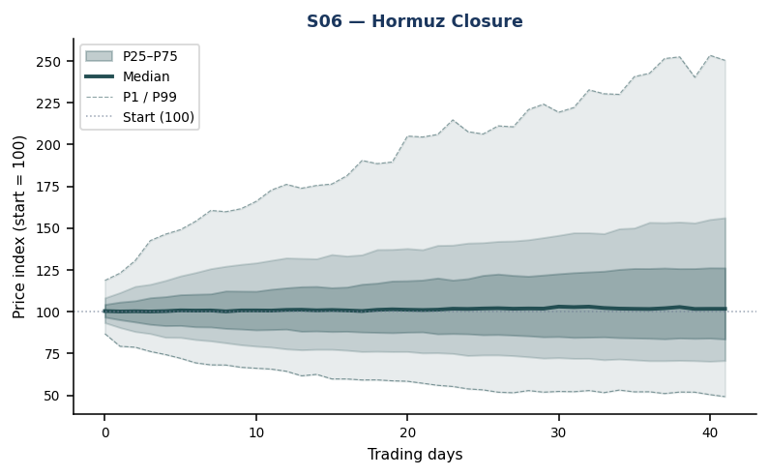

S07 | Energy Transition — Structural Demand Decline
Geography: Global (Long-term) | Analogy: IEA Net Zero 2050 pathway — oil demand peaks before 2030
A 2-year scenario modelling accelerated EV adoption, carbon border taxes, and industrial electrification structurally eroding oil demand. ν raised to 8 (lighter innovation tails — fewer extreme daily spikes as the market is more orderly in a managed-decline environment where forward curves provide guidance). Negative drift of −8 bps/day (≈−18 % annualised) reflects secular demand destruction compounding over a 2-year horizon. Lower idiosyncratic vol but sustained and ultimately predictable price erosion.

Model Assumptions  Calibration window 2015-01-01 – present  Horizon 504 trading days  Starting vol (σ₀) Unconditional  Leverage (γ) 1.0× fitted  Tail heaviness (ν) 8.0  Mean drift shock -0.08 % / day  Fitted ν (model) 5.19  Fitted β (persist.) 0.8840 | Risk Metrics  Metric Value  Annualised vol 39.9 %  Daily VaR 95% 3.82 %  Daily VaR 99% 6.65 %  Daily ES 99% 9.10 %  Horizon P1 cum. return -70.3 %  Horizon P10 cum. return -42.1 %  Horizon median return 15.2 %  Mean max drawdown 43.5 %  P95 max drawdown 69.7 %  Prob(drawdown > 20 %) 97.2 %  Prob(drawdown > 40 %) 53.7 %  Prob(total loss > 30 %) 17.7 %

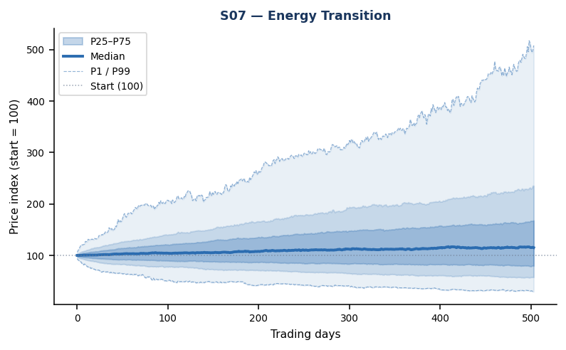

S08 | Fed Hawkish Shock — Strong Dollar
Geography: US / Global | Analogy: 2022 Fed tightening cycle; DXY +15 % in 9 months
Oil is priced in USD; a strong-dollar regime from surprise Fed rate hikes reduces Brent's affordability in non-USD terms and weakens emerging-market demand. Calibrated on 2022 — the year of the most aggressive Fed tightening in 40 years (425 bps in 12 months). Moderate negative drift of −3 bps/day captures the FX-driven demand headwind. Starting vol of 3 % reflects measured market stress at the onset of a new hawkish cycle rather than a full panic episode. 6-month horizon covers the initial tightening impact.

Model Assumptions  Calibration window 2022-01-01 – 2022-12-31  Horizon 126 trading days  Starting vol (σ₀) 3.0 % / day  Leverage (γ) 1.0× fitted  Tail heaviness (ν) Fitted  Mean drift shock -0.03 % / day  Fitted ν (model) 13.37  Fitted β (persist.) 0.8886 | Risk Metrics  Metric Value  Annualised vol 56.4 %  Daily VaR 95% 5.32 %  Daily VaR 99% 9.05 %  Daily ES 99% 12.34 %  Horizon P1 cum. return -43.4 %  Horizon P10 cum. return -21.5 %  Horizon median return 17.0 %  Mean max drawdown 29.3 %  P95 max drawdown 48.6 %  Prob(drawdown > 20 %) 80.9 %  Prob(drawdown > 40 %) 13.8 %  Prob(total loss > 30 %) 5.2 %

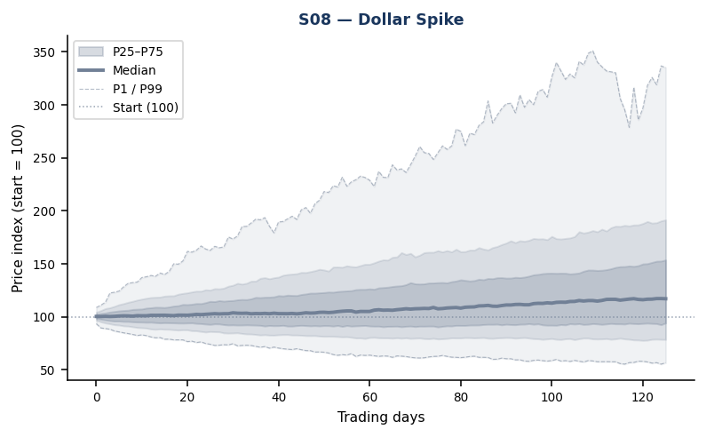

S09 | Stagflation — Supply Shock + Simultaneous Recession
Geography: Global | Analogy: 1973–74 oil embargo + 2022 H2 combined shock dynamics
The worst-case combination: a supply disruption keeps oil structurally elevated while a simultaneous recession weakens end-user purchasing power. Extreme tails (ν = 3.5 — near-Cauchy behaviour, matching Basel III internal model stress assumptions) model the tail-on-tail interaction when two independent crises materialise concurrently. Modest negative drift of −3 bps/day reflects net demand weakness eventually dominating supply support in the medium term. Starting vol of 5 % sets conditions in a pre-crisis elevated state. Most closely mirrors 1973–74 or late-2022 stagflationary oil market dynamics.

Model Assumptions  Calibration window 2015-01-01 – present  Horizon 252 trading days  Starting vol (σ₀) 5.0 % / day  Leverage (γ) 1.0× fitted  Tail heaviness (ν) 3.5  Mean drift shock -0.03 % / day  Fitted ν (model) 5.19  Fitted β (persist.) 0.8840 | Risk Metrics  Metric Value  Annualised vol 51.1 %  Daily VaR 95% 3.67 %  Daily VaR 99% 8.06 %  Daily ES 99% 14.11 %  Horizon P1 cum. return -70.4 %  Horizon P10 cum. return -24.6 %  Horizon median return 23.1 %  Mean max drawdown 31.5 %  P95 max drawdown 59.3 %  Prob(drawdown > 20 %) 75.3 %  Prob(drawdown > 40 %) 24.3 %  Prob(total loss > 30 %) 7.9 %

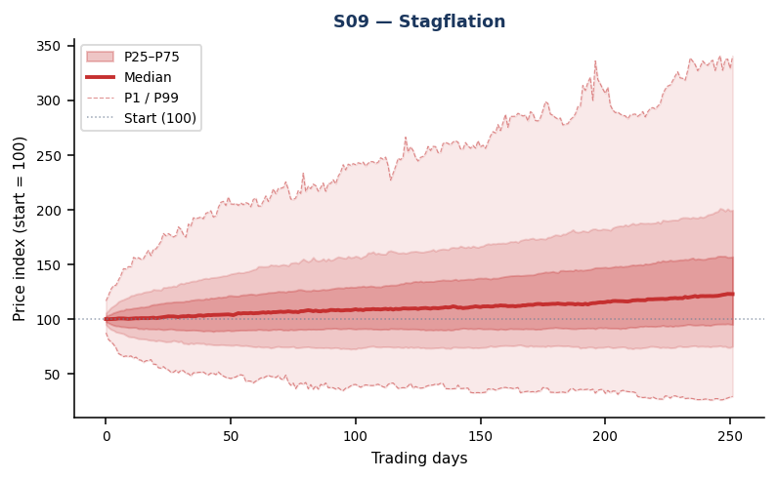

S10 | Benign Soft Landing — Pre-COVID Calm
Geography: Global (Benign) | Analogy: 2016–2018: recovering demand, OPEC compliance, absent shocks
A constructive baseline calibrated on 2016–2018 — a period of recovering demand post-2015 supply glut, gradual OPEC+ compliance, and absent geopolitical shocks. This scenario represents the lower bound on oil price risk: what Brent volatility looks like in an orderly macro environment with stable growth and no supply disruptions. Small positive drift (+2 bps/day) reflects gradual demand recovery. Used to stress-test model sensitivity to calibration-period choice and to provide the 'best-case' reference tail for risk budgeting.

Model Assumptions  Calibration window 2016-01-01 – 2018-12-31  Horizon 252 trading days  Starting vol (σ₀) Unconditional  Leverage (γ) 1.0× fitted  Tail heaviness (ν) Fitted  Mean drift shock +0.02 % / day  Fitted ν (model) 6.05  Fitted β (persist.) 0.9680 | Risk Metrics  Metric Value  Annualised vol 26.4 %  Daily VaR 95% 2.43 %  Daily VaR 99% 4.26 %  Daily ES 99% 5.82 %  Horizon P1 cum. return -32.2 %  Horizon P10 cum. return -2.3 %  Horizon median return 36.7 %  Mean max drawdown 18.6 %  P95 max drawdown 37.7 %  Prob(drawdown > 20 %) 35.4 %  Prob(drawdown > 40 %) 4.2 %  Prob(total loss > 30 %) 1.1 %

