**Boot Strap 3 Essential Training**

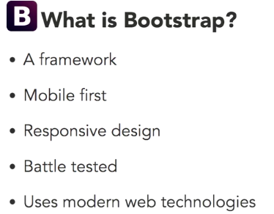

A CDN is a content delivery network which means a place that hosts common libraries like Bootstrap, when someone visits a site that uses a CDN link, their browser will check its cache or memory to see if the visitor has been to a similar site that is also using the same link.

In that case, the browser will load the cached version of the library. Now since it's already a memory, that makes the new site load faster since the browser won't have to request a file. Of course you can also download and install a copy of the Bootstrap framework manually. There's a couple of advantages to this. First, you can customize Bootstrap so that you use only the parts that you need, making the download smaller. Also during development, you won't need to be connected to the internet in order to preview and use Bootstrap. Regardless of the installation method you use, Bootstrap requires jQuery and it doesn't come with it so you'll need to download that separately or use a jQuery CDN.

<!-- IE Edge Meta Tag -->

<meta http-equiv="X-UA-Compatible" content="IE=edge">

This is a special tag that lets Internet Explorer know which versions engine to render the page with. By specifying edge here, we're saying that we want the latest and greatest rendering engine.

<!-- Viewport -->

<meta name="viewport" content="width=device-width, initial-scale=1">

By this your website is both viewable in website and mobile. Your work is efficient now. No more shrinking which will be hard to read.

<!-- Minified CSS -->

<link rel="stylesheet" href="https://maxcdn.bootstrapcdn.com/bootstrap/3.3.5/css/bootstrap.min.css">

This is the link to the max CDN website which has all the default Bootstrap styles in a minified form, so that it's as small as possible.

<!-- FOOTER SECTION - Before closing </body> tag -->

<!-- jQuery -->

<script src="https://ajax.googleapis.com/ajax/libs/jquery/1.11.3/jquery.min.js"></script>

<!-- Minified JavaScript -->

<script src="https://maxcdn.bootstrapcdn.com/bootstrap/3.3.5/js/bootstrap.min.js"></script>

you also need a copy of Bootstrap's JavaScript code. If you don't include this, then although your site will look great, some of the Boostrap features like the Carousel and Models will not work.

<link rel="stylesheet" href="https://maxcdn.bootstrapcdn.com/bootstrap/3.3.5/css/bootstrap.min.css">

<link rel="stylesheet" href="css/style.css">

make sure you write the css you want to overwrite the cdn of bootstrap after the link. This will over write the cdn.

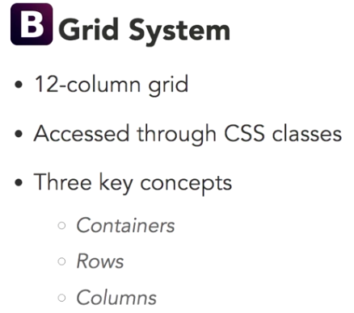

It is challenging to make the website responsive to both desktop and mobile versions. Since it involves lot of math. However, bootstrap does work for you. you need to understand the grid system.

Bootstrap Container:

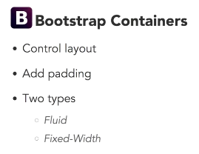

both have 15px padding.

fluid takes full width: class=”container-fluid”

fixed-width:

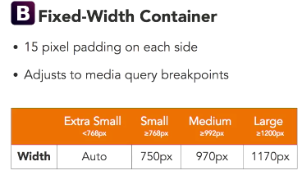

background-size: cover

without:

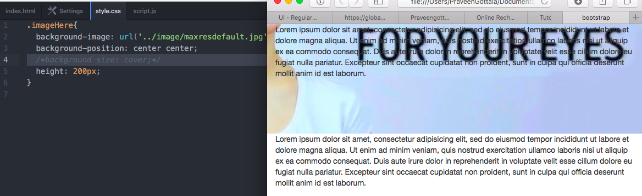

with:

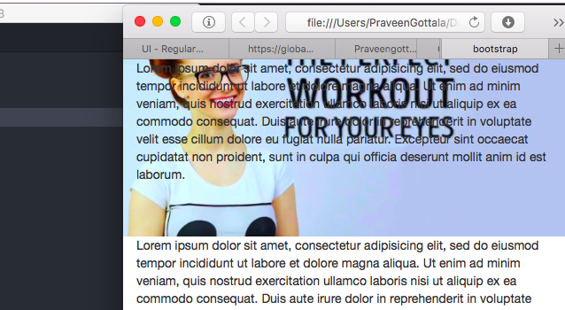

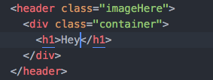

some content within the container and some outside.

