ADANI · CO-BOT CONSOLE
Architecture & Automation
From two data intake methods to three
System | Branch | Revision | Scope
RPA-UI-Dashboard | QA | 06 September 2026 | Data intake, scheduling, alerting, operations

1. Purpose and scope
This note covers how bot execution data gets into the Co-Bot Console, what changed when the Automation Anywhere pull was added, which jobs run at which times, and who receives which alert. It is written for the governance team and for whoever runs the platform day to day.
Everything here comes from the code on the QA branch. Where something is missing or looks risky it has been written down rather than left out; those items are collected in section 11.

2. What changed
Until the recent change the console took data in two ways, and both needed someone to act first. An admin uploaded the Control Room dump through the browser, or someone on the RPA team saved the same dump into the SharePoint folder for the console to collect. When nobody produced the file the dashboard went stale, and that usually came to light the next morning through the missing-data email.
The third method removes that dependency. A scheduled task signs in to the Automation Anywhere Control Room API twice a day, pulls the execution records for the seven runner machines, writes them into the same Excel layout the parser already handled, and puts the file into the same SharePoint folder.
What this actually changed
Method 3 is not a new route into the database. It is a new way of filling the SharePoint folder that method 2 was already watching. Nothing downstream needed changing: the parser, the file-log checks and the dashboard queries all stayed as they were.

Both manual paths are still in place. They are the fallback when the Control Room API cannot be reached, and method 1 is still the only way to load the master bot list, which is maintained by hand and has no API behind it.

3. The previous design — two methods
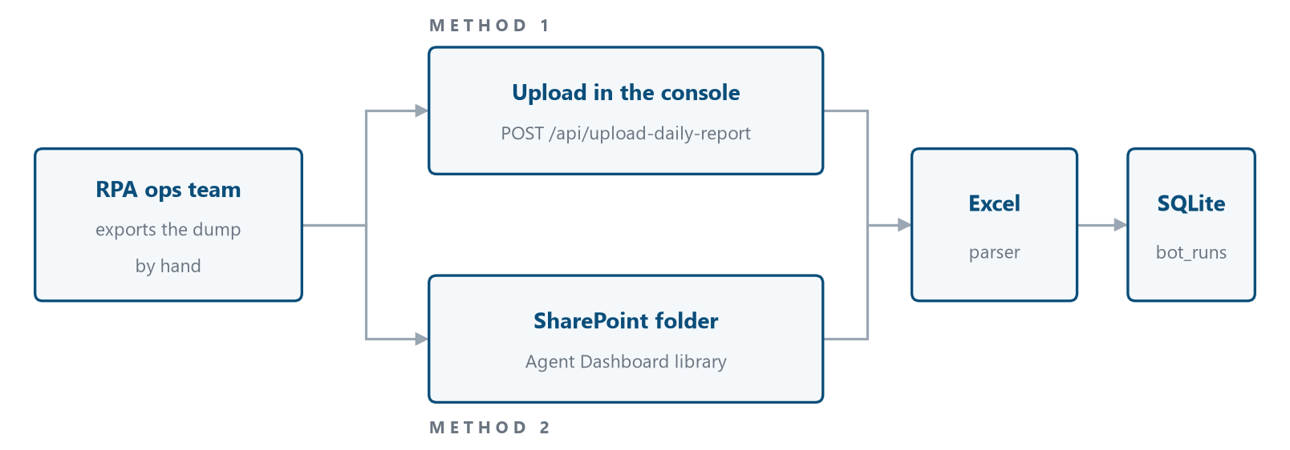
Figure 1. Both routes ended at the same parser and the same tables. The weak point sat before any of it: if the dump was not exported, neither route carried anything.

3.1 Method 1 — upload in the console
An admin picks a file in the console. There are two endpoints:
- The master bot list, holding departments, SPOCs, bots, schedules and savings figures. POST /api/upload-master
- The daily status dump exported from the Control Room. POST /api/upload-daily-report
The file is saved under the uploads directory with a date or timestamp in its name and handed to the parser. The response reports rows processed, bots matched, and the first ten parse errors.

3.2 Method 2 — SharePoint pull
The console signs in to Microsoft Graph with a client-credentials app registration, resolves the site drive and lists the target library. It then works through the files as follows:
- Keep .xlsx files whose name contains dump, control room or status report. Case does not matter.
- Sort oldest first by last-modified time so history loads in order.
- Skip anything already in the file log with status Success. This is what makes it safe to run the sync repeatedly.
- Read the report date out of the filename, matching a day followed by a three-letter month such as 3 Sep, and assume the current year.
- Parse the file, copy it into uploads/archive with a timestamp prefix, and write a file-log row holding the row count, unique bots, hours-saved estimate and any parse errors.
The sync runs from the admin screen on demand. It also runs as a background task after every successful SSO login.

3.3 Where this fell short
- Nothing loaded unless a person exported the dump first.
- How current the dashboard was depended on someone's working habits rather than on a schedule.
- A missed export surfaced at 09:00 the next morning, so up to a day late.

4. The current design — three methods
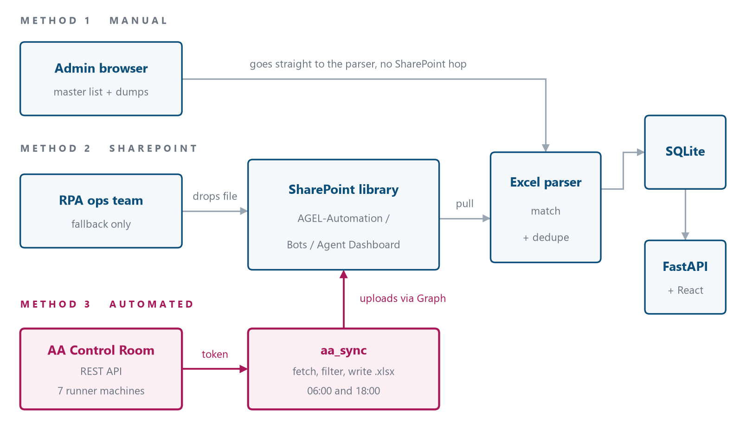
Figure 2. Method 3 feeds the SharePoint folder that method 2 already watched. Methods 1 and 2 work exactly as they did before.

4.1 Method 3 — pulling from the Control Room
One scheduled command does the whole job, in five steps:
- Sign in. Username, password and API key go to the Control Room authentication endpoint and the returned bearer token is held for the run. Transport errors are retried three times with a widening gap between attempts. A 401 or 403 is not retried, since more attempts will not fix bad credentials.
- Fetch. The activity list endpoint is paged 200 records at a time, filtered on end time and sorted newest first. If the token expires part way through, the job signs in again and repeats that page.
- Filter. Only records from the seven Cobot runner machines are kept. Paging stops once records older than the window start appear.
- Write. Records are de-duplicated on execution id, then written to an .xlsx whose header row matches what the parser expects. A JSON copy of the raw response is saved next to it for debugging.
- Publish. The Excel file is uploaded to the SharePoint library over Graph, where method 2 collects it on the next sync.
Columns written, in order:
Activity Name · Status · Started On · Ended On · Device Name · Automation Type · Error Message
Runner machines covered:
DT-1001-7B3NM24 · DT-1001-G62J7W3 · gcp10wbtrpap01 · gcp10wbtrpap02 · gcp10wbtrpap03 · gcp10wbtrpap04 · gcp10wbtrpap05
Option | What it does
--hours N | How many hours to look back from now. Defaults to 12.
--start / --end | An explicit ISO-8601 window. Overrides --hours, and is what you use for a backfill.
--no-upload | Write the Excel and JSON files but do not upload to SharePoint.

4.2 Why it runs twice a day
The 06:00 run looks back 12 hours. Its job is to get the dashboard current before the working day starts. The 18:00 run looks back 24 hours and produces the full day file that people open from SharePoint. The second window overlaps the first on purpose. De-duplication in the parser and the skip rule in the file log are what keep that overlap from double counting.

5. The three methods side by side
Method | Started by | How often | Needs a person | Carries
1 · Upload in console | An admin, in the UI | Whenever needed | Yes | Master list and daily runs
2 · SharePoint pull | SSO login, or the sync button | Every login | Only to put the file there | Daily runs
3 · Control Room pull | Windows Task Scheduler | 06:00 and 18:00 IST | No | Daily runs

Only method 1 can load the master bot list. Methods 2 and 3 carry execution records and nothing else.

6. What happens once the file lands
The route in makes no difference from here on:
- The Excel file sits in the uploads directory.
- The parser reads the sheet, tidies up the column names and works through the rows.
- Each row is matched to a bot by activity name. Rows that match nothing are counted as errors and reported back.
- A bot_runs row is written with the status, start and end times, device name, automation type and a report date.
- The file is copied into uploads/archive and a file_logs row records the filename, dates, counts, hours-saved estimate, archive path and status: Success, Partial_Success or Failed.
- Dashboard endpoints aggregate bot_runs into daily statistics, FTE trends and daily trends. The same tables feed the periodic reports and the generated deck.
If a file needs re-processing
The skip rule looks at the filename together with a Success status in file_logs. To make a file load again, delete or change that file_logs row and run the sync. Bot runs are keyed on the content, so running the same file twice does not duplicate history.

7. What runs when
All times are IST. Three things schedule work: Windows Task Scheduler, the APScheduler running inside the application, and triggers in the application itself.
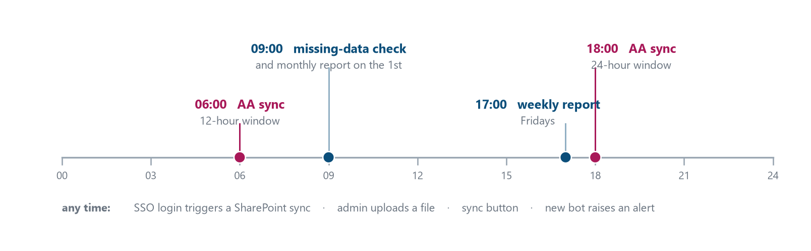
Figure 3. A single weekday. The 06:00 pull is what makes the dashboard current before anyone opens it; the 09:00 check reports when it did not.

7.1 Windows Task Scheduler
Created by setup_schedules.bat in the backend directory. Every task runs through the python.exe inside the backend virtual environment.
Task name | Runs | Command | Purpose
Adani_RPA_AA_Sync_Morning | Daily 06:00 | run_aa_sync.py --hours 12 | Quick dashboard refresh
Adani_RPA_AA_Sync_Evening | Daily 18:00 | run_aa_sync.py --hours 24 | Full day file for SharePoint users
Adani_RPA_Missing_Data_Check | Daily 09:00 | check_missing_data.py | Raises the data gap alert
Adani_RPA_Weekly_Report | Fridays 17:00 | send_periodic_reports.py --type weekly | 7 day digest with deck
Adani_RPA_Monthly_Report | 1st, 09:00 | send_periodic_reports.py --type monthly | 30 day digest with deck

7.2 APScheduler inside the application
A background scheduler starts with FastAPI and adds three cron jobs on the Asia/Kolkata timezone: the weekly report on Fridays at 17:00, the monthly report on the 1st at 09:00, and the missing-data check every day at 09:00. It is stopped cleanly when the application shuts down.
Open item: three jobs are scheduled twice
The missing-data check and both periodic reports are registered in two places. APScheduler starts them inside the FastAPI process, and setup_schedules.bat also creates them as Windows tasks. Where both are running, admins get each of those emails twice. One of the two should own them. Task Scheduler is the better choice: it survives an application restart, whoever runs the server can see it, and it will not multiply if the API is ever started with more than one worker.

7.3 Triggered by something happening
Trigger | When | What follows
SSO login | Every successful callback | A background SharePoint sync of anything not yet processed
Sync button | An admin clicks it | The same sync, run there and then
File upload | An admin uploads | The file is parsed straight away
Bot created | An admin adds a bot | New bot alert to all admins
New user | First login by an unknown address | New user alert to all admins
Manual report | An admin asks for it | The weekly digest is sent

8. Alerts

8.1 Who gets them
Recipients are worked out when the mail is sent, by looking up users whose role is Admin. There is no fixed distribution list anywhere, so adding someone as an admin in the console is what subscribes them, and removing them is what stops the mail. If no admin exists, the job writes a line to the log and stops rather than failing.

8.2 Mail settings
Setting | Value | Environment variable
Relay | smtp.adani.com | SMTP_SERVER
Port | 25 | SMTP_PORT
Sender | no-reply-ai-agel@adani.com | EMAIL_FROM
Credentials | Optional. STARTTLS and login are used only if a password is set | SMTP_USERNAME / SMTP_PASSWORD

8.3 The five alerts
Alert | Sent when | Type | Contains
Daily report data missing | 09:00 daily, if any of the last four dates has no run records | Problem | The dates with nothing in them, and the last date that did have data
New user joined | Somebody signs in by SSO for the first time | Event | The new user's name and email
New bot added | An admin creates a bot | Event | Bot, use case, department and SPOC contact details
Weekly performance report | Fridays 17:00, or on request from the admin screen | Digest | Runs, success rate, hours saved, daily trend, best and worst bots, deck attached
Monthly performance report | 1st of the month at 09:00 | Digest | The same figures over 30 days

8.4 How the missing-data check decides
The job reads the most recent report date in bot_runs, then counts run records for each of the four days before today. Any day with a count of zero goes into the alert. Weekends are included, so a quiet Sunday is reported too. The mail lists those dates alongside the last date that did have data.

8.5 Reports and the deck
The digest mails carry a deck rather than a link. The report builder works out total runs, success rate, hours saved, a per-day trend, the five strongest bots and the five with the most failures over the window, then builds an Adani-branded PPTX with a status pie and a trend chart. That file is attached. The same generator sits behind the download button in the console.
Gap: nothing tells us when the sync itself fails
A failed sign-in, an unreachable Control Room or an empty window all go to the rotating sync log and nowhere else. We find out the next morning at 09:00, indirectly, through a missing-data alert. Sending mail from the sync job on failure would close about a day of blind time, and would separate 'the API is down' from 'the bots did not run'.

9. Platform and data

9.1 What it is built on
Layer | Technology | Notes
Frontend | React with Vite | Built to frontend/dist and served by the API under the /cobot/ subpath
API | FastAPI on port 3123 | Routers for bots, departments, SPOCs, admin, integration, upload, summary and auth
Identity | Entra ID / Azure AD | OAuth authorization code flow through MSAL. Roles are held locally
Store | SQLite through SQLAlchemy | Tables are listed in 9.2
File transport | Microsoft Graph | Client credentials app registration, used to list, download and upload
Bot telemetry | Automation Anywhere Control Room API | Token auth with retry, paged activity fetch, filtered to seven devices
Scheduling | APScheduler and Windows Task Scheduler | See the open item in 7.2
Reporting | python-pptx | Adani-branded deck with pie and trend charts
Hosting | Windows service through NSSM, behind Nginx | Nginx strips the /cobot/ prefix; the API also copes if it does not

9.2 Tables
Table | Holds
departments | Business departments. Parent of bots
spocs | Single points of contact with email and phone
bots | The master bot list: use case, schedule, savings, status, dates, PDD links
bot_runs | One row per execution: status, start, end, device, automation type, report date
file_logs | One row per ingested file: counts, hours saved, archive path, status, errors
registered_users | Console users with role Admin or User. Drives who gets alerts
audit_log | Create, update and delete history with old and new values and who did it
visit_counts | Landing page visit counter

9.3 Configuration
Everything is read from the .env file in the backend directory.
Group | Variables
Automation Anywhere | AA_BASE_URL · AA_USERNAME · AA_PASSWORD · AA_API_KEY
SharePoint / Graph | SHAREPOINT_CLIENT_ID · SHAREPOINT_CLIENT_SECRET · SHAREPOINT_TENANT_ID · SHAREPOINT_SITE_URL · SHAREPOINT_TARGET_FOLDER · SHAREPOINT_SSL_VERIFY
Identity | AZURE_CLIENT_ID · AZURE_CLIENT_SECRET · AZURE_TENANT_ID · AZURE_REDIRECT_URI · JWT_SECRET · ADMIN_EMAILS
Mail | SMTP_SERVER · SMTP_PORT · SMTP_USERNAME · SMTP_PASSWORD · EMAIL_FROM
Network | PROXY_ENABLED · PROXY_URL · PROXY_INSECURE_SSL
Deployment | APP_BASE_URL · FRONTEND_BASE_URL

10. Running it day to day

10.1 The dashboard looks out of date
- Open backend/logs/aa_sync/aa_sync.log and find the last run and how many records it fetched.
- If the run worked but fetched nothing, there were no executions on the target machines in that window. Check the Control Room to confirm.
- If it failed at sign-in, check the AA credentials in .env and that the account is not locked.
- Once the file is in SharePoint, trigger the sync from the admin screen instead of waiting for the next login.

10.2 A missing-data alert has arrived
- Work out which half is at fault: no file was produced, or a file was produced and not ingested. The file log answers the second.
- If no file was produced, run the sync by hand for that window using --start and --end.
- If the file is in SharePoint but never loaded, look for a Failed or Partial_Success row in the file log and read the error it recorded.

10.3 Backfilling older dates
Run the sync with an explicit start and end. The file uploads under a fresh timestamped name so the skip rule will not ignore it, and de-duplication in the parser stops runs already in the database being counted twice.

10.4 Changing who gets alerts
Add the person in the admin screen and set their role to Admin. Nothing needs restarting; the next job picks up the new list.

10.5 Adding a runner machine
The seven machines are a constant in the Automation Anywhere service module. A new runner has to be added there. Until it is, its executions are fetched from the API and then dropped by the device filter without any warning.

11. Open items
# | Item | Effect | Suggested fix
1 | Weekly, monthly and missing-data jobs registered in both APScheduler and Task Scheduler | Admins get duplicate emails | Drop the APScheduler registrations and let Task Scheduler own all five
2 | No alert when the Control Room sync fails | Up to a day passes before it shows up indirectly | Send mail from the sync job when sign-in fails or nothing is returned
3 | TLS verification switched off across the SharePoint service | Traffic to Graph is not certificate checked | Limit the exception to the proxy, or install the corporate root certificate and turn verification back on
4 | CORS accepts any origin | Any site can call the API using the signed-in user's session | Restrict it to the deployed frontend origin before go-live
5 | AA credentials and client secrets sit in a plain .env file | Secrets spread across the application server | Move to a managed secret store, or at least lock the file down and rotate on a schedule
6 | The runner machine list is hard-coded | A new runner is silently ignored | Move it into configuration so it can change without a deployment
7 | SQLite as the store | One writer at a time; a sync and a report can contend | Fine at today's volume. Revisit if run volume grows

Adani Co-Bot Console · Architecture & Automation · 06 September 2026 · taken from the QA branch

