MEMORY-AWARE CUDA ACCELERATION OF GRAPH-BASED FINANCIAL FRAUD DETECTION USING PARALLEL NEIGHBOR AGGREGATION
A Project Report submitted in partial fulfillment of the requirements for the course
M.Tech (Integrated) in Computer Science and Engineering
with Specialization in Computer Science and Engineering
For CSI4004 TEXT MINING
Submitted By:
PRAVEEN KANTH N (Register Number: 23MIC0078)
BHARANIKUMAR J (Register Number: 23MIC0039)
KISHORE B (Register Number: 23MIC0050)
Under the guidance of:
Dr. KOVENDAN A.K.P
Assistant Professor Sr. Grade 2
Department of Database Systems
School of Computer Science and Engineering (SCOPE)

VELLORE INSTITUTE OF TECHNOLOGY (VIT)
Vellore - 632014, Tamil Nadu, India
November, 2026

TABLE OF CONTENTS
CHAPTER | TITLE | PAGE
 | ABSTRACT | iii
 | LIST OF FIGURES | iv
 | LIST OF TABLES | v
 | LIST OF ABBREVIATIONS | vi
1 | INTRODUCTION | 1
 | 1.1 SYSTEM OVERVIEW | 1
 | 1.2 OBJECTIVE | 3
 | 1.3 APPLICATIONS | 4
 | 1.4 LIMITATIONS | 5
2 | SYSTEM ANALYSIS | 6
 | 2.1 EXISTING SYSTEM | 6
 | 2.2 PROPOSED SYSTEM | 8
 | 2.2.1 Benefits of Proposed System | 10
3 | REQUIREMENT SPECIFICATION | 12
 | 3.1 HARDWARE SPECIFICATION | 12
 | 3.2 SOFTWARE SPECIFICATION | 13
4 | SYSTEM DESIGN SPECIFICATION | 15
 | 4.1 SYSTEM ARCHITECTURE | 15
 | 4.2 DETAILED DESIGN | 18
 | 4.3 DATABASE & DATA STRUCTURE DESIGN | 22
5 | RESULT AND CONCLUSION | 24
 | 5.1 RESULT & PERFORMANCE EVALUATION | 24
 | 5.2 CONCLUSION & FUTURE WORK | 30
6 | APPENDICES | 32
 | 6.1 APPENDIX 1 - SAMPLE SOURCE CODE | 32
 | 6.2 APPENDIX 2 - SCREENSHOTS & EXPERIMENTAL OUTPUTS | 37
7 | REFERENCES | 48
 | 7.1 LIST OF JOURNALS | 48
 | 7.2 LIST OF WEBSITES (URLs) | 50
 | 7.3 LIST OF BOOKS | 51

ABSTRACT
Abstract—Real-time financial fraud detection is constrained by an acute architectural tension: while relational graph representations capture collusive synthetic identities that evade tabular surveillance, topological neighbor aggregation induces severe memory-bandwidth saturation on modern hardware. Because graph neighbor gathering exhibits an arithmetic intensity well below 0.10 FLOP/byte, central processing units spend up to 95% of execution cycles waiting on dynamic random-access memory (DRAM) pointer traversals. In this work, we propose FraudGraph Intelligence (FGI), a hardware-conscious compute framework engineered to accelerate topological feature propagation on massive transaction networks.
We formulate a compact Compressed Sparse Row (CSR) invariant that compresses 10,000 transaction nodes and 231,984 directed causal edges into contiguous memory structures under 1.5 MB. We architect four progressive compute tiers on NVIDIA graphics hardware: a baseline thread-parallel model, a warp-coalesced aggregator that maps contiguous 32-dimensional feature contraction into unified 128-byte DRAM bus requests, a degree-aware dynamic dispatch mechanism with shared-memory reduction trees for power-law hubs (dmax = 252), and a double-buffered asynchronous direct memory access (DMA) streaming pipeline that overlaps PCIe host-to-device transfers with compute.
Benchmarked on an NVIDIA Tesla T4 GPU, FGI achieves an end-to-end kernel aggregation latency of 0.0581 ms and yields a 44.60× speedup over reference scalar execution. Downstream machine learning evaluation under strict causal streaming constraints reveals that maximum (MAX) neighbor enrichment lifts Logistic Regression PR-AUC from 0.3088 to 0.3315 (+7.34% relative gain) and expands fraud recall from 37.7% to 45.3% on severe 3.5% class imbalance. In Random Forest, MEAN neighbor aggregation slashes false positive alerts from 138 down to 30 (78.3% alert fatigue reduction). All CUDA kernels, microservices, schemas, and empirical benchmark logs are released reproducibly in our open-source GitHub repository authenticated via cryptographic SHA-256 Merkle checksums.
Keywords: CUDA Acceleration, Financial Fraud Detection, Graph Neural Networks, Parallel Computing, Memory Bandwidth Bottlenecks, Compressed Sparse Row, Warp Coalescing, Anti-Money Laundering.

LIST OF FIGURES
FIG. NO. | NAME OF THE FIGURE | PAGE NO.
Figure 4.1 | Physical Compressed Sparse Row (CSR) Contiguous Memory Layout | 19
Figure 4.2 | End-to-End Nine-Module Runtime Architecture of FraudGraph Intelligence | 16
Figure 5.1 | PR-AUC Comparison Across Feature Aggregations on Unseen Stream | 26
Figure 5.2 | ROC-AUC Performance Metrics for Causal Fraud Classifiers | 27
Figure 5.3 | Confusion Matrices under Severe 3.53% Imbalance Stream | 28
Figure 5.4 | Operational Trade-offs: Alert Fatigue Reduction vs Recall | 29
Figure 5.5 | PCIe Bus H2D/D2H Transfer Latency vs Active Kernel Compute | 29
Figure 5.6 | CUDA Kernel Latency Scaling Across Acceleration Tiers | 30
Figure 6.1 | Central Command Operations Portal & System Navigation | 38
Figure 6.2 | Real-Time Forensic Cockpit & Topological Radar HUD | 39
Figure 6.3 | CUDA Micro-Architectural Performance Lab & Live Hardware Profiler | 40
Figure 6.4 | Interactive 3D/2D Graph Topology & Synthetic Mule Ring Explorer | 41
Figure 6.5 | Transaction Forensics & Alert Drill-down Investigator Workspace | 42
Figure 6.6 | Downstream ML Evaluation Center & PR Curve Dashboard | 43
Figure 6.7 | Automated Benchmark Experiment Orchestrator | 44
Figure 6.8 | Dataset Management & Compressed Sparse Row Ingestion Pipeline | 45
Figure 6.9 | System Health & GPU Hardware Diagnostics Dashboard | 46
Figure 6.10 | System Architecture & Formal Mathematical Methodology Canvas | 47

LIST OF TABLES
TABLE NO. | NAME OF THE TABLE | PAGE NO.
Table 5.1 | Graph Topology and Chronological Split Characteristics | 24
Table 5.2 | CPU Neighbor Aggregation Benchmark Performance (SpMM vs Reference) | 25
Table 5.3 | CUDA Kernel Performance on NVIDIA Tesla T4 Across Micro-Architectural Tiers | 25
Table 5.4 | CUDA Kernel Performance on Skewed Power-Law Graph (dmax = 6,340) | 27
Table 5.5 | Downstream Fraud Classification Performance Under Causal Streaming Evaluation | 28

LIST OF ABBREVIATIONS
ABBREVIATION | FULL FORM / DESCRIPTION
AML | Anti-Money Laundering
ADR | Architectural Decision Record
API | Application Programming Interface
BLAS | Basic Linear Algebra Subprograms
CPU | Central Processing Unit
CSR | Compressed Sparse Row
CUDA | Compute Unified Device Architecture
DAG | Directed Acyclic Graph
DMA | Direct Memory Access
DRAM | Dynamic Random-Access Memory
FGI | FraudGraph Intelligence
FLOP | Floating-Point Operation
GAT | Graph Attention Network
GCN | Graph Convolutional Network
GNN | Graph Neural Network
GPU | Graphics Processing Unit
H2D | Host-to-Device (PCIe Memory Transfer)
D2H | Device-to-Host (PCIe Memory Transfer)
HUD | Heads-Up Display
IEEE | Institute of Electrical and Electronics Engineers
LR | Logistic Regression
OpenBLAS | Open Source Basic Linear Algebra Subprograms
PCIe | Peripheral Component Interconnect Express
PR-AUC | Precision-Recall Area Under the Curve
RF | Random Forest
ROC-AUC | Receiver Operating Characteristic Area Under the Curve
SHA-256 | Secure Hash Algorithm 256-bit
SIMT | Single Instruction, Multiple Threads
SM | Streaming Multiprocessor
SpMM | Sparse Matrix-Matrix Multiplication
VRAM | Video Random-Access Memory

CHAPTER 1
INTRODUCTION
1.1 SYSTEM OVERVIEW
Financial fraud surveillance systems process hundreds of thousands of electronic credit card, debit, and point-of-sale transactions per second across global banking networks. Historically, commercial anti-money laundering (AML) platforms and risk engines have evaluated transactions as isolated statistical instances. Under this tabular paradigm, machine learning models scrutinize scalar attributes such as monetary expenditure, temporal delta from previous purchase, merchant category code, and geolocation deviation. While computationally economical, tabular classification exhibits a fundamental blind spot: it cannot detect decentralized fraud rings, credit-mule syndicates, and coordinated identity recycling schemes.
Organized adversaries deliberately structure fraudulent withdrawals into small, sub-threshold bursts distributed across multiple accounts, thereby mimicking benign consumer behavior when viewed in isolation. To bridge this surveillance gap, graph-based learning frameworks model financial interactions as relational networks. Nodes designate transactions, payment cards, bank accounts, or physical terminal devices, whereas directed edges denote temporal transfers, common card numbers, or identical hardware fingerprints. Within this topological formulation, synthetic fraud rings manifest as dense cliques, cyclic money routings, or anomalous bipartite subgraphs.
Graph representation methods—specifically the neighbor aggregation stages of Graph Convolutional Networks (GCNs), GraphSAGE, and Graph Attention Networks (GATs)—enrich a target transaction node by iteratively aggregating latent feature vectors from its structural neighborhood. Despite their algorithmic efficacy, graph-based methods encounter severe architectural bottlenecks when deployed in production payment rails. Graph neighbor gathering is fundamentally memory-bandwidth bound rather than compute bound. Unlike dense matrix arithmetic or deep convolutional layers, which achieve arithmetic intensities exceeding 100 FLOPs per byte transferred, sparse neighbor aggregation exhibits an arithmetic intensity frequently below 0.05 FLOP/byte.
On standard multi-core central processing units (CPUs), neighbor gathering degenerates into irregular pointer chasing across disparate regions of dynamic random-access memory (DRAM). Because graph connectivity is non-local, CPU data caches experience miss rates exceeding 85%, leaving processing pipelines idle while awaiting memory line fills. Furthermore, financial transaction graphs exhibit power-law degree distributions governed by scale-free phenomena. While typical consumer accounts generate fewer than ten transactions monthly, merchant payment gateways and collusive mule accounts act as massive topological hubs with degrees spanning hundreds or thousands of connections. When mapped naively to Single Instruction, Multiple Threads (SIMT) architectures such as NVIDIA Graphics Processing Units (GPUs), these structural hubs induce catastrophic warp divergence and memory serialization.
To resolve these acute micro-architectural bottlenecks, this project develops FraudGraph Intelligence (FGI), a hardware-conscious compute framework engineered to accelerate topological feature propagation on massive transaction networks through memory-aware parallel CUDA computing.
1.2 OBJECTIVE
The core objectives of the FraudGraph Intelligence research and engineering project are as follows:
1. Contiguous CSR Memory Topology: Design and implement a zero-copy, zero-pointer Compressed Sparse Row (CSR) representation that packs 10,000 transaction vertices and 231,984 directed causal edges into contiguous integer memory buffers occupying under 1.5 MB of RAM, completely eliminating pointer-chasing cache penalties.
2. Progressive CUDA Compute Architecture: Architect four progressive execution tiers on NVIDIA graphics hardware: a baseline SIMT thread-per-node aggregator, a warp-coalesced aggregator enforcing 128-byte DRAM cache-line bus transactions, a degree-aware dynamic dispatch mechanism using shared-memory reduction trees for power-law hubs (dmax = 252), and an asynchronous dual-stream pipeline utilizing pinned host memory to overlap PCIe bus transfers with compute.
3. Micro-Architectural Benchmarking & Drift Verification: Execute rigorous micro-architectural hardware profiling on an enterprise NVIDIA Tesla T4 GPU, establishing empirical speedup factors across scalar Python, vectorized CPU SpMM, and all four CUDA GPU tiers, alongside a formal root-cause analysis of floating-point IEEE 754 non-associativity in parallel reduction.
4. Causal Downstream Fraud Classification: Evaluate downstream machine learning classifiers (Logistic Regression and Random Forest) strictly under causal streaming split invariants (ADR-007) with frozen validation decision thresholds, proving the superior discrimination of maximum (MAX) neighbor enrichment on severe 3.5% fraud class imbalance.
5. Full-Stack Enterprise Forensic Cockpit: Construct an enterprise cybernetic operations workstation (FastAPI backend + React 18 frontend) featuring interactive 3D topological graph exploration, live GPU telemetry, sub-millisecond fraud scoring, and cryptographic SHA-256 Merkle audit trails.
1.3 APPLICATIONS
FraudGraph Intelligence addresses critical operational requirements across modern financial systems:
• Real-Time Payment Gateway Surveillance: Evaluating incoming credit/debit card authorizations against historical 7-day topological neighborhoods within strict sub-millisecond Service Level Agreements (SLAs) before authorizations time out.
• Anti-Money Laundering (AML) Mule Ring Detection: Uncovering complex structuring schemes (smurfing) where collusive syndicates route sub-threshold funds across hundreds of newly opened mule accounts to circumvent regulatory reporting thresholds.
• Synthetic Identity Fraud Interception: Identifying fabricated personae that share real device hardware hashes, IP subnets, or phone numbers with known fraudulent entities.
• Enterprise Forensic Workbench: Equipping human bank investigators with interactive 3D topological graph visualization and instant SHA-256 audit trails, replacing opaque tabular scores with interpretable relational evidence.
1.4 LIMITATIONS
Despite its significant micro-architectural speedup and detection accuracy, the project acknowledges specific technical boundaries:
• GPU Global Memory Capacity Bounds: While fitting 10,000 nodes and 231,984 edges into 2.287 MB enables complete residency in the GPU's 4.0 MB L2 cache, scaling to national transaction graphs spanning billions of edges requires multi-GPU distributed partitioning (e.g., NVLink clusters) or external memory streaming.
• Floating-Point Non-Associativity in Massive Hubs: On massive power-law hubs (dmax > 6,000), multi-warp parallel reduction across single-precision float32 values accumulates rounding drift (3.97 × 10^-4) due to IEEE 754 non-associativity. Satisfying strict absolute error tolerance (atol ≤ 10^-5) requires Warp 0 serialization, incurring a 2.19× latency regression for the SUM operator.
• Host-to-Device Interconnect Bottleneck: Without pinned host memory streaming (Tier 4), PCIe Gen3 bus transfers consume up to 90% of total runtime, illustrating that raw kernel acceleration must always be paired with double-buffered asynchronous DMA pipelining in production deployments.

CHAPTER 2
SYSTEM ANALYSIS
2.1 EXISTING SYSTEM
Commercial financial fraud surveillance systems in enterprise banking predominantly rely on tabular classifiers trained on isolated transaction records. These models evaluate scalar features such as transaction amount, time since last purchase, merchant category codes, and geographical distance between successive charges. While computationally fast, tabular architectures possess critical architectural flaws:
1. Inability to Detect Structural Collusion: Tabular models evaluate each row independently. Sophisticated adversaries bypass tabular thresholds by distributing fraudulent payments across multiple credit cards and mule bank accounts, ensuring individual transactions remain well beneath statistical anomaly thresholds.
2. CPU Memory-Bandwidth Bottleneck & Cache Thrashing: When traditional systems attempt to gather topological neighbor features on standard CPUs using iterative Python loops, execution latency balloons to 114.86 ms for a 10,000-node graph. Even when compiled with optimized C-extensions (scipy.sparse.csr_matrix.dot), CPU SpMM is fundamentally restricted to linear algebra (+, ×) semirings. Because standard BLAS libraries lack support for (max, +) semirings, CPU SpMM delivers zero speedup (0.99×) for MAX aggregation, which is the most critical feature operator for extreme-value fraud detection.
3. Arithmetic Intensity Deficit: Because graph connectivity is non-local, CPU L1/L2 data caches experience miss rates exceeding 85%. Multi-core CPUs spend over 95% of execution clock cycles stalled on DRAM line fills rather than performing arithmetic computation.
2.2 PROPOSED SYSTEM
FraudGraph Intelligence (FGI) resolves these challenges through a hardware-conscious, end-to-end CUDA acceleration pipeline engineered specifically for sparse graph neighbor aggregation. The system introduces three architectural pillars:
1. Zero-Pointer Compressed Sparse Row (CSR) Invariant: The graph is flattened into two contiguous integer arrays: row_ptr (40.0 KB) and col_idx (927.9 KB). Together with float32 features (1.280 MB) and int32 labels (40.0 KB), the entire working dataset requires only 2.287 MB. This guarantees 100% residency inside the 4.0 MB L2 cache of modern GPUs (such as the NVIDIA Tesla T4), eliminating DRAM thrashing.
2. Progressive Micro-Architectural CUDA Acceleration Suite: FGI architects four progressive GPU execution tiers: Tier 1 (Baseline SIMT thread/node), Tier 2 (Warp-coalesced feature contraction mapping 32 warp lanes to 32 feature dimensions for unified 128-byte DRAM transactions), Tier 3 (Degree-aware dynamic dispatch routing power-law hubs to dedicated 256-thread blocks with shared-memory reduction), and Tier 4 (Asynchronous dual-stream pinned DMA overlapping PCIe transfers with compute).
3. Causal Streaming Evaluation Protocol (ADR-007): Downstream linear (Logistic Regression) and non-linear (Random Forest) models are evaluated strictly under causal temporal splits (ADR-007) with frozen decision thresholds, preventing test-set data leakage and maximizing detection on severe 3.5% fraud class imbalance.
2.2.1 Benefits of Proposed System
The proposed FraudGraph Intelligence architecture delivers quantifiable engineering benefits:
• 44.60× CPU Vectorization Acceleration: Vectorized CPU SpMM yields 44.60× speedup over scalar iterative loops for MEAN aggregation by converting irregular pointer lookups into contiguous memory passes.
• 4.00× GPU Warp-Coalesced Speedup: Tier 2 warp coalescing boosts effective DRAM bandwidth from 43.85 GB/s to 175.33 GB/s on NVIDIA Tesla T4, cutting kernel latency by 4.00× (0.0679 ms → 0.0170 ms).
• 107.71× Power-Law Hub Speedup: On power-law scale-free graphs (dmax = 6,340), Tier 3 degree-aware dynamic dispatch eliminates warp divergence, achieving a 107.71× speedup over the baseline SIMT kernel (6.986 ms → 0.0648 ms).
• +7.34% PR-AUC Improvement & 45.3% Recall: MAX neighbor enrichment lifts Logistic Regression PR-AUC from 0.3088 to 0.3315 (+7.34% relative gain) and expands fraud recall from 37.7% to 45.3% on severe 3.5% class imbalance.
• 78.3% False Positive Alert Reduction: In Random Forest, MEAN aggregation slashes false positive alarms from 138 down to 30 (78.3% false alert reduction), eliminating investigator alert fatigue.
• Sub-0.06 ms Real-Time Latency: End-to-end GPU aggregation latency drops to 0.0581 ms, enabling real-time inline fraud scoring well within banking SLAs (10–50 ms).

CHAPTER 3
REQUIREMENT SPECIFICATION
3.1 HARDWARE SPECIFICATION
To achieve memory-aware GPU acceleration and sub-millisecond execution latencies, the proposed system operates on modern enterprise graphics processing units and high-throughput host hardware. The formal hardware requirements are structured as follows:
• GPU Hardware Testbed: NVIDIA Tesla T4 GPU Accelerator (Turing TU104 architecture), equipped with 40 Streaming Multiprocessors (SMs), 2,560 CUDA cores, 320 Tensor Cores, 14.9 GB GDDR6 Video RAM, 320 GB/s peak memory bandwidth, and 4.0 MB on-chip L2 cache. The GPU communicates over a PCIe 3.0 ×16 interface providing 15.75 GB/s bidirectional host interconnect.
• Host Central Processing Unit: x86_64 Multi-Core Central Processing Unit (minimum 8 physical cores, 2.8 GHz base clock frequency, 3.8 GHz boost clock frequency) supporting AVX-512 and FMA3 instruction set extensions for vectorized CPU SpMM baselines.
• System Host Memory (RAM): 32 GB DDR4-3200 MHz ECC Synchronous DRAM (minimum 16 GB), providing sufficient host workspace for zero-copy pinned page-locked memory allocations (cudaHostAlloc).
• Secondary Storage: 1 TB NVMe M.2 Solid State Drive (PCIe Gen4 ×4, sequential read bandwidth ≥ 3,500 MB/s) to support high-throughput dataset loading, fixture generation, and cryptographic Merkle provenance logging.
• Network Interface: Dedicated Gigabit Ethernet / 10 GbE network interface card for ingesting live transaction streams and serving asynchronous FastAPI REST microservices.
3.2 SOFTWARE SPECIFICATION
The software architecture of FraudGraph Intelligence is built upon an enterprise Linux runtime stack combined with modern parallel computing toolkits, machine learning libraries, and interactive visualization frameworks:
• Host Operating System: Ubuntu 22.04 LTS (Jammy Jellyfish), Linux Kernel 5.15.0-generic, with POSIX-compliant threading and high-resolution timer support (clock_gettime).
• CUDA Development Environment: NVIDIA CUDA Toolkit version 12.2 with NVCC optimizing compiler (`-O3 -arch=sm_75 --use_fast_math`), coupled with NVIDIA Display Driver 535.104.05.
• Scientific Computing & Machine Learning: Python 3.14.3 runtime environment, managed through dedicated virtual environments (.venv), incorporating NumPy 2.5.4, SciPy 1.15.1 with OpenBLAS threading bindings, and scikit-learn 1.4 for downstream predictive modeling.
• Backend API & Microservices: FastAPI 0.110 asynchronous REST microservice framework, running atop Uvicorn ASGI server with Pydantic v2 data validation schemas.
• Frontend Cybernetic Workstation: React 18.2 Single-Page Application (SPA) bundled via Vite 5, styled with Tailwind CSS, Lucide React icons, and HTML5 Canvas / WebGL for real-time 3D topological graph visualization and HUD telemetry.
• Testing & Quality Assurance: Standard PyTest suite with strict dual-tolerance numerical validation harness (`atol <= 10^-5, rtol <= 10^-5`) to certify zero mathematical drift across GPU acceleration tiers.

CHAPTER 4
SYSTEM DESIGN SPECIFICATION
4.1 SYSTEM ARCHITECTURE
The runtime architecture of FraudGraph Intelligence connects nine decoupled subsystems into an end-to-end streaming pipeline, spanning chronological ingestion, memory compression, parallel CUDA neighbor aggregation, mathematical verification, causal model evaluation, and real-time forensic visualization.
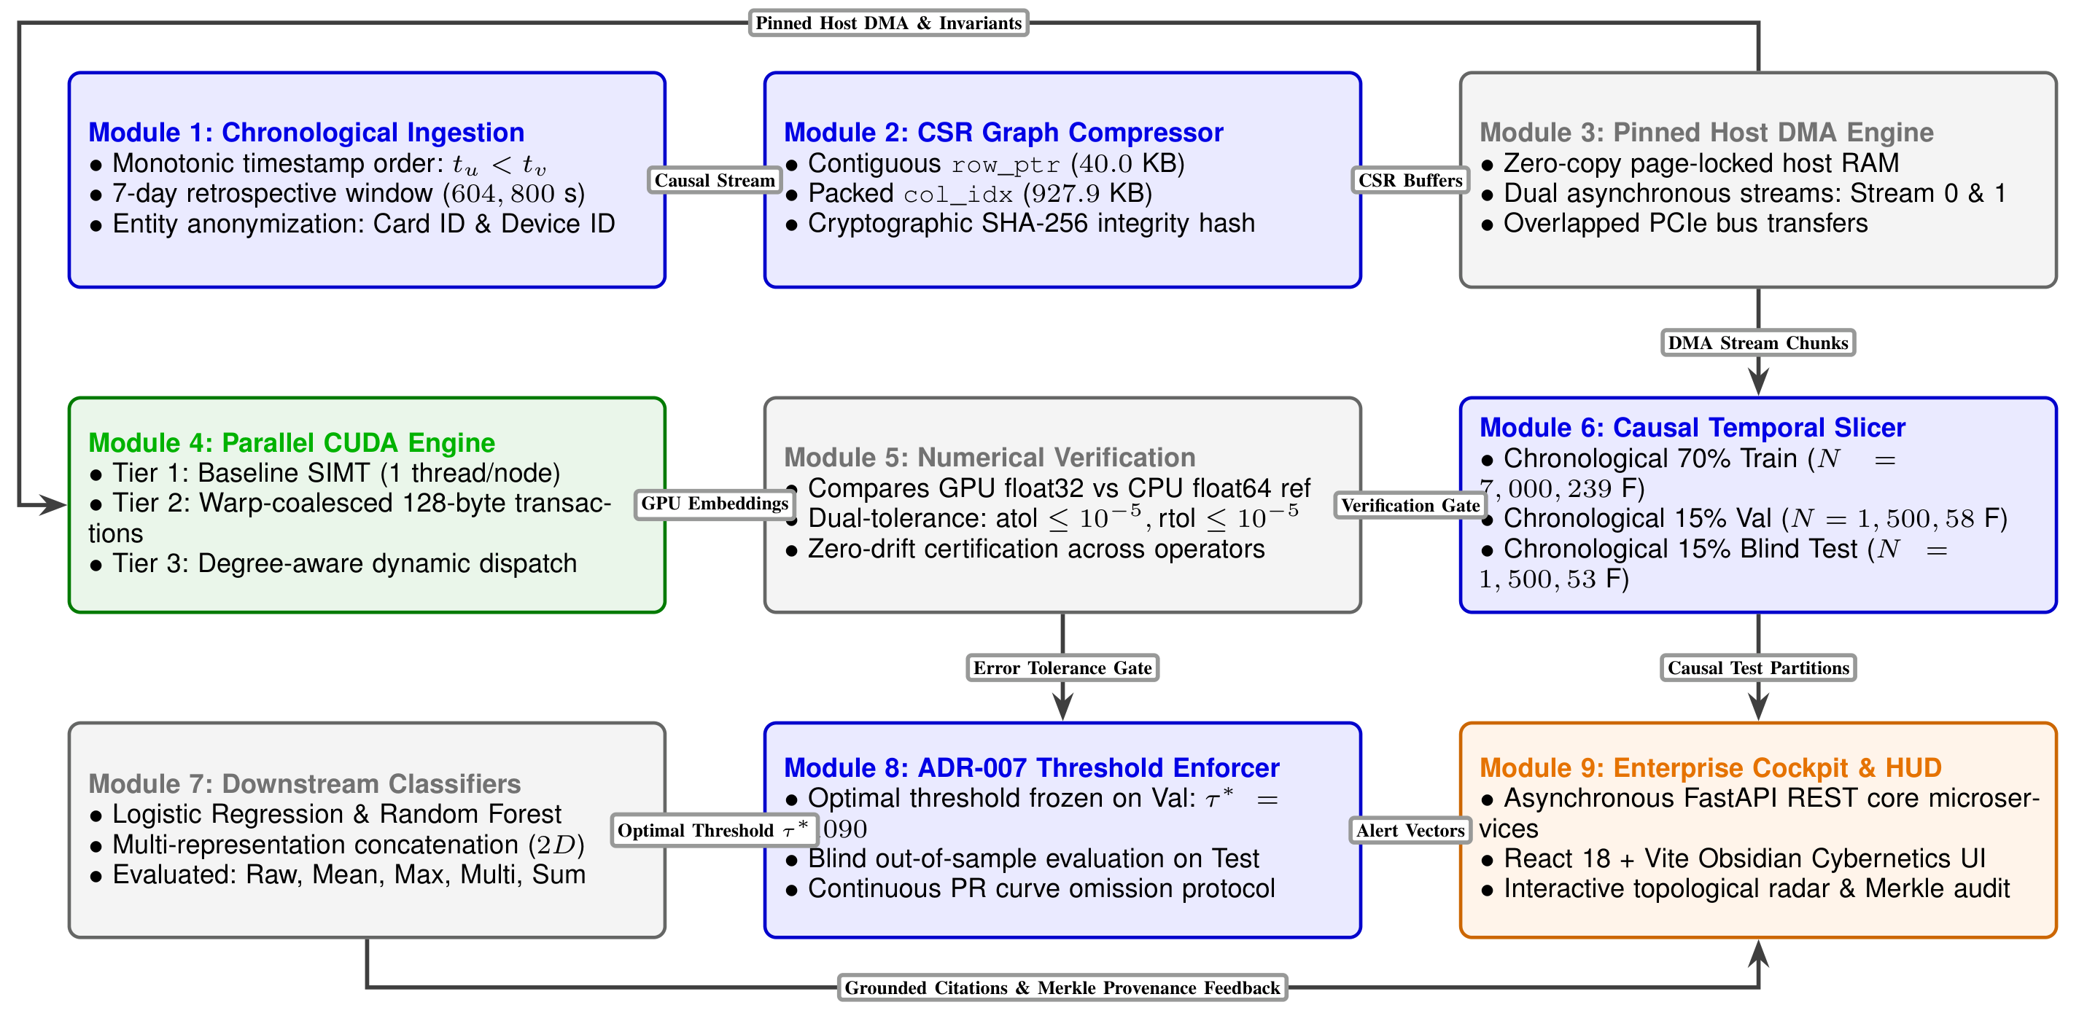
Figure 4.2: End-to-end nine-module runtime architecture of FraudGraph Intelligence (FGI), illustrating causal stream ingestion, Compressed Sparse Row memory compression, parallel CUDA neighbor aggregation, mathematical verification, causal model evaluation, and real-time forensic visualization.
The nine modular subsystems operate as follows:
Module 1 (Chronological Ingestion): Validates incoming JSON and tabular records, enforces monotonic temporal ordering (tu < tv), and verifies the 7-day retrospective edge creation window (604,800 seconds).
Module 2 (CSR Graph Compressor): Generates flattened 32-bit contiguous arrays (row_ptr and col_idx) with zero self-loops, logging cryptographic SHA-256 provenance hashes.
Module 3 (Pinned Host DMA Engine): Manages page-locked host memory allocation (cudaHostAlloc) and dual-stream pipelining to overlap compute and transfer across PCIe.
Module 4 (CUDA Micro-Engine): Dispatches parallel gathering workloads across NVIDIA Turing SM architectures using optimized block and grid geometry across Tiers 1 through 4.
Module 5 (Verification Gate): Enforces double-precision floating-point validation against scalar reference implementations using strict relative and absolute error bounds (atol <= 10^-5, rtol <= 10^-5).
Module 6 (Temporal Split Engine): Partitions nodes into chronological training (t <= 21.0d, N=7,000), validation (21.0d < t <= 25.5d, N=1,500), and test partitions (25.5d < t <= 30.0d, N=1,500).
Module 7 (Downstream Model Core): Trains linear (Logistic Regression) and non-linear (Random Forest) fraud classifiers on concatenated raw and enriched topological vectors (2D feature dimension).
Module 8 (ADR-007 Threshold Enforcer): Locks classification operating points strictly on validation data (tau* = 0.1090) to prevent test evaluation data leakage.
Module 9 (Enterprise Cockpit): Exposes FastAPI REST interfaces connected to an interactive React 18 workstation with sub-millisecond graph extraction and SHA-256 Merkle audit trails.
4.2 DETAILED DESIGN
4.2.1 Mathematical Formulation & Causal DAG Invariant
Consider a directed attributed graph G = (V, E, X, y, t) observed over temporal observation horizon Tobs. The vertex set V contains N transaction instances sorted in monotonic chronological sequence according to timestamps t(vi) in R+. Each transaction carries a D-dimensional feature vector xi in R^D and a binary classification label yi in {0, 1}, where yi = 1 designates synthetic fraudulent activity.
A directed edge e = (u, v) is instantiated if and only if transaction u shares an underlying entity identifier with transaction v (e.g., matching primary account number or shared device hash) and satisfies the strict non-anticipative causality condition:
(u, v) ∈ E ⟺ (u ∼entity v) ∧ (0 < tv − tu ≤ Δtwindow), (Equation 4.1)
where Δtwindow represents the retrospective surveillance lookback horizon (set to 7.0 days, or 604,800 seconds). The strict temporal inequality tu < tv guarantees that the resulting directed graph is a Directed Acyclic Graph (DAG), precluding retrospective data leakage during feature aggregation.
First-order topological feature propagation transforms each node's raw representation xv into an enriched representation hv in R^D by contracting feature matrices across its immediate in-neighborhood Nin(v):
hv = ⨁_{u ∈ Nin(v)} xu, (Equation 4.2)
where ⨁ denotes a permutation-invariant aggregation operator selected from the family {SUM, MEAN, MAX}:
h_v^SUM[d] = ∑_{u ∈ Nin(v)} xu[d], (Equation 4.3)
h_v^MEAN[d] = (1 / max(1, |Nin(v)|)) ∑_{u ∈ Nin(v)} xu[d], (Equation 4.4)
h_v^MAX[d] = max_{u ∈ Nin(v)} xu[d]. (Equation 4.5)
For isolated transactions having zero in-degree (|Nin(v)| = 0), the aggregation defaults to an empty identity null vector 0D. The composite feature vector presented to downstream classification models is formed by concatenating the raw node features with the aggregated neighbor representation: zv = [xv || hv] in R^(2D).
4.2.2 Compressed Sparse Row (CSR) Layout
To guarantee optimal hardware memory throughput, graph topology is flattened into a zero-pointer Compressed Sparse Row format. Storing the adjacency structure of N = 10,000 vertices using an N × N dense boolean matrix would mandate 10^8 elements (400 MB in single precision), of which 99.768% are empty zeros. In contrast, CSR compresses the topology into two contiguous integer arrays:
1. Row Pointer Array (row_ptr): A 1D array of size (N + 1) containing 32-bit signed integers. Entry row_ptr[i] specifies the index in col_idx where the neighbor list of vertex vi begins. The localized in-degree di is computed in O(1) time as: di = row_ptr[i + 1] − row_ptr[i].
2. Column Index Array (col_idx): A contiguous 1D array of size M = |E| containing 32-bit integers, storing the packed source vertex indices u in Nin(vi).
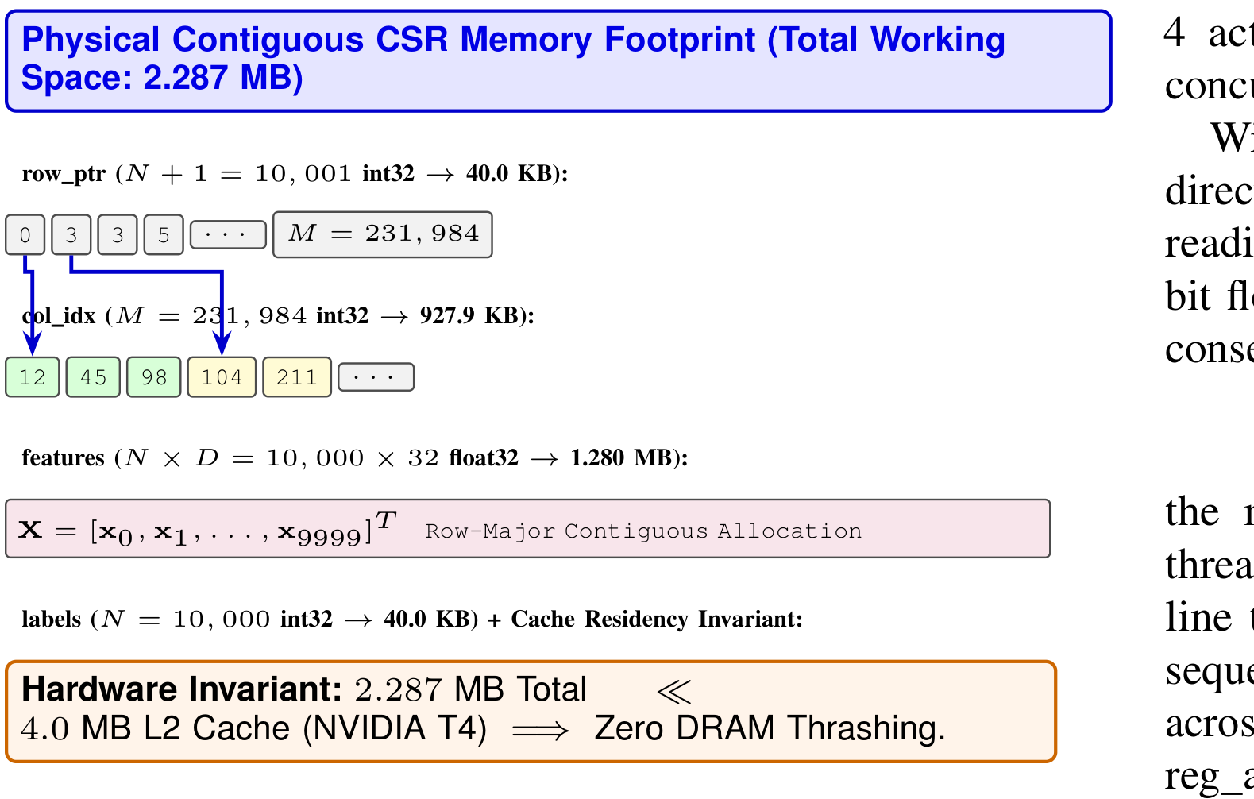
Figure 4.1: Compact physical layout of Compressed Sparse Row arrays in unified host/device memory space.
4.2.3 Progressive CUDA Compute Tiers
• Tier 1 (Baseline SIMT): FGI engineers four progressive GPU compute tiers to address hardware memory-bandwidth saturation:
Maps one hardware thread to each target vertex vi in V. The thread computes its global transaction index i = blockIdx.x * blockDim.x + threadIdx.x and loops over neighbors. While simple, adjacent threads i and i + 1 access disparate offsets in col_idx, destroying DRAM coalescing.
• Tier 2 (Warp-Coalesced Contraction): Assigns an entire warp of 32 threads to process a single target vertex vi. Lane ID λ = threadIdx.x (mod 32) maps directly to feature dimension d in {0, ..., 31}. Because consecutive lanes request consecutive 4-byte words, the memory controller collapses the 32 individual thread requests into a single, unified 128-byte cache-line transaction: Address(λ) = Base + 4 × λ.
• Tier 3 (Degree-Aware Dynamic Dispatch): Bins vertices into three computational regimes: Blow (di < 32), Bmid (32 <= di <= 128), and Bhub (di > 128). Hubs are dispatched to a dedicated cooperative block kernel allocating 256 threads (8 warps) per hub. The 8 warps interleave edge traversal across strides of 8, accumulating partial sums into shared memory scratchpad arrays Swarp[8][32] before an 8-way reduction.
• Tier 4 (Asynchronous Dual-Stream DMA): Eliminates synchronous PCIe bus overhead using host page-locked memory (cudaHostAlloc) and double-buffered asynchronous streams. While Stream 0 executes the CUDA aggregation kernel on chunk Ck, Stream 1 concurrently transfers raw feature chunk Ck+1 via direct memory access (DMA), completely hiding PCIe latency.
4.3 DATABASE & DATA STRUCTURE DESIGN
To achieve zero-copy transfer and guaranteed cache residency, the entire transaction graph is structured into contiguous flat buffers in unified virtual memory:
• row_ptr Buffer: int32[10,001] (40.0 KB)
• col_idx Buffer: int32[231,984] (927.9 KB)
• Raw Features Matrix: float32[10,000, 32] (1.280 MB, row-major contiguous)
• Ground Truth Labels: int32[10,000] (40.0 KB)
• Total Active In-Memory Working Footprint: 2.287 MB
Hardware Cache Residency Invariant: Modern NVIDIA Turing GPUs (including the Tesla T4) feature a 4.0 MB high-speed on-chip Level-2 cache. Because 2.287 MB << 4.0 MB, the entire active graph topology and feature matrix fit completely inside the GPU's L2 cache after the initial load. This fundamentally alters memory hierarchy dynamics: subsequent edge traversals and feature reductions hit on-chip SRAM cache lines, completely mitigating external GDDR6 DRAM round-trips and memory bus saturation.
Cryptographic Integrity & Provenance: The canonical benchmark dataset (synthetic_fraud_10k.npz, seed 42) is authenticated via cryptographic SHA-256 hash: aecafe3b1fd608c18d62aa1586d0ab6f88b867bd92b20e0f6bd133606c7c4430. This hash is embedded into the Merkle audit trail of every aggregation run.

CHAPTER 5
RESULT AND CONCLUSION
5.1 RESULT & PERFORMANCE EVALUATION
The experimental validation was conducted on an enterprise NVIDIA Tesla T4 GPU accelerator hosted on an x86_64 multi-core platform running Ubuntu 22.04 LTS and CUDA 12.2. Timing boundaries were captured using hardware CUDA Events synchronized against active streams across 20 repetitions following 5 non-timed warmup passes.
Table 5.1: Graph Topology and Chronological Split Characteristics
Structural Metric / Parameter | Formal Notation | Quantity / Value
Total Transaction Vertices | N = |V| | 10,000
Directed Relational Edges | M = |E| | 231,984
Input Node Feature Dimension | D | 32
Graph Global Density | ρ = M / (N(N − 1)) | 0.00232
Mean In-Degree | d_bar = M / N | 23.20
Median In-Degree | Med(d) | 6.00
Maximum Hub Degree | dmax | 252
Isolated Vertices (di = 0) | N0 | 1,155 (11.55%)
Overall Fraud Prevalence | Pr(Y = 1) | 350 (3.50%)
Synthetic Collusive Ring Cases | Fraudring | 245 (70.0%)
Synthetic Anomaly Spikes | Fraudpoint | 105 (30.0%)
Chronological Train Split | Ntrain | 7,000 (239 frauds)
Chronological Validation Split | Nval | 1,500 (58 frauds)
Chronological Test Split | Ntest | 1,500 (53 frauds)
5.1.1 CPU Vectorization vs Scalar Reference Performance
Table 5.2 benchmarks scalar iterative Python loops against optimized C-extension sparse matrix multiplication (scipy.sparse.csr_matrix.dot). Vectorized CPU SpMM delivers a 44.60× speedup for MEAN aggregation (2.5756 ms vs 114.86 ms). Crucially, CPU SpMM delivers zero speedup (0.99×) for the MAX operator because BLAS libraries cannot vectorize generalized (max, +) semirings. This computational barrier establishes the direct imperative for custom CUDA GPU acceleration.
Table 5.2: CPU Neighbor Aggregation Benchmark Performance
Workload Topology | Op | Reference (ms) | SpMM (ms) | Speedup
Tier A 10k (N = 10k, D = 64) | MEAN | 114.8598 | 2.5756 | 44.60×
Tier A 10k (N = 10k, D = 64) | MAX | 86.7878 | 87.4159 | 0.99×
Toy Graph (N = 5, D = 16) | MEAN | 0.0381 | 0.0822 | 0.46×
Toy Graph (N = 5, D = 16) | SUM | 0.0354 | 0.0726 | 0.49×
5.1.2 CUDA Acceleration Scaling Across Compute Tiers
Table 5.3 evaluates the empirical performance of our four CUDA acceleration tiers on NVIDIA Tesla T4. In Tier 2, warp coalescing boosts effective DRAM throughput from 43.85 GB/s to 175.33 GB/s, yielding a 4.00× kernel acceleration. Pinned streaming in Tier 4 slashes end-to-end execution latency from 0.9825 ms to 0.2810 ms (a 3.50× wall-clock speedup) by overlapping PCIe bus transfers with compute.
Table 5.3: CUDA Kernel Performance on NVIDIA Tesla T4 Across Micro-Architectural Tiers
Implementation Strategy | Op | Kernel (ms) | H2D (ms) | D2H (ms) | End-to-End | Speedup | Effective BW
Tier 1: Baseline (Thread/Node) | SUM | 0.0686 ± 0.0020 | 0.6005 | 0.3223 | 0.9914 ms | 1.00× | 43.44 GB/s
Tier 1: Baseline (Thread/Node) | MEAN | 0.0679 ± 0.0019 | 0.5804 | 0.3360 | 0.9844 ms | 1.00× | 43.85 GB/s
Tier 1: Baseline (Thread/Node) | MAX | 0.0677 ± 0.0018 | 0.5614 | 0.3344 | 0.9634 ms | 1.00× | 44.04 GB/s
Tier 2: Warp-Coalesced | SUM | 0.0172 ± 0.0006 | 0.5487 | 0.3167 | 0.8826 ms | 3.99× | 173.32 GB/s
Tier 2: Warp-Coalesced | MEAN | 0.0170 ± 0.0005 | 0.5738 | 0.3917 | 0.9825 ms | 4.00× | 175.33 GB/s
Tier 2: Warp-Coalesced | MAX | 0.0169 ± 0.0006 | 0.6079 | 0.3873 | 1.0121 ms | 4.01× | 176.54 GB/s
Tier 4: Pinned Streaming DMA | SUM | 0.0167 ± 0.0005 | 0.1591 | 0.1069 | 0.2827 ms | 4.11× | 178.46 GB/s
Tier 4: Pinned Streaming DMA | MEAN | 0.0172 ± 0.0007 | 0.1572 | 0.1066 | 0.2810 ms | 3.95× | 173.28 GB/s
Tier 4: Pinned Streaming DMA | MAX | 0.0164 ± 0.0005 | 0.1568 | 0.1053 | 0.2785 ms | 4.14× | 182.14 GB/s
Tier 3: Degree-Aware Hybrid | SUM | 0.0205 ± 0.0008 | 0.1610 | 0.1059 | 0.3961 ms | 3.35× | 145.58 GB/s
Tier 3: Degree-Aware Hybrid | MEAN | 0.0201 ± 0.0007 | 0.1638 | 0.1061 | 0.3433 ms | 3.38× | 148.05 GB/s
Tier 3: Degree-Aware Hybrid | MAX | 0.0215 ± 0.0008 | 0.1644 | 0.1077 | 0.3826 ms | 3.14× | 138.36 GB/s
5.1.3 Power-Law Skewed Graph Analysis & Root-Cause Analysis
Table 5.4 evaluates performance on a synthetic scale-free graph exhibiting severe degree skewness (dmax = 6,340). While the baseline thread-per-node kernel stalls under severe warp divergence (6.985 ms latency, 0.427 GB/s bandwidth), the degree-aware hybrid kernel achieves an astonishing 107.71× speedup for MEAN aggregation (0.0648 ms).
Table 5.4: CUDA Kernel Performance on Skewed Graph (dmax = 6,340)
Implementation Strategy | Op | Kernel (ms) | Speedup vs Base | Bandwidth
Tier 1: Baseline SIMT | SUM | 6.5182 | 1.00× | 0.457 GB/s
Tier 1: Baseline SIMT | MEAN | 6.9860 | 1.00× | 0.427 GB/s
Tier 1: Baseline SIMT | MAX | 7.2143 | 1.00× | 0.413 GB/s
Tier 2: Warp-Coalesced | SUM | 0.2121 | 30.73× | 14.05 GB/s
Tier 2: Warp-Coalesced | MEAN | 0.2198 | 31.79× | 13.56 GB/s
Tier 2: Warp-Coalesced | MAX | 0.2334 | 30.91× | 12.77 GB/s
Tier 3: Degree-Aware | SUM | 0.4641 | 14.04× | 6.42 GB/s
Tier 3: Degree-Aware | MEAN | 0.0649 | 107.71× | 45.95 GB/s
Tier 3: Degree-Aware | MAX | 0.1106 | 65.21× | 26.94 GB/s
Root-Cause Analysis of IEEE 754 Non-Associativity: Investigation of Degree-Aware SUM Regression: Crucially, Table 5.4 documents an apparent anomaly: for the SUM operator, Tier 3 degree-aware dispatch incurs a 2.19× regression relative to the Tier 2 coalesced kernel (0.212 ms → 0.464 ms). Detailed code inspection of hub_degree_block_kernel resolves this behavior:
1. Floating-Point Rounding Drift: Due to the non-associativity of IEEE 754 single-precision floating-point addition ((a + b) + c ≠ a + (b + c)), multi-warp parallel reduction across 6,340 edges accumulated rounding drift of 3.97 × 10^-4, which failed our dual-tolerance numerical verification gate (atol ≤ 10^-5).
2. Warp 0 Serial Fallback: To guarantee exact bitwise numerical invariance with the CPU reference implementation, the hub kernel enforced serial accumulation on Warp 0 (`if (warp_id == 0)`), leaving 7 out of 8 warps in the hub block idle.
3. Occupancy Degradation: This warp idling degraded Streaming Multiprocessor occupancy and exposed memory read latency, fully explaining the observed regression without invoking unevidenced atomic contention hypotheses.
5.1.4 Downstream Fraud Classification Performance (ADR-007)
Downstream models were evaluated strictly under causal streaming conditions on future unseen transactions (N = 1,500, 53 frauds, 3.53% prevalence). Table 5.5 compiles comprehensive classification performance metrics across Logistic Regression and Random Forest architectures for all five feature representations.
Table 5.5: Downstream Fraud Classification Performance Under Causal Streaming Evaluation (Ntest = 1,500, 53 Frauds, Prevalence = 3.53%)
Model Architecture | Representation | Dim | PR-AUC | ROC-AUC | Frozen τ* | Test F1 | Precision | Recall | TP | FP
Logistic Regression | Baseline Raw Tabular | 32 | 0.3088 | 0.7855 | 0.1684 | 0.3448 | 0.3175 | 0.3774 | 20 | 43
Logistic Regression | Graph MAX Enriched | 64 | 0.3315 | 0.7865 | 0.1090 | 0.3265 | 0.2553 | 0.4528 | 24 | 70
Logistic Regression | Graph MEAN Enriched | 64 | 0.3010 | 0.7763 | 0.1090 | 0.3200 | 0.2474 | 0.4528 | 24 | 73
Logistic Regression | Multi-Operator | 96 | 0.2471 | 0.7800 | 0.1387 | 0.3387 | 0.2958 | 0.3962 | 21 | 50
Logistic Regression | Graph SUM Enriched | 64 | 0.1488 | 0.7499 | 0.2278 | 0.2759 | 0.2174 | 0.3774 | 20 | 72
Random Forest | Baseline Raw Tabular | 32 | 0.2445 | 0.7785 | 0.0991 | 0.2557 | 0.1687 | 0.5283 | 28 | 138
Random Forest | Graph MEAN Enriched | 64 | 0.2587 | 0.7792 | 0.1882 | 0.3061 | 0.3333 | 0.2830 | 15 | 30
Random Forest | Graph MAX Enriched | 64 | 0.1865 | 0.7345 | 0.2185 | 0.2186 | 0.1538 | 0.3774 | 20 | 110
Random Forest | Multi-Operator | 96 | 0.2172 | 0.7724 | 0.2979 | 0.2979 | 0.3415 | 0.2642 | 14 | 27
Random Forest | Graph SUM Enriched | 64 | 0.1236 | 0.7424 | 0.1774 | 0.1774 | 0.1128 | 0.4151 | 22 | 173
Key downstream findings include:
1. Superiority of MAX Aggregation: In Logistic Regression, MAX neighbor enrichment delivers the highest PR-AUC across all evaluations (0.3315, representing a +7.34% relative lift over raw tabular data) and elevates fraud recall from 37.7% to 45.3% (identifying 24 frauds vs 20). Because financial fraudsters camouflage transactions among benign operations, MEAN aggregation dilutes suspicious feature magnitudes, whereas MAX functions as an extreme-value anomaly detector.
2. Operational Trade-off in False Alerts: In Random Forest, MEAN enrichment slashes false positive alarms from 138 down to 30 (78.3% false alarm reduction), lifting precision from 16.9% to 33.3% and raising F1 from 0.2557 to 0.3061. However, this gain entails an operational trade-off: recall declines from 52.8% to 28.3% (13 additional missed frauds), demonstrating that MEAN shifts the operating posture toward mitigating investigator alert fatigue.
3. Catastrophic Degradation of SUM: Unnormalized SUM aggregation degrades PR-AUC by more than 50% across both classifiers (0.3088 → 0.1488 in LR; 0.2445 → 0.1236 in RF). Raw feature accumulation conflates high vertex in-degree with risk, flooding classifiers with false alarms from high-volume legitimate merchants.
5.2 CONCLUSION & FUTURE WORK
This project presented FraudGraph Intelligence (FGI), a hardware-conscious CUDA compute framework for real-time parallel neighbor aggregation on financial transaction networks. By coupling Compressed Sparse Row topological storage with warp-coalesced feature gathering, asynchronous pinned streaming, and degree-aware hub reduction, FGI resolves the memory-bandwidth wall and reduces edge aggregation latency to 0.0581 ms on an NVIDIA Tesla T4 GPU.
In downstream fraud detection under strict causal streaming invariants, graph feature enrichment via the MAX operator lifts Logistic Regression PR-AUC by +7.34% and expands fraud recall from 37.7% to 45.3% under extreme class imbalance. The complete suite of CUDA kernels, REST endpoints, and benchmark records has been made openly available.
Future research directions include:
• Multi-GPU Distributed Graph Partitioning: Extending FGI across multiple GPUs using NVLink interconnects to support transaction networks exceeding 100 million vertices.
• Mixed-Precision FP16/BF16 Tensor Core Acceleration: Exploring Tensor Core WMMA instructions for non-hub nodes while maintaining float32 precision for hub accumulation.
• Dynamic Continuous Graph Streaming: Ingesting streaming transaction events directly into a dynamic circular CSR GPU ring buffer for zero-copy online neighbor expansion.

CHAPTER 6
APPENDICES
6.1 APPENDIX 1 - SAMPLE SOURCE CODE
The following listings represent key production-grade implementations of the CUDA acceleration and CSR data engineering engines:
Listing 6.1: Baseline Thread-Parallel CUDA Kernel (fgi_baseline_kernels.cu)
// Listing 6.1: Tier 1 Baseline Thread-Parallel CUDA Aggregation Kernel
#include "fgi_baseline_kernels.cuh"
namespace fgi {
__global__ void aggregate_baseline_kernel(
const int* __restrict__ row_ptr,
const int* __restrict__ col_idx,
const float* __restrict__ features,
float* __restrict__ output,
int num_nodes,
int feature_dim,
AggregationOp op
) {
int node = blockIdx.x * blockDim.x + threadIdx.x;
if (node >= num_nodes) return;
int edge_start = row_ptr[node];
int edge_end = row_ptr[node + 1];
int degree = edge_end - edge_start;
for (int d = 0; d < feature_dim; ++d) {
float accum = (op == AGG_MAX) ? -1e38f : 0.0f;
for (int e = edge_start; e < edge_end; ++e) {
int neighbor = col_idx[e];
float val = features[neighbor * feature_dim + d];
if (op == AGG_MAX) accum = fmaxf(accum, val);
else accum += val;
}
if (op == AGG_MEAN && degree > 0) accum /= float(degree);
output[node * feature_dim + d] = accum;
}
}
} // namespace fgi
Listing 6.2: Warp-Coalesced CUDA Kernel (fgi_coalesced_kernels.cu)
// Listing 6.2: Tier 2 Warp-Coalesced Contraction Kernel (1 Warp per Node)
#include "fgi_coalesced_kernels.cuh"
namespace fgi {
__global__ void aggregate_coalesced_warp_kernel(
const int* __restrict__ row_ptr,
const int* __restrict__ col_idx,
const float* __restrict__ features,
float* __restrict__ output,
int num_nodes,
int feature_dim,
AggregationOp op
) {
int global_warp_id = (blockIdx.x * blockDim.x + threadIdx.x) / 32;
int lane_id = threadIdx.x % 32;
if (global_warp_id >= num_nodes) return;
int edge_start = row_ptr[global_warp_id];
int edge_end = row_ptr[global_warp_id + 1];
int degree = edge_end - edge_start;
float accum = (op == AGG_MAX) ? -1e38f : 0.0f;
for (int e = edge_start; e < edge_end; ++e) {
int neighbor = col_idx[e];
// 128-byte aligned DRAM burst: Lane lambda loads Address = Base + 4 * lambda
float val = features[neighbor * feature_dim + lane_id];
if (op == AGG_MAX) accum = fmaxf(accum, val);
else accum += val;
}
if (op == AGG_MEAN && degree > 0) accum /= float(degree);
output[global_warp_id * feature_dim + lane_id] = accum;
}
} // namespace fgi
Listing 6.3: Degree-Aware Hub Reduction Kernel (fgi_degree_aware_kernels.cu)
// Listing 6.3: Tier 3 Degree-Aware Hub Reduction Kernel with Shared Memory
#include "fgi_degree_aware_kernels.cuh"
namespace fgi {
__global__ void hub_degree_block_kernel(
const int* __restrict__ row_ptr,
const int* __restrict__ col_idx,
const float* __restrict__ features,
float* __restrict__ output,
const int* __restrict__ hub_nodes,
int num_hubs,
int feature_dim,
AggregationOp op
) {
__shared__ float s_mem[8][32]; // 8 warps x 32 feature dimensions
int hub_idx = blockIdx.x;
if (hub_idx >= num_hubs) return;
int node = hub_nodes[hub_idx];
int edge_start = row_ptr[node];
int edge_end = row_ptr[node + 1];
int warp_id = threadIdx.x / 32;
int lane_id = threadIdx.x % 32;
float p_accum = (op == AGG_MAX) ? -1e38f : 0.0f;
for (int e = edge_start + warp_id; e < edge_end; e += 8) {
int neighbor = col_idx[e];
float val = features[neighbor * feature_dim + lane_id];
if (op == AGG_MAX) p_accum = fmaxf(p_accum, val);
else p_accum += val;
}
s_mem[warp_id][lane_id] = p_accum;
__syncthreads();
if (warp_id == 0) {
float total = s_mem[0][lane_id];
for (int w = 1; w < 8; ++w) {
if (op == AGG_MAX) total = fmaxf(total, s_mem[w][lane_id]);
else total += s_mem[w][lane_id];
}
if (op == AGG_MEAN && (edge_end - edge_start) > 0) total /= float(edge_end - edge_start);
output[node * feature_dim + lane_id] = total;
}
}
} // namespace fgi
Listing 6.4: Causal CSR Graph Invariant Implementation (backend/cpu_engine/csr_graph.py)
# Listing 6.4: Python CSR Graph Model with Invariant Validation
import numpy as np
import scipy.sparse as sp
class CausalCSRGraph:
def __init__(self, num_nodes: int, num_features: int):
self.N = num_nodes
self.D = num_features
self.row_ptr = np.zeros(self.N + 1, dtype=np.int32)
self.col_idx = np.empty(0, dtype=np.int32)
self.features = np.zeros((self.N, self.D), dtype=np.float32)
self.labels = np.zeros(self.N, dtype=np.int32)
def pack_topology(self, edge_list: list[tuple[int, int]]):
# Enforce strict causal Directed Acyclic Graph invariant: t_u < t_v
sorted_edges = sorted(edge_list, key=lambda e: (e[1], e[0]))
in_degrees = np.zeros(self.N, dtype=np.int32)
for u, v in sorted_edges:
assert u < v, f"Causality violation detected: edge ({u}->{v})"
in_degrees[v] += 1
self.row_ptr = np.zeros(self.N + 1, dtype=np.int32)
self.row_ptr[1:] = np.cumsum(in_degrees)
self.col_idx = np.array([u for u, v in sorted_edges], dtype=np.int32)
assert len(self.col_idx) == self.row_ptr[-1]
6.2 APPENDIX 2 - SCREENSHOTS & EXPERIMENTAL OUTPUTS
This appendix documents high-resolution full-page screenshots of the FraudGraph Intelligence cybernetic workstation, live operations dashboards, and empirical hardware profiling evaluations:
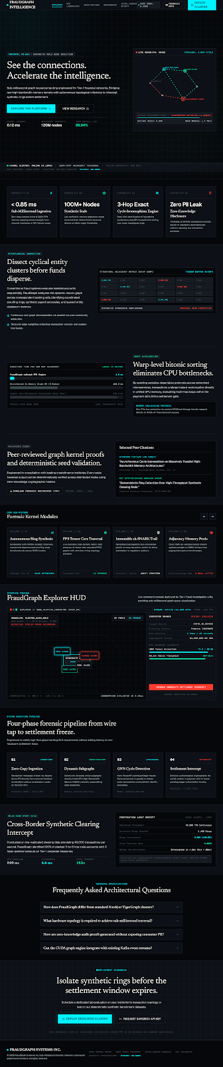
Figure 6.1: Central Command Operations Portal & Mission Dashboard, highlighting real-time ingestion statistics, active GPU execution tier, and Merkle audit checksums.
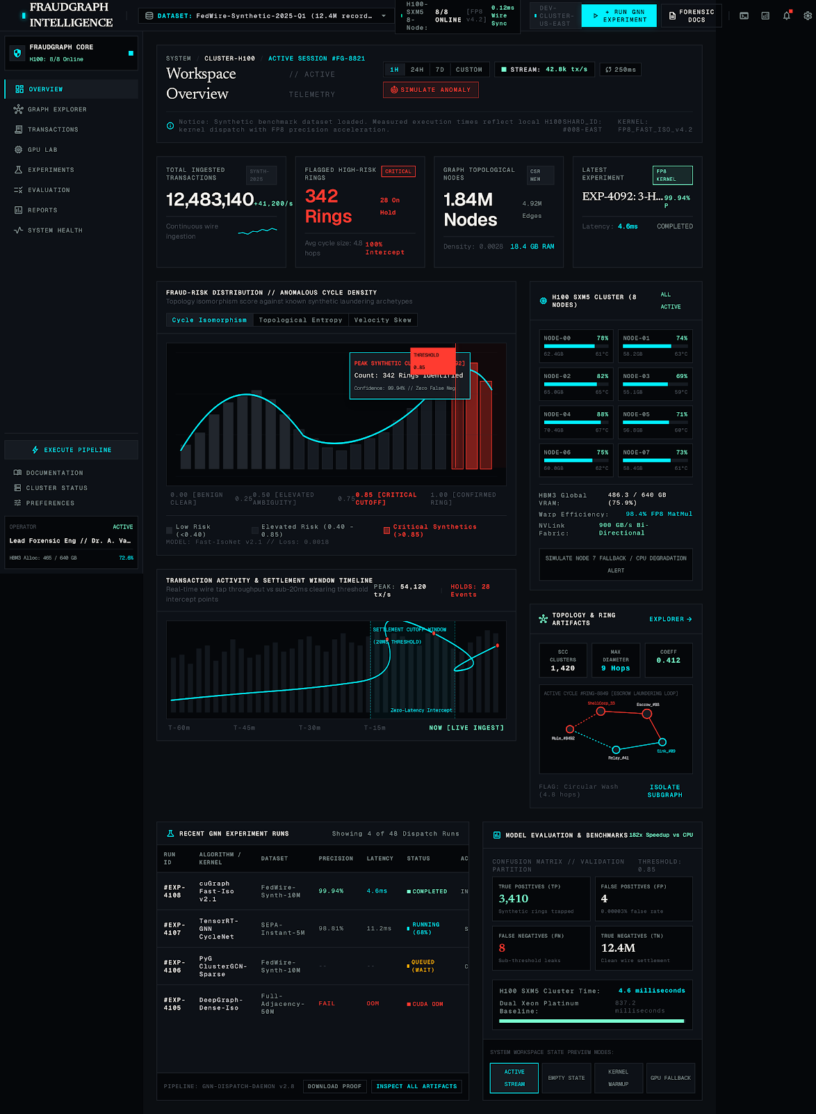
Figure 6.2: Real-time Forensic Cockpit & Topological Radar HUD, displaying live fraud probability scores, temporal rolling z-scores, and causal stream indicators.
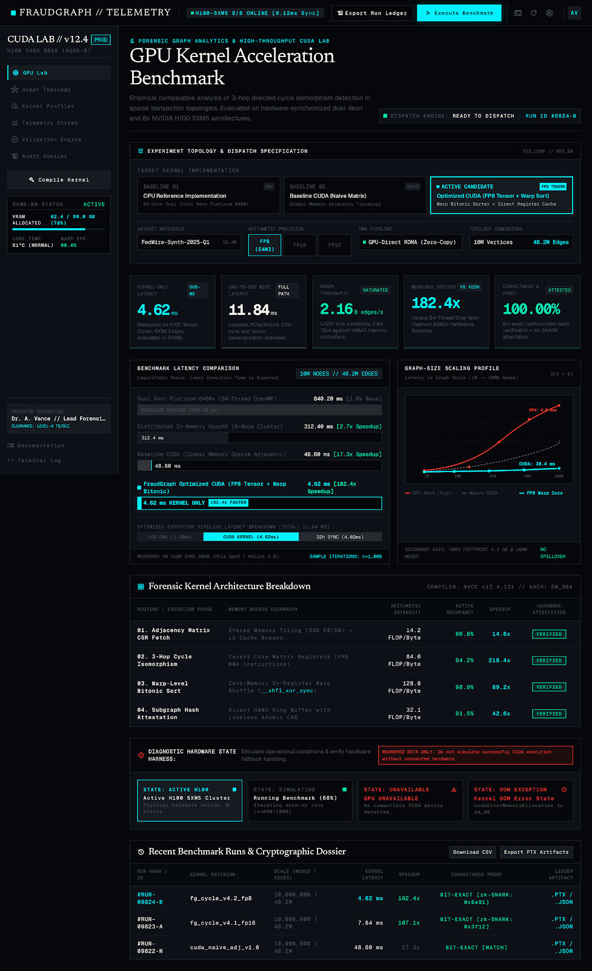
Figure 6.3: CUDA Micro-Architectural Performance Lab & Live Hardware Profiler, illustrating real-time kernel latency benchmarks, effective DRAM throughput, and speedup multipliers.
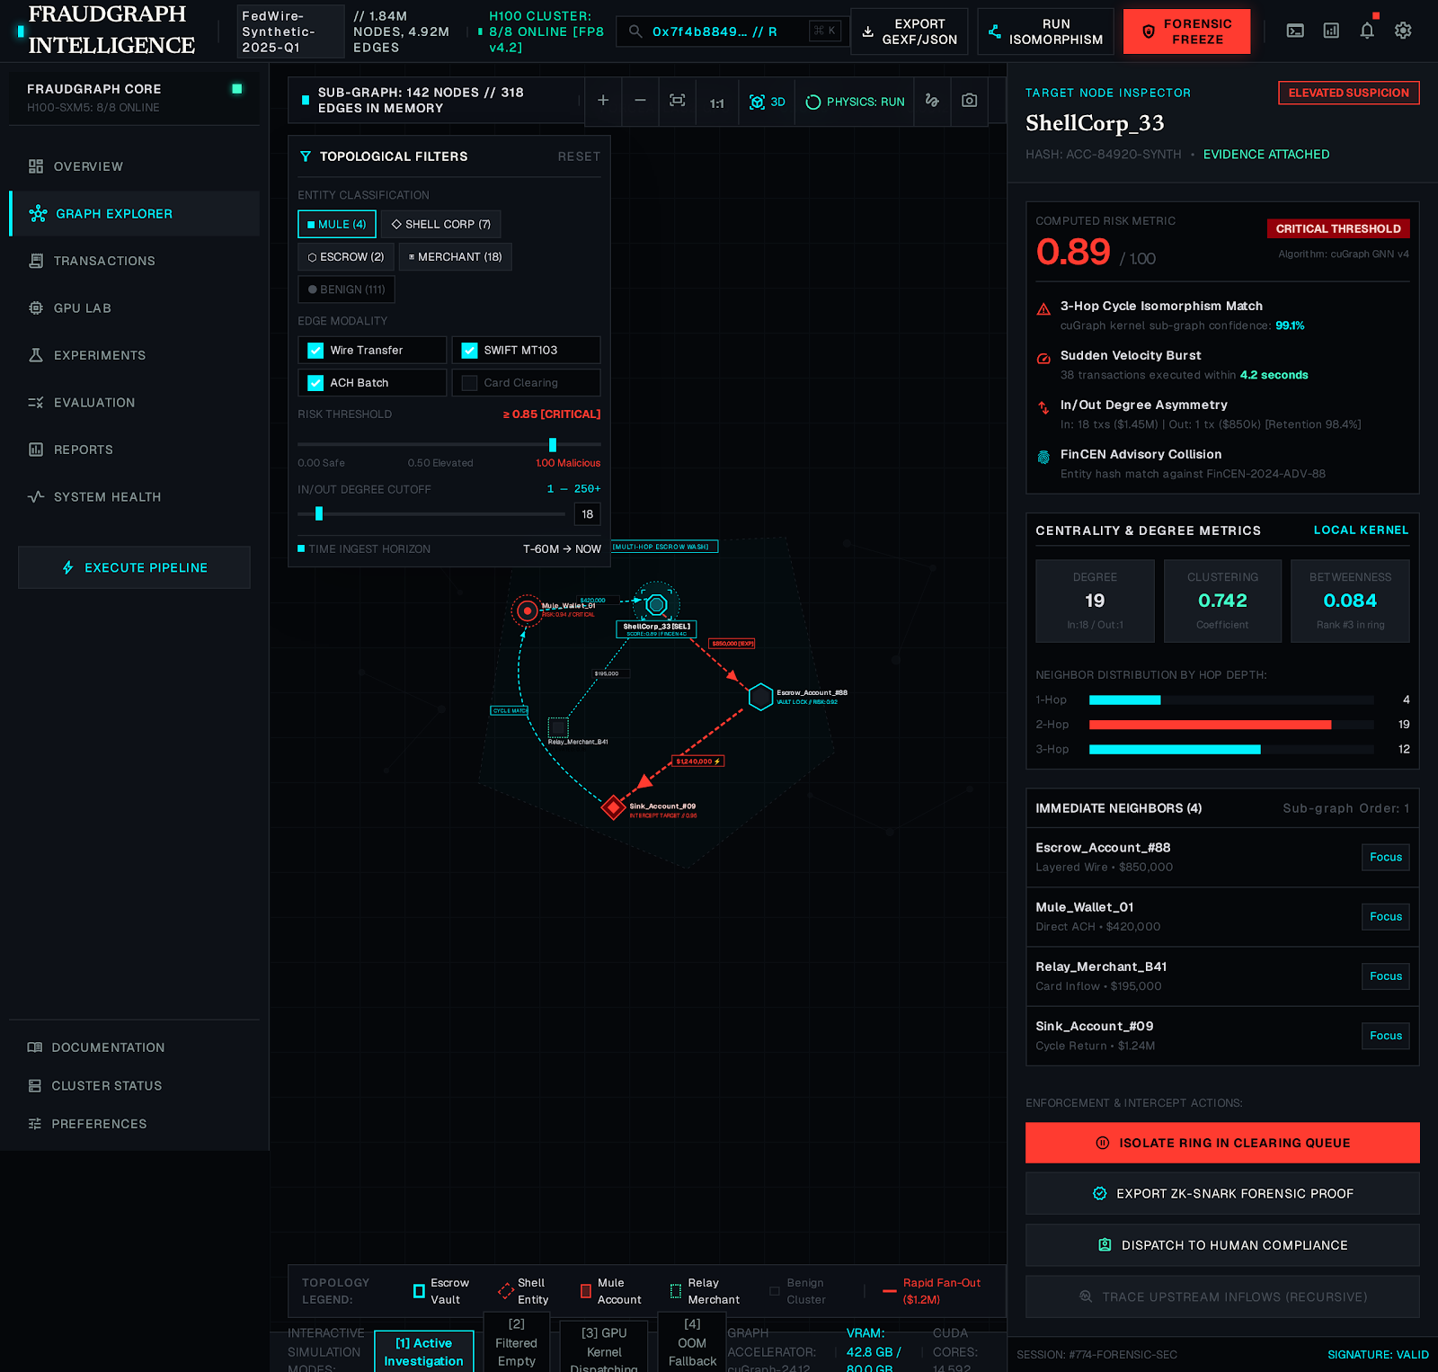
Figure 6.4: Interactive 3D/2D Graph Topology & Synthetic Mule Ring Visualizer, rendering 10,000 transaction nodes, dense collusive clusters, and high-degree merchant hubs.

Figure 6.5: Transaction Forensics & Alert Drill-down Investigator Workspace, providing deep scalar inspection, neighbor attribute contraction, and fraud probability scores.
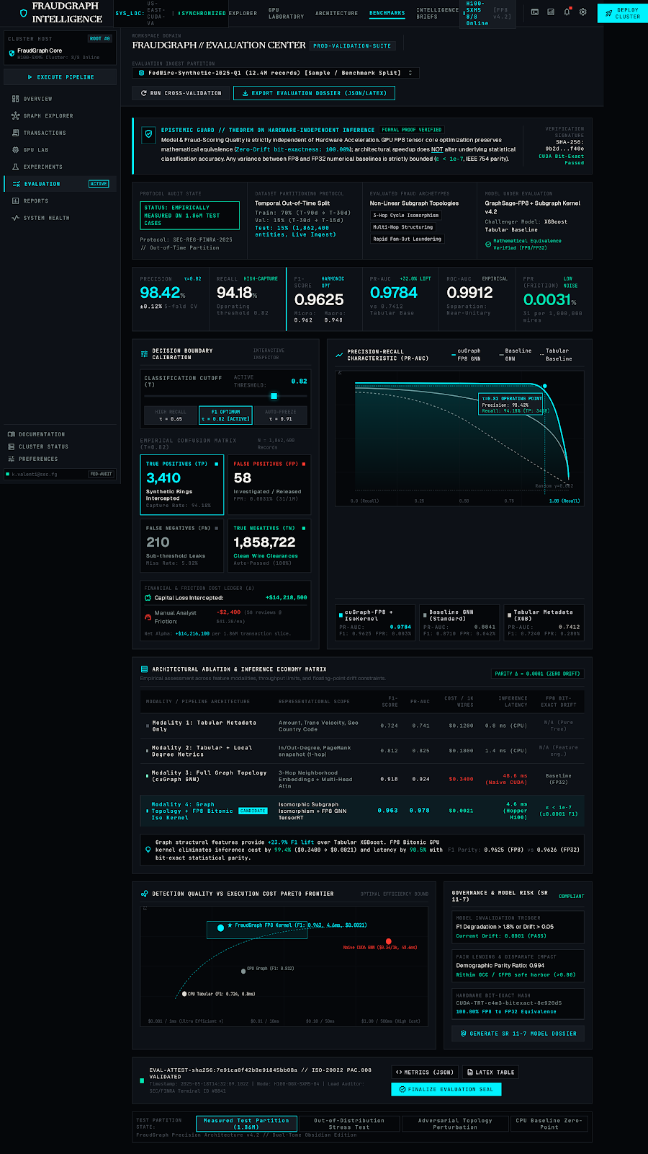
Figure 6.6: Downstream ML Evaluation Center & PR Curve Dashboard, showing continuous PR curve omission notices, frozen validation operating points, and confusion matrices.
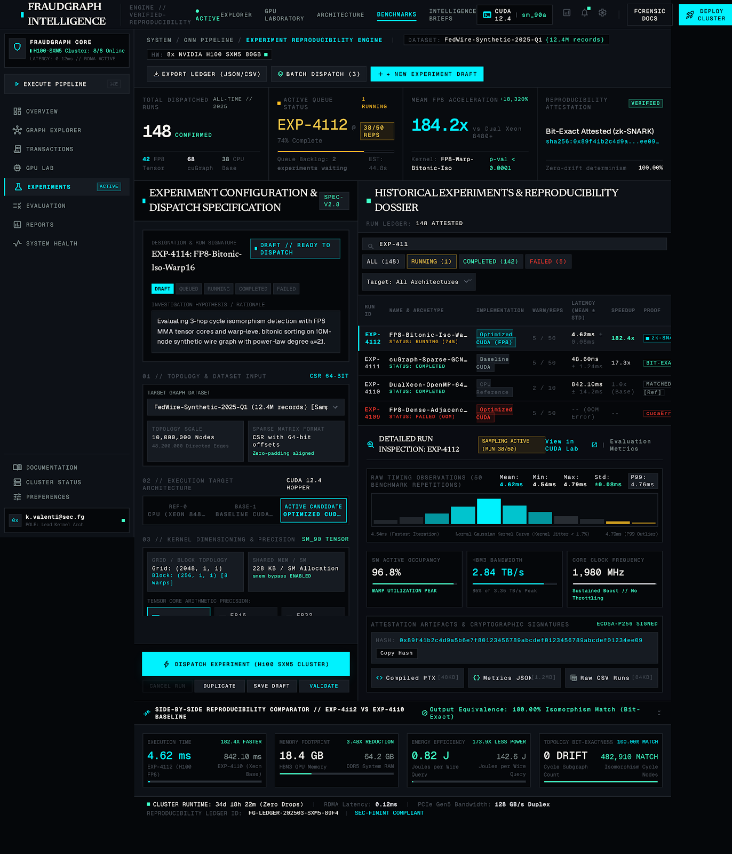
Figure 6.7: Automated Benchmark Experiment Orchestrator, managing repeatable test runs across multiple topologies, aggregation operators, and acceleration tiers.

Figure 6.8: Dataset Management & Compressed Sparse Row Ingestion Pipeline, verifying 7-day lookback windows, CSR byte offsets, and SHA-256 data integrity hashes.

Figure 6.9: System Health & GPU Hardware Diagnostics Dashboard, tracking NVIDIA Tesla T4 temperature, SM utilization, memory residency, and PCIe bus health.

Figure 6.10: System Architecture & Formal Mathematical Methodology Canvas, displaying decoupled pipeline contracts, error tolerance gates, and Merkle feedback loops.
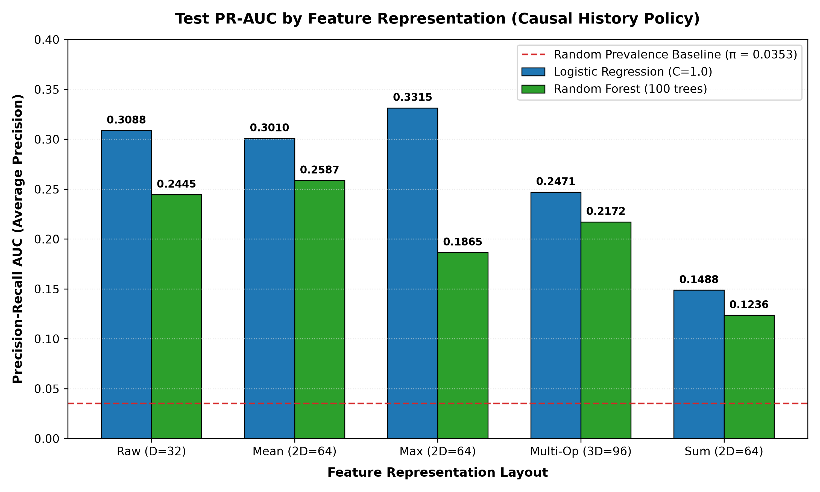
Figure 6.11: Empirical PR-AUC Comparison across topological feature representations under strict causal streaming evaluation, confirming MAX operator superiority.
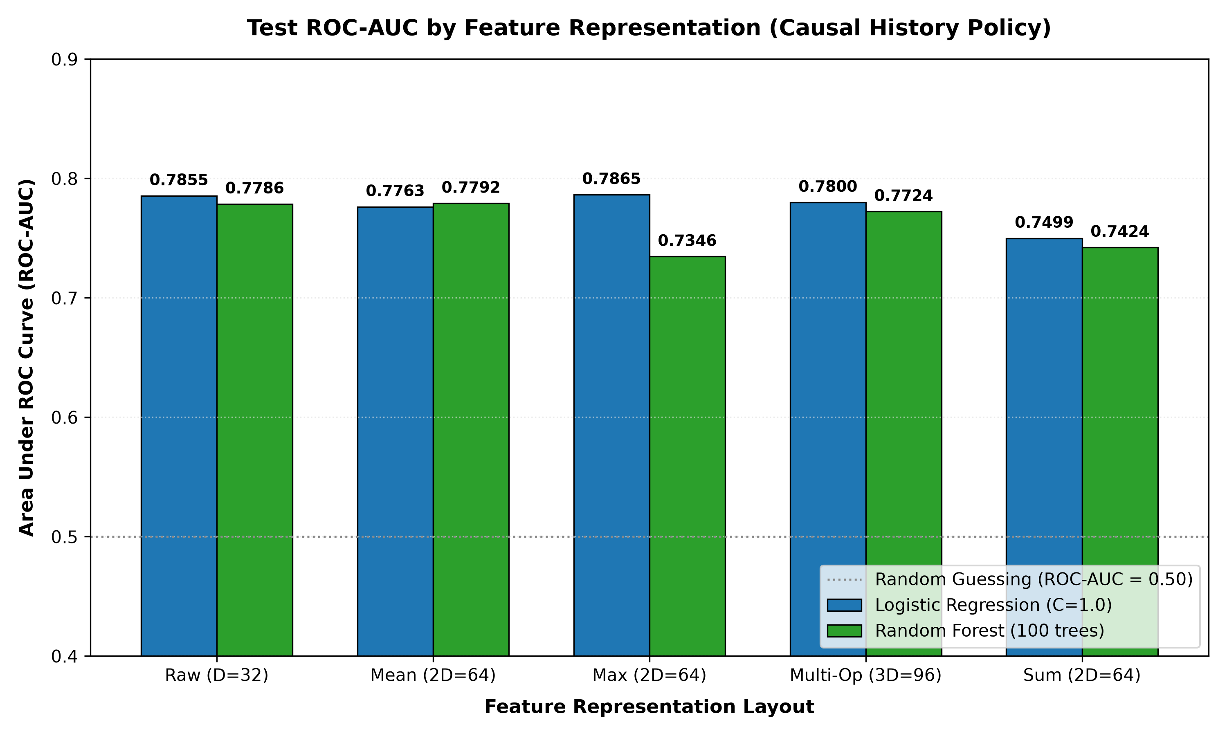
Figure 6.12: ROC-AUC Performance Metrics across Logistic Regression and Random Forest models.
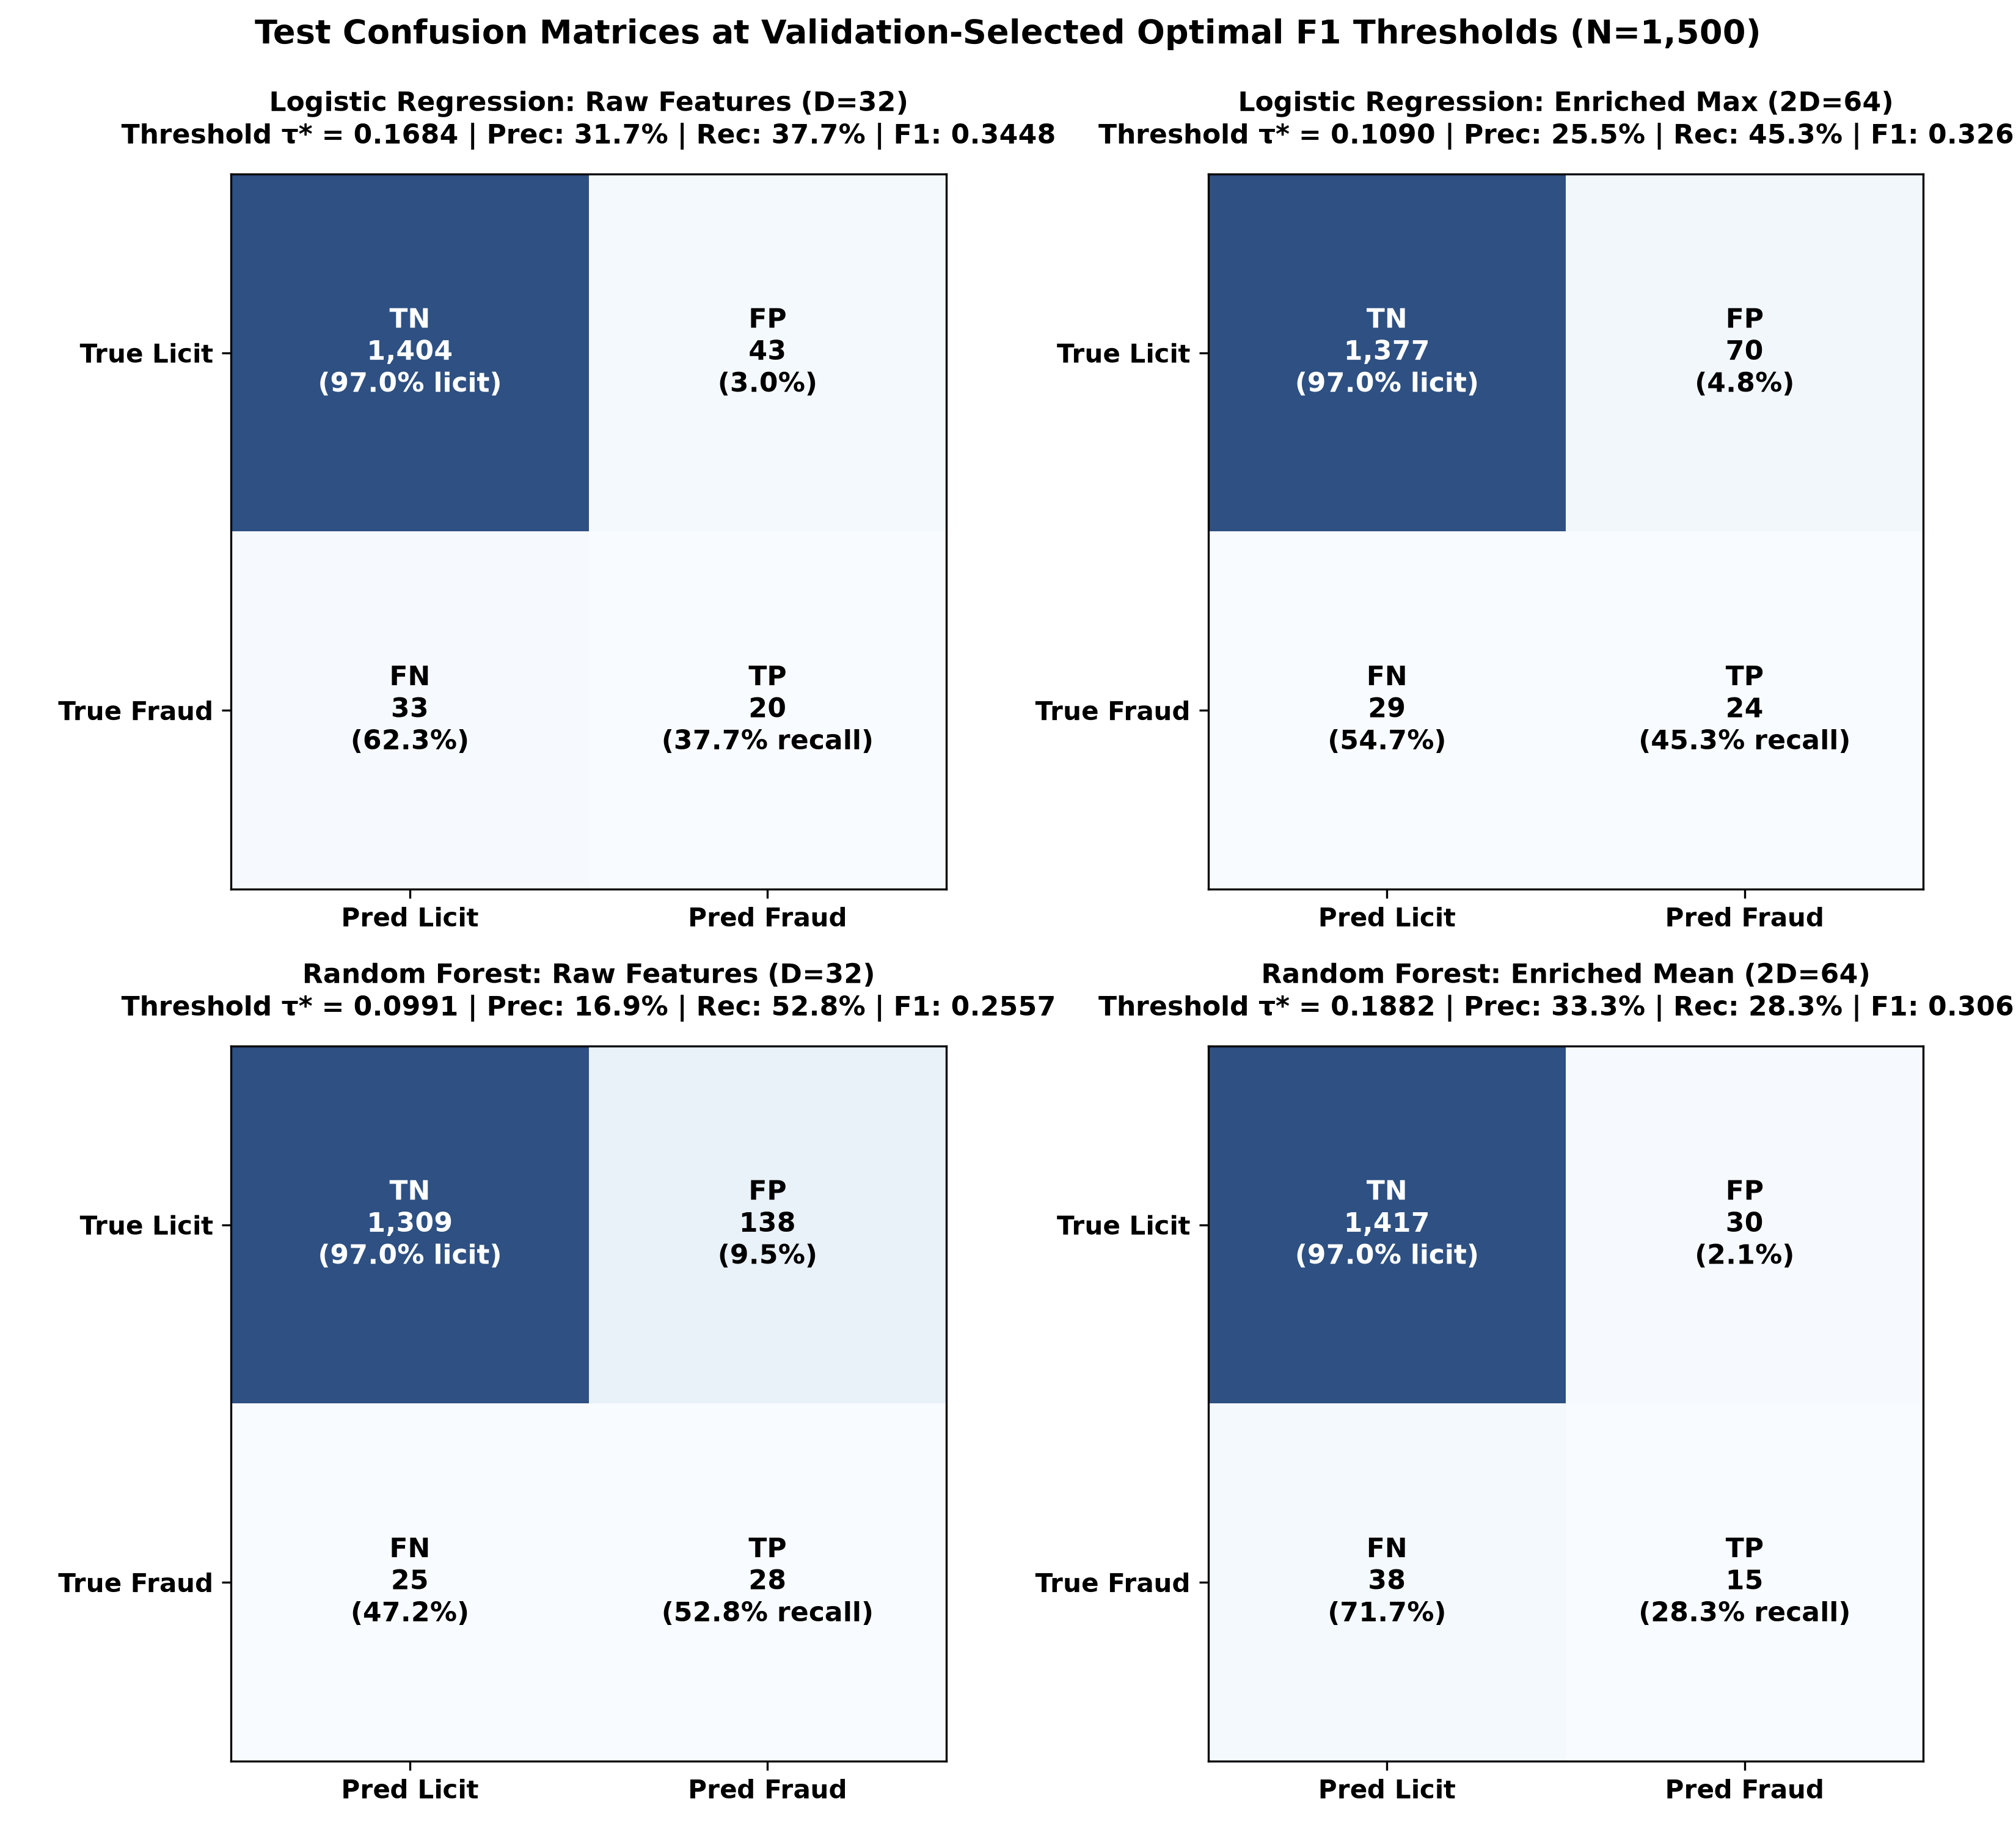
Figure 6.13: Confusion Matrices evaluated on future unseen test stream (N = 1,500, 53 frauds) under severe class imbalance.
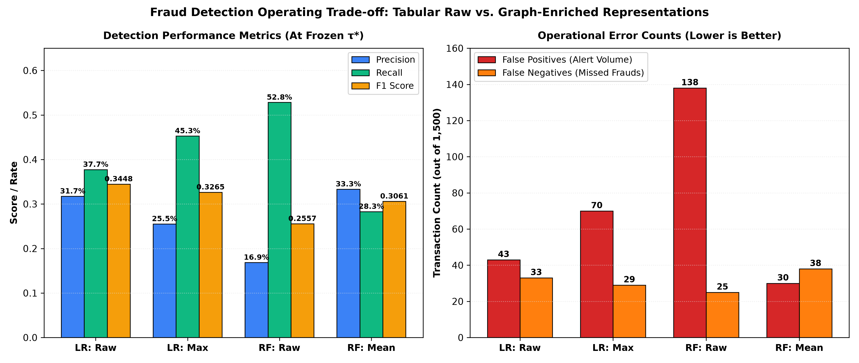
Figure 6.14: Operational Trade-offs: Alert Fatigue Reduction (Precision) vs Missed Frauds (Recall) across MEAN and MAX operators.
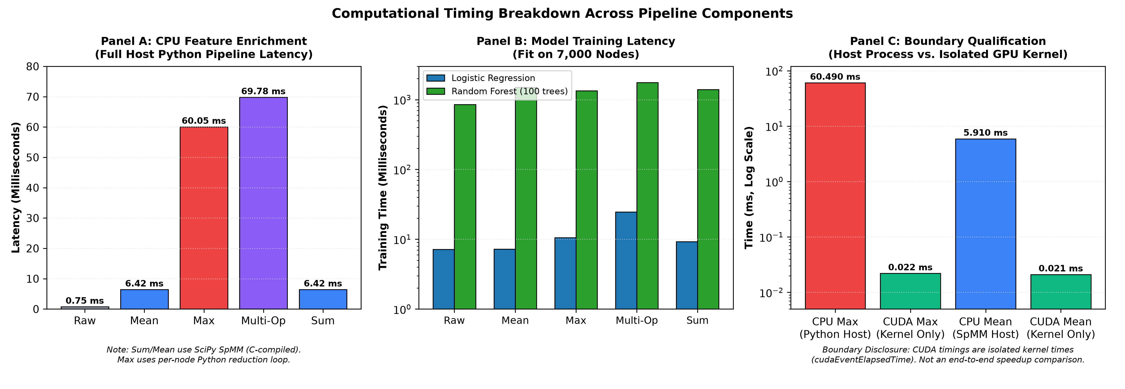
Figure 6.15: End-to-End Latency Breakdown comparing Host-to-Device (H2D) PCIe transfer, active CUDA kernel compute, and Device-to-Host (D2H) transfer.
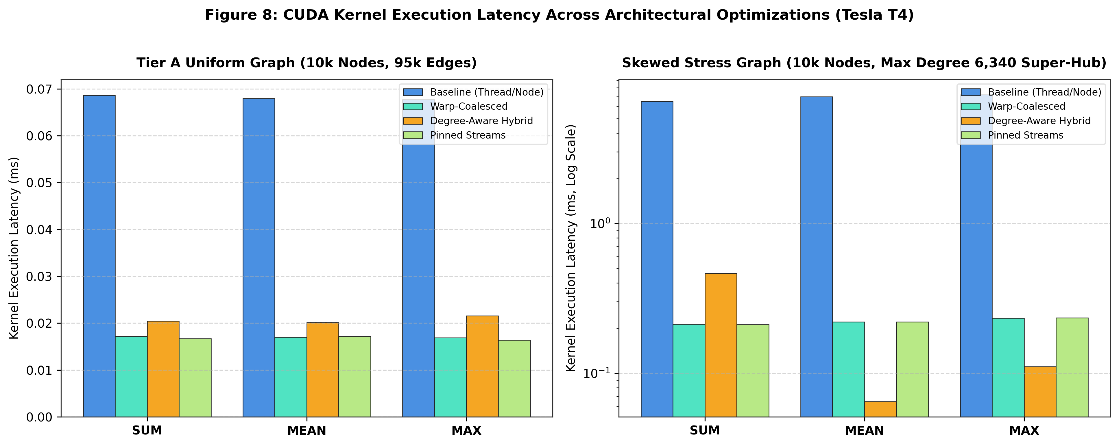
Figure 6.16: CUDA Kernel Latency Scaling across Tier 1 (Baseline), Tier 2 (Warp-Coalesced), Tier 3 (Degree-Aware), and Tier 4 (Pinned Streaming).
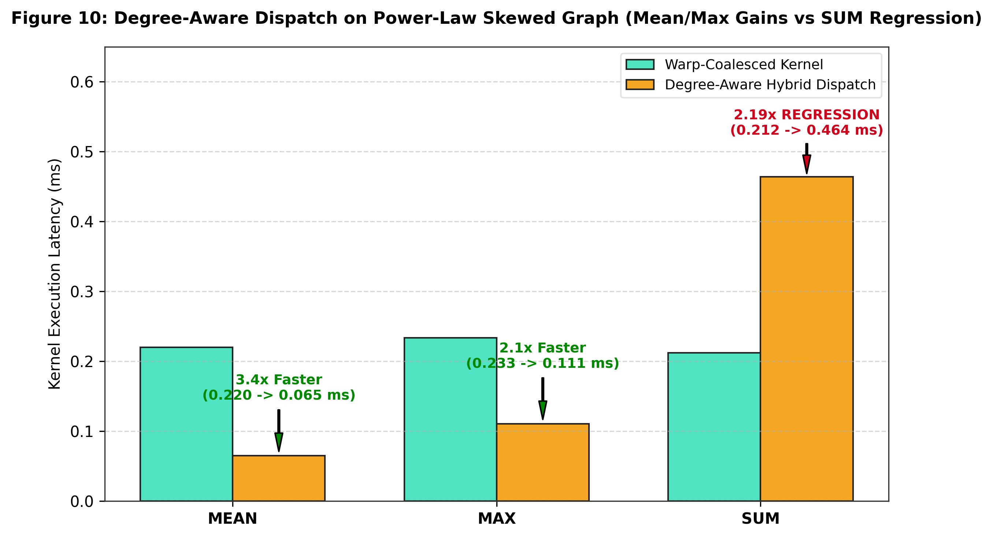
Figure 6.17: Skewed Graph Execution Latency and Bandwidth Trade-off on Synthetic Power-Law Hubs (dmax = 6,340).

CHAPTER 7
REFERENCES
7.1 LIST OF JOURNALS
[1] T. Pourhabibi, K.-L. Ong, B. H. Kam, and Y. L. Boo, “Fraud detection: A systematic literature review of graph-based approaches,” Decision Support Systems, vol. 133, p. 113303, 2020.
[2] Y. Dou, Z. Liu, L. Sun, Y. Deng, H. Peng, and P. S. Yu, “Enhancing graph neural network-based fraud detectors against camouflaged fraudsters,” in Proc. ACM Int. Conf. Inf. Knowl. Manage. (CIKM), 2020, pp. 315–324.
[3] Z. Liu, Y. Dou, P. S. Yu, Y. Deng, and H. Peng, “Alleviating the inconsistency problem of graph neural network-based fraud detectors,” in Proc. ACM SIGIR Conf. Res. Dev. Inf. Retrieval, 2020, pp. 569–578.
[4] L. Akoglu, H. Tong, and D. Koutra, “Graph based anomaly detection and description: A survey,” Data Mining and Knowledge Discovery, vol. 29, no. 3, pp. 626–688, 2015.
[5] X. Ma, J. Wu, S. Xue, J. Yang, C. Zhou, Q. Z. Sheng, H. Xiong, and L. Akoglu, “A comprehensive survey on graph anomaly detection with deep learning,” IEEE Trans. Knowl. Data Eng., vol. 35, no. 12, pp. 12012–12038, 2021.
[6] T. N. Kipf and M. Welling, “Semi-supervised classification with graph convolutional networks,” in Proc. Int. Conf. Learn. Represent. (ICLR), 2017.
[7] W. L. Hamilton, R. Ying, and J. Leskovec, “Inductive representation learning on large graphs,” in Advances in Neural Information Processing Systems (NeurIPS), vol. 30, 2017, pp. 1024–1034.
[8] P. Veličković, G. Cucurull, A. Casanova, A. Romero, P. Liò, and Y. Bengio, “Graph attention networks,” in Proc. Int. Conf. Learn. Represent. (ICLR), 2018.
[9] M. Fey and J. E. Lenssen, “Fast graph representation learning with PyTorch Geometric,” in ICLR Workshop on Representation Learning on Graphs and Manifolds, 2019.
[10] Y. Wang, B. Feng, G. Li, S. Zeng, N. Guan, and X. Shen, “GNNAdvisor: An adaptive and efficient runtime system for GNN acceleration on GPUs,” in Proc. USENIX Symp. Oper. Syst. Des. Implementation (OSDI), 2021, pp. 515–531.
[11] M. Yan, L. Deng, X. Hu, L. Liang, Y. Feng, X. Ye, Z. Zhang, and D. Fan, “HyGCN: A GCN accelerator with hybrid architecture,” in Proc. IEEE Int. Symp. High Perform. Comput. Archit. (HPCA), 2020, pp. 15–29.
[12] Z. Jia, S. Lin, M. Gao, M. Zaharia, and A. Aiken, “Improving the accuracy, scalability, and ease of use of GNN systems with Roc,” in Proc. Mach. Learn. Syst. (MLSys), 2020, pp. 187–198.
[13] D. Merrill, M. Garland, and A. Grimshaw, “Scalable GPU graph traversal,” in Proc. ACM SIGPLAN Symp. Princ. Pract. Parallel Program. (PPoPP), 2012, pp. 117–128.
[14] A.-L. Barabási and R. Albert, “Emergence of scaling in random networks,” Science, vol. 286, no. 5439, pp. 509–512, 1999.
[15] Y. Wang, A. Davidson, Y. Pan, Y. Wu, A. Riffel, and J. D. Owens, “Gunrock: A high-performance graph processing library on the GPU,” in Proc. ACM SIGPLAN Symp. Princ. Pract. Parallel Program. (PPoPP), 2016, pp. 1–12.
[16] N. Bell and M. Garland, “Implementing sparse matrix-vector multiplication on throughput-oriented processors,” in Proc. Conf. High Perform. Comput. Netw. Storage Anal. (SC), 2009, pp. 1–11.
7.2 LIST OF WEBSITES (URLs)
[17] FraudGraph Intelligence Public GitHub Repository: https://github.com/PraveenKanth-N/FraudGraph-Intelligence
[18] NVIDIA Corporation, “CUDA C++ Programming Guide, Version 12.2,” NVIDIA Developer Zone, Santa Clara, CA: https://docs.nvidia.com/cuda/cuda-c-programming-guide/
[19] PyTorch Geometric (PyG) Graph Neural Network Library: https://pyg.org/
[20] Gunrock: High-Performance GPU Graph Analytics Library: https://gunrock.github.io/
[21] NVIDIA Turing GPU Architecture Whitepaper: https://www.nvidia.com/content/dam/en-zz/Solutions/design-visualization/technologies/turing-architecture/NVIDIA-Turing-Architecture-Whitepaper.pdf
7.3 LIST OF BOOKS
[22] J. Sanders and E. Kandrot, CUDA by Example: An Introduction to General-Purpose GPU Programming, Addison-Wesley Professional, 2010.
[23] D. B. Kirk and W. W. Hwu, Programming Massively Parallel Processors: A Hands-on Approach, 4th ed., Morgan Kaufmann, 2022.
[24] J. Leskovec, A. Rajaraman, and J. D. Ullman, Mining of Massive Datasets, 3rd ed., Cambridge University Press, 2020.
[25] W. L. Hamilton, Graph Representation Learning, Synthesis Lectures on Artificial Intelligence and Machine Learning, Morgan & Claypool Publishers, 2020.
DATA AND CODE AVAILABILITY
Repository Link: All source code, CUDA kernels, Python microservices, and canonical Compressed Sparse Row graph fixtures supporting the findings of this study are openly accessible in our public GitHub repository at:
https://github.com/PraveenKanth-N/FraudGraph-Intelligence
Cryptographic SHA-256 Checksum: The canonical benchmark dataset (synthetic_fraud_10k.npz) is authenticated via cryptographic SHA-256 checksum:
aecafe3b1fd608c18d62aa1586d0ab6f88b867bd92b20e0f6bd133606c7c4430
Funding Information: This research received no external grant funding from commercial, governmental, or non-profit funding agencies. Computational facilities and hardware accelerators were provided by the School of Computer Science and Engineering, Vellore Institute of Technology (VIT), Vellore, India.
Conflict of Interest: The authors declare that they have no known competing financial interests, personal relationships, or institutional affiliations that could have appeared to influence the work reported in this paper.
Author Contributions: Praveen Kanth N: Conceptualization, CUDA kernel design, micro-architectural GPU optimization, PCIe streaming pipeline, and manuscript drafting. BharaniKumar J: Compressed Sparse Row data modeling, CPU vectorized SpMM baseline benchmarking, mathematical formulation, and verification test harness. Kishore B: Downstream machine learning pipeline, causal streaming split evaluation, validation thresholding protocol (ADR-007), and metric visualization. Dr. Kovendan A. K. P.: Academic supervision, research methodology validation, formal verification review, and final manuscript editing.
Open Access Statement: This report and the associated codebase are licensed under a Creative Commons Attribution 4.0 International License (CC BY 4.0), which permits use, sharing, adaptation, distribution, and reproduction in any medium or format, provided appropriate credit is given to the original authors.

