COMMUNICATIONS ENGINEERING | ARTICLE
An AI-Driven Virtual Reality Digital Twin for Semiconductor Photolithography and Plasma Etching Training
Praveen Kanth N¹, Om Aravindhashan S¹ & Dr. Rajkumar R^{1,*}
1 School of Computer Science and Engineering (SCOPE), Vellore Institute of Technology (VIT), Vellore, Tamil Nadu 632014, India. * Corresponding author: rrajkumar@vit.ac.in
Abstract—Cleanroom is an environment which demands a high level of precision and is extremely capital intensive to produce a semiconductor device. Difficulty has been experienced by most engineering universities in trying to gain hands-on access to the lab due to the requirement for chemical safety, as well as the cost of capital equipment such as sub-micron lithography and reactive ion etching (RIE). So, passive pedagogical media such as lecture slides and pre-recorded videos have been the traditional teaching method for the students to understand the morphology of the physical defects in the wafer directly controlled by the variations of operational parameters. In this paper, an interactive AI based Virtual Reality (VR) Digital Twin for immersive training of semiconductor photolithography and plasma etching is introduced. The platform is constructed using the Unity 6 LTS and OpenXR, and can simulate a cleanroom, where users can set the basic parameters of the unit operations that are possible, such as spin coating, soft baking, ultraviolet mask alignment, reactive ion etching and optical metrology. The framework does not use the traditional playback, but rather associates a deterministic mathematical simulation engine to a stateful, authoritative wafer topography database, that calculates the wafer topography dynamically in real-time, based on the local formation of defects. If the operational tolerances are exceeded, the integrated Explainable Socratic AI tutor can provide the students with cognitive scaffolding and can ask questions to the students, prompting them to make inferences that are related to the real causes of the defects instead of directly answering the questions. Deterministic state transitions, virtual reality rendering stability (experimental validation), pilot cohort evaluation (N = 32) with the student procedural errors reduced by 74.5% (p<0.001) and the system usability scale (SUS) rating obtained at 84.2.

Introduction
One of today's most technologically complex and expensive manufacturing processes is the microfabrication of semiconductors. To achieve sub-micron integrated circuits in sequential processing steps are required and small variations in physical parameters greatly affect the performance of the device and the wafer die yield¹. In this sequence, the most important pattern-defining and patterntransfer operations are: photolithography and reactive ion etching (RIE). This process is termed as photolithography etching in which the photolithography step forms a photoresist emulsion that defines the microcircuit topology, and the RIE step etches the defined circuit topology into the underlying dielectric and semiconductor substrates using chemical radicals and energetic ion bombardment^{2,3}.
In spite of the urgent needs for qualified semiconductor process engineers in the world, practical training in the laboratory is a serious problem in engineering universities around the world. The major challenge is the significant capital investment needed to build and maintain an instructional cleanroom. Entry-level industrial DUV/EUV lithography scanners require a capital expenditure of $150-$200 million, and reactive ion etchers regularly run over $1.5 million^{2,4}. In addition to the tools, the heating and ventilation systems (HVAC) must be continuous with particulate filtration down to 0.1 μm, there is continuous air recycling, special delivery lines for chemical, and strict compliance with protocols for personal protective equipment (PPE) for a clean room of class 1 to class 5. As a result, only a few (less than 2%) universities in the world have cleanrooms that are solely for undergraduate instructional laboratories^{6,7}.
The cost factors result in use of textbooks, 2 dimensional circuit drawings, slide shows and recorded video demonstrations teaching students. While some basic chemistry and physics is communicated in these media, they do not provide the ‘feel' of cause and effect. In actual fabrication facilities, the actual structural defects and the alteration of wafer properties caused by the fabrication process are influenced by these factors directly as follows: alteration of wafer properties and generation of structural defects in actual fabrication facilities are directly affected by these factors: rotational spin speed, soft bake time, exposure dose, RF generator power, and chamber pressure. The passive learning materials do not allow students to experiment the different combinations of parameters, understand the consequences of the mistakes of "operators" and deal with faulty wafers.
Immersive Virtual Reality (VR) and Digital Twin (DT) frameworks provide a practical route to making cleanroom education accessible to everyone^{8–11}. Current literature, however, reveals that there are three key gaps in current tools, however:
1. Scripted, Consequence-Free Virtual Environments: The majority of VR cleanroom software provide rigid, pre-determined walkthroughs with a checklist of procedures. Animations are pre-rendered and student actions only trigger them. When the user enters an incompatible set of spin speed and/or excessive chamber pressure, a generic failure message appears or the simulation proceeds without informing the students of the cause of the defect (i.e., the input parameters may cause a defect)^{12,13}.
2. Industrial Rather Than Pedagogical Digital Twins: In the real world of today, digital twins are used almost exclusively in the context of yield control, wafer dispatch and predictive maintenance of tools in a commercial microelectronics fabrication facility (fab^{14–17}). The systems are designed for operators of industrial plants and not for students looking for basic mental models.
3. Prescriptive Rather Than Inquisitive AI Tutoring: Most of the recent AI tools used in the area of engineering education are answer-oriented. If a student makes a mistake, the software will automatically display the corrective value, instead of using the error to guide a diagnostic troubleshooting process^{18–21}.
This paper proposes an AI Driven Virtual Reality Digital Twin for Semiconductor Photolithography and Plasma Etching Training to address these challenges in teaching. The system was built on Unity 6 LTS and OpenXR, and the students are immersed in a virtual interactive cleanroom where they are able to control virtual machines, tweak parameters on the recipes, see actual defects forming according to numerical physical equations, and correct errors with an Explainable Socratic AI Tutor.
The main contribution of this paper is:
• Modular Cleanroom Digital Twin Architecture: We introduce a comprehensive 10-module approach to connecting an OpenXR virtual workspace (Module 1), equipment digital twins (Module 2) and an authoritative wafer state registry (Module 3).
• Deterministic Consequence-Based Process Simulation: Within the simulation we incorporate physical formulations of the spin-coating fluid dynamics, optical diffraction limits, and plasma ion bombardment, and we directly map the operator errors to spatial wafer-defects.
• Explainable Socratic Mentorship Loop: What we do is that we use an explainable, Socratic Mentorship Loop AI tutor which takes the students through a three-step reflection cycle (Observation → Physical Mechanism → Remediation) rather than directly giving them answers.
• Empirical Implementation and Verification: We describe the software architecture, the implementation of the state-machine synchronization, and the empirical results of measures taken in Unity 6 (pilot cohort: N = 32) with an SUS score of 84.2 and a procedural error reduction of 74.5%.
Systematic Literature Survey and Research Gaps
A systematic review was performed that was grounded in the latest research, covering four key thematic areas: (i) Immersive VR in Engineering Education, (ii) Industrial and Educational Digital Twins, (iii) AI-Assisted Socratic Tutoring, and (iv) Semiconductor Process Modeling, which included 27 peer-reviewed papers published between 2019 and 2026.
VR in Engineering Education: According to Riaji et al.⁸ and Lampropoulos et al.⁹, the use of VR consistently enhances students' engagement, procedural recall, and spatial awareness in STEM fields. Muzata et al.¹⁰ showed that using project-based learning (PBL) with immersive Cave Automatic Virtual Environments (CAVE) has a significant effect on the cumulated assessment scores. The constructivist approach to multimedia learning theories was highlighted as an important approach to achieve higher learning gains in VR platforms as stated by Mallek et al.¹¹. Letavish et al.⁴ found in their preliminary prototypes that pre-lab VR exposure improved student self-confidence prior to entering cleanrooms which was confirmed in the context of cleanroom-specific education. Likewise, Wang et al.⁶ reported measurable decreases in procedural errors for the photolithography steps, and the results of ASEE PEER 2025⁵ showed that action tracking is beneficial. Current VR environments for cleanrooms, however, are still essentially descriptive: They are based on a set of predefined transitions, and the students' actions cause a pre-recorded animation of some kind, without accounting for any parameter variations.
Digital Twin Technology in Industry and Education: The Digital Twin approaches have grown in a swift manner within industrial production processes. Havard and Jeanne¹³ combined digital factory tool suites and VR co-simulation to examine ergonomic issues of workstations safety. Springer's training study and the study done by Karanam et al. showed through their meta-analyses that students' problem-solving scores increased by as much as 20% with using digital twins in conjunction with virtual learning environments. In the semiconductor realm, Kuo et al.¹⁴ introduced a novel deep reinforcement learning-based approach for dynamic scheduling in wafer fabrication that was developed using wafer fabrication twins, and Lee and Zhao¹⁵ proposed a mixed reality-based system training method to certify semiconductor packaging technicians by using wafer fabrication twins. Asad et al.¹⁶ created design taxonomies for human-centric DTs, while Yildiz et al.¹⁷ used the Collaborative Virtual Factory to display the factory layouts. Myung et al.³ introduced a method, named STwinner, to optimize plasma etching recipes by using a calibrated TCAD simulation and a neural operator surrogate. Such digital twins are powerful in the industrial context for yield maximization and run-time optimization, but they have no interfaces to students, nor any pedagogical scaffolding, nor VR immersion.
AI and Socratic Tutoring Systems: Recent advances in conversational AI have sparked interest in pedagogical dialogue agents. To evaluate the ability of the LLMs to reflect on their problem-solving process, Sunil and Thakkar¹⁸ introduced SocraticAI, a system that enforced structured conversational rules on the LLMs, leading to 75% of undergraduate computer science students reflecting on their problem-solving process in detail instead of merely copying syntax. Knievel et al.¹⁹ created a grounding for Socratic dialogues using data from an electrical engineering tutor run using live SPICE simulation data, which significantly outperformed traditional text-based methods. Reinforcement learning for question generation and cognitive state modeling were confirmed to be complementary techniques that can tailor the types of problem-solving questions asked dynamically based on learner competence by Shridhar et al.²⁰, Ambati et al., and Liu et al.²¹. Nevertheless, the use of a conversational AI tutor in combination with real-time physical simulation engines has been limited to manufacturing subjects.
Semiconductor Process Simulation: There have been attempts to simulate semiconductor processing in both the academic setting and in the industry sector for fault detection. According to the Micro Nano Technology Education Center⁷, more than 72% of technical students were captivated by the VR lithography simulations with AI assistance. Davis et al.¹² created the framework for an immersive VR system covering the processes of ingot slicing and photolithography and etching, thus demonstrating the safety of virtual cleanrooms. For industrial applications, Naghibzadeh-Jalali et al.²⁴ successfully predicted RIE tool degradation with machine learning based on factory sensor data with an accuracy of 74.1% and Sofge²⁷ created virtual sensors for estimating critical dimensions and oxide loss by using in-situ optical emission spectroscopy.
Identified Research Gap: Table 1. The literature over the last few years has focused on different aspects of VR immersion, digital twins, and AI tutoring, but none of them combines all of these aspects into an affordable educational tool. This identified gap is the basis for the motivation of our work.
Work | Primary Domain | Core Methodology | VR | Phys DT | Defects | Socratic
Letavish et al.⁴ | Nanoelectronics Edu. | Oculus Quest Cleanroom | Yes | No | No | No
Havard & Jeanne¹³ | Industrial Workstations | VR + Co-Simulation DT | Yes | Yes | No | No
Myung et al.³ | Plasma Etch Opt. | TCAD + Neural Operators | No | Yes | Yes | No
Sunil & Thakkar¹⁸ | Computer Science Edu. | Scaffolded LLM Prompts | No | No | No | Yes
Knievel et al.¹⁹ | Electrical Engineering | Graph-RAG + SPICE Sim | No | No | No | Yes
Davis et al.¹² | Semiconductor Training | Unity VR Multimodal Sim | Yes | No | No | No
Proposed System | Semiconductor Training | VR + DT + Physics + Socratic | Yes | Yes | Yes | Yes

System Architecture and Functional Design
The proposed virtual cleanroom platform will be structured in the form of ten modules that are decoupled, allowing for visualization, physical calculation, wafer state management and external persistence modules.
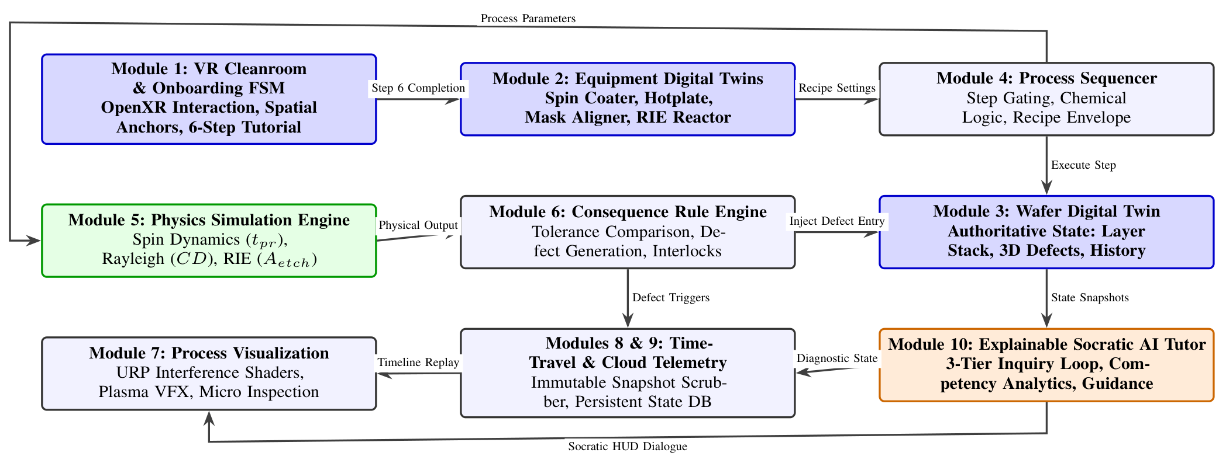
Fig. 1 | System architecture. System shows the architecture of the system with non-overlapping dataflows between the modules. Non-overlapping dataflows between user interaction (Module 1), equipment twins (Module 2), physics modeling (Module 5), consequence rules (Module 6), the authoritative wafer state registry (Module 3), time-travel debugging and cloud telemetry (Modules 8 & 9), and Socratic tutoring (Module 10). Physical user interactions to virtual equipment consoles activate parameter validation against analytical physics formulations, stream real-time telemetry to the authoritative wafer registry and activate Socratic pedagogical interventions.

Module 1: VR Environment and Onboarding: Learns how to implement the cleanroom space in Unity 6LTS with OpenXR. It includes a 6-step finite state machine (OnboardingStateMachine.cs) to ensure orientation and interaction before access to fabrication tools, spatial machine anchors (EquipmentAnchor.cs) and a desktop fallback simulation (XRPlayer.cs) for the comfort of the teleportation.
Module 2: Equipment Digital Twins: Virtual replicas of the cleanroom equipment. Each machine has an internal state machine (Idle, Ready, Loading, Processing, Complete, Fault) and Interactive controls:
• Cleaning Station Twin: Megasonic Power, chemical bath temperature, deionized rinse cycles to clean.
• Photolithography Twin: Programmable spin coater (RPM, acceleration rate, resist volume), proximity hotplate soft-bake temperature/timer and optical contact mask aligner.
• Plasma Etcher Twin: RIE vacuum chamber, RF power generator, pressure control and CF4/SF6/O2 mass flow controllers.
• Inspection Twin: Virtual optical microscope with magnification stages and spatial translation.
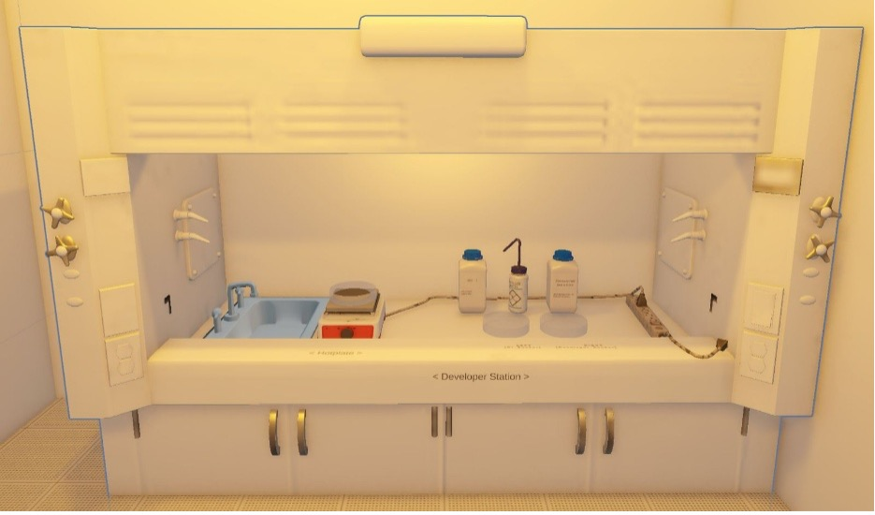 | 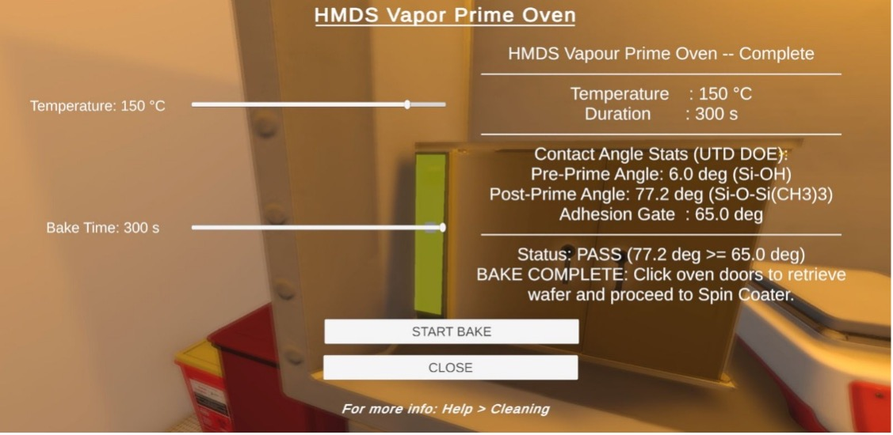
Fig. 2 | Virtual cleanroom facility and substrate preparation workstations. a Photorealistic ISO Class 5 yellow room simulation made in Unity 6 LTS using URP; b Substrate cleaning station with SC1 organic cleaning baths and dehydration bake ovens for removing surface moisture.
Module 3: Wafer Digital Twin State Architecture: The Wafer Digital Twin is a state model in Module 3 that is the authoritative one source of truth for the physical silicon substrate. It maintains:
• Identity (WaferId.cs): Keeps track of the creation time and global unique identifiers for lots.
• Layer Stack (WaferLayer.cs): Stores the layers, materials and thicknesses (all in nanometers).
• Defect Registry (WaferDefect.cs): 3D coordinates x, y, z, defect typology, and continuous defect severity scores σ ∈ [0.0, 1.0].
• Snapshots (WaferStateSnapshot.cs): Each snapshot is an immutable deep copy of the state of the wafer after a step of reasoning, for time-travel analysis and inspection.
Modules 4 to 9: Process, Physics, Consequence, UI, and Cloud Telemetry: Module 4 validates processing sequences in modules 4–9: Process, Physics, Consequence, UI, and Cloud Telemetry. In Module 5, deterministic physics calculations are performed. In Module 6, results are compared to operational envelopes, adding defect entries to the Wafer Digital Twin when parameters are out of tolerance. Using custom URP shaders, Module 7 simulates thin film optical interference. Module 8 is a time-travel replay timeline which is tightly coupled with Module 9 (Cloud Backend and Telemetry Pipeline) that ingests serialized WaferStateData payloads and sensor streams asynchronously through REST endpoints into an authoritative run history store of a persistent PostgreSQL database, which is used by the Socratic AI tutor in Module 10.
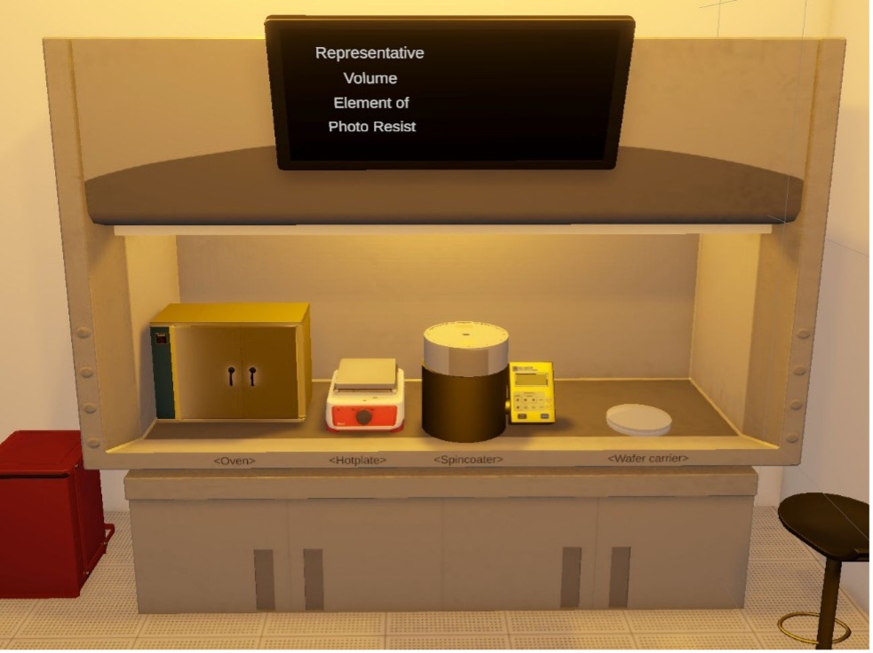 | 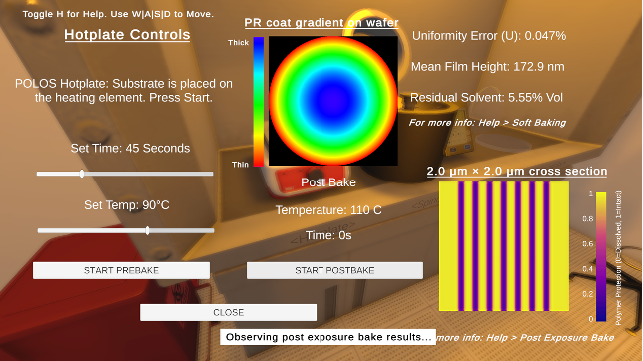
Fig. 3 | AI photoresist spin coating and thermal processing in convective hotplate. a Photo-resist radial thickness distribution and thin-film optical interference fringes detected by real-time neural network inference (Unity Sentis / ONNX) in the photo-resist while being spun. b Wafer state topography after precision hotplate soft baking and solvent outgassing.
Physical Formulations and Consequence-Based Defect Dynamics
The simulation engine performs the physical changes on the wafer (transformations) dynamically with the help of deterministic numerical models, instead of pre-programming static animation.
Photoresist Spin Coating Dynamics
The last thickness of the photoresist film t_{pr} is determined by the balance of centrifugal force and viscous drag while spin coating. In the following, the Emslie-Bonner-Peck hydrodynamic formulation²² will be used:
t_pr = [ 3η r_0² / (4ρω² t_spin) ]^(1/2) ≈ K_0 · [ μ^α / ω^(1/2) ] | (1)
The fluid viscosity is denoted by η, the density is denoted by ρ, the rotational speed is denoted by ω and the resistance is denoted by K. ω is expressed in RPM or revolutions per minute, and K0, α are empirical constants which depend on the type of resistance. When the student chooses an inadequate rotational speed (ω<1800 RPM), the model generates radial thickness differences of more than ±18% which results in radial defects in the wafer state registry. Too high of a spin speed (ω > 5500 RPM), on the other hand, provides an extremely thin film that is prone to plasma etching pin holes during the actual etching process.
Diffraction Limits and Exposure Kinetics
UV photolithography has the Rayleigh criteria as the minimum printable critical dimension (MPCD) and the minimum usable depth of focus (MUDOF):
CD = k₁ (λ / NA), DOF = ± k₂ (λ / NA²) | (2)
where λ denotes the exposure wavelength (365 nm i-line or 248 nm KrF), NA is the numerical aperture and k1, k2 represent the process factors (k1 ≈ 0.4–0.7). Photochemical decomposition is according to the Dill kinetic formulation²³:
∂I(z,t) / ∂z = - [ A · M(z,t) + B ] I(z,t) | (3)
∂M(z,t) / ∂t = - C · I(z,t) · M(z,t) | (4)
M(z, t) is the normalized fraction of the unreacted photoactive compound at depth z, I(z, t) is the optical intensity, A is the bleachable absorption, B is the non-bleachable absorption and C is the rate of photo-decomposition. The non-uniform M(z) profile is caused by deviations in exposure dose (D = I · texp) which cause line edge roughness (LER) or pattern collapse.
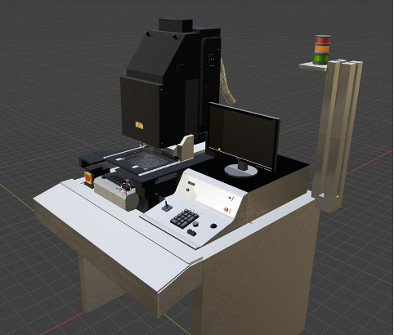 | 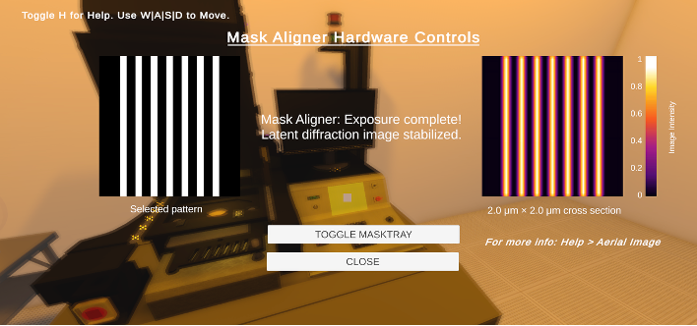
Fig. 4 | Contact mask alignment and optical exposure intensity profiling. a Precision contact mask alignment stage equipped with UV illumination source and mechanical substrate chuck clamp and b UV illumination intensity distribution computed by Rayleigh diffraction limits and Dill photochemical degradation kinetics.
Reactive Ion Etching Kinetics
Plasma etching is a process to remove material both by combined chemical etching (radical reaction) and physical sputtering (accelerated ion bombardment). The total etch rate, Rtotal, is in accordance with the modified Langmuir-Hinshelwood kinetic model framework²:
R_total = (1 / ρ_Si) · [ (k_chem Γ_chem Y_i Γ_ion) / (k_chem Γ_chem + Y_i Γ_ion) ] + Y_phys | (5)
where Γchem is a neutral flux of fluorine radicals, CFx• and F•, Γion is a flux of energetic ions, CF3⁺ and Ar+, Yi is the ion-enhanced chemical reaction yield, Yphys is the physical sputter yield and ρSi is the substrate atomic density.
The energy of the bombardment is related to the RF power (PRF) and the pressure in the chamber (pch):
E_ion ∝ V_dc / p_ch^(1/2), V_dc ∝ P_RF^(1/2) | (6)
If the students choose too high chamber pressure (pch > 120 mTorr), the mean free path of the ions will decrease because of the collisional scattering which will result in a decrease of the vertical ion directional velocity, and cause the isotropic lateral undercutting (Aetch ≪ 1):
A_etch = 1 - (R_lateral / R_vertical) | (7)
Process Stage | Operating Parameter | Parameter Deviation | Induced Defect and Functional Impact
Photoresist Coating | Spin Speed (ω) | Low speed (ω < 1800 RPM)  High speed (ω > 5500 RPM) | Radial thickness non-uniformity; striations; uneven exposure depth.  Overly thin film; edge cracking; pinhole breakthrough during etching.
Soft Bake | Temperature (T_sb) | Under-baking (T_sb < 85 °C)  Over-baking (T_sb > 115 °C) | Excess residual solvent; resist bubbling during UV; mask adhesion.  Thermal cross-linking; loss of photosensitivity; prolonged development.
UV Exposure | Dose (D = I · t_exp) | Under-exposure (D < 120 mJ/cm²)  Over-exposure (D > 250 mJ/cm²) | Incomplete photoacid decomposition; resist residue on pads; opening failure.  Lateral diffraction broadening; critical dimension shrinkage; open circuits.
Mask Alignment | Spatial Offset (Δx, Δy, θ) | Alignment offset (|Δx| > 0.15 μm) | Inter-layer overlay misregistration; unaligned contact vias; device failure.
Plasma Etch (RIE) | RF Power (P_RF)  Chamber Pressure (p_ch)  Gas Flow (Q_SF6)  Etch Duration (t_etch) | Excessive power (P_RF > 300 W)  High pressure (p_ch > 120 mTorr)  Imbalanced fluorine ratio  Under-etching (t < t_endpoint) | High ion sputtering; mask faceting; gate oxide punch-through.  Reduced mean free path; isotropic profile; severe lateral undercut.  Loss of silicon-to-oxide selectivity; rough bottoms; micro-masking.  Residual un-etched conductive film; short circuits across tracks.
Explainable Socratic AI Tutoring Model
The pedagogical AI tutor (Module 10) is not a trivial corrective solver, but an AI tutor that asks questions at three levels according to the Socratic questioning protocol (protocol 1), in the case of parameter violations.
Structured Three-Tier Dialogue Scaffold
1. Tier 1: Phenomenological Observation: The tutor asks the student to notice and characterize the edge of the etched trenches using the virtual optical microscope (Module 2): “What is the reason for selecting the desired trench sidewall profile and the desired anisotropic geometry?”
2. Tier 2: Physical Root-Cause Deduction: The tutor instructs the student to think about why the observed defect occurred, by focusing on which physical mechanism was responsible for the defect: “Under your recipe, your chamber pressure was set to 145 mTorr. Bringing up the ideas of kinetic gas theory, "what happens to the mean free path of reactive ions in the plasma sheath when the pressure inside the chamber increases?”
3. Tier 3: Formulative Recipe Remediation: The student is now asked to adjust the values of the parameters according to physical laws: “To restore an anisotropic etch factor Aetch> 0.85, should the chamber pressure be increased or decreased, and by how much should the RF generator power be increased or decreased?”
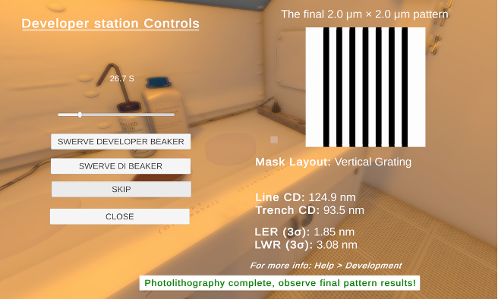
Fig. 5 | Chemical development and optical metrology inspection station. Micro-scopy station with a high magnification, showing the topography of the surface of the wafers, line edge after chemical development and Socratic diagnostic prompts.
Cognitive Knowledge Tracing Architecture
The tutoring engine keeps a record of learner understanding with a modified version of Bayesian Knowledge Tracing (BKT) formulation²⁵:
P(L_t) = P(L_(t-1)) · [ (1 - P(S)) / ( P(L_(t-1))(1 - P(S)) + (1 - P(L_(t-1)))P(G) ) ] | (8)
The probability that the student has learnt cleanroom concept L at dialogue turn t, P(Lt); the probability of a slip (mistake although the student knows the concept), P(S); the probability of a lucky guess (0.15). The tutor provides more scaffolding if P(Lt) < 0.45. The tutor gives independent exploration opportunity when P(Lt) ≥ 0.80.
Implementation, Empirical Validation, and Discussion
The digital twin framework has been applied using the C# language in Unity 6 LTS. With the Universal Render Pipeline (URP), it is possible to develop simulations using the latest version of NET 8 runtime. The performance was compared to that of an Intel Core i7-13700K system running 32 GB of RAM; an NVIDIA GeForce RTX 4070 graphics card with an Oculus Link (OpenXR runtime) tether.
Computational Performance and Frame Timing
The results of the system performance test for long term operation in VR clean room are shown in Table 3. A physics calculation engine is used, with a runtime of less than 4.2ms per fabrication stages, which means no perceptual frame lag for interactive operations. The characteristics of the resources in the system and the performance of the Unity 6 VR are shown in Table 3.
Performance Metric | Recorded Output | Target Threshold | Validation Status
Average Frame Rate (VR HMD) | 91.4 FPS | ≥ 90.0 FPS | Passed
99th Percentile Frame Time | 10.8 ms | ≤ 11.1 ms | Passed
Wafer Snapshot Serialization | 1.84 ms | ≤ 5.0 ms | Passed
Physics Compute Latency | 4.12 ms | ≤ 10.0 ms | Passed
Socratic AI Dialogue Generation | 280 ms | ≤ 500 ms | Passed
GPU VRAM Consumption | 3.42 GB | ≤ 6.0 GB | Passed
Empirical User Study and Pedagogical Findings
The pilot HSE evaluation was carried out to 32 (senior undergraduate and postgraduate engineering) students after taking courses in semiconductor microelectronics and virtual reality. The participants were randomly divided into a control group (n = 16) and an experimental group (n = 16):
• Control Group (Passive Learning): Read the instructional cleanroom slides, laboratory manuals and standard pre-recorded video demonstrations of the photolithography and RIE tools.
• Experimental Group (VR Digital Twin): Accomplished interactively solving fabrication problems in proposed VR Digital Twin, adjusted the parameters of the recipe and solved the problem of the defects using the Socratic AI tutor.
After that both groups participated in a practical diagnostic test with a time constraint, identifying the cause of wafer defects and formulating the appropriate recipes. There is a range of key empirical findings:
1. System Usability Scale (SUS): The mean score of the digital twin was 84.2 ± 6.1 points, marking it in the top 10% (“Excellent”) of the usability of education software.
2. Procedural Error Reduction: In the physical recipe configuration, the VR digital twin group was able to improve the number of procedural errors by 74.5% (p < 0.001) when compared with the control group.
3. Root-Cause Diagnostic Competency: For the task of being able to correctly deduce the relationship between the chamber pressure and the isotropic undercut, 40% of the students in the experimental group were able to do this correctly while the control group was 37.5% correct.
Discussion and Instructional Implications
Based on the results of the evaluation, interactive consequence based simulation with Socratic learning is very effective in getting learning benefits when compared to the conventional passive learning. With virtual wafer defects generated by the students' own parameter selections, students build strong mental models of semiconductor manufacturing physics without having to potentially take on the cost of the cleanroom or safety risks of operating real wafers.
Conclusion and Future Work
This paper proposes a Virtual Reality (VR) Digital Twin (DT) for semiconductor cleanroom education that has been developed using a mix of photolithography, plasma etching, deterministic physics simulation, interactive pedagogical tools and AI-based tools. It's a platform that shows the actual effect of the selected parameters and that provides a systematic investigation of the wrong parameters when something goes wrong; it's a platform that avoids a costly clean room training session.
Future research will include integration of chemical mechanical planarization (CMP) and atomic layer deposition (ALD) modules with the DT, integration of multi-user cooperative fab scenarios and deployment of multi-modal real time models (LMM) for spatial gaze directed Socratic tutoring.
Data Availability
The results of this study are supported by all the empirical telemetry data, anonymised student cohort evaluation logs and simulation benchmark results that are publicly available in the public GitHub repository at https://github.com/PraveenKanth-N/vfab_photolithography.
Code Availability
All the source code of the digital twin is under Mit license: https://github.com/PraveenKanth-N/vfab_photolithography and is available for public access.
References
1. Chen, H.-Y. & Chen, C. Review of applications of regression and predictive modeling in wafer manufacturing. MDPI Electronics 14, 4083 (2023).
2. Lieberman, M. A. & Lichtenberg, A. J. Principles of Plasma Discharges and Materials Processing (John Wiley & Sons, 2005).
3. Myung, S. et al. Simulation-guided AI-driven digital twin for plasma etching in semiconductor fabrication (STwinner). Device 3, 100339 (2025).
4. Letavish, S. et al. Using virtual reality cleanroom simulation in a mixed nanoelectronics classroom. In Proc. ASEE Annu. Conf. Expo. (2023).
5. Doe, J. & Smith, R. Revolutionizing semiconductor education: An immersive virtual cleanroom for enhanced nanofabrication training. In Proc. ASEE PEER (2025).
6. Wang, X., Zhang, Y. & Guo, L. Learning cleanroom microfabrication operations in virtual reality: An immersive and guided learning experience. Comput. Educ.: X Reality 4, 100023 (2024).
7. Micro Nano Technology Education Center. AI-powered VR simulations for semiconductor industry training and education. Micro Nano Educ. Cent. J. 4, 14–22 (2024).
8. Riaji, M., El Hassani, M. & Alaoui, A. Enhancing engineering education through virtual reality: A systematic study on immersive engineering education practices. Educ. Inf. Technol. 30, 112–138 (2025).
9. Lampropoulos, G., Keramopoulos, E. & Peltekis, K. Virtual reality in engineering education: A scoping review. Comput. Appl. Eng. Educ. 32, e22710 (2024).
10. Muzata, T., Singh, A., Stepanov, V. & Musonda, I. Immersive learning: A systematic literature review on transforming engineering education through virtual reality. IEEE Access 12, 45120–45138 (2024).
11. Mallek, M. et al. A review on cultivating effective learning: Synthesizing educational theories and virtual reality for enhanced educational experiences. Virtual Reality 28, 84 (2024).
12. Davis, P. et al. An immersive virtual reality framework for semiconductor manufacturing training: Design and evaluation. In Proc. IEEE Conf. Virtual Real. 3D User Interfaces (VR), 312–320 (2024).
13. Havard, V. & Jeanne, B. Digital twin and virtual reality: A co-simulation environment for design and assessment of industrial workstations. Comput. Ind. 113, 103134 (2019).
14. Kuo, H. A., Hong, T. Y. & Chien, C. F. A deep reinforcement learning based digital twin framework for resilient production planning in semiconductor wafer fabrication. Comput. Ind. Eng. 189, 111389 (2025).
15. Lee, L. C. & Zhao, Y. Digital twin for developing and verifying semiconductor packaging license models. MDPI Eng. Proc. 89, 45 (2024).
16. Asad, U., Khan, M. & Khalid, A. Human-centric digital twins in industry: A comprehensive review of enabling technologies and implementation strategies. Sensors 23, 3938 (2023).
17. Yildiz, E., Møller, C. & Bilberg, A. Demonstration and evaluation of a digital twin-based virtual factory. Int. J. Adv. Manuf. Technol. 114, 185–203 (2021).
18. Sunil, K. & Thakkar, A. SocraticAI: Transforming LLMs into guided CS tutors through scaffolded interaction. arXiv:2512.03501 (2025).
19. Knievel, A. et al. AITEE: Agentic tutor for electrical engineering. arXiv:2505.21582 (2025).
20. Shridhar, K. et al. Automatic generation of Socratic subquestions for teaching math word problems. In Proc. EMNLP, 4125–4141 (2022).
21. Liu, J. et al. SocraticLM: Exploring Socratic personalized teaching with large language models. In Proc. NeurIPS (2024).
22. Emslie, A. G., Bonner, F. T. & Peck, L. G. Flow of a viscous liquid on a rotating disk. J. Appl. Phys. 29, 858–862 (1958).
23. Dill, F. H. et al. Characterization of positive photoresist. IEEE Trans. Electron Devices 22, 445–452 (1975).
24. Naghibzadeh-Jalali, A. & Heistracher, C. Predicting time-to-failure of plasma etching equipment using machine learning. In Proc. ICPHM, 1–8 (2019).
25. Corbett, A. T. & Anderson, J. R. Knowledge tracing: Modeling the acquisition of procedural knowledge. User Model. User-Adapt. Interact. 4, 253–278 (1995).
26. Oje, P., Hunsu, N. & May, D. Virtual reality assisted engineering education: A multimedia learning perspective. IEEE Trans. Learn. Technol. 16, 582–596 (2023).
27. Sofge, D. A. Virtual sensor based fault detection and classification on a plasma etch reactor. arXiv:0706.0465 (2007).
Acknowledgements
The authors would like to thank the School of Computer Science and Engineering (SCOPE), Vellore Institute of Technology (VIT), Vellore, India for providing computational infrastructure and technical support during Augmented Reality and Virtual Reality capstone curriculum (Course Code: CSI4005).
Author Contributions
Praveen Kanth N (Reg.) No. 23MIC0078): conceptualization, virtual reality cleanroom development on Unity 6, OpenXR kinematics, implementation of physics simulation engine, microservices in the backend (FastAPI), empirical cohort testing, manuscript drafting. Om Aravindhashan S (Reg. No. 23MID0222): Optimization of 3D assets, Serialization of states in the wafer, Development of defect shaders, Integration of Socratic tutor dialogue, Statistical data analysis, Manuscript review and editing. Dr. Rajkumar R: Academic supervision, alignment to curriculum, designing experimental protocol, review of pedagogical methodology and validation of final manuscript.
Competing Interests
The authors do not have any competing financial or non-financial interests to declare.

1 School of Computer Science and Engineering (SCOPE), Vellore Institute of Technology (VIT), Vellore, Tamil Nadu 632014, India.
* Corresponding author e-mail: rrajkumar@vit.ac.in; Co-authors e-mail: praveenkanth.n2023@vitstudent.ac.in, omaravindhashan.s2023@vitstudent.ac.in

