Q10. Create a simple cloud software application for online super market using any Cloud Service Provider to demonstrate SaaS with the template of customer name, address, phone, email, items, quantity etc. with the item classification form.

# CREATING THE USER AUTORIZATION   
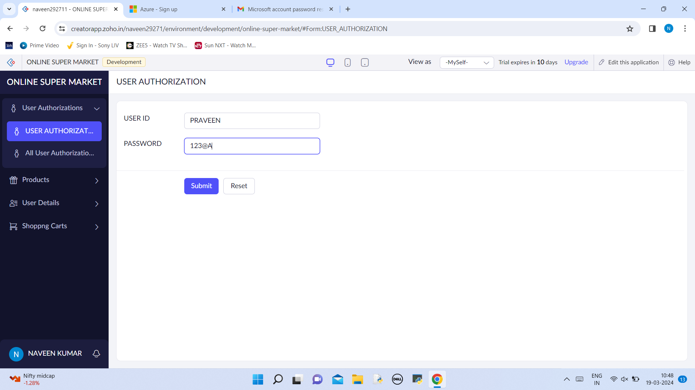

# LIST OF USER AUTHORIZATION PLACED   
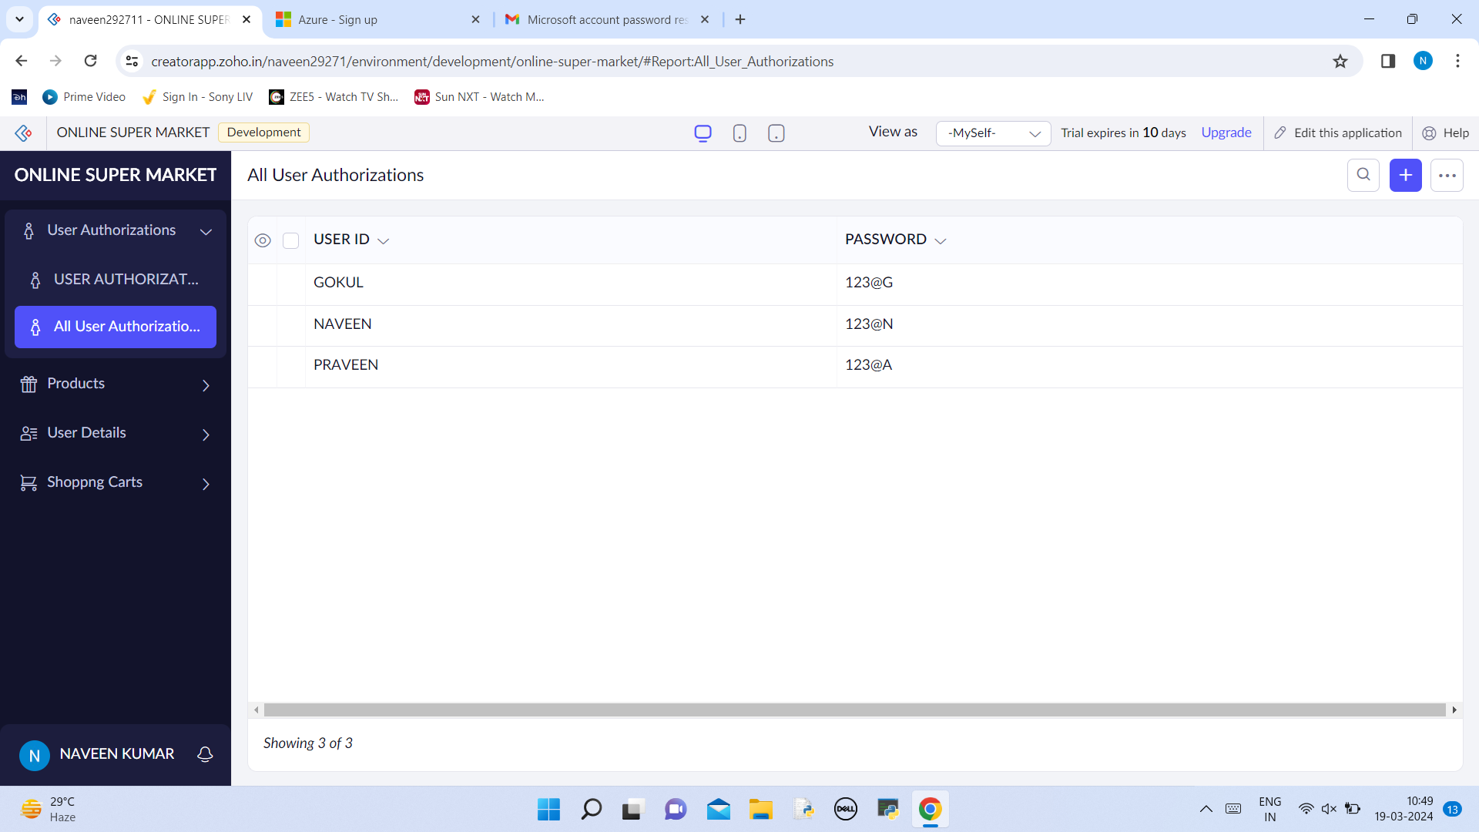

# CREATING A FORM FOR NO.OF PRODUCT  
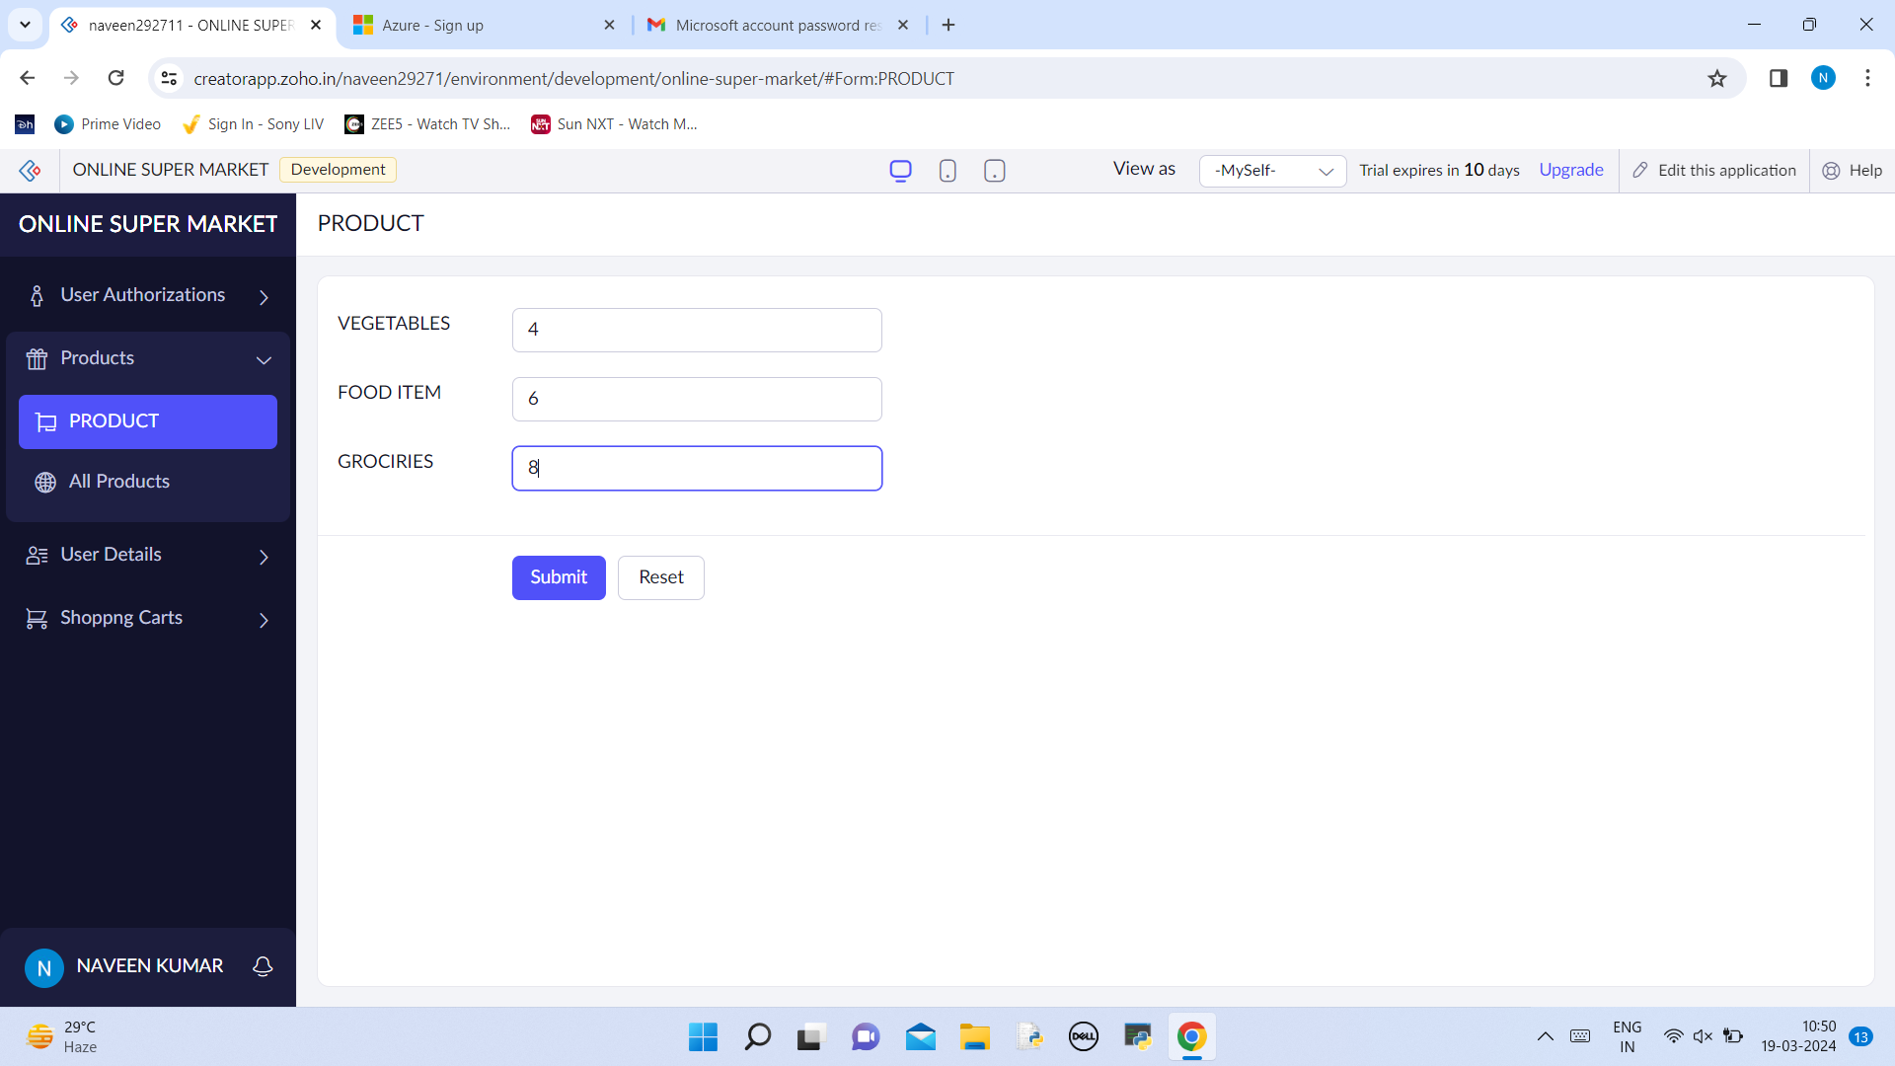

# LIST OF PRODUCTS  


# CREATING THE USER DETAILS  
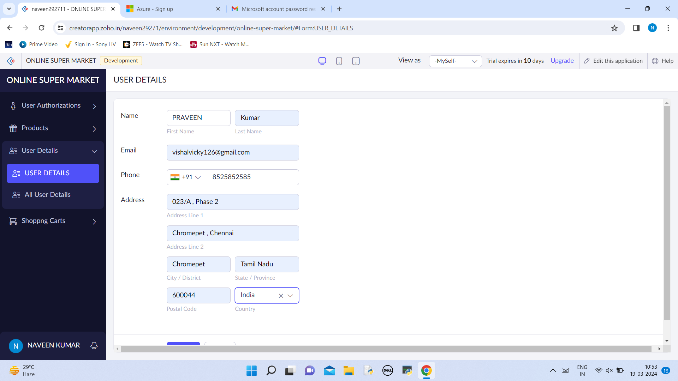

# LIST OF USER DETAILS  
