Create a Virtual Machine with 1 CPU, 2GB RAM and 15GB storage disk using a Type 2 Virtualization Software

# Create a new virtual machine wizard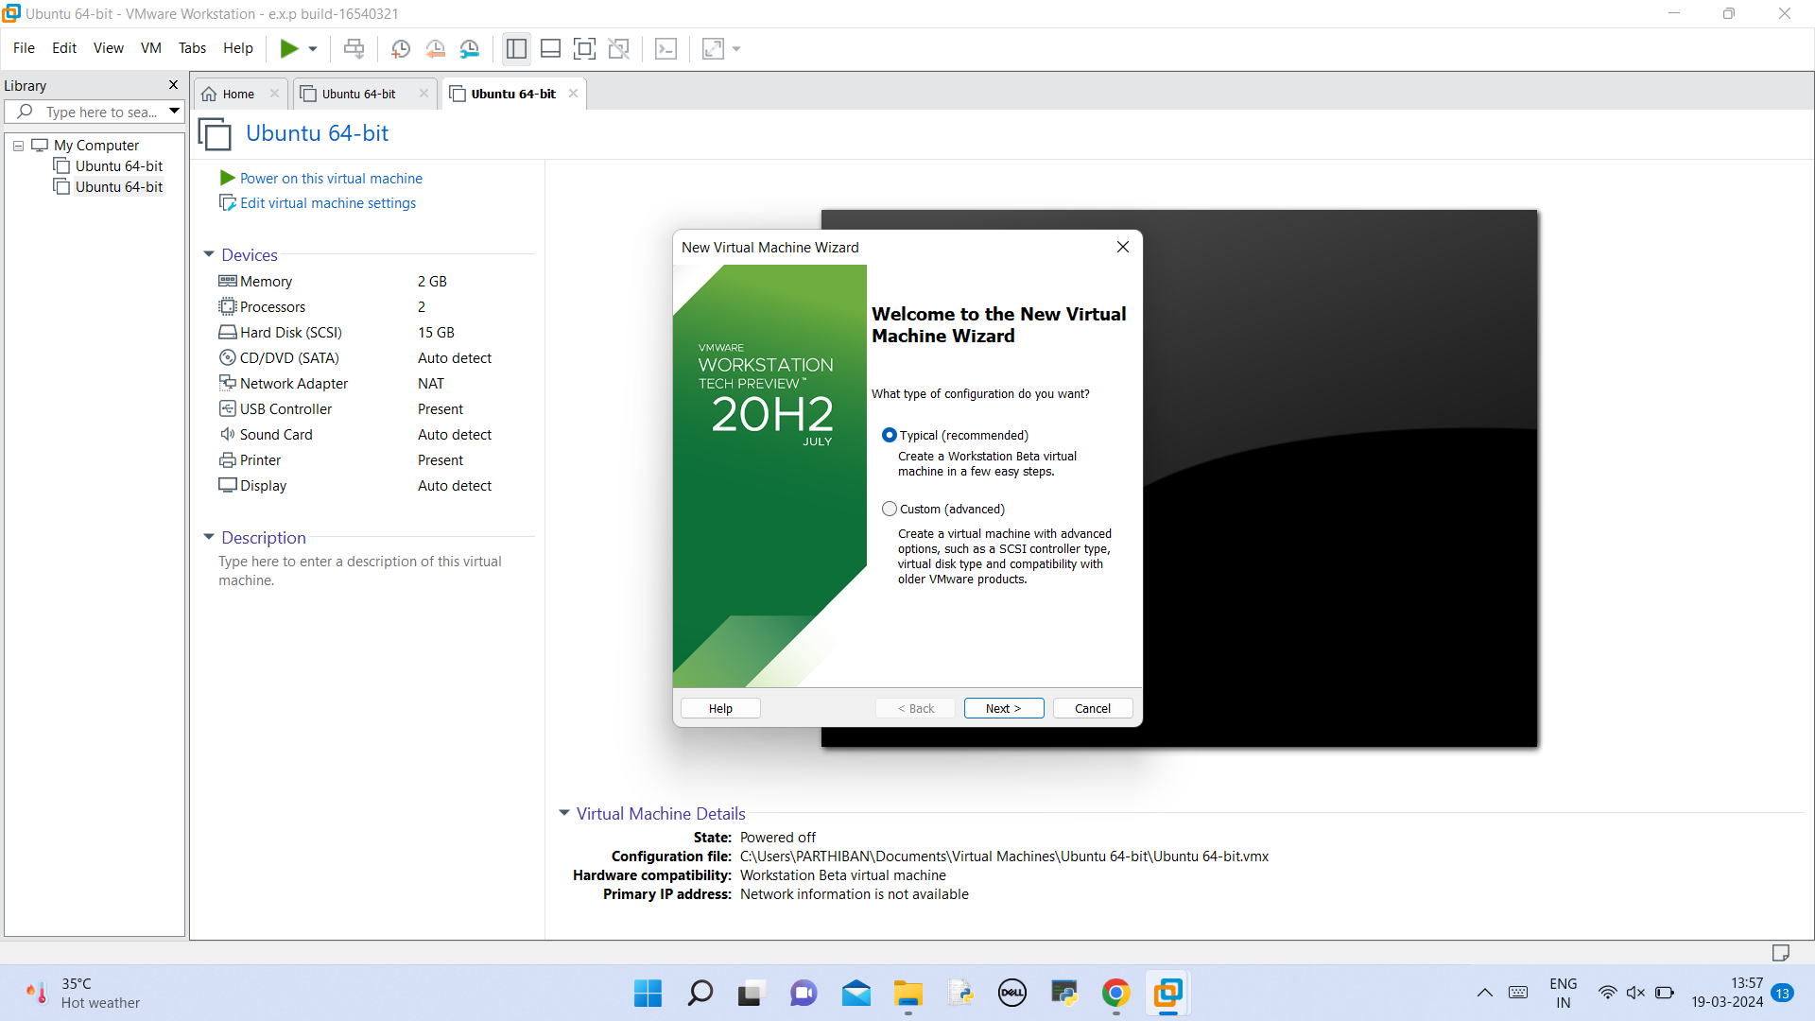

# select that instaling operating system later 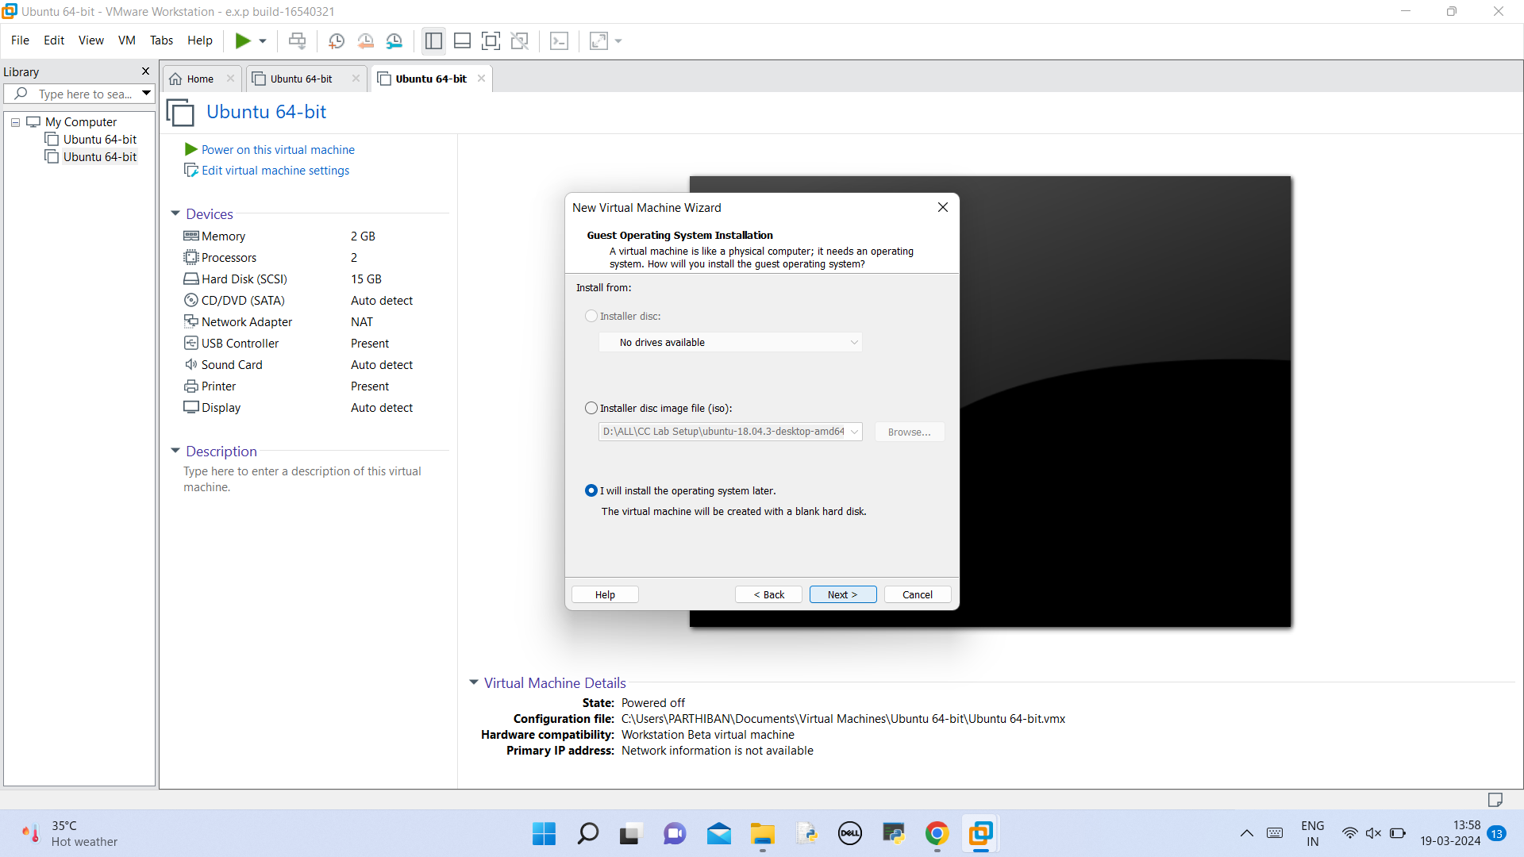

# Select linux in the form of os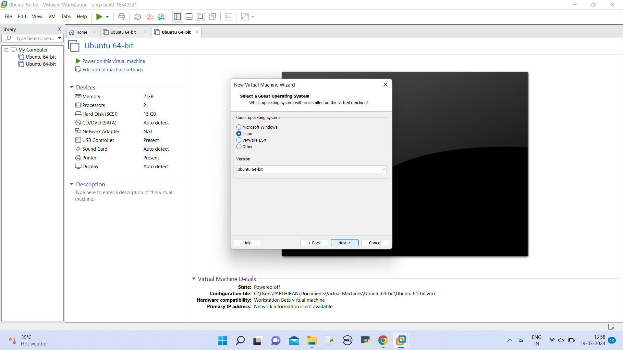

# Select the machine name and location to be stored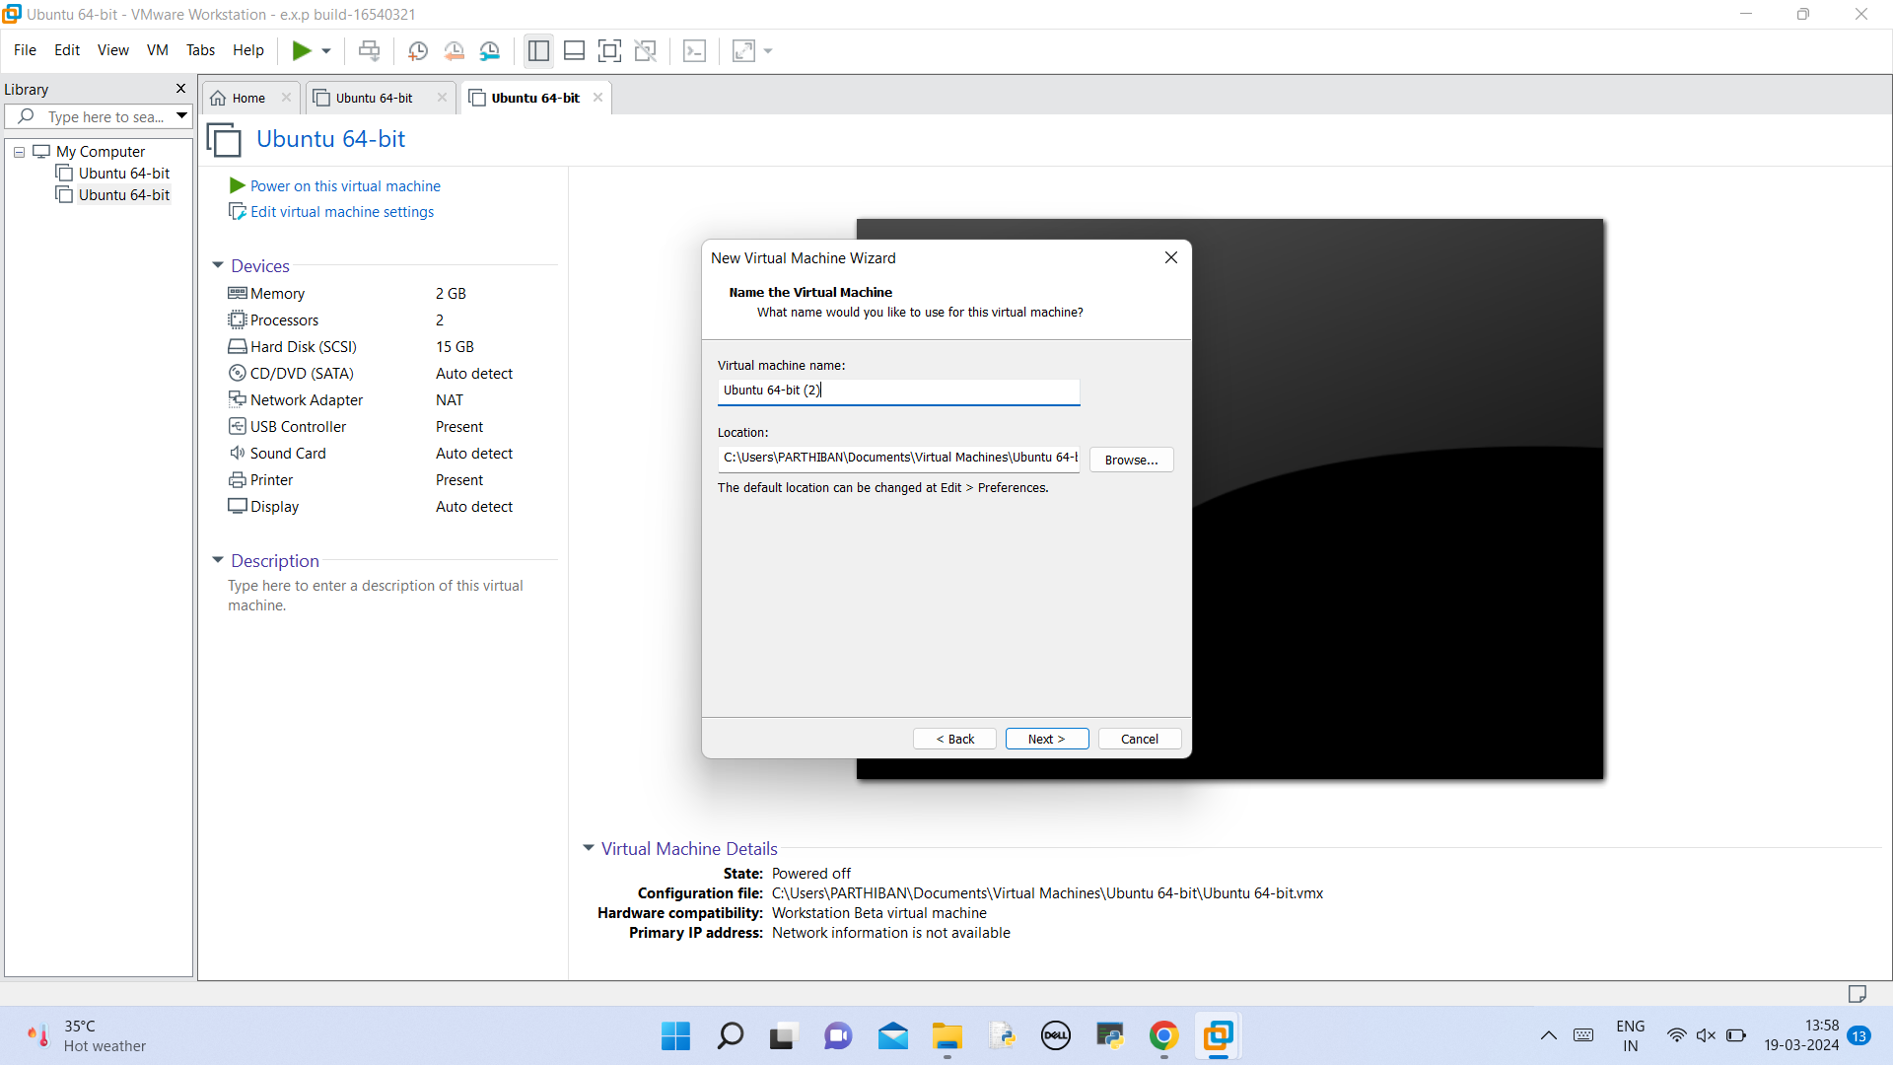

# space you allocate for disk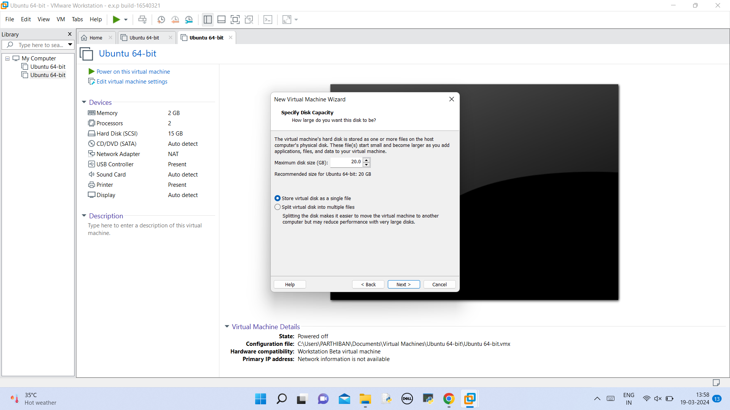

# Hardware is displayed for view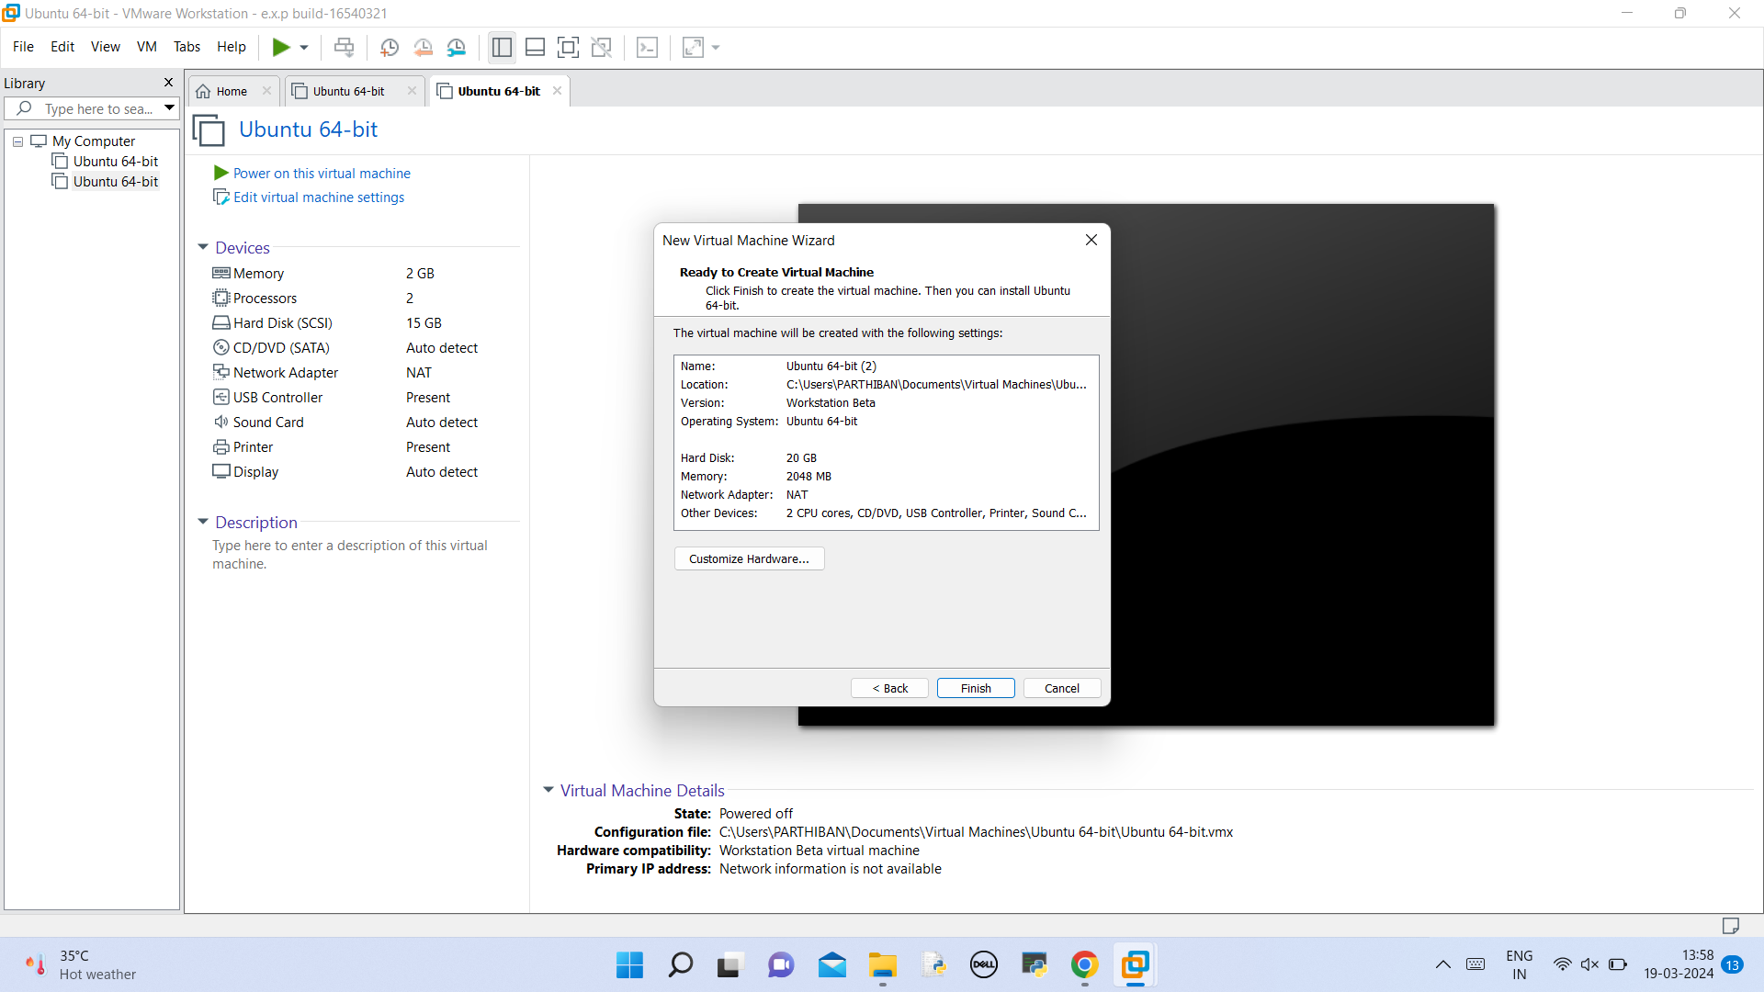

# Create a VM