2 Create a Cloning of a VM and Test it by loading the Previous Version/Cloned VM

# Create a VM> Manager > CLONE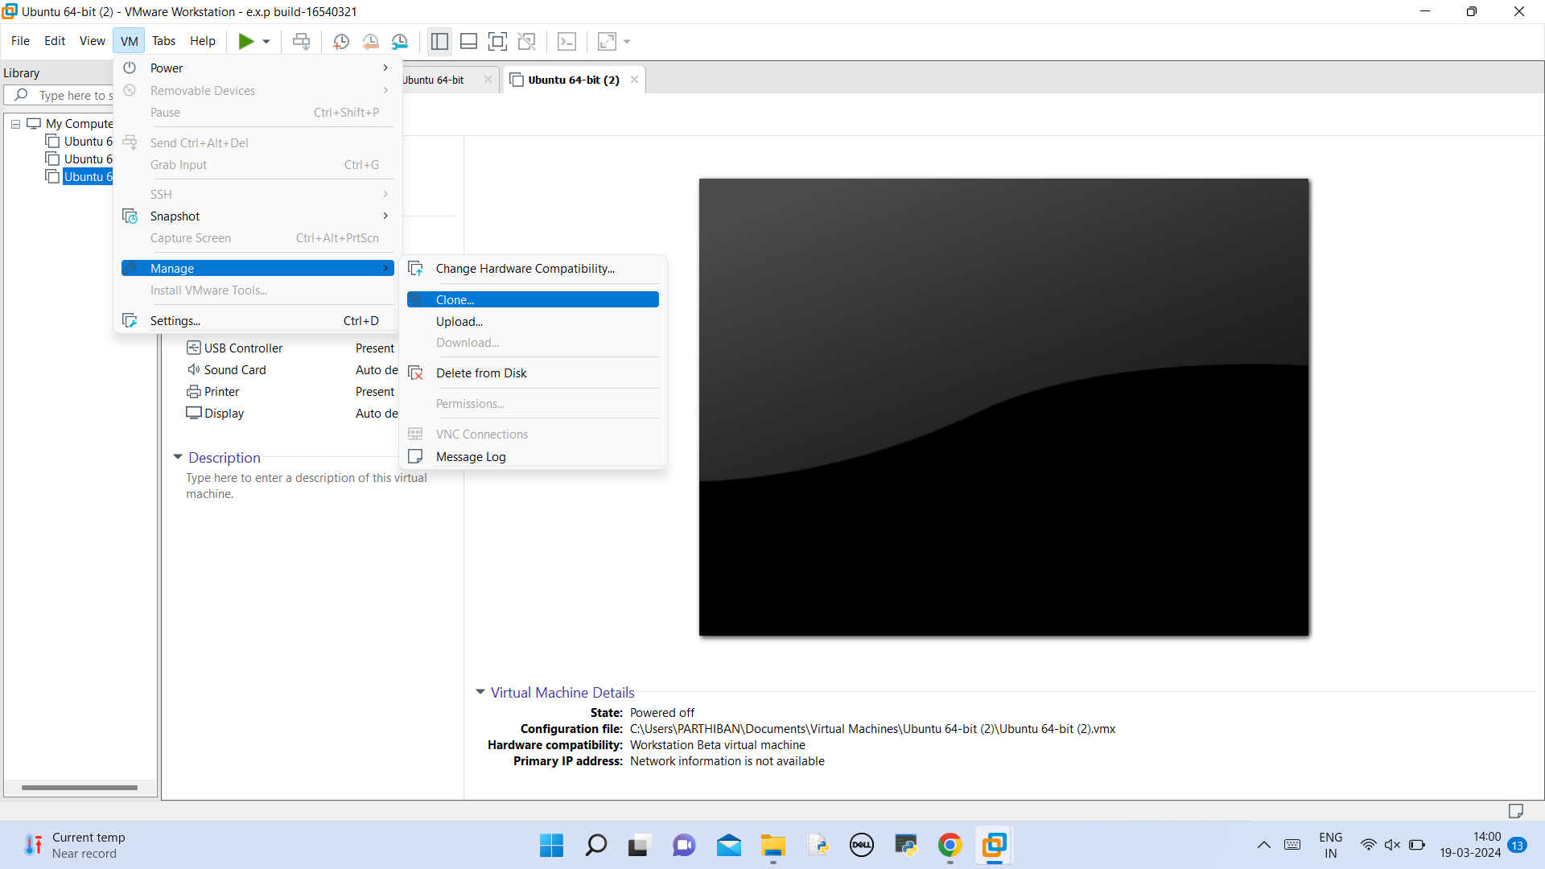

# CREATE A VM Wizard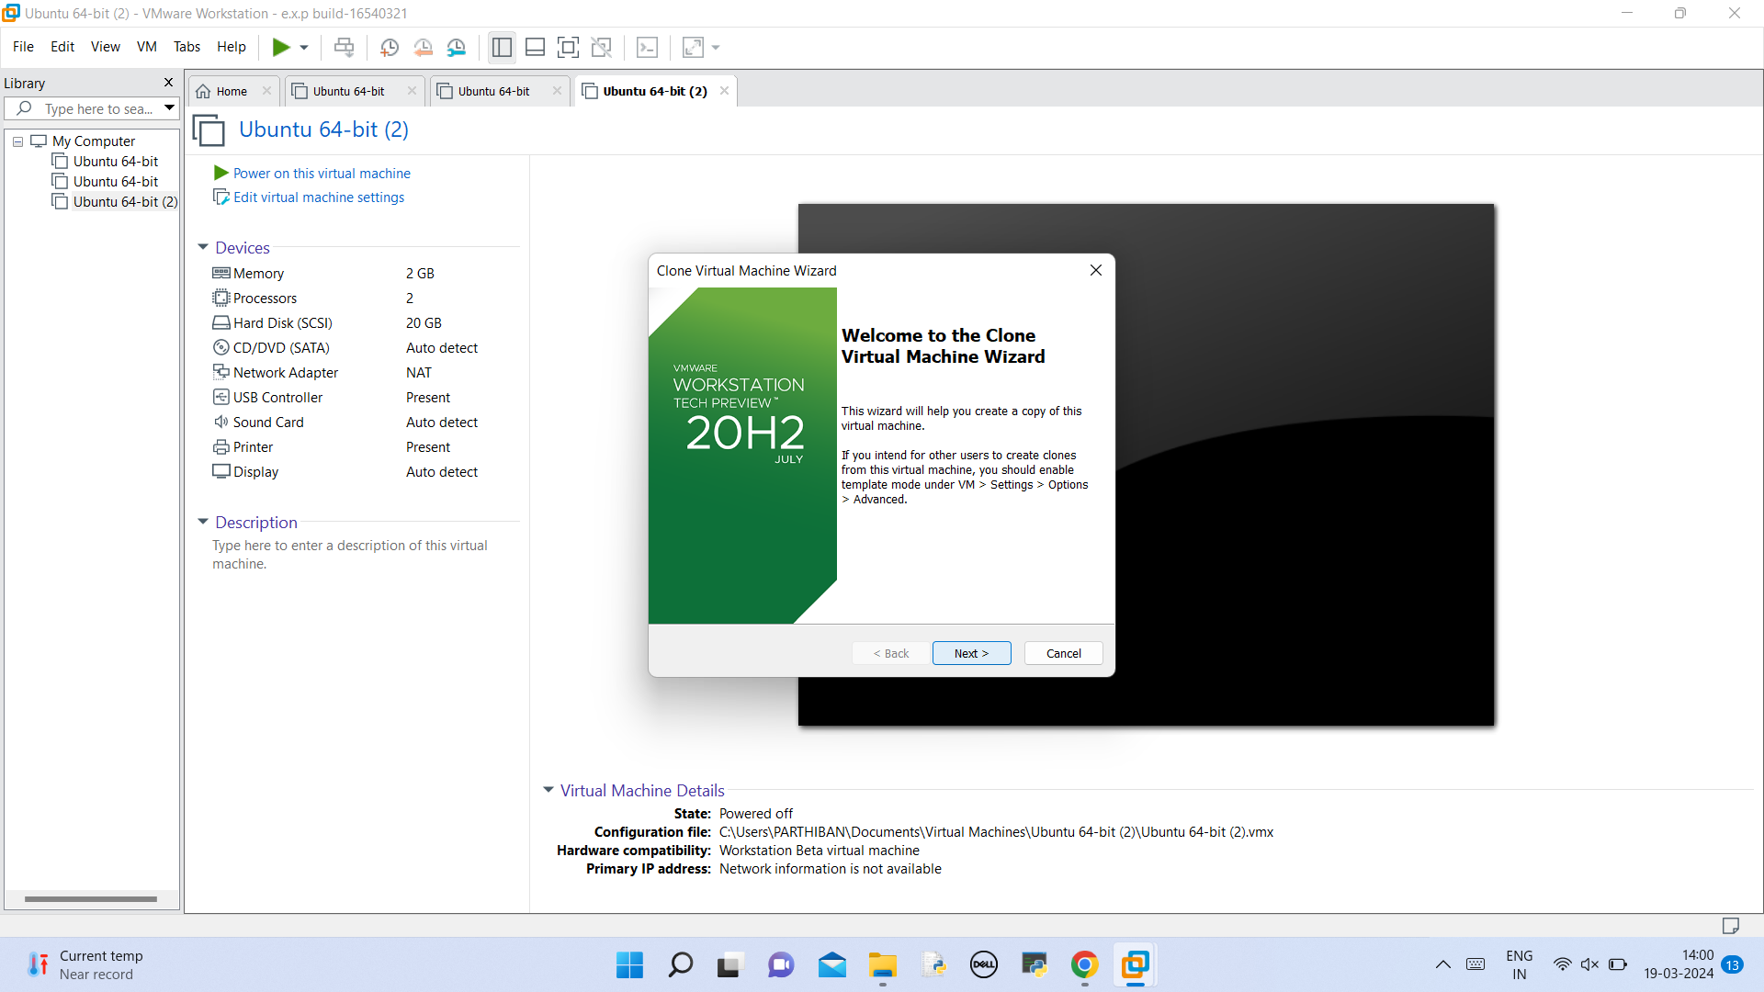

# Create a current state of VM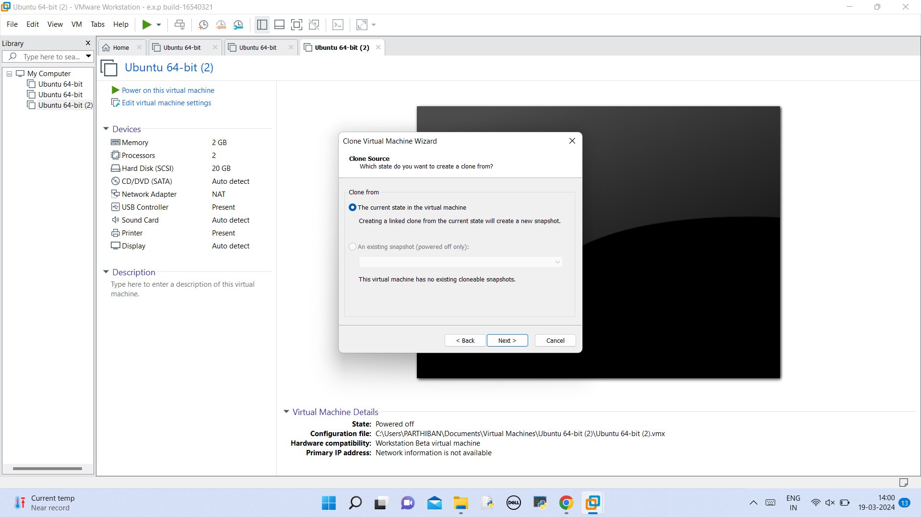

# Create a linked clone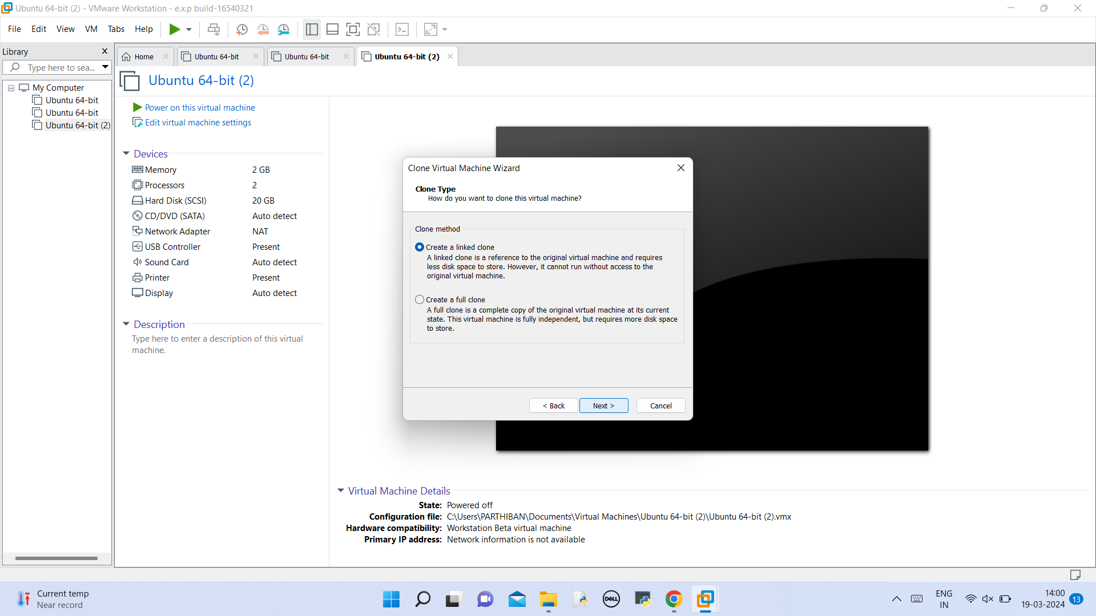

# Select the name and the location 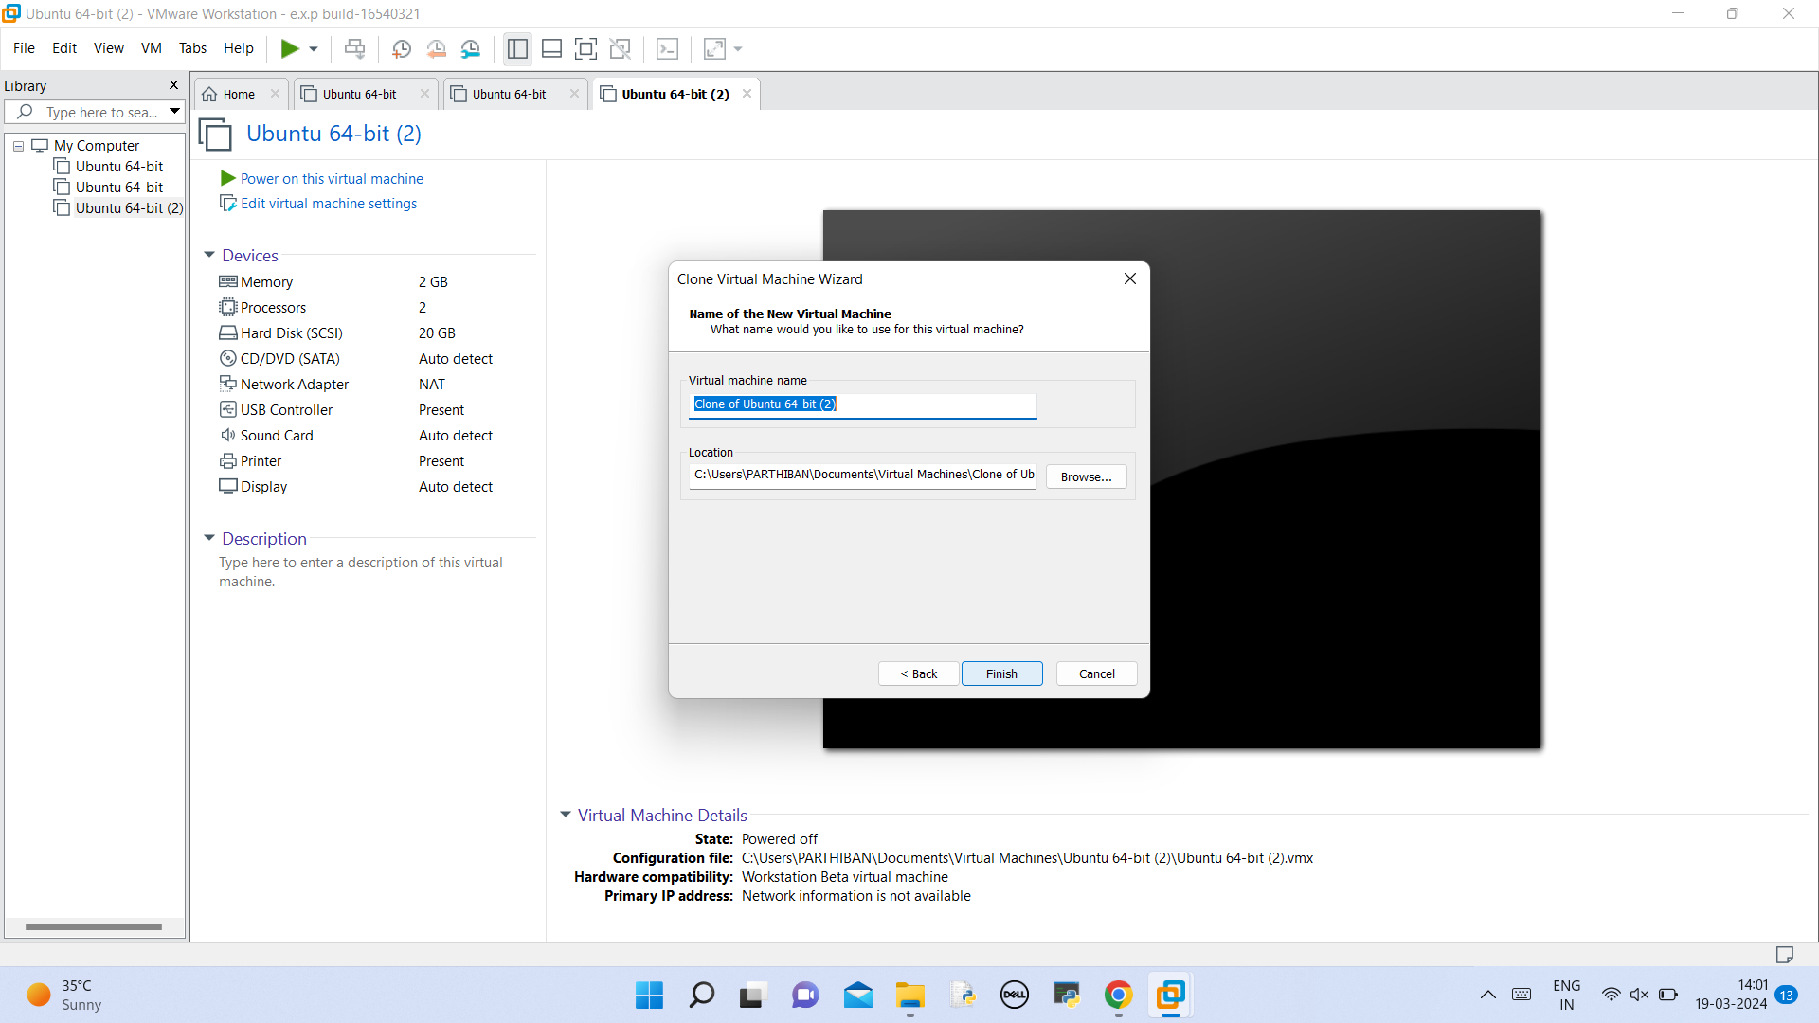

# Clone is executed 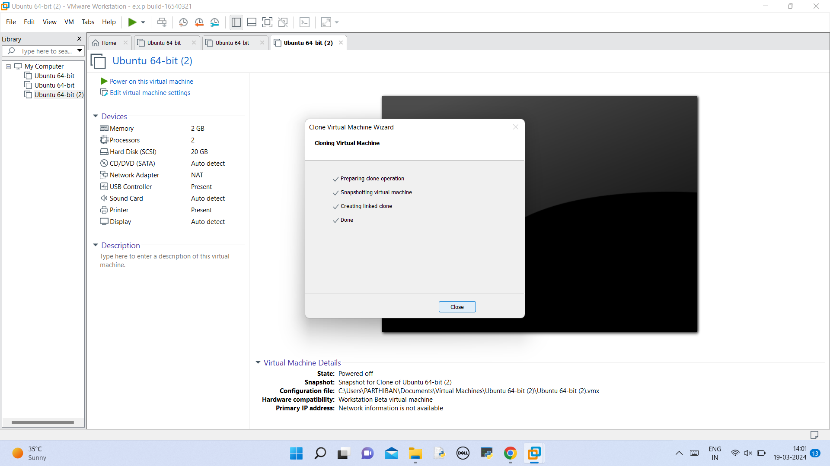

# In the configuration file you can see the clone .