4 Demonstrate virtualization by Installing Type -2 Hypervisor in your device, create and configure VM image with a Host Operating system (Either Windows/Linux).

# create a new virtual machine. Click on the installer disc image file(iso) and locate ubuntu operating system.

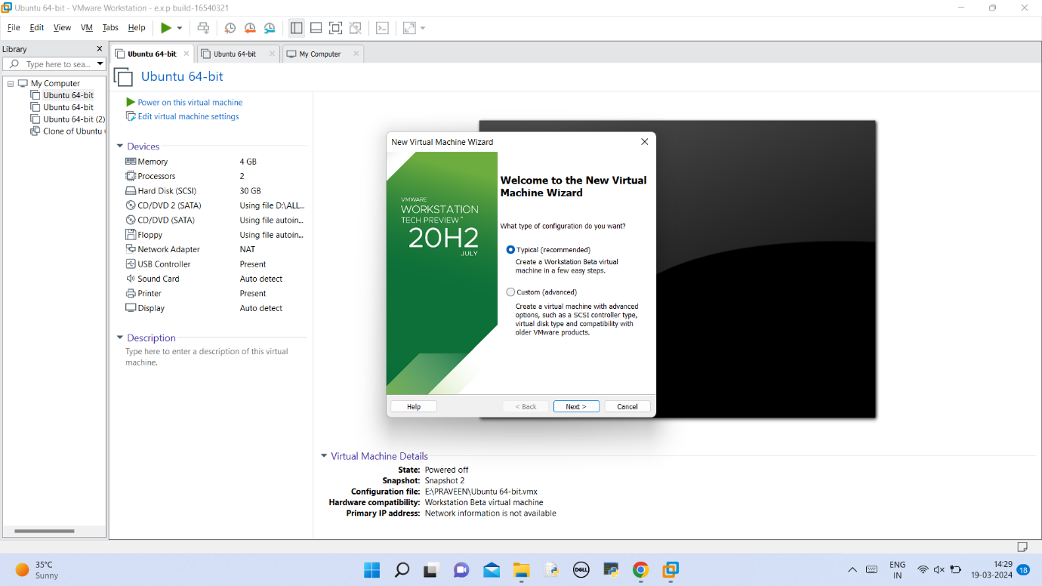

# create a new virtual machine. Click on the installer disc image file(iso) and locate ubuntu operating system.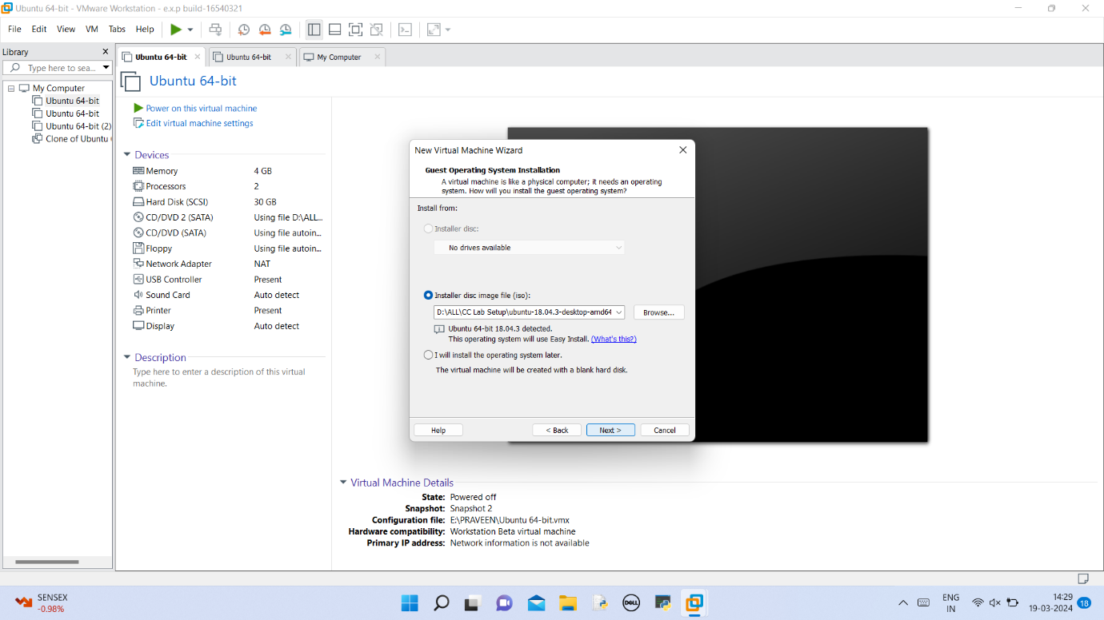

# Give login details for linux operating system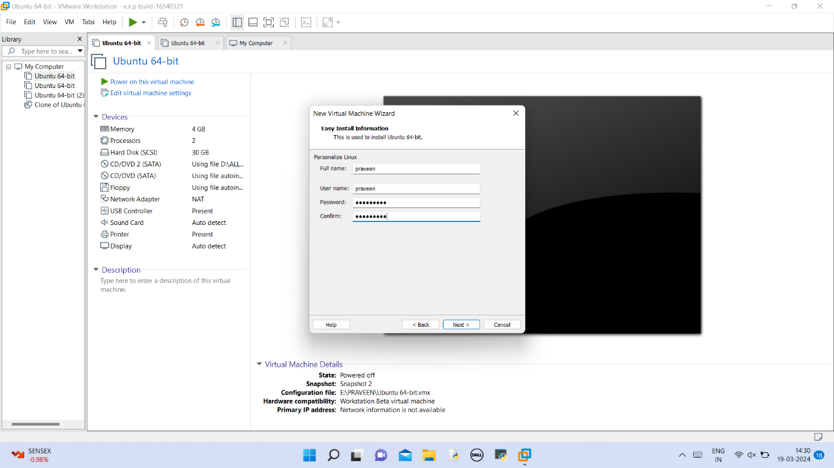

# Give virtual machine name and location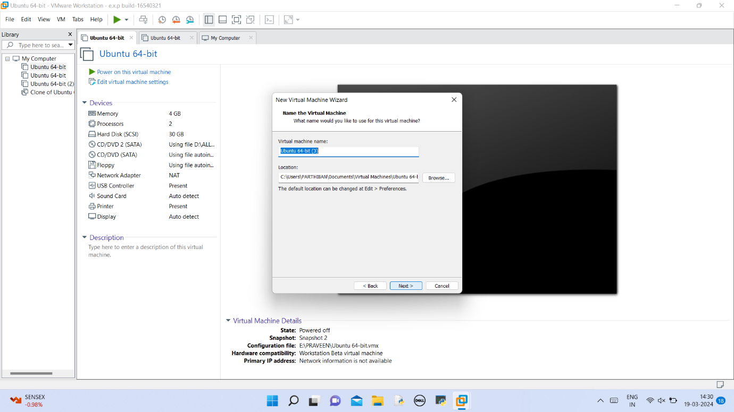

# Give the disk size.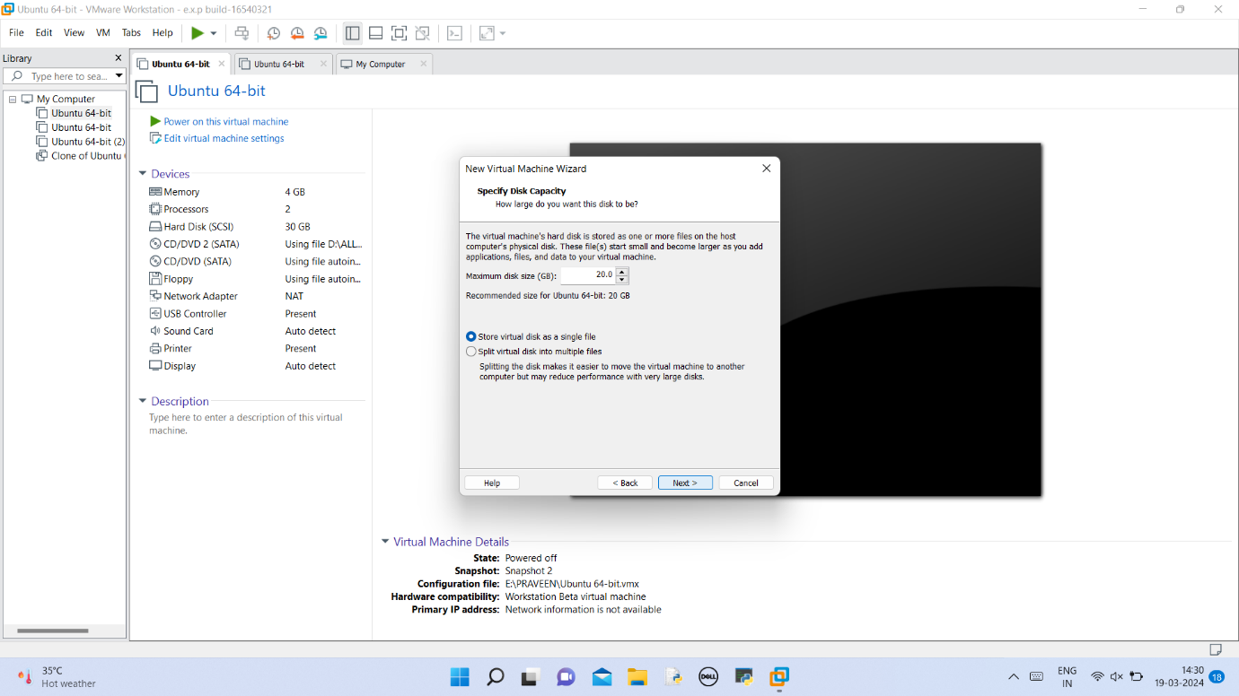

# Here we can see virtual machine created details.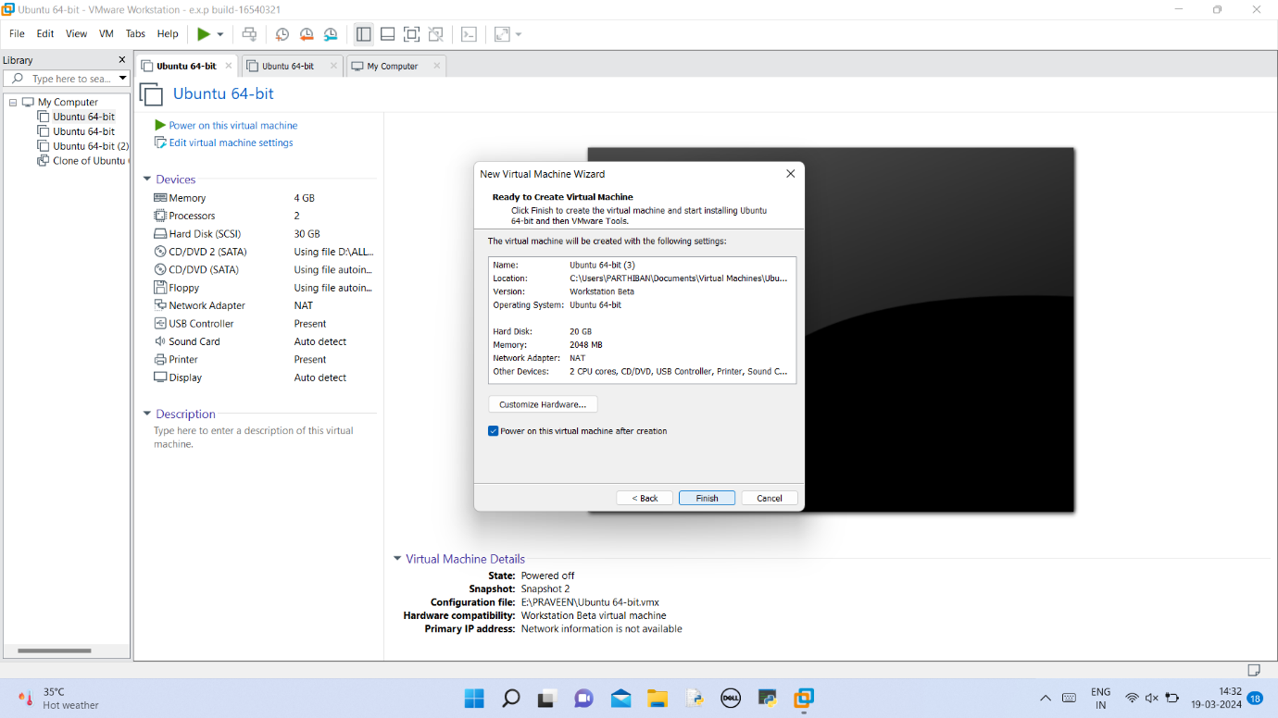

# virtual machine created and now it was booting.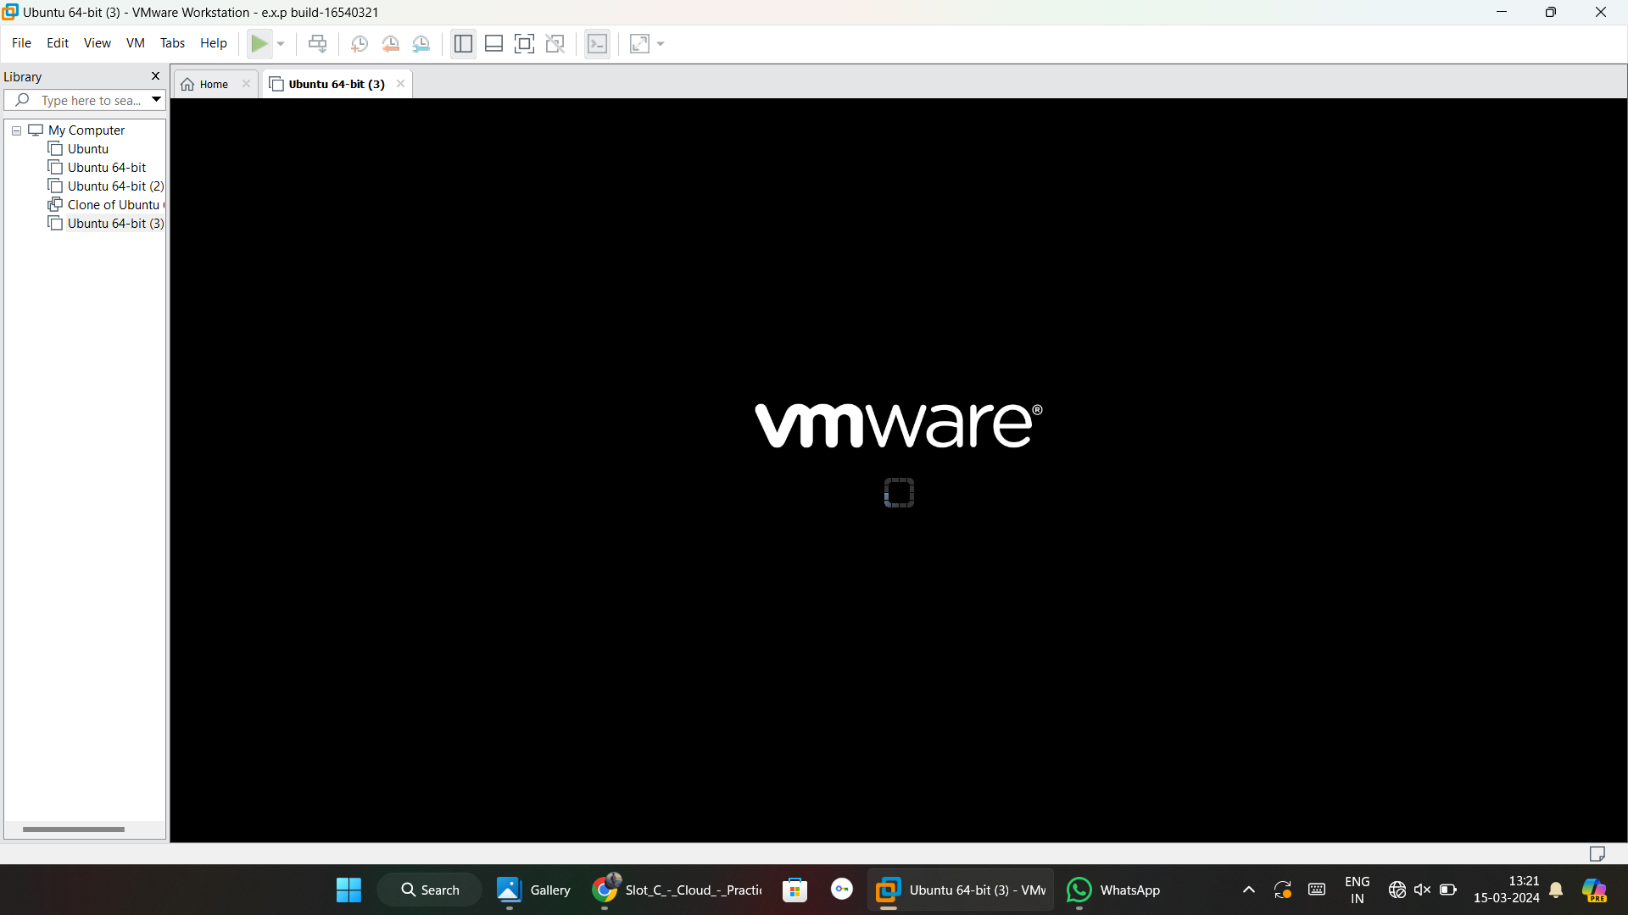

# finally linux os is created.