5 Create a Virtual Hard Disk and allocate the storage using VM ware Workstation

# Create a virtual machine 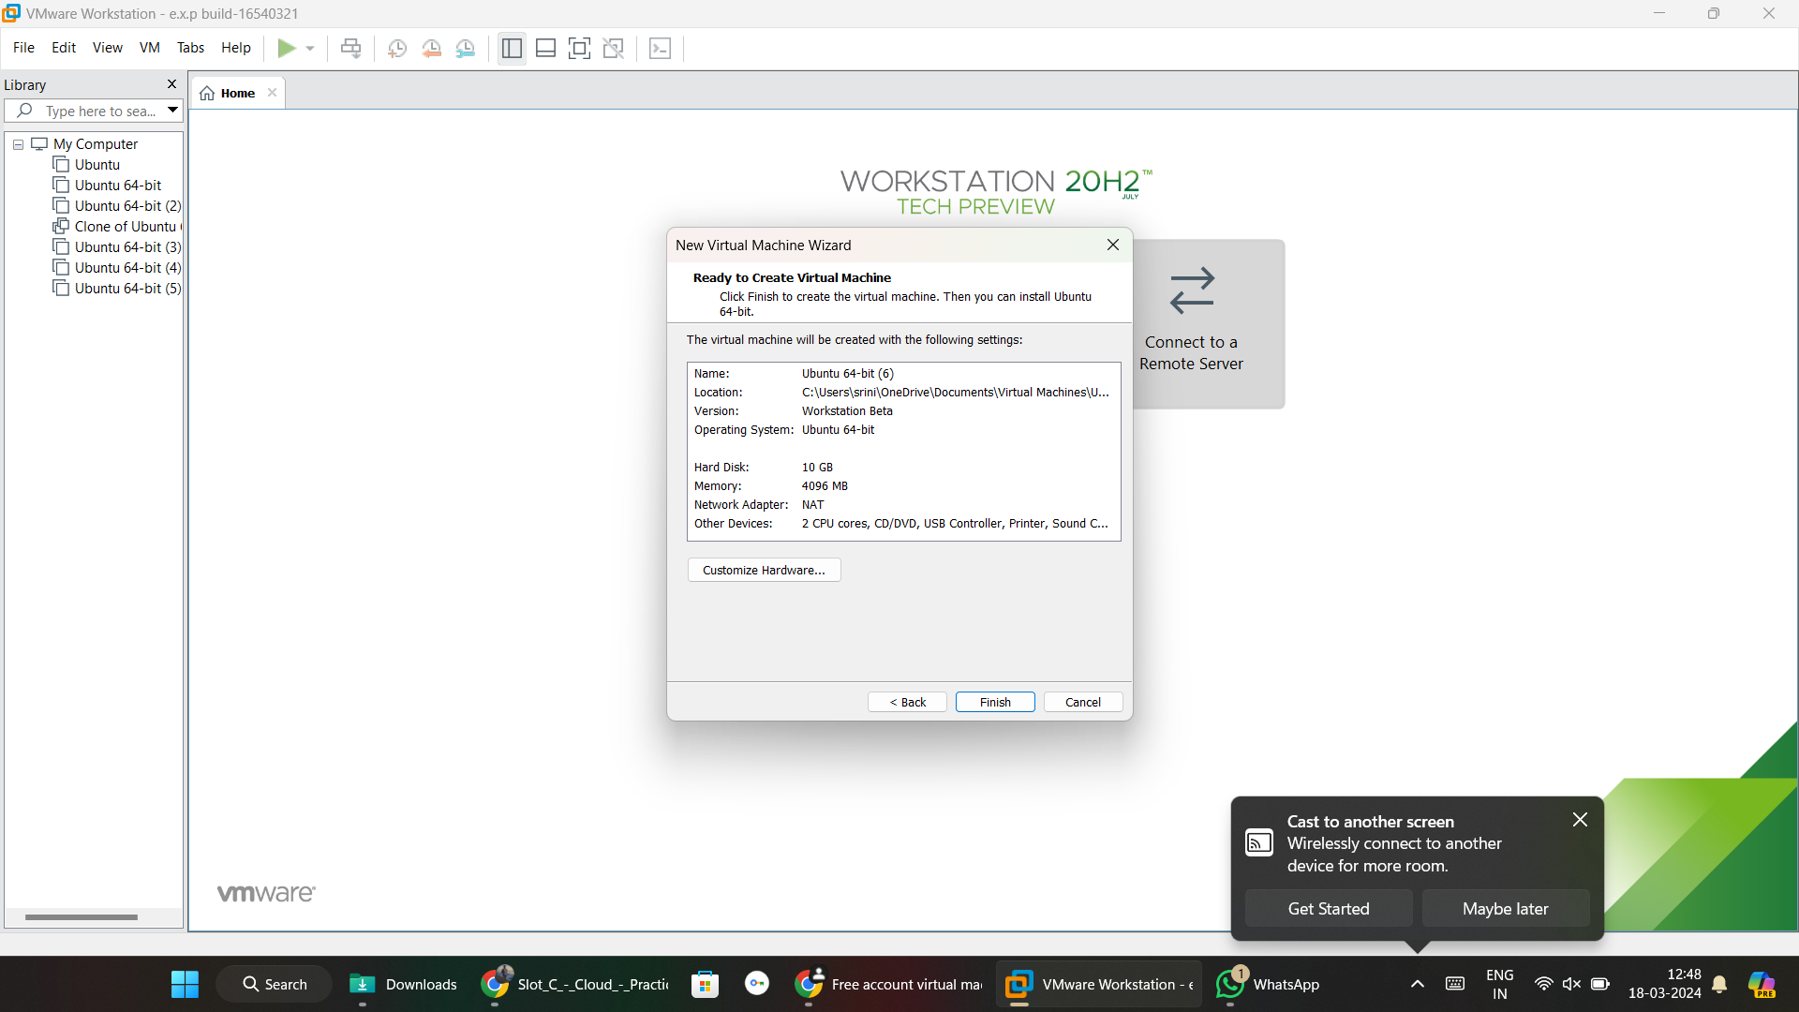

# Click on edit virtual machine and click add.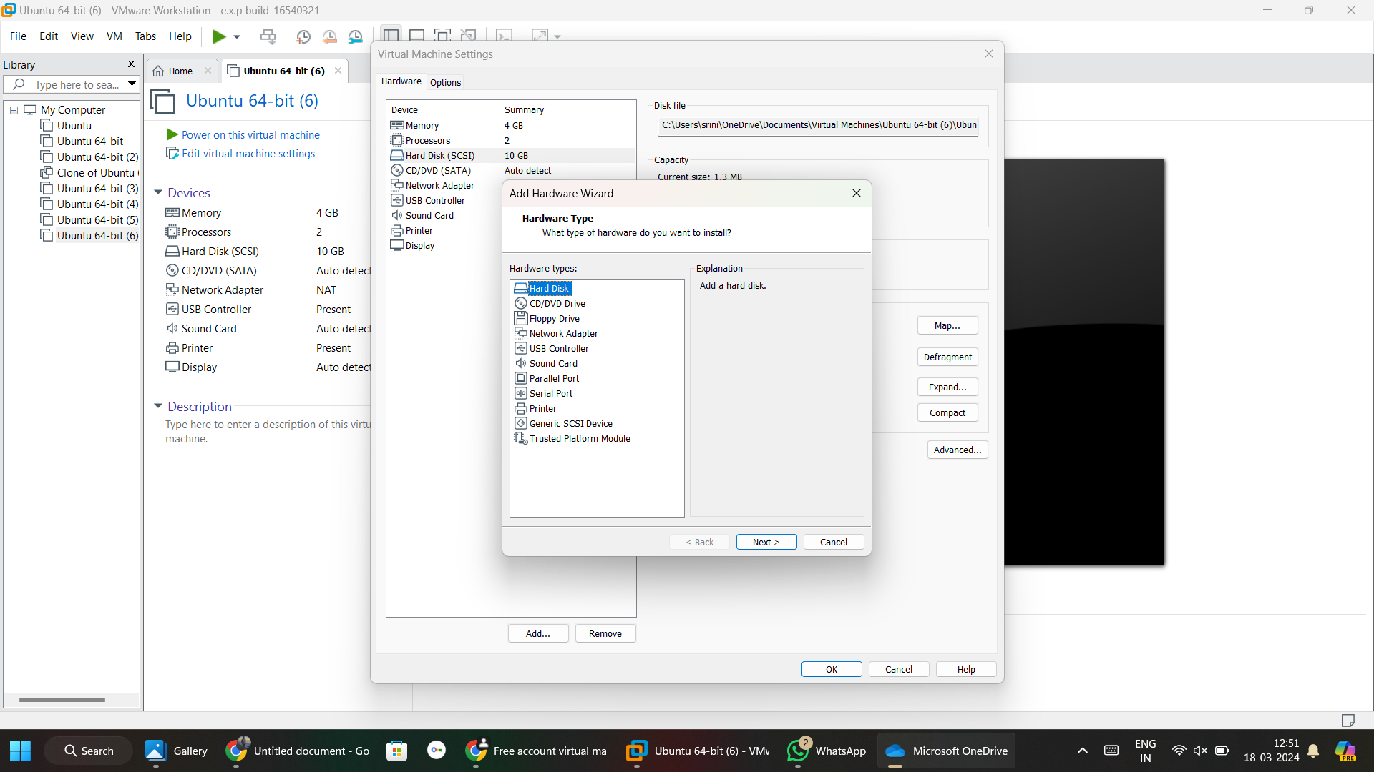

# Select hard disk and click on next, you can see to add another hard disk storage 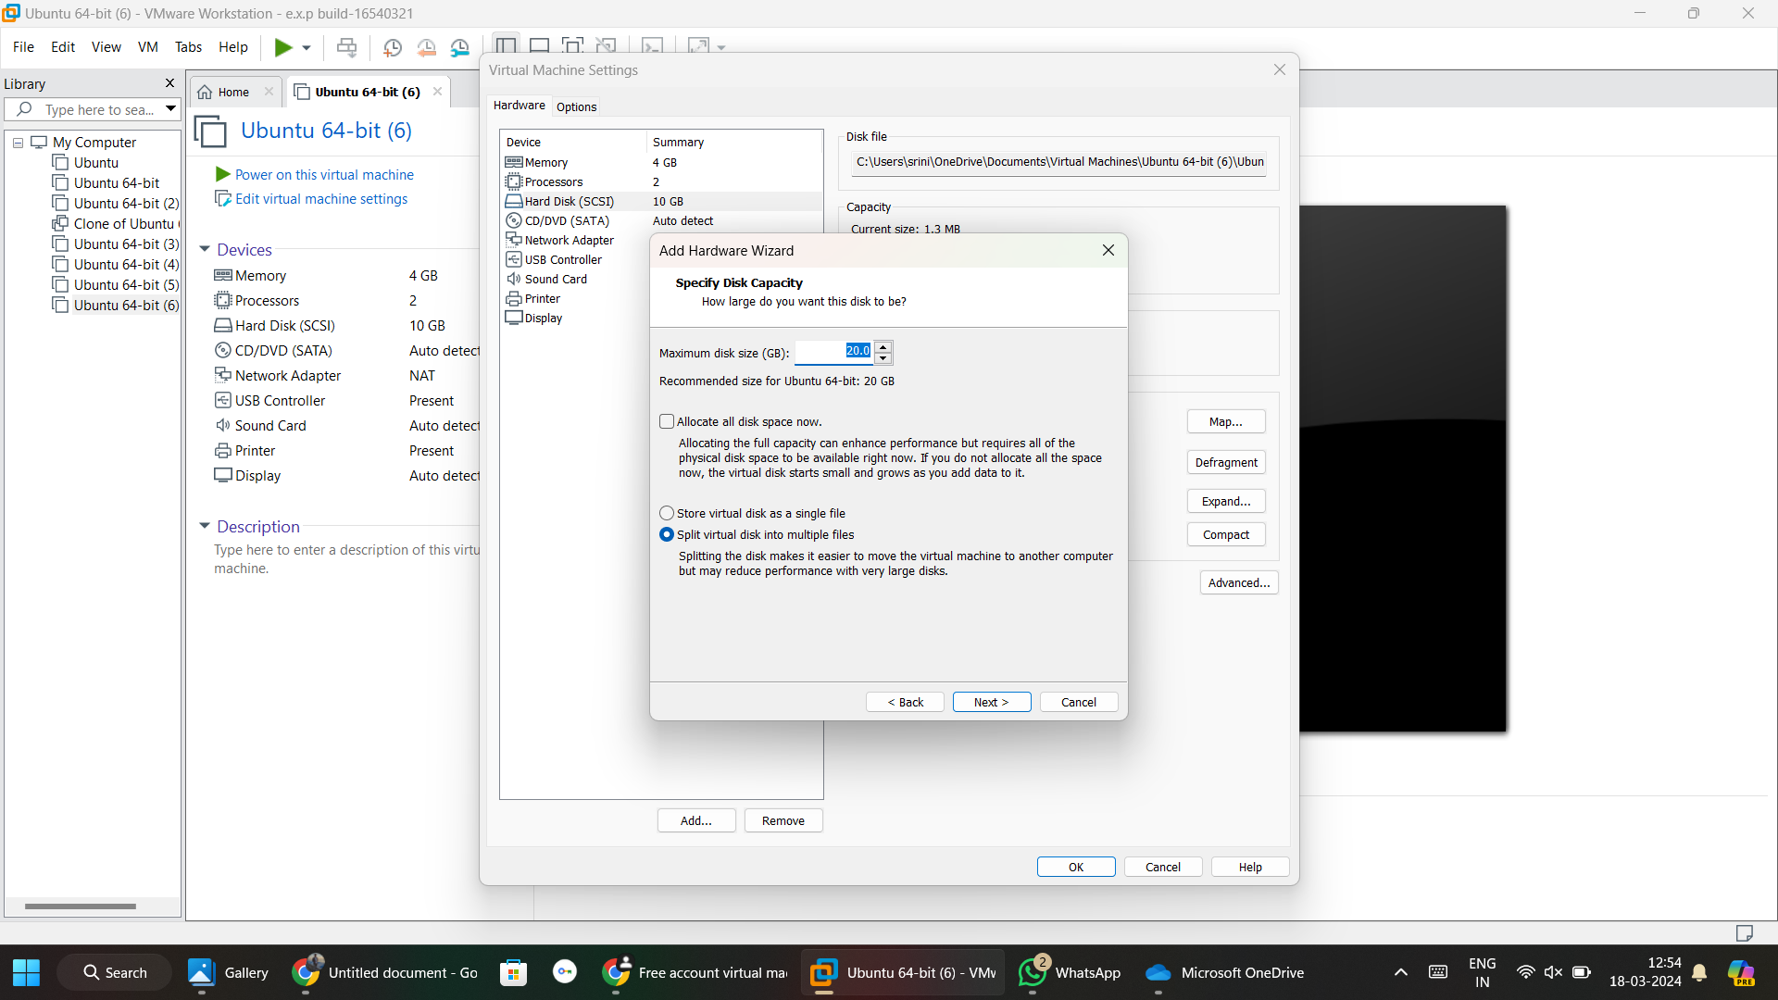

# Additional hard disk added.