Expno-5 MANAGING FILES AND USER PRIVILEGES 917723IT111

AIM:

To execute commands related to managing files and file privileges.

COMMANDS:

1. mkdir- Used to make or create a directory

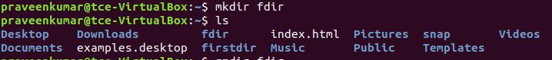

1. rmdir- This command removes an empty directory

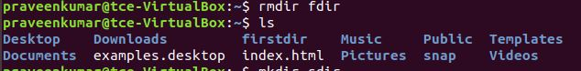

1. rm –r –This command used to remove directories and their contents recursively.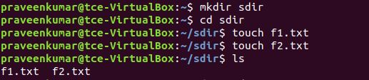

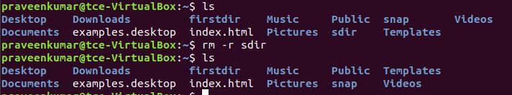

1. mv- This command moves or removes file or directories from source to destination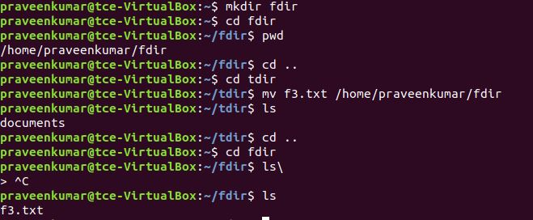
2. cp- This command is used to copy or rename files or directories.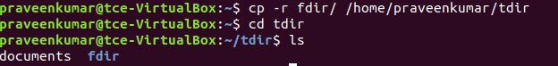
3. chmod a-rwx <filename> - This command is used to deny access to users, groups, others to read, write and execute a file.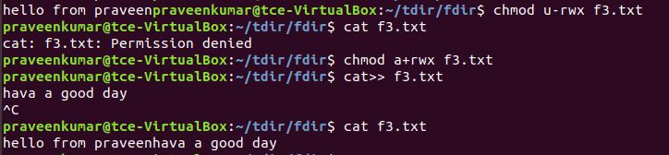
4. chmod 777 <filename> - This command is used to provides access to users, groups, others to read, write and execute a file.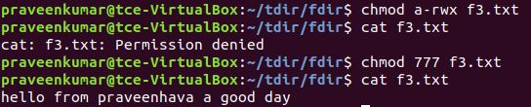
5. chown – This is used to change ownership of file or directory.

RESULT:

The above commands are successfully implemented, executed and verified.