


INDIVIDUAL ASSIGNMENT

LANKA

COMP40004

WEB DEVELOPMENT AND OPERATING SYSTEMS-1
COM2421, COM2422, COM2423, COM2424

HAND OUT DATE: 18th March 2024

HAND IN DATE: ASSIGNMENT2: 20th May 2024

WEIGHTAGE: ASSIGNMENT 2: 30%

INSTRUCTION TO CANDIDATES:

- Students are advised to underpin their answers with the use of references (cited using the Harvard Name System of Referencing).

- Late submission will be awarded zero (0) unless Extenuating Circumstances (EC) are upheld.

- Cases of plagiarism will be penalized

- Assignment presentation should be submitted in the form of softcopy and hardcopy both; modeling work should be submitted in softcopy form

Challenges I faced, how I overcame them and what I learned from this assignment

I had to face several challenges while developing the website. The basic challenge was to decide how to start the project. I did not know if I was to begin by designing the home page or the three product pages. When asked, my friends suggested that I start the process by developing the home page. Therefore, I first began to draw wireframes. It took me three days to complete the wireframes. Afterward, I went on to build the structure. Adding the navigation bar was a very difficult task. In order to overcome the difficulties, I chose to watch a number of YouTube videos about adding a navigation bar. Besides, w3school was also referred to as an aid. The next challenge was concerning the Flex and Grid. Fortunately, our lecturer was generous enough to do a revision of that part. It helped me solve almost all the problems I had about it. Building a mobile compatible website was the most difficult part of the project. Although we had learnt HTML and CSS in school, I did not have any idea about the aspect of mobile responsiveness. I was compelled to change certain places in the code. Apart from that there were some other places where I introduced a different part for the mobile view. On the average I benefited from the YouTube and w3schools website in addressing the issues I had in this regard. My friends helped me to add some styles to the website. The whole exercise was an opportunity for me to learn how to structure a website using HTML and CSS, build a responsive website and design it. In Addition, the task paves the way for me to use technology to overcome problems and manage the time.

Dairy Page - Mobile
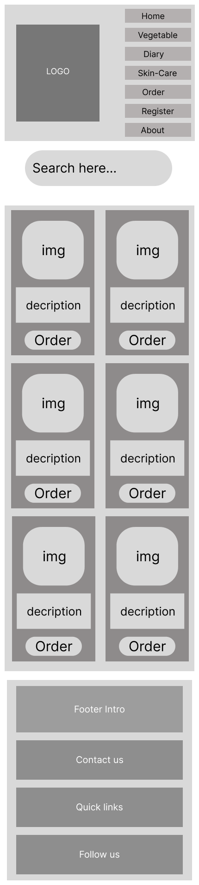

About Us page- Mobile
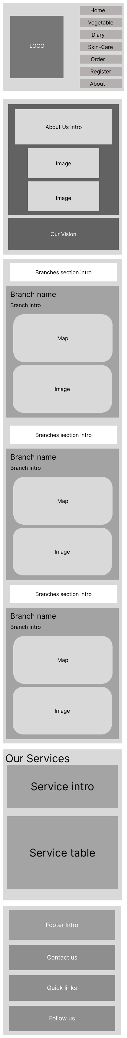
About Us Page - Desktop

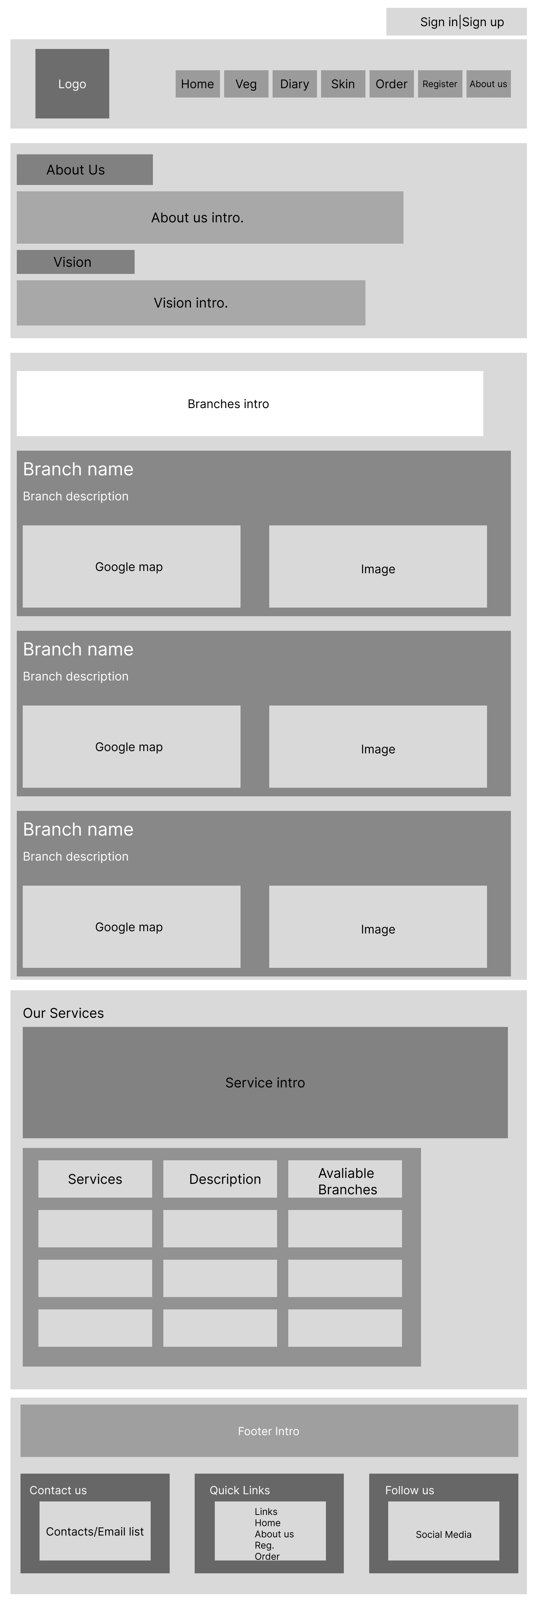

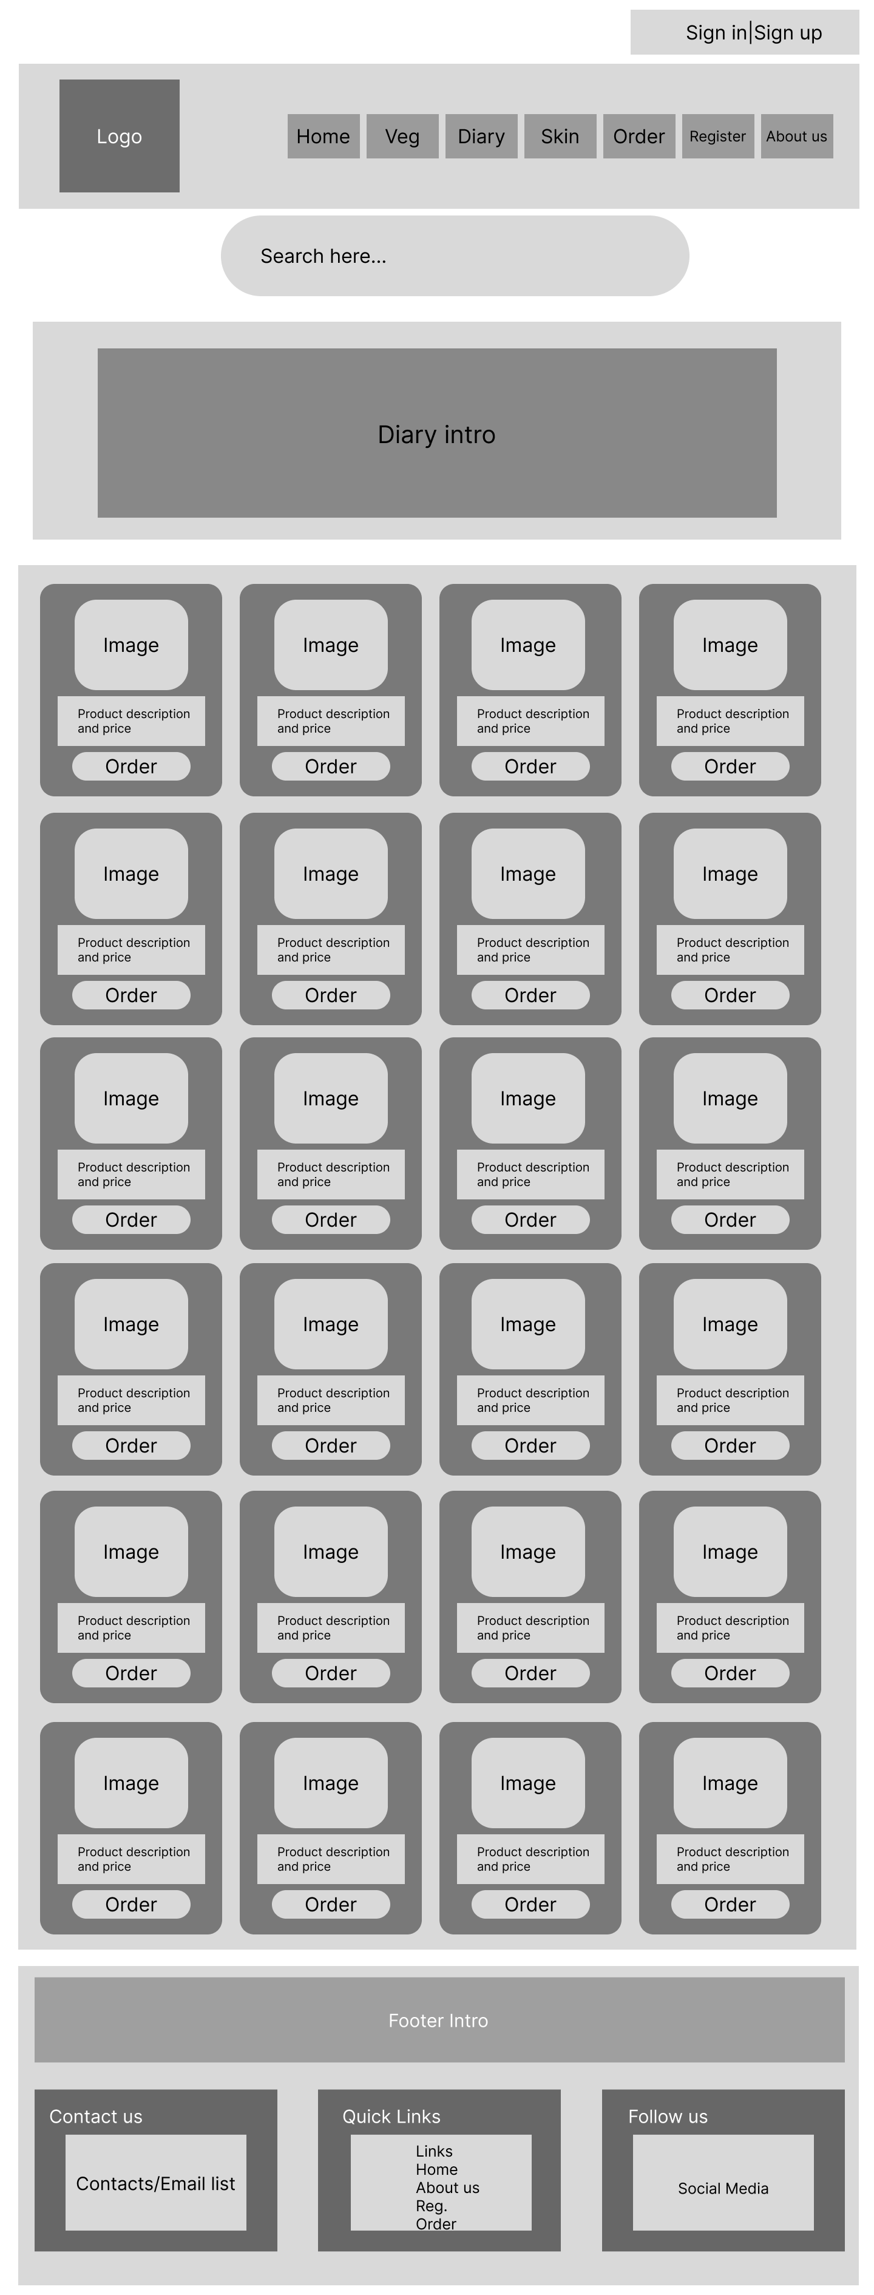
Dairy Page - Desktop

Home Page - Mobile

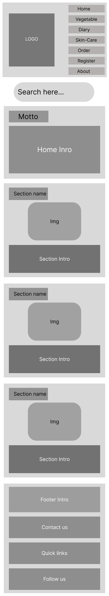

Home Page - Desktop
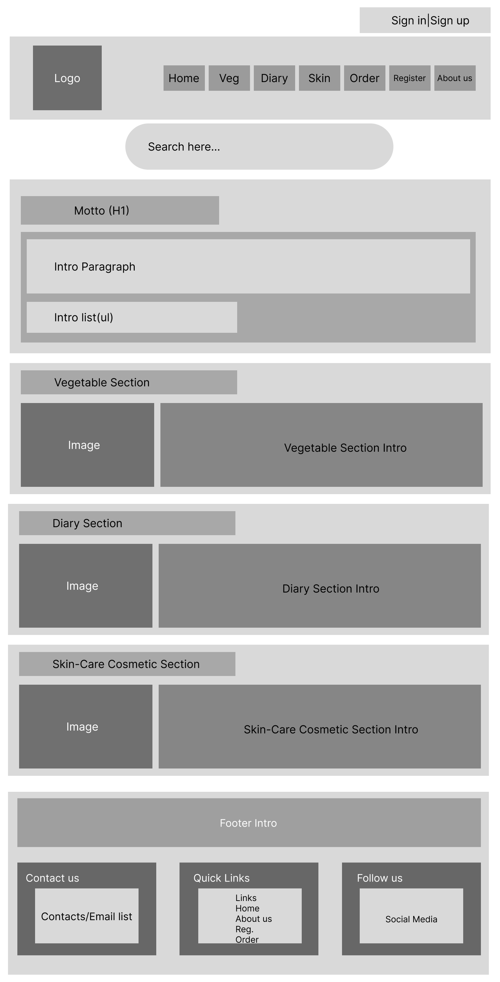

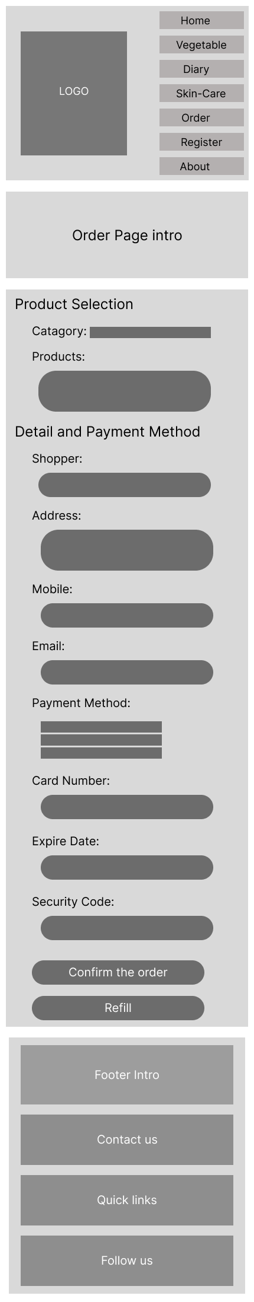
Order Page – Mobile

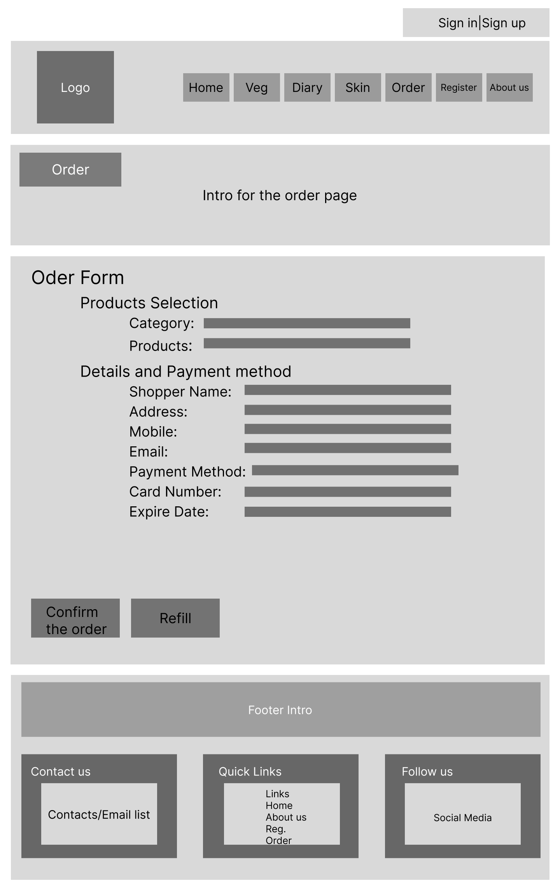
Order Page - Desktop

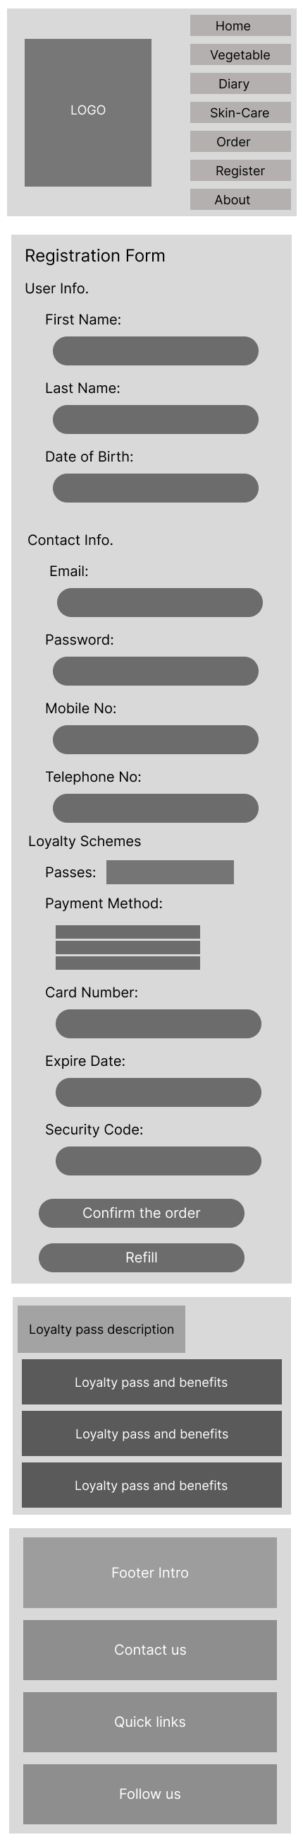
Registration Page – Mobile

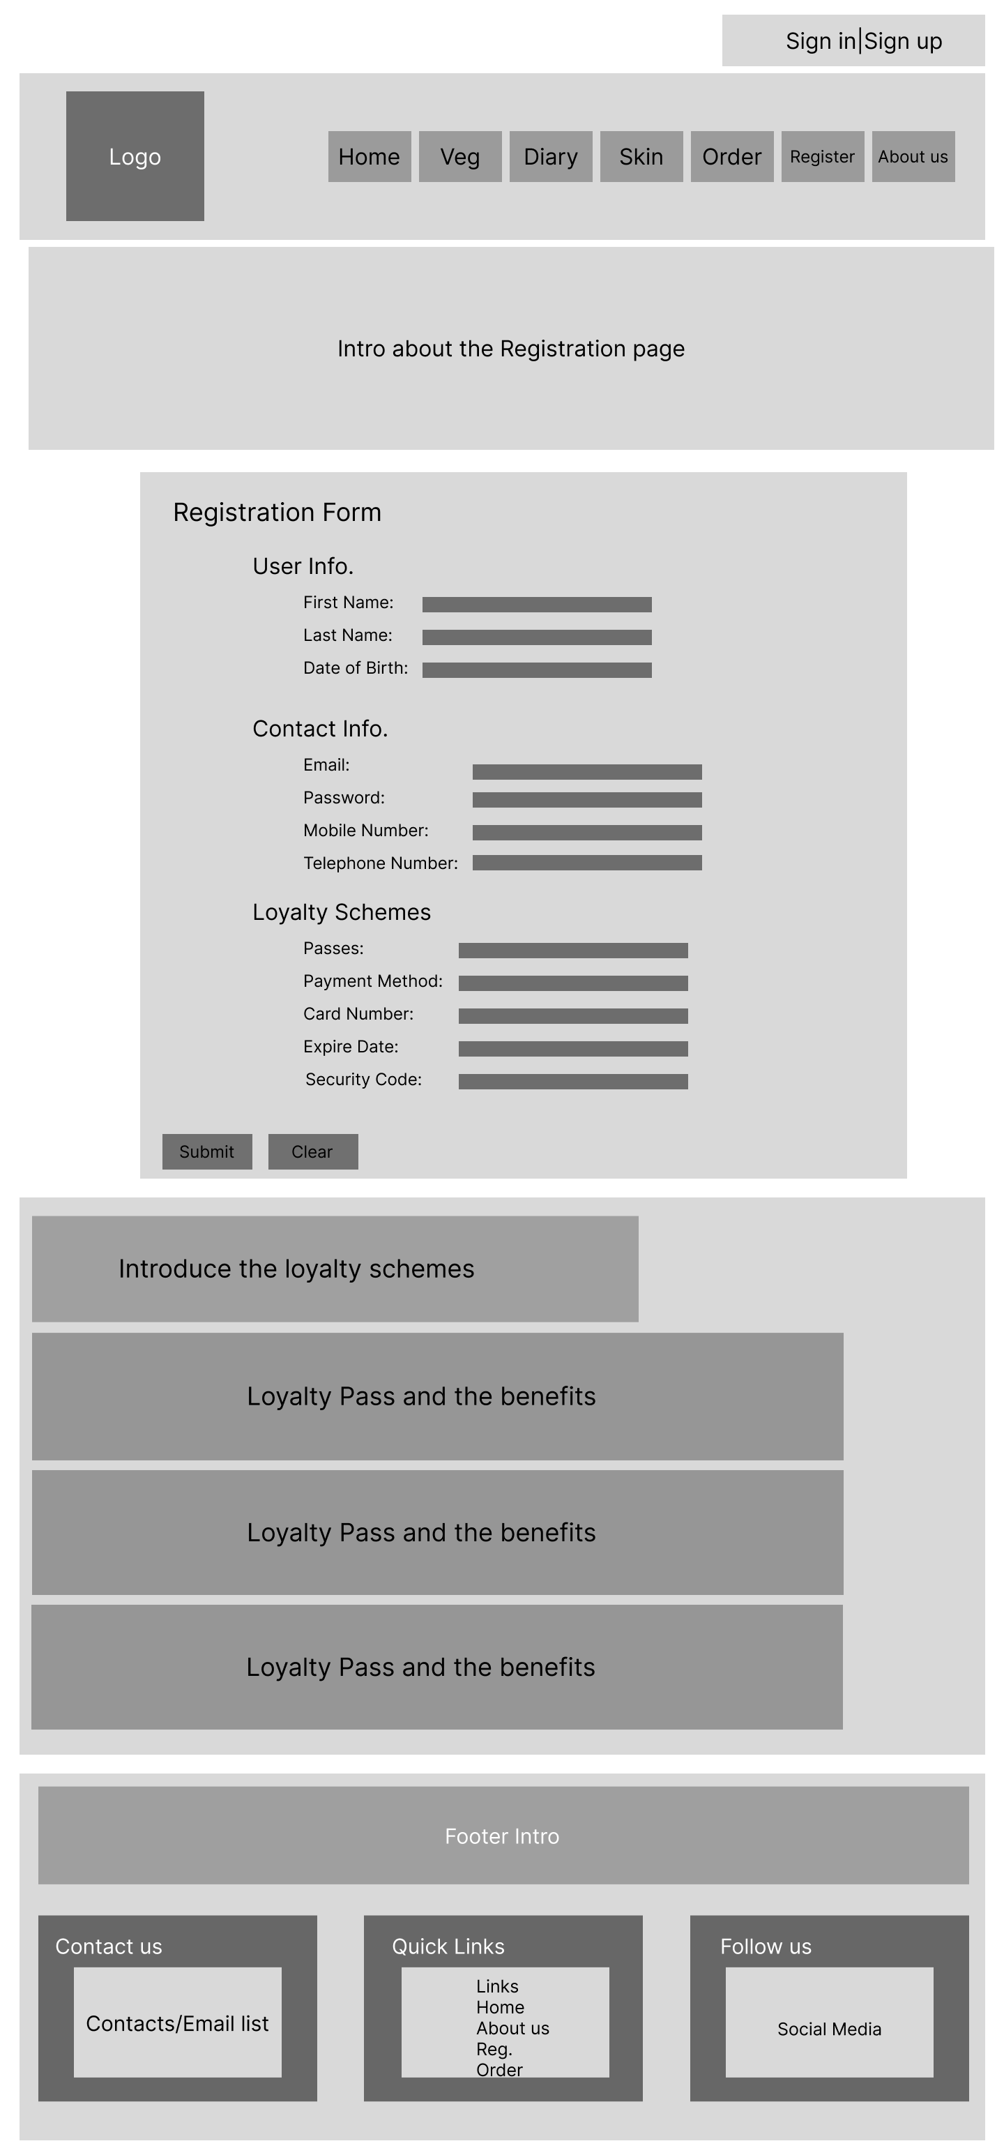
Registration Page - Desktop

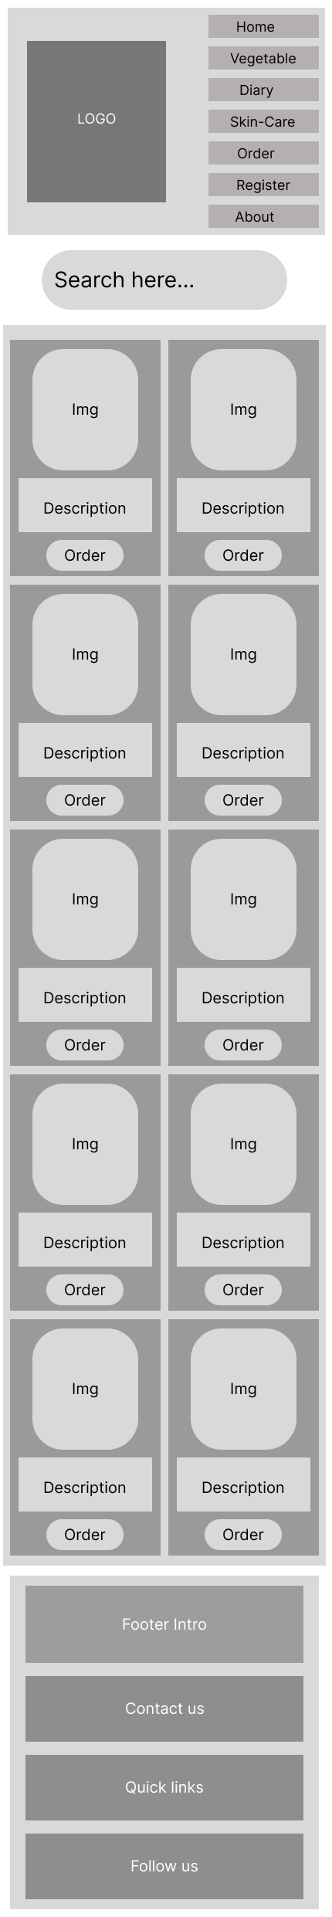
Skin-care Page – Mobile

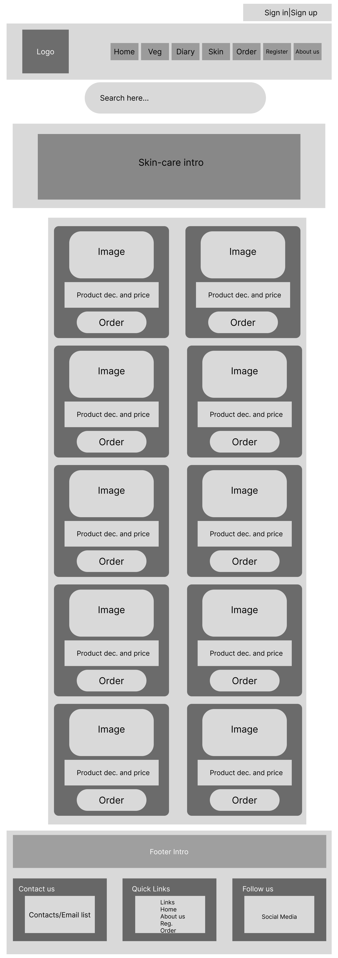
Skin-Care Page - Desktop

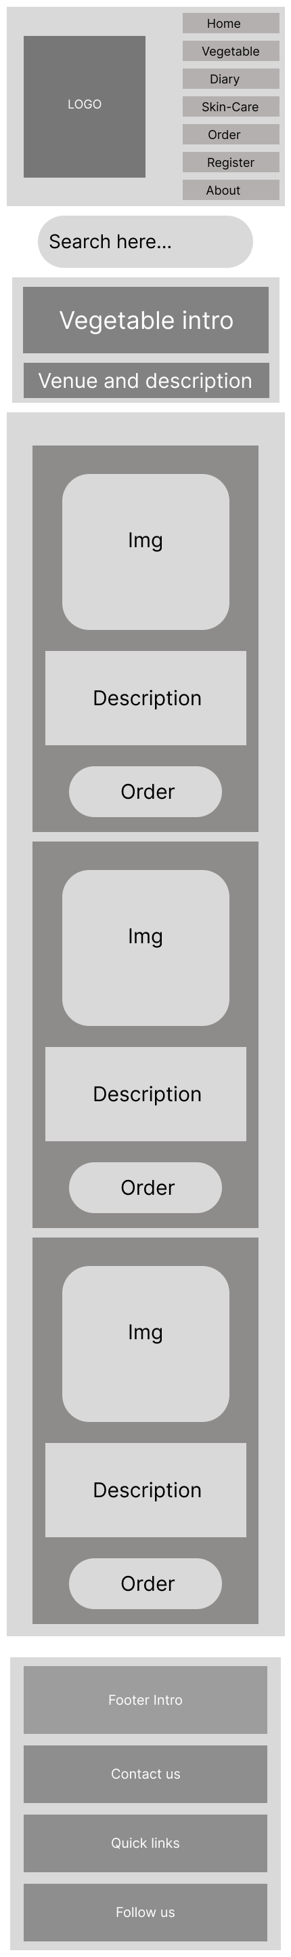
Vegetable Page – Mobile

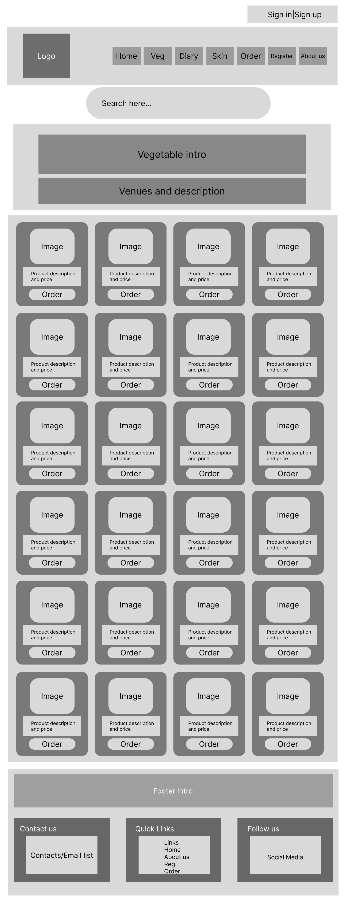
Vegetable Page - Desktop

