Playwright Automation Report - OTCS

Distributed Agent Status
Distributed Agent | Primary | Last Update | Status
DAAgent_otcsvm_2099_1 | Yes | 03/31/2026 02:34 AM | Running

Enterprise Partition Map Status
Partition 1 State: Normal
Enterprise Update Distributor: Running
Enterprise Search Federator: Running

Step: Navigate to Distributed Agent Status
Result: Navigated to http://otcsvm.otxlab.net:8080/OTCS/cs.exe?func=distributedagent.AgentStatus
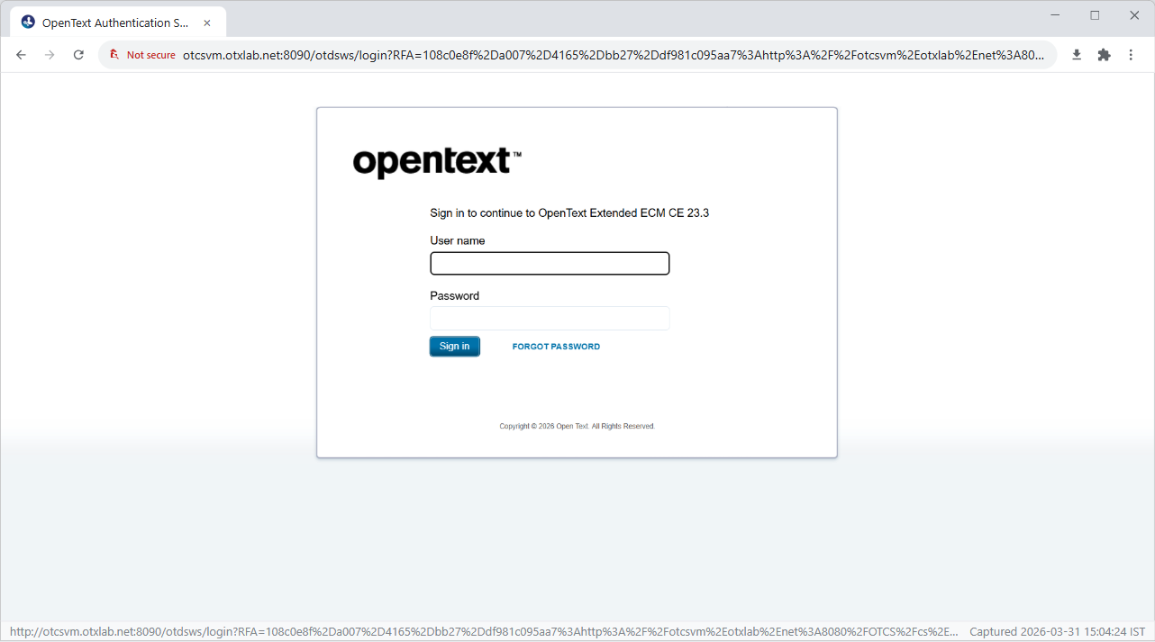

Step: Login
Result: Successfully logged in.
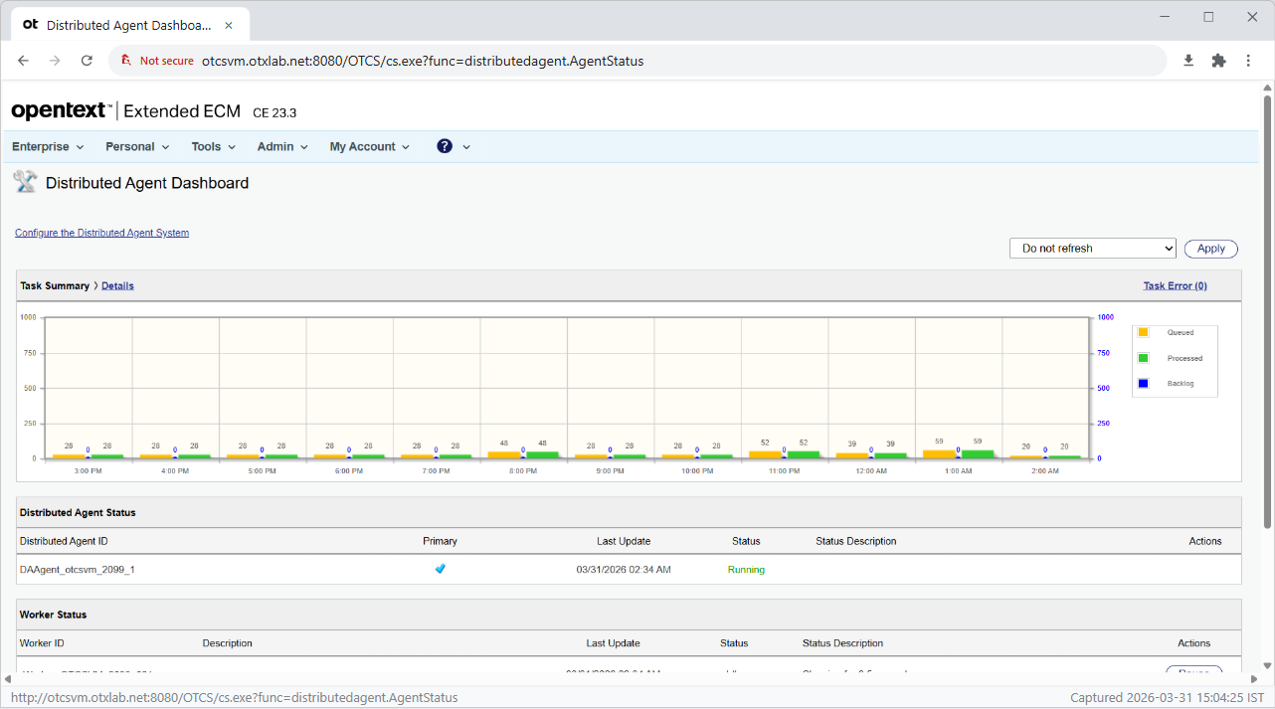

Step: Extract Distributed Agent Status
Result: Extracted 1 distributed agents.
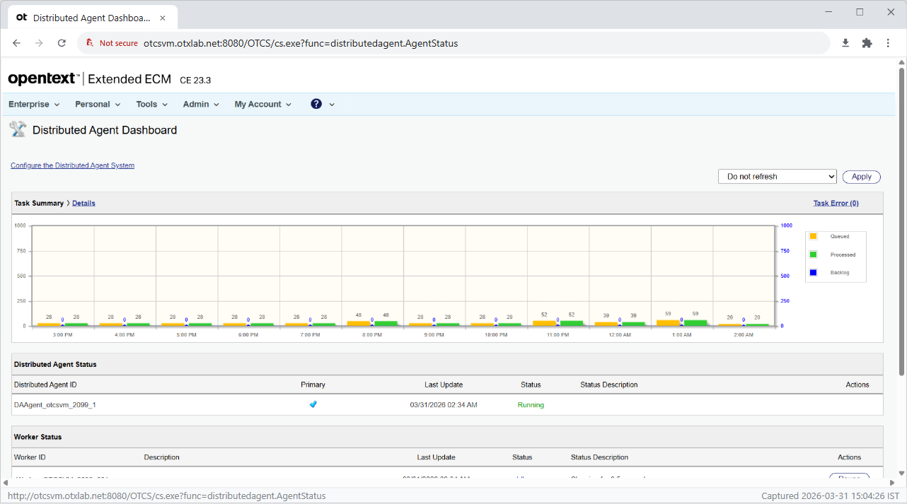

Step: Navigate to Enterprise Partition Map
Result: Navigated to http://otcsvm.otxlab.net:8080/OTCS/cs.exe?func=ll&objId=2539&objAction=browse&viewType=1
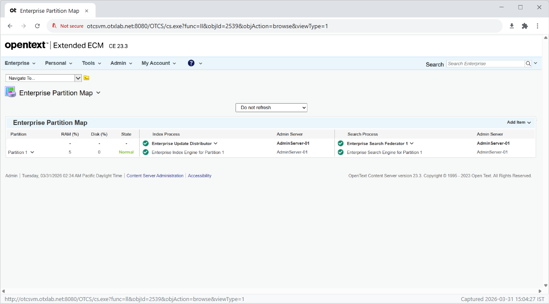

Step: Extract Enterprise Partition Map Status
Result: Partition State: Normal, Update Distributor: Running, Search Federator: Running
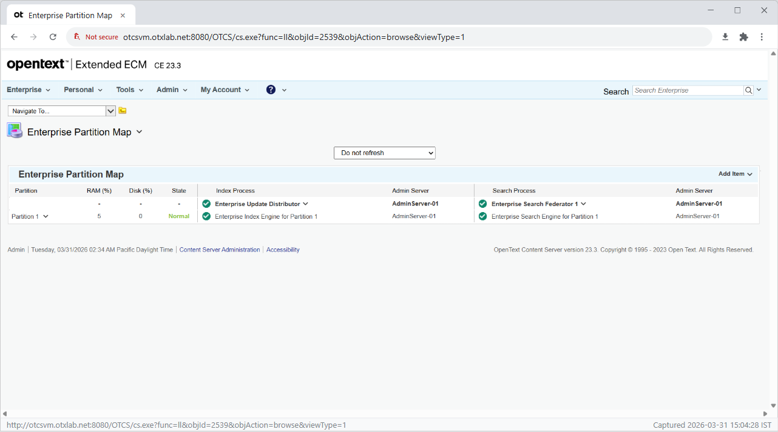

Step: Navigate to Admin Servers List
Result: Navigated to http://otcsvm.otxlab.net:8080/OTCS/cs.exe?func=ll&objtype=148&objaction=browse
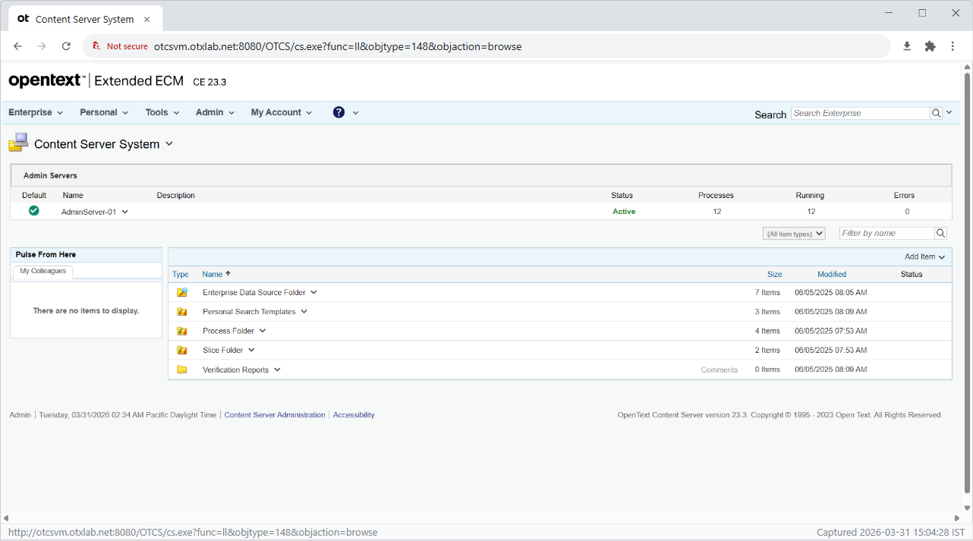

Step: Open Action Menu for AdminServer-01
Result: Opened action menu for 'AdminServer-01'.
