OTCS Folder Creation and Bulk Upload Report
Report generated on: 2026-03-31 15:06:18
Target URL: http://otcsvm.otxlab.net:8080/OTCS/cs.exe/app/nodes/2004
Created Folder Name: Upload_Test_20260331_150532
Uploaded from Directory: C:\Users\pnandank\Downloads\OTCS_Upload_Test

Execution Summary
Step | Action | Result
1 | Navigate to OTCS Base URL | Navigated to http://otcsvm.otxlab.net:8090/otdsws/login?RFA=108c0e8f%2Da007%2D4165%2Dbb27%2Ddf981c095aa7%3Ahttp%3A%2F%2Fotcsvm%2Eotxlab%2Enet%3A8080%2FOTCS%2Fcs%2Eexe%3Ffunc%3Dotdsintegration%2Eredirect%26NextURL%3Dhttp%253A%252F%252Fotcsvm%252Eotxlab%252Enet%253A8080%252FOTCS%252Fcs%252Eexe%252Fapp%252Fnodes%252F2004&PostTicket=true&PostParams=true&ux_version=2&PreserveFragment=true&logon_style=signin-cs&logon_appname=OpenText%20Extended%20ECM%20CE%2023%2E3
2 | Login to OTCS | Successfully logged in.
3 | Click Add Item Button | Add item menu opened.
4 | Select 'Folder' | Folder creation form displayed.
5 | Create Folder 'Upload_Test_20260331_150532' | Folder created and verified in list.
6 | Sort by 'Modified' Column | Table sorted. Current URL: http://otcsvm.otxlab.net:8080/OTCS/cs.exe/app/nodes/2004?order_by=modify_date_desc
7 | Enter Folder 'Upload_Test_20260331_150532' | Navigated into folder: http://otcsvm.otxlab.net:8080/OTCS/cs.exe/app/nodes/63475
8 | Click Add Item Button (inside new folder) | Add item menu opened.
9 | Select 'Document' | Document upload dialog/file chooser initiated.
10 | Upload Files Triggered | Files set. Count: 5
11 | Bulk Upload Files | Successfully uploaded 5 files.

Step Screenshots

Step 1: Navigate to OTCS Base URL
Result: Navigated to http://otcsvm.otxlab.net:8090/otdsws/login?RFA=108c0e8f%2Da007%2D4165%2Dbb27%2Ddf981c095aa7%3Ahttp%3A%2F%2Fotcsvm%2Eotxlab%2Enet%3A8080%2FOTCS%2Fcs%2Eexe%3Ffunc%3Dotdsintegration%2Eredirect%26NextURL%3Dhttp%253A%252F%252Fotcsvm%252Eotxlab%252Enet%253A8080%252FOTCS%252Fcs%252Eexe%252Fapp%252Fnodes%252F2004&PostTicket=true&PostParams=true&ux_version=2&PreserveFragment=true&logon_style=signin-cs&logon_appname=OpenText%20Extended%20ECM%20CE%2023%2E3
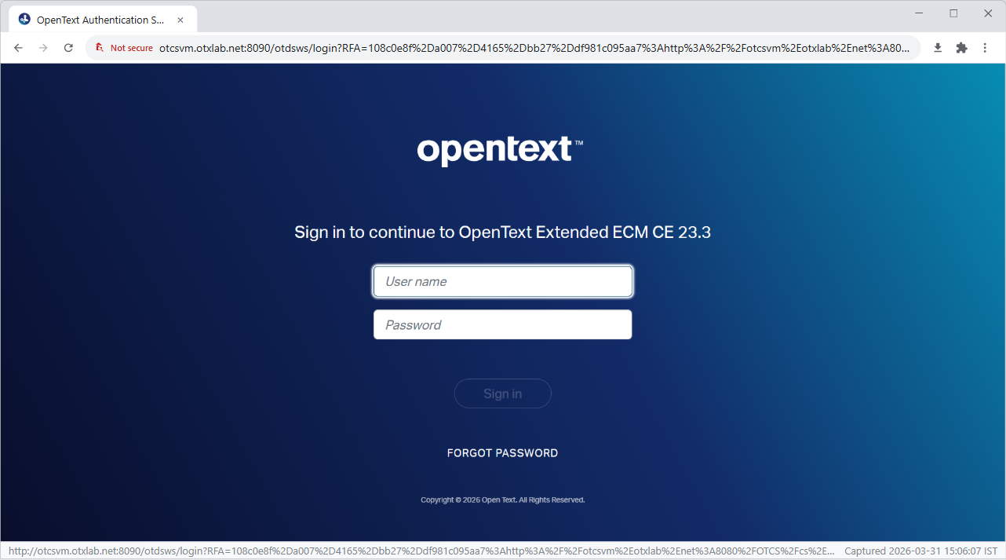

Step 2: Login to OTCS
Result: Successfully logged in.
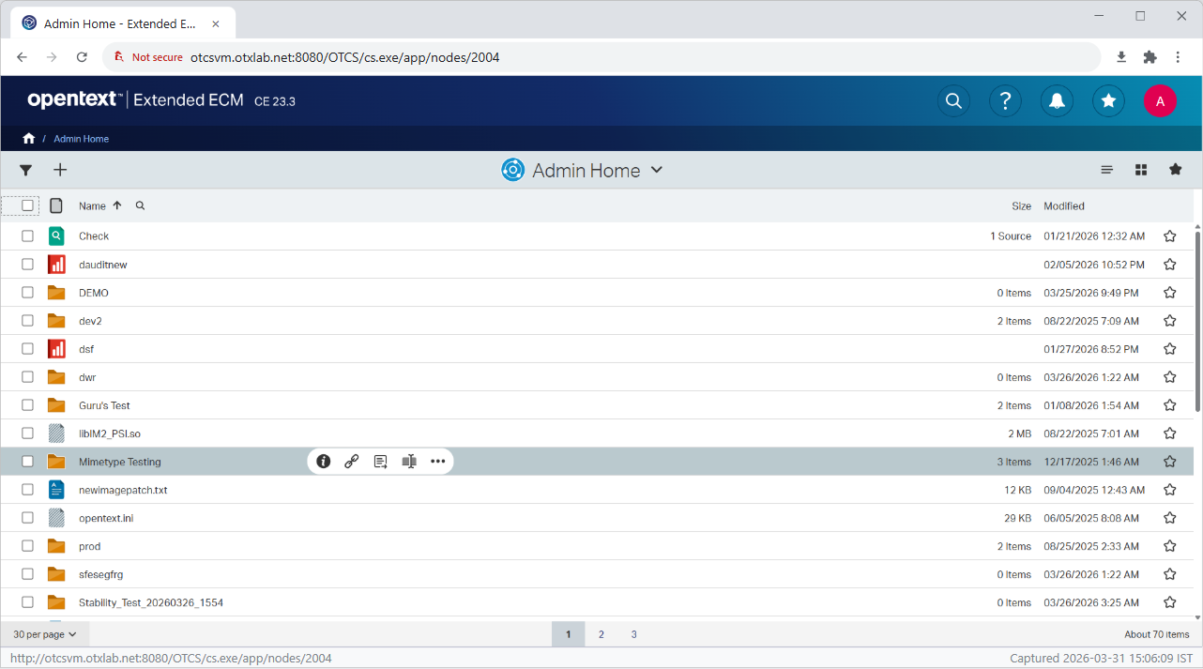

Step 3: Click Add Item Button
Result: Add item menu opened.
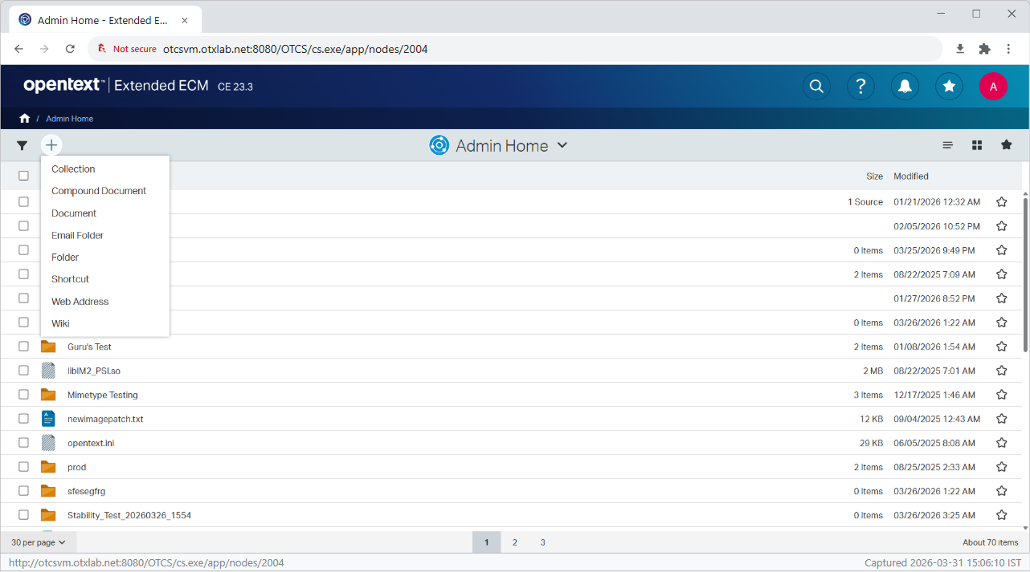

Step 4: Select 'Folder'
Result: Folder creation form displayed.
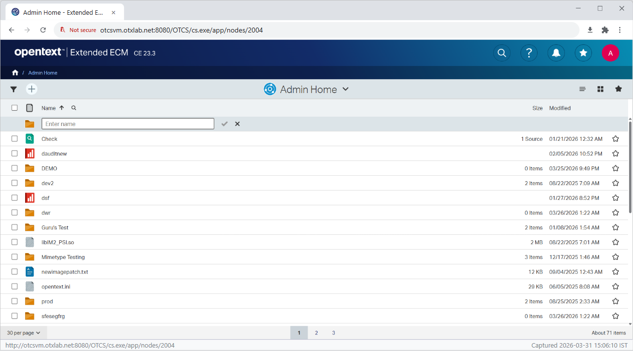

Step 5: Create Folder 'Upload_Test_20260331_150532'
Result: Folder created and verified in list.
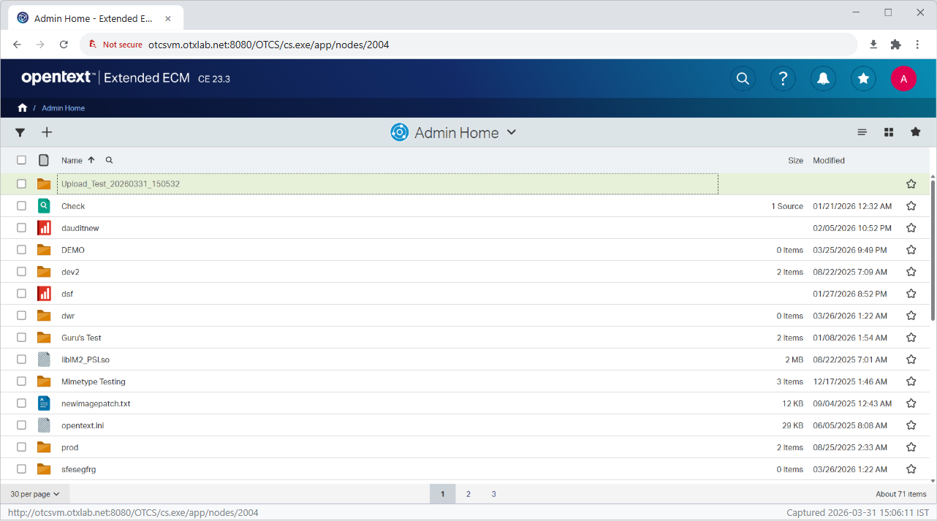

Step 6: Sort by 'Modified' Column
Result: Table sorted. Current URL: http://otcsvm.otxlab.net:8080/OTCS/cs.exe/app/nodes/2004?order_by=modify_date_desc
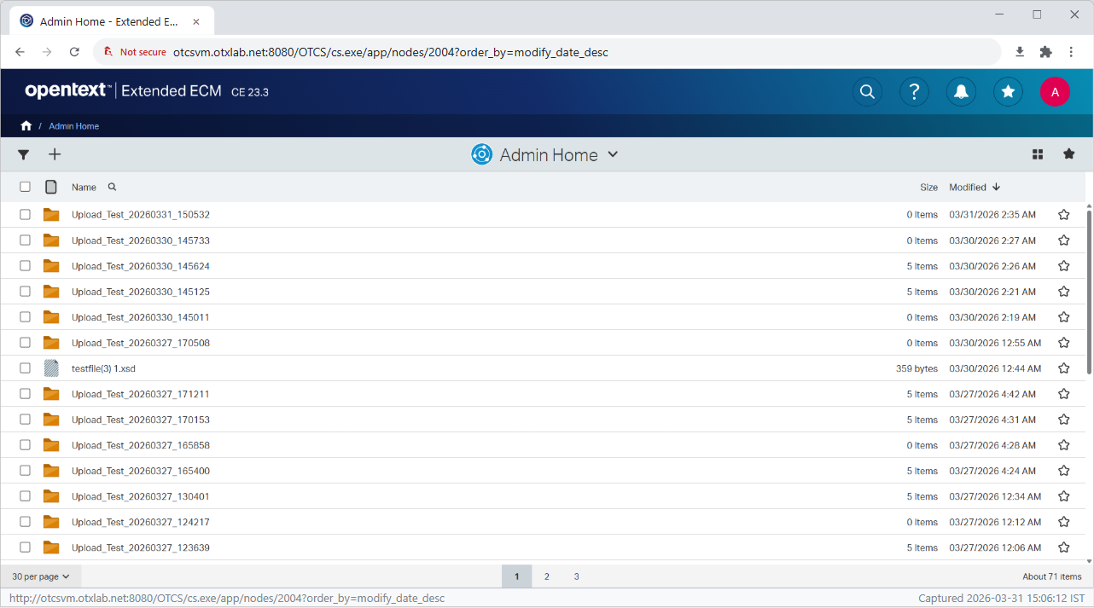

Step 7: Enter Folder 'Upload_Test_20260331_150532'
Result: Navigated into folder: http://otcsvm.otxlab.net:8080/OTCS/cs.exe/app/nodes/63475
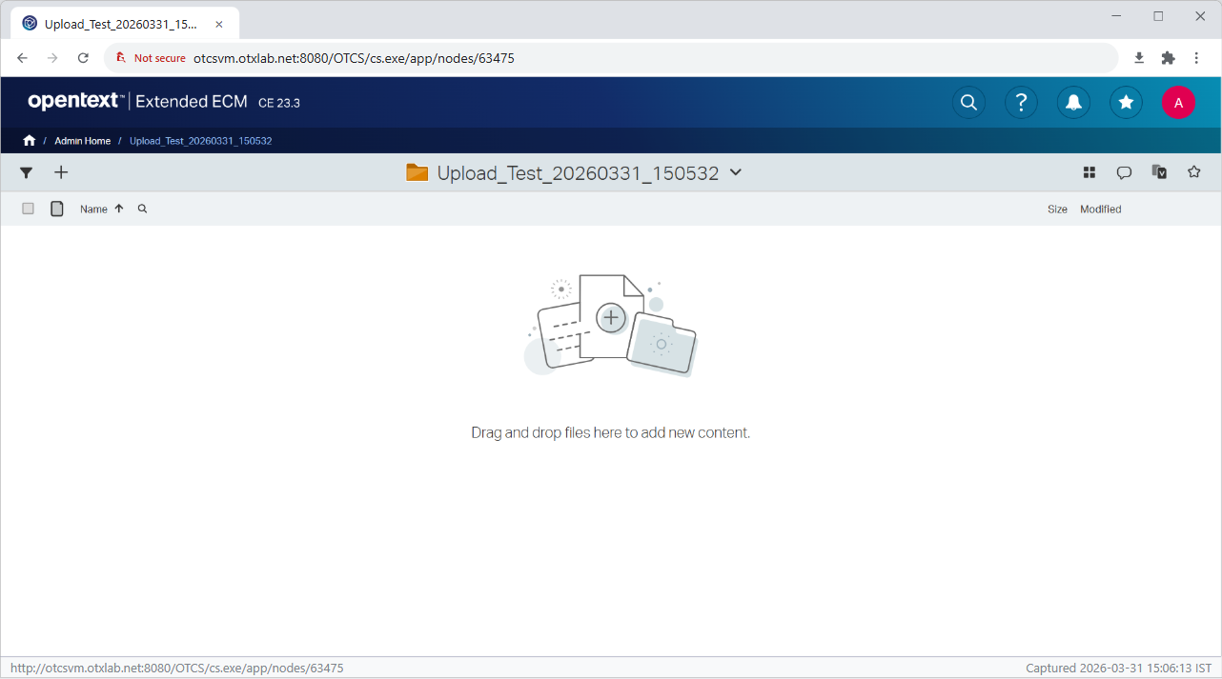

Step 8: Click Add Item Button (inside new folder)
Result: Add item menu opened.
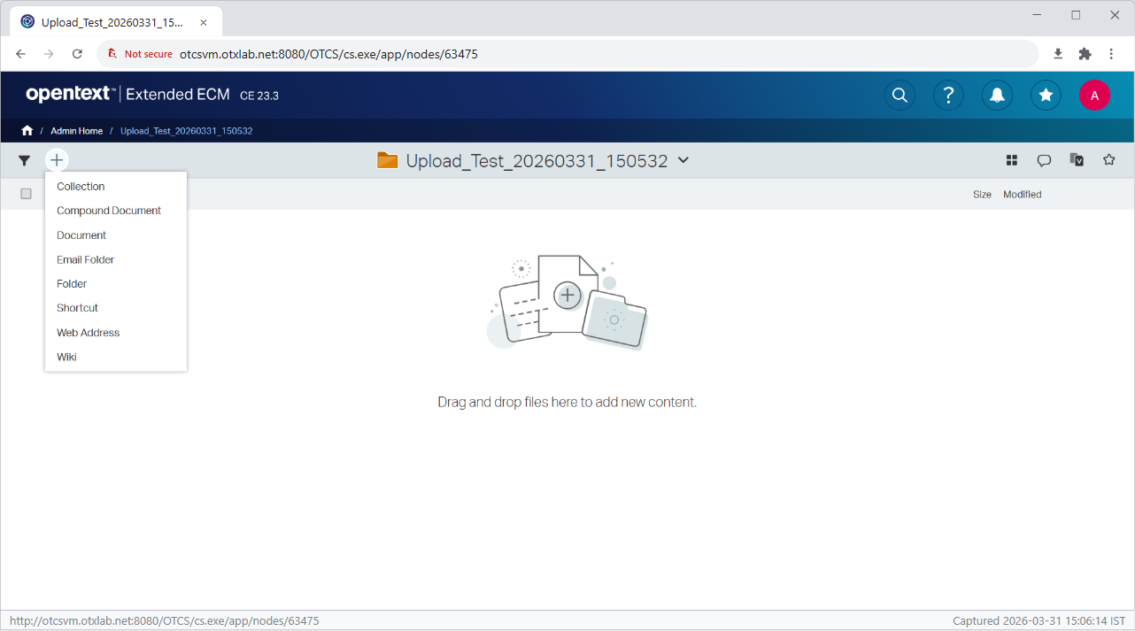

Step 9: Select 'Document'
Result: Document upload dialog/file chooser initiated.
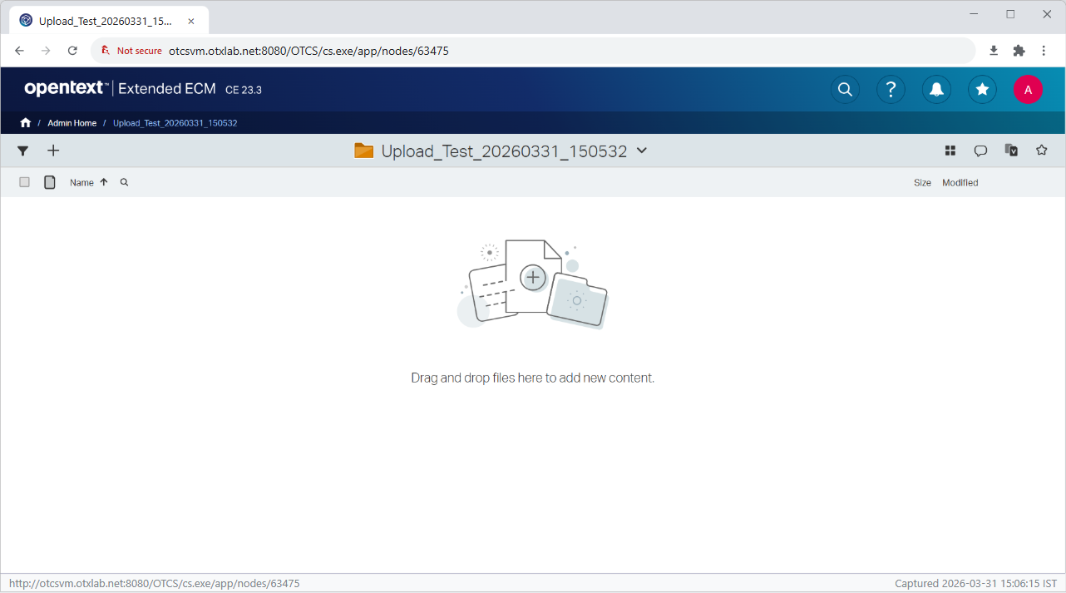

Step 10: Upload Files Triggered
Result: Files set. Count: 5
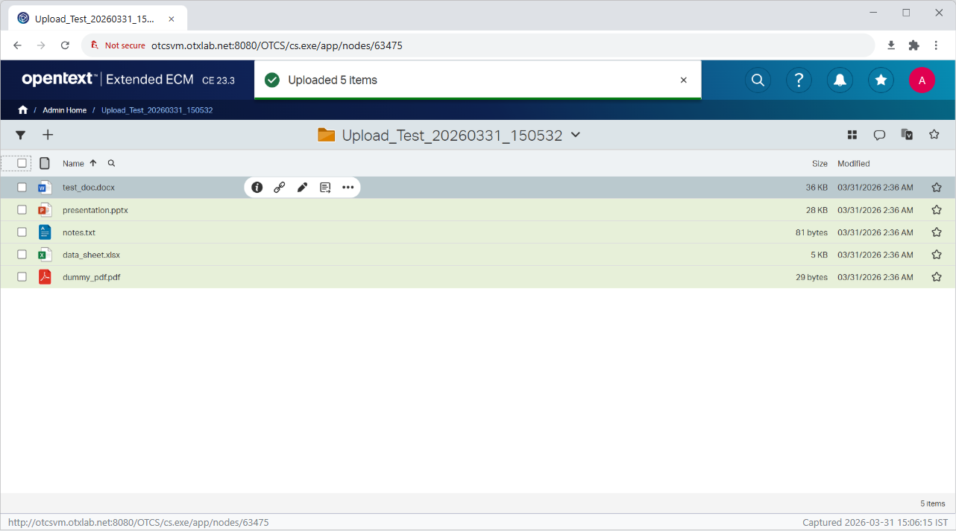

Step 11: Bulk Upload Files
Result: Successfully uploaded 5 files.
