Automation Report: IAWA Storage Usage Extraction

Navigating to OTDS and logging in
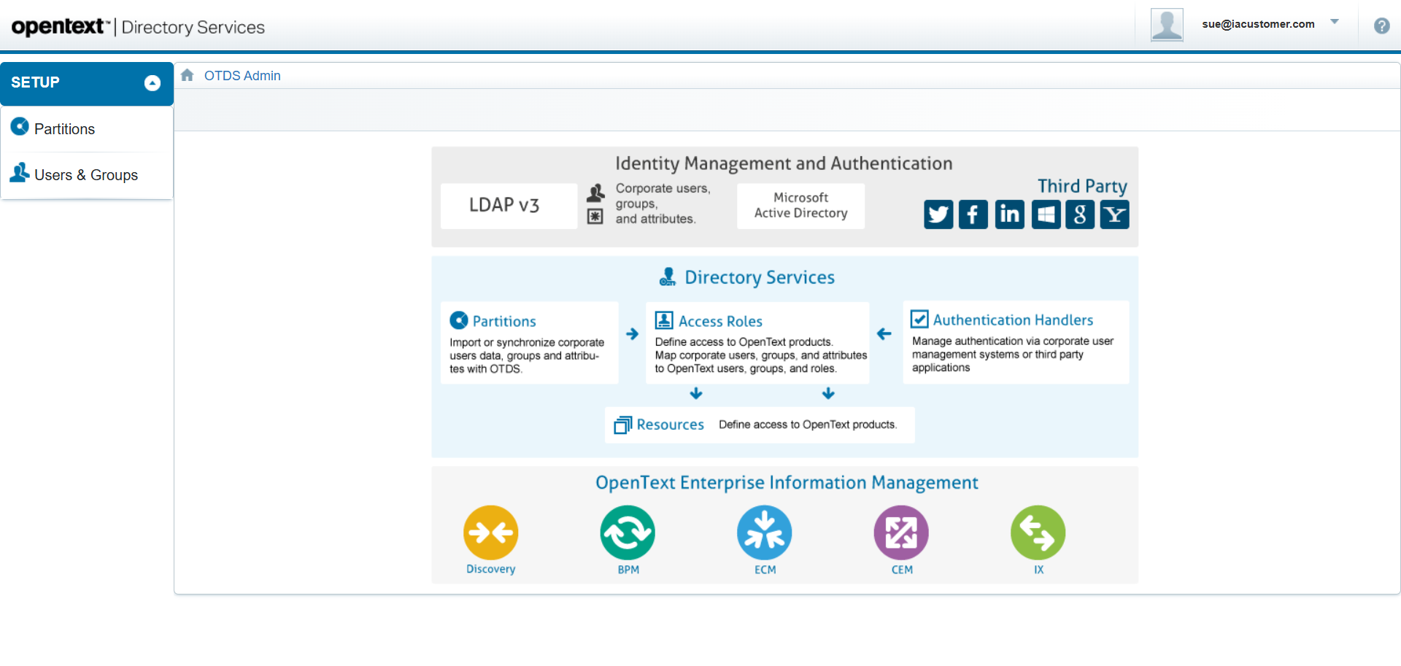

Navigating to IAWA
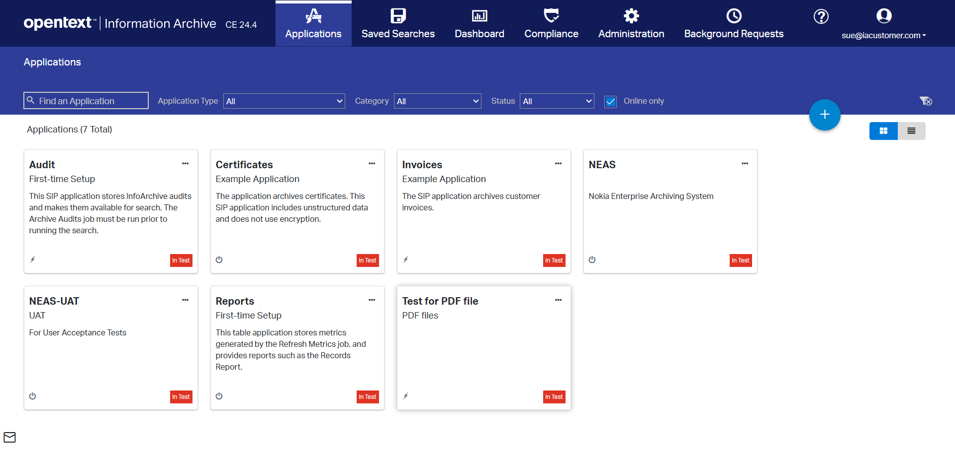

Clicking 'Dashboard' menu item
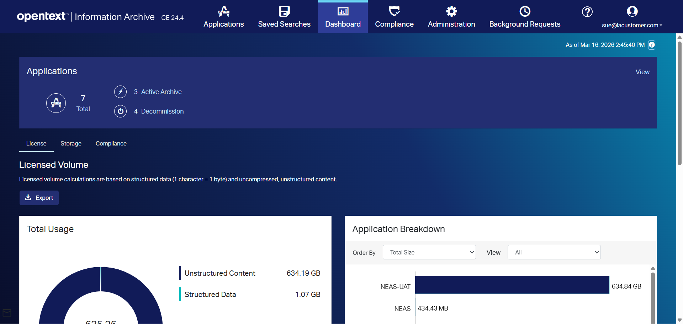

Clicking 'Storage' sub-menu item
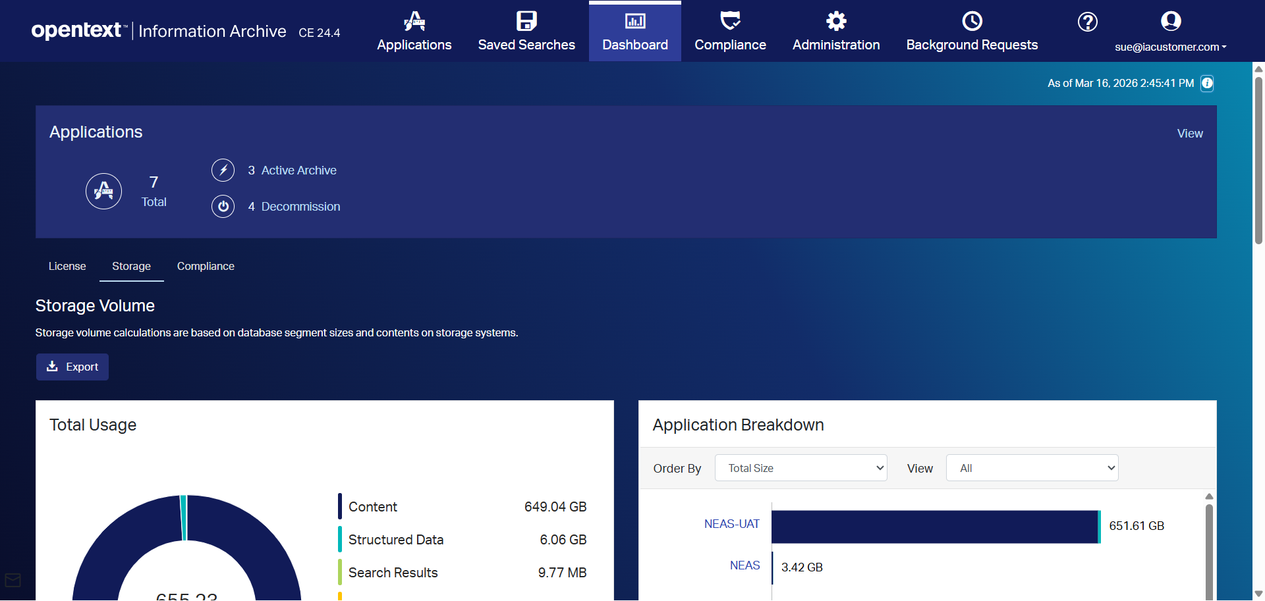

Extracting Total Usage from pie chart


Summary of Navigation Steps
Step Description | Screenshot
Navigating to OTDS and logging in | See above
Navigating to IAWA | See above
Clicking 'Dashboard' menu item | See above
Clicking 'Storage' sub-menu item | See above
Extracting Total Usage from pie chart | See above

Extracted Data
Metric | Value
Total Usage | 651.61 GB

