OTCS Agent Status and Admin Server Report

Execution Summary
Step | Action | Result
1 | Navigate to Base URL | Navigated to http://otcsvm.otxlab.net:8080/OTCS/cs.exe
2 | Fill Login Credentials | Username and password fields filled.
3 | Click Login Button | Login button clicked. Redirected to authenticated page.
4 | Navigate to Distributed Agent Status | Navigated to http://otcsvm.otxlab.net:8080/OTCS/cs.exe?func=distributedagent.AgentStatus
5 | Scroll Page Down | Scrolled down by 500px.
6 | Scroll Page Down Again | Scrolled down by 500px again.
7 | Extract Distributed Agent Statuses | Extracted 8 agent statuses. Needs reconfiguration: True
8 | Click Configure Distributed Agent System | Navigated to configuration page.
9 | Select Agent for Reconfiguration | Selected radio button for agent ID:
10 | No Agent Selected for Reconfiguration | No non-running agent found to select for reconfiguration.
11 | Return to Agent Status Page | Returned to agent status page after reconfiguration.
12 | Verify Reconfiguration | Some agents are still not 'Running' after reconfiguration.
13 | Navigate to Admin Servers | Navigated to http://otcsvm.otxlab.net:8080/OTCS/cs.exe?func=ll&objtype=148&objaction=browse
14 | Open Action Menu for AdminServer-01 | Action menu opened successfully.

Distributed Agent Status
Distributed Agent ID | Status
 | Processed
 | 03/17/2026 01:34 AM
 | Running
 | 03/17/2026 01:34 AM
 | Idle
 | Worker_OTCSVM_2099_002
Reconfiguration performed: No
AdminServer-01 action menu opened: Yes

Step Screenshots

Step 1: Navigate to Base URL
Result: Navigated to http://otcsvm.otxlab.net:8080/OTCS/cs.exe
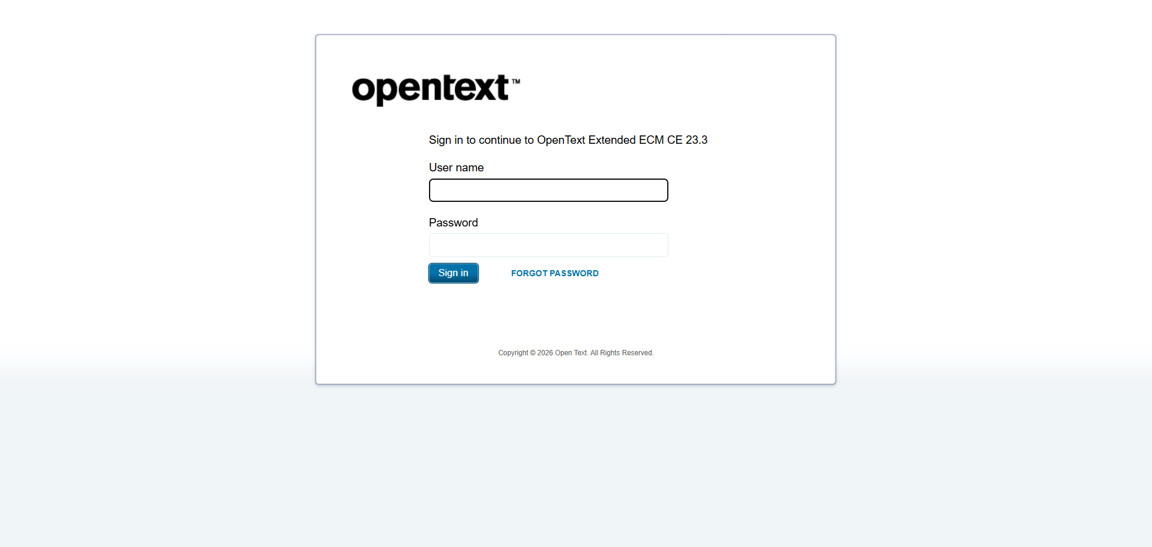

Step 2: Fill Login Credentials
Result: Username and password fields filled.
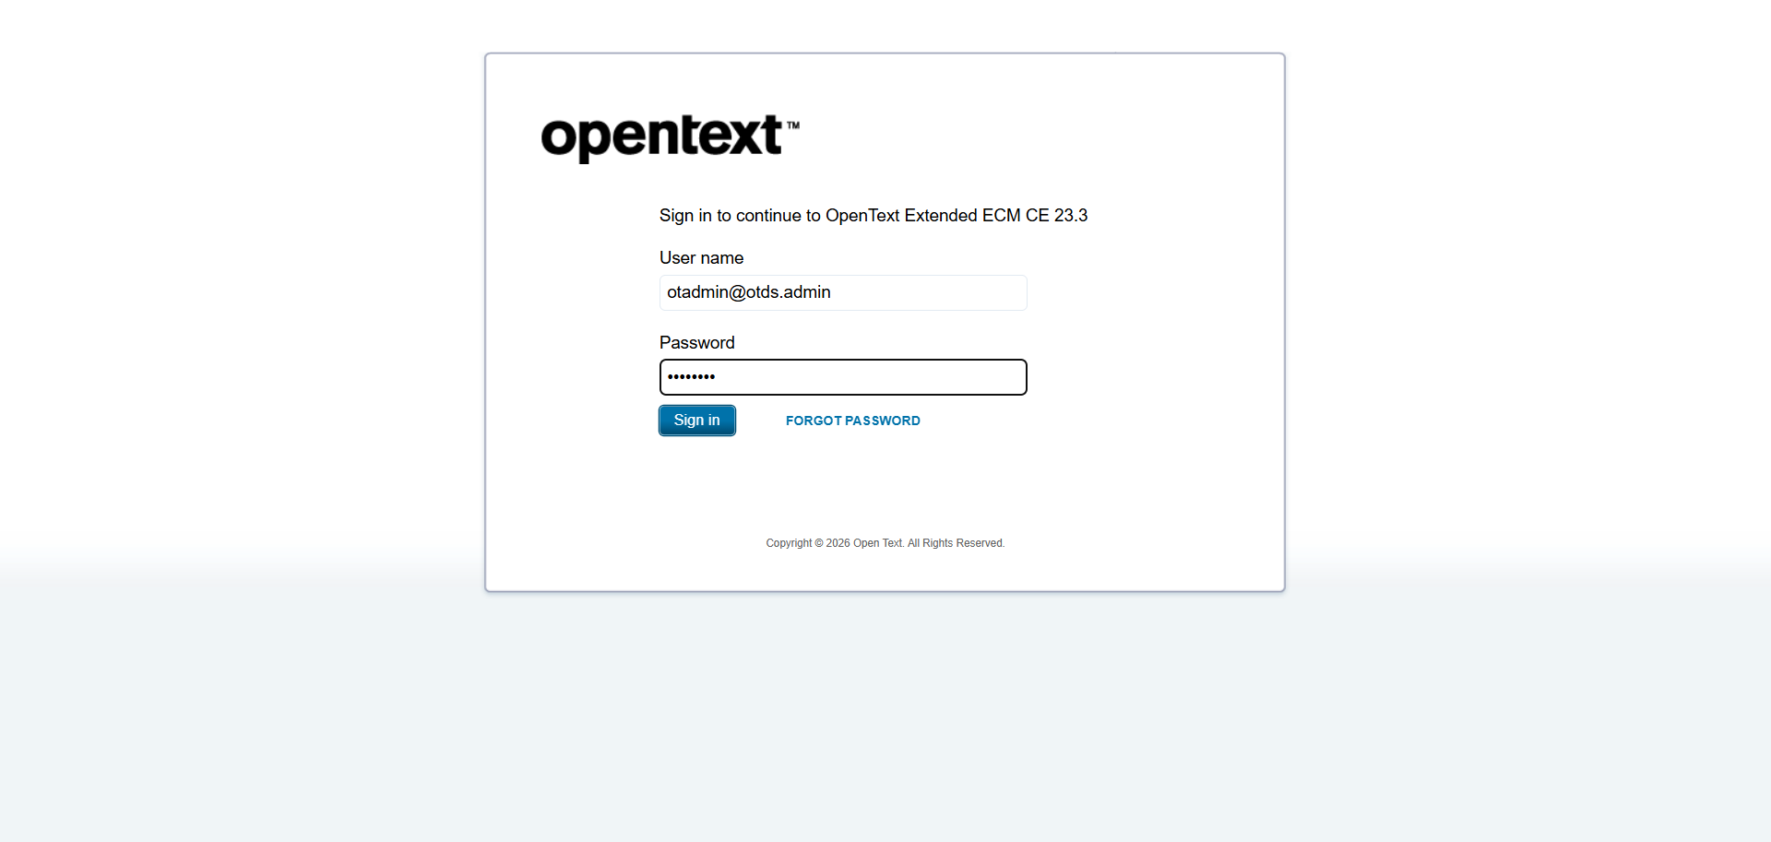

Step 3: Click Login Button
Result: Login button clicked. Redirected to authenticated page.
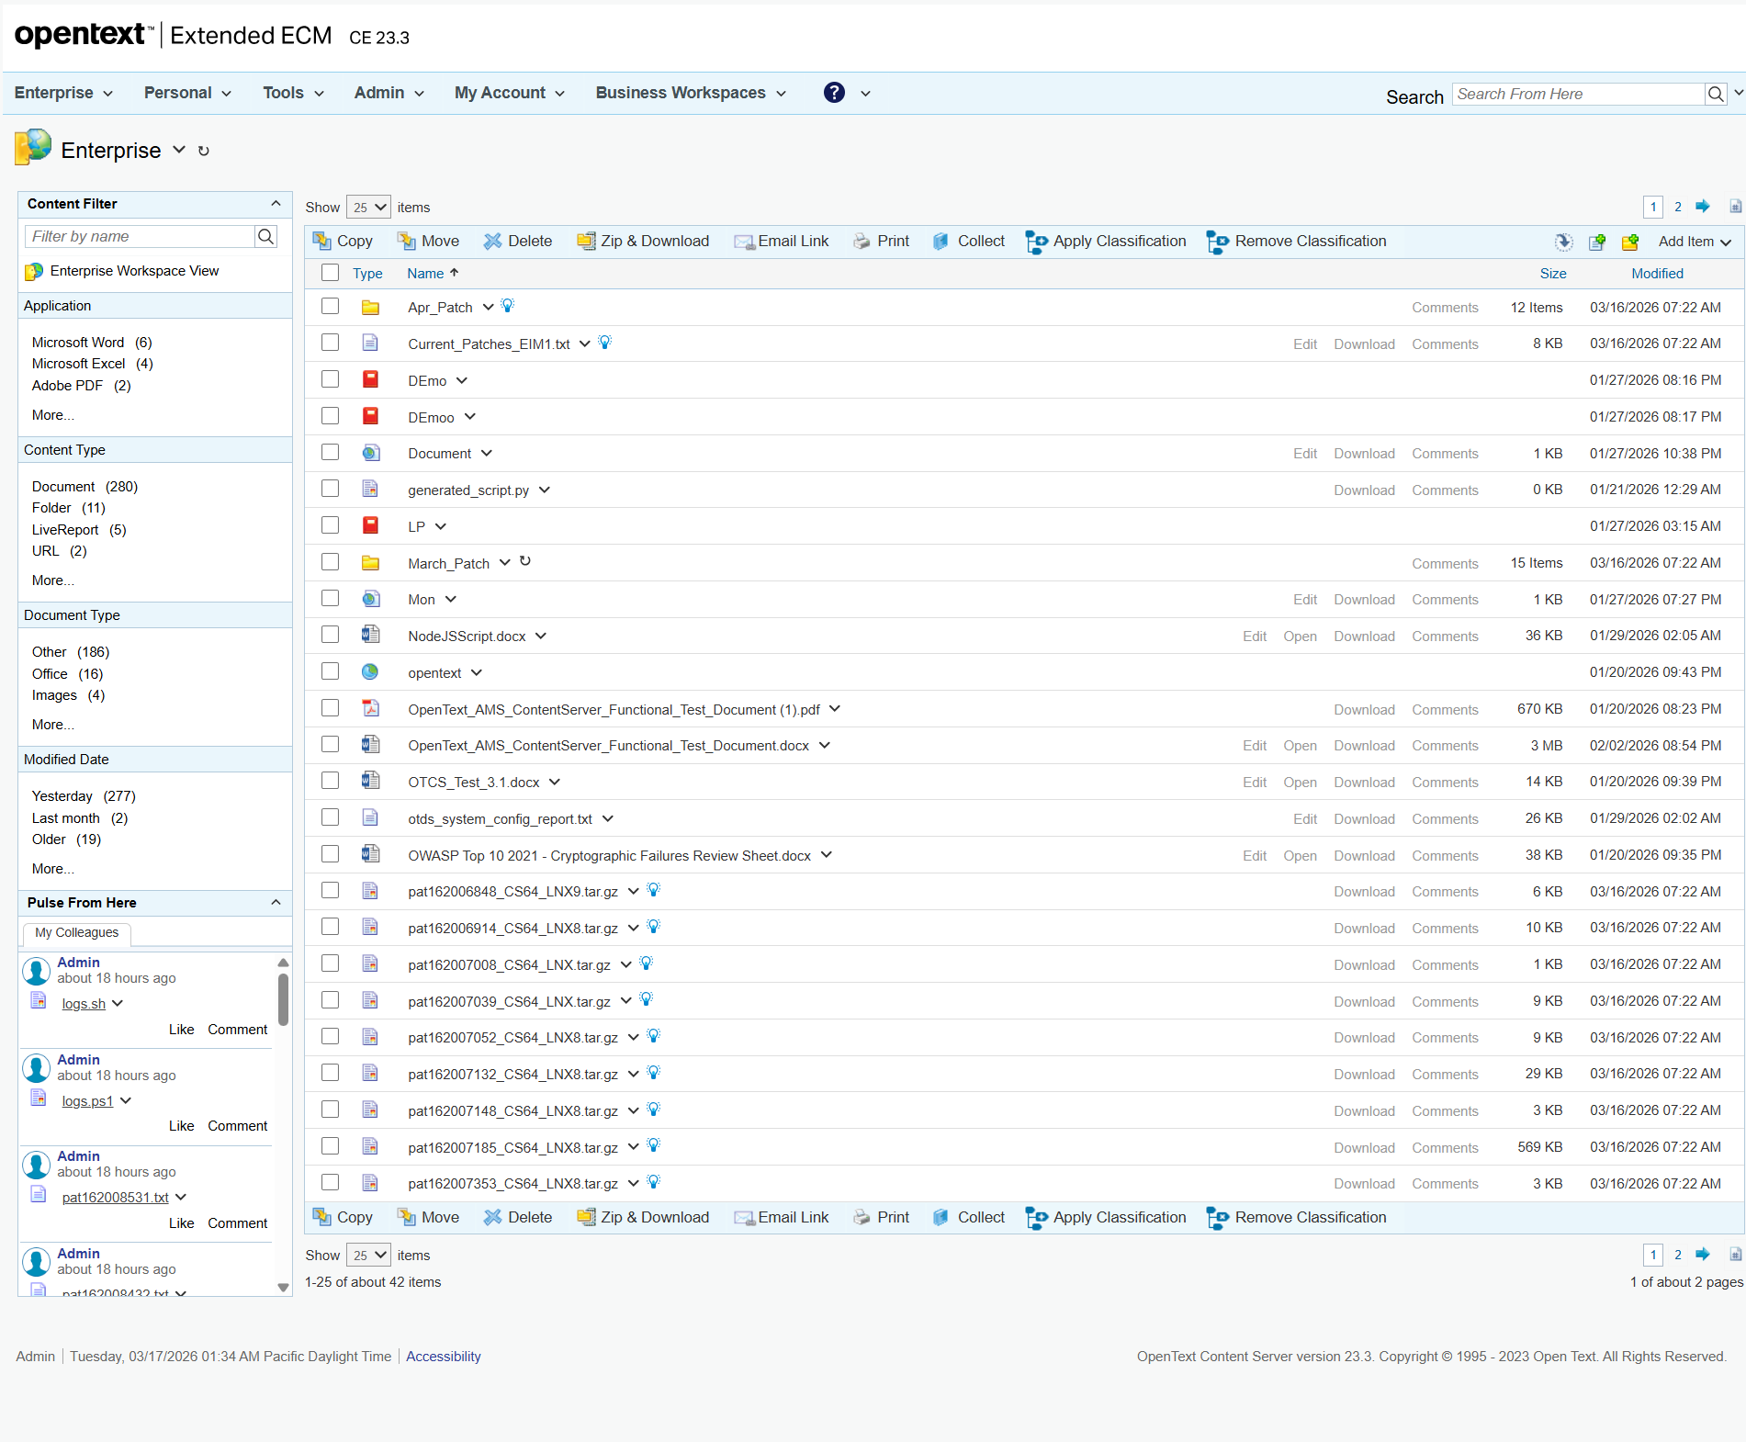

Step 4: Navigate to Distributed Agent Status
Result: Navigated to http://otcsvm.otxlab.net:8080/OTCS/cs.exe?func=distributedagent.AgentStatus
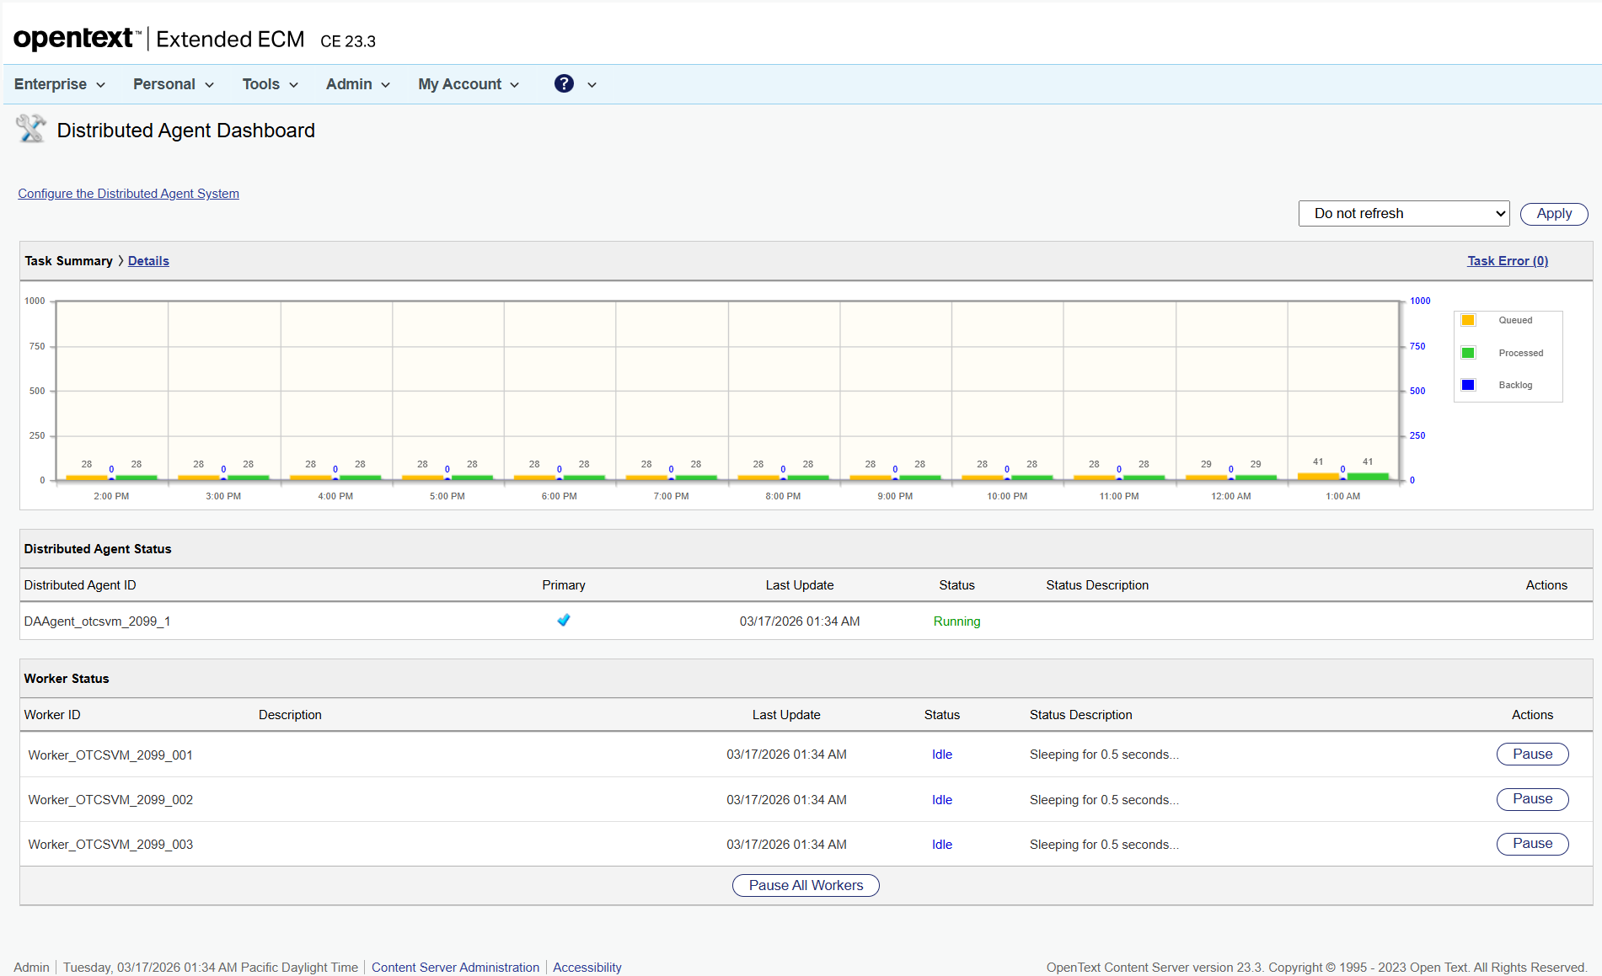

Step 5: Scroll Page Down
Result: Scrolled down by 500px.


Step 6: Scroll Page Down Again
Result: Scrolled down by 500px again.


Step 7: Extract Distributed Agent Statuses
Result: Extracted 8 agent statuses. Needs reconfiguration: True


Step 8: Click Configure Distributed Agent System
Result: Navigated to configuration page.
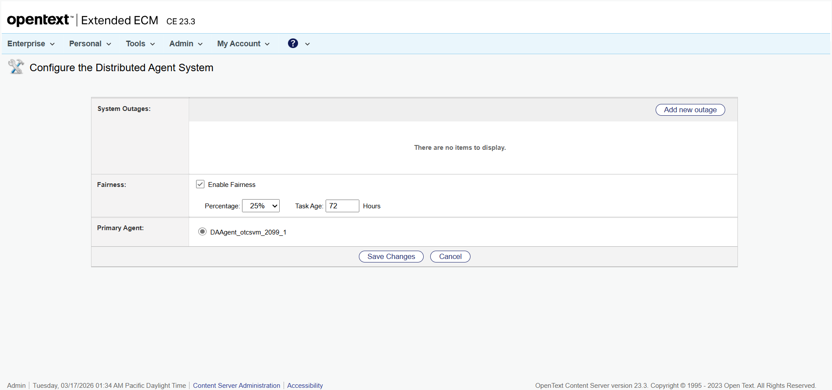

Step 9: Select Agent for Reconfiguration
Result: Selected radio button for agent ID:
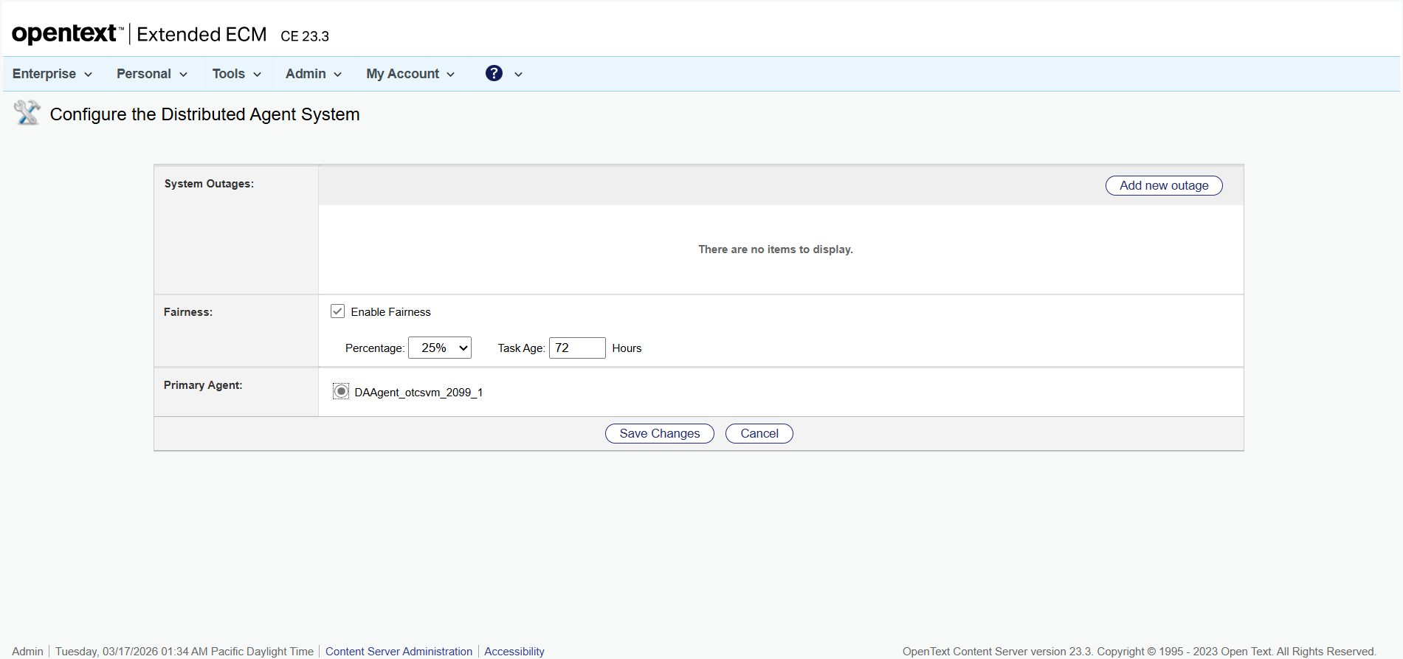

Step 10: No Agent Selected for Reconfiguration
Result: No non-running agent found to select for reconfiguration.


Step 11: Return to Agent Status Page
Result: Returned to agent status page after reconfiguration.


Step 12: Verify Reconfiguration
Result: Some agents are still not 'Running' after reconfiguration.


Step 13: Navigate to Admin Servers
Result: Navigated to http://otcsvm.otxlab.net:8080/OTCS/cs.exe?func=ll&objtype=148&objaction=browse
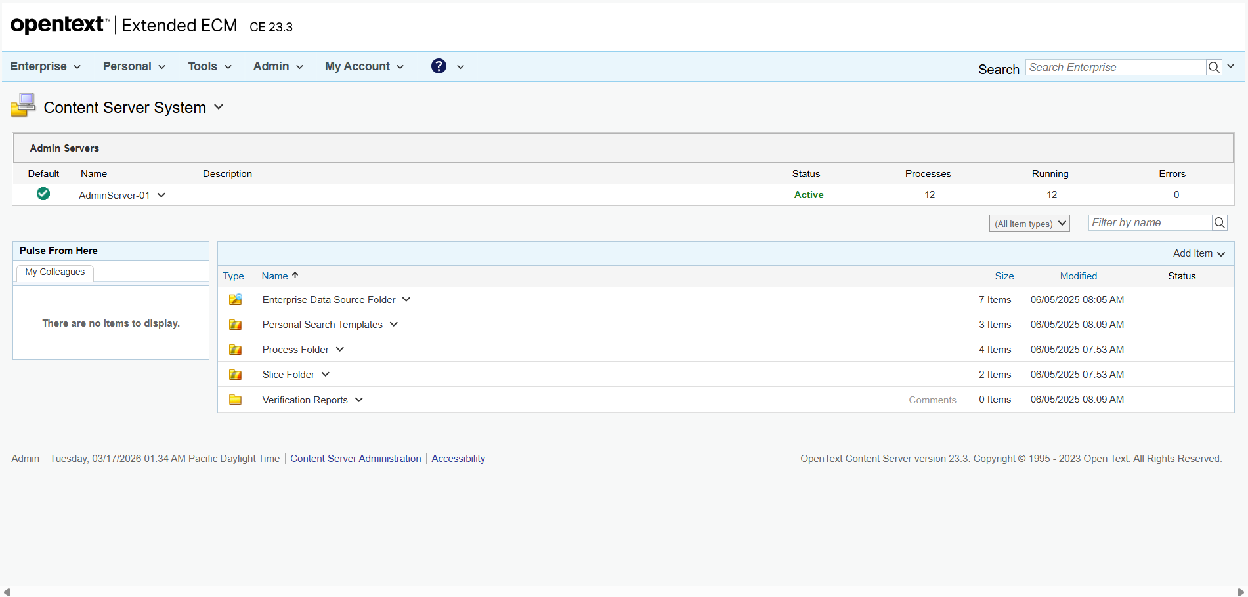

Step 14: Open Action Menu for AdminServer-01
Result: Action menu opened successfully.
