OTCS Automation Report

1. Login to OTCS
Login failed: Locator.click: Timeout 30000ms exceeded.
Call log:
- waiting for locator("button[type='submit'], #login_button, .submit-btn, button:has-text('Sign in')").filter(visible=True).first
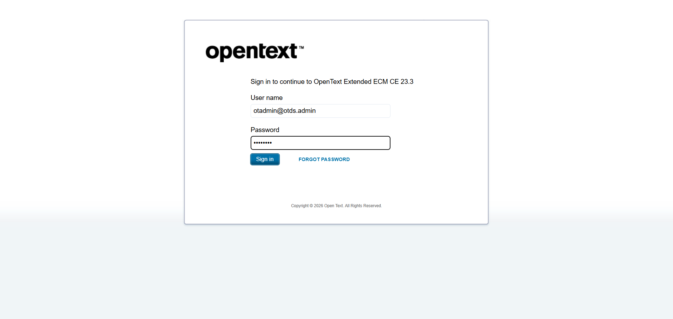
An error occurred: Locator.click: Timeout 30000ms exceeded.
Call log:
- waiting for locator("button[type='submit'], #login_button, .submit-btn, button:has-text('Sign in')").filter(visible=True).first


