Step: Login
Result: Logged in as otadmin@otds.admin


Step: Add Folder Initiated
Result: Clicked Add Item -> Folder
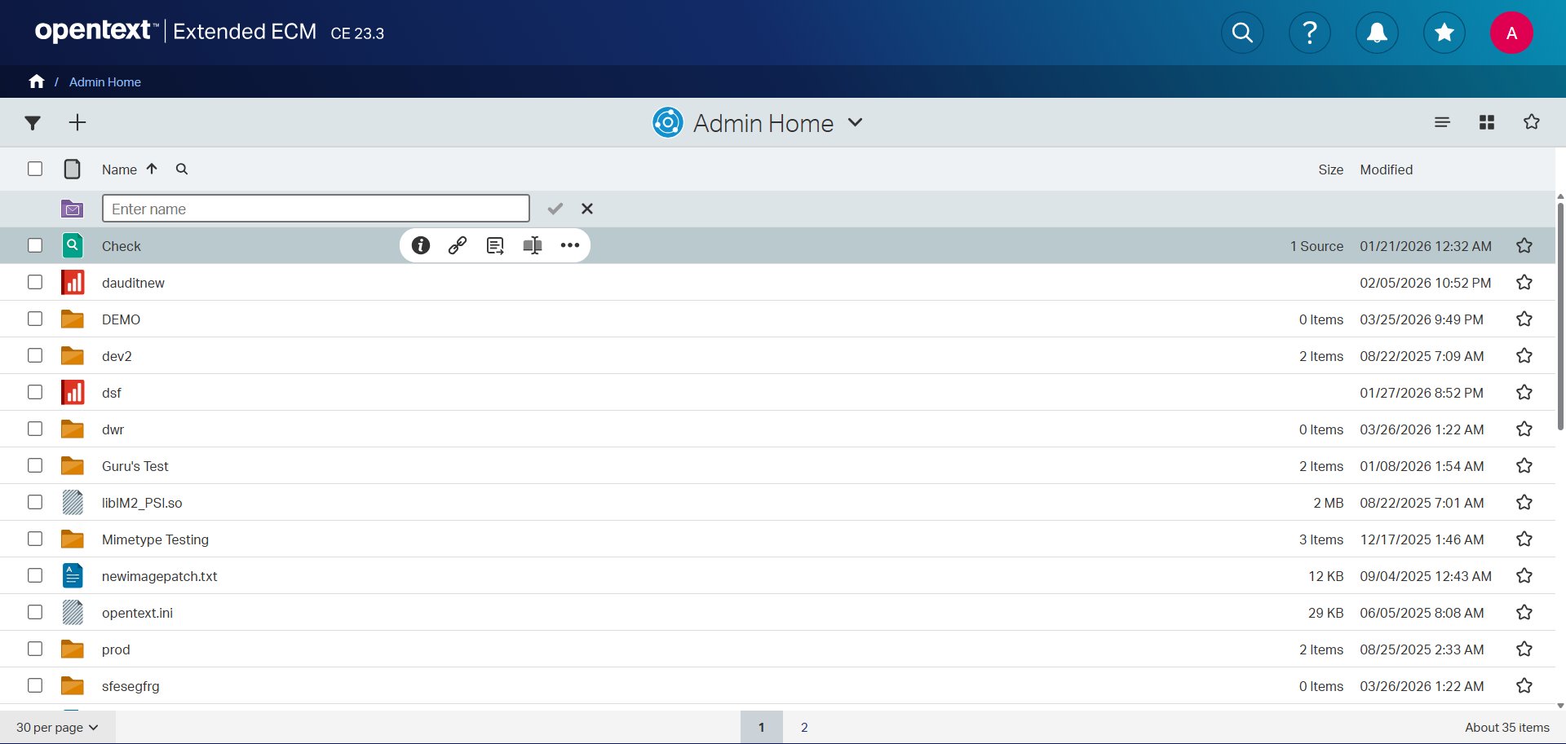

Step: Folder Created
Result: Folder 'Upload_Test_20260326_150203' created via ENTER.
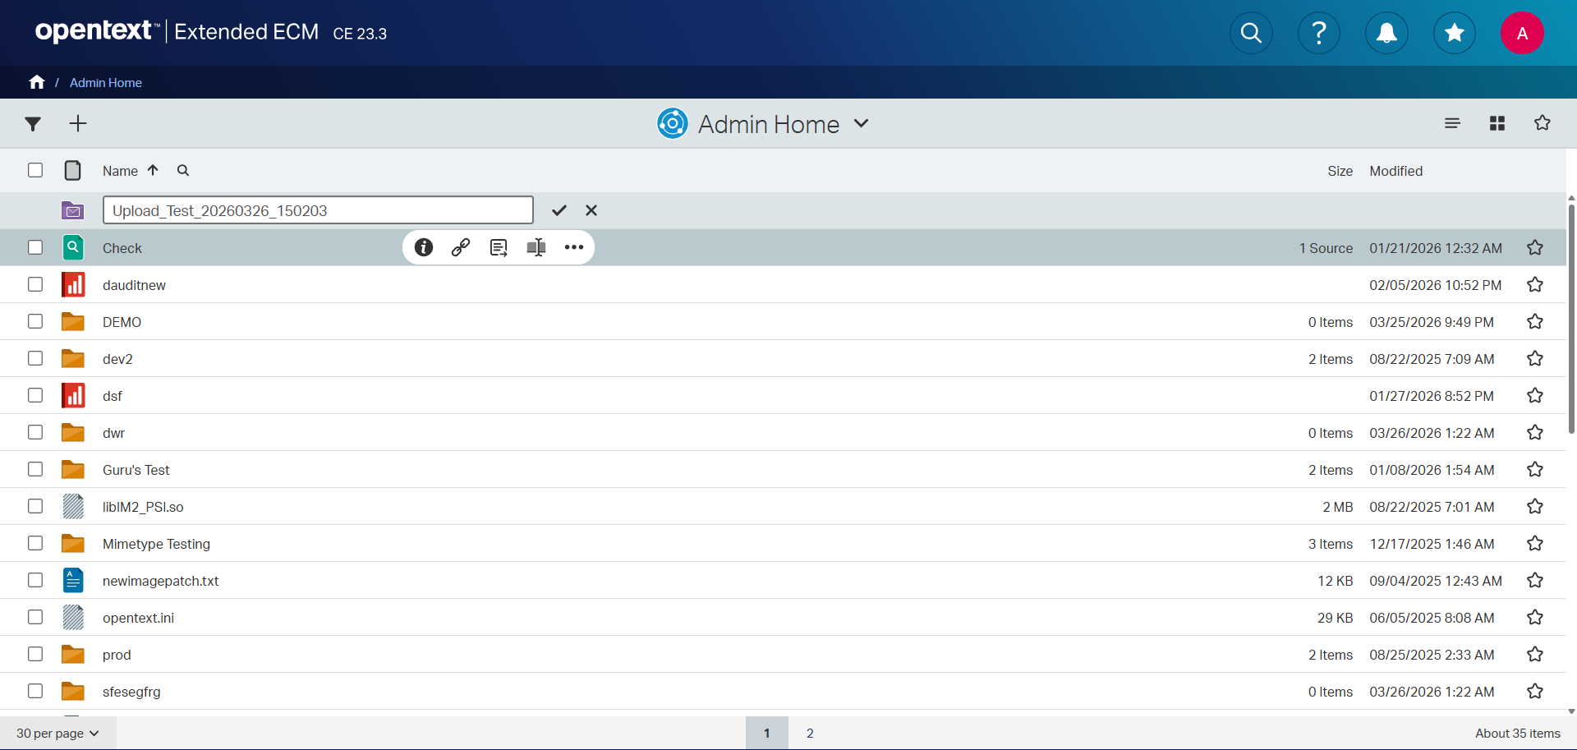

Step: Sort Applied
Result: Sorted by Modified date (Descending).
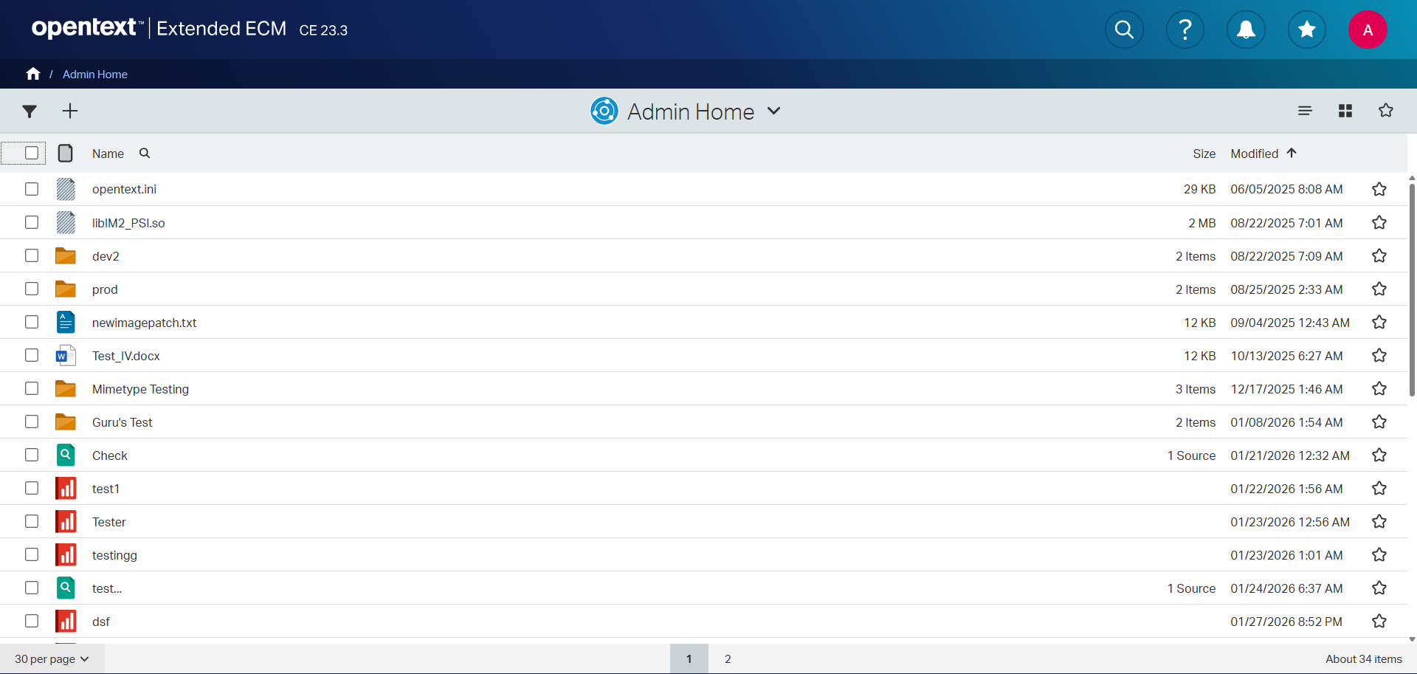

Step: Error
Result: Locator.click: Timeout 30000ms exceeded.
Call log:
- waiting for locator("a").filter(has_text=re.compile(r"Upload_Test_20260326_150203", re.IGNORECASE)).first
