Step: Login
Result: Logged in as otadmin@otds.admin


Step: Add Folder Initiated
Result: Clicked Add Item -> Folder
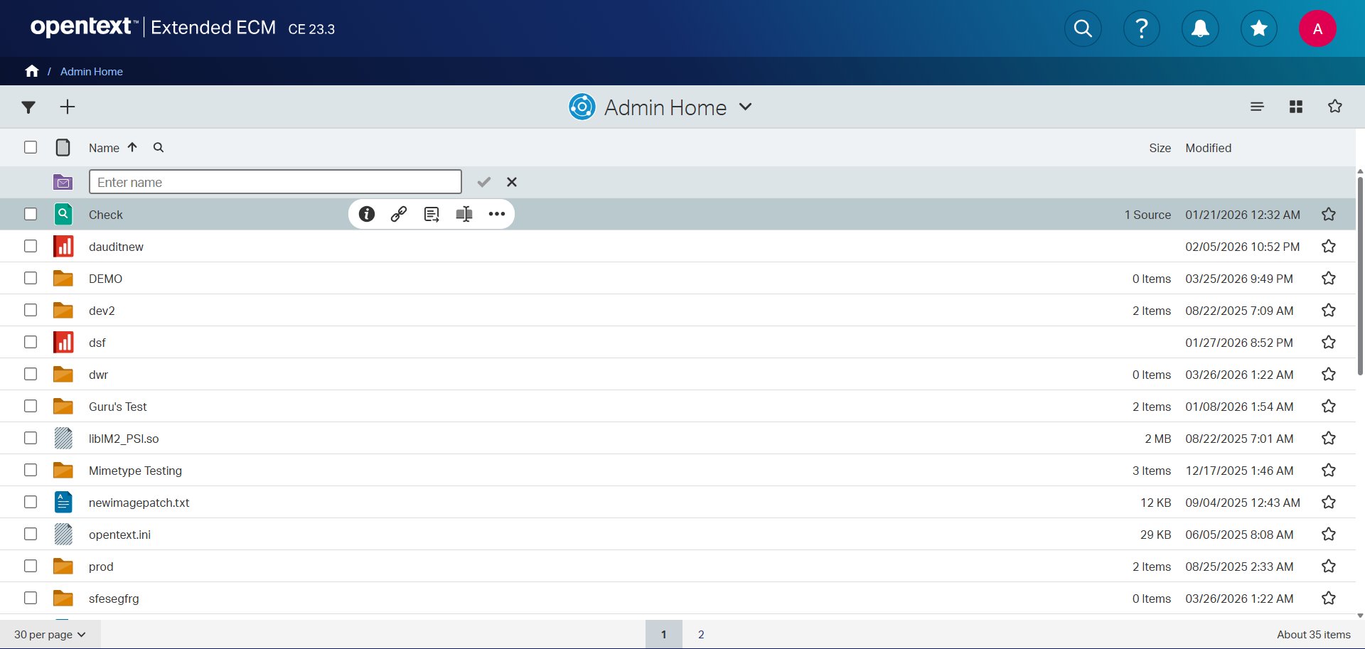

Step: Folder Created
Result: Folder 'Upload_Test_20260326_150451' created via ENTER.
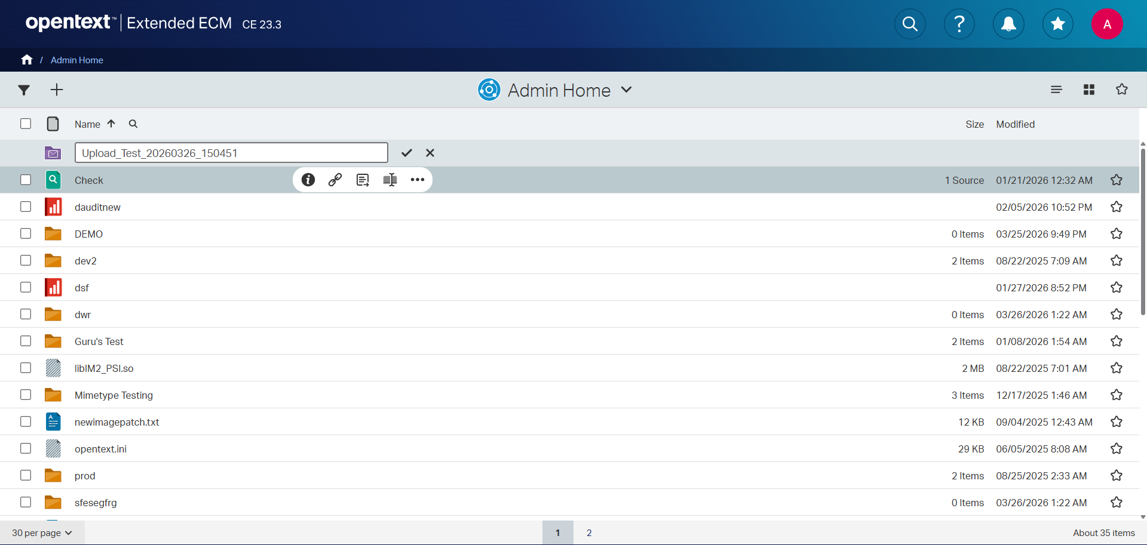

Step: Sort Applied
Result: Sorted by Modified date (Descending).
