Automation Report

Login
Navigated to login page: http://otcsvm.otxlab.net:8090/otdsws/login?RFA=108c0e8f%2Da007%2D4165%2Dbb27%2Ddf981c095aa7%3Ahttp%3A%2F%2Fotcsvm%2Eotxlab%2Enet%3A8080%2FOTCS%2Fcs%2Eexe%3Ffunc%3Dotdsintegration%2Eredirect%26NextURL%3Dhttp%253A%252F%252Fotcsvm%252Eotxlab%252Enet%253A8080%252FOTCS%252Fcs%252Eexe&PostTicket=true&PostParams=true&ux_version=1&PreserveFragment=true&logon_style=signin-cs&logon_appname=OpenText%20Extended%20ECM%20CE%2023%2E3
Login successful.
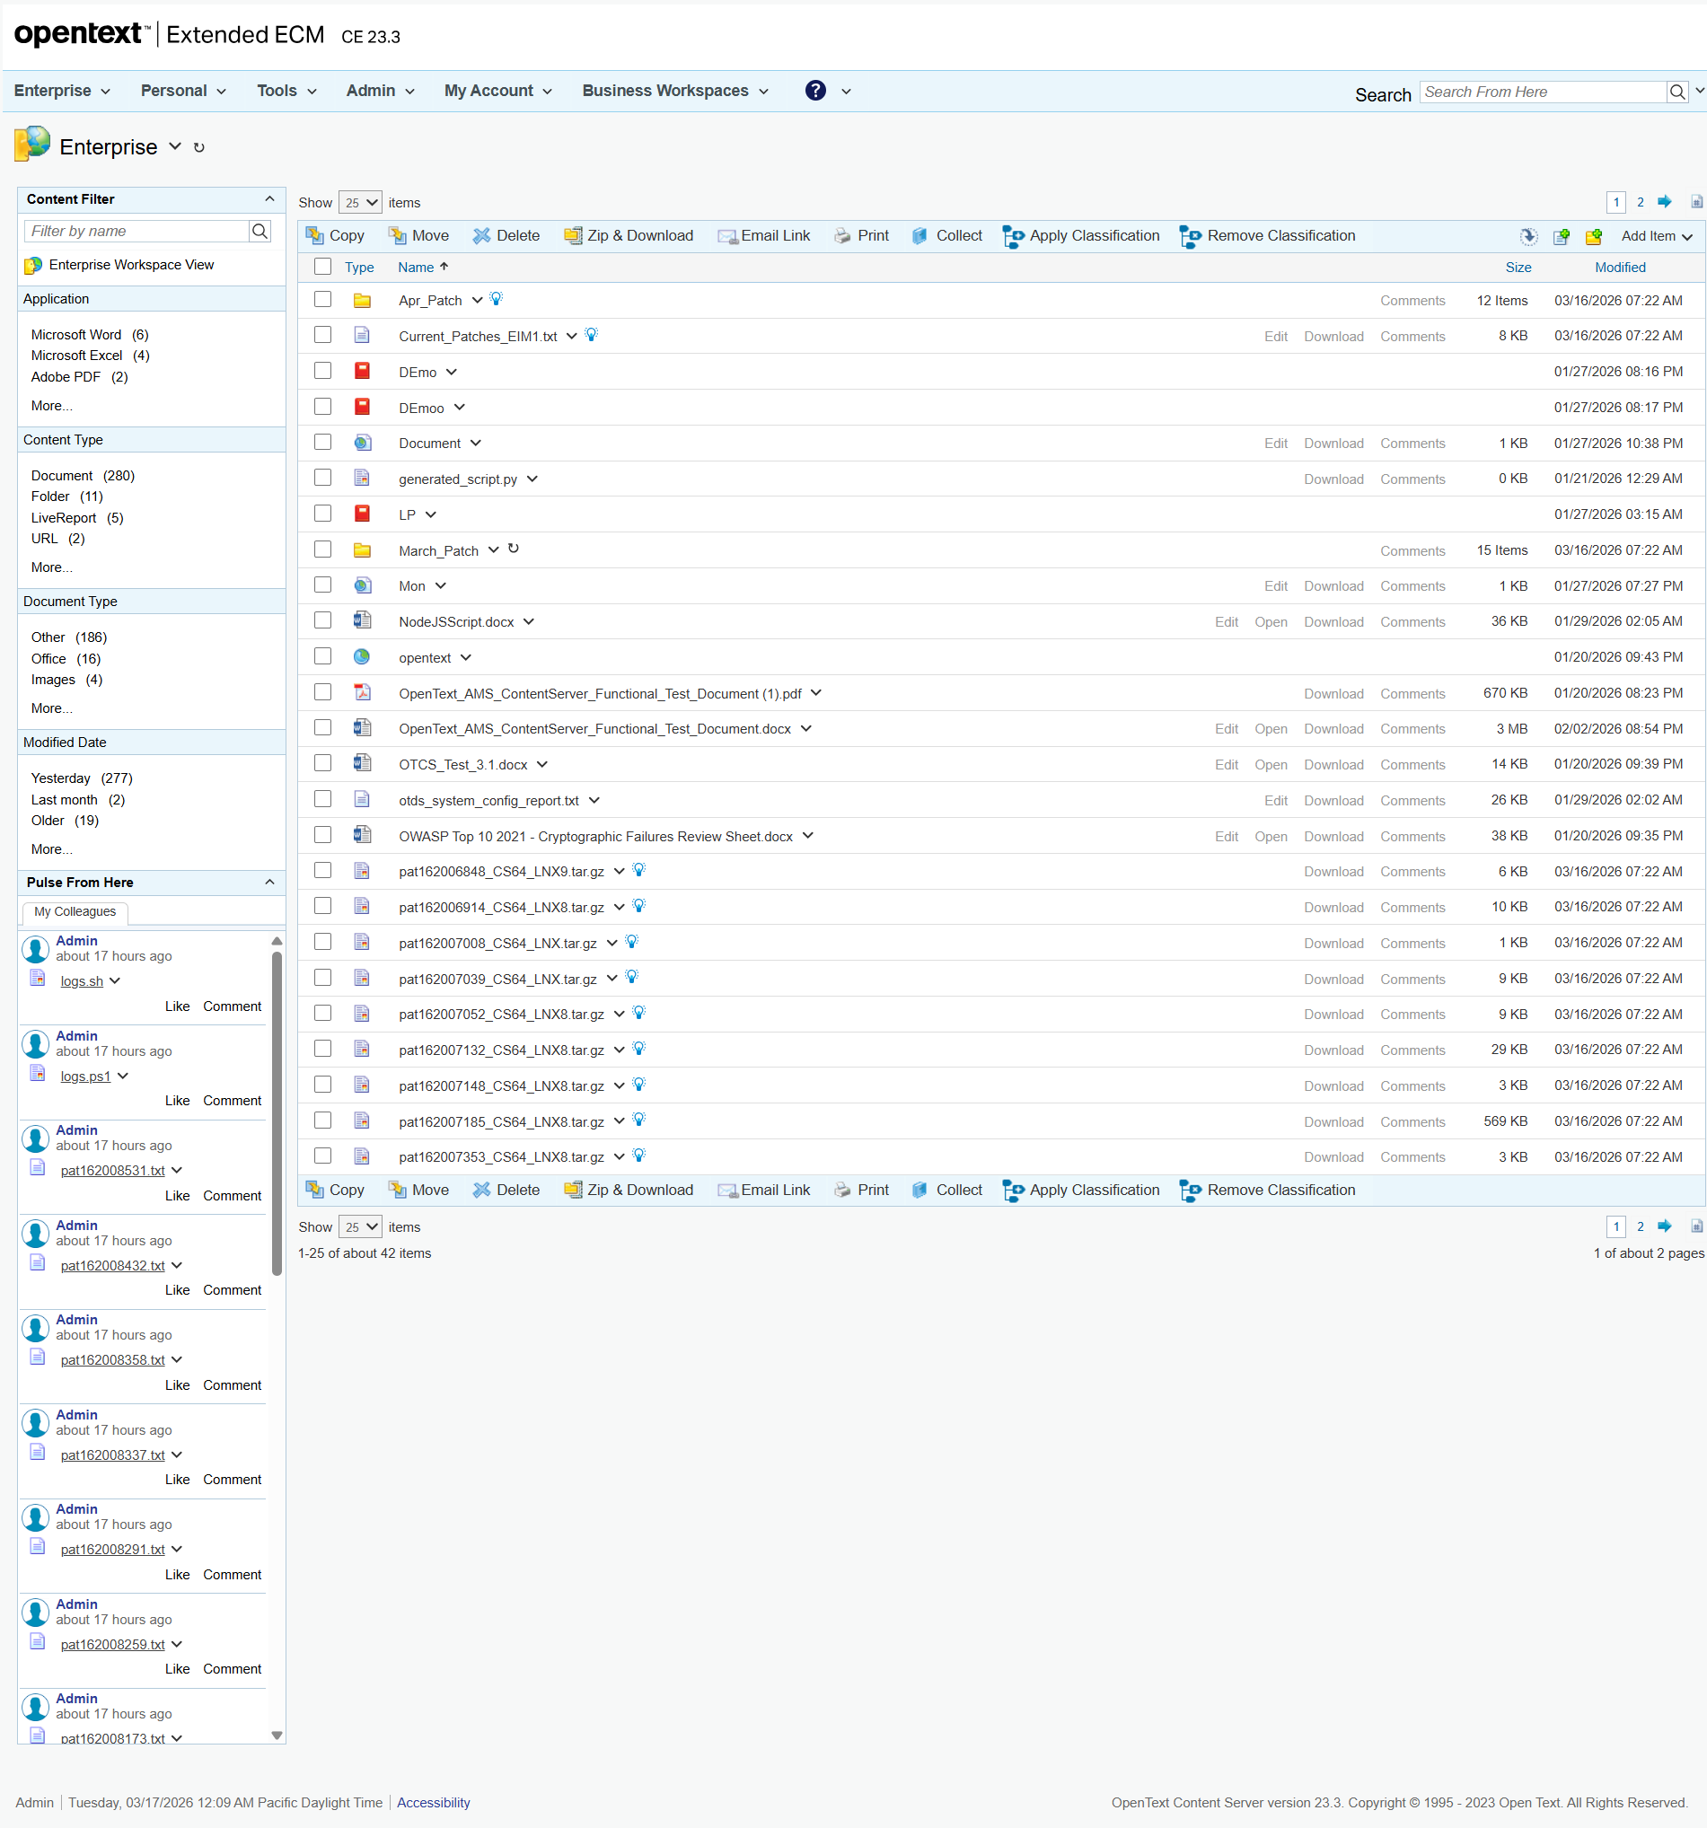

Distributed Agent Status
Navigated to Distributed Agent Status page: http://otcsvm.otxlab.net:8080/OTCS/cs.exe?func=distributedagent.AgentStatus
An error occurred: Locator.wait_for: Timeout 15000ms exceeded.
Call log:
- waiting for locator("h2").filter(has_text="Distributed Agent Status").first to be visible
