OTCS Distributed Agent Status Report

1. Login to OTCS
Navigated to http://otcsvm.otxlab.net:8080/OTCS/cs.exe
Filled username and password, clicked login button.
Login successful.
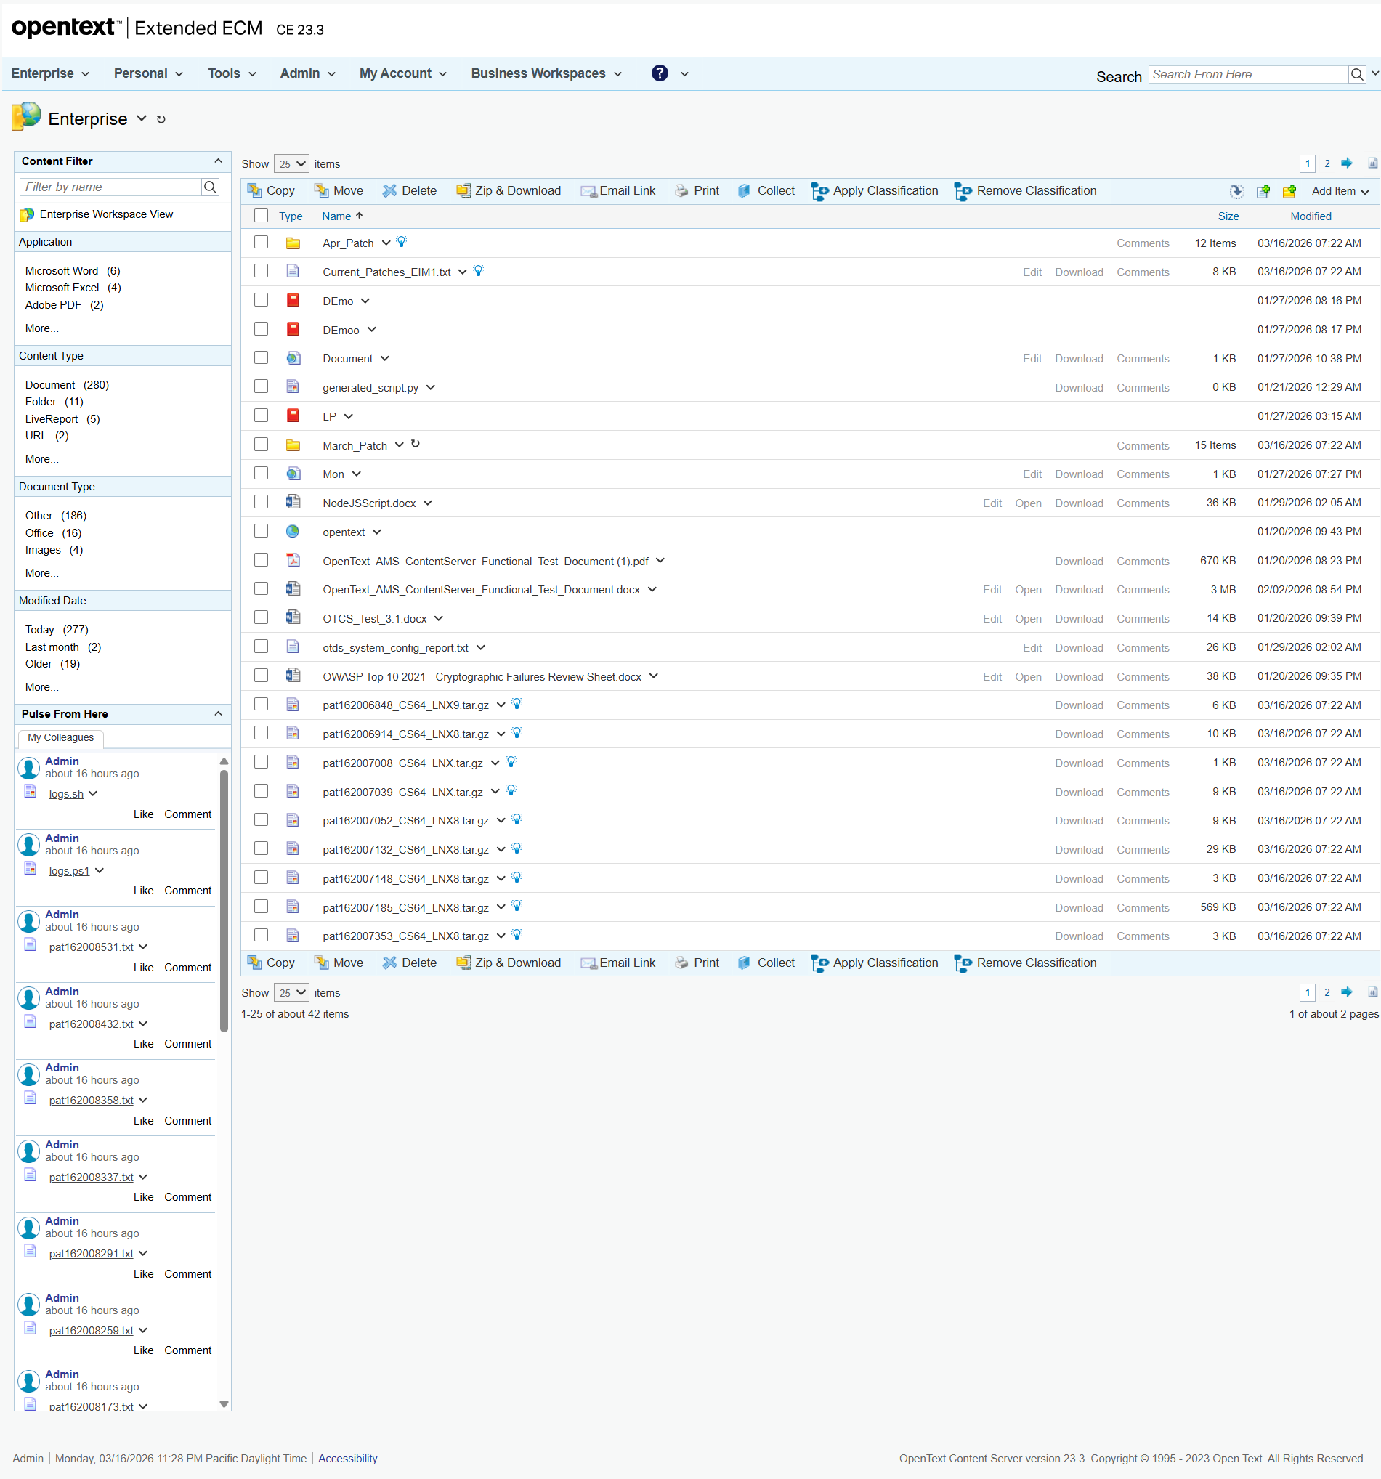

2. Distributed Agent Status

Error
An error occurred: Distributed Agent Status table not found.
Traceback (most recent call last):
File "C:\Users\pnandank\Downloads\Dynamic_Scrapper_4008 1\Dynamic_Scrapper_4008\Dynamic_Scrapper\web-ui\tmp\agent_history\20260317_103919_log-in-to-httpotcsvmotxlabnet8080otcscsexe-using-v_93c8fa95\20260317_103919_log-in-to-httpotcsvmotxlabnet8080otcscsexe-using-v_93c8fa95_LLM.py", line 126, in run
agent_data = await get_agent_status(page)
^^^^^^^^^^^^^^^^^^^^^^^^^^^^
File "C:\Users\pnandank\Downloads\Dynamic_Scrapper_4008 1\Dynamic_Scrapper_4008\Dynamic_Scrapper\web-ui\tmp\agent_history\20260317_103919_log-in-to-httpotcsvmotxlabnet8080otcscsexe-using-v_93c8fa95\20260317_103919_log-in-to-httpotcsvmotxlabnet8080otcscsexe-using-v_93c8fa95_LLM.py", line 97, in get_agent_status
raise RuntimeError("Distributed Agent Status table not found.")
RuntimeError: Distributed Agent Status table not found.
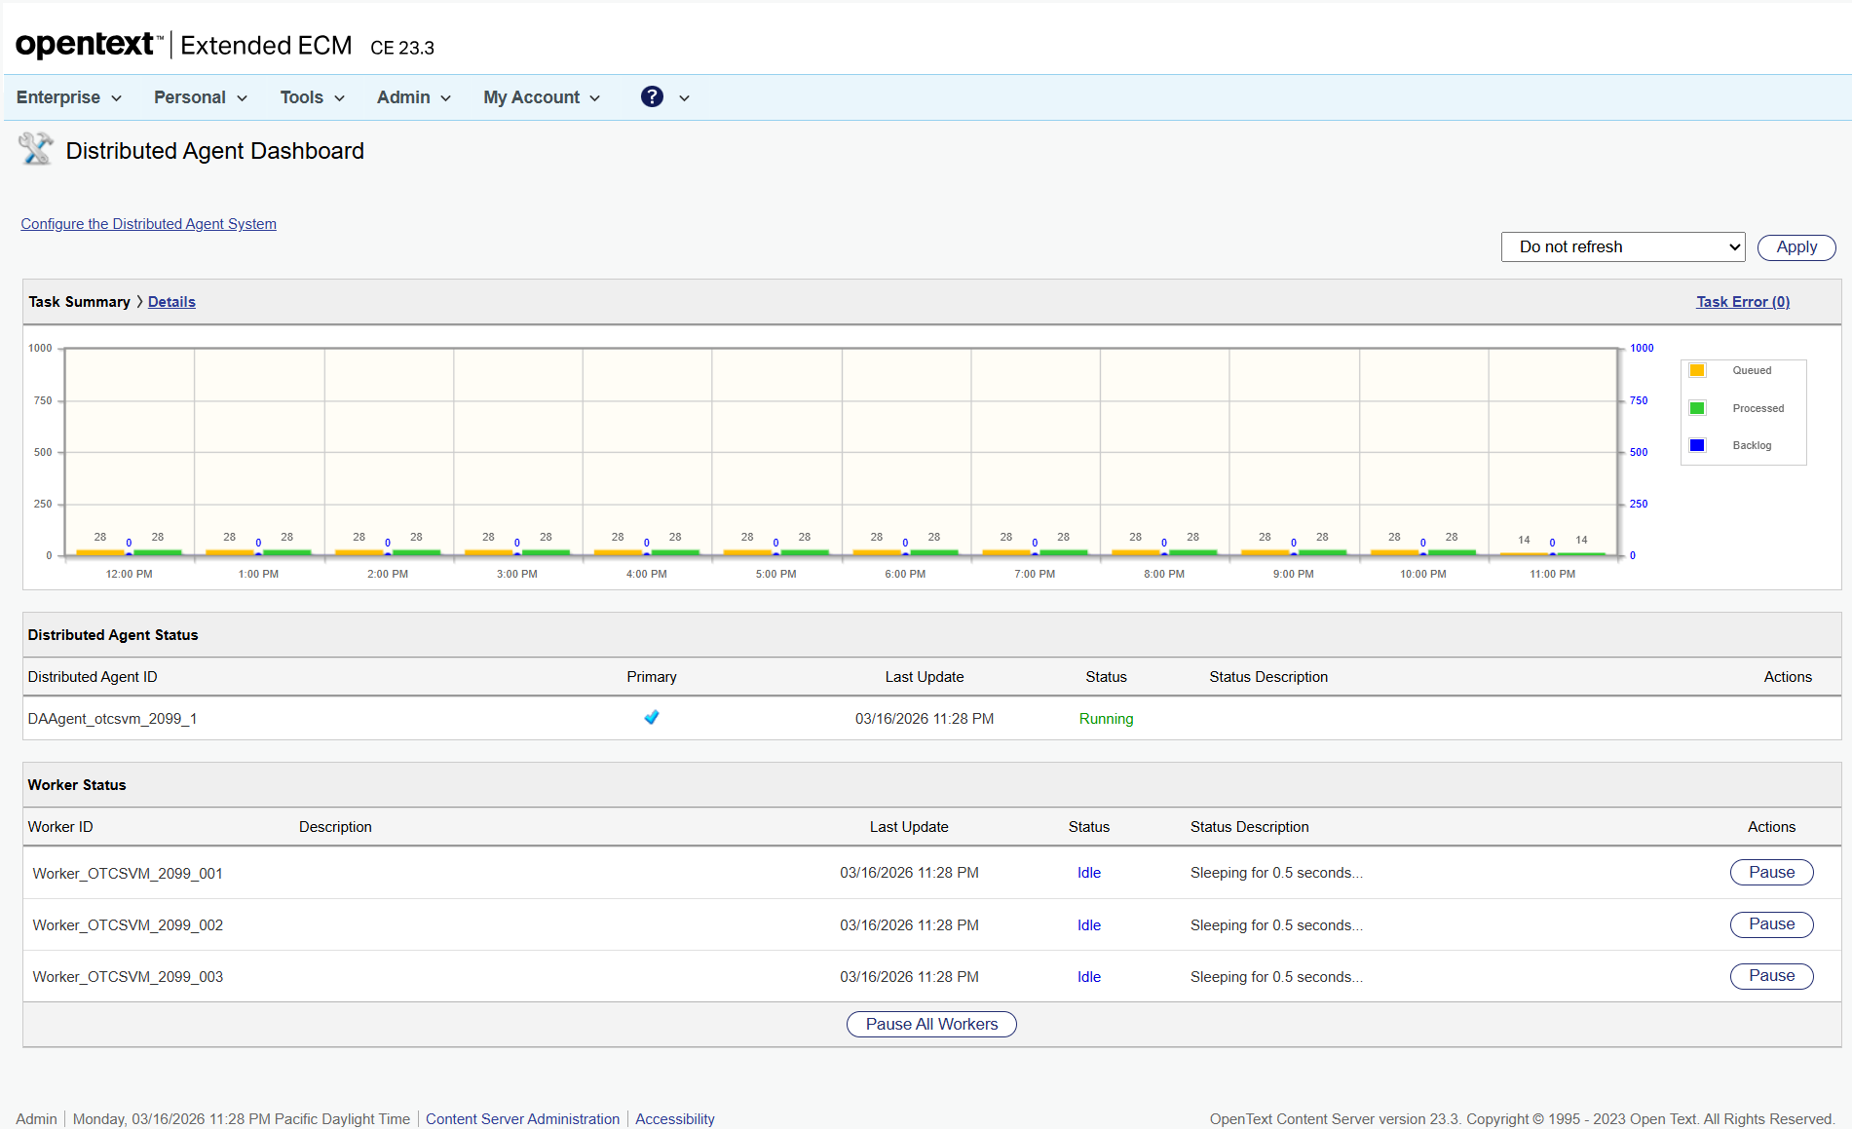

Summary
Distributed Agent Status:
Initial agent status could not be retrieved.
No reconfiguration was needed as all agents were 'Running'.
AdminServer-01 action menu was opened: False

