OTCS Distributed Agent and Admin Server Report

Step 1: Login to OTCS
Screenshot after login:
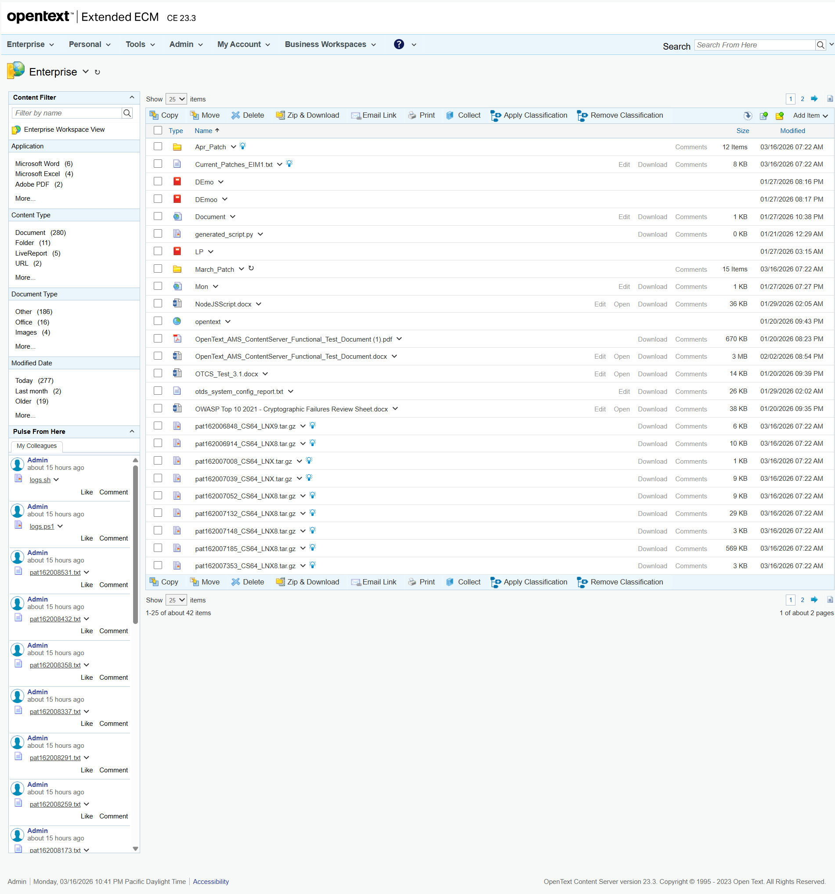

Step 2: Distributed Agent Status Check
Initial Distributed Agent Statuses:
Agent ID | Status
$(function(){  onLoadFunc( "/img/" );  setRTL( "false" );  });  $.jqplot.config.enablePlugins = true;  Configure the Distributed Agent System  Do not refresh  5 second refresh  10 second refresh  30 second refresh  1 minute refresh  1 and a half minute refresh  2 minute refresh  3 minute refresh  5 minute refresh  Task Summary  Details  Task Error (0)  11:00 AM12:00 PM1:00 PM2:00 PM3:00 PM4:00 PM5:00 PM6:00 PM7:00 PM8:00 PM9:00 PM10:00 PM0250500750100002505007501000212828282828282828282828212828282828282828282828QueuedProcessedBacklog000000000000  Distributed Agent Status  Distributed Agent ID  Primary  Last Update  Status  Status Description  Actions  DAAgent_otcsvm_2099_1  03/16/2026 10:41 PM  Running  Worker Status  Worker ID  Description  Last Update  Status  Status Description  Actions  Worker_OTCSVM_2099_001  03/16/2026 10:41 PM  Idle  Sleeping for 0.5 seconds...  Worker_OTCSVM_2099_002  03/16/2026 10:41 PM  Idle  Sleeping for 0.5 seconds...  Worker_OTCSVM_2099_003  03/16/2026 10:41 PM  Idle  Sleeping for 0.5 seconds...  if ( window.contentTable )  {  if ( contentTable )  {  document.write( '<\/TD><\/TR><\/TABLE><\/TD><\/TR><TR><TD class="cs-valign-bottom">' );  }  } | Task Summary  Details
Task Summary  Details  Task Error (0)  11:00 AM12:00 PM1:00 PM2:00 PM3:00 PM4:00 PM5:00 PM6:00 PM7:00 PM8:00 PM9:00 PM10:00 PM0250500750100002505007501000212828282828282828282828212828282828282828282828QueuedProcessedBacklog000000000000 | Task Error (0)
Task Summary
Details
Task Error (0)
11:00 AM12:00 PM1:00 PM2:00 PM3:00 PM4:00 PM5:00 PM6:00 PM7:00 PM8:00 PM9:00 PM10:00 PM0250500750100002505007501000212828282828282828282828212828282828282828282828QueuedProcessedBacklog000000000000
11:00 AM12:00 PM1:00 PM2:00 PM3:00 PM4:00 PM5:00 PM6:00 PM7:00 PM8:00 PM9:00 PM10:00 PM0250500750100002505007501000212828282828282828282828212828282828282828282828QueuedProcessedBacklog000000000000
Distributed Agent Status
Distributed Agent ID
Primary
Last Update
Status
Status Description
Actions
DAAgent_otcsvm_2099_1
03/16/2026 10:41 PM
Running
Distributed Agent Status
Distributed Agent ID
Primary
Last Update
Status
Status Description
Actions
DAAgent_otcsvm_2099_1
03/16/2026 10:41 PM
Running
Distributed Agent ID  Primary  Last Update  Status  Status Description  Actions  DAAgent_otcsvm_2099_1  03/16/2026 10:41 PM  Running | DAAgent_otcsvm_2099_1
DAAgent_otcsvm_2099_1 | Running
Worker Status
Worker ID
Description
Last Update
Status
Status Description
Actions
Worker_OTCSVM_2099_001
03/16/2026 10:41 PM
Idle
Sleeping for 0.5 seconds...
Worker_OTCSVM_2099_002
03/16/2026 10:41 PM
Idle
Sleeping for 0.5 seconds...
Worker_OTCSVM_2099_003
03/16/2026 10:41 PM
Idle
Sleeping for 0.5 seconds...
Worker Status
Worker ID
Description
Last Update
Status
Status Description
Actions
Worker_OTCSVM_2099_001
03/16/2026 10:41 PM
Idle
Sleeping for 0.5 seconds...
Worker_OTCSVM_2099_002
03/16/2026 10:41 PM
Idle
Sleeping for 0.5 seconds...
Worker_OTCSVM_2099_003
03/16/2026 10:41 PM
Idle
Sleeping for 0.5 seconds...
Worker ID  Description  Last Update  Status  Status Description  Actions  Worker_OTCSVM_2099_001  03/16/2026 10:41 PM  Idle  Sleeping for 0.5 seconds...  Worker_OTCSVM_2099_002  03/16/2026 10:41 PM  Idle  Sleeping for 0.5 seconds...  Worker_OTCSVM_2099_003  03/16/2026 10:41 PM  Idle  Sleeping for 0.5 seconds... | Worker_OTCSVM_2099_001
Worker_OTCSVM_2099_001 | Idle
Worker_OTCSVM_2099_002 | Idle
Worker_OTCSVM_2099_003 | Idle
Distributed Agent Dashboard:
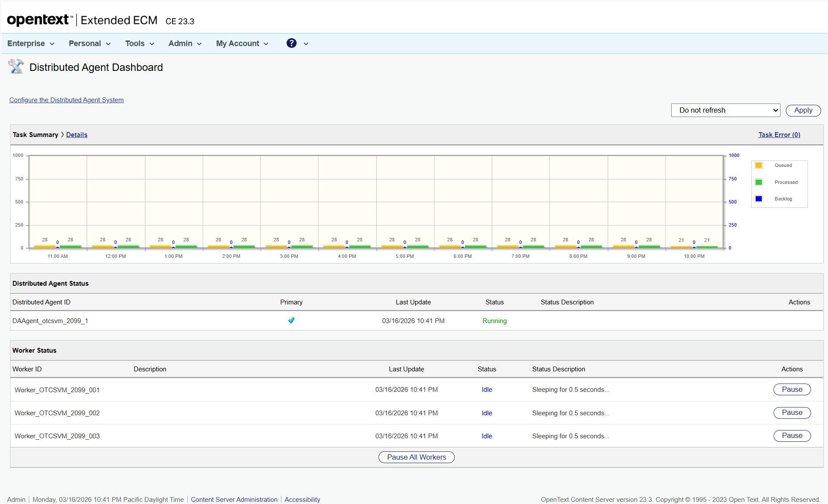

Step 3: Reconfiguration

Error
Error: Page.goto: Protocol error (Page.navigate): Cannot navigate to invalid URL
Call log:
- navigating to "/OTCS/cs.exe?func=distributedagent.ConfigureSystem", waiting until "load"
Traceback (most recent call last):
File "C:\Users\pnandank\Downloads\Dynamic_Scrapper_4008 1\Dynamic_Scrapper_4008\Dynamic_Scrapper\web-ui\tmp\agent_history\20260317_103919_log-in-to-httpotcsvmotxlabnet8080otcscsexe-using-v_93c8fa95\20260317_103919_log-in-to-httpotcsvmotxlabnet8080otcscsexe-using-v_93c8fa95_LLM.py", line 127, in run
await page.goto(configure_url, timeout=30000)
File "C:\Users\pnandank\AppData\Local\Programs\Python\Python312\Lib\site-packages\playwright\async_api\_generated.py", line 9041, in goto
await self._impl_obj.goto(
File "C:\Users\pnandank\AppData\Local\Programs\Python\Python312\Lib\site-packages\playwright\_impl\_page.py", line 552, in goto
return await self._main_frame.goto(**locals_to_params(locals()))
^^^^^^^^^^^^^^^^^^^^^^^^^^^^^^^^^^^^^^^^^^^^^^^^^^^^^^^^^
File "C:\Users\pnandank\AppData\Local\Programs\Python\Python312\Lib\site-packages\playwright\_impl\_frame.py", line 153, in goto
await self._channel.send(
File "C:\Users\pnandank\AppData\Local\Programs\Python\Python312\Lib\site-packages\playwright\_impl\_connection.py", line 69, in send
return await self._connection.wrap_api_call(
^^^^^^^^^^^^^^^^^^^^^^^^^^^^^^^^^^^^^
File "C:\Users\pnandank\AppData\Local\Programs\Python\Python312\Lib\site-packages\playwright\_impl\_connection.py", line 559, in wrap_api_call
raise rewrite_error(error, f"{parsed_st['apiName']}: {error}") from None
playwright._impl._errors.Error: Page.goto: Protocol error (Page.navigate): Cannot navigate to invalid URL
Call log:
- navigating to "/OTCS/cs.exe?func=distributedagent.ConfigureSystem", waiting until "load"

Summary
Step | Action | Status
1.1 | Navigated to login URL | Success
1.2 | Logged in | Success
2.1 | Navigated to Distributed Agent Dashboard | Success
2.2 | Read Distributed Agent statuses | Success
Error | Page.goto: Protocol error (Page.navigate): Cannot navigate to invalid URL  Call log:  - navigating to "/OTCS/cs.exe?func=distributedagent.ConfigureSystem", waiting until "load" | Failed
Reconfiguration performed: True
AdminServer-01 menu opened: False

