Playwright Automation Report

Execution Summary
Script: 68cc8cce-8f24-472b-897e-4c44640aefe0.py
Status: Execution Complete
Total Steps: 7

Captured Outputs
Step | Action | Output
1 | go_to_url | URL: http://otcsvm.otxlab.net:8090/otdsws/login?RFA=108c0e8f%2Da007%2D4165%2Dbb27%2Ddf981c095aa7%3Ahttp%3A%2F%2Fotcsvm%2Eotxlab%2Enet%3A8080%2FOTCS%2Fcs%2Eexe%3Ffunc%3Dotdsintegration%2Eredirect%26NextURL%3Dhttp%253A%252F%252Fotcsvm%252Eotxlab%252Enet%253A8080%252FOTCS%252Fcs%252Eexe&PostTicket=true&PostParams=true&ux_version=1&PreserveFragment=true&logon_style=signin-cs&logon_appname=OpenText%20Extended%20ECM%20CE%2023%2E3
2 | input_text | URL: http://otcsvm.otxlab.net:8090/otdsws/login?RFA=108c0e8f%2Da007%2D4165%2Dbb27%2Ddf981c095aa7%3Ahttp%3A%2F%2Fotcsvm%2Eotxlab%2Enet%3A8080%2FOTCS%2Fcs%2Eexe%3Ffunc%3Dotdsintegration%2Eredirect%26NextURL%3Dhttp%253A%252F%252Fotcsvm%252Eotxlab%252Enet%253A8080%252FOTCS%252Fcs%252Eexe&PostTicket=true&PostParams=true&ux_version=1&PreserveFragment=true&logon_style=signin-cs&logon_appname=OpenText%20Extended%20ECM%20CE%2023%2E3
3 | input_text | URL: http://otcsvm.otxlab.net:8090/otdsws/login?RFA=108c0e8f%2Da007%2D4165%2Dbb27%2Ddf981c095aa7%3Ahttp%3A%2F%2Fotcsvm%2Eotxlab%2Enet%3A8080%2FOTCS%2Fcs%2Eexe%3Ffunc%3Dotdsintegration%2Eredirect%26NextURL%3Dhttp%253A%252F%252Fotcsvm%252Eotxlab%252Enet%253A8080%252FOTCS%252Fcs%252Eexe&PostTicket=true&PostParams=true&ux_version=1&PreserveFragment=true&logon_style=signin-cs&logon_appname=OpenText%20Extended%20ECM%20CE%2023%2E3
4 | click_element_by_index | URL: http://otcsvm.otxlab.net:8080/OTCS/cs.exe?func=llworkspace
5 | go_to_url | URL: http://otcsvm.otxlab.net:8080/OTCS/cs.exe?func=ll&objtype=148&objaction=browse
6 | extract_content | Extracted: Open Text Content Server Enterprise Personal Tools Admin My Account Help Search [ Last Results ] Content Server System Admin Servers Default Name Description Status Processes Running Errors AdminServer-01 Active 12 12 0 (All item types) Pulse From Here My Colleagues There are no items to display. Add Item Type Name Size Modified Status Enterprise Data Source Folder 7 Items 06/05/2025 08:05 AM Personal Search Templates 3 Items 06/05/2025 08:09 AM Process Folder 4 Items 06/05/2025 07:53
7 | done | URL: http://otcsvm.otxlab.net:8080/OTCS/cs.exe?func=ll&objtype=148&objaction=browse

Automation Steps

Step 1: go_to_url
Action | go_to_url
Captured Output | URL: http://otcsvm.otxlab.net:8090/otdsws/login?RFA=108c0e8f%2Da007%2D4165%2Dbb27%2Ddf981c095aa7%3Ahttp%3A%2F%2Fotcsvm%2Eotxlab%2Enet%3A8080%2FOTCS%2Fcs%2Eexe%3Ffunc%3Dotdsintegration%2Eredirect%26NextURL%3Dhttp%253A%252F%252Fotcsvm%252Eotxlab%252Enet%253A8080%252FOTCS%252Fcs%252Eexe&PostTicket=true&PostParams=true&ux_version=1&PreserveFragment=true&logon_style=signin-cs&logon_appname=OpenText%20Extended%20ECM%20CE%2023%2E3
Screenshot:
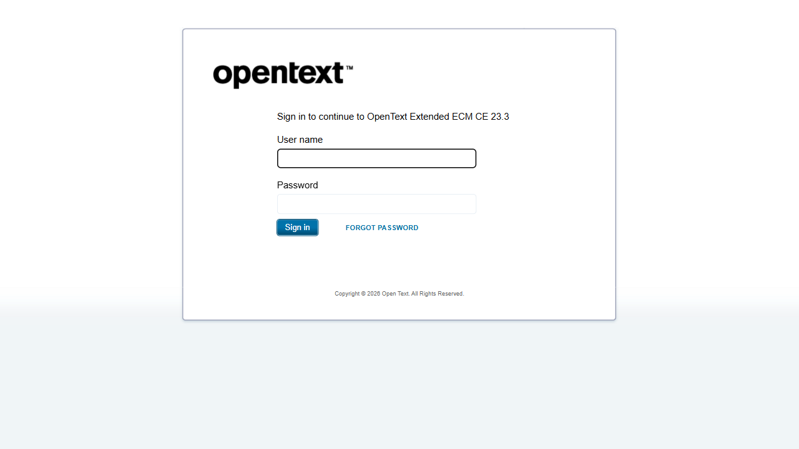

Step 2: input_text
Action | input_text
Captured Output | URL: http://otcsvm.otxlab.net:8090/otdsws/login?RFA=108c0e8f%2Da007%2D4165%2Dbb27%2Ddf981c095aa7%3Ahttp%3A%2F%2Fotcsvm%2Eotxlab%2Enet%3A8080%2FOTCS%2Fcs%2Eexe%3Ffunc%3Dotdsintegration%2Eredirect%26NextURL%3Dhttp%253A%252F%252Fotcsvm%252Eotxlab%252Enet%253A8080%252FOTCS%252Fcs%252Eexe&PostTicket=true&PostParams=true&ux_version=1&PreserveFragment=true&logon_style=signin-cs&logon_appname=OpenText%20Extended%20ECM%20CE%2023%2E3
Screenshot:
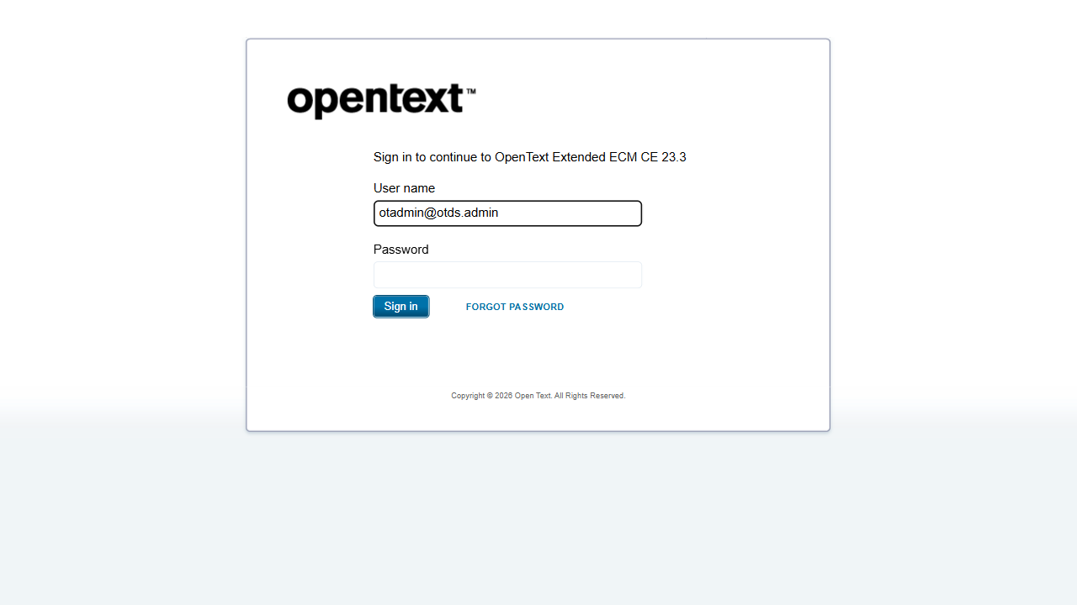

Step 3: input_text
Action | input_text
Captured Output | URL: http://otcsvm.otxlab.net:8090/otdsws/login?RFA=108c0e8f%2Da007%2D4165%2Dbb27%2Ddf981c095aa7%3Ahttp%3A%2F%2Fotcsvm%2Eotxlab%2Enet%3A8080%2FOTCS%2Fcs%2Eexe%3Ffunc%3Dotdsintegration%2Eredirect%26NextURL%3Dhttp%253A%252F%252Fotcsvm%252Eotxlab%252Enet%253A8080%252FOTCS%252Fcs%252Eexe&PostTicket=true&PostParams=true&ux_version=1&PreserveFragment=true&logon_style=signin-cs&logon_appname=OpenText%20Extended%20ECM%20CE%2023%2E3
Screenshot:
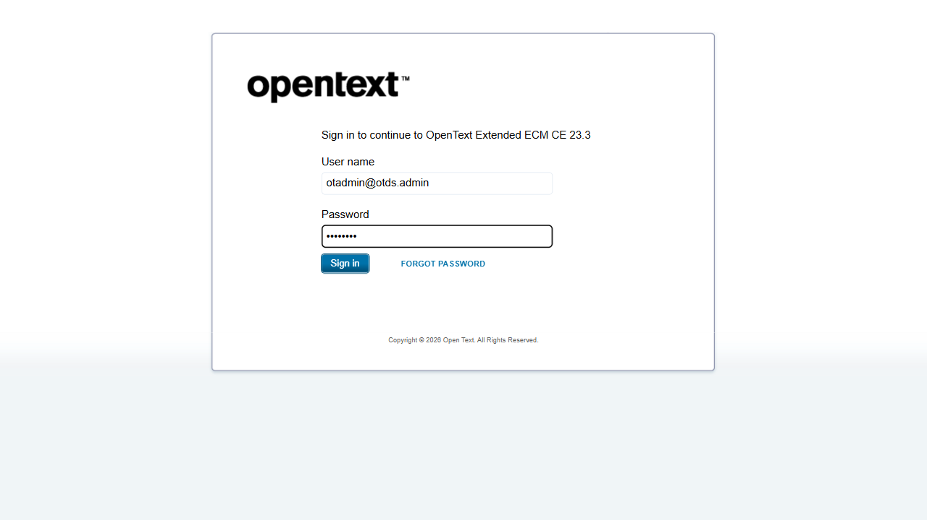

Step 4: click_element_by_index
Action | click_element_by_index
Captured Output | URL: http://otcsvm.otxlab.net:8080/OTCS/cs.exe?func=llworkspace
Screenshot:
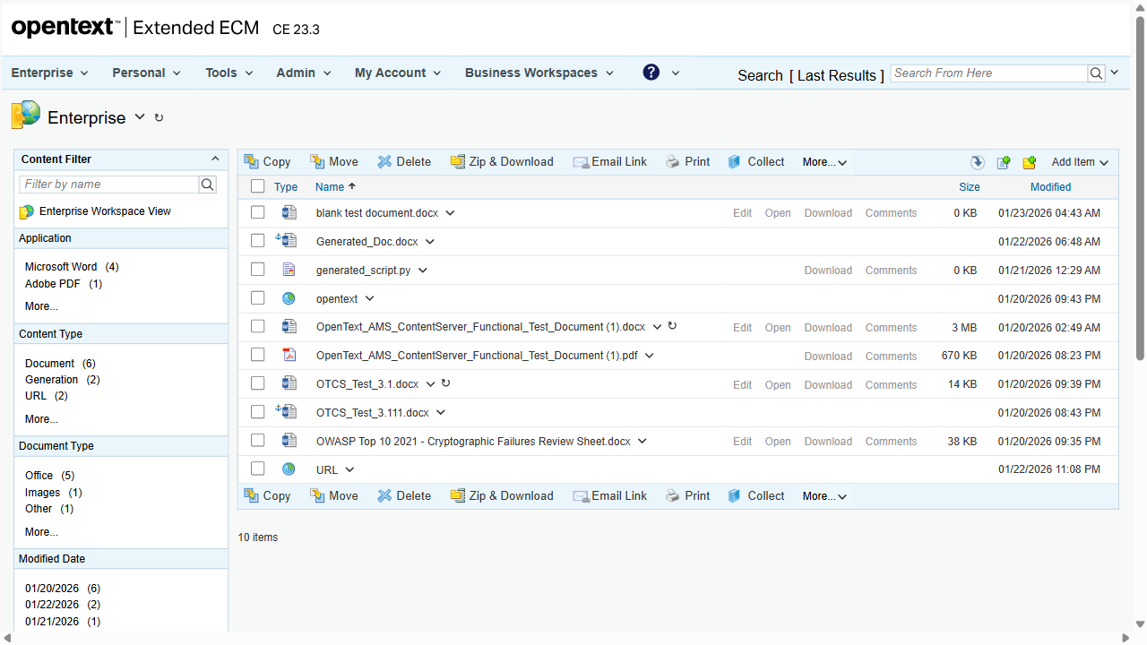

Step 5: go_to_url
Action | go_to_url
Captured Output | URL: http://otcsvm.otxlab.net:8080/OTCS/cs.exe?func=ll&objtype=148&objaction=browse
Screenshot:
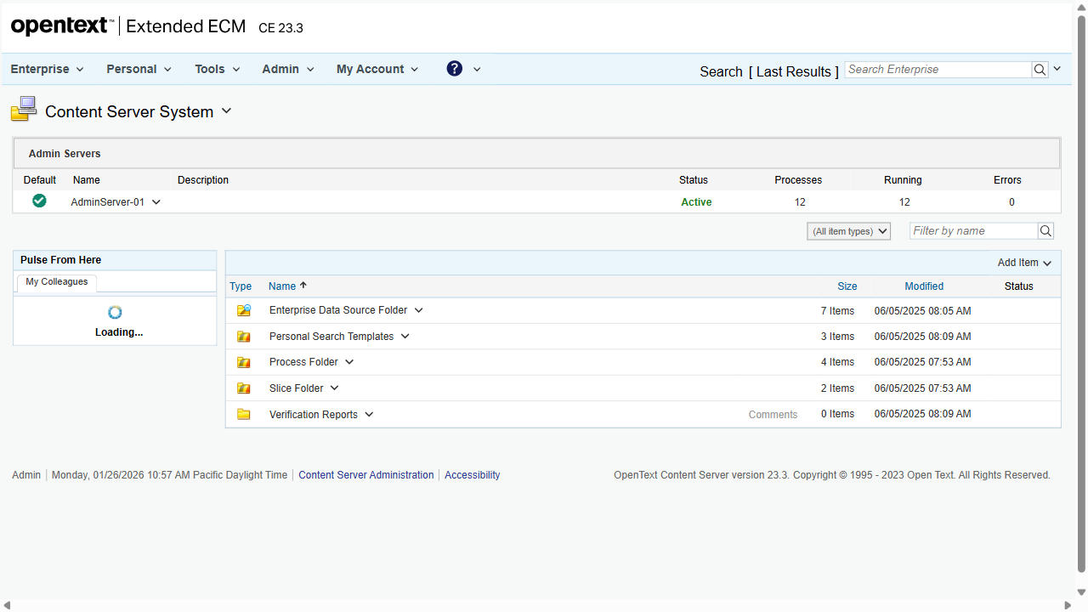

Step 6: extract_content
Action | extract_content
Captured Output | Extracted: Open Text Content Server Enterprise Personal Tools Admin My Account Help Search [ Last Results ] Content Server System Admin Servers Default Name Description Status Processes Running Errors AdminServer-01 Active 12 12 0 (All item types) Pulse From Here My Colleagues There are no items to display. Add Item Type Name Size Modified Status Enterprise Data Source Folder 7 Items 06/05/2025 08:05 AM Personal Search Templates 3 Items 06/05/2025 08:09 AM Process Folder 4 Items 06/05/2025 07:53 AM Slice F
Screenshot:
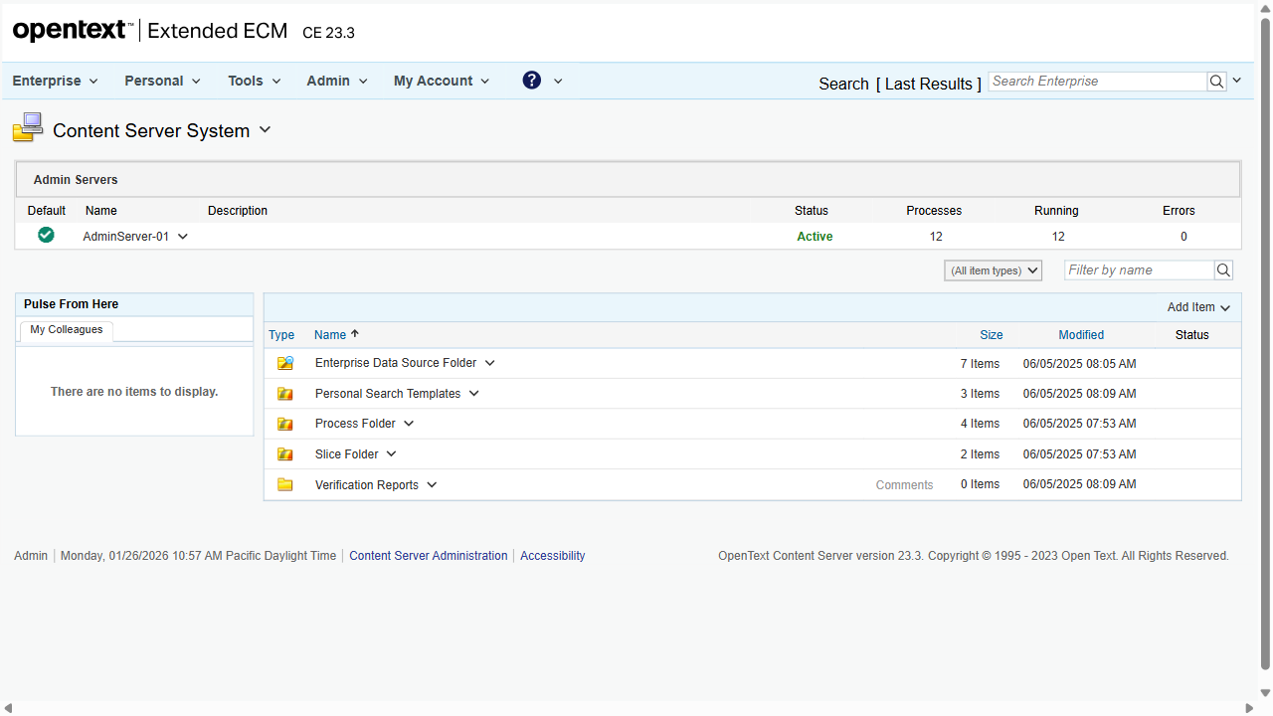

Step 7: done
Action | done
Captured Output | URL: http://otcsvm.otxlab.net:8080/OTCS/cs.exe?func=ll&objtype=148&objaction=browse
Screenshot:


