1.CONCAT-concat is to join two given column data

Pig script:

Here the emp name and his dept are concatenated

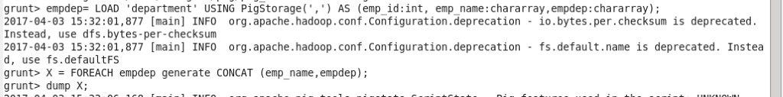

This is the concatenated output

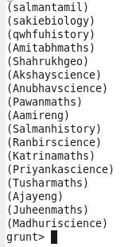

1. TOKENIZE-it is to divide the content of the file based on the given tokenizer

Input:C:\Users\Jayachandran\Desktop\asg pics\tokenize ip.jpg

PIG SCRIPT: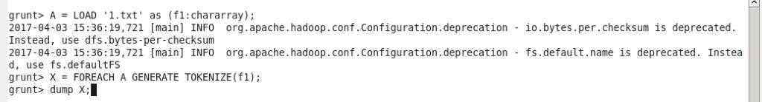OUTPUT:C:\Users\Jayachandran\Desktop\asg pics\tokenize op.jpg

1. SUM-it is to add the values of the specified column

PIG SCRIPT:

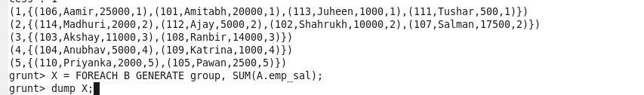

OUTPUT:

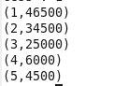

1. MAX-this command is used to determine the maximum value on the specified column

PIG SCRIPT:

C:\Users\Jayachandran\Desktop\asg pics\max cmd.jpg

OUTPUT: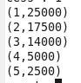

1. MIN- this command is used to determine the minimum value on the specified column

PIG SCRIPT:

C:\Users\Jayachandran\Desktop\asg pics\min cmd.jpg

OUTPUT: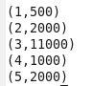

1. LIMIT-it is used to limit the content based on the given imit condition

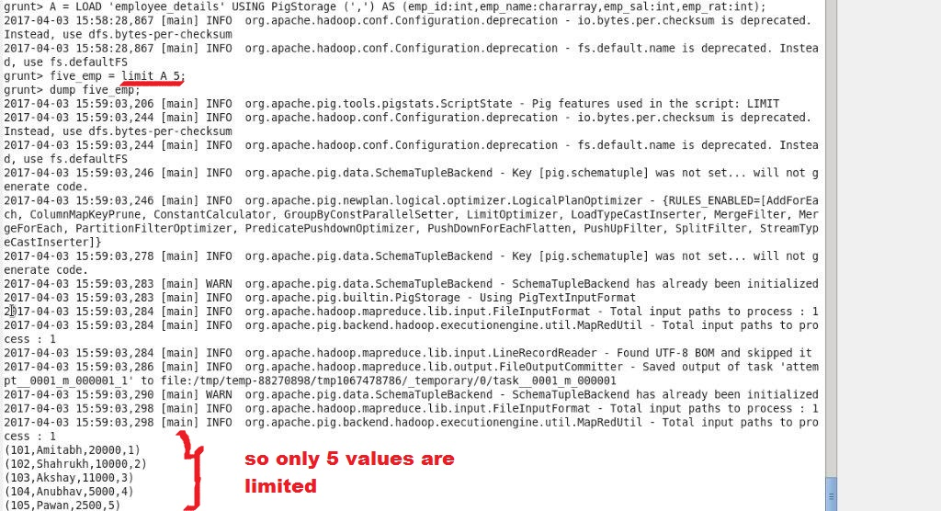

1. STORE-it is used to store the content in the specified file

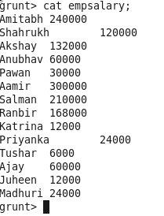

1. DISTINCT –it will give us the distinct values without any repetation

C:\Users\Jayachandran\Desktop\asg pics\distinct cmd.jpg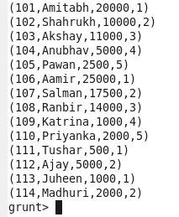

1. FLATTEN-flatten is used to remove the bag and display it as a simple tupple

C:\Users\Jayachandran\Desktop\asg pics\flatten cmd.jpgC:\Users\Jayachandran\Desktop\asg pics\flatten op.jpg

1. ISEMPTY-it is used to heck the presence of empty column values

