1.Write a pig script find the average age of male and female persons died in the titanic tragedy

PIG SCRIPT: loading the data file into pig, first we are filtering the people who are dead and then group by sex to get avg on each sex ,by using avg fn we got the avg of men and women who died in the tragic

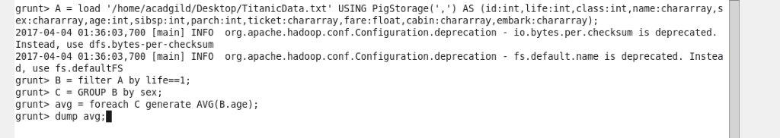

Output terminal:

C:\Users\Jayachandran\Desktop\asg pics\10.4.1 op.jpg

2. Write a pig script to find the number of people died and survived in each class

PIG SCRIPT: here we are grouping by survivability and then the number is counted

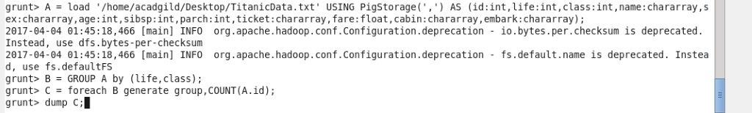

Output terminal:

