1.Write a pig script to find the minimum temperature observed in a given weather station in a particular year.

In dataset we can see that there is only one year by grouping the station we can find minimum temperature of a station using MIN function.

2. Write a pig script to find the maximum temperature observed in a given weather station in a particular year.

In dataset we can see that there is only one year by grouping the station we can find maximum temperature of a station using MAX function.

3. Write a pig script to find the number of readings given by each weather station according to the DATASET  
In dataset we can see that there is only one year by grouping the station and check whether is there any null values in temperature column and count the stations.

**PIG COMMAND:**

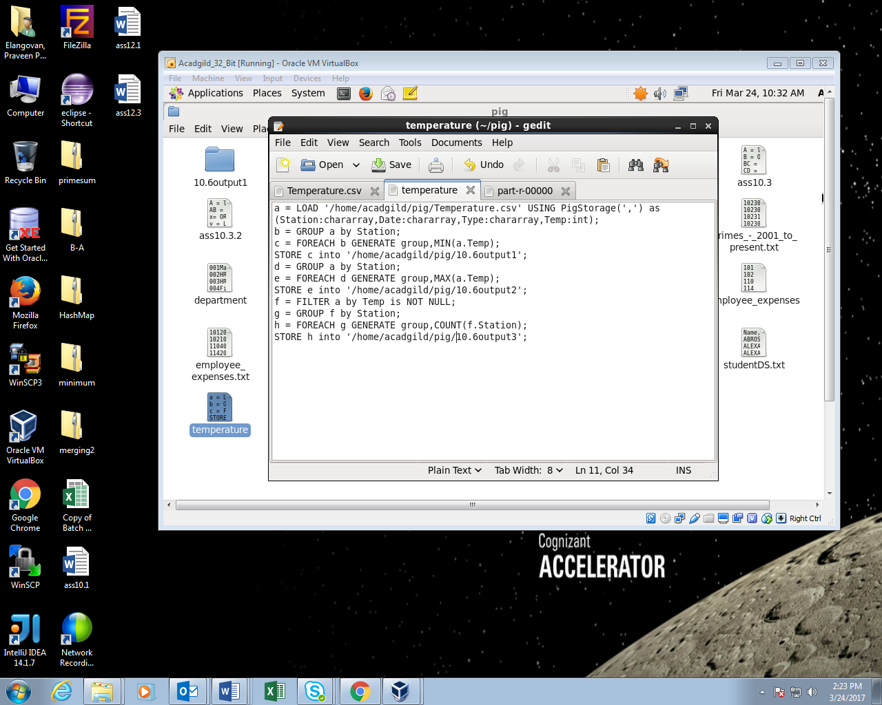

**RUNNING PIG SCRIPT:**

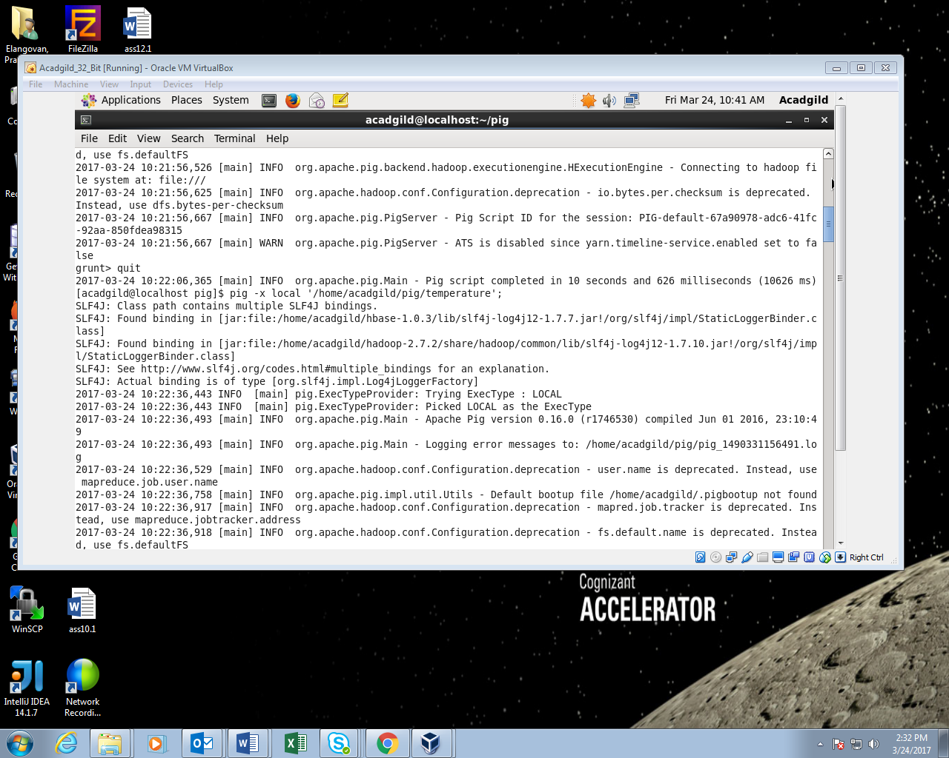

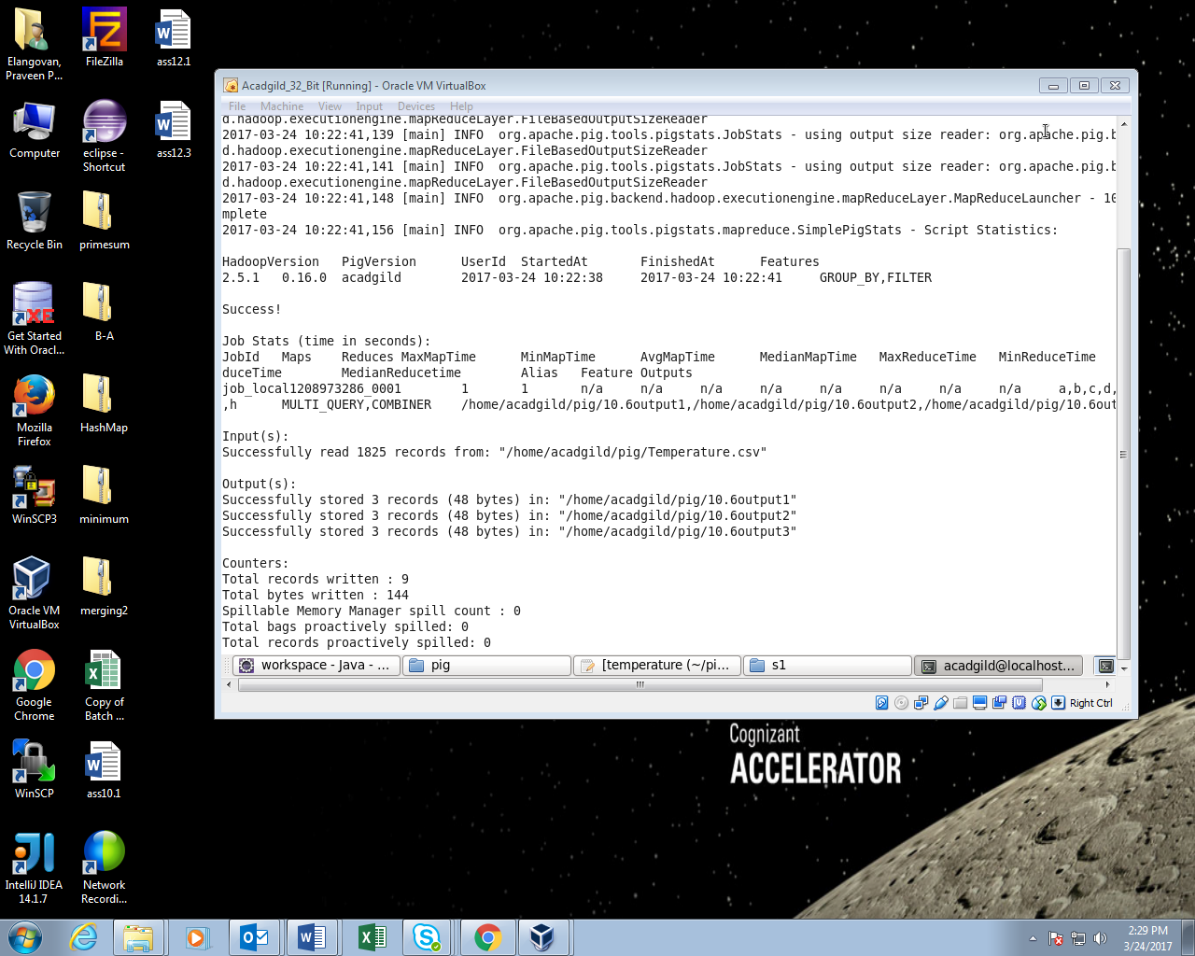

**OUTPUT:**

